**COMP 7003**

**Introduction to Information and Network Security**

*Assignment-02*

*Testing*

##### Anmol Mittal A01397754

##### February 2nd, 2025

##### Course Reference Number (CRN): 91662

**Tests** 4

Test 01 4

Test 02 4

Test 03 4

Test 04 5

Test 05 5

Test 06 5

Test 07 6

Test 08 6

Test 09 7

Test 10 7

Test 11 8

Test 12 8

Test 13 9

Test 14 9

|  |  |  |  |
| --- | --- | --- | --- |
| **Test** | **Expected** | **Actual** | **Screenshot** |
| Enter invalid BPF filter | fail | fail | Test 1 |
| Too many arguments in the BPF Filter | fail | fail | Test 2 |
| Enter no BPF filter | pass | pass | Test 3 |
| Run the program with too many CLI arguments | fail | fail | Test 4 |
| Enter non-number/integer in the number of packets to capture | fail | fail | Test 5 |
| No number in the number of packets to capture prompt | pass | pass | Test 6 |
| Negative number in the number of packets to capture | pass | pass | Test 7 |
| Positive number in the number of packets to capture | pass | pass | Test 8 |
| Valid BPF filter for ARP | pass | pass | Test 9 |
| Valid BPF filter for TCP | pass | pass | Test 10 |
| Valid BPF filter for UDP | pass | pass | Test 11 |
| Valid BPF filter for ICMP | pass | pass | Test 12 |
| No interface entered | pass | pass | Test 13 |
| No arguments entered at all | pass | pass | Test 14 |

# **Tests**

## Test 01

## Test 02

## Test 03

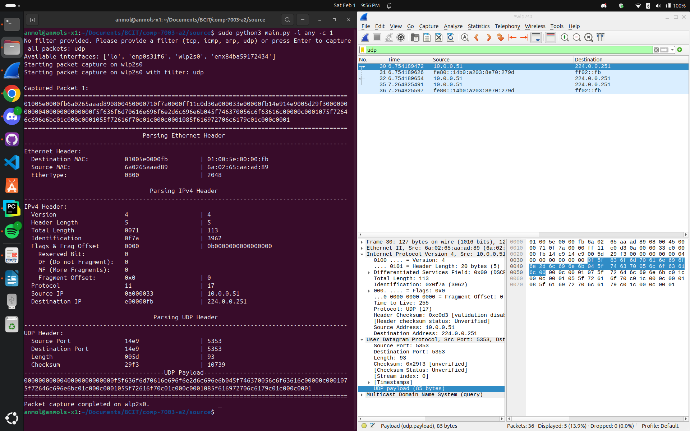

## Test 04

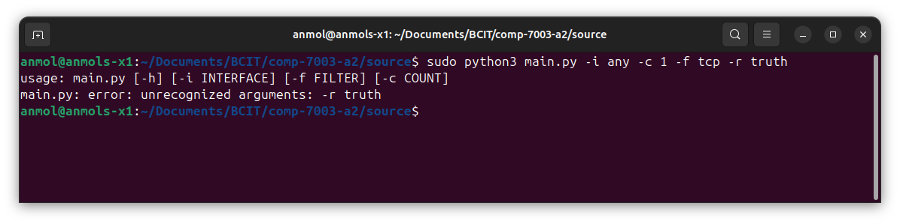

## Test 05

## Test 06

## Test 07

## Test 08

## Test 09

## Test 10

## Test 11

## Test 12

## Test 13

## Test 14

