Collision Data Dictionary

This dictionary provides a description of all the data fields contained in the collision data file and the corresponding codes. This is prepared to assist in the interpretation and analysis of the data.

Each data element is introduced as follows:

D.E. No.: This refers to the data element number as per the National Collision Database (NCDB-1) Data Dictionary, published by Transport Canada. “N/A” denotes a data field that is not found in the NCDB-1 Data Dictionary and is specific to the Northwest Territories.

Name: This is the data field name. This appears in the column header in the data file.

Column: This is the column where the data field is found in the data file.

Description: This is a description of the data file.

Table of Contents

D.E. Number | Name | Column | Description | Page
N/A | C_NREC | A | Record Number | 6
N/A | C_REP | B | Collision Replicate “x” | 6
01. | C_PROV | C | Province (stamped “11” for “NWT”) | 6
02. | C_POLC | D | Police Detachment | 7
03. | C_CASE | E | Collision Case Number | 8
04. | C_SCATT | F | Scene Attended | 8
05. | C_YEAR | G | Year of Collision | 8
06. | C_MNTH | H | Month of Collision | 9
07. | C_MDAY | I | Day of the Month | 9
08. | C_WDAY | J | Day of the Week | 10
09. | C_HOUR | K | Hour of Collision | 10
10. | C_SEV | L | Severity of Collision | 11
11. | C_DEAD | M | Persons Killed | 12
12. | C_INJ | N | Persons Injured | 12
13. | C_VEHS | O | Number of Vehicles Involved | 13
14. | C_CONF | P | Collision Configuration | 13
15. | C_HRUN | Q | Hit & Run Flag | 15
16. | C_RCFG | R | Roadway Configuration | 15
17. | C_WTHR | S | Weather Condition | 16
18. | C_LITE | T | Light Condition | 17
19. | C_ALITE | U | Artificial Light Condition | 17
20. | C_RCL1 | V | Road Classification I | 18
21. | C_RCL2 | W | Road Classification II | 18
22. | C_RCL3 | X | Road Classification III | 19
23. | C_RMTL | Y | Road Material | 19
24. | C_RSUR | Z | Road Surface | 20
25. | C_RCON | AA | Road Condition | 21
26. | C_RALN | AB | Road Alignment | 21
27. | C_TRAF | AC | Traffic Control | 22
28. | C_SPED | AD | Posted Speed Limit | 22
N/A | C_PRIOR | AE | Major Contributing Factor | 23
N/A | V_REP | AF | Vehicle Replicate “x” | 24
29. | V_ID | AG | Vehicle Sequence Number | 24
30. | V_NOCC | AH | Number of Occupants in Vehicle | 24
31. | V_DIR | AI | Direction of Travel | 25
32. | V_LICJ | AJ | Vehicle Licence Plate Jurisdiction | 25
33. | V_VIN | AK | Vehicle Identification Number | 26
34. | V_YEAR | AL | Vehicle Model Year | 27
35. | V_TYPE | AM | Vehicle Type | 27
36. | V_USE | AN | Vehicle Use | 28
37. | V_EMER | AO | Emergency Use | 29
38. | V_TRLR | AP | Trailer Type | 29
39. | V_LITE | AQ | Use of Vehicle Headlights | 30
40. | V_SPED | AR | Vehicle Speed | 31
41. | V_MNVR | AS | Vehicle Manoeuvre | 32
42. | V_DSEV | AT | Vehicle Damage Severity | 33
43. | V_IMPL | AU | First Impact Location | 33
44. | V_EVT1 | AV | Vehicle Event #1 | 35
45. | V_EVT2 | AW | Vehicle Event #2 | 35
46. | V_EVT3 | AX | Vehicle Event #3 | 35
47. | V_CF1 | AY | Contributing Factor #1 | 37
48. | V_CF2 | AZ | Contributing Factor #2 | 37
49. | V_CF3 | BA | Contributing Factor #3 | 38
50. | V_CF4 | BB | Contributing Factor #4 | 38
51. | V_PRIOR | BC | Prioritization of Contributing Factors | 39
52. | V_DANG | BD | Dangerous Goods Class | 39
53. | V_LDST | BE | Load Status of Commercial Vehicles | 40
54. | P_ID | BF | Person Sequence Number | 41
55. | P_SEX | BG | Person Sex | 41
56. | P_AGE | BH | Person Age | 42
N/A | P_LCLS | BI | Driver’s Licence Class | 42
57. | P_YLIC | BJ | Years Licensed in Jurisdiction | 43
58. | P_LICS | BK | Driver’s Licence Status | 44
59. | P_DLIC | BL | Province of Driver’s Licence | 45
60. | P_DBAC | BM | Blood Alcohol Concentration | 45
61. | P_PSN | BN | Person Position | 46
62. | P_EJCT | BO | Occupant Ejection From Vehicle | 47
63. | P_EJCLC | BP | Ejection Location | 48
64. | P_ISEV | BQ | Medical Treatment Required | 49
65. | P_SAFE | BR | Safety Device Used | 49
66. | P_PUSE | BS | Proper Use of Safety Device | 50
67. | P_ABAG | BT | Air Bag Deployment | 51
68. | P_PACT | BU | Pedestrian Action | 51
N/A | P_RCLS | BV | Road User Class | 52
N/A | C_HWY | BW | Highway Number | 53
N/A | C_KM | BX | Highway Location | 53
N/A | C_LTYP | BY | Collision Location Type | 54
N/A | C_COMM | BZ | Community Name | 54
N/A | C_STRT1 | CA | Name of Street/Road/Avenue | 56
N/A | C_KM2 | CB | Highway Location of Intersecting Highway | 56
N/A | C_HWY2 | CC | Highway Number of Intersecting Highway | 57
N/A | C_STRT2 | CD | Name of Intersecting Street/Road/Avenue | 57
N/A | C_DIST | CE | Distance From Reference (If Not At Intersection) | 57
N/A | C_UNITS | CF | Distance Units (If Not At Intersection) | 58
N/A | C_DIR | CG | Direction From Reference (If Not At Intersection) | 58
N/A | C_REF | CH | Reference Description (If Not At Intersection) | 58
N/A | C_SPEC | CI | Special Reference | 59
N/A | C_ALC | CJ | Alcohol Involvement | 59
N/A | C_ORV | CK | Off-Road Vehicle Involvement | 60

D.E. No. | Name | Column | Description
N/A | C_NREC | A | RECORD NUMBER

RECORD NUMBER

This is a sequential numbering of records in the database.

D.E. No. | Name | Column | Description
N/A | C_REP | B | COLLISION REPLICATE

COLLISION REPLICATE

This element distinguishes the first collision-level record from duplicate records for a collision. This is needed in carrying out analysis at the collision level to exclude records duplicated at the vehicle and person level.

Code | Description
x | First collision-level record
 | Duplicate collision-level record

D.E. No. | Name | Column | Description
01 | C_PROV | C | PROVINCE OF COLLISION

01. PROVINCE

This is the province or territory in which the collision occurred, and by whose administration the collision was recorded. In this database, C_PROV is “11” (Northwest Territories) for all collision records.

Code | Description
01 | Newfoundland
02 | Prince Edward Island
03 | Nova Scotia
04 | New Brunswick
05 | Quebec
06 | Ontario
07 | Manitoba
08 | Saskatchewan
09 | Alberta
10 | British Columbia
11 | Northwest Territories
12 | Yukon Territory
13 | Nunavut

D.E. No. | Name | Column | Description
02 | C_POLC | D | POLICE DETACHMENT

02. POLICE DETACHMENT

This describes the RCMP detachment in which the collision occurred, not the detachment where the collision report was filled out. The police detachment code provides information on how frequently a general geographic area experiences collisions. It also further defines geographic regions and this information is extremely important to Transport Canada in weighting randomly selected survey samples.

This information can also be used for such purposes as regional comparisons (e.g. North Slave vs. Inuvik, communities vs. rural areas), traffic modelling, study of traffic trends in any particular location and traffic forecasting.

The following 8-character codes have been assigned to the detachments:

Code | Detachment | Code | Detachment
NT100-02 | Deline | NT100-23 | Hay River
NT100-03 | Fort Liard | NT100-24 | Inuvik
NT100-10 | Sachs Harbour | NT100-25 | Tulita
NT100-11 | Fort Resolution | NT100-26 | Norman Wells
NT100-13 | Tlicho | NT100-28 | Fort Providence
NT100-15 | Aklavik | NT100-30 | Fort Simpson
NT100-18 | Ulukhaktok | NT100-31 | Tuktoyaktuk
NT100-19 | Fort McPherson | NT100-32 | Yellowknife
NT100-20 | Fort Smith | NT100-39 | Lutsel K’e
NT100-22 | Fort Good Hope

D.E. No. | Name | Column | Description
03 | C_CASE | E | COLLISION CASE NUMBER

03. COLLISION CASE NUMBER

This is a unique identifier assigned to each collision by the RCMP. This data element provides the key to uniquely identifying each collision. The Collision Identification Number consists of the calendar year in which the collision file was opened by the RCMP, followed by a hyphen followed by a 4 to 7 digit number.

D.E. No. | Name | Column | Description
04 | C_SCATT | F | SCENE ATTENDED

04. SCENE ATTENDED

This indicates whether the collision scene was attended by police and identifies the person that provided the information about the collision. In most jurisdictions, legislation requires that collisions not attended by the police be reported by the persons involved in the collision. This data element identifies the source of information for the collision report.

Code | Description
1 | Police attended the scene
2 | Police did not attend the scene

D.E. No. | Name | Column | Description
05 | C_YEAR | G | YEAR

05. YEAR

This is the calendar year in which the collision occurred.

Code | Description
YYYY | Calendar year of collision

D.E. No. | Name | Column | Description
06 | C_MNTH | H | MONTH

06. MONTH

This is the month in which the collision occurred.

Code | Description | Code | Description
01 | January | 08 | August
02 | February | 09 | September
03 | March | 10 | October
04 | April | 11 | November
05 | May | 12 | December
06 | June | UU | Unknown
07 | July

D.E. No. | Name | Column | Description
07 | C_MDAY | I | DAY

07. DAY

This is the day of the month that the collision occurred. This data element, together with month allows analysis of monthly variations in the number of collisions (e.g. Are there more traffic collisions during the vacationing months of July and August? Are there more collisions during holiday periods such as July 1 or Christmas season?) This information is useful for designing driver education programs and allocating resources for enforcement and program development.

Code | Description
01 through 31 | 01 through 31
UU | Unknown

D.E. No. | Name | Column | Description
08 | C_WDAY | J | DAY OF WEEK

08. DAY OF WEEK

This describes the day of week of the collision. For example, if the collision occurred on a Sunday, DAY OF WEEK would be recorded as “7”.

This data element allows analysis of collisions by the day of week (e.g. Are there more traffic collisions on weekends and holidays than on weekdays?)

Code | Description | Code | Description
1 | Monday | 5 | Friday
2 | Tuesday | 6 | Saturday
3 | Wednesday | 7 | Sunday
4 | Thursday | U | Unknown

D.E. No. | Name | Column | Description
09 | C_HOUR | K | HOUR

09. HOUR

This describes the hour of day when the collision occurred, using the 24-hour system. For example, if the collision occurred at 5:35 pm, HOUR would be recorded as “17”.

This data element allows analysis of hourly variations in the number of collisions (e.g. Are there more traffic collisions during the rush hours? Are there more during night-time hours?) This information is useful for such purposes as designing driver education programs and allocating resources for traffic safety countermeasures.

Code | Description | Code | Description | Code | Description
00 | Midnight to 0:59 | 09 | 9:00 to 9:59 | 18 | 18:00 to 18:59
01 | 1:00 to 1:59 | 10 | 10:00 to 10:59 | 19 | 19:00 to 19:59
02 | 2:00 to 2:59 | 11 | 11:00 to 11:59 | 20 | 20:00 to 20:59
03 | 3:00 to 3:59 | 12 | 12:00 to 12:59 | 21 | 21:00 to 21:59
04 | 4:00 to 4:59 | 13 | 13:00 to 13:59 | 22 | 22:00 to 22:59
05 | 5:00 to 5:59 | 14 | 14:00 to 14:59 | 23 | 23:00 to 23:59
06 | 6:00 to 6:59 | 15 | 15:00 to 15:59 | UU | Unknown
07 | 7:00 to 7:59 | 16 | 16:00 to 16:59
08 | 8:00 to 8:59 | 17 | 17:00 to 17:59

D.E. No. | Name | Column | Description
10 | C_SEV | L | COLLISION SEVERITY

10. COLLISION SEVERITY

Collision severity indicates the most severe effects of the collision. Property damage collisions are the least severe and fatal collisions are the most severe. This data element identifies the severity of the collision. It provides a primary selection criteria in sub-setting the type of collision to be analyzed.

Code | Description
1 | Fatal - death of any person involved in the collision within 30 days, caused by injuries related to the collision.
2 | Injury - any bodily harm, visible or complaint thereof of any driver, occupant or pedestrian caused by the collision with no fatalities.
3 | Property Damage – a collision which results in at least $1000 damage to vehicles or property with no injuries or fatalities
U | Unknown

D.E. No. | Name | Column | Description
11 | C_DEAD | M | NUMBER KILLED

11. NUMBER KILLED

This is the total number of persons who were killed as a result of the collision. This number must be the same as the number of fatally injured persons as indicated in the ALL INVOLVED section.

Code | Description
00 | No persons killed in this collision
01-98 | 01-98 persons killed in this collision
99 | 99 or more persons killed in this collision
UU | Unknown

D.E. No. | Name | Column | Description
12 | C_INJ | N | NUMBER INJURED

12. NUMBER INJURED

This is the total number of persons sustaining at least a minor injury as a result of the collision. This number must be the same as the number of injured persons as indicated in the ALL INVOLVED section.

Code | Description
00 | No persons injured in this collision
01-98 | 01-98 persons injured in this collision
99 | 99 or more persons injured in this collision
UU | Unknown

The data element provides a count of the number of persons injured in the collision. It allows, at a quick glance, the severity of the collision.

D.E. No. | Name | Column | Description
13 | C_VEHS | O | NUMBER OF VEHICLES

13. NUMBER OF VEHICLES

This indicates the number of vehicles involved in the collision. This number must equal the number of vehicles described in the DRIVER/VEHICLE/OWNER section of the report form.

Code | Description
01-98 | 01-98 vehicles involved
99 | 99 unknown

D.E. No. | Name | Column | Description
14 | C_CONF | P | COLLISION CONFIGURATION

14. TYPE (COLLISION CONFIGURATION)

This identifies the configuration of the first collision event. If more than two vehicles are involved, the configuration is determined by the two vehicles that were first involved in the collision.

Approximately 30% of fatal collisions involved single vehicles, yet information on this type of collision is lacking. The study of collision configuration gives the road safety community a chance to understand how collisions occur. This knowledge is extremely useful in work such as the development of countermeasure programs, driver education campaigns, resource allocations, development of new safety standards and regulations.

In addition to the codes shown in the table, “1a” denotes “Animal Strike”, “1p” denotes “Collision with Pedestrian”, “3r” denotes “Ran Off Road – Left with Rollover” and “4r” denotes “Ran Off Road – Right with Rollover” .

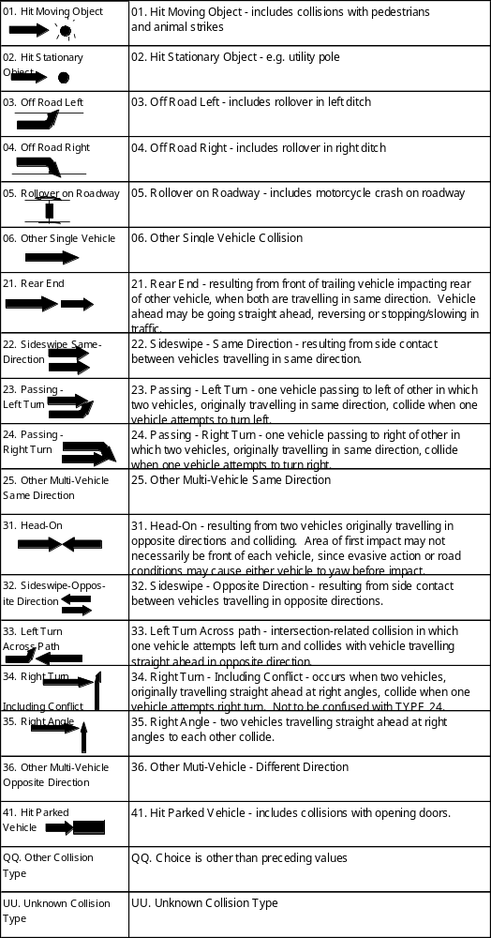
D.E. No. | Name | Column | Description
15 | C_HRUN | Q | HIT AND RUN

15. HIT AND RUN

This indicates if there was a hit-and-run involvement in the collision. A “hit and run” is defined as an collision following which an involved driver fails to remain at the scene.

According to past data, 3 to 20% of collisions involve hit-and-run drivers, and some of the police communities perceive this problem to be increasing. More interestingly, the jurisdictions with the highest incidence of hit-and-run collisions are those with government insurance (e.g. BC, Manitoba and Quebec). This data element allows the road safety community and the insurance industry to monitor hit-and-run trends, both nationally and by jurisdiction. This information can be used in formulating education campaigns and setting policies.

Code | Description
1 | Hit-and-run
2 | Not a hit-and-run case
U | Unknown

D.E. No. | Name | Column | Description
16 | C_RCFG | R | ROADWAY CONFIGURATION

16. ROADWAY CONFIGURATION

This describes intersections and distinct road features directly related to the site. If an collision takes place at an intersection, an intersection location should be coded regardless of whether the collision is intersection related. An intersection is defined as the common area of two roads plus two car lengths adjacent to the common area on each road.

If a through vehicle is in collision with a vehicle entering from an approach the collision is intersection related. If a vehicle runs off the road at an intersection because the driver fell asleep, the collision is not intersection related but should still be recorded as an intersection collision. A rear end collision that occurs in a string of vehicles several car lengths from the intersection. This is also an intersection related collision. Most collisions occurring on rural highways, winter roads or trails would be coded as non-intersection.

Code | Description
1 | Non-intersection e.g. “mid-block”
2 | Intersection-Related
3 | Intersection with parking lot entrance/exit, private driveway or laneway
4 | Railway level crossing
5 | Bridge, overpass, viaduct
6 | Tunnel or underpass
Q | Choice is other than preceding values
U | Unknown

D.E. No. | Name | Column | Description
17 | C_WTHR | S | WEATHER CONDITION

17. WEATHER CONDITION

This describes the weather condition prevalent at the scene of the collision.

Code | Description
1 | Clear and/or sunny
2 | Cloudy - overcast with no precipitation
3 | Raining
4 | Snowing, not including drifting snow
5 | Sleet, hail, freezing rain
6 | Visibility limitation – e.g. blowing snow, fog, smog, dust, smoke, mist
7 | Strong wind
Q | Choice is other than the preceding values
U | Unknown

D.E. No. | Name | Column | Description
18 | C_LITE | T | LIGHT CONDITION

18. LIGHT CONDITION

This is the ambient light condition at the scene of the collision based on the time and season when the collision occurred.

Code | Description
1 | Daylight Between sunrise to sunset
2 | Dawn Up to one hour before sunrise
3 | Dusk Up to one hour after sunset
5 | Darkness Between dusk to dawn
U | Unknown

D.E. No. | Name | Column | Description
19 | C_ALITE | U | ARTIFICIAL LIGHT CONDITION

19. ARTIFICIAL LIGHT CONDITION

This is a supplementary field to describe the state of street lighting at the scene.

Code | Description
1 | None, no artificial light available
2 | Yes, artificial light illuminated the scene
3 | No, artificial light available but not on
U | Unknown

D.E. No. | Name | Column | Description
20 | C_RCL1 | V | ROAD CLASSIFICATION I

20. ROAD CLASSIFICATION I

This describes the predominant characteristics of the land use adjacent to the collision site.

Code | Description
1 | Urban - collision occurred within the corporate boundaries of a community
2 | Rural - collision occurred outside corporate boundaries of a community
U | Unknown

D.E. No. | Name | Column | Description
21 | C_RCL2 | W | ROAD CLASSIFICATION II

21. ROAD CLASSIFICATION II

This is the orderly grouping of roads according to travel speed, traffic flow and land services they provide to the public within the road network. The hierarchial nature of the road network is such that local roads feed traffic into collectors, collectors feed into arterials, and arterials feed into freeways.

The classification for roadways on the NWT Highway System is shown in Appendix A.

Code | Description
2 | Arterial – e.g. numbered NWT Highways, Franklin Ave. (Yellowknife), Mackenzie Rd. (Inuvik), Old Airport Rd. (Yellowknife), Woodland Dr. (Hay River)
3 | Collector – e.g. NWT Highway Access and Winter Roads, Forrest Dr. (Yellowknife), Riverview Dr. (Hay River). Industrial Rd. (Inuvik), Range Lake Rd. (Yellowknife)
4 | Local – e.g. all residential streets, service roads, alleys
Q | Choice is other than preceding values – e.g. parking lots, commercial/private driveways
U | Unknown

D.E. No. | Name | Column | Description
22 | C_RCL3 | X | ROAD CLASSIFICATION III

22. ROAD CLASSIFICATION III

This describes the road characteristics related to the design. It is necessary to subdivide the primary road classification because different roadways providing the same service (or function) may have markedly different geometric designs.

Code | Description
1 | One – way, two lane
2 | One – way, multi-lane
3 | Undivided, two – way, two lane
4 | Undivided, two – way, multi-lane
5 | Divided, barrier median
6 | Divided, with median, no barrier
7 | Divided, type of divider not specified
Q | Choice is other than the preceding values
U | Unknown

D.E. No. | Name | Column | Description
23 | C_RMTL | Y | ROAD MATERIAL

23. ROAD MATERIAL
This is the surface material of the roadway at the collision site. For collisions taking place on the NWT Highway System, please refer to Appendix A in this manual to ensure that the road surface material is consistent with the highway location.

 | Code |  | Description
 | 1 |  | Asphalt
 | 2 |  | Concrete
 | 3 |  | Gravel
 | 4 |  | Earth, dirt
 | 5 |  | Chip-seal
 | 6 |  | Brick, cobblestone
 | 7 |  | Wooden – e.g. bridge
 | 8 |  | Steel deck – e.g. bridge
 | 9 |  | Ice road Frozen body of water used as roadway during winter
 | Q |  | Choice is other than the preceding values
 | U |  | Unknown
D.E. No. |  | Name |  | Column | Description
24 |  | C_RSUR |  | Z | ROAD SURFACE

24. ROAD SURFACE

This describes the condition of the top of the road surface caused by weather and short-term maintenance operations. The most significant condition of the road surface at the scene of the collision should be coded.

Code | Description
1 | Dry, normal
2 | Wet
3 | Snow (fresh, loose snow)
4 | Slush, wet snow
5 | Icy - includes packed snow
6 | Loose Sand, Dirt or Gravel Refers to the debris on the road, not the material used to construct the road
7 | Muddy
8 | Oil - includes spilled liquid or road application
9 | Flooded
Q | Choice is other than preceding values
U | Unknown

D.E. No. | Name | Column | Description
25 | C_RCON | AA | ROAD CONDITION

25. ROAD CONDITION

This describes the construction and/or maintenance condition of the road.

Code | Description
1 | Good
2 | Potholes, ruts, bumps
3 | Under construction, repair
4 | Uneven pavement surface
5 | Worn - i.e. low coefficient of friction
6 | Obscured or faded pavement markings
Q | Choice is other than the preceding values
U | Unknown

D.E. No. | Name | Column | Description
26 | C_RALN | AB | ROAD ALIGNMENT

26. ROAD ALIGNMENT

This is the visual alignment of the roadway the vehicle was travelling on at the time of the collision.

Code | Description | Code | Description
1 | Straight and level | 5 | Top of hill or grade
2 | Straight with gradient | 6 | Bottom of hill or grade (“Sag”)
3 | Curved and level | Q | Choice is other than the preceding values
4 | Curve with grade | U | Unknown

D.E. No. | Name | Column | Description
27 | C_TRAF | AC | TRAFFIC CONTROL

27. TRAFFIC CONTROL

Traffic control is the device present at the scene of the collision. If the device is missing or vandalized, the control that should be there should be recorded if the police know what that is.

Code | Description | Code | Description
01 | Traffic signals fully operational | 11 | No passing zone sign
02 | Traffic signals in flashing mode | 12 | Markings on road - eg. no passing
03 | Stop sign | 13 | School bus stopped - lights flashing
04 | Yield sign | 14 | School bus stopped - signals not flashing
05 | Warning sign | 15 | Railway crossing with signals, or signals and gates
06 | Pedestrian cross walk | 16 | Railway crossing with signs only
07 | Police officer | 17 | Control device not specified
08 | School guard, flagman | 18 | No control present
09 | School crossing | QQ | Choice is other then the preceding values
10 | Reduced speed zone | UU | Unknown

D.E. No. | Name | Column | Description
28 | C_SPED | AD | POSTED SPEED LIMIT

28. POSTED SPEED LIMIT

This is the posted speed limit at the collision site. A table of posted speed limits for roadways on the NWT Highway System is shown in Appendix A.

“Driving too fast” has been attributed as the cause of nearly 15% of driver fatalities. By knowing the posted speed and the travelling speed of the vehicle, the safety community can better design countermeasure programs, education campaigns and enforcement resource allocations.

Code | Description | Code | Description
1 | 30 km/h or less | 6 | 80 km/h
2 | 35 or 40 km/h | 7 | 90 km/h
3 | 45 or 50 km/h | 8 | 100 km/h
4 | 60 km/h | 9 | 110 km/h or more
5 | 70 km/h | U | Unknown

D.E. No. | Name | Column | Description
NA | C_PRIOR | AE | MAJOR CONTRIBUTING FACTOR

MAJOR CONTRIBUTING FACTOR

This is the factor, deemed by the Traffic Analyst, to have contributed most significantly to the collision. The value recorded for C_PRIOR must be one of; HUMAN CONDITION, DRIVER ACTION, VEHICLE CONDITION, or ENVIRONMENTAL FACTOR for any vehicle or driver involved in the collision other than “NN”.

Code | Description | Code | Description
01 | Fatigued, fell asleep | 42 | Defective steering
02 | Inexperience | 43 | Defective lights
03 | Under influence - alcohol | 44 | Tire blown out
04 | Under influence - drugs | 45 | Unsecured or spilled load
05 | Sudden illness, lost consciousness | 46 | Oversized load, overload
09 | Other driver condition | 47 | Visibility obstructed
21 | Following too close | 48 | Other defective parts
22 | Distracted, inattentive | 49 | Other vehicle contributing factor
23 | Driving too fast for conditions | 51 | Animal on roadway
24 | Improper turning or passing | 52 | Road surface or other condition
25 | Fail to yield right-of-way | 53 | Obstruction on road
26 | Disobeyed traffic control device/officer | 54 | View obstructed, glare, reflection
27 | Driving on wrong side of road | 55 | Weather or other acts of God
29 | Backing unsafely | 59 | Other environmental contributing factor
30 | Lost control | QQ | Choice is other than the preceding values
39 | Other driver action | UU | Unknown
41 | Defective brakes

D.E. No. | Name | Column | Description
NA | V_REP | AF | VEHICLE REPLICATE

VEHICLE REPLICATE

This element distinguishes the first vehicle-level record from duplicate records for a vehicle. This is useful in carrying out analysis at the vehicle level to exclude records duplicated at the person level.

Code | Description
x | First vehicle-level record
 | Duplicate vehicle-level record

D.E. No. | Name | Column | Description
29 | V_ID | AG | VEHICLE SEQUENCE NUMBER

29. VEHICLE SEQUENCE NUMBER

A sequence number is assigned to every vehicle and pedestrian involved in the collision. Each vehicle involved must have a sequence number, regardless of vehicle type or whether it was parked or a run-away vehicle. The vehicle sequence number is reset to “01” for every collision. Note that the highest vehicle sequence number assigned in an collision equals the number of vehicles involved in that collision (with the exception of “99” which is reserved for pedestrians).

Pedestrians are assigned a vehicle sequence number of “99”.

Code | Description
01 through 98 | 1 through 98
99 | VEHICLE SEQUENCE NUMBER assigned to pedestrians

D.E. No. | Name | Column | Description
30 | V_NOCC | AH | TOTAL OCCUPANTS

30. TOTAL OCCUPANTS

This describes the number of occupants in/on the vehicle. Record “99” if the number of occupants is unknown. This data element provides information to compose national collision profiles. Knowing the number of occupants can help answer questions such as “How many Canadians are involved in collisions every year?” and “How many actually walk away from collisions without sustaining an injury?”

Code | Description
01 through 98 | 01 to 98 occupants in/on the vehicle
99 | 99 or more occupants
NN | Unoccupied

D.E. No. | Name | Column | Description
31 | V_DIR | AI | DIRECTION OF TRAVEL

31. DIRECTION OF TRAVEL

This describes the direction of travel of the vehicle just prior to the collision. If the vehicle was turning at the time of the collision, record the direction of travel prior to turning.

Code | Description | Code | Description
1 | North | 7 | West
2 | Northeast | 8 | Northwest
3 | East | 9 | Parked vehicle
4 | Southeast | U | Unknown
5 | South
6 | Southwest

D.E. No. | Name | Column | Description
32 | V_LICJ | AJ | PROVINCE/STATE OF LICENCE PLATE

32. PROVINCE/STATE OF LICENCE PLATE

This is the province or territory that provided the vehicle’s licence plate. This data element serves two primary purposes. First, it provides information that can be used for traffic modelling. Secondly, it identifies the province that issued the licence plate. Transport Canada requires this information in order to obtain the VIN from the vehicle registration file.

Code | Description | Code | Description | Code | Description
01 | Newfound-  land | 08 | Saskatchewan | 15 | All States of the USA
02 | Prince Edward Island | 09 | Alberta | 16 | Other Foreign
03 | Nova Scotia | 10 | British Columbia | 17 | No licence
04 | New Brunswick | 11 | Northwest Territories | 18 | Nunavut
05 | Quebec | 12 | Yukon Territory | QQ | Choice is other than preceding values
06 | Ontario | 13 | Canadian Military | UU | Unknown
07 | Manitoba | 14 | Diplomatic

D.E. No. | Name | Column | Description
33 | V_VIN | AK | VEHICLE IDENTIFICATION NUMBER

33. VIN (VEHICLE IDENTIFICATION NUMBER)

Because of the confidential nature of this data element, the VEHICLE IDENTIFICATION NUMBER cannot be made available and is recorded as “XXXXXXXXXXXXXXXXX” for all records in the database.

D.E. No. | Name | Column | Description
34 | V_YEAR | AL | VEHICLE MODEL YEAR

34. VEHICLE MODEL YEAR

This is the model year of the vehicle as specified by the manufacturer. This information is embedded in the VIN (Vehicle Identification Number). When Transport Canada receives VIN files from all jurisdictions, this data element may be eliminated.

Code | Description
19yy to 20yy | Model Year 19yy to 20yy
UUUU (record single “U”) | Unknown

D.E. No. | Name | Column | Description
35 | V_TYPE | AM | VEHICLE TYPE

35. VEHICLE TYPE

This is a classification of the vehicle according to its general design characteristics.

As details related to heavy trucks are described under TRAILER TYPE, they will not be collected through this data element, other than to identify the vehicle type as “unit trucks - 4536 kg. & over” or “road tractor”. Similarly, special vehicles such as ambulances, taxis and police cruisers are classified according to their basic vehicle type in this data element, whereas their special purposes or use is recorded in VEHICLE USE.

This is one of the most important data elements used by researchers and automotive engineers in collision analysis. There are very specific safety standards and regulations related to each type of vehicle. Therefore, by knowing the exact vehicle type, and the severity of the injuries, researchers and automotive engineers can better design and regulate future vehicles.

Secondly, different types of vehicles tend to be involved in different collision configurations (e.g. pickup trucks are thought to be involved in more loss of control single vehicle collisions than passenger cars). By knowing as accurately as possible the vehicle type, the road safety community can better design countermeasure programs and education campaigns.

Code | Description | Code | Description
01 | Passenger cars | 12 | Inter-city bus
02 | Passenger van - multi-purpose vehicles with van bodies designed primarily for passenger transport | 14 | Motorcycle - motorized two or three wheeled vehicles capable of speeds greater than 70 km/h
03 | Light utility vehicles - vehicles on truck chassis designed for passenger transport and for off-road use (eg. Blazer, Bronco) | 15 | Limited speed motorcycle - motorized two or three wheeled vehicles with top speed less than 70 km/h (e.g. small scooters, mopeds)
04 | Pickup trucks under 4536 kg. - pickups with open load bed, with camper top, etc. | 16 | Off road vehicles – e.g. ATVs
05 | Panel cargo/vans under 4536 kg.  - panel or window type van designed primarily for carrying goods. | 17 | Bicycle - any number of wheels
06 | Other trucks and vans under 4536 kg. - unspecified, or any other types of LTVs that do not fit into the above categories (e.g. delivery or service vehicles, small tow trucks, etc.) | 18 | Purpose-built motorhome - excludes pickup campers
07 | Unit trucks over 4536 kg - all heavy unit trucks, with or without a trailer e.g. water trucks | 19 | Farm equipment
08 | Road tractor - with or without a semi-trailer | 20 | Construction equipment
09 | School bus | 22 | Snowmobile
11 | Urban transit bus | QQ | Choice is other than preceding values
UU | Unknown

D.E. No. | Name | Column | Description
36 | V_USE | AN | VEHICLE USE

36. VEHICLE USE

This indicates whether the vehicle was used for a function other than the original function intended for that type of vehicle.

Transport Canada is frequently asked about collisions involving vehicles operating in special situations. Both the public and the media have often requested statistics on collisions involving vehicles in special situations (e.g. police cruisers in emergency use). This data element, coupled with EMERGENCY USE will provide answers to those queries, and data that may help to improve safety in emergency vehicle operations.

Code | Description | Code | Description
01 | Taxi | 09 | Tow truck
02 | School bus | 10 | Delivery vehicle
03 | Vehicle used as other bus | 11 | Road maintenance
04 | Military | 12 | Utilities maintenance – e.g. electrical, water, cable, gas, phone
05 | Police cruiser | 13 | Fire response vehicle
06 | Other police vehicles | 99 | No special use
07 | Ambulance | QQ | Choice is other than the preceding values
08 | Hearse | UU | Unknown

D.E. No. | Name | Column | Description
37 | V_EMER | AO | EMERGENCY USE

37. EMERGENCY USE

Indicates whether the vehicle was used in an emergency situation or not.

Code | Description
1 | Emergency situation or response mode
2 | Not in emergency situation or response mode
N | Not an emergency vehicle
U | Unknown

D.E. No. | Name | Column | Description
38 | V_TRLR | AP | TRAILER TYPE

38. TRAILER TYPE

This is a classification or description of the trailer(s) according to its (their) general characteristics.

Heavy trucks are involved in approximately 10% of all fatal collisions, yet very little is known about these collisions. It s essential to understand the nature of collisions involving heavy truck combinations in order to establish new safety regulations, countermeasure programs, and driver education campaigns. This data element will also provide information on trailers towed by cars and light trucks and vans.

Code | Description
1 | Recreational trailer - includes house and tent trailers
2 | Light utility trailer - includes boat and snowmobile trailers, komatiks
3 | Commercial full trailer - single drawbar connection
4 | One semi-trailer
5 | Two semi-trailers - A train, single drawbar dolly
6 | Two semi-trailers - B train, 5th wheel connections only
7 | Two semi-trailers - C train, double drawbar dolly
8 | Two semi-trailers, connector unknown
9 | Three semi-trailers, all connector types
N | No trailer - vehicle not pulling trailer at time of collision
Q | Choice is other than preceding values - eg. towed vehicle
U | Unknown

D.E. No. | Name | Column | Description
39 | V_LITE | AQ | USE OF VEHICLE HEADLIGHTS

39. USE OF VEHICLE HEADLIGHTS

This describes the use of vehicle headlights. Since the introduction of Daytime Running Lights (DRL) as required equipment in 1990, there has been some concern that drivers are using their headlights improperly, especially during night time. Some drivers incorrectly assume that the DRL is adequate in illuminating the road at night and thus neglect to turn on the headlights. Similarly, during foggy conditions, drivers with DRL occasionally do not turn on their headlights thus causing rear-end collisions because their taillights were not on. This data element would also provide information on drivers who are driving vehicle without DRL, but voluntarily use headlights during daytime.

Code | Description
1 | No lights on - includes vehicles not equipped with headlights
2 | Daytime running lights on
3 | Headlights on
4 | Parking lights only on
5 | Fog or auxiliary lights on
Q | Choice is other than preceding values
U | Unknown

D.E. No. | Name | Column | Description
40 | V_SPED | AR | VEHICLE SPEED

40. VEHICLE SPEED

This is the estimated speed of the vehicle just prior to the collision. “Driving too fast” has been attributed as a causal factor in nearly 15% of driver fatalities. By knowing the posted speed and the travelling speed of the vehicle, the safety community can better design countermeasure programs, education campaigns and enforcement resource allocation.

In addition, driving speed and damage to the vehicle are directly related. The faster a vehicle is being driven, the greater damage it is likely to sustain in a collision. This data element will enable automotive engineers to further their work in designing safer vehicles and provide better occupant protection.

Code | Description
01 | Less than 20 km per hour – includes stopped in traffic
02 | 20 – 29 km per hour
03 | 30 – 39 km per hour
04 | 40 – 49 km per hour
05 | 50 – 59 km per hour
06 | 60 – 69 km per hour
07 | 70 – 79 km per hour
08 | 80 – 89 km per hour
09 | 90 – 99 km per hour
10 | 100 – 109 km per hour
11 | 110 – 119 km per hour
12 | 120 km per hour or more
NN | Parked
UU | Unknown

D.E. No. | Name | Column | Description
41 | V_MNVR | AS | VEHICLE MANOEUVRE

41. VEHICLE MANOEUVRE

This is the actual movement of the vehicle just prior to the collision. This identifies the manoeuvre of each vehicle prior to the collision or the driver’s realization that the collision might occur. Therefore, abrupt vehicle actions immediately prior to the collision should not be coded.

Code | Description | Code | Description | Code | Description
01 | Going straight ahead | 08 | Overtaking, passing | 15 | Swerving to avoid collision
02 | Turning left | 09 | Negotiating a curve | 16 | Run-away or roll-away vehicle
03 | Turning right | 10 | Slowing or stopped in traffic | 21 | Vehicle manoeuvre unspecified
04 | Making U-turn | 11 | Starting in traffic | QQ | Choice is other than the preceding values – e.g. vehicle being pushed or walked
05 | Changing lanes | 12 | Leaving roadside | UU | Unknown – e.g. hit-and-run cars
06 | Merging into traffic | 13 | Stopped/parked legally – excludes vehicles stopped in traffic
07 | Reversing | 14 | Stopped/parked illegally – excludes vehicles stopped in traffic

This data element, coupled with others, will provide information on the collision events. For example, to monitor the impact of the Central High Mounted Stop (regulated January 1, 1987), the analyst would need to select all cases involving rear-end collisions involving two vehicles travelling in the same direction. One vehicle was “slowing or stopped on roadway” and the other was “going straight ahead”.

Information of this nature is important in both predicting and monitoring the impact of new safety standards and regulations. In addition, this information is useful in designing education campaigns. For example, the most frequent vehicle manoeuvres just prior to collisions are “going straight ahead”, “slowing or stopping in traffic”, “reversing” and “turning left”. The education campaigns can gear their targets in training of drivers with these manoeuvres.

D.E. No. | Name | Column | Description
42 | V_DSEV | AT | DAMAGE SEVERITY

42. DAMAGE SEVERITY

This is a qualitative assessment of the damage sustained by the vehicle. This indicates the extent of the vehicle damage as a result of the collision. This data element, coupled with other data elements such as FIRST IMPACT LOCATION and VEHICLE EVENTS can provide valuable information on how to better design and regulate safety standards for future vehicles.

Code | Description
1 | No visible damage
2 | Light - superficial, driven away from the scene
3 | Moderate - still drivable but does not meet requirements of the law for further use without repairs, driven away from the scene
4 | Severe - not drivable, but worth repairing, towed from scene
5 | Demolished - totally destroyed, not worth repairing
Q | Choice is other than the preceding values
U | Unknown

D.E. No. | Name | Column | Description
43 | V_IMPL | AU | FIRST IMPACT LOCATION

43. FIRST IMPACT LOCATION

This describes the location of the initial point of impact on the vehicle. This information, along with DAMAGE SEVERITY and VEHICLE EVENTS can provide valuable information on how to improve safety through standards and regulations and voluntary changes in future vehicles.

Code | Description | Code | Description
01 | Front - includes engine hood and windshield | 13 | Right rear third of vehicle
02 | Roof | 14 | Right front two-thirds of vehicle
03 | Rear - includes trunk | 15 | Right rear two-thirds of vehicle
04 | Left front third of vehicle | 16 | Entire right side
05 | Left middle third of vehicle | 17 | Right side - unspecified
06 | Left rear third of vehicle | 18 | Undercarriage
07 | Left front two-thirds of vehicle | 19 | Interior
08 | Left rear two-thirds of vehicle | 20 | Attachment (either towed or trailer) was hit first
09 | Entire left side | 99 | No apparent damage
10 | Left side - unspecified | QQ | Choice is other than preceding values
11 | Right front third of vehicle | UU | Unknown
12 | Right middle third of vehicle

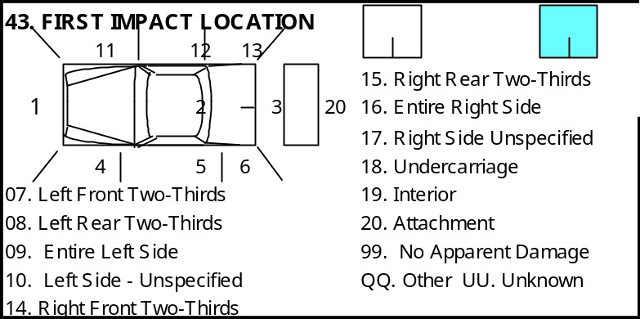
D.E. No. | Name | Column | Description
44-46 | V_EVT1 to V_EVT3 | AV to AX | VEHICLE EVENTS

44 - 46. VEHICLE EVENTS

This is a set of three codes that describe, in sequence, the events occurring to each vehicle in its involvement in the collision. All three fields should be filled. If a vehicle is involved in less than three events, the remaining fields should be coded “NN” (not applicable). Note that the choice for the first event for Vehicle 1 CANNOT be “NN”. If the vehicle underwent two events, the choice for the second event CANNOT be “NN”.

This data element, coupled with others, such as DAMAGE SEVERITY and FIRST IMPACT LOCATION, can provide valuable information on how to improve safety standards and regulations for future vehicles. Currently, there is insufficient Canadian data on events that cause fatalities and injuries. Canadian road designers must therefore rely on U.S. data from the Fatal Collision Reporting System (FARS) and the National Collision Sampling System (NASS) which uniquely identify specific events and objects struck. With similar codes as FARS and NASS, NCDB-1 will not only provide unique Canadian data, but will allow comparison with the U.S. data.

Code | Description | Code | Description | Code | Description
 | Non-Collision Events: | 12 | Hit pedestrian | 26 | Hit end of culvert, drainage structure
01 | Skidded or spun on roadway | 13 | Hit bicyclist | 27 | Hit tree, large bush/hedge
02 | Ran off roadway | 14 | Hit animal | 28 | Hit utility/lamp pole
03 | Overturned, roll-over | 15 | Hit train | 29 | Hit curb
04 | Jack-knife or trailer swing | 16 | Hit street car | 30 | Hit sign post
05 | Fire or explosion | 19 | Hit other moving object | 31 | Hit traffic barrier – e.g. Impact attenuator, moveable barrier, fence
06 | Load spill |  | Hit Non-Moving Object | 32 | Hit fixed object part of road structure – e.g. bridge railing, abutment
07 | Load shift | 21 | Hit parked vehicle | 33 | Hit fixed object not part of road structure - eg. utility box, fire hydrant
08 | Submersion | 22 | Hit a non-fixed object. Includes trailers, farm/construction equipment, etc. | 39 | Hit other type fixed object
09 | Other non-collision event | 23 | Hit a building | NN | No second or third event for this vehicle
 | Hit Moving Objects: | 24 | Hit ditch | QQ | Choice is other than preceding values
11 | Hit moving motor vehicle | 25 | Hit embankment, dirt pile | UU | Unknown

CONTRIBUTING FACTORS

There are four categories of contributing factors: DRIVER CONDITION, DRIVER ACTION, VEHICULAR CONTRIBUTING FACTOR, and ENVIRONMENTAL CONTRIBUTING FACTOR.

These four fields are intended to describe the factors that appear to have contributed to the occurrence of the collision. All four fields should be filled, even if to record “Not Applicable”. However, at least one category should have a choice other than “Not Applicable” recorded for at least one vehicle or pedestrian.

D.E. No. | Name | Column | Description
47 | V_CF1 | AY | DRIVER CONDITION

47. DRIVER CONDITION

This describes the condition of drivers involved in the collision.

Code | Description | Code | Description
1 | Fatigue/fell asleep | 5 | Sudden illness, lost consciousness
2 | Inexperience | N | Apparently normal
3 | Under influence - alcohol | Q | Choice is other than preceding values
4 | Under influence - drugs | U | Unknown

D.E. No. | Name | Column | Description
48 | C_CF2 | AZ | DRIVER ACTION

48. DRIVER ACTION

This describes the action of drivers immediately prior to the collision.

Code | Description | Code | Description
21 | Following too close | 27 | Driving on wrong side of road
22 | Distracted, inattentive | 29 | Backing unsafely
23 | Driving too fast for conditions | 30 | Lost control
24 | Improper turning or passing | NN | Driving properly
25 | Fail to yield right-of-way | QQ | Choice is other than preceding values
26 | Disobeyed traffic control device/officer | UU | Unknown

D.E. No. | Name | Column | Description
49 | V_CF3 | BA | VEHICLE FACTORS

49. VEHICLE FACTORS

This describes the presence of any mechanical defects in the involved vehicles which may have contributed to the collision.

Code | Description | Code | Description
41 | Defective brakes | 47 | Visibility obstructed
42 | Defective steering | 48 | Other defective parts
43 | Defective lights | NN | No apparent defects
44 | Tire blown out | QQ | Choice is other than preceding values
45 | Unsecured or spilled load | UU | Unknown
46 | Oversized load, overload

D.E. No. | Name | Column | Description
50 | V_CF4 | BB | ENVIRONMENTAL FACTORS

50. ENVIRONMENTAL FACTORS

This describes any environmental factors which may have contributed to the collision.

Code | Description | Code | Description
51 | Animal on roadway | 55 | Weather or other acts of God
52 | Road surface or other condition | NN | No apparent environmental factors
53 | Obstruction on road | QQ | Choice is other than the preceding values
54 | View obstructed, glare, reflection | UU | Unknown

The data elements which identify contributing factors is vital in providing safety analysts with an understanding of how collisions occur. The information is used in developing countermeasure programs, education campaigns, new safety standards and regulations.

The values can also serve in subsetting particular cases of interest. For example, if an analyst is studying collisions caused by driver fatigue, particularly among commercial vehicle drivers, this data element provides one of the first levels of case selection.

D.E. No. | Name | Column | Description
51 | V_PRIOR | BC | PRIORITIZATION OF CONTRIBUTING FACTORS

51. PRIORITIZATION OF CONTRIBUTING FACTORS

This data element indicates whether the contributing factors are prioritized, that is, the contributing factor deemed most responsible to cause the collision is listed first.

In the Northwest Territories collision data base, the contributing factors are NOT prioritised. In other words, a contributing factor is selected from each of the four categories. V_PRIOR is therefore coded as “2” for all vehicle records in the database. The contributing factor deemed most responsible for the cause of the collision is recorded in C_PRIOR.

Code | Description
1 | Yes, contributing factor are prioritized
2 | No, contributing factors are not prioritized

D.E. No. | Name | Column | Description
52 | V_DANG | BD | DANGEROUS GOODS CLASS

52. DANGEROUS GOODS CLASS

This describes the type of hazardous material being transported by using the standard classification scheme. This applies only to unit trucks and tractor-trailer combinations.

Code | Description
1 | Explosives
2 | Gases
3 | Flammable liquids
4 | Flammable solids, spontaneous combustibles
5 | Oxidizers and organic peroxides
6 | Poisonous and infectious peroxides
7 | Radioactives
8 | Corrosives
9 | Miscellaneous dangerous goods
N | Not a commercial vehicle, not carrying dangerous goods (commercial vehicles)
Q | Choice is other than the preceding values
U | Unknown

Transport Canada is sometimes asked about the number and type of collisions involving vehicles carrying dangerous goods. In addition to satisfying public inquiries, this data element can also provide information for use in developing countermeasure programs and commercial driver education campaigns.

D.E. No. | Name | Column | Description
53 | V_LDST | BE | LOAD STATUS COMMERCIAL VEHICLES

53. LOAD STATUS COMMERCIAL VEHICLES

This data element applies only to unit trucks and tractor-trailer combinations. This describes the presence of cargo in the case of a truck greater than 4536 kg involved in a collision.

Part of the NCDB-1 function is to relieve the jurisdictions of having to report the National Safety Code (NSC) monitoring tables to Transport Canada. This data element provides information that fulfils the requirements of NSC Table 8.

Code | Description
1 | Fully or partially loaded
2 | Not loaded
N | Not a unit truck or tractor-trailer unit
Q | Choice is other than preceding values
U | Unknown

D.E. No. | Name | Column | Description
54 | P_ID | BF | PERSON SEQUENCE NUMBER

54. PERSON SEQUENCE NUMBER

The PERSON SEQUENCE NUMBER uniquely identifies each person involved in the collision. The person sequence number is reset to “01” for every vehicle. The highest person sequence number assigned in an collision cannot be greater than TOTAL OCCUPANTS in a particular vehicle. Similarly, the highest person sequence number assigned to pedestrians cannot be greater than the total number of pedestrian involved in the collision.

Code | Description
01 through 99 | 1 through 99
UU | Unknown
NN | Dummy person record for unoccupied vehicles

D.E. No. | Name | Column | Description
55 | P_SEX | BG | PERSON SEX

55. PERSON SEX

This indicates the gender of the person. This data element provides information to compose national profiles of persons involved in collisions. For example, what are the characteristics of the people involved in collisions. Person profiles are useful to traffic planners, safety engineers, safety promoters and enforcement agencies in designing countermeasure programs, developing education campaigns, deciding resource allocations, and designing traffic modelling.

Code | Description
M | Male
F | Female
U | Unknown - applies to hit-and-run cars
N | Dummy person record for unoccupied vehicles

D.E. No. | Name | Column | Description
56 | P_AGE | BH | PERSON AGE

56. PERSON AGE

This indicates the age of the person according to the last birthday. Record “00” if the person was less than 1 year old. Record “UU” if the age of the person is not known.

Code | Description
00 | Less than 1 year old
01-98 | Person’s age in years according to last birthday
99 | 99 years or older
UU | Unknown
NN | Dummy person record for unoccupied vehicles

D.E. No. | Name | Column | Description
N/A | P_LCLS | BI | DRIVER’S LICENCE CLASS

DRIVER’S LICENCE CLASS

This describes the class of licence held by the driver. If the driver holds a licence from outside of the Northwest Territories, the equivalent class of licence is recorded. “N” is recorded for all passengers, pedestrians and unlicensed drivers.

Code | Description
1 | Class 1 – for tractor trailer units
2 | Class 2 – for buses greater than 24 passengers
3 | Class 3 – for unit trucks with 3 or more axles
4 | Class 4 – for taxis, ambulance, buses up to 24 passengers
5 | Class 5 – for 2-axle vehicles GVWR less than 450 kg
6 | Class 6 - for motorcycles
7 | Class 7 – Learner’s permit
N | Not licensed, person not a driver, licence not required for vehicle type
U | Unknown

D.E. No. | Name | Column | Description
57 | P_YLIC | BJ | YEARS LICENSED

57. YEARS LICENCED

This describes the number of years the driver of the vehicle had been licensed in the jurisdiction. Several jurisdictions have implemented or are considering the “Graduated Licensing Program” for new drivers. Information on the length of time that a driver has been licensed will provided valuable information in formulating policies on this issue.

Code | Description
00 | Less than one year
01-79 | 1 to 79 years licensed
80 | 80 or more years licensed
90 | Learner’s permit (Class 7)
NN | Not licensed, operating a vehicle that does not require a driver’s licence, suspended driver, etc.
UU | Unknown – e.g. hit -and-run vehicle

D.E. No. | Name | Column | Description
58 | P_LICS | BK | LICENCE STATUS

58. LICENCE STATUS

This describes the status of the driver’s licence. This identifies whether the driver of the vehicle was driving with a valid licence or not. There is a concern that many seriously or fatally injured motorcyclists were driving without a proper licence. This data element provides information on this issue, and allows road safety agencies to develop appropriate countermeasures. This data element also provides monitoring of number of suspended drivers involved in collisions.

Code | Description
1 | Valid licence
2 | Driving with incorrect licence
3 | Not licensed
4 | Licence revoked, suspended, cancelled
5 | Licence expired
N | Not applicable vehicle type, pedestrians, driver operating vehicle which does not require driver’s licence
Q | Choice is other than preceding values
U | Unknown

D.E. No. | Name | Column | Description
59 | P_DLIC | BL | PROVINCE/STATE OF DRIVER’S LICENCE

59. PROVINCE/STATE OF DRIVER’S LICENCE

This identifies the jurisdiction that issued the driver’s licence. This information allows NCDB-1 to trace back to the originating jurisdiction that issued the driver’s licence.

Code | Description | Code | Description
01 | Newfoundland | 10 | British Columbia
02 | Prince Edward Island | 11 | Northwest Territories
03 | Nova Scotia | 12 | Yukon Territories
04 | New Brunswick | 13 | Canadian Military
05 | Quebec | 14 | Diplomatic
06 | Ontario | 15 | All states of the USA
07 | Manitoba | 16 | Other Foreign
08 | Saskatchewan | 17 | Not Licenced, licence not required to operate this type of vehicle
09 | Alberta | 18 | Nunavut
UU | Unknown | NN | Dummy person record

D.E. No. | Name | Column | Description
60 | P_DBAC | BM | BLOOD ALCOHOL CONCENTRATION

60. BLOOD ALCOHOL CONCENTRATION

If alcohol involvement was suspected, and a Blood Alcohol Concentration (BAC) reading was obtained from the driver or pedestrian, record the actual BAC reading, expressed as the number of milligrams of alcohol in 100 millilitres of blood (mg%).

Driving under the influence of alcohol has long been a major concern of the road safety community, yet the BAC levels of uninjured or non-fatally injured drivers involved in collisions are virtually unknown. Currently, there is a Canadian database containing the BAC of fatally injured drivers. BAC information is also available from the periodic roadside surveys conducted by Transport Canada in conjunction with the provinces. The BAC’s contained in that database are of randomly selected drivers who are not involved in collisions. This data element will provide extremely valuable information in designing countermeasure programs, rehabilitation programs and resource allocations.

This data element applies to drivers and pedestrians (not passengers).

Code | Description
000-500 | BAC (mg%) of driver/pedestrian either dead or alive
600 | Not tested, driver/pedestrian dead, but alcohol use suspected
610 | Not tested due to injury, but alcohol use suspected
620 | Not tested due to other reasons, but alcohol use suspected
998 | No alcohol suspected
999 | Passenger
NNN | Dummy person record for unoccupied vehicles
UUU | Unknown if alcohol was involved

D.E. No. | Name | Column | Description
61 | P_PSN | BN | PERSON POSITION

61. PERSON POSITION

This indicates the seating position of the person in the vehicle according to the diagram provided on the form. The seating position, along with VEHICLE TYPE, FIRST IMPACT LOCATION, TYPE (COLLISION CONFIGURATION), MEDICAL TREATMENT REQUIRED and SAFETY DEVICE USED will provide valuable information for research work to further occupant protection.

Code | Description
11 | Driver
12 | Front row, centre
13 | Front row, right outboard, including motorcycle passenger in sidecar
21 | Second row, left outboard, including motorcycle or snowmobile passenger or person in child seat of bicycle
22 | Second row, centre
23 | Second row, right outboard
31 | Third row, left outboard
32 | Third row, centre
33 | Third row, right outboard
 | Etc.
96 | Position unknown, but person was definitely an occupant
97 | Sitting on someone’s lap
98 | Outside passenger compartment – e.g. riding in the back of a pickup truck. Also used to describe passengers on ATVs and persons “riding double” on bicycles
99 | Pedestrian
QQ | Choice is other than preceding values
UU | Unknown
NN | Dummy person record for unoccupied vehicles

D.E. No. | Name | Column | Description
62 | P_EJCT | BO | OCCUPANT EJECTION FROM VEHICLE

62. OCCUPANT EJECTION FROM VEHICLE

This indicates whether an occupant was ejected from the applicable vehicle as a result of the collision. This data element applies only to occupants seated in an enclosed compartment. In other words, it does not apply to occupants of motorcycles, bicycles, snowmobiles, or ATVs as well as pedestrians. This data element, coupled with VEHICLE TYPE, SAFETY DEVICE USED and EJECTION LOCATION, will provide information for further research in occupant protection so that automotive engineers can design better vehicles. A composite profile of occupants who are ejected will also provide information to improved seat belt education campaigns.

Code | Description
1 | Not ejected
2 | Partially ejected
3 | Fully ejected
N | Not applicable vehicle type – e.g. occupant of motorcycle, bicycle, snowmobile, ATV, pedestrian.
Q | Choice is other than preceding values
U | Unknown – e.g. applies to hit-and-run cars

D.E. No. | Name | Column | Description
63 | P_EJCLC | BP | EJECTION LOCATION

63. EJECTION LOCATION

This data element further describes which part of the vehicle the person was ejected from. This data element applies only to occupants seated in an enclosed compartment. In other words, it does not apply to occupants of motorcycles, bicycles, snowmobiles, or ATVs as well as pedestrians. This data element, coupled with VEHICLE TYPE, SAFETY DEVICE USED and EJECTION LOCATION, will provide information for further research in occupant protection. For example, if occupants are ejected through doors, then door latches need to be improved. If people are being ejected through windows, then we need to strengthen the windows.

Code | Description
1 | Windshield
2 | Adjacent side window
3 | Opposite side window
4 | Adjacent side door
5 | Opposite side door
6 | Rear window or gate
7 | Sun roof
8 | Opened convertible
N | Not applicable vehicle type – e.g. motorcycles, bicycles, snowmobiles, ATV’s, all occupants which were not ejected, and pedestrians
Q | Other
U | Unknown - applies to hit-and-run cars

D.E. No. | Name | Column | Description
64 | P_ISEV | BQ | MEDICAL TREATMENT REQUIRED

64. MEDICAL TREATMENT REQUIRED

This describes the severity of the injuries, if any, based on required medical treatment, sustained by the person. Note that NUMBER INJURED as recorded near the top of the form must equal the number of persons with MEDICAL TREATMENT REQUIRED recorded as either 2, 3, 4, 6 or 7. NUMBER KILLED must equal the number of persons with MEDICAL TREATMENT REQUIRED recorded as 5.

This data element provides important information for research in occupant protection. By knowing the extent of the injury, along with other related data, automotive engineers can design better vehicles, and develop new safety standards and regulations.

Code | Description
1 | Not injured, unknown if injured (e.g. hit & run drivers)
2 | Minimal Person sustained injuries, but not serious enough to require medical attention (e.g. abrasions and contusions)
3 | Minor Person went to hospital, was treated but not admitted. Also includes persons who were treated at a medical clinic or by family physician.
4 | Major Person admitted to hospital. Includes persons admitted for observation.
5 | Fatal Died immediately or within 30 days of the collision
6 | Death due to natural cause – e.g. heart attack
7 | Not determined Person was injured, but extent unknown
N | Dummy person record for unoccupied vehicles

D.E. No. | Name | Column | Description
65 | P_SAFE | BR | SAFETY DEVICE USED

65. SAFETY DEVICE USED

This describes the type of safety equipment, if any, used by each person in the collision. Injury severity has been found to be directly related to the type of safety device used (or not used). This data element, coupled with various other data elements, will provide valuable information to further work in occupant protection.

The information provided will also be used by program planners to develop education campaigns to promote public and police awareness of different restraint types, particularly child restraints.

Code | Description
01 | No safety device used
02 | Lap belt only or lap portion of lap/torso belt used
03 | Should belt only or shoulder portion of lap/shoulder belt used
04 | Lap/shoulder belt used
05 | Front facing infant/child seat used
06 | Rear facing infant/child seat used
07 | Booster seat
08 | Infant/child seat used, type unspecified
09 | Helmet worn - for motorcyclists, bicyclists, snowmobilers and ATV riders
10 | Reflective clothing worn - for motorcyclists, bicyclists, snowmobilers, ATV riders and pedestrians
11 | Both helmet and reflective clothing worn - for motorcyclists, bicyclists, snowmobilers and ATV riders
12 | Other safety device used
13 | No safety device available for this occupant position (eg. buses, box of pickup)
QQ | Choice is other than preceding values
UU | Unknown
NN | Dummy person record for unoccupied vehicles

D.E. No. | Name | Column | Description
66 | P_PUSE | BS | PROPER USE OF SAFETY DEVICE

66. PROPER USE OF SAFETY DEVICE

This describes whether the safety device was used properly or not. This data element, coupled with various others, will provide valuable information to further research in occupant protection, particularly related to air bag fitment.

Code | Description
1 | Correctly used
2 | Incorrectly used
3 | No safety device fitted
N | No safety device used
Q | Choice is other than preceding values
U | Unknown – e.g. applies to hit-and-run cars

D.E. No. | Name | Column | Description
67 | P_ABAG | BT | AIR BAG DEPLOYMENT

67. AIR BAG DEPLOYMENT

This describes the availability of air bags for each occupied seating position in the vehicle, and whether or not they deployed during the collision. Injury severity has been found to be directly related to the type of restraint system used. Of concern is the placement of rear-facing child restraint devices in seating positions equipped with air bags. This data element, coupled with various others, will provide valuable information to further research in occupant protection, particularly related to air bag fitment.

Code | Description | Code | Description
1 | No air bag fitted in this seating position | N | Not applicable vehicle type – e.g. snowmobiles, motorcycles, pedestrians, bicycles, ATVs
2 | Air bag fitted - not deployed | Q | Choice is other than preceding values
3 | Air bag fitted - deployed | U | Unknown
4 | Air bag fitted - deployment unknown

D.E. No. | Name | Column | Description
68 | P_PACT | BU | PEDESTRIAN ACTION

68. PEDESTRIAN ACTION

This data element describes the action of an involved pedestrian prior to the occurrence of the collision. This provides information on the pedestrians action prior to the collision. This information is useful in designing countermeasure programs

Code | Description | Code | Description
01 | Crossing intersection with right-of-way | 13 | Running into roadway
02 | Crossing intersection without right-of-way | 14 | Getting on/off school bus
04 | Crossing roadway in Cross Walk | 15 | Getting on/off other vehicles
05 | Crossing roadway at mid-block | 16 | Pushing vehicle on road - includes person walking bicycle
06 | Walking on road against traffic | 17 | Working on vehicle on road
07 | Walking on road with traffic | 18 | Playing on roadway
08 | On sidewalk, median, safety zone | 19 | Working on roadway - eg construction worker
11 | Coming from behind parked vehicle/object | 20 | Lying on roadway
12 | Coming from behind moving vehicle | NN | Not a pedestrian
UU | Unknown | QQ | Choice is other than the preceding values

D.E. No. | Name | Column | Description
N/A | P_RCLS | BV | ROAD USER CLASS

ROAD USER CLASS

This describes the road user class of persons involved in collisions based on person position and the type of vehicle occupied.

Code | Description
MV Driver | Motor Vehicle Driver: includes operators of passenger cars, trucks (of all types), vans, motor homes and buses. Excludes operators of motorcycles, mopeds, bicycles, all-terrain vehicles, snowmobiles, and farm/construction equipment.
MV Passenger | Motor Vehicle Passenger: includes passengers of passenger cars, trucks (of all types), vans, motor homes and buses. Excludes passengers of motorcycles, mopeds, bicycles, all-terrain vehicles, snowmobiles, and farm/construction equipment.
ATV Driver | All Terrain Vehicle Driver: includes operators of all-terrain vehicles.
ATV Passenger | All Terrain Vehicle Passenger: includes passengers of all-terrain vehicles.
Cyclist | Includes operators and passengers of human powered wheeled vehicles (excluding wheelchairs).
MC Drivers | Motorcycle Driver: includes operators of motorcycles and mopeds.
MC Passenger | Motorcycle Passenger: includes passengers of motorcycles and mopeds.
Pedestrian | Includes persons on foot, in wheelchairs (motorized or not), mobility devices, in strollers, carriages, wagons, toboggans etc or persons carried by another pedestrian.
SM Driver | Snowmobile Driver: includes operators of snowmobiles and similar tracked vehicles designed to travel on snow.
SM Passenger | Snowmobile Passenger: includes passengers of snowmobiles and similar tracked vehicles designed to travel on snow.
EQ Driver | Equipment Driver: includes operators of farm/construction equipment.
EQ Passenger | Equipment Passenger: includes passengers of farm/construction equipment.
QQ Driver | “Other” Vehicle Type Operator: includes operators of dog sleds and animal drawn vehicles.
QQ Passenger | “Other” Vehicle Type Passenger: includes passengers of dog sleds and animal drawn vehicles.
Dummy | Dummy person record for unoccupied vehicles. All person level data fields are denoted by a series of N’s.
Unknown | Unknown

D.E. No. | Name | Column | Description
N/A | C_HWY | BW | HIGHWAY NUMBER

HIGHWAY NUMBER

If the collision occurred on one of the eight numbered highways on the NWT Highway System, the highway number must be recorded in this field. Note that at least one of the vehicles/pedestrians involved must be travelling on a numbered highway at the time of the collision.

Code | Description
1 | Highway #1 (Mackenzie)
2 | Highway #2 (Hay River)
3 | Highway #3 (Yellowknife)
4 | Highway #4 (Ingraham Trail)
5 | Highway #5 (Fort Smith)
6 | Highway #6 (Fort Resolution)
7 | Highway #7 (Liard)
8 | Highway #8 (Dempster)
 | Collision did not occur on a numbered highway

D.E. No. | Name | Column | Description
N/A | C_KM | BX | HIGHWAY LOCATION

HIGHWAY LOCATION

If the collision occurred on one of the eight numbered highways or on a Winter or Access Road on the NWT Highway System, the location (to the nearest 0.1 km) must be recorded in this field. This must be a value between 0.0 km and the total length of the highway.

Code | Description
0.0 to 1172.0 | Location to nearest 0.1 km if collision occurred on the NWT Highway System. The value cannot be greater than the total length of the highway.
 | Collision did not occur on the NWT Highway System.

D.E. No. | Name | Column | Description
N/A | C_LTYP | BY | COLLISION LOCATION TYPE

COLLISION LOCATION TYPE

Collision Location Type is a general description of the location based on whether the collision occurred on the NWT Highway system, within the corporate limits of a community, or in a rural area.

Code | Description
H# | Numbered Highway: Collision took place on one of the eight numbered highways on the NWT Highway system, whether inside the corporate limits of a community or outside.
HA | Access Road: Collision took place on any of the access roads on the NWT Highway system, whether inside the corporate limits of a community or outside.
HW | Winter Road: Collision took place on any of the winter roads on the NWT Highway system, whether inside the corporate limits of a community or outside. This excludes privately maintained winter roads such as the Lupin and Colomac Winter Roads.
C | Community: Collision took place within the corporate limits of a community but NOT on any of the roads on the NWT Highway system as mentioned above.
R | Rural: Collision took place outside the corporate limits of a community AND off of any of the roads on the NWT Highway System. Collisions that took place on the Lupin or Colomac Winter Roads fall under the “Rural” category since these do not pass through any community and are not part of the NWT Highway system.
U | Unknown

D.E. No. | Name | Column | Description
N/A | C_COMM | BZ | COMMUNITY NAME

COMMUNITY NAME

This describes the community the collision occurred in. If the collision occurred outside the corporate limits of a community, this field describes the nearest community by road from the collision location.

Acceptable values for C_COMM are:

AKLAVIK | FORT SIMPSON | RAE
COLVILLE LAKE | FORT SMITH | RAE LAKES
DELINE | HAY RIVER | SACHS HARBOUR
DETTAH | HOLMAN | TROUT LAKE
EDZO | INUVIK | TSIIGEHTCHIC
ENTERPRISE | JEAN MARIE RIVER | TUKTOYAKTUK
FORT GOOD HOPE | KAKISA | TULITA
FORT LIARD | LUTSEL K’E | WEKWETI
FORT MCPHERSON | NAHANNI BUTTE | WHA TI
FORT PROVIDENCE | NORMAN WELLS | WRIGLEY
FORT RESOLUTION | PAULATUK | YELLOWKNIFE

D.E. No. | Name | Column | Description
N/A | C_STRT1 | CA | Name of Street/Road/Avenue

Name of Street/Road/Avenue

If the collision occurred on a named street within a community or on a Winter/Access Road on the NWT Highway System, the name of the street/road/avenue, including the full suffix, must be recorded in this field. Note that at least one of the vehicles/pedestrians involved must be travelling on the named street or Winter/Access Road on the NWT Highway System described in this field at the time of the collision.

D.E. No. | Name | Column | Description
N/A | C_KM2 | CB | Highway Location of Intersecting Highway

Highway Location of Intersecting Highway

If the collision occurred at the intersection with a highway on the NWT Highway System, the location of the intersecting highway must be recorded in the C_KM2 field. For example, if the collision occurred on Old Airport Road at Highway #3, “336.7” must be recorded in C_KM2. Similarly, if the collision occurred on Highway #4 at Highway #3, “338.8” must be recorded in C_KM2. If the intersecting roadway is a Winter/Access Road on the NWT Highway System, the location (to the nearest 0.1 km) must also be recorded in C_KM2.

D.E. No. | Name | Column | Description
N/A | C_HWY2 | CC | Highway Number of Intersecting Highway

Highway Number of Intersecting Highway

If the collision occurred at the intersection of a numbered highway on the NWT Highway System, the Highway Number of the intersecting highway must be recorded in C_HWY2.

Code | Description
1 | Highway #1 (Mackenzie)
2 | Highway #2 (Hay River)
3 | Highway #3 (Yellowknife)
4 | Highway #4 (Ingraham Trail)
5 | Highway #5 (Fort Smith)
6 | Highway #6 (Fort Resolution)
7 | Highway #7 (Liard)
8 | Highway #8 (Dempster)
 | Collision did not occur at intersection with numbered highway

D.E. No. | Name | Column | Description
N/A | C_STRT2 | CD | Name of Intersecting Street/Road/Avenue

Name of Intersecting Street/Road/Avenue

If the collision occurred at the intersection of a named street or a Winter/Access Road on the NWT Highway System, the name of the intersecting street (including the full suffix), must be recorded in C_STRT2.

NOTE: If the involved vehicles/pedestrians were traveling on two different roadways at the time of the collision, the name of the most significant (major) roadway should be recorded in C_STRT1. The name of the minor roadway should be recorded in C_STRT2.

D.E. No. | Name | Column | Description
N/A | C_DIST | CE | Distance From Reference (If Not At Intersection)

Distance From Reference (If Not At Intersection)

This is the distance from the collision location to the nearest intersecting named street or highway, if the collision did NOT occur at an intersection.

D.E. No. | Name | Column | Description
N/A | C_UNITS | CF | Distance Units (If Not At Intersection)

Distance Units (If Not At Intersection)

This field denotes the units in which the distance from the nearest intersecting street or highway is measured if the collision did not occur at an intersection.

Code | Description
M | Metres
K | Kilometres
 | Data element not required to describe location

D.E. No. | Name | Column | Description
N/A | C_DIR | CG | Direction From Reference (If Not At Intersection)

Direction From Reference (If Not At Intersection)

This field denotes the direction the nearest intersecting street or highway is situated from the collision location if the collision did NOT occur at an intersection.

Code | Description
N | North
S | South
E | East
W | West
 | Data element not required to describe location

D.E. No. | Name | Column | Description
N/A | C_REF | CH | Reference Description (If Not At Intersection)

Reference Description (If Not At Intersection)

If the collision did NOT occur at an intersection, the name of the nearest intersecting street or highway is recorded in the C_REF field.

D.E. No. | Name | Column | Description
N/A | C_SPEC | CI | Special Reference

Special Reference

This field is used to describe the collision location more precisely. It can include names of local landmarks, buildings, parks, etc. This field can be used to describe locations in communities that have unnamed streets and should make reference to locally-known landmarks. Examples include “Road in front Northern Store” and “Intersection by Hamlet Garage”.

NOTE: If the collision occurred within the confines of a private driveway or parking lot, the name of the driveway or parking lot should be described in the C_SPEC field. All other location fields should be left blank.

D.E. No. | Name | Column | Description
N/A | C_ALC | CJ | Alcohol Involvement

Alcohol Involvement

This data element denotes alcohol involvement at the collision level and is defined as “1” (or “Yes”) when one or more drivers involved in a collision had been drinking or was impaired by alcohol. “C_ALC” is defined as “2” (or “No”) when none of the drivers involved in a collision had been drinking or were impaired by alcohol. This data element is important to analyze the characteristics of the non-drinking vehicle and their occupants in multi-vehicle collisions involving alcohol.

Code | Description
1 | One or more drivers involved had been drinking or were impaired by alcohol.
2 | None of the drivers involved had been drinking or were impaired by alcohol.

D.E. No. | Name | Column | Description
N/A | C_ORV | CK | Off-Road Vehicle Involvement

Off-Road Vehicle Involvement

This data element identifies off-road vehicle involvement at the collision level. “C_ORV” is defined as “1” (or “Yes”) when one or more of the vehicles involved in a collision was a snowmobile or an All-Terrain Vehicle (ATV). “C_ORV” is defined as “2” (or “No”) when none of the vehicles involved in a collision was a snowmobile or an ATV. This data element is import to analyze the characteristics of road vehicles and their occupants in multi-vehicle collisions involving a snowmobile or ATV.

Code | Description
1 | One or more vehicles involved was a snowmobile or an ATV.
2 | None of the vehicles involved was a snowmobile or an ATV.

Location Fields

This sections discusses the data fields that are used to describe the location of collisions in the Excel database files. This is written to assist in interpreting the location fields. Most of these fields are NOT found in the NCDB-1 (National Collision Database) Dictionary. Example descriptions are provided.

General Comments on Describing Collision Locations

Because the same collision location can be described in several different ways, it is important that locations are described properly and consistently. In communities that have named streets, close attention must be paid to spelling and ensure that the suffix (i.e. “Street”, “Road, “Avenue”, “Place”, “Crescent”, etc.) is correct.

For collisions occurring on the eight numbered NWT Highways, the location description must include the highway number and the location to the nearest 0.1 km. The location distance increases as one proceeds from south to north or from west to east along a highway.

For collisions occurring on any of the Access or Winter roads on the NWT Highway system, the location description must include the name of the Access or Winter road and the distance (to the nearest 0.1 km) from the nearest intersecting numbered highway, intersecting Access/Winter road, or community.

If the collision took place in a parking lot or private driveway, the location should be described in “Special Reference”.

Location Block on Collision Report Form

The following illustration shows the location block on the Collision Report Form and the corresponding field names (highlighted in red text) in the Excel database:

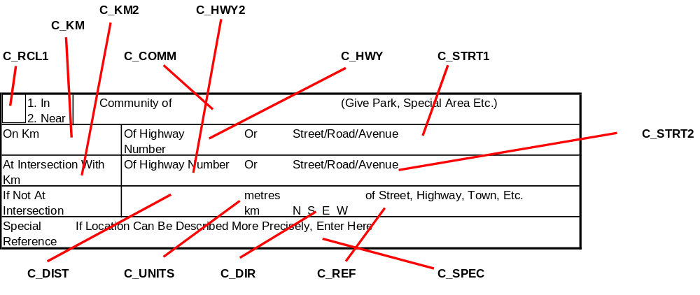

Description of Data Fields

Each field is described in detail.

Field Name: C_RCL1
Description: Road Classification I
Column Reference: V

This field identifies whether the collision occurred within the corporate limits of a community. “1” indicates that the collision occurred within a community while “2” indicates that the collision occurred outside of a community. C_RCL1 is “1” for all City of Yellowknife collision records.

Field Name: C_HWY
Description: Highway Number
Column Reference: BW

This field identifies whether the collision occurred on one of the eight numbered highways on the NWT Highway System. If one or more of the vehicles involved were on a numbered highway at the time of the collision, a value of between “1” and “8” must be recorded in this field. Within Yellowknife City limits, possible numbered highways are “3” and “4”.

Field Name: C_KM
Description: Highway Location
Column Reference: BX

This field identifies the highway location to the nearest 0.1 km if the collision occurred on a numbered highway or Winter/Access Road on the NWT Highway System. Within Yellowknife City limits, possible values are shown in the following table:

Highway | Between Km | And Km
Highway #3 | 330.3 | 338.8
Highway #4 | 0.0 | 9.0
Dettah Winter Access Road | 0.0 | 2.0 (approx.)
Vee Lake Access Road | 0.0 | 3.0 (approx.)
Yellowknife Access Road | 0.0 | 1.7

Field Name: C_LTYE
Description: Location Type
Column Reference: BY

This describes the general characteristics of the collision location and is required to produce various charts and tables in the “NWT Traffic Collision Facts” report. The values for “C_LTYP” are defined as follows:

H# Numbered Highway: Collision took place on one of the eight numbered highways on the NWT Highway system, whether inside the corporate limits of a community or outside. Within Yellowknife City limits “H#” indicates that the collision occurred on Highway #3 or Highway #4

HA Access Road: Collision took place on any of the access roads on the NWT Highway system, whether inside the corporate limits of a community or outside. Within Yellowknife City limits, “HA” indicates that the collision occurred on the Yellowknife Access Road or Vee Lake Access Road.

HW Winter Road: Collision took place on any of the winter roads on the NWT Highway system, whether inside the corporate limits of a community or outside. This excludes privately maintained winter roads such as the Lupin and Colomac Winter Roads. Within Yellowknife City limits, “HW” indicates that the collision occurred on the Dettah Winter Access Road.

C Community: Collision took place within the corporate limits of a community but NOT on any of the roads on the NWT Highway system as mentioned above. C_LTYP will be “C” for most of the City of Yellowknife collision records.

R Rural: Collision took place outside the corporate limits of a community AND off of any of the roads on the NWT Highway System. Collisions that took place on the Lupin or Colomac Winter Roads fall under the “Rural” category since these do not pass through any community and are not part of the NWT Highway system. C_LTYP will NOT be “R” for any of the City of Yellowknife collision records.

Field Name: C_COMM
Description: Community
Column Reference: BZ

This is the name of the community in which the collision occurred if C_RCL1 is “1”. If C_RCL1 is “2”, C_COMM indicates the nearest community. For all City of Yellowknife collision records, C_COMM is “YELLOWKNIFE”.

Field Name: C_STRT1
Description: Name of Street/Road/Avenue
Column Reference: CA

If the collision occurred on a named street or on a Winter/Access Road on the NWT Highway System, the name of the street/road/avenue (including the full suffix) must be recorded in this field. If the collision occurred on a numbered highway on the NWT Highway System, the highway number must be recorded in the C_HWY field and the C_STRT1 field must be left blank.

Field Name: C_KM2
Description: Highway Location of Intersecting Highway
Column Reference: CB

If the collision occurred at the intersection with a highway on the NWT Highway System, the location of the intersecting highway must be recorded in the C_KM2 field. For example, if the collision occurred on Old Airport Road at Highway #3, “336.7” must be recorded in C_KM2. Similarly, if the collision occurred on Highway #4 at Highway #3, “338.8” must be recorded in C_KM2. If the intersecting roadway is a Winter/Access Road on the NWT Highway System, the location (to the nearest 0.1 km) must also be recorded in C_KM2.

Field Name: C_HWY2
Description: Highway Number of Intersecting Highway
Column Reference: CC

If the collision occurred at the intersection of a numbered highway on the NWT Highway System, the Highway Number of the intersecting highway must be recorded in C_HWY2. Within Yellowknife City limits, possible values for C_HWY2 are “3” and “4”.

Field Name: C_STRT2
Description: Name of Intersecting Street/Road/Avenue
Column Reference: CD

If the collision occurred at the intersection of a named street or a Winter/Access Road on the NWT Highway System, the name of the intersecting street (including the full suffix), must be recorded in C_STRT2.

NOTE: If the involved vehicles were traveling on two different roadways at the time of the collision, the name of the most significant (major) roadway should be recorded in C_STRT1. The name of the minor roadway should be recorded in C_STRT2. To assist in determining the major roadway within Yellowknife City limits, the following table should serve as a guide.

Hierarchy | Street/Highway
# NWT Highway - Arterial | Highway #3
# NWT Highway - Collector | Highway #4
NWT Access Road - Collector | Dettah Winter Access Road, Yellowknife Access Road
Urban - Arterial | Franklin Avenue, Old Airport Road, Kam Lake Road
Urban - Collector | Con Road, 54th Street, Forrest Drive, Range Lake Road, Finlayson Drive, Finlayson Drive North, Borden Drive, Borden Drive North
Urban - Local | All other named streets within YK City limits
Alleys | All back lanes and alleys
Private Property | All private driveways and parking lots

Field Name: C_DIST
Description: Distance From Reference (If Not At Intersection)
Column Reference: CE

This is the distance from the collision location to the nearest intersecting named street or highway, if the collision did NOT occur at an intersection.

Field Name: C_UNITS
Description: Distance Units (If Not At Intersection)
Column Reference: CF

This field denotes the units in which the distance from the nearest intersecting street or highway is measured. C_UNITS may be either “M” (metres) or “K” (kilometers).

Field Name: C_DIR
Description: Direction From Reference (If Not At Intersection)
Column Reference: CG

This field denotes the direction the nearest intersecting street or highway is situated from the collision location. C_DIR may be “N” (north), “S” (south), “E” (east), or “W” (west).

Field Name: C_REF
Description: Direction From Reference (If Not At Intersection)
Column Reference: CH

If the collision did NOT occur at an intersection, the name of the nearest intersecting street or highway is recorded in the C_REF field.

NOTE: If the C_REF field is populated and the C_DIST, C_UNITS, and C_DIR fields are blank, this means that the distance and direction of the nearest intersecting named street from the collision location is unknown.

Field Name: C_SPEC
Description: Special Reference
Column Reference: CI

This field is used to describe the collision location more precisely. It can include names of local landmarks, buildings, parks, etc.

NOTE: If the collision occurred within the confines of a private driveway or parking lot, the name of the driveway or parking lot should be described in the C_SPEC field. All other location fields should be left blank.

Examples

Following are some examples of how Collision locations should be described on the form and are represented in the Excel database files.

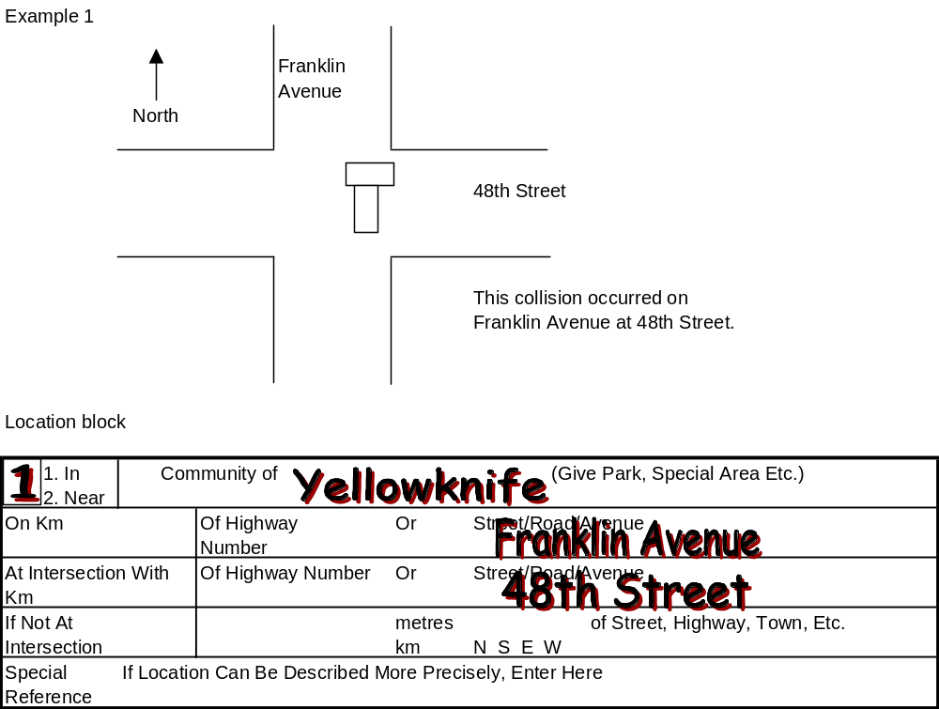
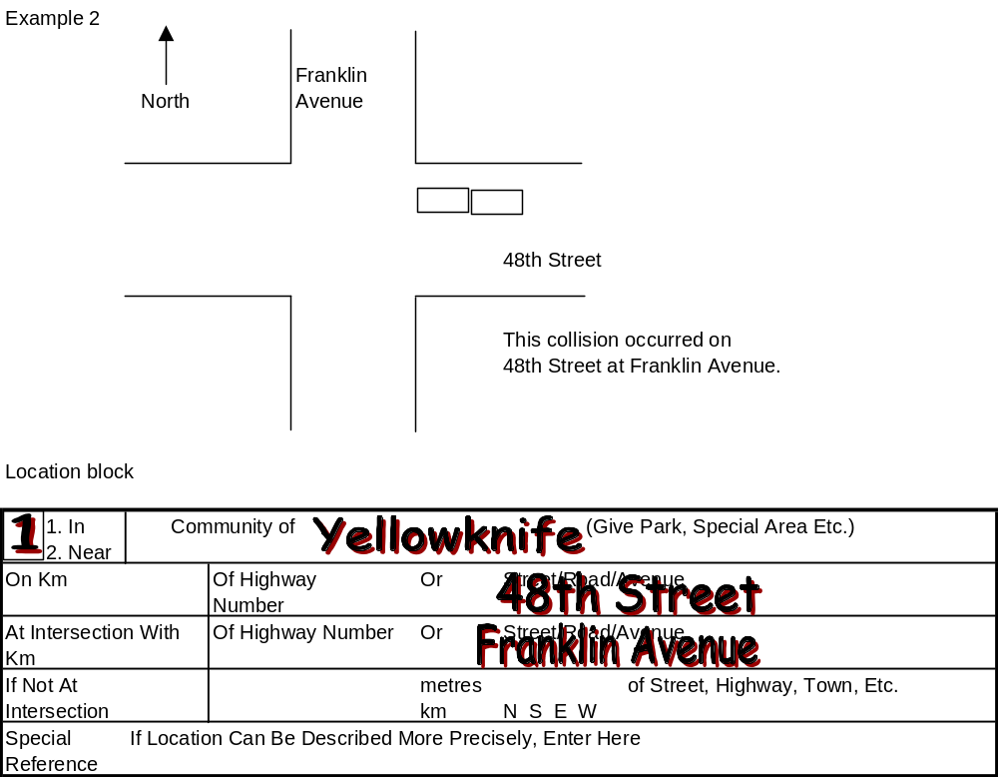
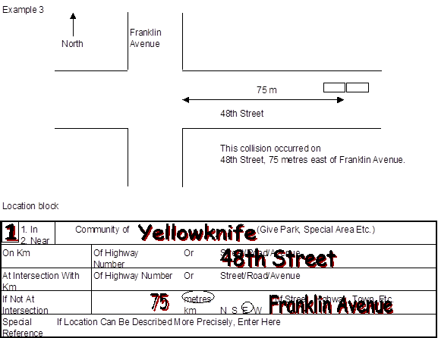
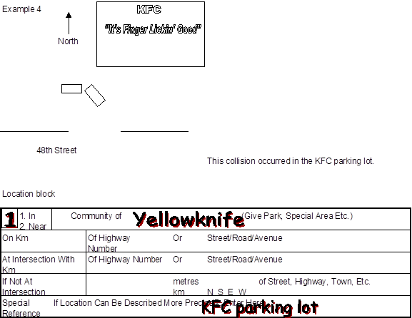
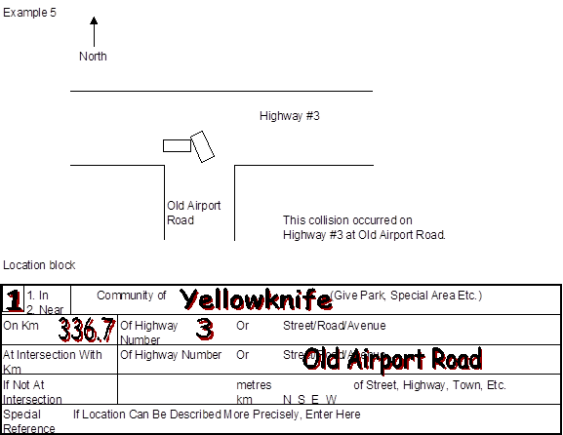
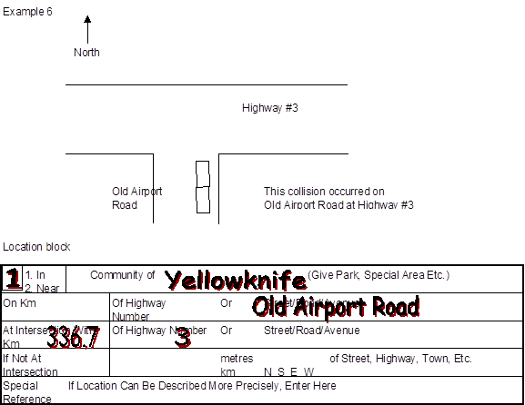
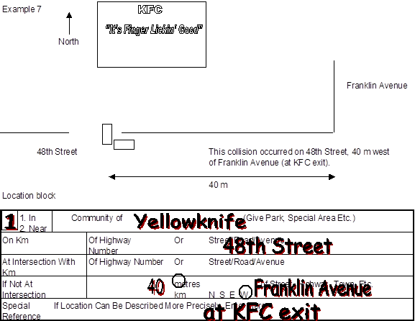
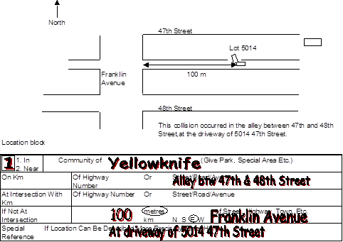

Understanding the Data Layout

Each collision data file contains 89 columns of data. The number of rows in the file is determined by the number of person records (including “dummy” person records for unoccupied vehicles) in the database and will vary from year to year.

The first row of the Excel file contains the column labels that describe the data elements (or fields). These appear in the order as described in the table shown on Pages 6 to 9.

The second row of the Excel file is intentionally left blank.

The third row of the Excel file contains the first collision record in the database.

The data records (rows) are arranged by month, day of the month, and case number. In other words, records appearing near the top of the Excel file will correspond to collisions occurring on January 1 of a calendar year while those at the bottom will correspond to collisions occurring on December 31.

Collision level records (i.e. data contained in columns with labels beginning with ”C_”) are repeated for every person record associated with that collision.

Vehicle level records (i.e. data contained in columns with labels beginning with ”V_”) are repeated for every person record associated with that vehicle.

Person level records (i.e. data contained in columns with labels beginning with ”P_”) appear once for every person record associated with that collision and vehicle. In other words, each person has its own unique record.

For example, a report was entered for a collision involving two vehicles. There were two occupants in Vehicle 1 and three occupants in Vehicle 2. There will be five rows of data in the Excel file to describe this collision. The collision level records will be repeated five times for each of the five persons involved. The vehicle level records for Vehicle 1 will be repeated twice for each of the two occupants in that vehicle. The vehicle level records for Vehicle 2 will be repeated three times for each of the three occupants in that vehicle. Each person will have its own unique record.

A schematic representation of the data records for this example is shown as follows:

