**Human Age Detection:**

Age Detection can be divided to 2 categories

1. Face detection (extraction)

2. Age detection

**Face Detection**:

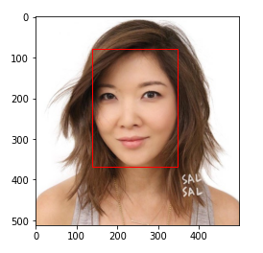

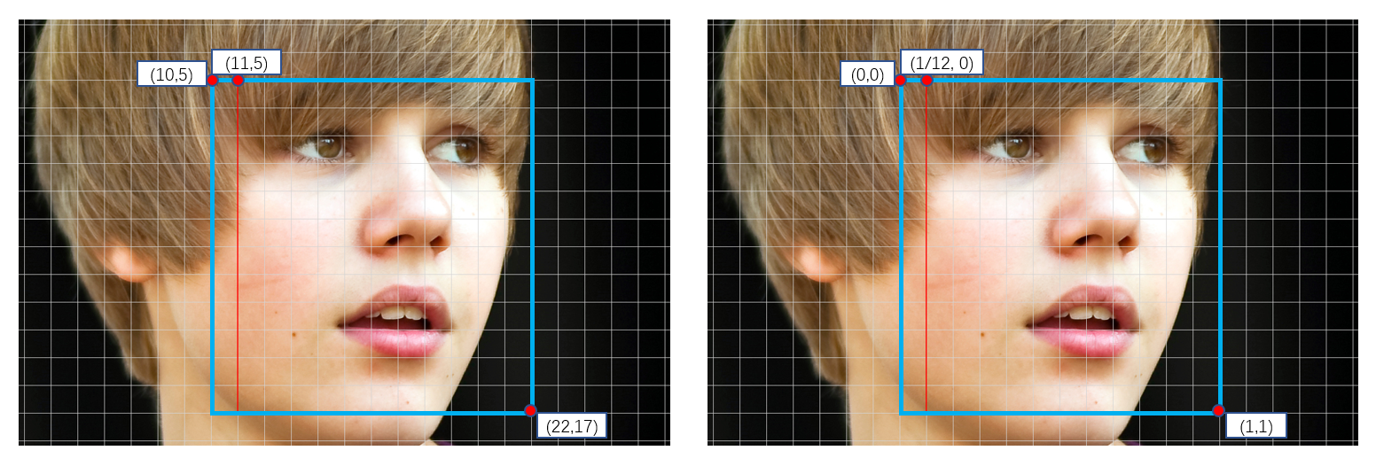

The job of face detector is to find the location of the face in the given image. This is just face detection.

For age detection, we need only face of the person. So

There is a need to extract only face from the image as shown below. Face extraction is similar to that of face detection except for the part where we need to remove the parts of image that is not a face.

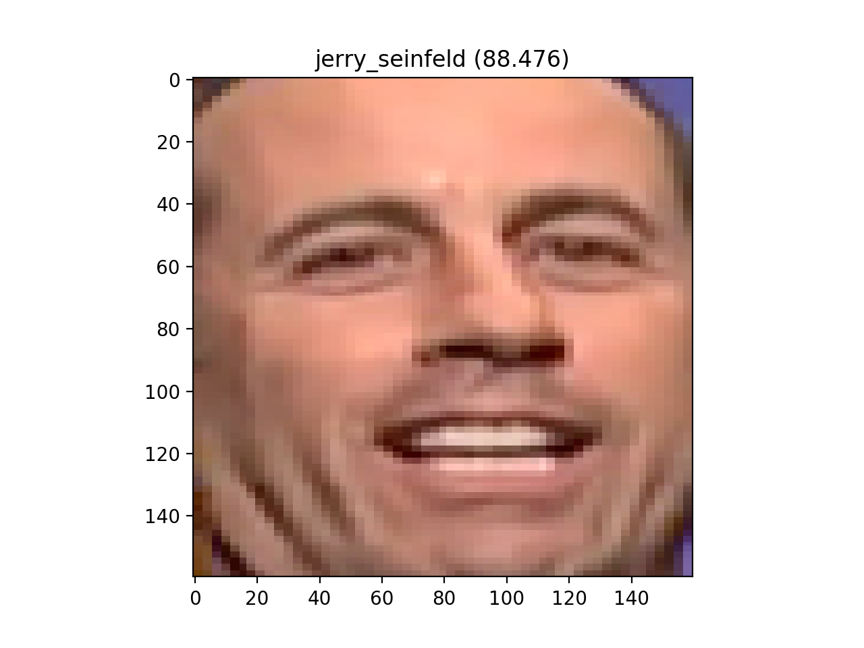

This can be done by using many methods **Cascade Classifier from cv2,**

**Dlib, Multi-Task Cascade Convolution Neural Network, DNN from opencv etc.**

They can be used for face detection also.

The extracted facial image can be used for human age detection, which will increase the accuracy. If age recognition is done without face extraction model may not work as expected.