**Data Flow Diagram**

Management Reports

Inventory Items

Borrowed Items

Borrower Items

Inventory Data

Borrower Items

Receipt

Borrower Order

**4.0**

**3.0**

**2.0**

**1.0**

**Management**

**Inventory**

**Produce Reports**

**Process Borrow Items**

**Update Inventory Information**

**Borrow Item/s**

**Borrower**

**Table Structure**

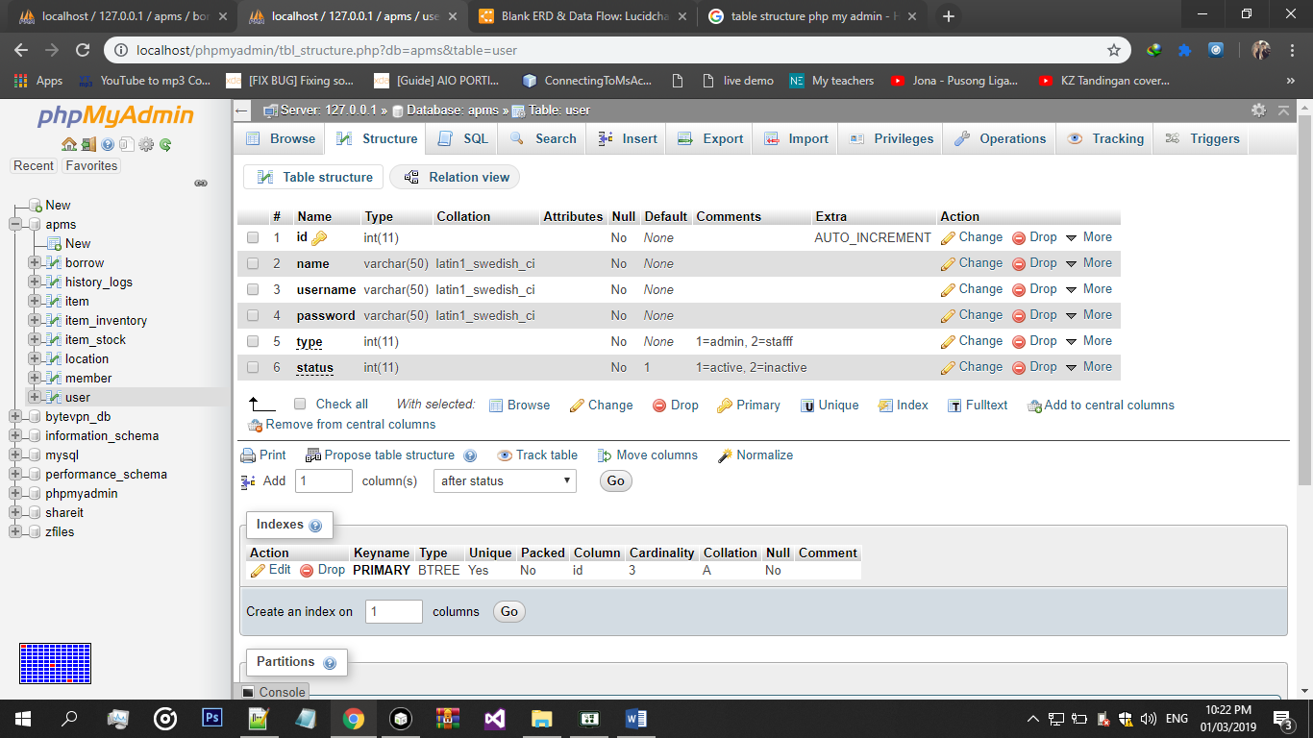

**Users Table Structure**

**Member/Borrower Table Structure**

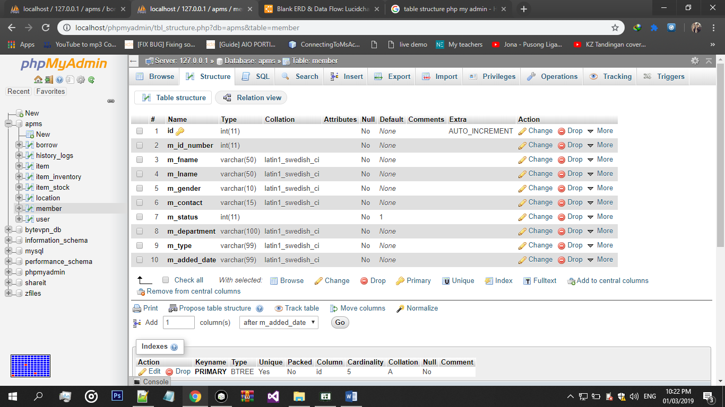

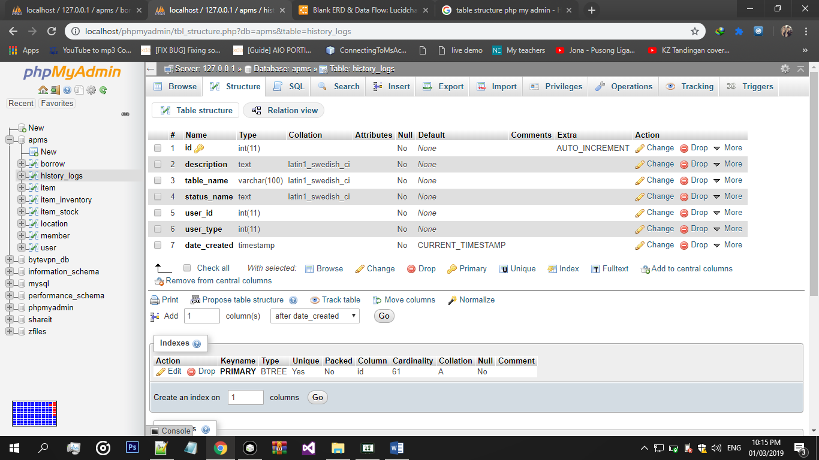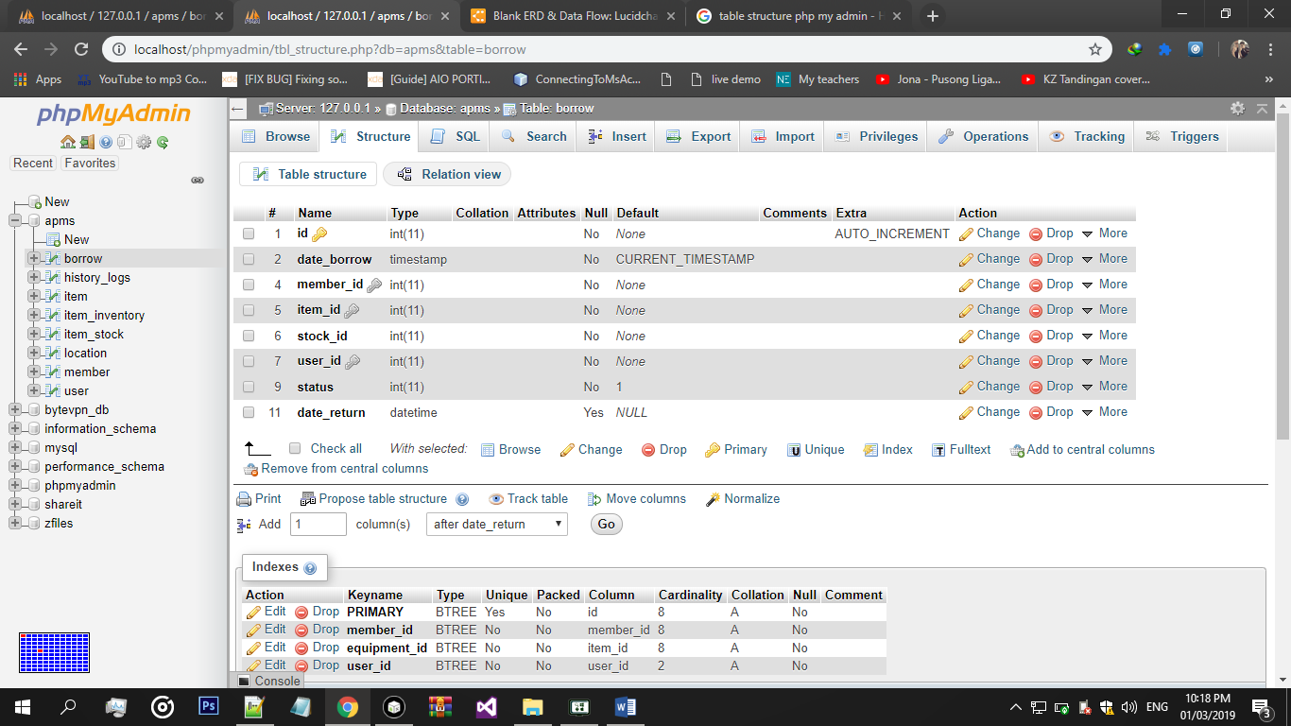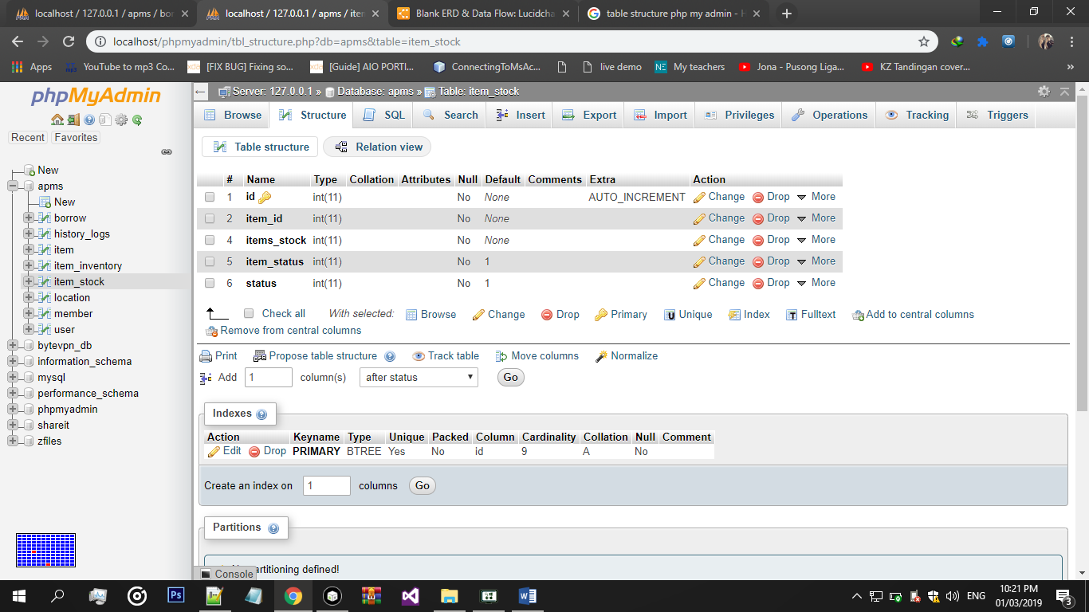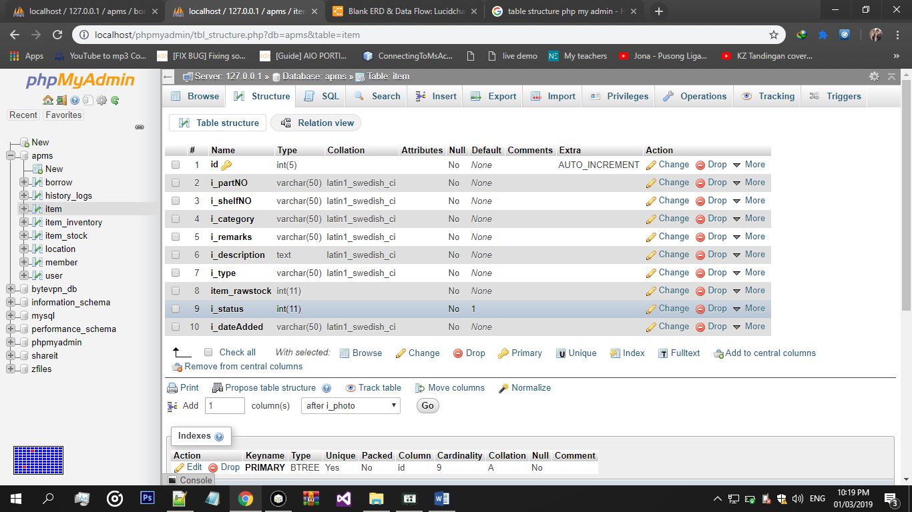

**Logs Table Structure**

**Borrow Table Structure**

**Item Stock TableStructure**

**Item Table Structure**

**Entity Relationship Diagram**

