SPrint One

**CS2450-002, Team 2**

Cody Strange-*Scribe and Information Manager*

Ethan Taylor-*GUI Developer*

Jaden Albrecht-*Team Manager*

Tyler Deschamps-*Chart and Milestone document builder*

Craig Sharp-*Stakeholder*

# Table of contents

##### Introduction……………………………………………………….........................................3

Requirements Gathering……………………………………...………………………………………3

Prototype Candidates…………………………………………………………………………………4

Resources………………………………………………………………………………….…………..6

Agile Methods………………………………………………………………………………………………7

Scrum………………………………………………………………………………………………….7

Crystal Clear………………………………………………………………………………………….7

Others………………………………………………………………………………………………….8

Charts/Templates…………………………………………………………………………………………9

Work breakdown structure……………………………………………………………………...……9

PERTT Chart………………………..………………………………………………………………..9

Gantt Chart…………………..………………………………………………………………………10

MoSCoW Chart………………………………………………………………………………………10

Meeting Logs………………………………………………………………………………………………11

Meeting Log#1……………………………………………………………………………………….11

Meeting Log#2……………………………………………………………………………………….12

Meeting Log#3……………………………………………………………………………………….13

# Introduction

## Requirements Gathering

#### Identify Customer

Summary: Currently it is unknown exactly who our customer is. While we know it is Craig Sharp, we do not know enough about him to identify him. We will have to have a stakeholder meeting in order to get the required information.

#### Requirements

Summary: There is still a lot of work to be done on figuring out what requirements will be required for the product. For now here are some general points that we can go off of for now.

* Gathering: we will be gathering the following information
  + What does the customer intend to use the product for
  + What specific features are required
  + What specific features are preferred
  + What is the size of the company that this product will be used for
* Assuming: we are assuming the following information
  + Customer is using the product for business purposes only
  + Python is the only language we will need
  + That CS1400-CS2420 is enough programming experience to complete the project
* Expecting
  + All information required can be found through the book and course materials

## Prototype candidates

#### Ethan Taylor

Summary: The program can read in a csv file of employee information, each employee is required to have an Id, first name, last name, Address, City, State, zip code, and pay classification. The program holds every employee’s information in a list that can be accessed to look up an individual’s information.

* Reads in an csv file and out puts a list of employee objects
* Employee object
  + Employee id
  + First name
  + Last name
  + Address
  + City
  + State
  + Zip code
  + Classification
    - Hourly pay
    - Commissioned pay
    - Salary pay
* Return employee object using the employee id
* Read in an csv file of employee ids and their associated timecards and adds them to the employee object with the corresponding id
* Read in an csv file of employee ids and their associated receipts and adds them to the employee object with the corresponding id
* Issue payments to Employees
* Add a timecard to those that get paid hourly
* Compute pay
* Add receipts for those who get paid by commission

#### Jaden Albrecht

Summary: The program can read in a csv file of employee information, each employee is required to have an Id, first name, last name, Address, City, State, zip code, and pay classification. The program holds every employee’s information in a list that can be accessed to look up an individual’s information. This candidate is unique from the last in that it allows you to return a lot more of the individual pieces of data.

* Reads in an csv file and out puts a list of employee objects
* Employee object
  + Employee id
  + First name
  + Last name
  + Address
  + City
  + State
  + Zip code
  + Classification
  + Hourly pay
  + Commissioned pay
  + Salary pay
* Establishes classification
* Return employee’s ID number
* Return employee’s name
* Returns employee’s address
* Returns employee’s city
* Returns employee’s state
* Returns employee’s zip code
* Returns employee’s classification
* Returns employee’s salary
* Returns employee’s commission rate
* Returns employee’s hourly rate
* Make employee a salaried employee
* Make employee an hourly employee
* Make employee a commissioned employee
* Return employee object using the employee id
* Read in an csv file of employee ids and their associated timecards and adds them to the employee object with the corresponding id
* Read in an csv file of employee ids and their associated receipts and adds them to the employee object with the corresponding id
* Issue payments to Employees
* Add a timecard to those that get paid hourly
* Compute pay
* Add receipts for those who get paid by commission

## Resources

#### Communication

Summary: We primarily use text messaging group to stay in contact with each other outside of planned meetings. We use it to ask for quick updates on tasks that may affect what we are currently doing. MS teams is what we use for our team meetings, we are currently planning to meet twice a week Monday and Friday at 7:00pm. There is also the project email and google drive that is being used to send documents to each other and to store files for the project.

* MS teams
* Text group chat
* Project email and Google drive

#### Software

Summary: We are using Lucid Charts as the software to create the PERTT, Gantt, MoSCow, and Work Breakdown charts. Microsoft word is what we are using for documentation for our meeting logs, notes, and sprint documents. We are using Trello to help us organize a to-do list that is similar to Kanban. Python is the programming language that we will be working in, and we are still not sure whether we will be using Thonny or Visual Studio Code as the IDE. Tkinter will be used for the GUI.

* Lucid Charts
* Microsoft word
* Trello
* Python
* Thonny/VS code
* Tkinter

# Agile Methodologies

## Scrum

#### Overview

Summary: As the project sprints are designed around the Scrum methodology, we will be using Scrum in our project management. We will be completing our project in incremental iterations so that at the end of each sprint we will have a fully tested and approved piece of software. We still need to decide exactly what parts of Scrum will and won’t work for our team.

* Scrum focuses on breaking large problems into smaller tasks and completing tasks with speed and efficiency.
* Scrum focuses on creating a small workable product soon and building new and more complex versions of that product every sprint.
* Scrum is flexible, allowing constant changes throughout development to meet customers everchanging requirements.

## Crystal Clear

#### Overview

Summary: Along with Scrum will be incorporating part of the Crystal Clear development methodology. Crystal Clear like scrum focuses on frequent releases that get additional features as time goes on. Crystal Clear is very heavy on team communication, it recognizes that in small teams it is valuable to have everyone pitch in on ideas and that rigid structures are not necessary.

* Much more informal methodology
* Expected to deliver production every 2-3 weeks, possibly shorter with non-released development iterations
* Take into consideration what the program will be used for when deciding how strict certain requirements such as testing need to be
* Emphasis on communication and in person collaboration whenever possible

## Extreme Programing

#### Overview

Summary: XP programming’s selling point is the quality of code that is produced from having two programmers at one computer reviewing the code as it is being written. With our rather small team we found that it would be difficult to double up on programmers because with us being brand new to this it would slow us down to much. We simply do not have the manpower nor the experience to use this methodology

* XP management methodologies align closely with that of SCRUM
* Focuses on quality code through pair programming and test-driven development
* Uses quick and simple meetings and having a customer on site to increase speed of development

# Charts/Templates

## Work Breakdown Structure

#### Chart

Summary: This is a Work Breakdown Structure for our four (soon to be five) members. It details each of our Team members and their roles along with the general tasks that their role comes with.

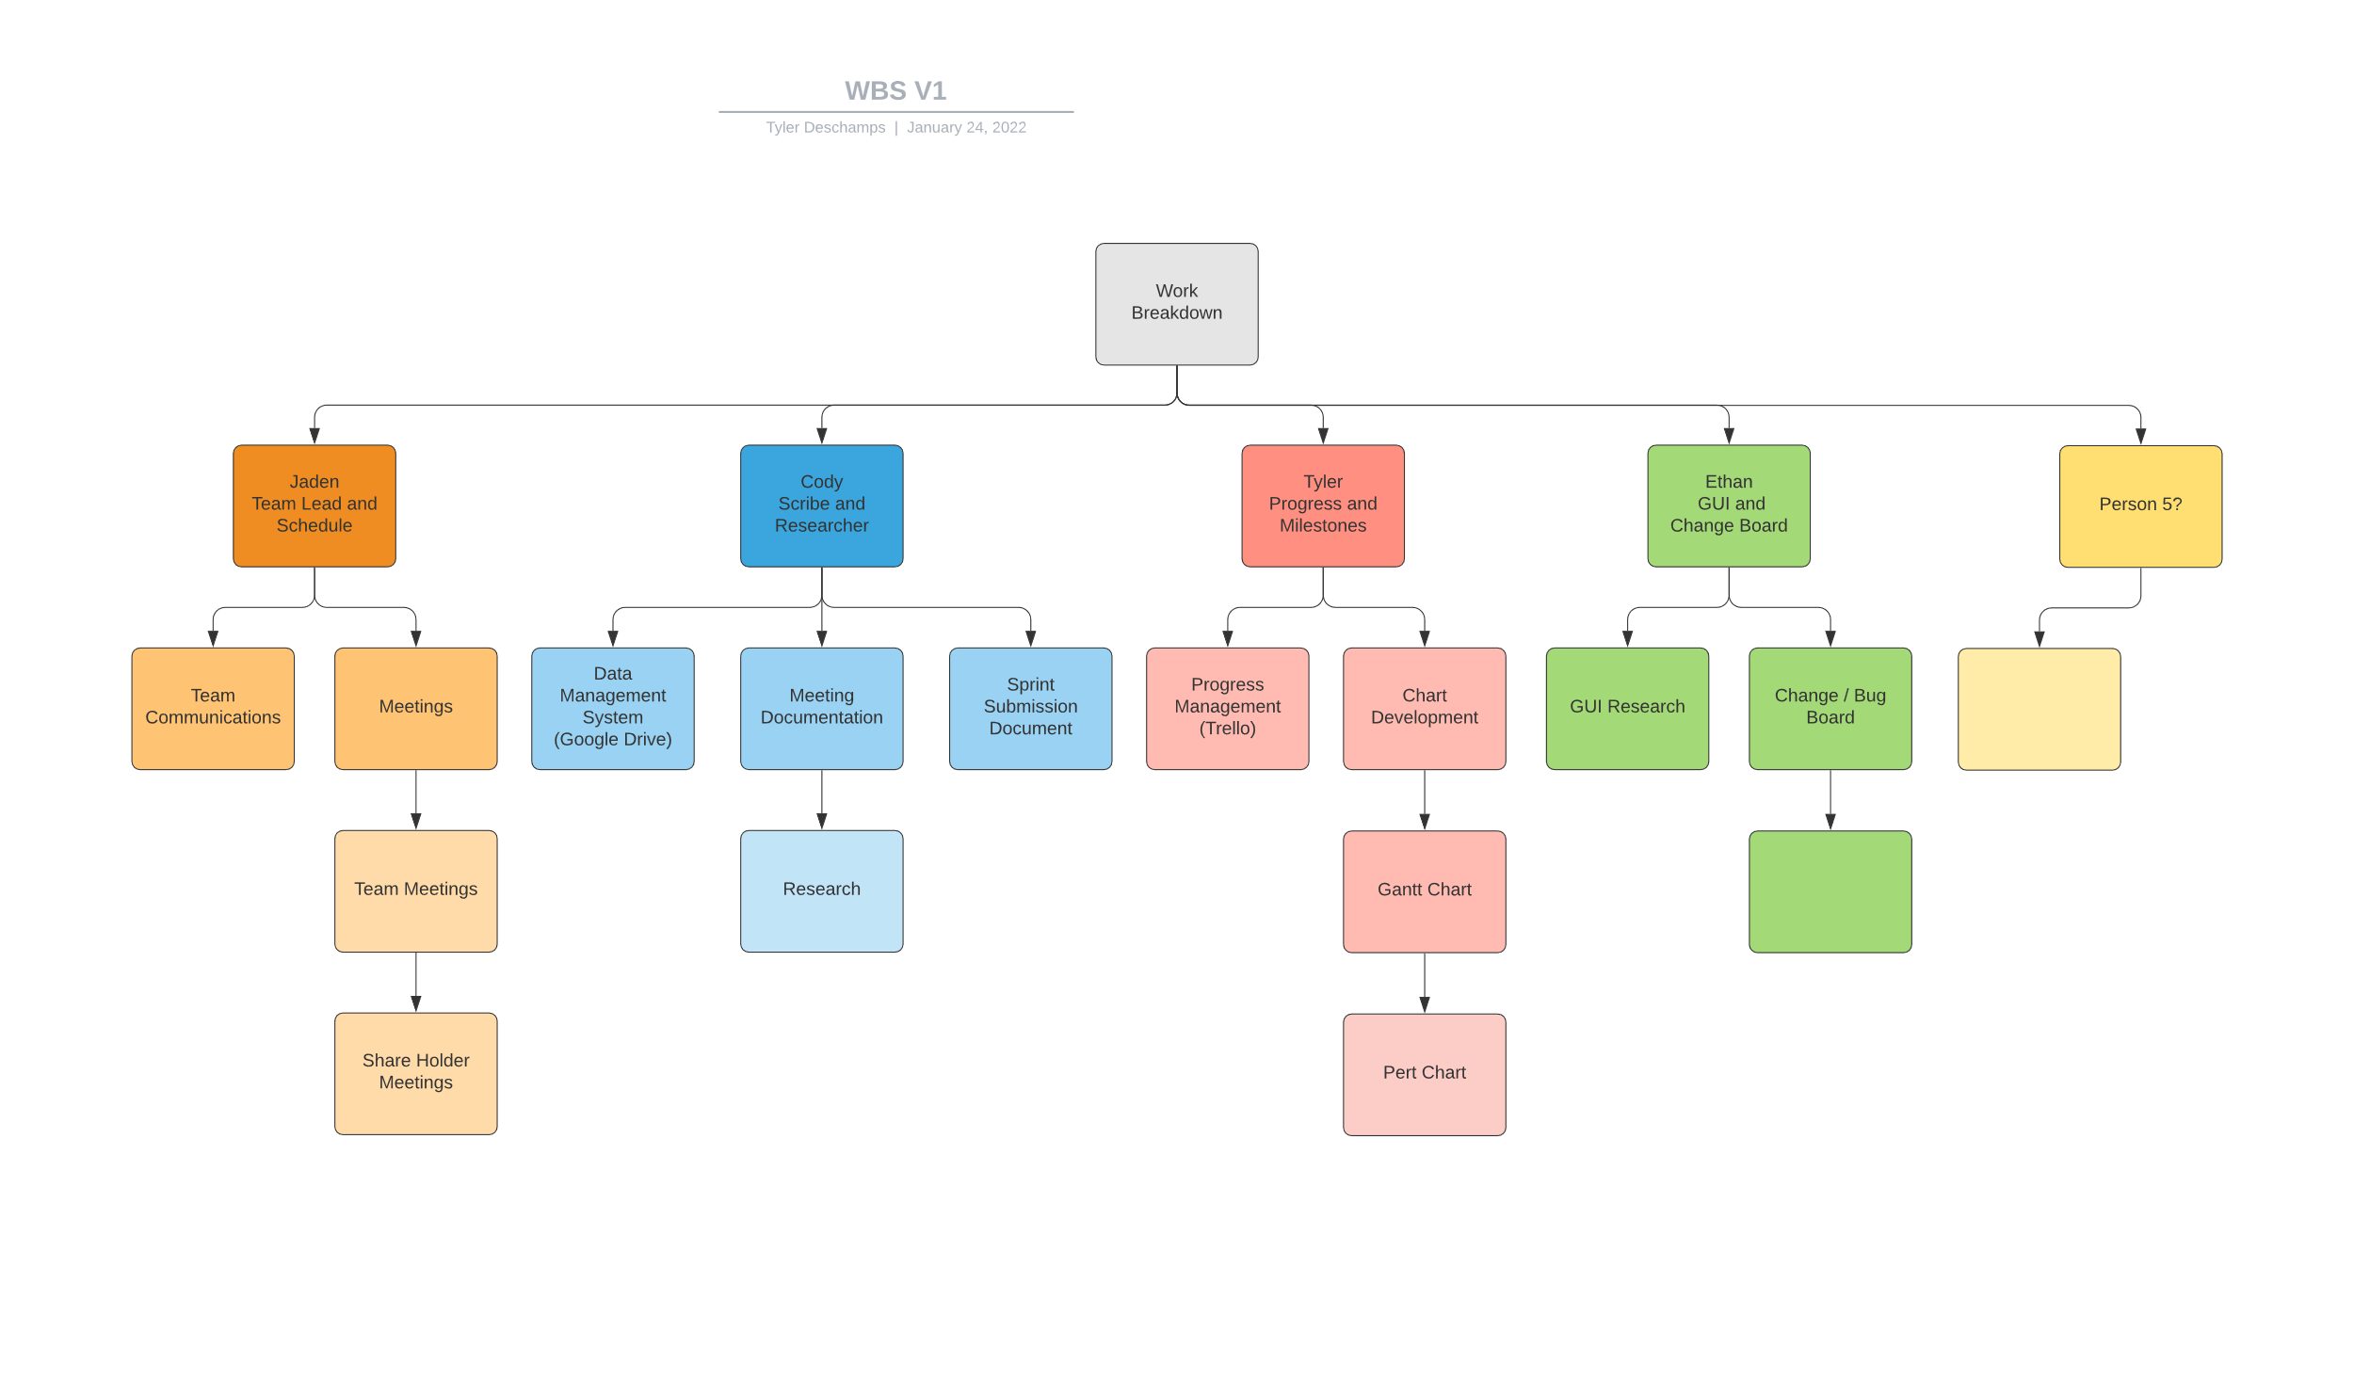

## PERTT Chart

#### Template

Summary: This is a PERTT Chart Template, for each of the six stages. We will be able to fill it out with the estimated time we expect each task to take and come up with a total amount of time for the project

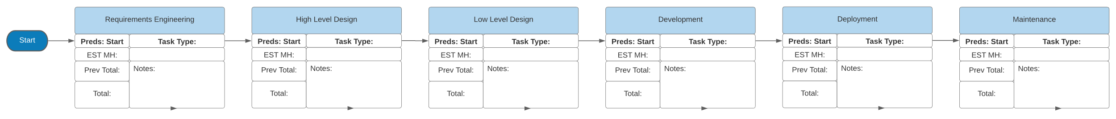

## Gantt Chart

#### Template

Summary: This is a Gantt chart template; it will list each of the tasks that we will be doing in each sprint.

## MoSCoW Chart

#### Overview

Summary: This is a MoSCoW chart template; it will have each team member listing what they believe the product Must have, Should have, Could have, and Won’t have. We will each make a separate one and eventually combine/narrow them down to one.

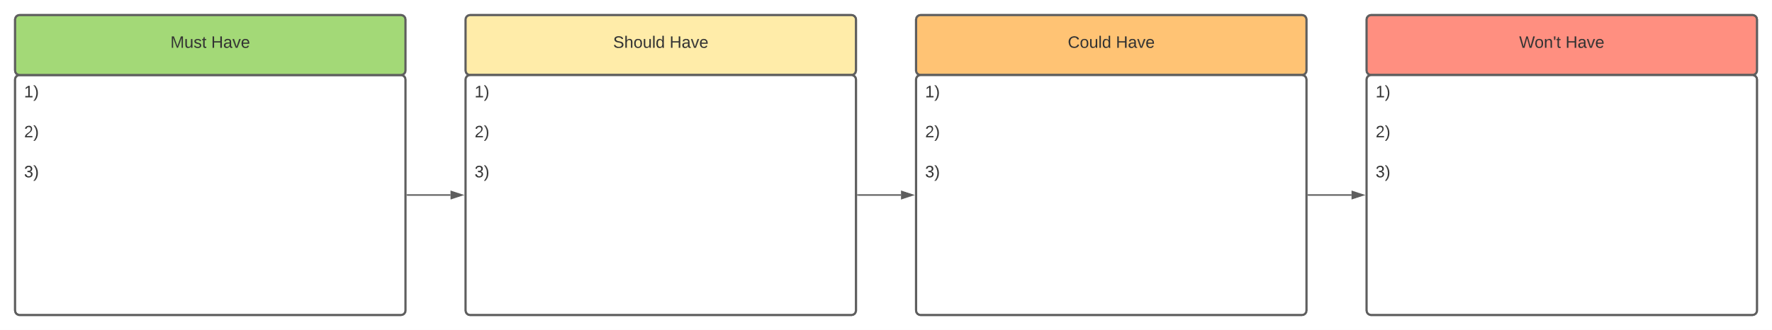

# Meeting Logs

## Meeting Log#1

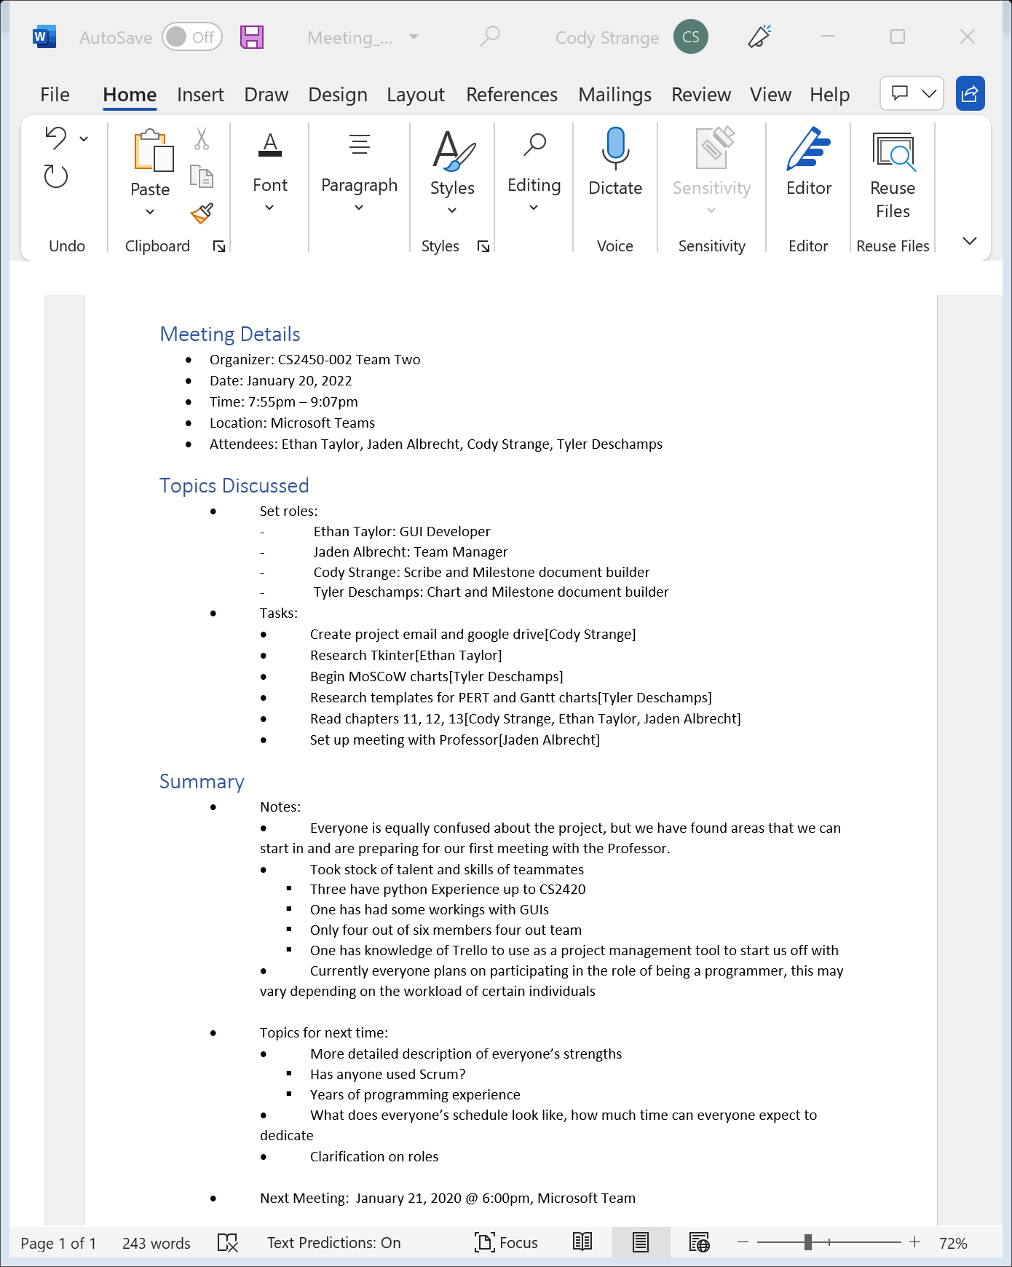

## Meeting Log#2

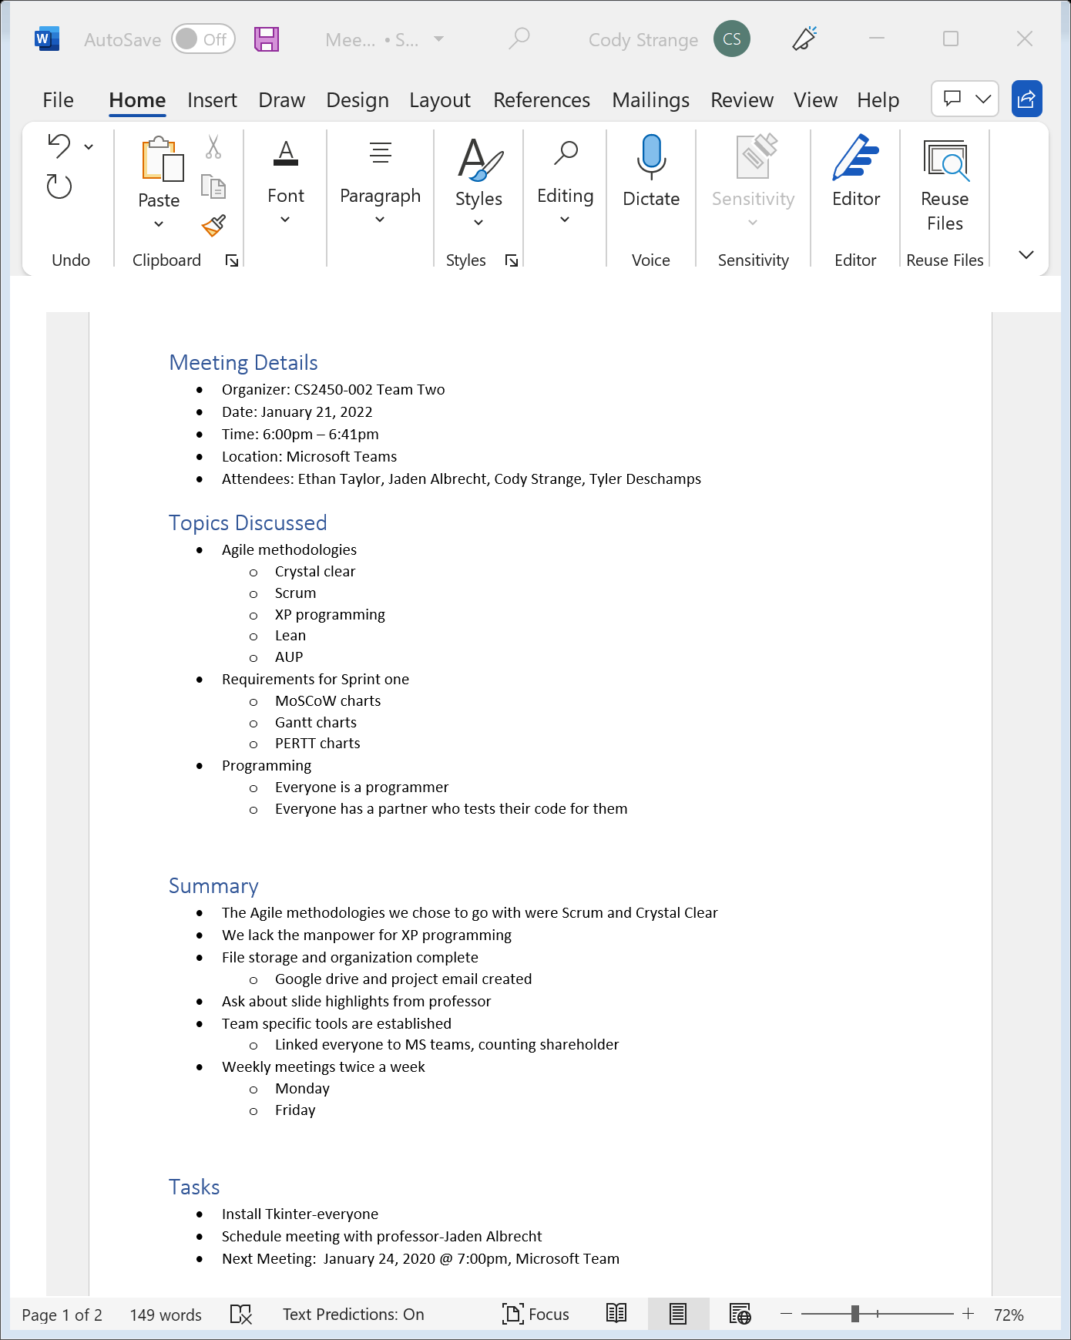

## Meeting Log#3

