1. The value a is always going to be set to 1
2. It gets set to 1
3. It gets set to 0
4. Data
5. It turns into whatever D is
6. Set write enable set and cleared
7. The single write enable
8. 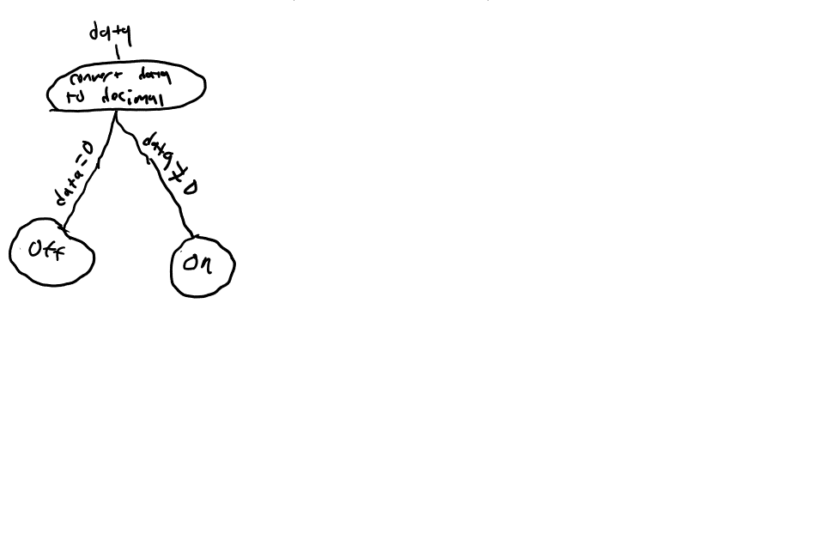
9. A picture containing diagram

   Description automatically generated