1. Diagram

   Description automatically generated
2. N/A
3. 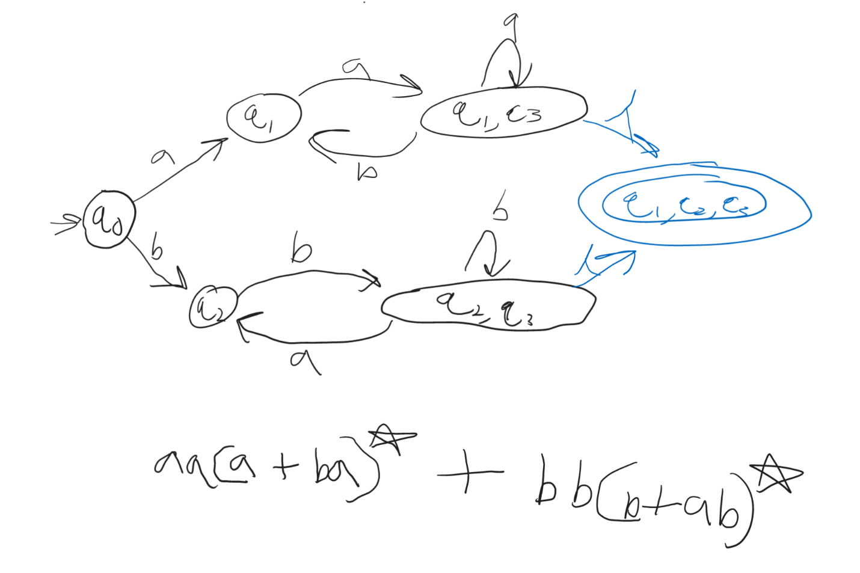
4. Diagram

   Description automatically generated
5. Diagram

   Description automatically generated