1. anb(a + b)n, where n is > 0

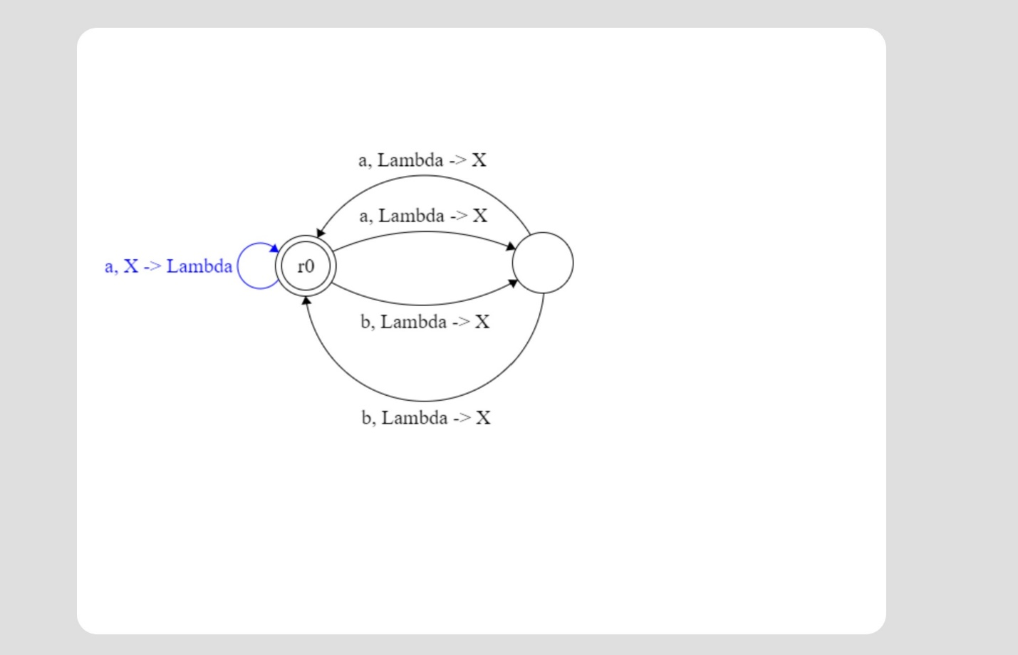

1. 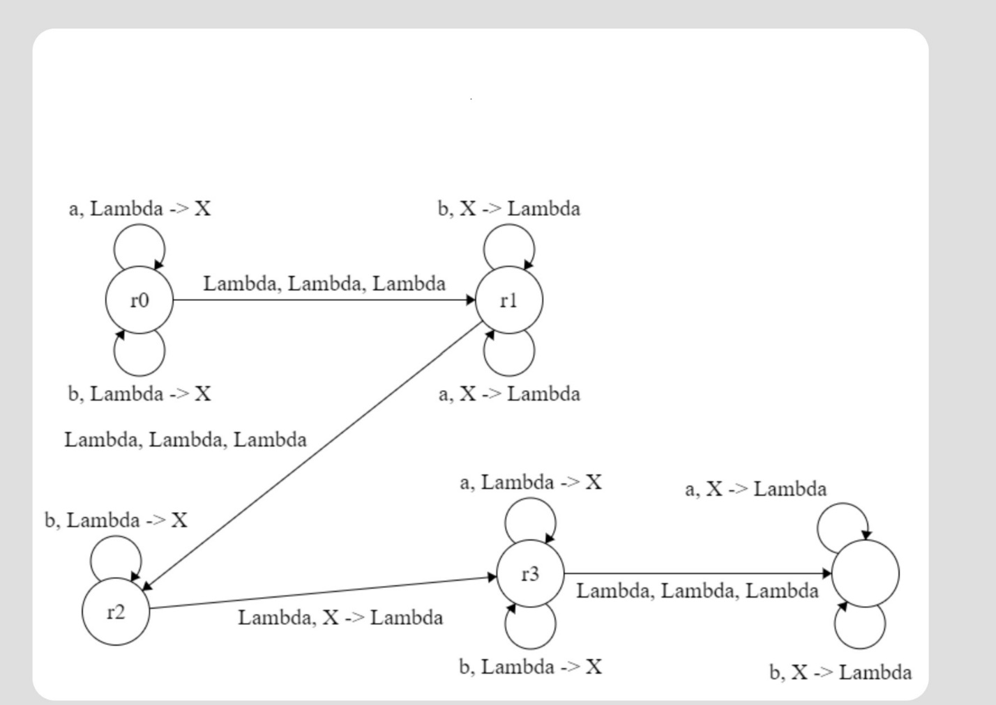
2. (ab)n(ab)n
3. anbnan