1. ancoambmdobn
2. S->aSb->aaSbb->aaXbb->aacXdbb->aacYdbb->aacabdbb
3. A picture containing insect, lawn mower, linedrawing

   Description automatically generated
4. S→SS→(S)S→()S→()

S→S→(S)→()

1. B→B|E | B&E | E

E→E+M | E-M | M

M→ M\*R | M/R | R

R→(B) | a | b | c

1. 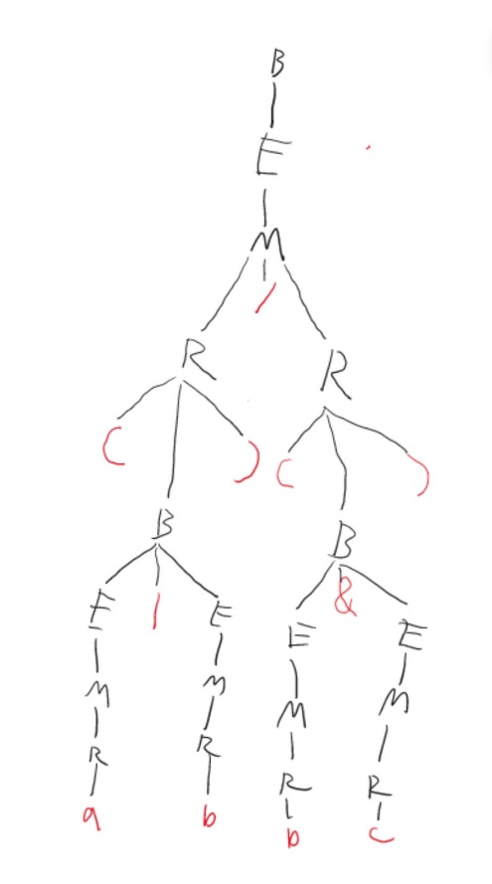
2. 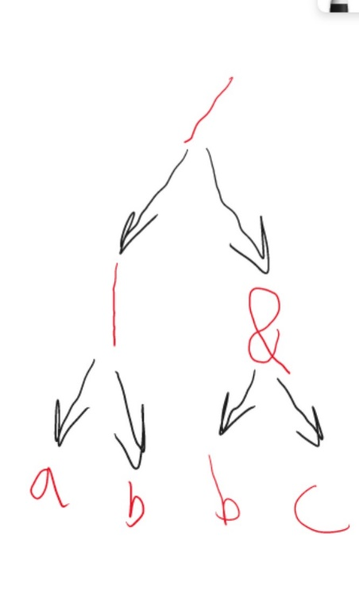
3. /|ab&bc
4. ab|bc&/