Assignment: Homework Ten Name: Cody Strange  
Disclaimer: This is my work, not that of others  
Total Score: 40 (in points, not percentage)

Problem 1 score: 10  
Problem 2 score: 10  
Problem 3 score: 10

Problem 4 score: 10

1. Diagram

   Description automatically generated

**R = 89%**

**Slope: .359**

**Y-Intercept: 4.888**

1. 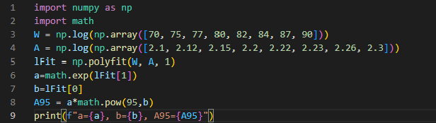

1. 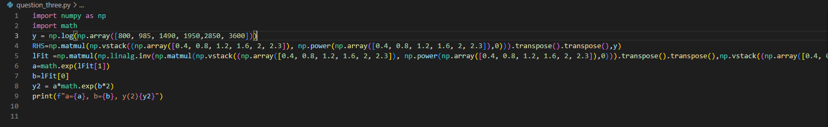

1. Graphical user interface, application

   Description automatically generated

**Regression Model: y = 0.04688x3-1.0412x2+7.1438x-11.4887**