Assignment: Homework Twelve Name: Cody Strange  
Disclaimer: This is my work, not that of others  
Total Score: 40 (in points, not percentage)

Problem 1 score: 20  
Problem 2 score: 10  
Problem 3 score: 10

1a. 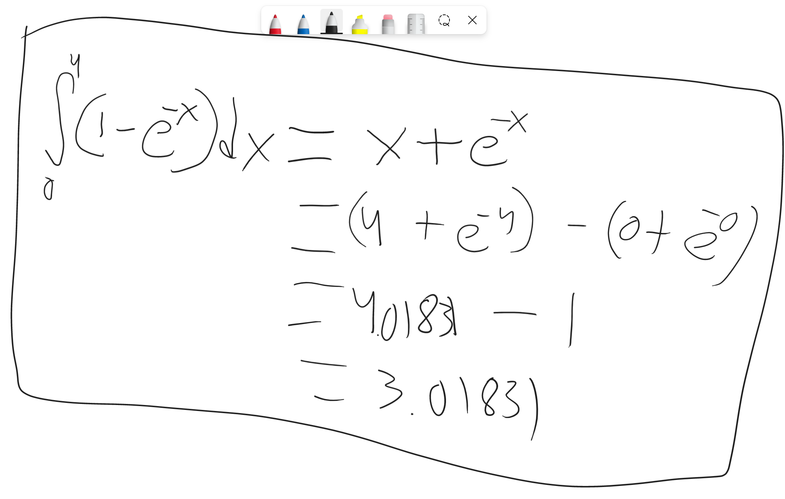

**3.01831**

1b.

**Numerical Integration = 1.9633**

**Estimate Error = 34.95%**

1c.

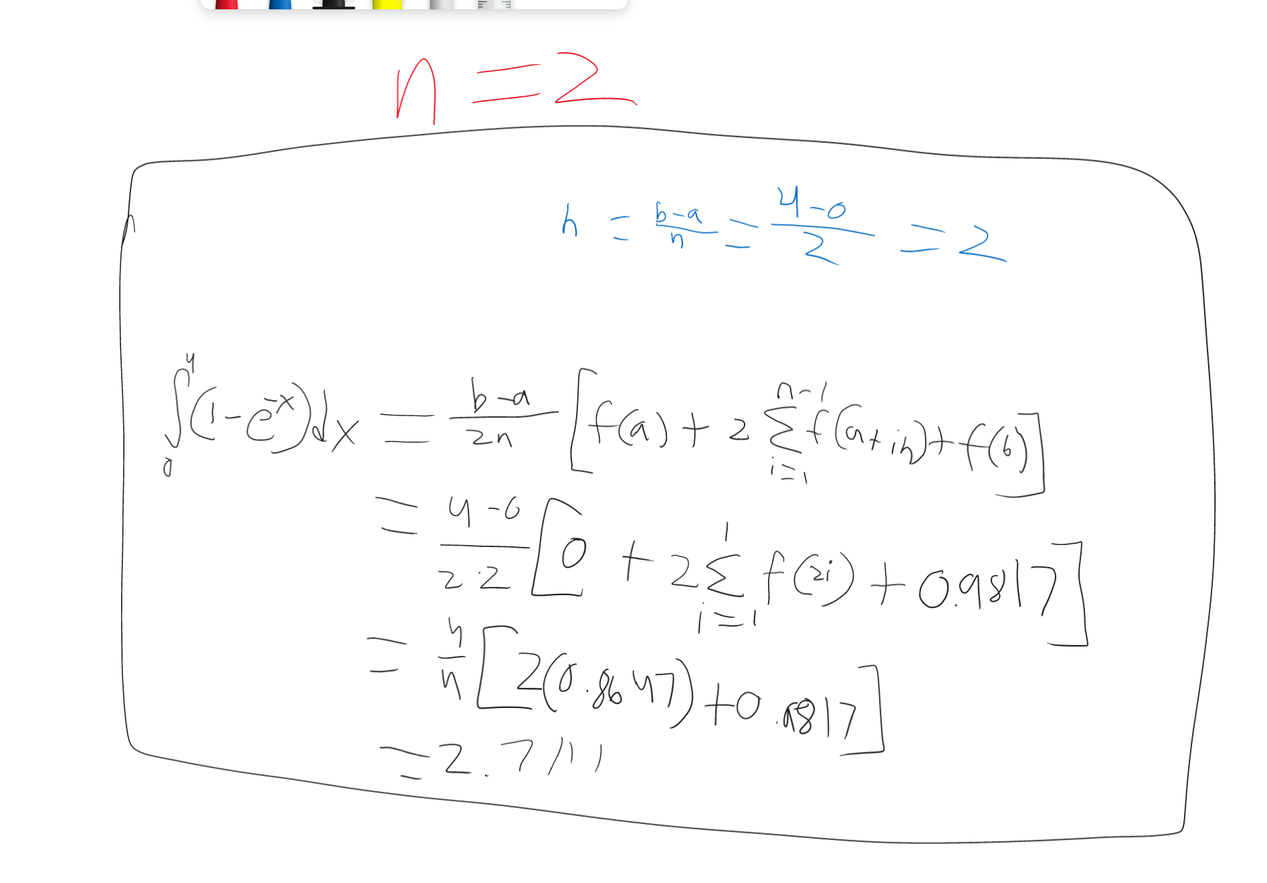

**N=2:**

**Integral = 2.7111**

**Relative Error = 10.18%**

**N=4:**

**Integral = 2.93785**

**Relative Error = 2.67%**

1d.

**Integral = 2.9603**

**Relative Error = 1.92%**

1e.

**Integral = 3.0134**

**Relative Error = 0.1627%**

2a.

**Average = 6.6806 m/s**

2b.

**60.0359 m**

3.

