Assignment: Homework Eight Name: Cody Strange  
Disclaimer: This is my work, not that of others  
Total Score: 50 (in points, not percentage)

Problem 1 score: 10  
Problem 2 score: 30  
Problem 3 score: 10

1. Graphical user interface, text

   Description automatically generated

**x1 = -1518115942, x2 = -7.24637681, x3 = -0.14492754**

1. A. ete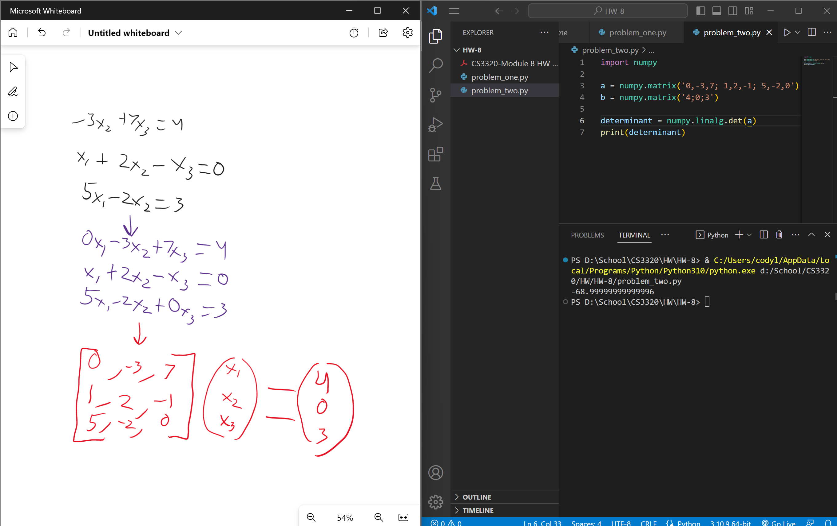

**Determinant = -68.9999999999999996**

**x3 = 0.5652173913**

**x2 = -0.0144927536**

**x1 = 0.5942028986**

3. 

