Numerical Software Development

# Chapter One

Numerical Methods

* Techniques by which mathematical problems are formulated so that they can be solved with arithmetic and logical operations.
* Computer mathematics

Mathematical model

* A formulation or an equation that expresses the essential features of a physical system or process
* 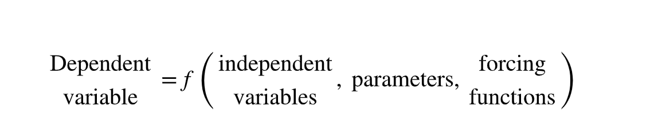

Dependent Variable

* Is a characteristic that typically reflects the behavior or state of the system

Independent Variable

* Usually dimensions, such as time and space, along which the system’s behavior is being determined

Parameters

* Reflective of the system’s properties or composition

Forcing Function

* Are external influences

# Chapter Six (Roots: Open Methods)