1. 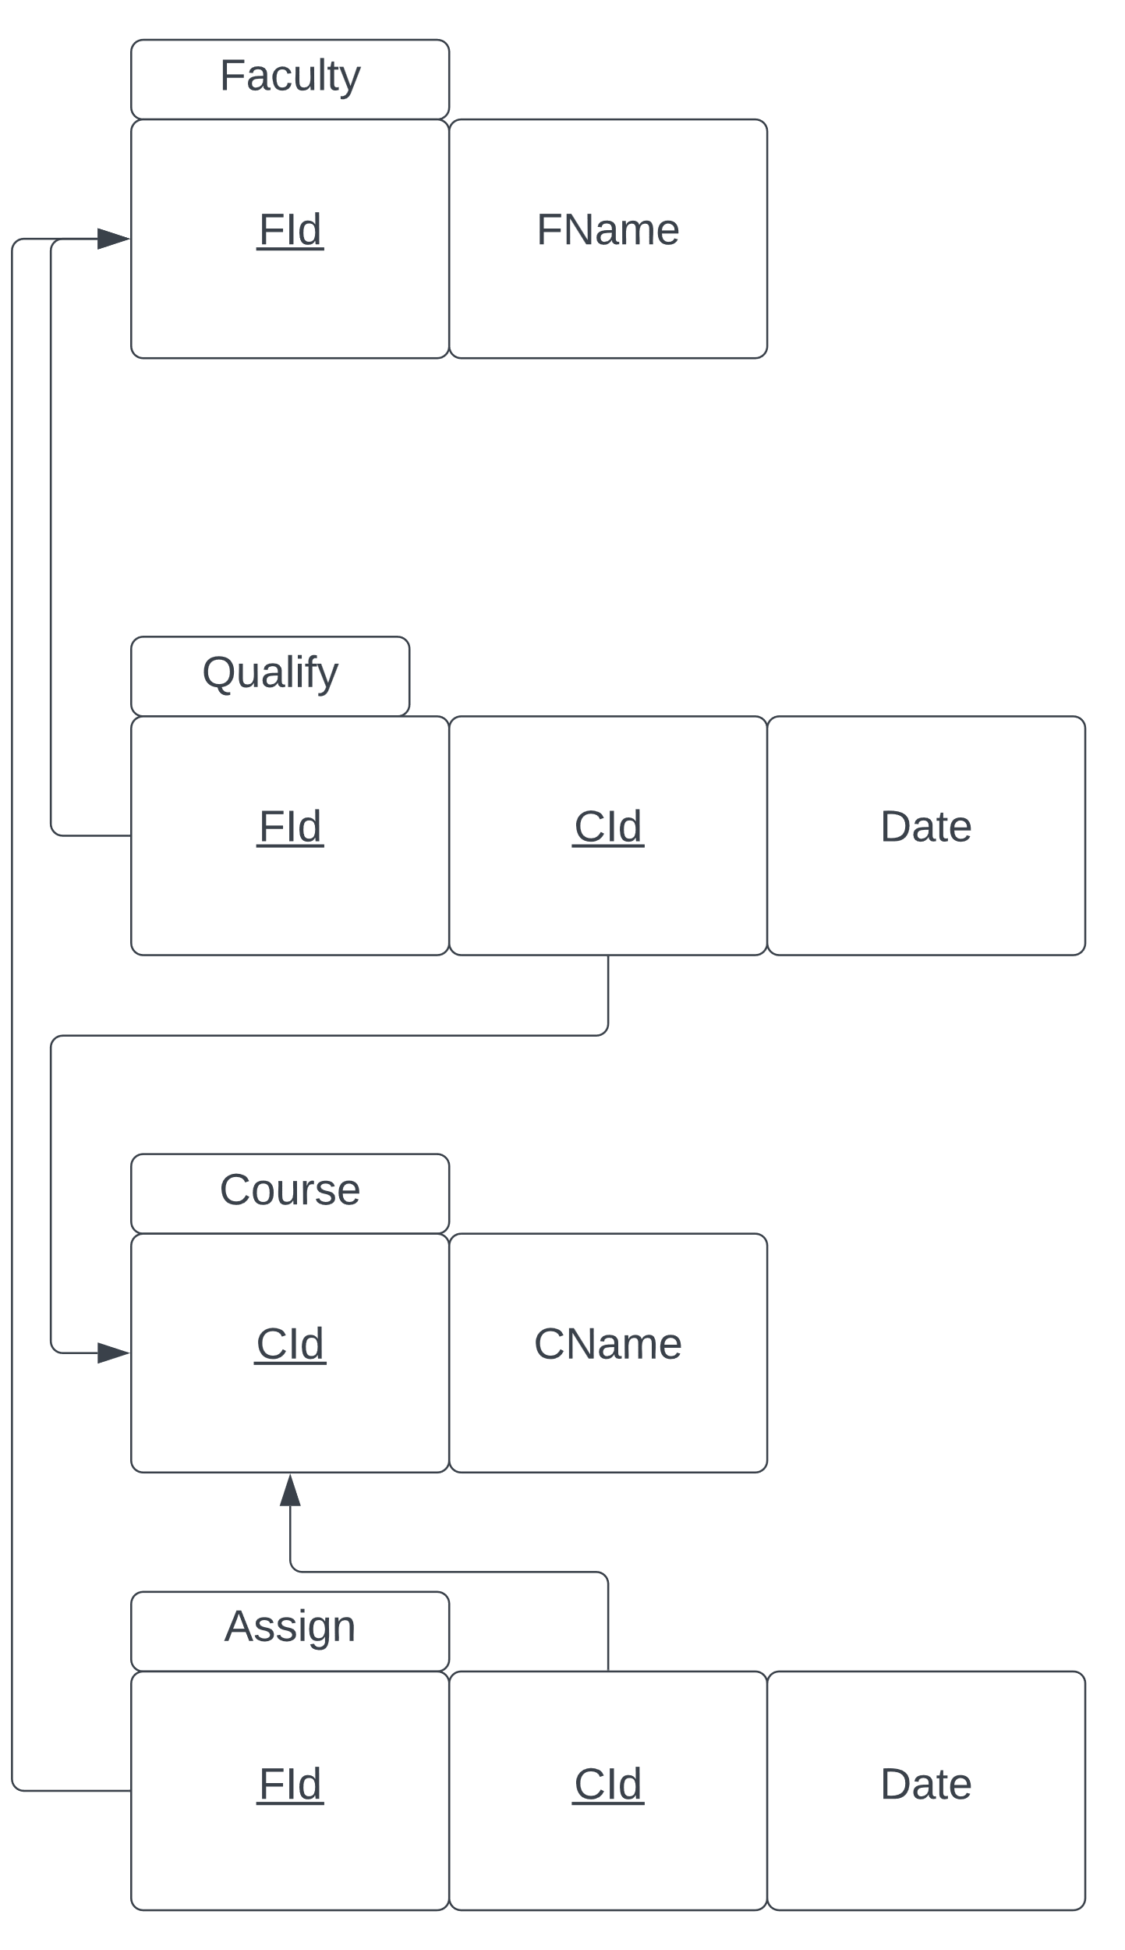
2. CREATE TABLE Assign(

FId VARCHAR(8),

CId VARCHAR(8),

Assign_Date DATE,

CONSTRAINT Assign_FId_CId_pk PRIMARY KEY(FId, CId),

CONSTRAINT Assign_FId_fk FOREIGN KEY(FId) REFERENCES Faculty(FId),

CONSTRAINT Assign_CId_fk FOREIGN KEY(CId) REFERENCES Course(CId));

CREATE TABLE Qualify(

FId VARCHAR(8),

CId VARCHAR(8),

Qualify_Date DATE,

CONSTRAINT Faculty_FId_CId_pk PRIMARY KEY(FId, CId),

CONSTRAINT Faculty_FId_fk FOREIGN KEY(FId) REFERENCES Faculty(FId),

CONSTRAINT Faculty_CId_fk FOREIGN KEY(CId) REFERENCES Course(CId

CREATE TABLE Course(

Cname VARCHAR(128),

CId VARCHAR(8),

CONSTRAINT Faculty_CId_pk PRIMARY KEY(CId));

CREATE TABLE Faculty (

FId VARCHAR(8),

FName VARCHAR(32),

CONSTRAINT Faculty_FId_pk PRIMARY KEY(FId));

1. INSERT INTO Assign

WITH names(FId,CId,assign_date) AS(

SELECT '00000002', '10000002', '01-30-2022' FROM dual UNION ALL

SELECT '00000003', '10000003', '10-12-2015' FROM dual UNION ALL

SELECT '00000004', '10000004', '03-25-1999' FROM dual UNION ALL

SELECT '00000005', '10000005', '05-15-2017' FROM dual UNION ALL

SELECT '00000006', '10000006', '07-26-1998' FROM dual UNION ALL

SELECT '00000007', '10000007', '08-30-2000' FROM dual UNION ALL

SELECT '00000008', '10000008', '10-31-2005' FROM dual UNION ALL

SELECT '00000009', '10000009', '11-30-2001' FROM dual UNION ALL

SELECT '00000010', '10000010', '12-25-2003' FROM dual UNION ALL

SELECT '00000011', '10000011', '07-14-1978' FROM dual UNION ALL

SELECT '00000012', '10000012', '05-10-2009' FROM dual UNION ALL

SELECT '00000013', '10000013', '09-15-2017' FROM dual UNION ALL

SELECT '00000014', '10000014', '06-10-2012' FROM dual UNION ALL

SELECT '00000015', '10000015', '04-20-2011' FROM dual

)

SELECT * FROM names;

INSERT INTO Qualify

VALUES(

'00000001', '10000001', '01-30-2022'

);

INSERT INTO Qualify

WITH names(FId,CId,qualify_date) AS(

SELECT '00000002', '10000002', '01-30-2022' FROM dual UNION ALL

SELECT '00000003', '10000003', '10-12-2015' FROM dual UNION ALL

SELECT '00000004', '10000004', '03-25-1999' FROM dual UNION ALL

SELECT '00000005', '10000005', '05-15-2017' FROM dual UNION ALL

SELECT '00000006', '10000006', '07-26-1998' FROM dual UNION ALL

SELECT '00000007', '10000007', '08-30-2000' FROM dual UNION ALL

SELECT '00000008', '10000008', '10-31-2005' FROM dual UNION ALL

SELECT '00000009', '10000009', '11-30-2001' FROM dual UNION ALL

SELECT '00000010', '10000010', '12-25-2003' FROM dual UNION ALL

SELECT '00000011', '10000011', '07-14-1978' FROM dual UNION ALL

SELECT '00000012', '10000012', '05-10-2009' FROM dual UNION ALL

SELECT '00000013', '10000013', '09-15-2017' FROM dual UNION ALL

SELECT '00000014', '10000014', '06-10-2012' FROM dual UNION ALL

SELECT '00000015', '10000015', '04-20-2011' FROM dual

)

SELECT * FROM names;

INSERT INTO Course

WITH names(CId,Fname) AS(

SELECT '10000001', 'Software Engineering' FROM dual UNION ALL

SELECT '10000002', 'Calculus' FROM dual UNION ALL

SELECT '10000003', 'English' FROM dual UNION ALL

SELECT '10000004', 'Spanish' FROM dual UNION ALL

SELECT '10000005', 'Dance' FROM dual UNION ALL

SELECT '10000006', 'Python Development' FROM dual UNION ALL

SELECT '10000007', 'Database Theory' FROM dual UNION ALL

SELECT '10000008', 'Operating Systems'FROM dual UNION ALL

SELECT '10000009', 'Java'FROM dual UNION ALL

SELECT '10000010', 'Javascript' FROM dual UNION ALL

SELECT '10000011', 'Physics' FROM dual UNION ALL

SELECT '10000012', 'English Two' FROM dual UNION ALL

SELECT '10000013', 'Ethics' FROM dual UNION ALL

SELECT '10000014', 'Art' FROM dual UNION ALL

SELECT '10000015', 'Discrete Math' FROM dual

)

SELECT * FROM names;

INSERT INTO Faculty (FId, Fname)

VALUES

('00000001', 'John');

INSERT INTO Faculty

WITH names(FId,Fname) AS(

SELECT '00000002', 'Mary' FROM dual UNION ALL

SELECT '00000003', 'George' FROM dual UNION ALL

SELECT '00000004', 'James' FROM dual UNION ALL

SELECT '00000005', 'Jessy' FROM dual UNION ALL

SELECT '00000006', 'Ash' FROM dual UNION ALL

SELECT '00000007', 'Kindred' FROM dual UNION ALL

SELECT '00000008', 'Gwen' FROM dual UNION ALL

SELECT '00000009', 'Zoe' FROM dual UNION ALL

SELECT '00000010', 'Ashe' FROM dual UNION ALL

SELECT '00000011', 'Kaisa' FROM dual UNION ALL

SELECT '00000012', 'Luke' FROM dual UNION ALL

SELECT '00000013', 'Mark' FROM dual UNION ALL

SELECT '00000014', 'Cody' FROM dual UNION ALL

SELECT '00000015', 'Bradley' FROM dual

)

SELECT * FROM names;