Q 0. Retrieve the birth date and address of the employee(s) whose name is: ‘John B. Smith’.

* SELECT Bdate, Address

FROM employee

WHERE Fname = 'John' AND Lname = 'Smith' AND Minit = 'B';

* 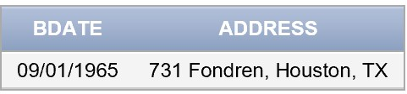

Q 1. Retrieve the birth date and address of the employee(s) who work for the: ‘Research’ department

* SELECT Bdate, Address

FROM employee

JOIN department

ON employee.Dno=department.Dnumber

WHERE Dname = 'Research';

* 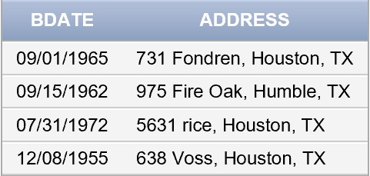

Q 2. For every project located in ‘Stafford’, list the project number, the controlling department number and the department manager’s last name, address, and birth date

* SELECT project.Pnumber, project.Dnum, employee.Lname, employee.Address, employee.Bdate

FROM project

JOIN department

ON project.Dnum = department.Dnumber

Join employee

ON department.Mgr_ssn = employee.Ssn

WHERE project.Plocation = 'Stafford';

* 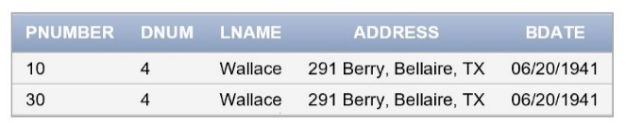

Q 3. Retrieve all employees whose address is in Houston, Texas.

* SELECT *

FROM employee

WHERE Address LIKE '%Houston%';

* Table

  Description automatically generated

Q 4. Make a list of all project numbers for projects that involve an employee whose last name is ‘Smith’ either as a worker or as a manager of the department that controls the project

* SELECT works_on.Pno

FROM works_on

JOIN employee

ON works_on.Essn = employee.Ssn

WHERE employee.Lname = 'Smith';

* Graphical user interface, application

  Description automatically generated

Q 5. Find all employees who were born during the 1950s.

* SELECT *

FROM employee

WHERE EXTRACT(YEAR FROM Bdate) BETWEEN 1950 AND 1960;

* Graphical user interface, application

  Description automatically generated

Q 6. Retrieve all employees in department 5 whose salary is between $30000 and $40000.

* SELECT *

FROM employee

WHERE Dno = 5 AND Salary BETWEEN 30000 AND 40000;

* Graphical user interface, application, table

  Description automatically generated

Q 7. Show the resulting salaries if every employee working on the ‘ProductX’ project is given a 10 percent raise.

* SELECT employee.salary *1.1

FROM employee

JOIN project

ON employee.Dno = project.Dnum

JOIN works_on

ON employee.Ssn = works_on.Essn AND works_on.Pno = project.Pnumber

WHERE project.Pname = 'ProductX';

* 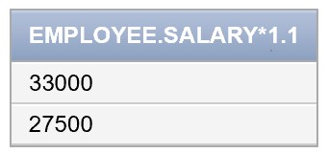

Q 8. Retrieve a list of employees and the projects they are working on, ordered by department and, within each department, ordered alphabetically by last name, first name.

* SELECT employee.*, works_on.Pno

FROM employee

JOIN works_on

ON employee.Ssn = works_on.Essn

ORDER BY employee.Dno, employee.Lname, employee.Fname;

* Graphical user interface, text, application, email

  Description automatically generated

Q 9. Retrieve the name of all employees who do not have supervisor.

* SELECT Fname, Minit, Lname

FROM employee

WHERE Super_ssn IS NULL;

* 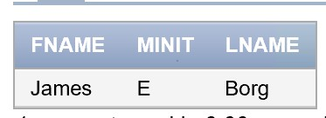

Q10. Retrieve the social security numbers of all employees who work on project numbers 1, 2, or 3.

* SELECT DISTINCT employee.Ssn

FROM employee

JOIN works_on

ON employee.Ssn = works_on.Essn

WHERE works_on.Pno = 1 OR works_on.Pno = 2 OR works_on.Pno = 3;

* Application

  Description automatically generated with medium confidence

Q11. Find the sum of the salaries of all employees, the maximum salaries, the minimum salaries and the average salaries.

* SELECT DISTINCT SUM(Salary), MAX(salary), MIN(salary), AVG(salary)

FROM employee;

* Graphical user interface, application

  Description automatically generated

Q12. Retrieve (find) the number of employees in the ‘Research’ department.

* SELECT COUNT(employee.Dno)

FROM employee

JOIN department

ON employee.Dno = department.Dnumber

WHERE department.Dname = 'Research';

* 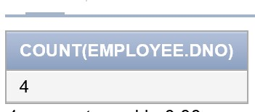

Q13. For each project, retrieve the project number, the project name, and the number of employees who work on that project

* SELECT DISTINCT project.Pnumber, project.Pname, COUNT(project.Pname) as empcount

FROM project

JOIN employee

ON project.Dnum = employee.Dno

JOIN works_on

ON project.Pnumber = works_on.Pno AND works_on.Essn = employee.Ssn

GROUP BY project.Pnumber, project.Pname;

* 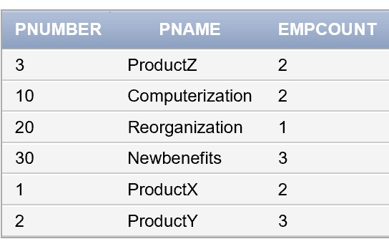

Q14. For each project on which more than two employees work, retrieve the project number, the project name, and the number of employees who work on the project.

* SELECT DISTINCT project.Pnumber, project.Pname, COUNT(project.Pname) as empcount

FROM project

JOIN employee

ON project.Dnum = employee.Dno

JOIN works_on

ON project.Pnumber = works_on.Pno AND works_on.Essn = employee.Ssn

GROUP BY project.Pnumber, project.Pname

HAVING COUNT(project.Pname) > 2;

* Graphical user interface, application

  Description automatically generated

Q15. For each project retrieve the project number, the project name, and the number of employees from department 5 who work on the project.

* SELECT Pnumber, Pname, COUNT(*)

FROM PROJECT, WORKS_ON, EMPLOYEE

WHERE Pnumber=Pno AND Ssn=Essn AND Dno=5

Group BY Pnumber, Pname;

* Table

  Description automatically generated