**PARKING FINDER APP**

A Project Report

Submitted in partial fulfilment of the

Requirements for the award of the Degree of

BACHELOR OF BUSINESS ADMINISTRATION (COMPUTER APPLICATION)

By

**Rohan Topno (24)**

**Zaid Abdul Majid Nadeemulk(76)**

Under the esteemed guidance of

**Mrs. Seema Purandare**,

**Mrs. Ashwini Waghmare**



DEPARTMENT OF COMPUTER APPLICATION

**NESS WADIA COLLEGE OF COMMERCE**

*(Affiliated to Savitribai Phule Pune University)*

PUNE,

MAHARASHTRA

2023-2024

**Abstract**

Now-a-days, vehicle parking has become a major problem in urban areas with the shortage of parking spaces. It is very difficult and frustrating to find a parking space in most metropolitan areas, especially during the rush hours to solve this problem. The paper entitled smart parking system using android application, the major motivation of this paper is to reduce the traffic congestion in roads, multi-storeyed buildings and malls due to unavailability of parking spaces. The proposed application provides an easy way for reservation of parking slot.

In this application user can view various parking areas and also view whether space is available or not. If the booking space is available then he can book it for specific time slot. The paper displays the nearest empty slot if present with respect to user location. Our project aims to make efficient use of parking spaces. Also, this system provides an additional feature for user. To alleviate the parking problems, smart parking systems must be implemented. In this paper, the background on parking problems is introduced and relevant algorithms, systems, and techniques behind the smart parking are reviewed and discussed. This system gives a further feature of cancelling the bookings. User can cancel their booked area anytime. Users may even make price online primarily based totally at the time taken for the reserved area the quantity might be calculated and the person can make charge. This paper provides a good insight into the guidance, monitoring and reservations components of the smart parking and directions to the future development.

**ACKNOWLEDGEMENT**

The satisfaction that accompanies that the successful completion of any task would be incomplete without the mention of people whose ceaseless Cooperation made it possible, whose constant guidance and encouragement crown all efforts with success. We are grateful to our project guide **Prof. Seema Purandare, Ashwini Waghmare** for the guidance, inspiration and constructive suggestions that helpful us in the preparation of this Project.

We are also grateful to the individuals who provided us with feedback and testing during the development process. Your input was valuable in helping us refine the website and ensure that it meets the needs of our users.

Finally, we would like to thank our families, friends, and colleagues for their support and understanding throughout the project. Your encouragement and patience have been greatly appreciated.

**TABLE OF CONTENTS**

**Chapter 1: Introduction**

**1.1 Background**

**1.2 Objectives**

**1.3 Purpose, Scope and Applicability**

1.3.1 Purpose

1.3.2 Scope

1.3.3 Applicability

**1.4 Achievements**

**Chapter 2: Survey of Technologies**

**2.1 Existing System**

**2.2 Proposed System**

**2.3 Requirements Analysis**

**2.4.1 Functional Requirements**

**2.4 Hardware Requirements**

**2.5 Software Requirements**

**Chapter 3: Analysis**

**2.1 Feasibility study**

* **Technical Feasibility**
* **Economical Feasibility**
* **Operational Feasibility**

**Chapter 4: System Design Diagrams**

**4.1 Basic Modules**

**4.2 ER Diagram**

**4. DFD Diagrams**

**[Chapter 5: Implementation](https://www.slideshare.net/PawanYadav348/black-book-238871302?from_search=3" \l "8)**

**5.1 Screenshots**

**Chapter 6: Limitations**

**Chapter 7: Conclusion and Future Work**

**Chapter 8: References**

**Chapter 1**

**Introduction**

The number of personal vehicles usage is increasing day by day. Due to this searching for a vacant parking area during peak hours is not only time-consuming but also results in wastage of fuel. The drivers keep searching for a proper parking lot that leads to increased traffic. Increasing volume of vehicular exhaust creates a negative impact on the environment. Hence reservation-based smart parking has become the need of the day .At this time, most existing parking lots do not have a system in place. Most of them are managed by hand and are a bit ineffective. Every user's demand should be

1. Should be more efficient
2. User friendly
3. They should provide more security.

The idea behind our Android Application- “Parking Finder” is to help the user for online parking booking. The Smart Parking Application aims at helping users to find the most suitable area for parking, make reservations and extend them, if required. In this application user can view various parking areas also he can select it to view whether parking slot is available or not. If the parking slot is available in parking, then user can book it for some specific time slot also, this system provides an additional feature of cancelling the bookings. It also utilizes the open ground for parking with security. Thus, it is going to solve the parking and traffic problem. In this case, it is not necessary to use an extra expensive camera and scanner for verification. The smart parking system based on slot reservation is implemented, utilizing the Android application. The app having the features of slot allocation, by using the slot allocation method, user can reserve their own lowest-cost parking slot. It is an effective way in resolving the parking issues, which helps for traffic congestions and also provide the automated payment billing

process. This work gets extended as a fully automated system using multilayer parking method. Security measures such as searching for the vehicle number in front of the driver recognition in order to avoid theft may also be the designed. We plan to broaden the testing on the real-time environment where users can have the "Smart Parking" system in their portable devices.

If the parking space is not available where customer wants to a park then this application helps the user to find the valid parking space nearby that location. This application helps the user to reserve the parking spot when they stay at home form not being frustrated of finding a parking spot. The interface is easy to use and allows the user to easily switch between other apps. The Android mobile operating system is used, which can be found on many mobile phones today. The Android operating system uses a marketplace to sell applications for the phone. The application is particularly focused on collecting parking space availability data through crowdsourcing from the input of its users. In the delivery item we describe the desired functionality of the application, from which we extract the requirements for the mobile app.

* 1. **Background**

In the contemporary urban landscape, the challenges associated with finding convenient and accessible parking have become increasingly prevalent. Rapid urbanization, a surge in vehicle ownership, and limited parking infrastructure contribute to the growing frustration experienced by drivers searching for suitable parking spaces. In response to this ubiquitous issue, the development of a Parking Finder App aims to alleviate the stress and time-consuming nature of parking by providing users with a streamlined and efficient solution.

Urban mobility is evolving, and as cities continue to expand, the need for intelligent parking solutions becomes imperative. Traditional methods of searching for parking spaces, such as circling city blocks or relying on physical signage, are often inefficient and contribute to traffic congestion and environmental concerns. The Parking Finder App addresses these challenges by leveraging modern technology to offer users real-time information on available parking spaces, thereby optimizing the overall parking experience.

The app's foundation rests on the principles of user convenience, accessibility, and sustainability. By harnessing the power of mobile technology, the Parking Finder App empowers users to make informed decisions about their parking choices, ultimately saving time, reducing frustration, and contributing to more sustainable urban mobility practices.

As urban populations continue to grow, and the demand for parking solutions intensifies, the Parking Finder App emerges as a valuable tool in enhancing the efficiency of urban transportation. This document outlines the key objectives and features of the Parking Finder App, highlighting its potential to revolutionize the way individuals approach and experience parking in modern urban environments.

* 1. **Objectives**

Efficient Parking Management:

Streamlining the parking process by providing users with a reliable and efficient tool to locate available parking spaces in real-time, reducing congestion and enhancing overall urban mobility.

User Convenience and Satisfaction:

Prioritizing user experience by developing an intuitive and user-friendly interface, ensuring that the Parking Finder App becomes the go-to solution for drivers seeking hassle-free parking options.

Data Accuracy:

Implementing a robust system that updates parking availability information, ensuring users receive accurate and up-to-date data for informed decision-making

Customization through Filters:

Enabling users to tailor their parking search based on specific preferences such as price range, parking type, and distance, enhancing the flexibility and personalization of the app.

Reservation System Efficiency:

Developing a reliable reservation system that allows users to secure parking spaces in advance, minimizing the uncertainty associated with finding parking upon arrival.

**1.3 Purpose, Scope and Applicability**

**1.3.1 Purpose**

The purpose of this document is to outline the objectives, features, and functionalities of the Parking Finder App, a technological solution designed to address the challenges associated with urban parking. By providing a comprehensive overview, this document aims to guide the development team, stakeholders, and users in understanding the app's goals, capabilities, and the value it brings to the urban mobility landscape.

**Aim for Project:**

The project that we have undertaken aims to develop a Parking finder app. The project “Parking Finder App” includes the following functionalities:

➢ Realistic Experience

➢ User friendly

➢ Robust Data Accuracy

➢ Reservation system

**1.3.2 Scope**

The Parking Finder App is envisioned as a versatile and user-centric solution to optimize parking experiences in urban environments. The scope of the app encompasses:

* Real-Time Parking Information
* User-Friendly Interface
* Reservation System

**1.3.3 Applicability**

The Parking Finder App is intended for use by:

Individual Drivers:

Seeking convenient and efficient parking solutions in urban areas.

Businesses and Commercial Entities:

With a focus on optimizing parking for customers, employees, and visitors.

City Planners and Administrators:

To gain insights into parking patterns, usage, and demand for informed urban planning decisions.

Technology Enthusiasts:

Interested in leveraging modern technology for improving urban mobility and addressing parking challenges.

**Chapter 2**

**Survey Of Technologies**

**2.1 Existing System**

While existing systems have made strides in addressing parking challenges, there remains substantial room for improvement. Upon evaluating the existing systems, it becomes apparent that there is a significant opportunity to improve the efficiency, accessibility, and user experience of parking navigation and management. The limitations and challenges present in current parking solutions underscore the need for a comprehensive and innovative approach to address urban parking issues effectively.

**2.1.1 Limitations of Current System:**

Limited Availability Information:

Drivers often lack real-time information about available parking spaces, leading to inefficiencies and frustration while searching for parking.

Manual Search Processes:

Current methods rely heavily on manual searches, such as circling city blocks or relying on physical signage, which are time-consuming and prone to inaccuracies.

Uncertain Reservation Processes:

Existing reservation systems may lack reliability, resulting in uncertainty for users who reserve parking spaces in advance.

**2.2 Proposed System**

To overcome the drawbacks of the existing system the proposed system has been evolved. This project aims to revolutionize the way drivers navigate urban environments by providing a comprehensive and user-friendly solution to parking challenges. Leveraging modern technology and innovative features, the app seeks to optimize the parking experience, enhance user convenience, and contribute to more sustainable urban mobility practices..

**2.1 Advantages of Proposed System:**

* Convenience and Accessibility
* Enhanced User Experience:
* Time-Saving Reservation System:
* Optimization of Urban Mobility

**2.3 Requirement Analysis**

**2.3.1 Functional Requirements**

➢ A functional requirement describes what a system should do.

➢ Functional requirements specify a function that a system or system

component must be able to perform.

➢ It can be documented in various ways. The most common ones are written descriptions in documents and use cases

➢ User Registration and Authentication

➢ Parking Search.

➢ Parking Availability

**2.4 Hardware Requirements**

|  |  |
| --- | --- |
| CPU | SSE2 instruction set support |
| Memory | 4 GB Ram |
| Hard drive | Minimum 10 GB Free Space |
| Graphic Hardware | Graphics card with DX10 (shader model 4.0) capabilities |

**2.5 Software Requirements**

|  |  |
| --- | --- |
| Operating System | Android SDK |
| Programming Language | Java |
| IDE | Android Studio |

**2.7 Justification of Selection of Technology**

➢ Everything is going on smoothly by using all the above H/W and S/W.

➢ The sytem is exported for Andrio Platform but in future it can also be made

available for PCs & other devices.

**Chapter 3**

**Analysis**

**3.1 Feasibility Study**

The purpose of this feasibility report is to assess the viability of developing a Parking Finder App using Android as the primary programming language. This report will consider various aspects, including technical feasibility, financial feasibility, and market feasibility.

**Technical Feasibility**

* 1. **Hardware Requirements:** The Parking Finder App does not demand high-end

hardware, making it feasible for a broad range of devices, including smartphones,

tablets. Android devices vary in hardware specifications, but the app can

be designed to run efficiently on a wide range of devices, including smartphones

and tablets.

* 1. **Software Tools:** A development environment like Android Studio, Android SDK, along with JAVA , will be needed. All these tools are readily available and cost-effective.

**Economical Feasibility**

The financial feasibility report evaluates the costs and revenue potential associated

with developing and releasing Parking Finder App using Android:

1. **Budget:** Since this project is for a college assignment, the cost of development may primarily involve time and effort invested by students and faculty.
2. **Software and Tools:** Development tools and resources, such as software licenses or cloud hosting services, may incur minimal costs, but these can be mitigated through the use of free or open-source alternatives.
3. **Revenue:** As this project is educational and not intended for commercial use, revenue generation may not be a primary concern.

However, if the project is deployed as a real-world solution within the college campus, revenue generation could be explored through sponsorship or partnership with local businesses or parking facilities..

**Operational Feasibility**

Operational feasibility assesses whether the proposed parking finder app can be

developed and maintained efficiently over its lifecycle. This involves evaluating the

day-to-day operational aspects of the project. Here's an operational feasibility report

for a Parking Finder App built using Android:

1. **Resource Availability:**

**Minimum hardware and software are required as the system doesn’t need massive memory or latest operating system, but android is needed**

1. **Development process:**

**For developing, waterfall model will be used as a** development methodology and establish workflows to ensure a smooth development process.

1. **User Engagement:**

**Ensuring active participation and engagement from students, faculty, and staff within the college community is crucial for the success of the project.**

1. **User-Friendly Interface:**

**Designing an intuitive and user-friendly interface is essential to encourage adoption and facilitate ease of use for all stakeholders..**

Developing a Parking Finder App built using Android is technically feasible,

cost-effective, and can cater to a wide range of devices. As thorough

research and planning were done to maximize the chances of creating a

successful game that provides a good user experience.

**Chapter 4**

**System Design Diagrams**

**4.3 Use Case Diagram**

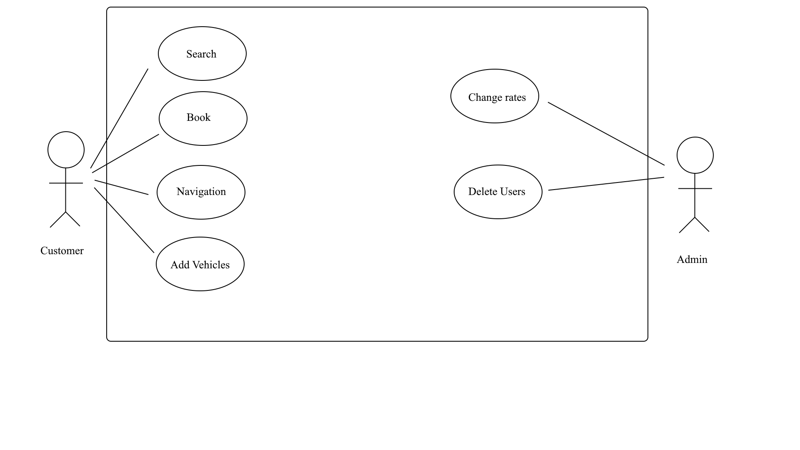

**4.3.2 Class Diagram**

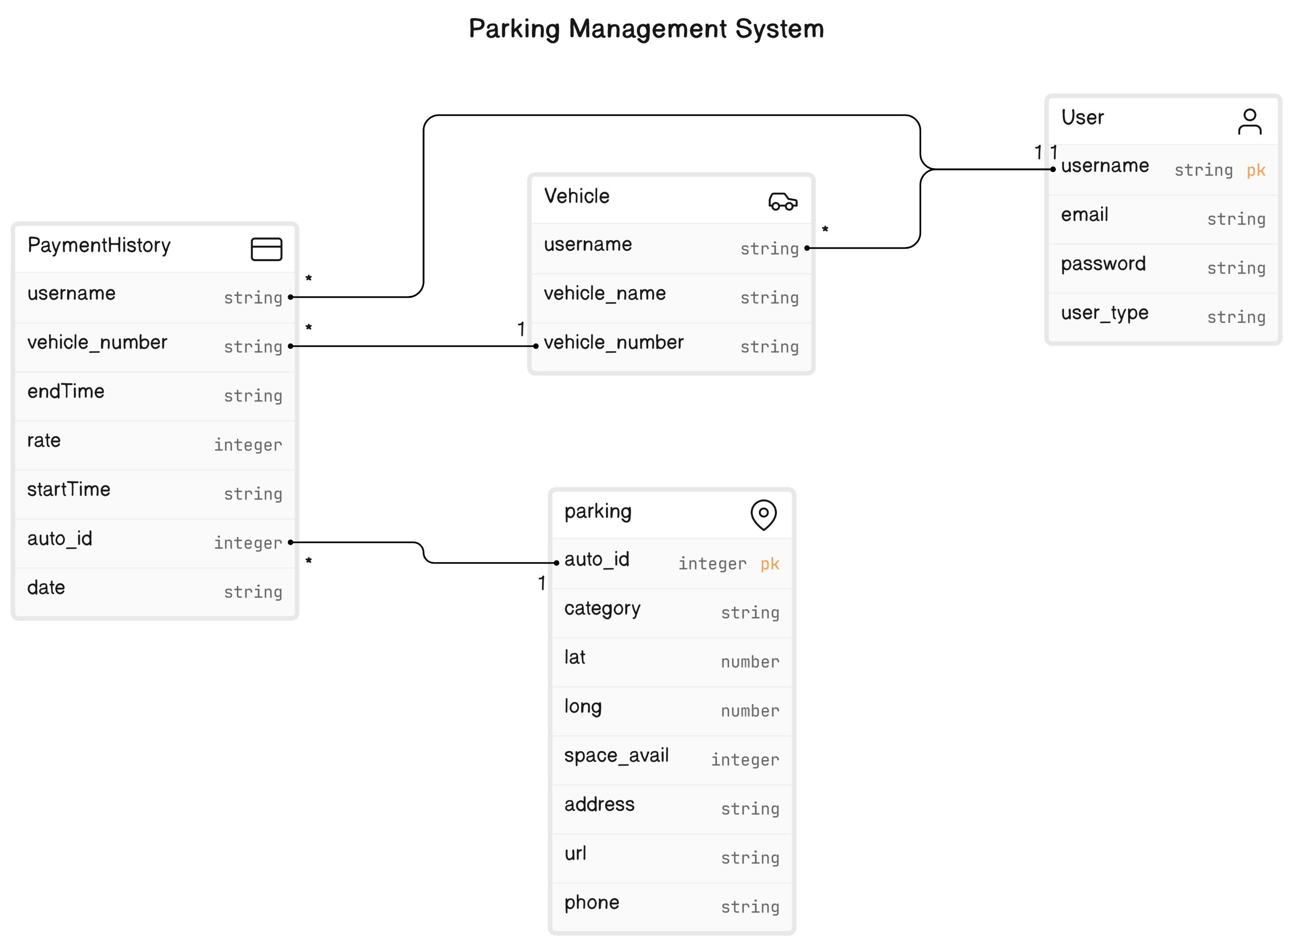

**4.3.3 Sequence Diagram**

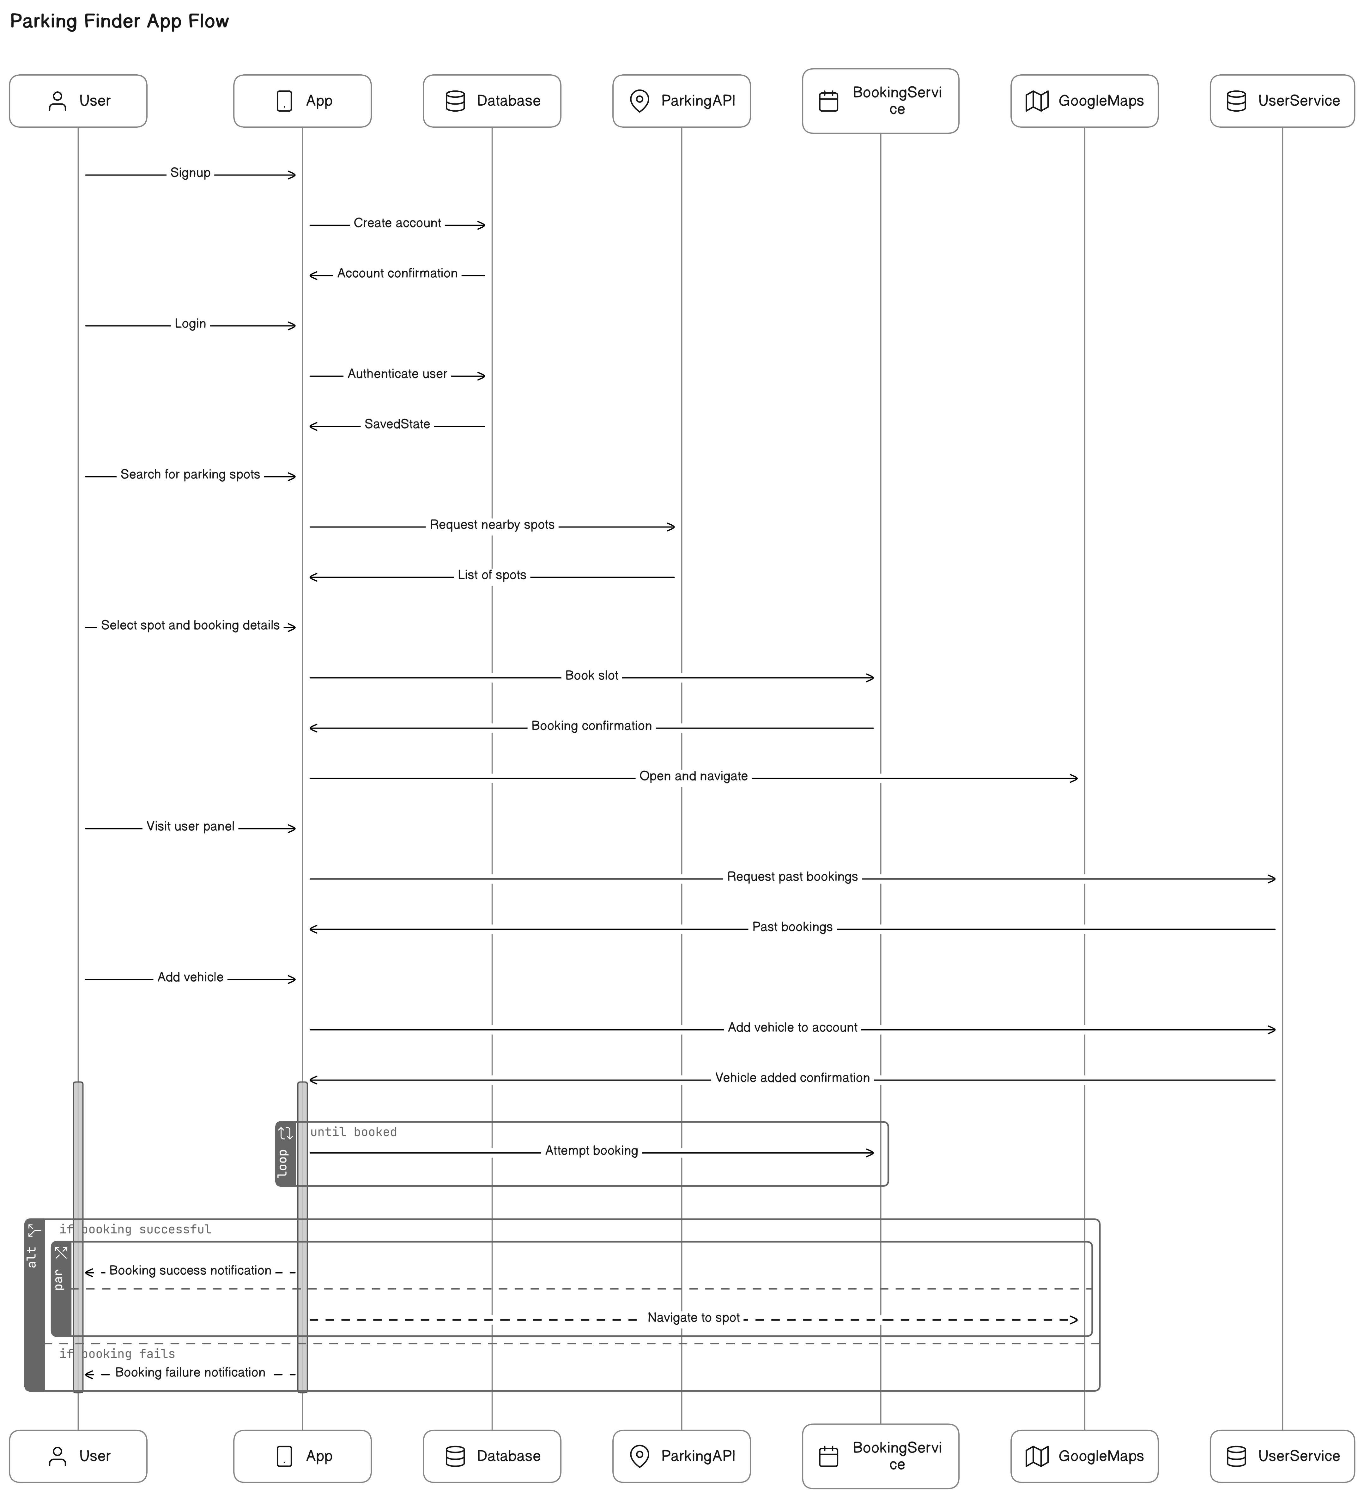

**Chapter 5**

**Implementation**

**5.1 Screenshots**

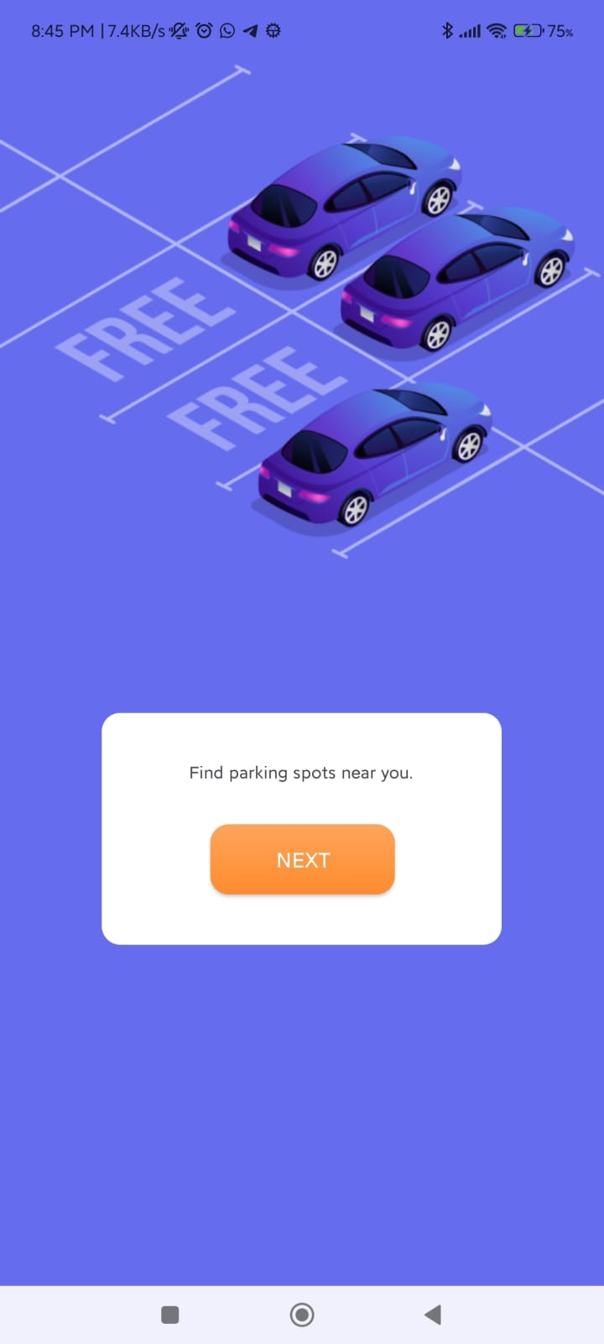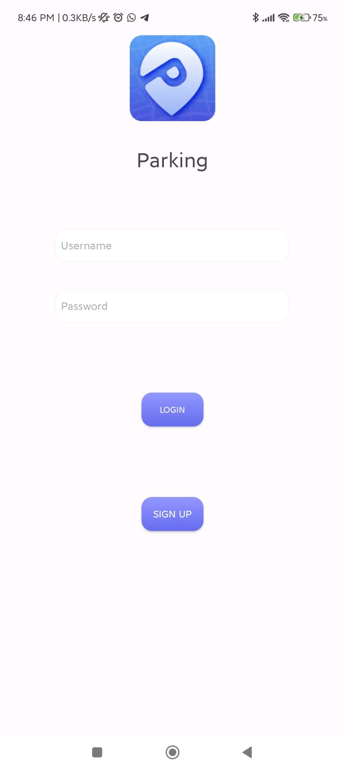

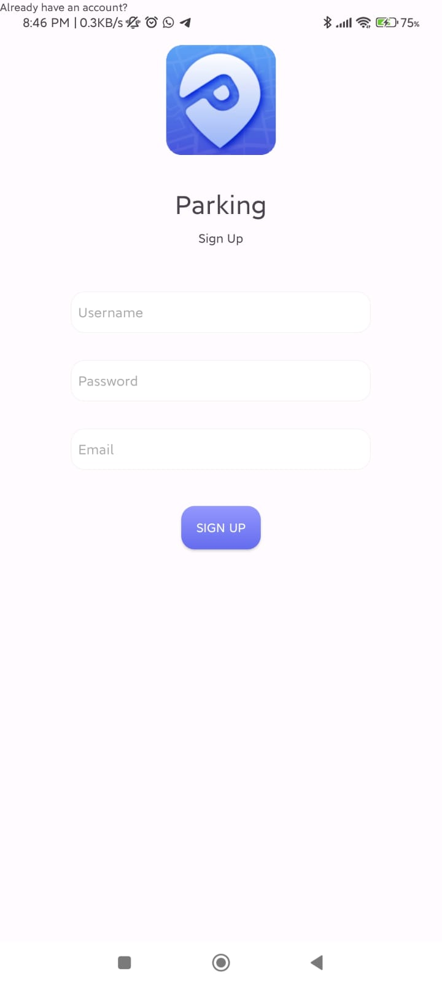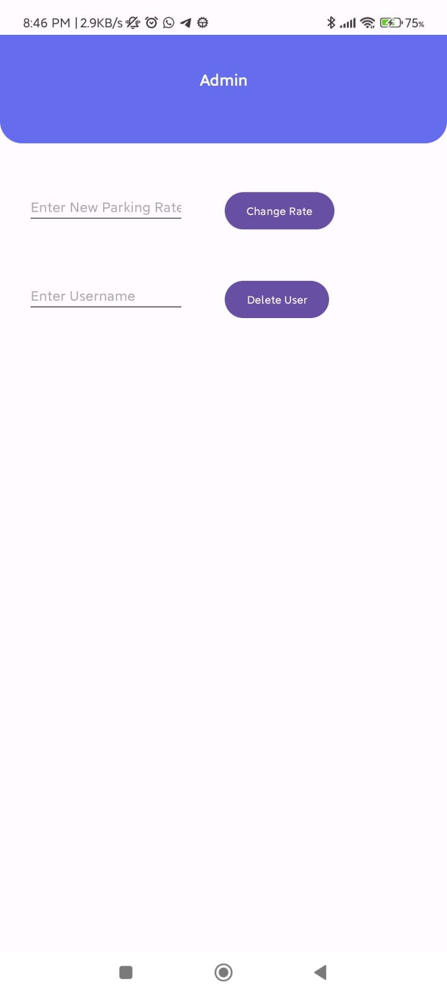

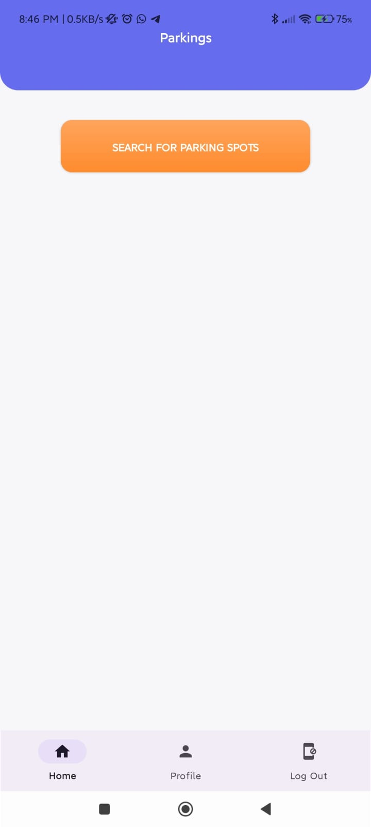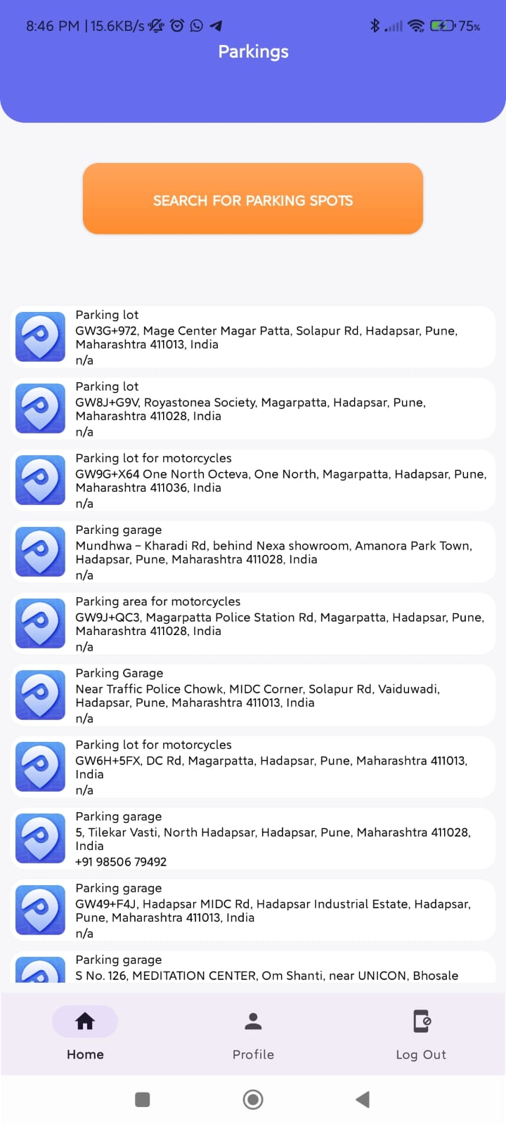

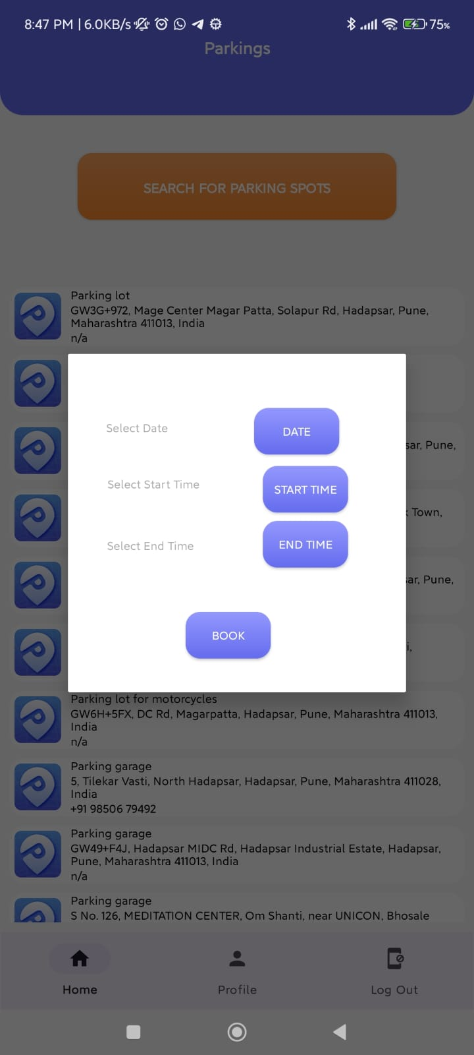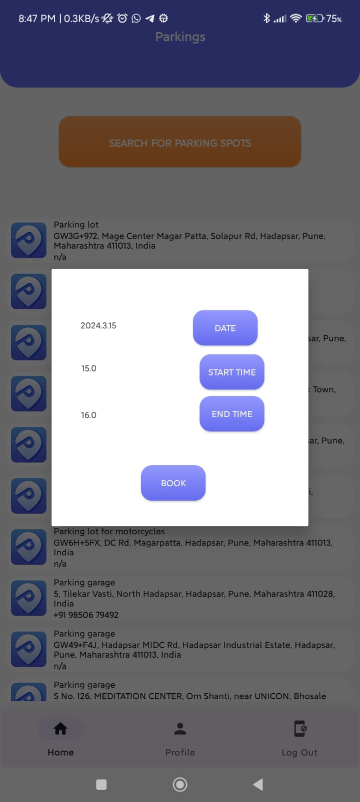

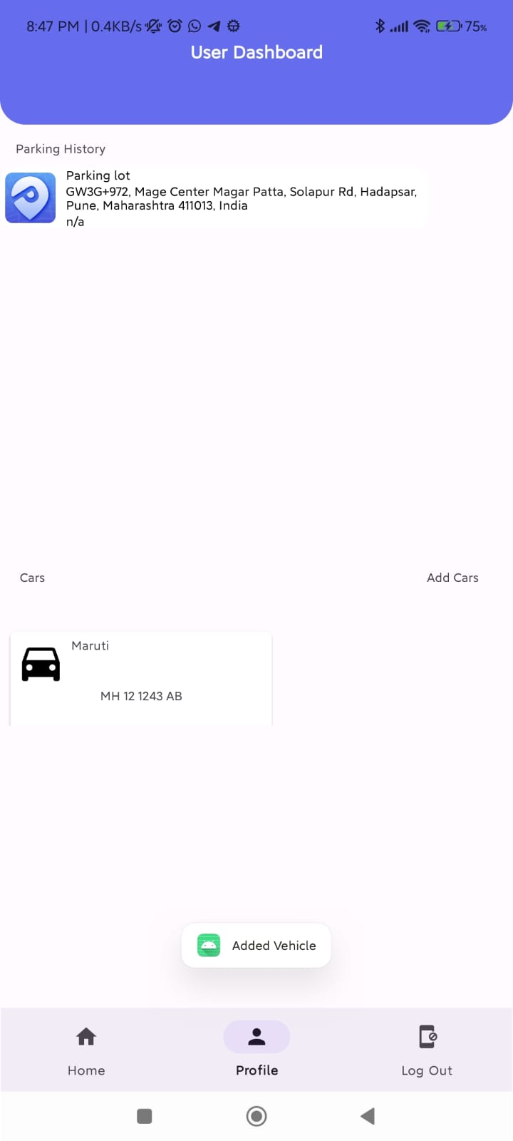

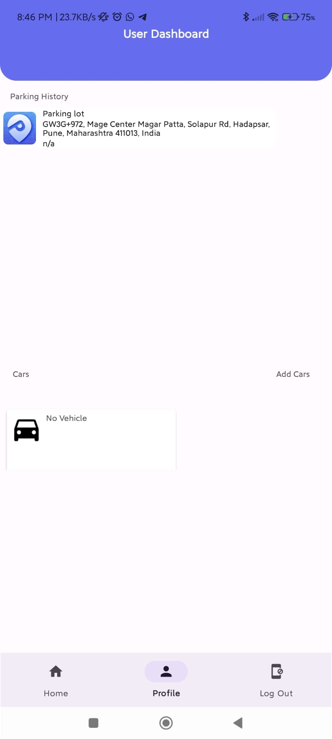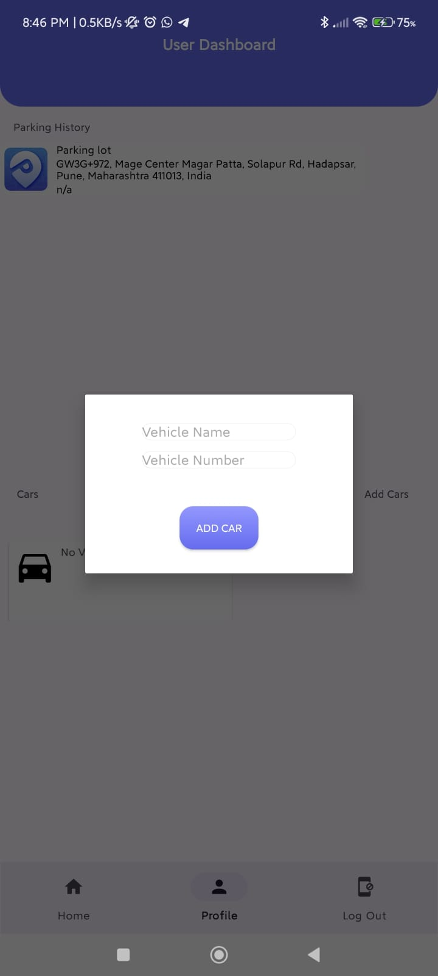

**Chapter 6**

**Limitations**

While the Parking Finder System holds great potential to address parking challenges within the college community, it also faces limitations, particularly in the areas of navigation and payment functionalities.

The absence of navigation options within the system may hinder users' ability to efficiently locate parking spaces within the city, potentially leading to frustration and inefficiencies in the parking process. However, by leveraging alternative navigation strategies or providing clear signage and directions, some of these limitations can be mitigated.

Similarly, the limitations surrounding payment options, security concerns, dependency on external payment gateways, and accessibility challenges highlight the need for careful consideration and potential improvements in the payment processes of the system. Implementing a diverse range of payment options, enhancing security measures, and providing user-friendly payment interfaces can help address these limitations and ensure a seamless payment experience for users.

**Chapter 7**

**Conclusion And Future Work**

**7.1 Conclusion**

In conclusion, the Parking Finder App presents a promising solution to address urban parking challenges by providing real-time information about available parking spaces, enhancing user convenience, and promoting sustainable transportation practices. Throughout the development process, various aspects such as technical feasibility, economic viability, and operational effectiveness were analyzed to ensure the success of the app.

The app offers numerous advantages, including efficient parking navigation, enhanced user experience, and promotion of sustainability initiatives. However, it also faces limitations, particularly in navigation and payment functionalities, which need to be addressed to improve the overall effectiveness and user satisfaction of the app.

Despite these limitations, the Parking Finder App holds significant potential to revolutionize the way individuals approach parking in urban environments. By continuously refining its features, addressing user feedback, and staying abreast of technological advancements, the app can further solidify its position as a valuable tool for urban mobility and parking management..

**7.1.1 Lessons Learned**

First of all, we come to realize that keeping it simple is good. Having great core options that is polished is very valuable. Sometimes we just keep inventing cool new features without realizing they just make the app unpleasantly complex and hard to approach. If the core mechanic cannot stand on its own then there is not much that new features can do to improve it.

Clearly, We learned to implement the smooth android-based model which is a good versatile method that can be used to make apps other than parking finder as well.

We also came to notice, that there are many little aspects and features that we were not aware of before. For example, the considerations for adopting an agile approach to development allows for flexibility, adaptability, and continuous improvement. Breaking down the project into manageable tasks, conducting regular sprints, and iterating based on feedback enable faster delivery of features and better responsiveness to changing requirements.

**7.2 Future Work**

Moving forward, several areas of future work can be explored to enhance the Parking Finder App:

Integration of Navigation Features: Incorporating navigation features within the app to provide users with seamless guidance to their selected parking spots, thus improving the overall user experience.

Expansion of Payment Options: Introducing a wider range of payment options and enhancing security measures to ensure smooth and secure transactions for users, thereby increasing accessibility and user satisfaction.

Enhanced Sustainability Initiatives: Implementing additional features to promote sustainability, such as incentives for carpooling, integration with public transportation options, and prioritization of eco-friendly parking spaces.

**Chapter 8**

**References**

**8.1**

* medium.com
* developer.android.com
* geeksforgeeks.org
* stackoverflow.com
* Youtube Channels
* sqlite.org
* eraser.io