**A PROJECT REPORT ON**

TASK MANGER / PLANNER APP

By: ROHAN TOPNO

**BBA (CA)-SEM V**



**Modern Education Society’s**

**NESS WADIA COLLEGE OF COMMERCE**

**(BBA (CA) Department)**

**19, Late Prin. V.K Joag Path, Pune 411001**

**Tel. 02026167024**

**Fax no: 26167024**

**SAVITRIBAI PHULE, PUNE UNIVERSITY,**

**2020-21**

 **Modern Education Society’s**

**NESS WADIA COLLEGE OF COMMERCE**

19, Late Prin. V.K Joag Path, Pune 411001

This is to certify that,

Mr. / Miss. 1) ________________________________________

2) ________________________________________

3) ________________________________________

has/have successfully completed the Project Entitled ____________________________________________________

and submitted the same to the satisfaction during the academic Year _______________________ towards the partial fulfillment of the degree `Bachelors of Business Administration (Computer Application)` of Savitribai Phule Pune University.

**BBA-CA Co-ordinator Principal**

**Internal Examiner External Examiner**

**ABSTRACT**

This task management system provides an efficient and user-friendly way of managing tasks. It includes features such as user authentication, subtask management, and a relational database for storing and organizing data. Built using AngularJS and MySQL, this system offers scalability and can be easily adapted to accommodate more users and data as needed. While the system has some limitations in terms of functionality and security, future enhancements could address these issues and further improve the system. Overall, this task management system offers a valuable tool for individuals or teams seeking a streamlined approach to managing their tasks.

**ACKNOWLEDGEMENT**

I would like to take this opportunity to express my gratitude to all those who have helped to make the Task Manager project a success.

A project like this for a student is a good first-hand experience on what all steps are needed to be take for a development of a project like this.

I would like to thank my project guide, Prof. Leena Thorat, for her valuable guidance and support throughout the design, implementation, and evaluation phases of the project. Her insights and expertise have been invaluable in helping me to develop a high-quality project.

I would also like to extend my thanks to the entire staff of the Bachelor's in Computer Application Department for their cooperation and support throughout the project.

Thank you all for your support and encouragement!

Rohan Topno

**INDEX**

1. **Project Synopsis**
2. **Company Profile**
3. **Project Profile**
4. **Study of the existing system**
   1. Existing System
   2. Problems with existing system
   3. Fact finding Techniques
5. **Proposed System**
   1. Scope of proposed system
   2. Objectives of proposed system
   3. Feasibility Study
   4. Hardware and Software Requirement
6. **System Analysis**
   1. Context Level Diagram
   2. Data Flow Diagram
   3. Entity Relationship Diagram
7. **System Design**
   1. Data Dictionary
   2. Table Design
   3. Form Design
   4. Report Design
8. **System Benefits and Limitations**
9. **Future Enhancements**
10. **Conclusion**
11. **Bibliography**

**1. PROJECT SYNOPSIS**

1. **Project Title :** Task Manager
2. **Company Name :** AgilePlan Solutions
3. **Technology :** Node.js, AngularJS, Express.js, MySQL / Sqlite, Bootstrap
4. **Team Member :** Rohan Topno
5. **Objective/aim :**
   * In this modern, fast-paced world we often forget to keep a track of our time and the tasks we are supposed to finish within the given time. Many people specially the younger generation growing in the age of scrollable media in the form of short videos spend too much time in other things rather than the tasks they are supposed to do.
   * Our goal is to prevent this from happening to a certain degree by having a task-manager application which would help people keep a track of the things they have to do and the time they have left to do that task.
6. **Technical Details :** 
   * The hardware and software requirements are :-
   * For the server-side system: 1. Dual Core Processor with hyperthreading 2. 8 GB Ram, 3. Hard-Disk / SSD 4. Internet port / WiFi
   * Client Side requirement: Any modern web browser: Firefox , or any chromium based browser like Microsoft Edge, Firefox, Opera, Google Chrome etc.

**2. COMPANY PROFILE**

* Name of the Company : AgilePlan Solutions
* Email : rohantopno@hotmail.com
* We create solutions to problems and fix things which are broken. We can create and sell software quickly through planning and quick design.
* We aim to create software that provides innovative and efficient solutions to the problems which are given to us by our clients. We can cater to even the most specific needs in any application.
* We specialize in agile project management which enable us to deliver high quality product quickly and efficiently. We can do web design and development and develop for mobile-first applications.
* The work we do is cost effective using modern technologies which will help us create our projects faster.

**3. PROJECT PROFILE**

* This project is focused on creating a mobile-first website which means that the i/o is made so that it can be viewable in a mobile as well as a desktop/laptop environment.
* The goal of this project is to create an application which will be easy to use and the users will be able to manage all their tasks inside this app.
* It has a notification system through sounds which play when the task is close to being finished which the users may/may not be able to hear depending on their sound settings being turned on/turned off.
* This application has multiple modules / pages which do:
  + Registration / Login : It is used to create a user and then login to the user id which then will be used to show the particular user their tasks. It also uses server-side encryption to hide their password.
  + Task Manager : This is the main task-manager app which has the job of displaying all the tasks which the user has created. Through this view, the tasks which are displayed can be deleted / edited. We can also add subtasks through this which can also be deleted.
  + Task Creator : We can create all the tasks here with their name, description and the time to finish.
  + User-Control : We have a navigation bar which can login / logout and register users. Logout only shows when the user is logged in and register only shows when no user is logged in.

**4. STUDY OF THE EXISTING SYSTEM**

**4.1 EXISTING SYSTEM**

* Google Tasks is a task management application developed by Google. It is available as a web application, as well as a mobile app for iOS and Android devices. Google Tasks allows users to create and manage tasks, set due dates, add notes or details, and organize tasks into different lists.

**4.2 Problems with the Existing System**

* A Drawback of the system is that it does not have a feature for time tracking or resource allocation, which makes it challenging to monitor task progress and estimate project completion time accurately.

**4.3 Fact-Finding Techniques**

* To study the existing-system the following was used:
  + Interviewing students to understand what their needs are and what are the problems which they have to face.
  + Observing users interact with the existing system.
  + Analysing the competitor and finding their best practices.

**5. PROPOSED SYSTEM**

* We are developing a system which will overcome the drawback of the existing system.
* This system provides the user with a time limit which they can set or change according to their need and it has a reminder which will help the user to know when their task is to be finished.
* They will be given a live countdown on when their task will reach its ending phase with days, hours, minutes and seconds left.
* The user will be able to create an account and the log into it in order to access this system and their data will be stored accordingly along with their password being safe after being encrypted.

**SCOPE OF THE PROPOSED SYSTEM**

* Task Management: This system will help the user to manage their tasks and create / update their tasks as easily as possible and to have their due dates marked and sub tasks added.
* Time Limit Calculator: It has a time limit calculator giving a countdown to the user and thereby helping them stay on time.
* Login: This login creates a safe environment for the user to store their data as its only accessible to them by the use of their password which also stays encrypted to the end user is safe.
* Creation and Deletion : Good UI design makes it easy for the user to create and delete tasks on the go.

**OBJECTIVES OF THE PROPOSED SYSTEM**

* Enhance Productivity: The system aims to provide a task management app that helps users to work more better, manage their time, and improve their productivity.
* Increase Accountability: The system aims to provide tracking the progress of tasks. This will help to ensure that the user is aware of their tasks, and that tasks are completed on time.
* Encourage Task Completion: This system aims to encourage users to complete their tasks by sending timely reminders. This will help users to stay motivated, aware and focused on their tasks, leading to a more efficient and productive work process.

**FEASIBILITY STUDY**

1. **Technical Feasibility**
   * This system is technically feasable as the required technologies and tools / resources are available to develop it. The system can be created using a wide number of technologies which include web platforms which also transforms into mobile platform.
2. **Economical Feasibility**
   * This system is economically feasible as the developmental cost is within limits and this system can be built within a time frame and the implementation cost is less.
3. **Operational Feasibility**
   * The system is operationally feasible as its easy to use and can work on most hardware / software. It provides a user-friendly interface for each users to make it easy for them.

**HARDWARE AND SOFTWARE REQUIREMENTS**

* Client-Side requirement:
  + Hardware
    - Processor: Any dual core processor: Intel Pentium D / AMD Athlon X2
    - RAM: 8GB
    - Hard Disk: 200GB
  + Software
    - Operating System: Windows / Linux / MacOs
    - Any modern web-browser like Firefox, Chromium based browsers like Google Chrome, Microsoft Edge, Opera. Safari etc.
* Server-Side requirement:
  + Hardware
    - Processor: Any quad core processor: AMD Opteron / INTEL i7 950 Quad core cpu (2009)
    - Ram : 8GB
    - Hard Disk: 512GB
  + Software
    - Operating sytem: Windows / Linux
    - Software: node.js
    - Database : Sqlite3 / MySQL

**6. SYSTEM ANALYSIS**

**CONTEXT LEVEL DIAGRAM**

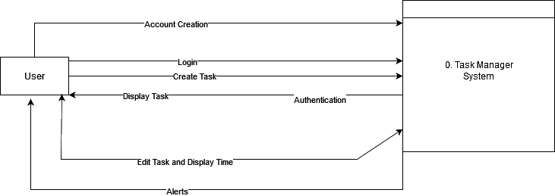

**DATA FLOW DIAGRAM**

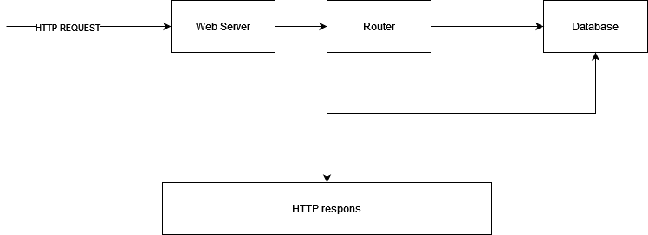

**ENTITY RELATIONSHIP DIAGRAM**

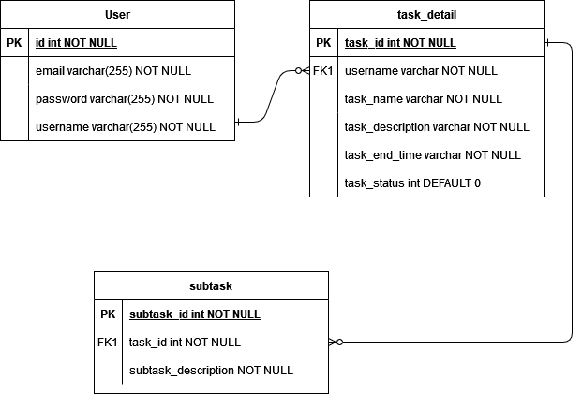

**7. SYSTEM DESIGN**

**Data Dictionary:**

task_detail table:

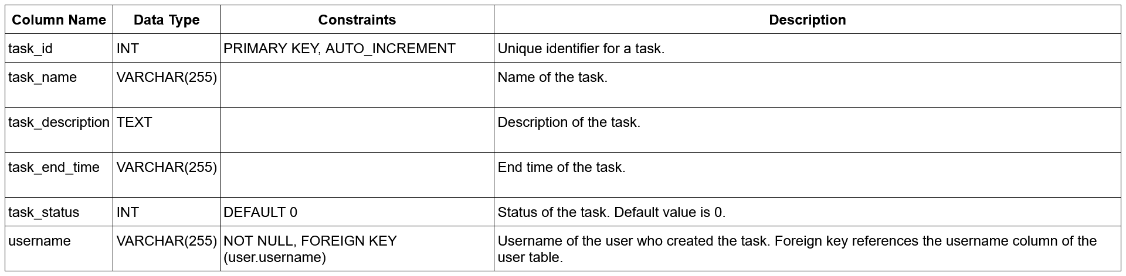

### User table:

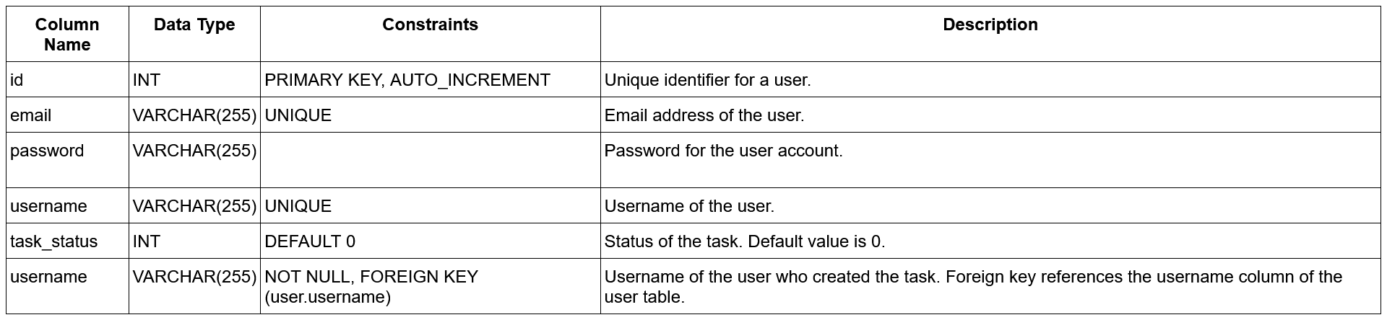

### Subtask table:

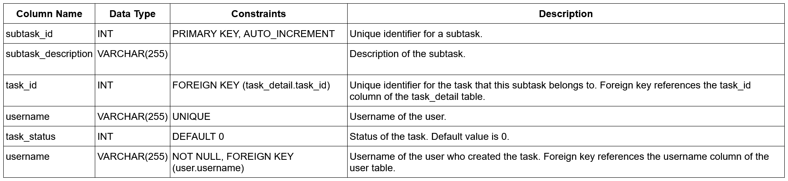

**PAGES**

Home page:

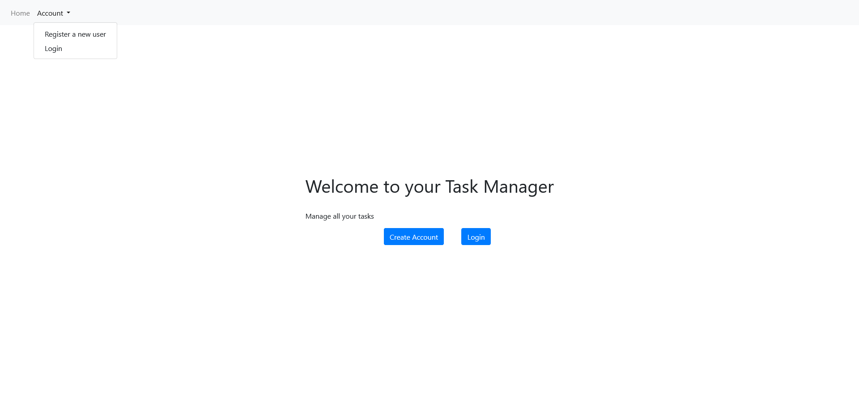

Create Account:

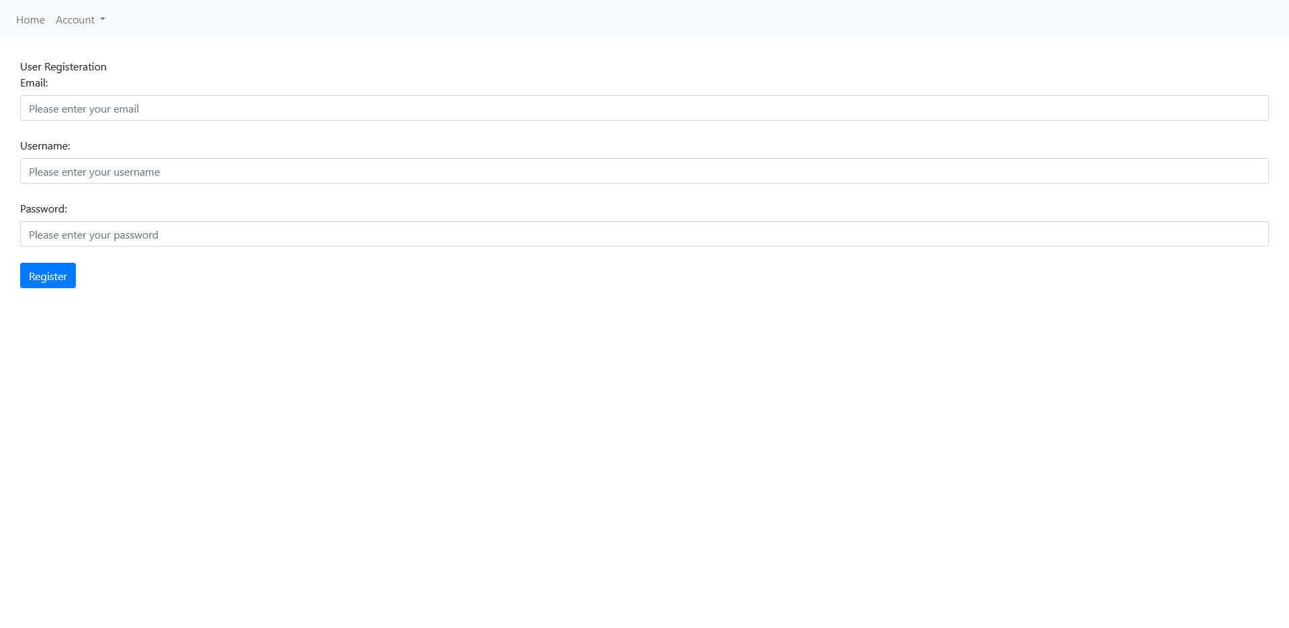

Login:

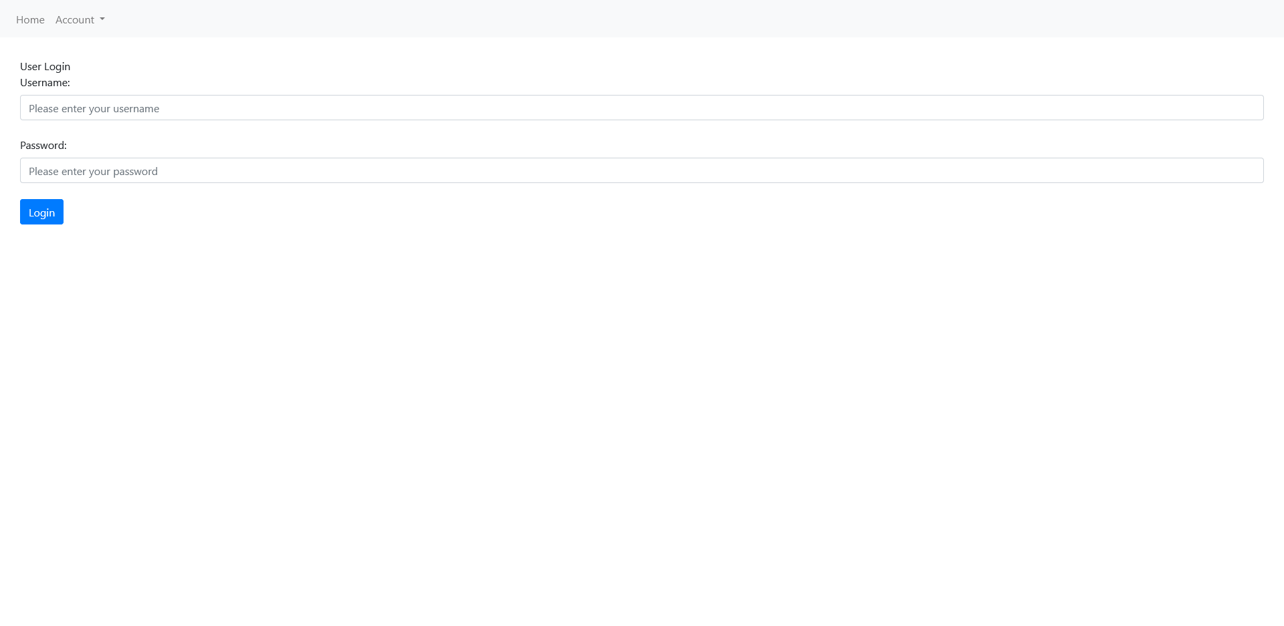

Logged-in Home page:

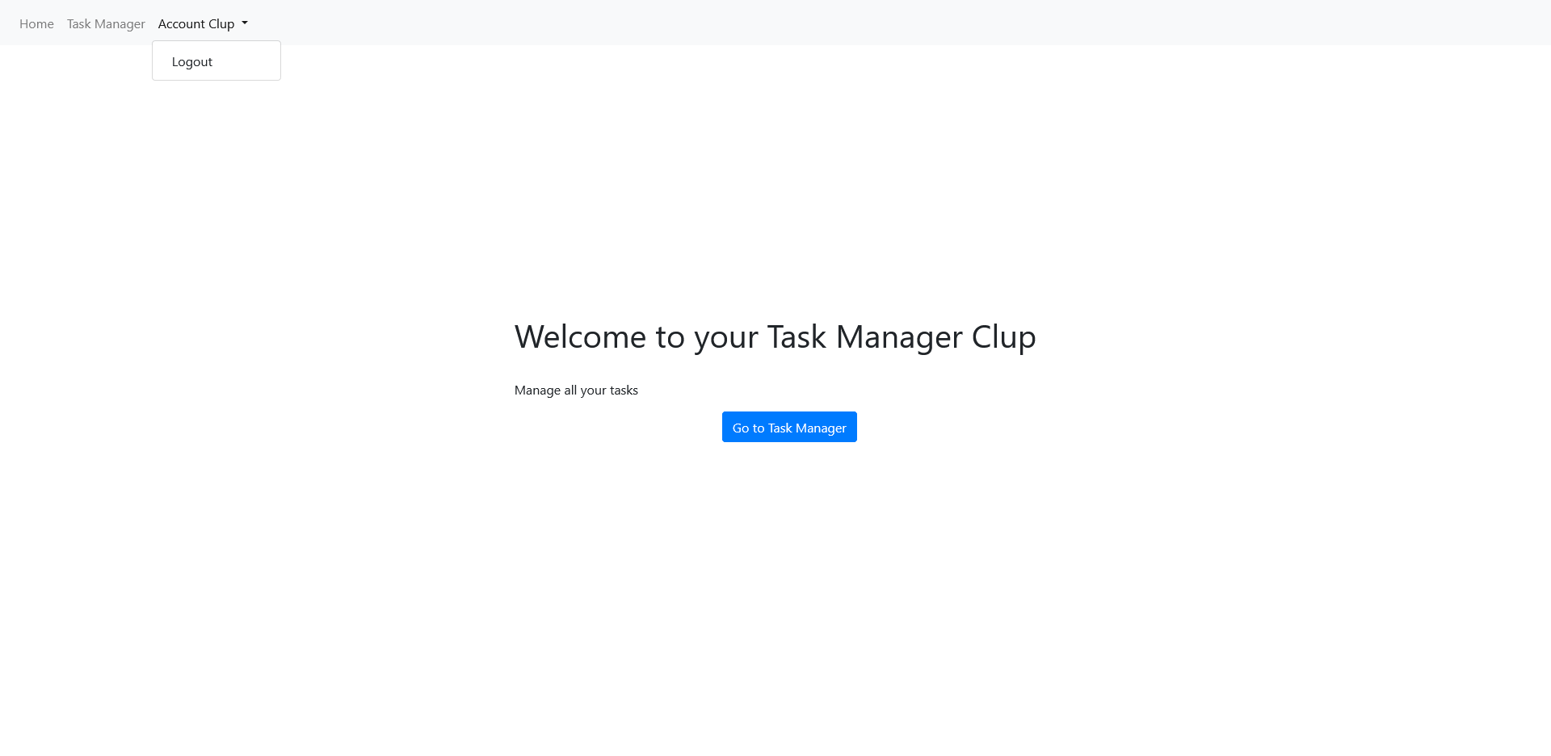

Task-Manager:

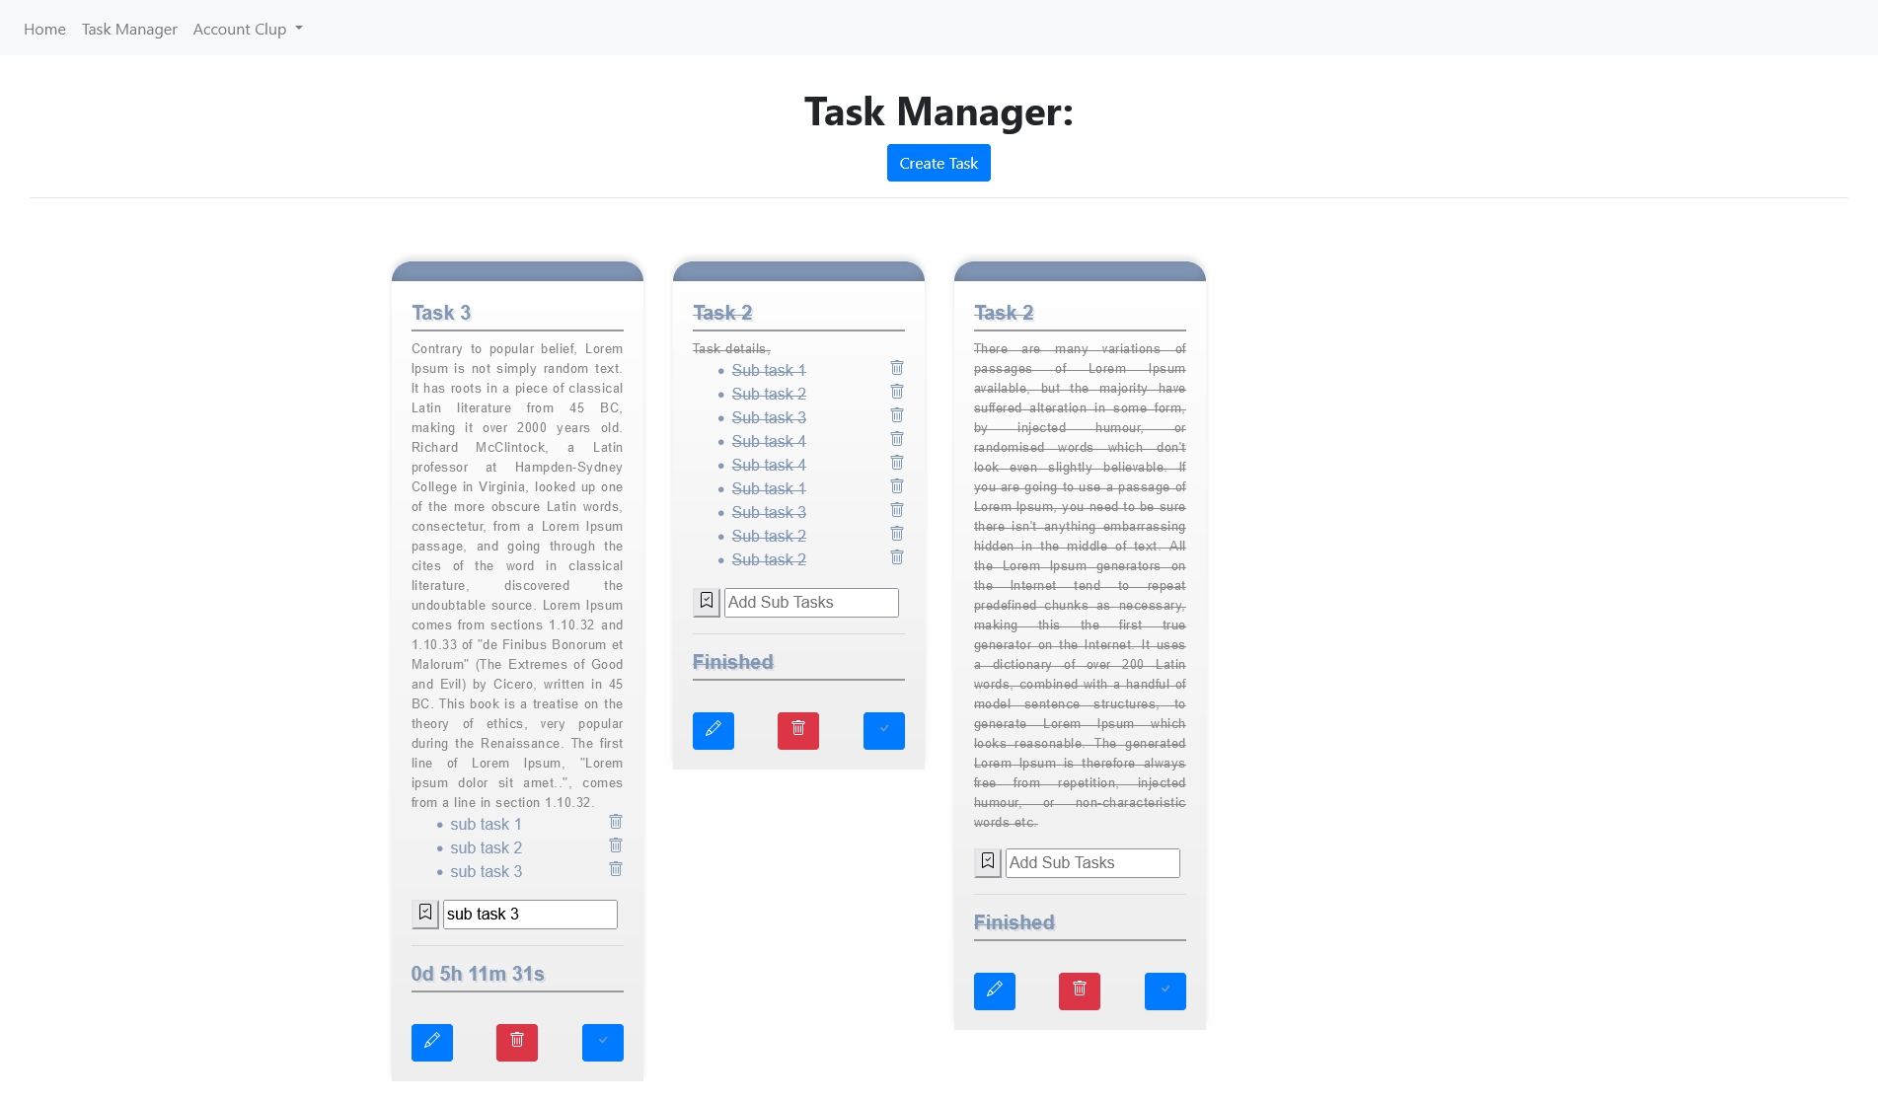

Create Task:

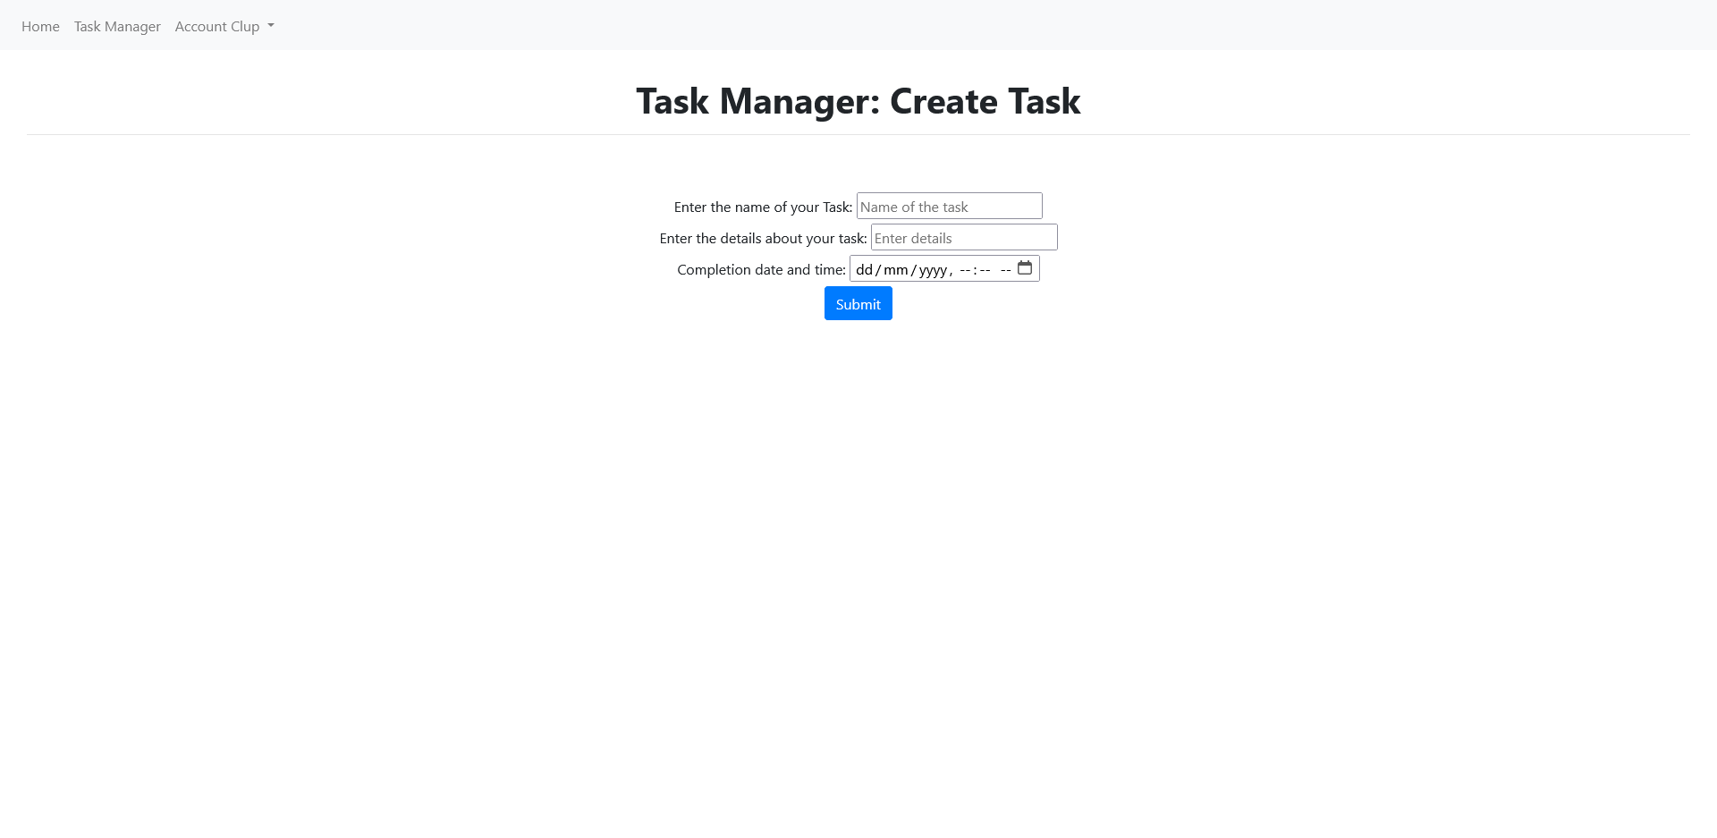

Edit Task:

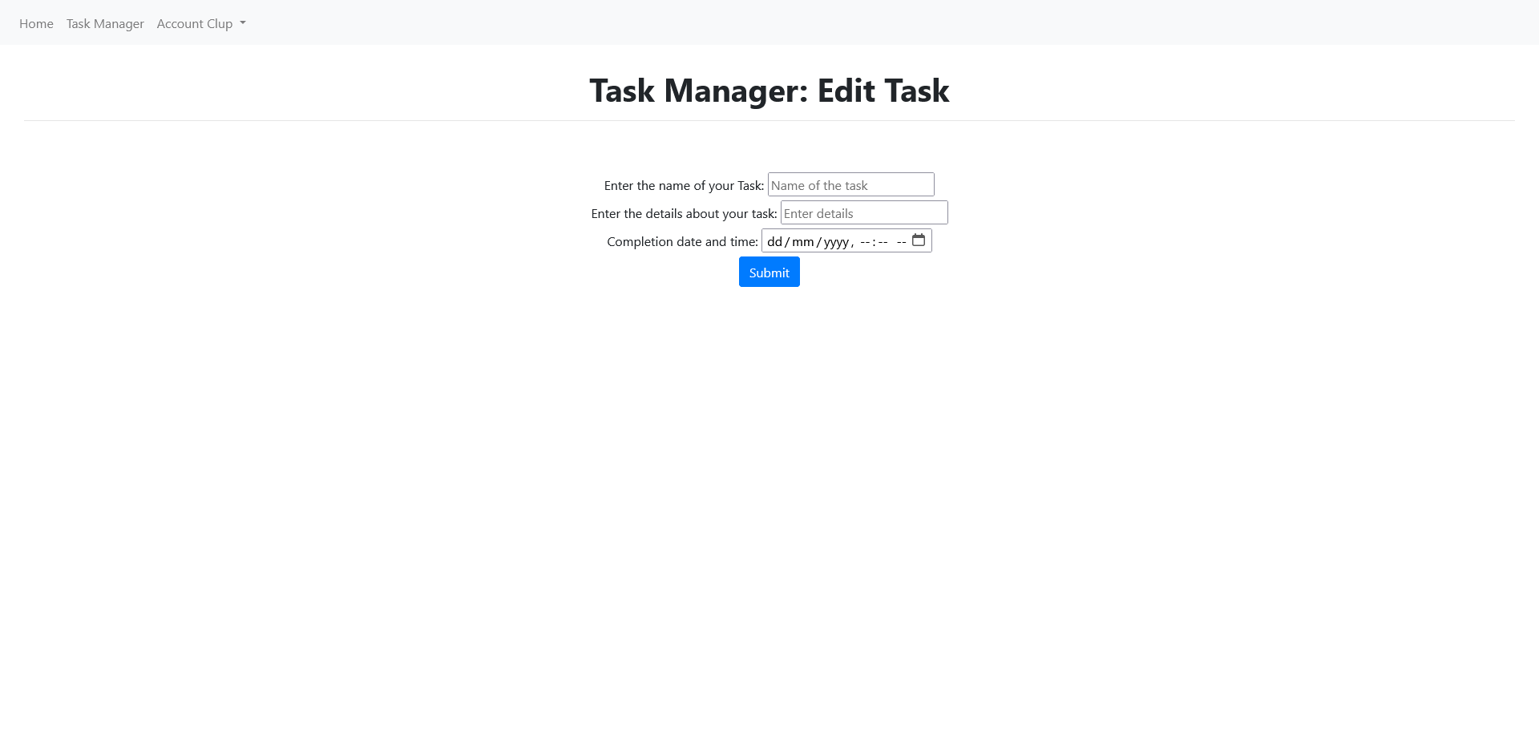

**8. BENEFITS AND LIMITATIONS OF SYTEM**

**BENEFITS:-**

1. **Efficient Task Management:** It provides efficient way of managing tasks by allowing users to create, update, and delete tasks, as well as view their progress and deadlines.
2. **User Authentication:** This system includes user authentication to ensure that only authorized users can access and modify their tasks.
3. **Subtask Management:** This system provides the ability to create and manage subtasks for each task, allowing users to break down tasks into smaller pieces.
4. **Relational Database:** This system uses a relational database to store and organize data, which makes it easier to manage and maintain over time.
5. **Scalability:** Your system can be easily scaled to accommodate more users and data as needed.

**LIMITATIONS:-**

1. **Limited Functionality:** Your system provides basic task management functionality and may not be suitable for users with more complex task management needs.
2. **Performance:** Depending on the number of users and tasks in the system, the performance may be impacted.
3. **Security:** While the system includes user authentication, it has no protection against SQL injection attacks.

**9. FUTURE ENHANCEMENTS**

* **Integration with Other Tools**: Integrating your task management system with other productivity tools, such as calendars and project management software, can provide users with a more comprehensive productivity solution.
* **Advanced Task Tracking**: Adding features such as task priority and due date reminders can help users better manage their tasks and improve their productivity.
* **Customizable Task Views**: Allowing users to customize their task views by sorting , filtering, and grouping tasks based on different criteria.
* **Collaboration Features**: Adding collaboration features, such as the ability to assign tasks to other users and to share tasks, can improve team productivity and collaboration.
* **Reporting and Analytics**: Adding reporting and analytics features can provide users with insights into their work and help them identify where they can improve.
* **Enhanced Security**: Improving the system's security , by implementing protection to prevent SQL injection attacks and adding two-factor authentication, can help protect user data.

**CONCLUSION**

* The task management system we have designed provides a user-friendly and effective way for people to manage their tasks. It has important features like authentication, subtask management, and a database which is used to store and organize data.
* This system is scalable and can easily be expanded to add more features to this and add more users and expand the user base.
* While having its limitations, like security, it can be addressed through future improvements which will be made
* This task management application can serve as a basis for a future of a complex management software which can be expanded to companies and big teams to co-ordinate their work.

**BIBLIOGRAPHY**

Websites reffered

* MySQL. <https://www.mysql.com/>
* Node.js. <https://nodejs.org/en/>
* Express.js. Express.js. <https://expressjs.com/>
* Bootstrap. <https://getbootstrap.com/>
* jQuery. <https://jquery.com/>
* W3Schools. https://www.w3schools.com/
* AngularJS. <https://angularjs.org/>.
* Wikipedia. https://en.wikipedia.org/
* Digital Ocean. https://www.digitalocean.com/
* SQLite. <https://www.sqlitetutorial.net/>