WEB-BASED ACCREDITATION MANAGEMENT AND READINESS
ASSESSMENT SYSTEM
A Capstone Project
Presented to the Faculty of the Graduate School
State University of Northern Negros
Sagay City, Negros Occidental
In Partial Fulfillment
of the Requirements for the Degree
Master in Information Technology
By:
JOSE MARIE CLYDE B. TABURADA
November 5, 2026
APPROVAL SHEET
ACKNOWLEDGEMENT
DEDICATION
ABSTRACT
Philippine higher education institutions undergo periodic accreditation through the Philippine Association of Colleges and Universities Commission on Accreditation (PACUCOA), yet decentralized file storage fragments documentary exhibits and hinders readiness forecasting. Using an Agile developmental methodology across four iterations, this study designed, developed, and evaluated a Web-Based Accreditation Management and Readiness Assessment System piloted on the Bachelor of Science in Computer Science (BSCS) program of STI West Negros University. Built with Next.js, TypeScript, Tailwind CSS, and Supabase PostgreSQL with Row-Level Security, the system maps exhibits across ten PACUCOA areas, enforces role-based access control with an independent verification block, computes weighted ratings (total weight of 30) under area and criterion floor rules, and provides a 5x2 command dashboard, what-if simulation sandbox, and four-column compliance matrix.
Testing on loaded BSCS exhibits yielded a 3.22 baseline rating, meeting Candidate Status while flagging Areas IV (2.67), V (2.82), and VII (1.30) below the 3.00 Level I floor; this reflects loaded repository files rather than official status, as BSCS earned PACUCOA Level I accreditation in September 2026. Simulating ten priority criteria raised the overall rating to 3.57 (+0.35), clearing all Level I floors while five areas remained below the 3.50 Level II floor. ISO/IEC 25010 evaluation by 20 respondents (15 institutional users, 4.83; 5 IT experts, 4.40) produced a 4.72 grand mean (Very Highly Acceptable), led by Security (4.89).
Keywords: Accreditation Management, Quality Assurance, PACUCOA, Readiness Assessment, What-If Simulation, Separation of Duties, ISO/IEC 25010.
TABLE OF CONTENTS
Page
TITLE PAGE i
APPROVAL SHEET ii
ACKNOWLEDGEMENT iii
DEDICATION iv
ABSTRACT v
TABLE OF CONTENTS vi
LIST OF TABLES ix
LIST OF FIGURES x
CHAPTER I: INTRODUCTION 1
Background of the Study 1
Background of the Institution 6
The Developed System 7
Objective of the Study 9
General Objective 9
Specifically, the study sought to: 10
Conceptual Framework 11
Narrative of the Conceptual Framework 11
Significance of the Study 13
Scope and Limitation of the Study 14
Scope of the Study 14
Limitations of the Study 15
Definition of Terms 17
CHAPTER II: RELATED LITERATURE AND PRIOR ARTS SEARCH 22
Review of Related Literature 22
Accreditation and Quality Assurance in Philippine Higher Education 22
Digital Evidence Management and Continuous Readiness 25
Decision Support and What-If Analysis in Education 26
Access Control and Separation of Duties 28
Software Quality Evaluation 30
Accreditation and Quality Assurance Information Systems in Southeast Asia 31
Prior Arts Search 33
Scope of the Search 33
Existing Systems 33
Comparative Analysis 34
Synthesis and Research Gap 36
CHAPTER III: MATERIALS AND METHODS 38
System Design 38
Requirements Gathering 38
Development Methodology 38
System Architecture 40
Hardware and Software Requirements 41
Machine Learning and Artificial Intelligence Specifications 43
Users, Roles, and Access Control 45
Process Modeling 47
Data Design 48
System Process Flow 51
Functional Modules 66
Illustration of the Scoring Mechanics 67
Research Design 69
Locale of the Study 69
Respondents of the Study (with sampling technique) 70
Data Gathering Procedure 73
Data Analysis 75
Evaluation Instrument 75
Statistical Treatment 75
Ethical Considerations 76
Declaration of the Use of AI 78
CHAPTER IV: PRESENTATION, ANALYSIS AND INTERPRETATION 80
System Implementation and Operational Features 80
Executive 5x2 Command Dashboard and Heatmap Visualization 80
Evidence Management and Mapping Implementation 81
Role-Based Access Control and Independent Verification (Self-Verification Block) 83
What-If Readiness Simulation Sandbox 84
Four-Column Post-Visit Compliance Tracking Matrix 85
Verification of PACUCOA Scoring Mechanics and Empirical Assessment 87
Baseline Assessment of the BSCS Program 87
Dual-Constraint Threshold Analysis 89
Relationship to the Official Accreditation Status 89
Simulation Analysis and Readiness Optimization 90
Software Quality Evaluation (ISO/IEC 25010) 93
Respondent Profile 93
Evaluation Results Across Quality Characteristics 94
Interpretation and Qualitative Synthesis 95
CHAPTER V: SUMMARY, CONCLUSION AND RECOMMENDATION 99
Summary of Findings 99
Conclusion 101
Recommendation 103
REFERENCES 106
APPENDICES 115
Appendix A. CURRICULUM VITAE 115
Appendix B. CERTIFICATE OF PLAGIARISM 117
Appendix C. CERTIFICATE OF UTILIZATION 119
Appendix D. USER'S MANUAL 121
LIST OF TABLES
Table Page
Table 1. PACUCOA Undergraduate Areas and Equivalent Weights (Total Weight = 30) 2
Table 2. Comparison of Reviewed Systems and the Proposed System, Based on Public Materials 35
Table 3. Development Timeline, August to October 2026 38
Table 4. Roles and Permissions 45
Table 5. Principal Data Entities 49
Table 6. Hypothetical Computation of a Program Rating (Illustration) 68
Table 7. Respondent Breakdown and Qualifications 71
Table 8. Interpretation of Weighted Means 76
Table 9. Baseline Assessment of the BSCS Program by PACUCOA Area 87
Table 10. Summary of ISO/IEC 25010 Software Quality Evaluation Results Across User and Expert Groups 94
LIST OF FIGURES
Figure Page
Figure 1. Conceptual Framework of the Study (Input–Process–Output Model with Feedback Loop) 11
Figure 2. Software Development Life Cycle (SDLC) Framework (Agile Scrum with Four Iterations) 40
Figure 3. System Architecture of the Web-Based Accreditation Management and Readiness Assessment System 41
Figure 4. Context Flow Diagram (Data Flow Diagram Level 0) of the Accreditation System 47
Figure 5. Data Flow Diagram (Level 1) of the Accreditation System 48
Figure 6. Entity-Relationship Diagram (ERD) of the Accreditation Management Database 51
Figure 7. System Process Flow from Setup to Post-Visit Compliance Tracking 52
Figure 8. User Flow of the System Administrator 54
Figure 9. User Flow of the Quality Assurance Officer 56
Figure 10. User Flow of the Dean 58
Figure 11. User Flow of the Program Head 60
Figure 12. User Flow of the Area Chair and Co-Chair 62
Figure 13. User Flow of the Faculty Member 64
Figure 14. User Flow of the Alumni and Student Representative 65
Figure 15. Location of STI West Negros University, Burgos Street, Bacolod City 70
Figure 16. Executive 5x2 Command Dashboard and PACUCOA Area Status Overview 81
Figure 17. Accreditation Evidence Repository and Exhibit Ingestion Interface 82
Figure 18. Independent Verification Queue with Enforced Self-Verification Block 84
Figure 19. What-If Readiness Simulation Sandbox with Dual-Constraint Threshold Forecast 85
Figure 20. PACUCOA Four-Column Post-Visit Compliance Tracking Matrix 87

INTRODUCTION
Background of the Study
Accreditation is one of the main ways in which a higher education institution (HEI) in the Philippines demonstrates that its academic programs meet recognized standards of quality. Through peer review and documentary audits, accreditation evaluates whether an institution provides the faculty, facilities, curricula, and student services necessary to deliver quality higher education (Conchada & Tiongco, 2015). Under the policies of the Commission on Higher Education (CHED), accredited status qualifies programs for progressive benefits, such as administrative deregulation, curricular autonomy, priority in government grants, and the authority to offer new graduate programs without prior CHED approval (Commission on Higher Education, 2019; Conchada & Tiongco, 2015).
The Philippine Association of Colleges and Universities Commission on Accreditation (PACUCOA) is one of the premier accrediting bodies in the country. The standard instrument for undergraduate programs is detailed in the Manual of Accreditation (PACUCOA, 2023), which organizes evaluation into ten distinct Areas: Area I (Philosophy and Objectives), Area II (Faculty), Area III (Instruction), Area IV (Laboratory), Area V (Research), Area VI (Library), Area VII (Student Services), Area VIII (Social Orientation and Community Involvement), Area IX (Physical Plant and Facilities), and Area X (Organization and Administration).
The Manual also fixes how the self-survey is scored. Each Area is rated by the self-survey committee on a 0-to-5 scale, and those ratings are combined into a weighted average using the weights specified for each academic level. For undergraduate programs, the weights across the ten Areas sum to thirty (30), as established in the official PACUCOA framework and presented in Table 1:
Table 1
PACUCOA Undergraduate Areas and Equivalent Weights (Total Weight = 30)
Area Number and Name | Equivalent Weight
Area I: Philosophy and Objectives | 3
Area II: Faculty | 3
Area III: Instruction | 4
Area IV: Laboratory | 3
Area V: Research | 3
Area VI: Library | 3
Area VII: Student Services | 3
Area VIII: Social Orientation and Community Involvement | 3
Area IX: Physical Plant and Facilities | 2
Area X: Organization and Administration | 3
Total Weight | 30
Note. Adapted from the PACUCOA Manual of Accreditation (Revised September 2023).
As established in the official PACUCOA undergraduate framework, Instruction carries a weight of four (4), Physical Plant and Facilities carries a weight of two (2), and each of the other eight Areas—including Faculty—carries a weight of three (3), bringing the aggregate total weight to thirty (30). To qualify for Candidate status, a program must achieve a minimum overall rating of 3.00. For Level I formal accredited status, the program must achieve an overall rating of 3.00 with no individual Area mean falling below 3.00. For Level II, the required overall rating rises to 3.50, again with no Area mean below 3.50. Levels III and IV introduce still higher requirements, including a minimum rating of 4.00 and the condition that no single criterion fall below 4.00.
Meeting these ratings requires a large body of documentary evidence, such as faculty records, course syllabi, research publications, library acquisition receipts, student services logs, laboratory inventories, and administrative minutes. Area I requires the statement of philosophy, vision, mission, and core values; Area II requires faculty qualification and service records, recruitment and ranking policies, and development programs; Area III requires syllabi, sample examinations, class records, and supervisory reports; Area VI requires budget allocations, holdings lists, and accession logs; Area IX requires site plans, building permits, occupancy certificates, and fire safety inspection certificates. The remaining Areas have similarly extensive documentary requirements.
The Manual's policies are also time-bound. Under the Policy on Revisit in the PACUCOA Manual of Accreditation (PACUCOA, 2023), a compliance report addressing prior recommendations is to be submitted at least thirty (30) days before a scheduled revisit. Under the Manual's provisions on the Level II Reaccreditation Visit, a program preparing for Level II reaccreditation, such as the BSCS program (scheduled for next survey in 2030 under its four-year validity period), submits a letter of intent at least six (6) months before its accredited status expires, together with a compliance report on previous recommendations and an updated self-survey.
Empirical investigations into higher education accreditation workflows affirm that conventional, folder- and paper-based evidence preparation imposes a severe administrative burden, causes document scattering, and impedes readiness monitoring. In an empirical study of Philippine higher education accreditation, Galande (2025) observed that conventional manual evidence curation relies heavily on physical folders and decentralized files, generating significant administrative fatigue, misplaced exhibits, delayed retrieval during actual accreditation surveys, and substantial physical archiving expenditures. Similarly, Mindoro-Mesana et al. (2022) revealed that academic departments routinely suffer from fragmented document repositories stored across isolated workstations and personal storage drives, producing version confusion, documentary redundancies, and a persistent inability to track overall institutional readiness before accreditor visits. Corroborating these operational bottlenecks, Salac et al. (2025) highlighted that manual accreditation collation is constrained by unindexed and dispersed digital materials across disparate media, making it arduous for quality assurance teams and evaluators to systematically monitor compliance progress or assess accreditation preparedness in real time. Furthermore, Dres and Rabut (2025) documented that traditional folder-centric and paper-based document tracking in educational settings creates notable administrative friction, exhibit misplacement, and poor visibility across evaluative committees. These widespread operational challenges directly reflect the operational reality at STI West Negros University, where accreditation documents are prepared by different people and kept in different drives, creating substantial difficulties in locating critical exhibits when needed and complicating real-time readiness monitoring.
Background of the Institution
STI West Negros University (STI WNU) is a private university in Bacolod City, Negros Occidental, Philippines. It was founded in 1948 as West Negros College by three Baptist women leaders (STI West Negros University, n.d.). In 2008, the Commission on Higher Education granted the institution university status (STI West Negros University, n.d.). In 2013, STI Education Systems Holdings, Inc. acquired a controlling interest in the university, integrating its nationwide educational network with the university's established academic traditions (Philippine Daily Inquirer, 2013a, 2013b).
Today, the university awards associate, bachelor's, master's, and doctoral degrees (STI West Negros University, n.d.). The College of Information and Communications Technology (CICT) offers the Bachelor of Science in Computer Science (BSCS) and Bachelor of Science in Information Technology (BSIT) programs. In September 2026, the BSCS program was granted PACUCOA Level I accredited status with a validity period of four (4) years (valid until September 2030), while the BSIT program maintains Level II reaccredited status under PACUCOA. The next scheduled survey activity for the BSCS program is set for 2030, requiring the systematic collation and continuous verification of comprehensive digital exhibits across all ten evaluative Areas.
The Developed System
This study developed and evaluated the Web-Based Accreditation Management and Readiness Assessment System for STI West Negros University, with the BSCS program as its pilot implementation. Designed directly around the PACUCOA undergraduate framework, the system incorporates six core pillars:
1. Criterion-Based Evidence Mapping: It organizes exhibits under PACUCOA's ten areas and criteria, letting program heads and area chairs map files directly to expected criteria.
2. Independent Verification (Self-Verification Block): It enforces separation of duties by requiring that evidence be verified by an authorized reviewer other than the person who uploaded it (an assigned Area Chair or Co-Chair, or a Program Head within the program), with a programmatic block on self-verification. The QA Officer role is exempt from this check in the current policy.
3. Mathematical Readiness Engine: It computes indicative readiness ratings in real time using the Manual's official weighting formula (total weight of 30) and evaluates dual-constraint level floor rules.
4. Executive 5x2 Command Dashboard: It visualizes the ten Areas in a unified 5-column by 2-row layout, complete with progress bars and color-coded status badges.
5. What-If Readiness Simulation: It lets administrators simulate how completing up to ten selected unresolved criteria would affect Area means and level eligibility, isolated from production data.
6. Post-Visit Compliance Matrix: It tracks post-survey opportunities for improvement and recommendations using a four-column compliance matrix with sub-numbered action tracking, following the format of the CICT BSCS Compliance Report (CICT, n.d.).
The six pillars are delivered through the four functional modules of the system. Pillars 1 and 2 (Criterion-Based Evidence Mapping and Independent Verification) are implemented in the Evidence Management and Mapping module. Pillars 3 and 4 (the Mathematical Readiness Engine and the Executive 5x2 Command Dashboard) are implemented in the Readiness Scoring and Executive Dashboard module. Pillar 5 (What-If Readiness Simulation) corresponds to the Readiness Simulation module, and Pillar 6 (Post-Visit Compliance Matrix) corresponds to the Post-Visit Compliance Tracking module. Role-based access control applies across all four modules.
Objective of the Study
General Objective
This study aimed to design, develop, and evaluate a Web-Based Accreditation Management and Readiness Assessment System for STI West Negros University that automates evidence mapping, enforces independent verification with a self-verification block, calculates PACUCOA-compliant readiness ratings, provides what-if readiness simulation, and tracks post-visit compliance.
Specifically, the study sought to:
1. Build an Evidence Management and Mapping module that stores accreditation exhibits under PACUCOA criteria and validates file types, effective dates, and required document counts.
2. Implement a Readiness Scoring and Executive Dashboard module that computes ratings at the criterion, Area, and program levels using PACUCOA's weighted formula and displays them in a 5x2 layout.
3. Provide a Readiness Simulation module that projects program ratings and accreditation level thresholds if up to ten unresolved criteria are addressed.
4. Incorporate a Post-Visit Compliance Tracking module that records opportunities for improvement, recommendations, sub-numbered actions taken, and linked verification exhibits.
5. Enforce role-based access control and separation of duties that prevents self-verification while restricting access according to academic delegation.
6. Assess the quality of the system against the software quality characteristics of ISO/IEC 25010 in terms of functional suitability, performance efficiency, compatibility, usability, reliability, security, maintainability, and portability.
Conceptual Framework
The study followed an Input–Process–Output (IPO) model with a feedback loop, as illustrated in Figure 1. This model illustrates how institutional accreditation inputs are transformed through computational and administrative processes into evaluative outputs, which in turn feed back into continuous quality improvement.
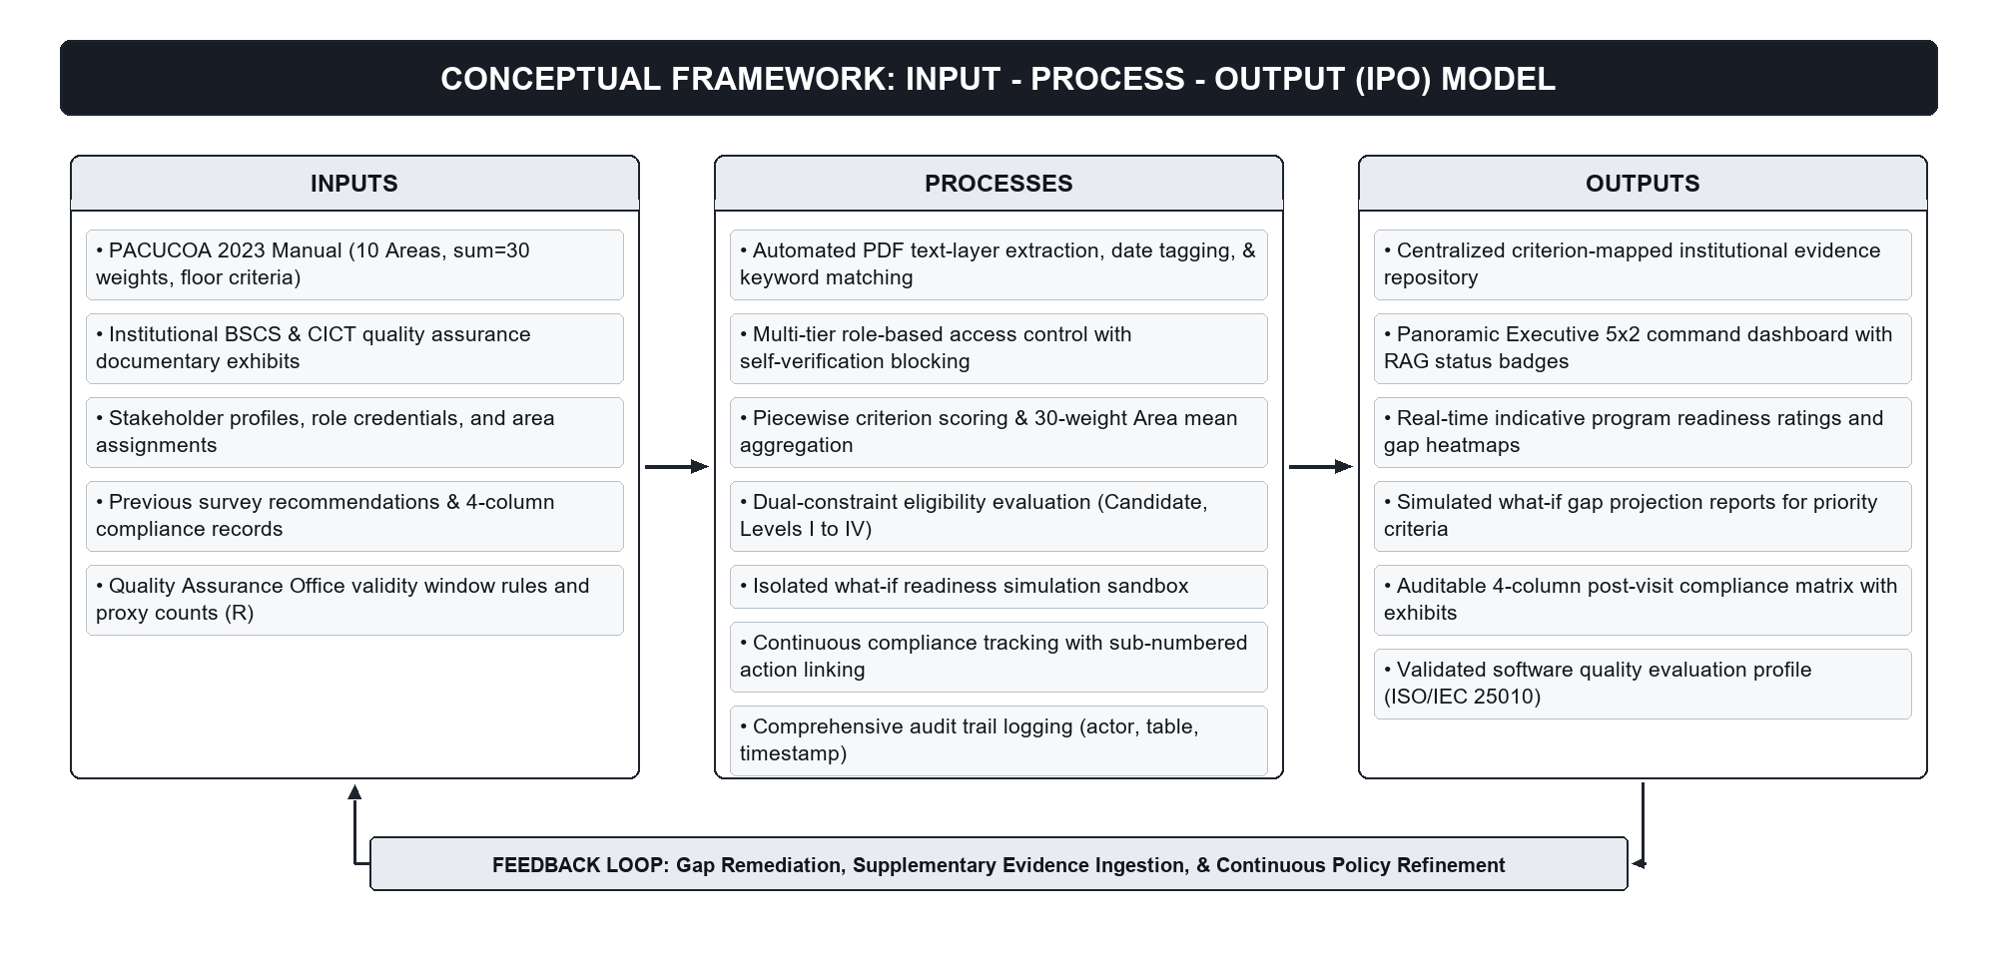
Figure 1. Conceptual Framework of the Study (Input–Process–Output Model with Feedback Loop)
Narrative of the Conceptual Framework
Within the conceptual framework, the Inputs form the foundation on which the entire system operates. These include the PACUCOA Manual of Accreditation standards, criteria, and weights; institutional evidence exhibits (syllabi, faculty profiles, research outputs, administrative reports); user account credentials and role assignments; and post-visit survey recommendations.
These inputs are transformed through core computational and procedural Processes. The system maps exhibits to specific criteria, validates document types and dates, enforces independent verification with a self-verification block, calculates criterion and Area scores using the official mathematical formula, runs non-mutating what-if simulation projections, and organizes compliance action items.
These processes yield the system Outputs: a centralized, searchable evidence repository; real-time indicative readiness scores and level threshold determinations; an Executive 5x2 command dashboard; simulated readiness forecast reports; and a four-column post-visit compliance matrix. Finally, the Feedback Loop channels these outputs back to institutional stakeholders (QA officers, deans, program heads, faculty), informing continuous document curation and policy adjustments before official PACUCOA visits.
Significance of the Study
The results and implementation of this study provide substantial benefits to various educational stakeholders:
• STI West Negros University. The institution gains an institutional digital repository and continuous accreditation platform that is designed to reduce episodic preparation and paper-based handling and to preserve institutional memory.
• Quality Assurance (QA) Office. The QA Office gains a university-wide oversight tool to monitor readiness across academic programs, standardize criteria configurations, and verify compliance deadlines.
• College Deans and Program Heads. Academic leaders obtain objective, real-time metrics on program readiness, enabling data-driven resource allocation and pinpointing specific documentary gaps.
• Area Chairs, Co-Chairs, and Faculty Members. Faculty members benefit from structured exhibit checklists, transparent verification workflows, and clear role boundaries designed to reduce redundant uploads.
• Alumni and Student Representatives. External stakeholders access high-level readiness summaries without access to confidential files.
• Future Researchers. The study provides a documented architecture and an acceptability evaluation of an accreditor-specific readiness system, serving as a foundation for future higher education software engineering.
Scope and Limitation of the Study
Scope of the Study
The study covers the design, development, and evaluation of a web-based accreditation management and readiness assessment platform for STI West Negros University. The system is built around the PACUCOA undergraduate framework (Revised September 2023), covering all ten evaluative Areas, their respective weights totaling 30 (with Instruction carrying 4, Physical Plant 2, and the remaining eight Areas 3 each), the 0-to-5 rating scale, and level thresholds (Candidate, Level I, Level II, Level III, Level IV). In the pilot implementation focusing on the Bachelor of Science in Computer Science (BSCS) program of CICT, the survey instrument is currently operationalized across seventy-nine (79) active evaluative criteria. These criteria were generated by a script from the opportunities for improvement in the CICT BSCS Compliance Report (CICT, n.d.); they are not a list prescribed by PACUCOA. The system's underlying data architecture is fully dynamic and program-configurable: while the ten Areas and weighting rules are fixed by the PACUCOA framework, the specific number of criteria is not a rigid universal constant and can vary across different academic programs based on curricular specialization, applicable provisions, and quality assurance templates. The software includes four functional modules: Evidence Management and Mapping, Readiness Scoring and Executive Dashboard, Readiness Simulation, and Post-Visit Compliance Tracking. Access control supports eight user roles: System Admin, QA Officer, Dean, Program Head, Area Chair, Area Co-Chair, Faculty Member, and Alumni/Student Representative. An audit log records completed evaluative and administrative transactions.
Limitations of the Study
The system boundary is focused on Step Two (Institutional Self-Survey) of the PACUCOA accreditation process; it does not automate Step One (Application) or Step Three (Organization of the Accrediting Team), nor the conduct of any accreditation visit. The seventy-nine (79) evaluative criteria in the database were generated by a script from the opportunities for improvement in the CICT BSCS Compliance Report (CICT, n.d.). They are the working configuration for the BSCS pilot and not an accreditor-mandated list for all disciplines, and the platform allows different criteria sets to be configured for other degree programs. In the criterion scoring formula, the required document count (R) is a configurable proxy; it is not set by PACUCOA, because the Manual does not specify document counts for its provisions. The Manual's text on the Level III Reaccreditation Visit states that Level III requires an overall rating of 4.00 with a mean of at least 4.00 in every survey area, whereas its minimum-rating summary states that no individual criterion should fall below 4.00; the system applies the stricter rule (no criterion below 4.00). Official Level III and Level IV accreditation also involve supplementary criteria, such as community outreach and research tradition, that lie outside the program-level self-survey scoring engine. The following additional limitations apply. First, the automated extraction routine reads text-layer PDF files only; scanned or image-only documents are not read, and optical character recognition (OCR) is not implemented. Second, the system does not keep versions of uploaded documents. Third, only the BSCS program has been populated; the BSIT program has not yet been populated. Fourth, licensure eligibility, which the Manual describes as a separate board-examination-based track, is not modeled. Fifth, because some respondents in the software quality evaluation were also institutional stakeholders involved in requirements consultations, their prior familiarity with the system may introduce potential evaluator bias. Finally, automated document tagging assists with keyword detection but does not evaluate qualitative academic merit; physical scanning of legacy paper documents is outside the software boundary; and the technical evaluation was conducted within CICT and supporting offices of STI WNU using the ISO/IEC 25010 framework.
Definition of Terms
The following operational and conceptual definitions clarify key terms used throughout this study:
Accreditation. A voluntary, standards-based process by which an authorized accrediting agency evaluates an educational institution or program to verify that it meets or exceeds predefined quality criteria.
PACUCOA. The Philippine Association of Colleges and Universities Commission on Accreditation, an affiliate member of the Federation of Accrediting Agencies of the Philippines (FAAP).
Manual of Accreditation. The official regulatory instrument (Revised September 2023) published by PACUCOA specifying evaluative areas, weights, rating scales, and level rules.
Self-Survey (Step Two). An internal comprehensive assessment conducted by an institution's faculty and administration to evaluate program readiness prior to an external accreditation audit, representing the specific operational scope of this system.
Area. One of the ten major evaluative divisions in the PACUCOA undergraduate survey instrument, each assigned a specific numerical weight summing to 30.
Criterion. A specific evaluative standard within an Area against which documentary exhibits are uploaded, verified, and scored. The system dynamically supports program-specific criteria sets, currently instantiated with seventy-nine (79) active criteria for the BSCS pilot implementation, generated from the CICT BSCS Compliance Report.
PACUCOA 0-to-5 Rating Scale. The official rating scale used in self-surveys: 5 = Excellent, 4 = Very Good, 3 = Good, 2 = Fair, 1 = Poor, and 0 = Missing (provision is missing but necessary). Provisions marked N.A. (Not Applicable) are excluded from the active Area divisor.
PACUCOA Compliance-Verification Scale. The official five-point scale used by PACUCOA visiting teams during revisits: 5 = Full Compliance, 4 = Very Satisfactory Partial Compliance, 3 = Satisfactory Partial Compliance, 2 = Unsatisfactory Partial Compliance, and 1 = Non-Compliance.
Evidence (Exhibit). A document, syllabus, report, or certification uploaded to demonstrate compliance with an accreditation criterion.
Evidence Mapping. The systematic digital tagging and linking of an uploaded exhibit to its corresponding PACUCOA Area and criterion.
Verification. The formal administrative review of an uploaded exhibit by an authorized reviewer (an Area Chair, Co-Chair, Program Head, or QA Officer), confirming its validity, document type, and effective date.
Separation of Duties (Self-Verification Block). A core security constraint that prohibits the user who uploaded an exhibit from acting as the verifier of that same exhibit. In the current policy, the QA Officer role is exempt from this check.
Criterion Score. A computed value ranging from 0.00 to 5.00 reflecting the proportion of verified valid documents relative to the configurable required document count (R), a proxy that is not set by PACUCOA.
Area Mean. The arithmetic average of all active criterion scores within an Area, indicating the section's overall performance.
Program Rating. The weighted average across all ten Area means, computed using PACUCOA's official weighting formula.
Dual-Constraint Level Threshold. The regulatory rule requiring a program to meet both an overall program rating and a minimum floor rating in every individual Area (e.g., Level I requires ≥ 3.00 overall with no Area below 3.00).
Readiness Simulation. A non-mutating mathematical sandbox that projects hypothetical Area means and level eligibility based on the completion of up to ten selected criteria.
Post-Visit Compliance Matrix. A tracking format of four columns (Opportunities for Improvement, Recommendations, Sub-numbered Actions Taken, and Linked Exhibits) that follows the format of the CICT BSCS Compliance Report (CICT, n.d.); it is not a format mandated by PACUCOA or the QA Office.
Role-Based Access Control (RBAC). A security paradigm that restricts system operations and view permissions based on assigned institutional user roles and academic scopes.
Audit Trail. A tamper-evident chronological record documenting the actor, timestamp, and details of all completed evaluative and administrative transactions.
CICT, BSCS, BSIT. The College of Information and Communications Technology at STI West Negros University, its Bachelor of Science in Computer Science program, and its Bachelor of Science in Information Technology program.

RELATED LITERATURE AND PRIOR ARTS SEARCH
Review of Related Literature
Accreditation and Quality Assurance in Philippine Higher Education
Quality assurance in Philippine higher education operates through a dual architecture comprising governmental oversight by the Commission on Higher Education (CHED) and peer-based programmatic accreditation administered by voluntary accrediting agencies under the Federation of Accrediting Agencies of the Philippines (FAAP). Under CHED Memorandum Order No. 12, Series of 2019 (Commission on Higher Education, 2019), formal accreditation status is directly linked to vital regulatory privileges for private higher education institutions, including administrative deregulation, curricular autonomy to revise programs without prior commission approval, financial flexibility, and priority consideration for institutional development grants. In the private non-sectarian higher education sector, the Philippine Association of Colleges and Universities Commission on Accreditation (PACUCOA) conducts voluntary institutional and programmatic evaluations across eight progressive phases (PACUCOA, 2023). Under the official PACUCOA undergraduate framework (PACUCOA, 2023), evaluations evaluate ten distinct Areas: Philosophy and Objectives, Faculty, Instruction, Laboratory, Research, Library, Student Services, Social Orientation and Community Involvement, Physical Plant and Facilities, and Organization and Administration. These Areas are assigned fixed numerical weights summing to an aggregate denominator of thirty (30), evaluated on a calibrated 0-to-5 rating scale.
The PACUCOA accreditation framework enforces strict dual-constraint mathematical thresholds for level eligibility (PACUCOA, 2023). To attain Candidate status, a program must achieve an overall weighted grand mean of at least 3.00. For Level I formal accredited status, the program must satisfy a dual constraint: achieve an overall rating of at least 3.00 with no individual Area mean falling below the 3.00 floor. Level II requires an overall rating of 3.50 with no Area mean below 3.50, whereas Levels III and IV require a minimum overall rating of 4.00 alongside criterion-level minimum thresholds. Furthermore, PACUCOA policies impose strict procedural timelines: under the Policy on Revisit (PACUCOA, 2023), an institution preparing for a revisit must submit a comprehensive compliance report addressing previous recommendations at least thirty (30) days prior to the scheduled survey. Under Level II Reaccreditation provisions, a letter of intent, an updated self-survey report, and compliance documentation must be submitted at least six (6) months before the accredited status expires. In an empirical analysis of Philippine higher education governance, Aldaba et al. (2024) observed that while accreditation serves as a primary pillar for academic accountability, institutions routinely encounter severe administrative friction and compliance burdens due to decentralized records and disjointed reporting workflows across academic units. Similarly, Aquino (2025) highlighted that high-performing Philippine universities succeed in accreditation not through episodic compliance exercises, but by embedding internal quality assurance (IQA) systems that continuously align institutional operations with accrediting body rubrics. The proposed system natively operationalizes these regulatory parameters by automating the PACUCOA 30-weight scoring engine and dual-constraint floor rules, providing academic leaders at STI West Negros University with real-time, transparent visibility into baseline readiness and upcoming survey deadlines.
Digital Evidence Management and Continuous Readiness
Traditional accreditation preparation in higher education is predominantly episodic, characterized by frantic documentary compilation and physical binder collation in the final weeks preceding an on-site visit. Akdemir et al. (2020) demonstrated that episodic compliance models introduce substantial operational stress, increase the risk of missing or outdated records, and obscure institutional deficiencies until formal audits take place. In contrast, modern quality assurance paradigms advocate for continuous quality improvement (CQI), where documentary evidence is curated systematically and incrementally as part of daily academic operations (Akdemir et al., 2020). Developing web-based platforms that support active evidence management and traceability enables academic departments to replace fragmented paper archives with structured digital assets (Al-Qawasmi, 2026).
Digital evidence management systems require structured mechanisms to map, index, and validate complex documentary requirements. Al-Qawasmi (2026) demonstrated through a web-based academic quality management system that establishing direct traceability between instructional artifacts (such as syllabi, assessment rubrics, and faculty credentials) and specific accreditation criteria drastically reduces audit preparation cycles while ensuring evidence veracity. Similarly, Schellekens et al. (2023) underscored that digital quality assurance applications must support collaborative multi-user workflows, structured document tagging, and real-time status tracking to ensure that institutional stakeholders remain continuously audit-ready. In the context of institutional accreditation, Sidhimantra et al. (2024) verified that deploying centralized digital repository systems eliminates physical archive bottlenecks, provides reliable multi-user access across academic committees, and streamlines evidentiary retrieval during accreditation reviews. The platform developed in this study applies these principles to the PACUCOA framework by providing a criterion-mapped digital evidence repository where faculty upload exhibits incrementally, supported by a server-side routine that extracts the text layer of PDF files to suggest matching document categories and recency dates.
Decision Support and What-If Analysis in Education
Navigating complex accreditation frameworks presents higher education administrators with multi-criteria optimization challenges. Because PACUCOA evaluations combine weighted arithmetic averages with non-negotiable area floor thresholds, academic managers cannot easily intuit which documentary deficiencies represent the most critical operational bottlenecks. Decision support systems (DSS) incorporating mathematical modeling provide university leadership with analytical tools to optimize institutional resource allocation, faculty development, and infrastructure investments toward strategic quality benchmarks (Makki et al., 2022). By modeling constraints and criteria relationships algorithmically, decision support tools transform raw institutional data into actionable managerial guidance (Makki et al., 2022).
A critical capability in educational decision support is what-if scenario simulation. Samaranayake et al. (2023) demonstrated that interactive decision support platforms incorporating what-if simulation eliminate tedious, error-prone manual calculations, allowing educational decision-makers to model hypothetical policy changes, evaluate trade-offs, and observe projected outcomes across complex requirement matrices before committing resources. However, as Nauman et al. (2021) emphasized, decision support algorithms deployed in higher education must be formally verifiable and algorithmically transparent; unverified or opaque automated calculations risk presenting misleading projections to academic leadership. Crucially, scenario simulations must execute within an isolated sandbox environment to guarantee that live audit records and production readiness ratings remain completely unaltered during hypothetical experimentation. The proposed system directly implements these decision-support concepts through an isolated What-If Readiness Simulation Sandbox, enabling program heads and deans to select up to ten unresolved criteria, project the mathematical impact of their completion across Area means and level thresholds, and evaluate target upgrade trajectories without mutating production database tables.
Access Control and Separation of Duties
Because accreditation management platforms store sensitive academic records, faculty credential portfolios, research manuscripts, and confidential institutional evaluations, rigorous data governance and access control architectures are paramount (Farhadighalati et al., 2025). Farhadighalati et al. (2025) observed that modern distributed and cloud-hosted web applications require fine-grained role-based access control (RBAC) models that strictly enforce the principle of least privilege, restricting user operations to predefined functional responsibilities across distinct operational scopes.
Beyond baseline access permissions, high-integrity regulatory audit platforms must incorporate the fundamental security principle of Separation of Duty (SoD). In an authoritative review of information security architectures, Groll et al. (2025) established that separation of duties is indispensable for preventing conflicts of interest, curbing fraudulent authorization, and eliminating single-point vulnerabilities where an individual possesses unilateral authority to initiate and approve the same transaction. Aftab et al. (2019) demonstrated through mathematical modeling of dynamic role-based access control that permission-level separation constraints can be programmatically enforced to block self-evaluation and enforce independent multi-tier verification pipelines. In an accreditation self-survey context, permitting a faculty member or committee chair to verify and approve their own documentary submissions undermines the objectivity of the review process. To establish verifiable separation of duties, the system developed in this study enforces an independent verification workflow backed by a database-level self-verification block (requiring uploader_id != verifier_id) implemented via PostgreSQL Row-Level Security (RLS) policies, ensuring that documentary exhibits are independently validated by assigned Area Chairs or Program Heads while exempting the institutional QA Officer under current university policy.
Software Quality Evaluation
To rigorously evaluate modern enterprise and educational software systems, the International Organization for Standardization and the International Electrotechnical Commission established the ISO/IEC 25000 SQuaRE series. The product quality model defined under ISO/IEC 25010 (ISO & IEC, 2023) provides a standardized multi-dimensional taxonomy for assessing software characteristics, encompassing functional suitability, performance efficiency, compatibility, usability (interaction capability), reliability, security, maintainability, and portability (flexibility). Applying standardized quality models ensures that academic platforms are not merely functionally operational, but also robust, secure, and user-centric across heterogeneous institutional environments (ISO & IEC, 2023).
Empirical research demonstrates that evaluating web-based academic systems against ISO/IEC 25010 criteria provides an objective methodology for validating software acceptability among educational stakeholders. In an empirical evaluation of educational management platforms in Philippine higher education, Urera and Balahadia (2019) determined that functional suitability and usability are critical predictors of system adoption among faculty members and academic administrators. More recently, Lagman et al. (2024) developed an enterprise-level digital governance platform for Philippine state universities and colleges, employing an Agile development methodology and validating system quality across institutional administrators using the ISO/IEC 25010 model. Their findings confirmed that rigorous adherence to standardized quality characteristics guarantees data security, architectural maintainability, and high user acceptance in higher education institutions (Lagman et al., 2024). In alignment with this established methodology, the system engineered in this study was formally evaluated under the ISO/IEC 25010 quality model by twenty (20) purposive respondents comprising fifteen (15) institutional users and five (5) IT experts, verifying its software quality, security controls, and operational suitability for accreditation governance.
Accreditation and Quality Assurance Information Systems in Southeast Asia
Across Southeast Asia, higher education institutions are increasingly deploying specialized web-based platforms to automate quality assurance workflows and fulfill national accreditation standards. In the Philippines, Pardiñan et al. (2024) conducted an empirical study investigating the perceptions of key academic informants regarding the digitization of accreditation records and web-based platforms across state universities and colleges. Their findings revealed that transitioning from paper-bound archives to web-based platforms drastically reduces evidence collation timelines, minimizes lost or duplicated records, improves accessibility during external audits, and promotes institutional transparency (Pardiñan et al., 2024).
The necessity of dedicated software architectures for higher education quality assurance is further supported by regional developments in neighboring countries. In the Philippines, Ramos (2024) designed a dedicated Quality Assurance Information System (QAIS) framework for tertiary institutions, demonstrating that automating accreditation data collation and compliance monitoring overcomes the chronic data fragmentation caused by siloed departmental spreadsheets. In Indonesia, Tarigan and Zahara (2024) examined the implementation of paperless internal quality assurance information systems (SIQA) across higher education institutions, concluding that digitalizing internal quality audits and evidence tracking directly correlates with higher institutional accreditation scores and sustained compliance. Building upon these regional insights, the platform developed in this study provides a tailored accreditation management and readiness assessment system engineered specifically around the PACUCOA undergraduate framework and the four-column compliance matrix format utilized by CICT at STI West Negros University, addressing documentary fragmentation and facilitating continuous accreditation readiness.
Prior Arts Search
Scope of the Search
The prior arts search examined publicly accessible literature, vendor documentation, product whitepapers, and existing commercial platforms designed for educational accreditation, continuous quality improvement, and institutional compliance tracking.
Existing Systems
• Watermark Planning & Self-Study: A commercial higher education platform (Watermark Insights, 2024) described as providing centralized document repositories, collaborative authoring workflows, and rubric mapping. The reviewed materials did not show native support for PACUCOA's 30-weight mathematical formula, dual-constraint area floor rules, or database-enforced self-verification blocks.
• AchieveIt: A cloud-based execution and compliance management platform (AchieveIt, 2024) featuring institutional progress dashboards, automated reminders, and multi-level initiative tracking. The reviewed materials did not show accreditor-specific criterion evaluation formulas, PACUCOA level thresholds, or an isolated what-if readiness simulation sandbox.
• Creatrix Campus: An enterprise higher education management suite (Creatrix Campus, 2023) featuring accreditation modules integrated with student information and learning management systems. The reviewed materials did not show PACUCOA-specific undergraduate evaluative rubrics or four-column post-visit compliance matrix structures.
Comparative Analysis
Table 2 presents a systematic feature-by-feature comparison between the reviewed software platforms and the proposed system developed in this study.
Table 2
Comparison of Reviewed Systems and the Proposed System, Based on Public Materials
Feature / Evaluative Dimension | Watermark | AchieveIt | Creatrix Campus | Proposed System
Centralized evidence repository | Described | Described | Described | Yes (Supabase Storage mapped to criteria)
Accreditor-specific framework or templates | Pre-built templates | Requirements tracking | Templates available | Yes (PACUCOA 2023 undergraduate framework)
Assignment of responsibility | Collaborative workflows | Accountability features | Tasks assigned to users | Yes (Delegated Area Chairs, Co-Chairs, Members)
Progress or readiness dashboards | Described | Real-time progress | Reports and dashboards | Yes, with 5x2 executive command layout
PACUCOA framework named in materials | Not stated | Not stated | Not stated | Yes (explicit native implementation)
Rating computed with PACUCOA weighting (Sum=30) and floor rules | Not stated | Not stated | Not stated | Yes (real-time automated calculation)
What-if readiness simulation | Not stated | Not stated | Not stated | Yes (non-mutating projection with deltas)
Enforced verification by someone other than the uploader | Not stated | Not stated | Not stated | Yes (enforced self-verification block)
Post-visit compliance matrix with linked exhibits | Not stated | Not stated | Not stated | Yes (4-column matrix, sub-numbered actions)
Integration with SIS or LMS | Not stated | Not stated | Described | No (out of scope for pilot prototype)
Note. Evaluated based on publicly available documentation, system feature sheets, and technical product whitepapers as of 2026.
Synthesis and Research Gap
The comparative analysis shows that the reviewed commercial systems are described as supporting general document storage and institutional task management. However, the reviewed materials did not show a platform that natively implements the PACUCOA accreditation framework, its 30-weight aggregation formula, or its dual-constraint level thresholds. The reviewed materials also did not show an enforced self-verification block at the database level or an isolated what-if simulation sandbox tailored to PACUCOA criteria. This study addresses this gap, within the scope of the reviewed materials, by building a web-based platform around the PACUCOA undergraduate framework and around the four-column compliance matrix format used in the CICT BSCS Compliance Report (CICT, n.d.), which is not a format mandated by PACUCOA.

MATERIALS AND METHODS
System Design
Requirements Gathering
Requirements were gathered through document analysis of the PACUCOA Manual, review of the CICT BSCS Compliance Report (CICT, n.d.), and consultations with CICT academic administrators, program heads, faculty members, and Quality Assurance personnel. The PACUCOA Manual of Accreditation (Revised September 2023) supplied the regulatory and mathematical constraints used in the system: the ten undergraduate evaluative Areas, their weights summing to thirty (30), the 0-to-5 rating scale, and the level thresholds.
Development Methodology
The system was engineered using an Agile developmental approach (Beck et al., 2001), incorporating iterative Scrum practices (Schwaber & Sutherland, 2020). Development progressed across four iterations from August to October 2026, as outlined in Table 3 and illustrated in Figure 2.
Table 3
Development Timeline, August to October 2026
Period | Development Activities | Deliverables
August 2026 | Proposal preparation; study of the PACUCOA framework; CICT requirements analysis | System proposal; requirements matrix; initial conceptual architecture
Late August to Early September 2026 | Iteration 1: Database schema design; Supabase authentication; role-based access control setup | Functional database schema; user registration and login; role management
September 2026 | Iteration 2: PACUCOA criteria setup; evidence upload module; PDF text extraction and tagging | Evidence repository; file upload UI; PDF text-layer tagging; verification workflow
Late September to Early October 2026 | Iteration 3: Mathematical scoring engine; 5x2 executive command dashboard; what-if simulation | Automated scoring engine; 5x2 dashboard; simulation sandbox; boundary test suite
October 2026 | Iteration 4: 4-Column Post-Visit Compliance Matrix module; sub-numbered action tracking; security polish | Compliance matrix module; audit log; end-to-end testing; user documentation
Note. Organized into four developmental iterations from August to October 2026 following Agile Scrum principles.
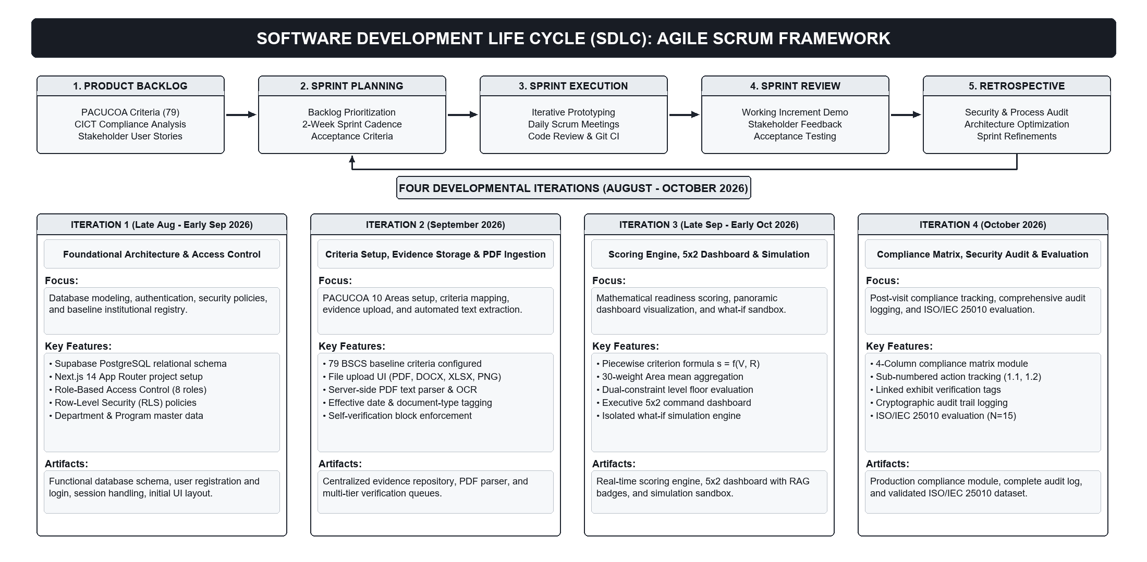
Figure 2. Software Development Life Cycle (SDLC) Framework (Agile Scrum with Four Iterations)
System Architecture
The system was implemented using a modular three-tier cloud architecture. The presentation layer was developed with Next.js (Vercel, n.d.) and TypeScript and styled with Tailwind CSS for modern responsive browser interfaces. The backend utilizes Supabase, an open-source Backend-as-a-Service built on PostgreSQL, which provides user authentication, relational data persistence, and object storage. Access control is enforced through PostgreSQL Row-Level Security (RLS) policies (Supabase, n.d.) and private storage buckets with time-limited signed URLs. A server-side routine extracts the text layer of uploaded PDF files to assist users with document-type suggestion and keyword matching. Figure 3 illustrates the three-tier system architecture with component icons.
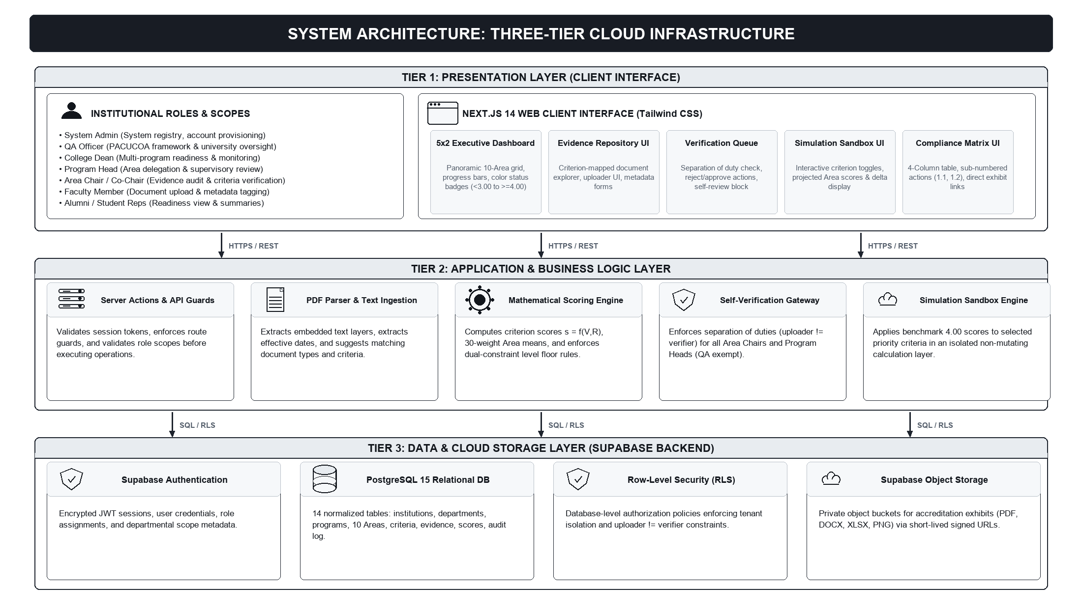
Figure 3. System Architecture of the Web-Based Accreditation Management and Readiness Assessment System
Hardware and Software Requirements
The development, deployment, and operational execution of the Web-Based Accreditation Management and Readiness Assessment System required specific hardware and software configurations across the developmental workstation, cloud hosting infrastructure, and client access tiers.
1. Development Environment Requirements
• Processor: Intel Core i5 / AMD Ryzen 5 (multi-core, 2.5 GHz or higher clock speed).
• Memory: 8 GB RAM minimum (16 GB recommended for concurrent Next.js dev server compilation and container execution).
• Storage: 256 GB Solid State Drive (SSD) with at least 20 GB available storage for local repository assets and test documents.
• Operating System: 64-bit Windows 10/11 or Ubuntu Linux 22.04 LTS.
• Development Runtime & Tools: Node.js (v20.x LTS or v24.x), npm package manager, Git version control, and Visual Studio Code IDE.
2. Server and Cloud Infrastructure Specifications
• Application Hosting: Vercel Cloud Serverless Edge Platform supporting automated continuous deployment and Next.js App Router streaming.
• Backend-as-a-Service (BaaS): Supabase Cloud Infrastructure with dedicated PostgreSQL 15.x relational database engine.
• Database Extensions: pgjwt for cryptographic token verification and Row-Level Security (RLS) enforcement.
• Storage Engine: Supabase S3-compatible Private Object Storage with time-limited signed URLs (300-second expiry) for secure document streaming.
• Network & Transmission Security: Full HTTPS/TLS 1.3 transport encryption with AES-256 cryptographic encryption at rest.
3. Client-Side Workstation and Browser Requirements
• Client Hardware: Standard desktop PC, laptop, or tablet equipped with at least 4 GB RAM and display resolution of 1366 x 768 or higher (1920 x 1080 recommended for optimal 5x2 dashboard and compliance matrix layout).
• Operating System: Operating system agnostic (Microsoft Windows 10/11, Apple macOS 12+, Linux, ChromeOS, iPadOS, Android).
• Web Browser: Evergreen web browsers supporting ECMAScript 2022 and modern CSS Grid (Google Chrome 110+, Microsoft Edge 110+, Mozilla Firefox 115+, Apple Safari 16+).
• Network Connectivity: Stable broadband or campus Wi-Fi connection (minimum 5 Mbps download and upload) to support exhibit file ingestion and PDF previewing.
Machine Learning and Artificial Intelligence Specifications
In designing the accreditation management platform, technical specifications regarding the deployment of Machine Learning (ML) and Artificial Intelligence (AI) were determined by the institutional necessity for legal defensibility, complete auditability, and deterministic adherence to PACUCOA regulatory standards.
Accreditation surveys are rigorous evaluative procedures where every numeric rating, Area mean, and eligibility determination must be mathematically explainable and verifiable by external accreditors and university administrators. Consequently, the scoring engine and readiness assessment modules deliberately avoid non-deterministic black-box machine learning algorithms (such as deep neural networks or stochastic regression models with opaque latent weights). All quantitative aggregations are governed by explicit, piecewise mathematical formulations, PACUCOA's official 30-weight area distribution, and strict dual-constraint floor logic (Candidate through Level IV).
For documentary ingestion, the system implements deterministic rule-based algorithms and heuristic regular expression (regex) text pattern extraction. When institutional exhibits (such as syllabi, board meeting minutes, and faculty profile summaries) are uploaded, a server-side text layer parser scans the extracted document text for chronological date patterns (ISO 8601 and alphanumeric date expressions), institutional keywords, and exhibit identifiers. This heuristic layer assists the user by suggesting the probable document type and pre-populating the effective date field, while maintaining a strict human-in-the-loop workflow where the uploader confirms or modifies metadata prior to formal submission. This architecture guarantees 100% explainability, deterministic repeatability, and total compliance with academic accreditation auditing protocols.
Users, Roles, and Access Control
Access follows role-based access control (Sandhu et al., 1996) combined with program and Area delegations. Table 4 details the eight supported roles and their permissions.
Table 4
Roles and Permissions
Role | Scope | Main Permissions
System Admin | Institution | Creates departments, programs, and user accounts. No access to evaluate or alter evidence.
QA Officer | Institution | Configures frameworks, Areas, weights, criteria, and levels; reviews university-wide readiness; may verify evidence in any program and is not subject to the uploader check in the current policy.
Dean | College | Views readiness dashboards, heatmaps, and simulations for all programs in the college; views compliance.
Program Head | Program | Assigns Area Chairs, Co-Chairs, and Members; monitors readiness; verifies exhibits within own program (except own uploads); runs simulations.
Area Chair / Co-Chair | Assigned Area | Verifies uploaded evidence within assigned Area (except own uploads); tracks Area progress.
Faculty Member | Assigned Area | Uploads evidence for criteria in assigned Areas; inputs metadata. Cannot verify documents.
Alumni / Student Rep | Program | Views high-level program readiness summaries and RAG badges. No access to evidence files or users.
Note. Enforced through application route guards, database RLS policies, and private storage controls. Verification rules follow the RLS policy definitions in the project migration scripts.
Process Modeling
To establish the functional boundaries, external entities, and logical data transitions of the platform, structured process modeling was conducted using Data Flow Diagrams (DFD). Figure 4 illustrates the Context Flow Diagram (DFD Level 0), depicting the central system process (Process 0.0) and the bi-directional information exchanges with seven external entities: the System Administrator, QA Officer, CICT Dean, Program Head, Area Chair/Co-Chair, Faculty Member, and PACUCOA Accreditors.
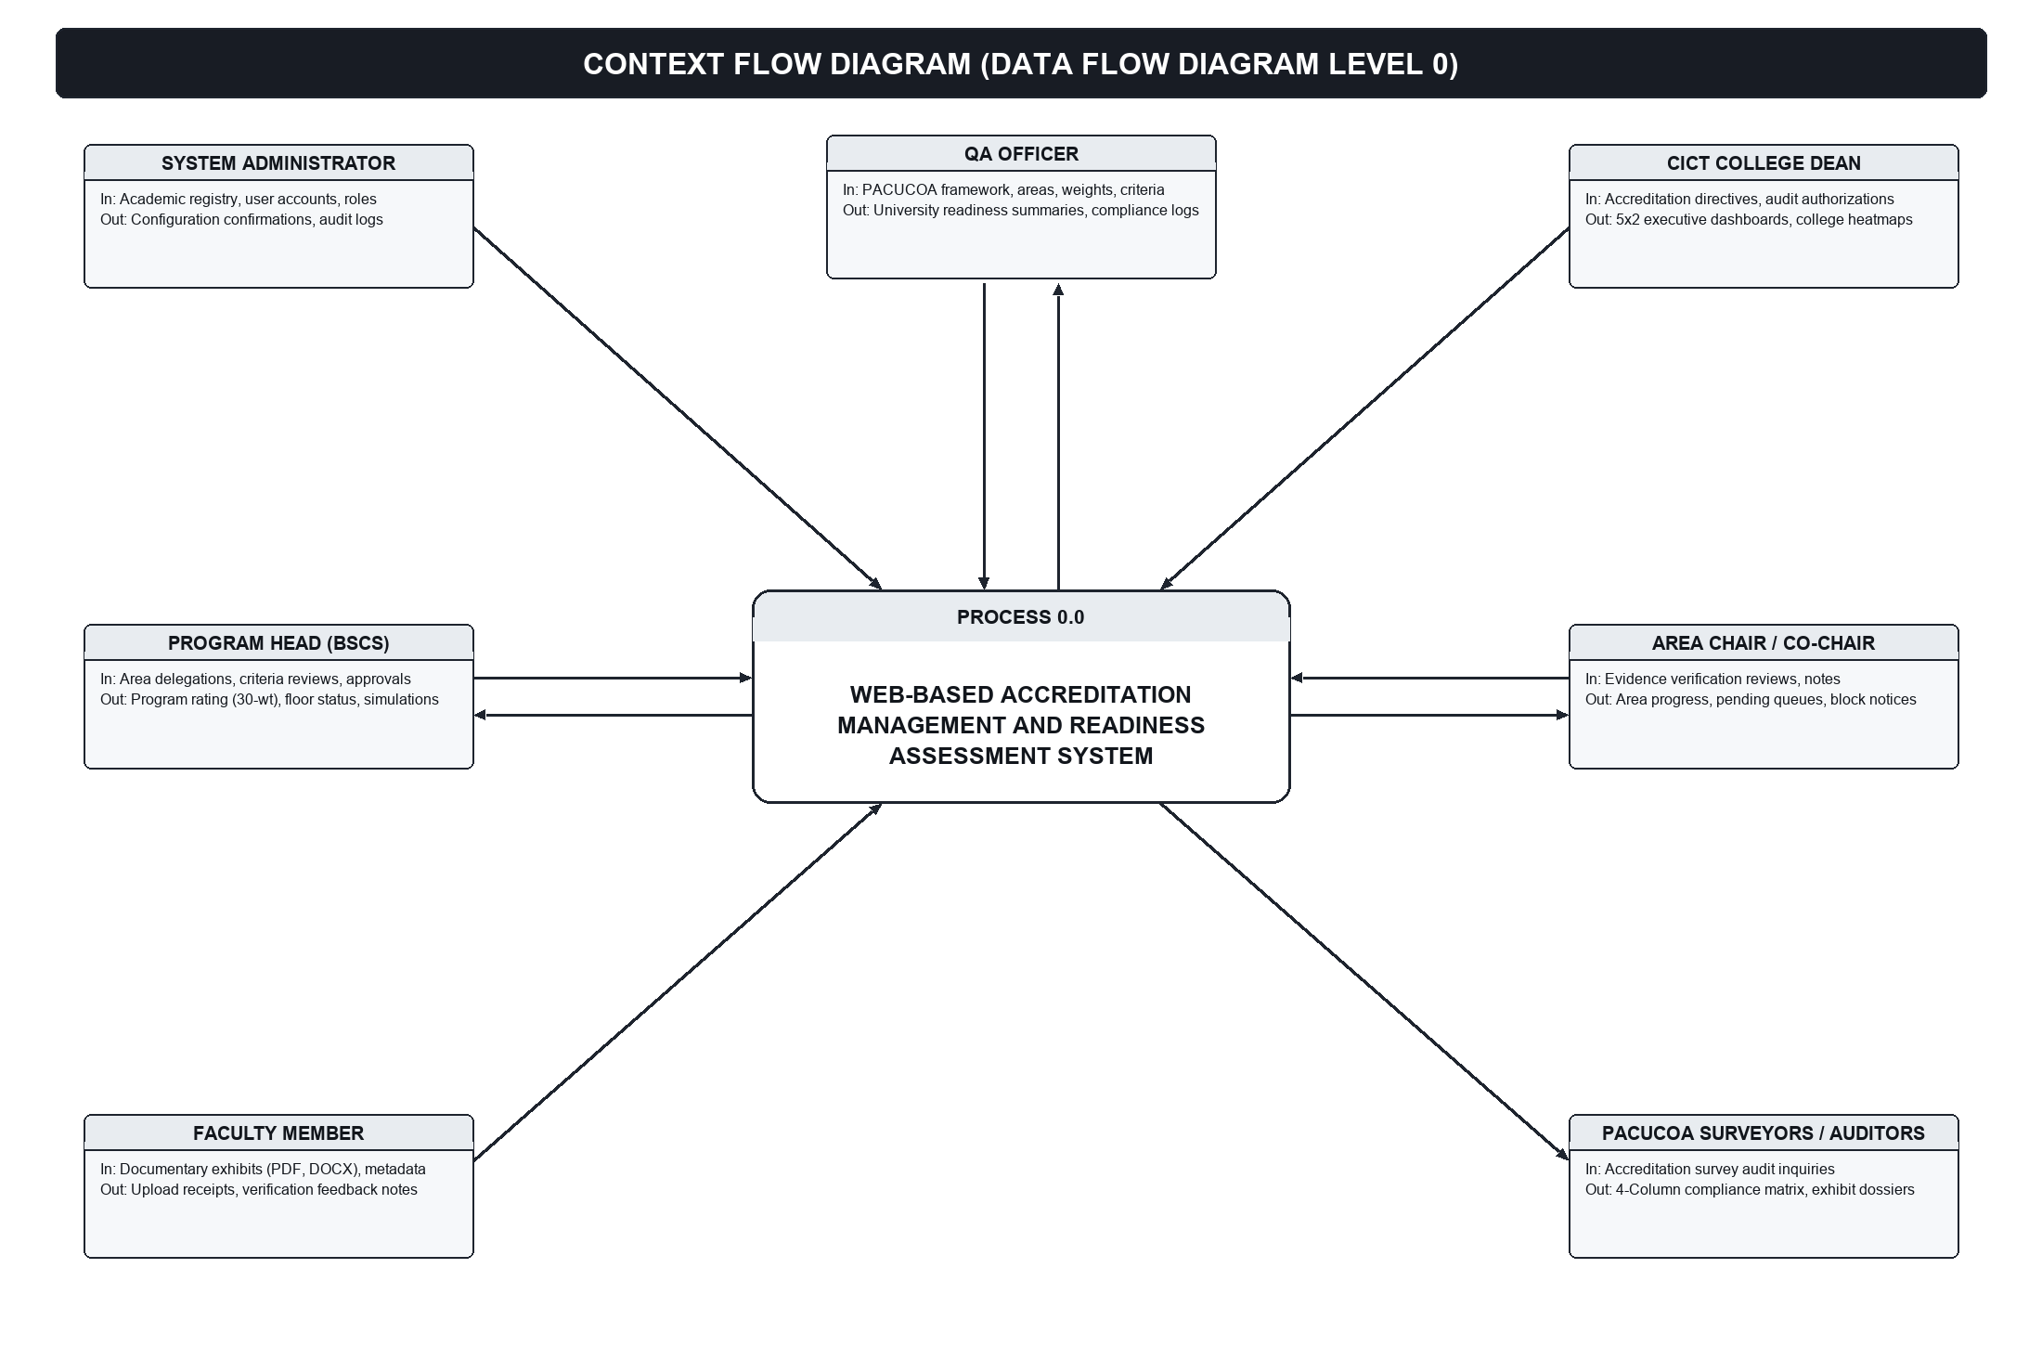
Figure 4. Context Flow Diagram (Data Flow Diagram Level 0) of the Accreditation System
Figure 5 presents the Data Flow Diagram (Level 1), detailing the decomposition of the system into seven core sub-processes: User Authentication & Access Control (1.0), Framework Setup & Area Delegation (2.0), Evidence Ingestion & PDF Text Extraction (3.0), Independent Verification & Separation of Duty (4.0), Mathematical Scoring & Dual-Constraint Engine (5.0), What-If Readiness Simulation Sandbox (6.0), and Post-Visit Compliance Tracking (7.0), interacting across six relational data stores (D1 to D6).
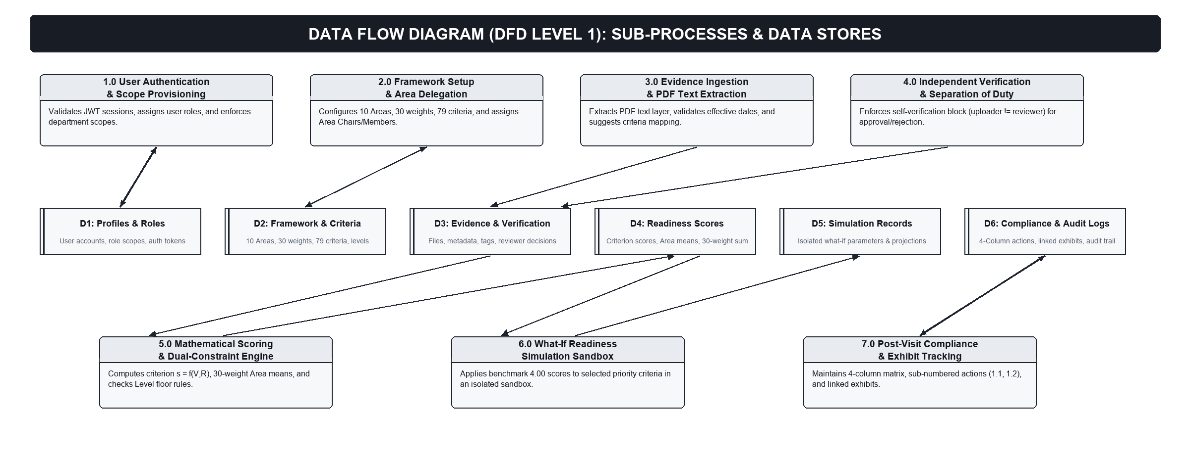
Figure 5. Data Flow Diagram (Level 1) of the Accreditation System
Data Design
The database schema was structured to be highly configurable, storing framework definitions in relational tables rather than hardcoding them in application logic. Table 5 summarizes the principal data entities.
Table 5
Principal Data Entities
Entity / Table | Purpose
institutions, departments, programs | Represents the academic organizational structure (e.g., STI WNU, CICT, BSCS).
accreditation_frameworks | Stores framework definitions (e.g., PACUCOA Undergraduate 2023).
accreditation_areas | Defines the ten Areas (Area I to Area X), titles, and numerical weights (sum = 30).
accreditation_criteria | Defines criteria under each Area, expected document types, and required document counts.
accreditation_levels | Stores accreditation levels, labels, and general average threshold values.
users | User accounts with assigned roles and departmental scopes.
area_assignments | Maps users to an Area of a program as Area Chair, Co-Chair, or Member.
evidence_documents | Uploaded file records with criterion ID, document type, effective date, and verification status.
readiness_scores | Stores computed criterion scores and statuses per program; Area means and program rating.
accreditation_cycles | Groups post-visit recommendations by program accreditation cycle.
accreditation_recommendations | Stores post-visit survey opportunities for improvement and recommendations.
compliance_actions | Stores sub-numbered actions taken, team verification text, and linked evidence IDs.
simulations | Stores parameters and results of what-if simulation runs, isolated from production.
audit_log | Records actor, action type, affected record, and timestamp for completed actions.
Note. Implemented in PostgreSQL via Supabase with relational foreign key integrity.
The database schema was implemented in PostgreSQL via Supabase, enforcing relational referential integrity, foreign key constraints, and granular Row-Level Security policies. Figure 6 presents the Entity-Relationship Diagram (ERD) detailing the primary keys, foreign keys, and cardinalities across the relational tables.
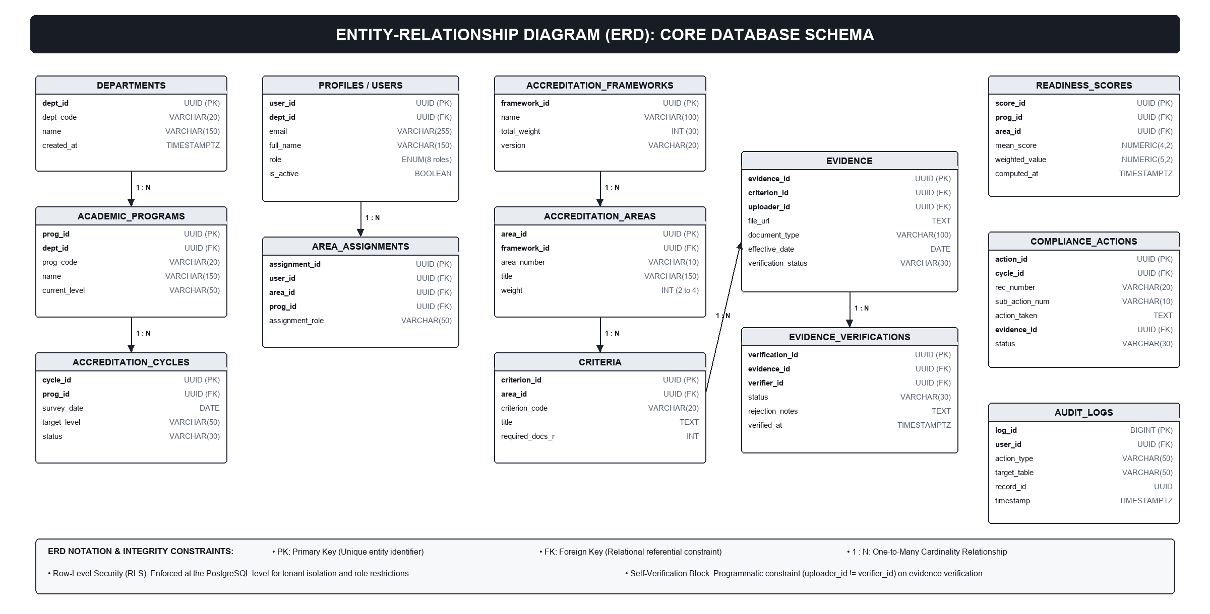
Figure 6. Entity-Relationship Diagram (ERD) of the Accreditation Management Database
System Process Flow
Figure 7 illustrates the overall lifecycle of the system from initial framework setup to post-visit compliance tracking across six integrated stages: framework configuration, evidence upload and automated tagging, independent verification with self-verification enforcement, automated rating calculation and executive dashboard display, what-if readiness simulation, and post-visit compliance matrix management. To detail how specific institutional roles interact with these functional capabilities, the distinct user flows for each role are discussed in Figures 8 through 14.
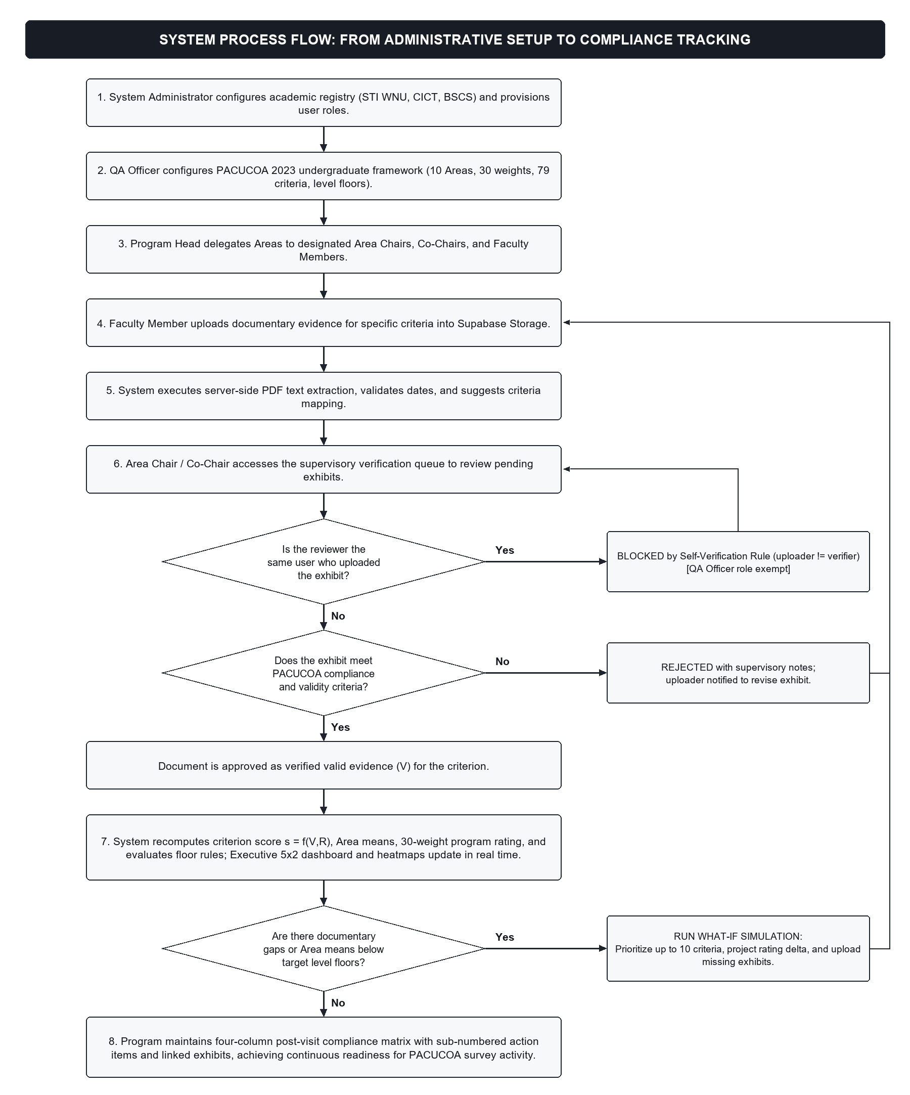
Figure 7. System Process Flow from Setup to Post-Visit Compliance Tracking
User Flow of the System Administrator. The goal of the System Administrator is to establish and maintain the organizational hierarchy and secure user access profiles across the institution. The administrator authenticates into the administrative console, creates academic departments (e.g., CICT), defines degree programs (e.g., BSCS, BSIT), registers user accounts, assigns security roles, and inspects system-wide audit logs. During account creation and role modification, the system validates organizational unique constraints and email uniqueness, preventing duplicate account creations or malformed role assignments. Crucially, to maintain administrative neutrality and prevent evaluative tampering, the System Administrator is restricted from uploading accreditation evidence, modifying criterion scores, or verifying self-survey exhibits. The primary outputs of this flow are active department and program entities, provisioned user credential profiles, and timestamped administrative audit log entries.
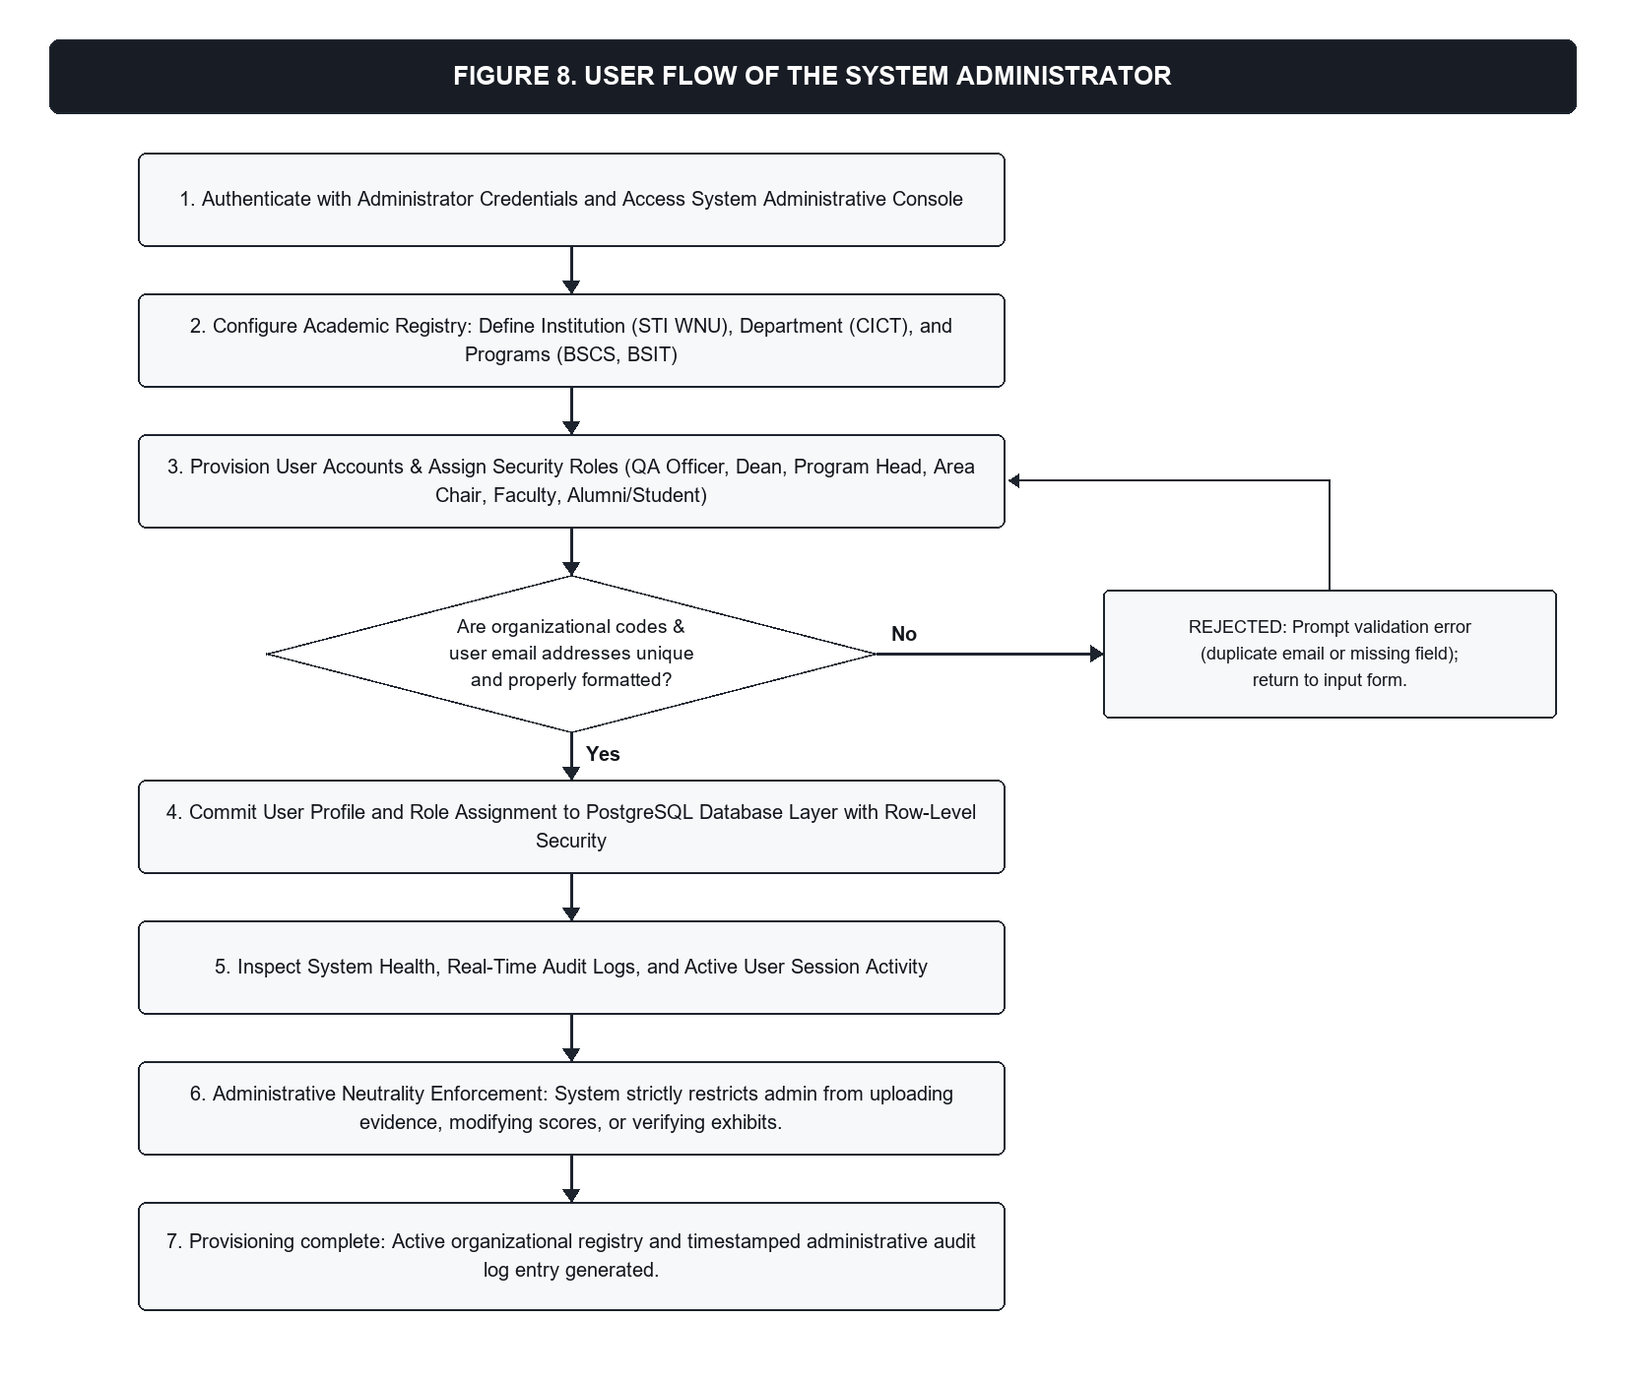
Figure 8. User Flow of the System Administrator
User Flow of the Quality Assurance Officer. The goal of the Quality Assurance Officer is to establish standardized accreditation frameworks, configure evaluative areas and weights, define criteria provisions, and maintain institutional oversight of accreditation readiness. The QA Officer navigates to the Framework Configuration module to instantiate accreditation frameworks (such as the PACUCOA Undergraduate 2023 instrument). The officer configures the ten evaluative Areas, defines their standard numerical weights summing to thirty (30), establishes criteria provisions and required document proxy counts (R), and reviews readiness dashboards across university programs. The system validates framework mathematical integrity, requiring Area weights to sum exactly to 30 before activating a framework. When conducting documentary oversight, the QA Officer reviews uploaded exhibits across all Areas. In the verification workflow, the QA Officer holds institutional oversight authority and is exempt from the self-verification block in the current policy, enabling centralized institutional review when required. The principal outputs are active, standardized accreditation instruments, configured program criteria sets, validated institutional exhibits, and university-wide readiness summaries.
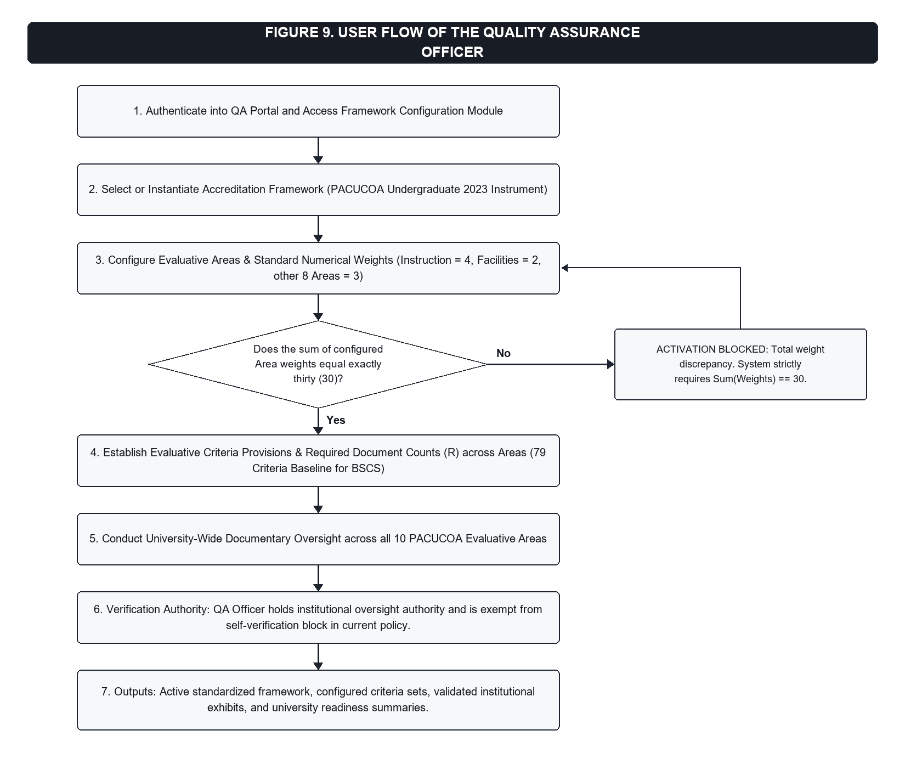
Figure 9. User Flow of the Quality Assurance Officer
User Flow of the Dean. The goal of the College Dean is to provide executive leadership and monitor college-wide accreditation preparedness, simulation forecasts, and post-visit compliance progress across all departmental programs. The Dean authenticates into the executive portal and selects the college scope (CICT). The Dean inspects the Executive 5x2 Command Dashboard, observing color-coded Area status cards (Red, Amber, Yellow, Green) and evaluating overall program ratings against Candidate, Level I, and Level II floor rules. The Dean reviews isolated what-if readiness simulation scenarios to assess the impact of targeted criteria completion and inspects the four-column post-visit compliance matrix to verify progress on accreditor recommendations. The system enforces an executive read-only and analytical decision-support scope across college programs: the Dean is blocked from uploading exhibit files or manually altering calculated criterion scores, ensuring that executive assessments remain objective and grounded in verified faculty evidence. The outputs of this flow are college-wide accreditation evaluations, strategic resource allocation directives, and approved post-visit compliance tracking reports.
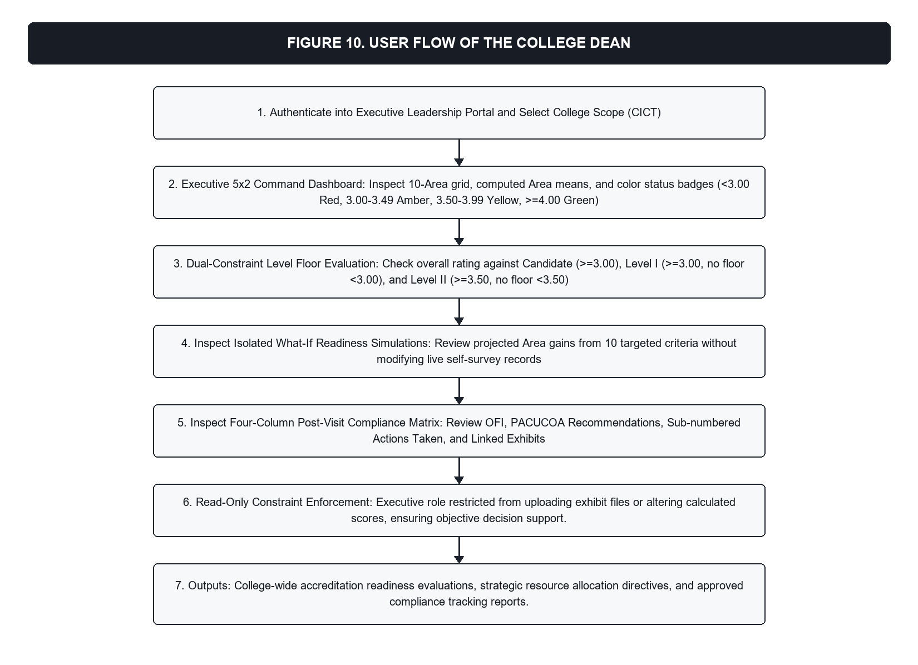
Figure 10. User Flow of the Dean
User Flow of the Program Head. The goal of the Program Head is to oversee program-level accreditation preparation, delegate evaluative responsibilities, verify evidentiary exhibits, execute readiness simulations, and monitor real-time compliance against PACUCOA level thresholds. The Program Head enters the program workspace and accesses the Area Assignment module to assign faculty members to specific PACUCOA Areas as Area Chairs, Co-Chairs, or Members. The Program Head accesses the supervisory review queue to inspect exhibits submitted by committee members, examining uploaded documents, metadata, and extracted text layers. When reviewing exhibits, the system enforces the self-verification block: if the Program Head is the uploader of an exhibit (uploader_id = verifier_id), the verification action is disabled in the interface and rejected by database Row-Level Security policies, requiring another authorized verifier (such as the Area Chair or QA Officer) to approve it. If the exhibit was uploaded by another faculty member, the Program Head can mark it as verified or return it with comments. Additionally, the Program Head can configure and execute what-if readiness simulations targeting up to ten unresolved criteria and manage the four-column post-visit compliance matrix. The outputs comprise active committee assignments, verified program exhibits, isolated what-if simulation projections, updated compliance action items, and real-time program ratings.
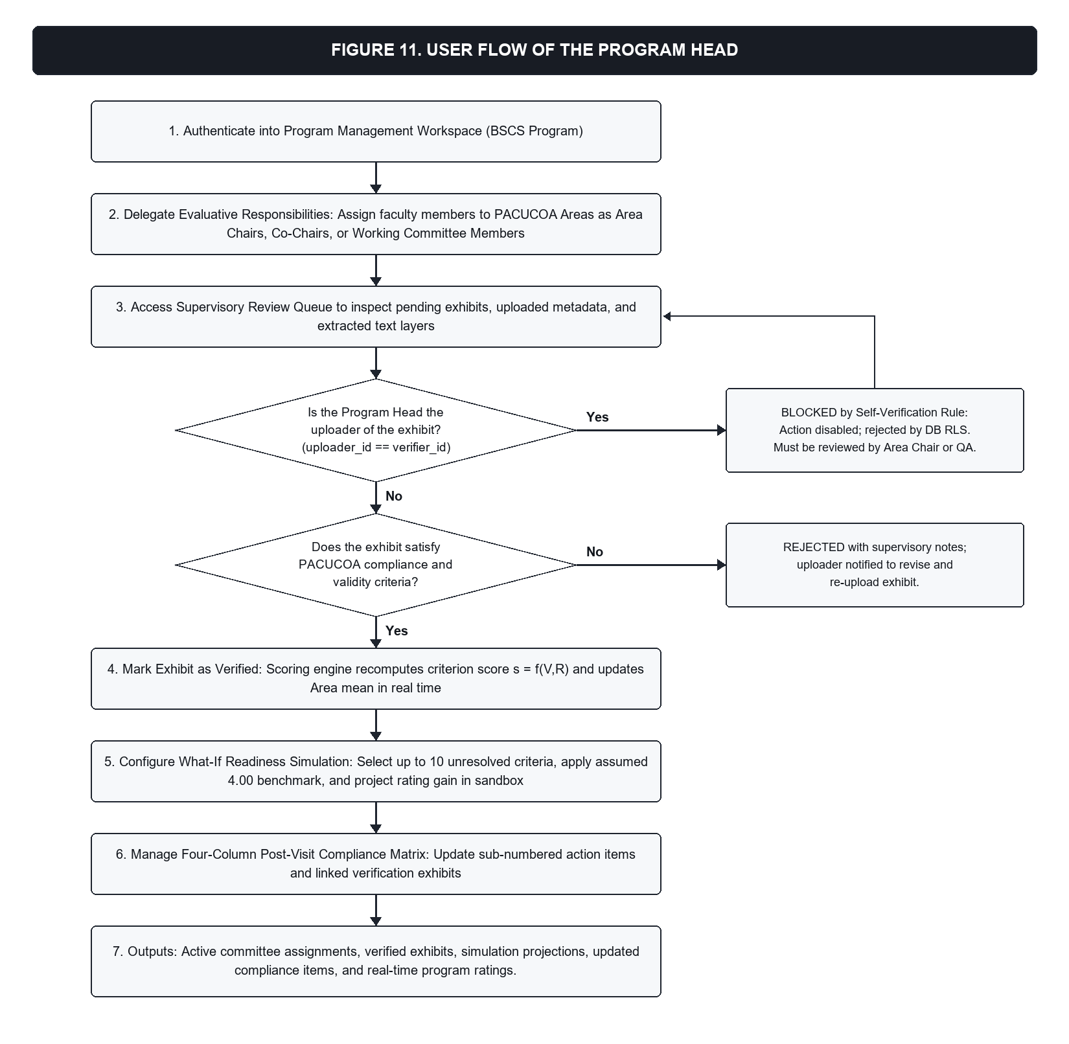
Figure 11. User Flow of the Program Head
User Flow of the Area Chair and Co-Chair. The goal of the Area Chair and Co-Chair is to coordinate evidence collection, ensure document sufficiency, and verify uploaded exhibits within their assigned PACUCOA Area. Upon authentication, the Area Chair or Co-Chair accesses their assigned Area workspace, reviewing the active criteria checklist and required document proxy count (R). The chair accesses the verification queue to inspect pending exhibits submitted by area committee members, verifying file completeness, metadata accuracy, and extracted text-layer alignment. The system enforces strict role-based and area-scoped boundaries alongside the self-verification block: Area Chairs and Co-Chairs can only verify exhibits belonging to their assigned Area. When an Area Chair or Co-Chair attempts to verify an exhibit that they personally uploaded, the system detects matching identifiers (uploader_id = verifier_id) and blocks the verification button, returning an authorization rejection at the PostgreSQL Row-Level Security layer. In such cases, the exhibit must be verified by the Co-Chair, Program Head, or QA Officer. If the exhibit was uploaded by another member, the chair approves the exhibit as verified or rejects it with feedback. The outputs include verified Area exhibits, rejection notices with corrective remarks, updated Area documentary completion counts, and recalculated Area mean scores.
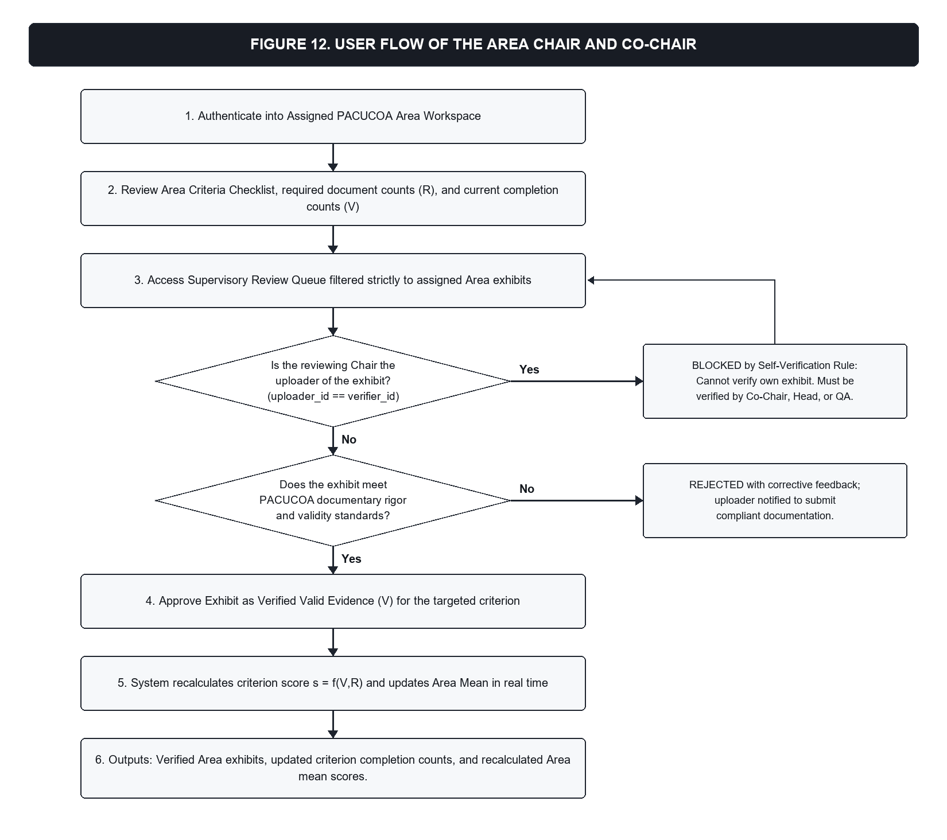
Figure 12. User Flow of the Area Chair and Co-Chair
User Flow of the Faculty Member. The goal of the Faculty Member (working committee member) is to prepare, map, and upload legitimate institutional exhibits to support designated PACUCOA evaluative criteria. The faculty member accesses the evidence submission module, selects the assigned Area, and chooses the target criterion. The faculty member uploads digital exhibits (PDF, DOCX, XLSX, PNG, JPG) and enters metadata including document title, document type, academic school year, and effective dates. For text-layer PDF documents, the system automatically triggers server-side text extraction to suggest matching document types and dates. The system validates file types, file size constraints, and required metadata fields before committing the file to private object storage. Crucially, the system restricts faculty members to upload and view permissions: faculty members cannot approve or verify their own exhibits or any other exhibits, enforcing separation between evidence contribution and quality verification. The outputs are securely stored digital exhibits in private cloud storage, parsed document metadata records, and pending verification requests placed in the supervisory review queue.
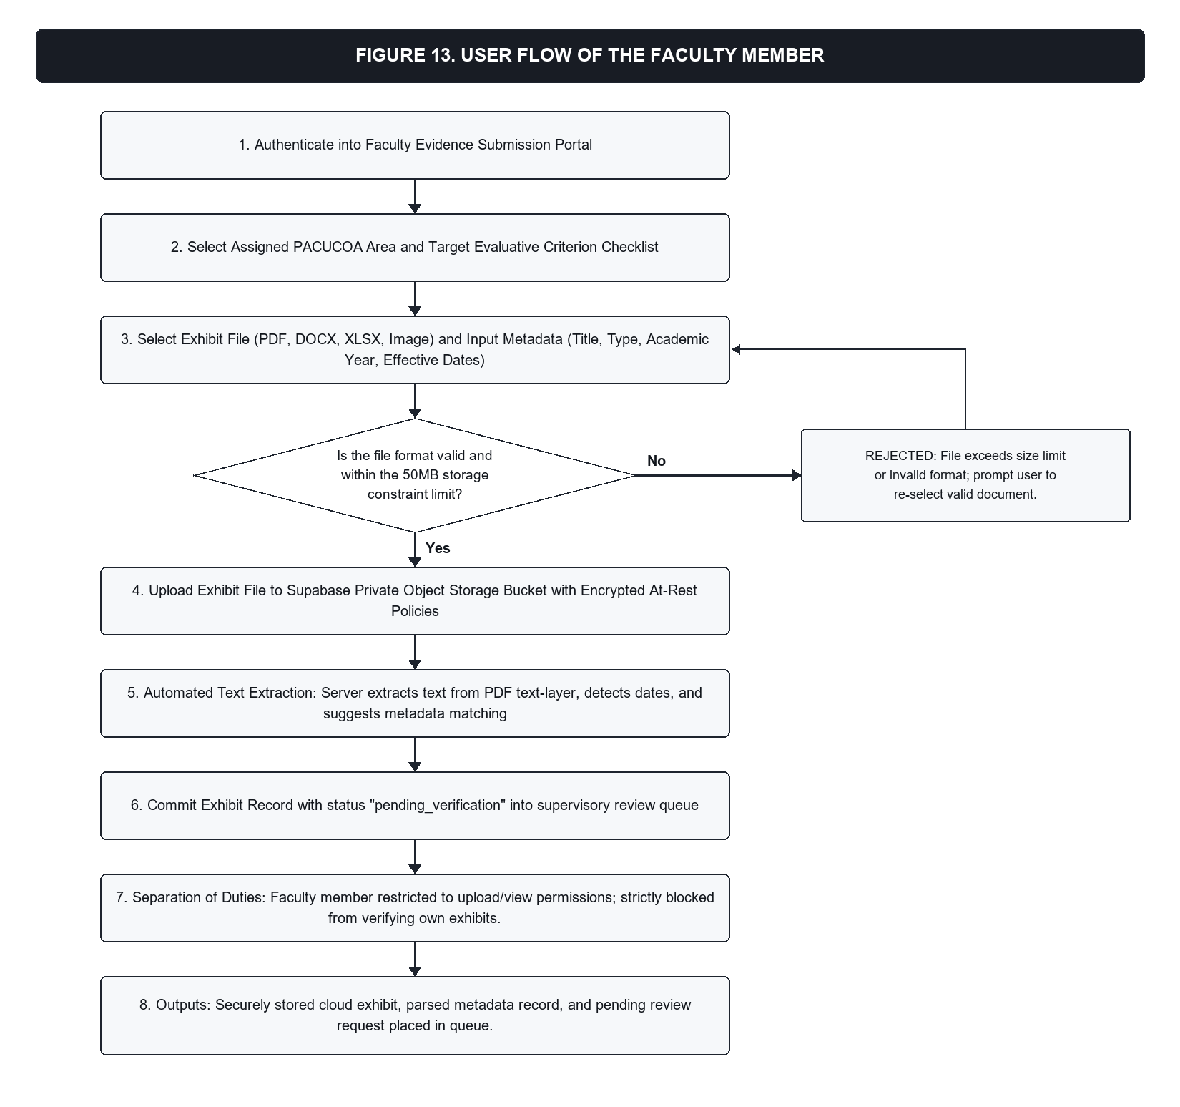
Figure 13. User Flow of the Faculty Member
User Flow of the Alumni and Student Representative. The goal of the Alumni and Student Representative is to review high-level institutional accreditation progress and readiness achievements to support external stakeholder engagement without compromising data confidentiality. The representative authenticates into the stakeholder portal and accesses the sanitized executive readiness summary. The representative can view overall program readiness scores, accreditation level eligibility statuses (Candidate, Level I, Level II), and high-level Area progress badges. The system enforces a strict read-only boundary through database Row-Level Security: representatives are blocked from viewing individual confidential exhibits, accessing faculty profiles, uploading files, or altering scoring configurations. The outputs of this flow are high-level institutional readiness summary views and transparency reports.
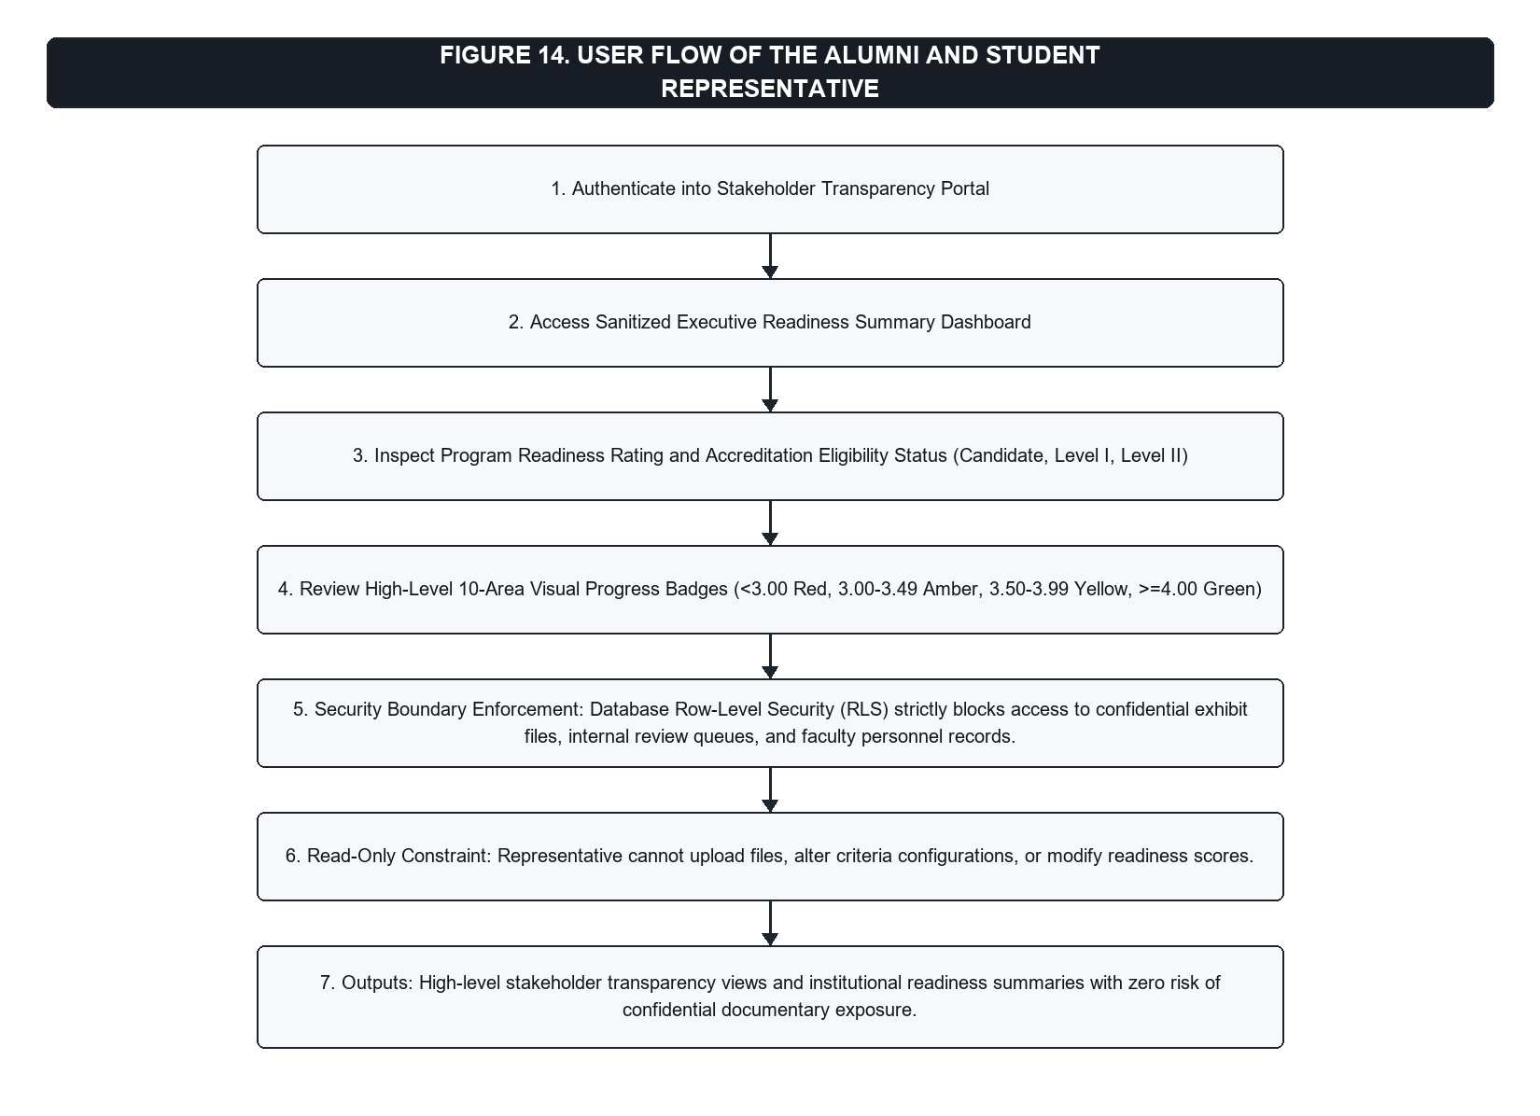
Figure 14. User Flow of the Alumni and Student Representative
Functional Modules
1. Evidence Management and Mapping Module: Enables faculty to upload files into Supabase Storage, mapped to specific criteria. When a PDF is uploaded, its text layer is extracted to suggest document types; scanned or image-only PDFs are not read. An Area Chair, Co-Chair, or Program Head reviews pending documents. The system prevents self-verification: for all roles except the QA Officer, a verification request is blocked in the interface and rejected by the database Row-Level Security policy when the verifying user is the uploader (uploader_id != verifier_id).
2. Readiness Scoring and Executive Dashboard Module: Computes scores in real time. For each criterion, let R be the required documents and V the valid verified documents. The criterion score s (from 0.00 to 5.00) is computed piecewise: s = 0.00 when V = 0; s = max(1.00, 2.00 * (V / R)) when 0 < V < R; s = 3.00 + 2.00 * ((V / R) - 1) capped at 5.00 when V >= R. Area Means are calculated as the arithmetic average of criterion scores. The Program Rating is computed as:
Program Rating = Sum(Area Mean * Area Weight) / Sum(Area Weight) = Sum(Area Mean * Area Weight) / 30
The system evaluates ratings against PACUCOA dual-constraint rules: Candidate status (overall >= 3.00); Level I (overall >= 3.00, no Area mean < 3.00); Level II (overall >= 3.50, no Area mean < 3.50); Levels III and IV (overall >= 4.00, no individual criterion < 4.00). The Executive 5x2 Command Dashboard displays all ten Areas simultaneously in two rows of five cards, designed to avoid vertical scrolling and featuring color-coded status badges (Red: < 3.00; Amber: 3.00-3.49; Yellow: 3.50-3.99; Green: >= 4.00).
3. Readiness Simulation Module: Allows administrators to select up to ten unresolved criteria, applies a simulated completion score of 4.00 (Very Good) to each, and recalculates projected Area means, program ratings, and level eligibility. Results are stored in isolated simulation tables without altering production records.
4. Post-Visit Compliance Tracking Module: Manages a four-column matrix that follows the format of the CICT BSCS Compliance Report (CICT, n.d.); the format is not mandated by PACUCOA or the QA Office. Column 1 (Opportunity for Improvement), Column 2 (PACUCOA Recommendation), Column 3 (Actions Taken, sub-numbered e.g. 1.1, 1.2), and Column 4 (Team Verification and Linked Exhibits).
Illustration of the Scoring Mechanics
Table 6 presents a hypothetical computation illustrating how the mathematical weighting formula and floor rules operate across the ten Areas.
Table 6
Hypothetical Computation of a Program Rating (Illustration)
Area | Area Mean | Weight | Weighted Value
I. Philosophy and Objectives | 4.00 | 3 | 12.00
II. Faculty | 3.50 | 3 | 10.50
III. Instruction | 3.00 | 4 | 12.00
IV. Laboratory | 3.00 | 3 | 9.00
V. Research | 2.50 | 3 | 7.50
VI. Library | 3.50 | 3 | 10.50
VII. Student Services | 4.00 | 3 | 12.00
VIII. Social Orientation and Community Involvement | 3.00 | 3 | 9.00
IX. Physical Plant and Facilities | 4.00 | 2 | 8.00
X. Organization and Administration | 3.50 | 3 | 10.50
Total | -- | 30 | 101.00
Note. Computed as 101.00 / 30 = 3.37. The program meets the Candidate threshold of 3.00 but fails Level I because Area V (2.50) is below the 3.00 floor constraint. These values are illustrative and are not BSCS results.
Research Design
The study employed a Developmental Research Design with a descriptive evaluative component (Richey & Klein, 2007). The developmental component encompassed the engineering of the software following the System Development Life Cycle (SDLC; Pressman & Maxim, 2020) and Agile Scrum. The descriptive evaluative component assessed the technical and operational acceptability of the system using the ISO/IEC 25010 product quality model.
Locale of the Study
The study was conducted at the College of Information and Communications Technology (CICT) and the Quality Assurance Office of STI West Negros University, located along Burgos Street, Bacolod City, Negros Occidental, Philippines. Figure 15 illustrates the geographical location and institutional vicinity of STI West Negros University, Burgos Street, Bacolod City.
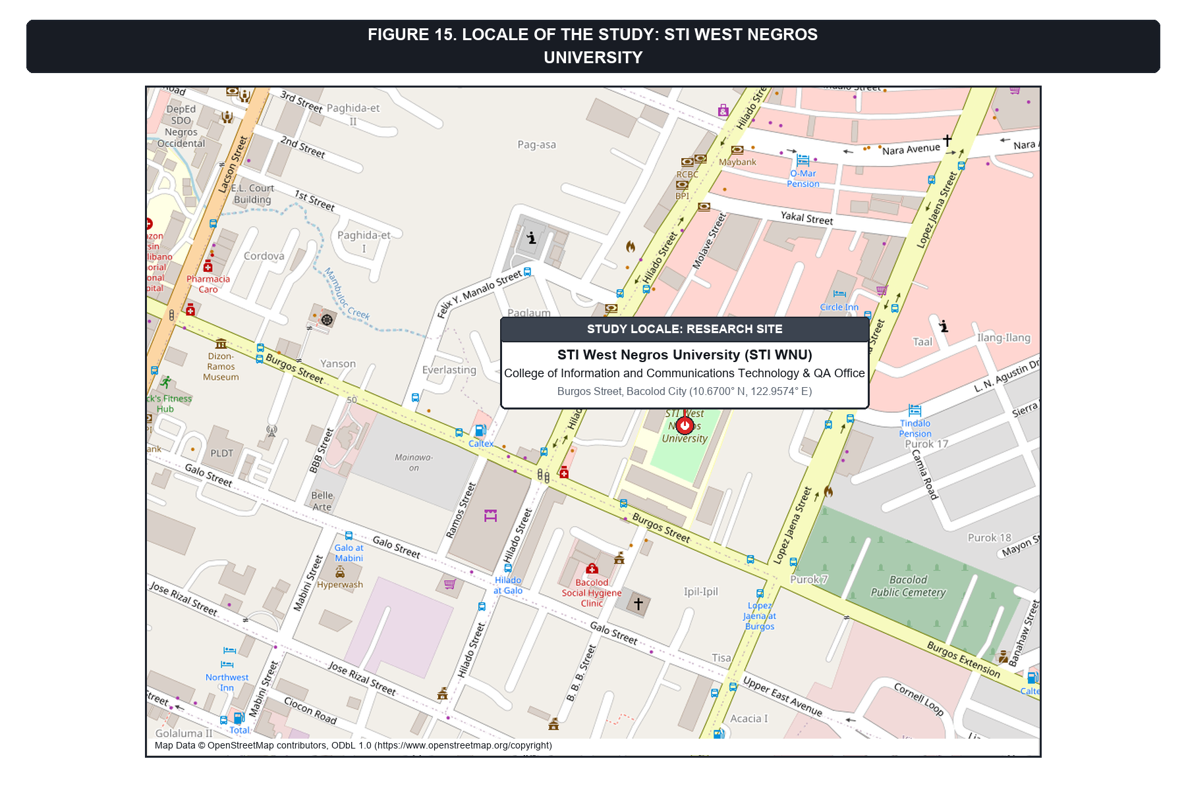
Figure 15. Location of STI West Negros University, Burgos Street, Bacolod City
Respondents of the Study (with sampling technique)
The study utilized a purposive sampling technique (Etikan et al., 2016), selecting twenty (20) respondents comprising fifteen (15) institutional stakeholders directly involved in accreditation management and curriculum delivery at STI West Negros University, and five (5) external IT experts. Purposive sampling was chosen because evaluating an accreditor-specific platform requires respondents who possess direct operational experience with PACUCOA self-survey workflows as well as technical professionals who can critically appraise software architecture and security. Table 7 details the respondent breakdown and their respective academic and professional qualifications.
Table 7
Respondent Breakdown and Qualifications
Respondent Category / Role | n | Qualification / Educational Background
Quality Assurance (QA) Officer | 1 | Bachelor's degree with Quality Assurance professional certifications
Dean, College of Information and Communications Technology (CICT) | 1 | PhD
Program Heads (BSCS and BSIT) | 2 | BSCS Program Head holds an MSCS; BSIT Program Head's master's is ongoing (CAR)
Faculty Members (Area Chairs and Committee Members) | 11 | 1 MIT; 10 pursuing master's degrees
IT Experts (External Systems and Software Evaluators) | 5 | 1 DIT; 1 master's degree holder; 3 IT industry practitioners
Total Respondents | 20 | --
Note. Selected via purposive sampling across institutional accreditation stakeholders and external technical evaluators with verified computing credentials and industry experience.
To complement institutional stakeholder feedback with rigorous technical evaluation, five (5) IT experts were purposively selected based on demonstrated professional expertise in software development, cloud systems architecture, database management, or software quality evaluation, requiring a minimum of three to five years of professional industry experience. The IT expert panel comprised one (1) Doctor of Information Technology (DIT) holder, one (1) master's degree holder in computing, and three (3) active IT industry practitioners specializing in web technologies and enterprise software evaluation. This dual-group composition ensured that the software was evaluated both from an operational domain standpoint by end users immersed in PACUCOA self-survey workflows and from an architectural and technical standpoint by external computing professionals.
Evaluation responses from both institutional stakeholders and IT experts were collected anonymously, with no names or email addresses recorded on the evaluation forms, and all ratings are reported in aggregate only.
Data Gathering Procedure
Data gathering was executed systematically through a six-stage procedure aligned with the project development timeline:
(a) Document Analysis: From August 10 to August 25, 2026, the researcher conducted a comprehensive documentary analysis of the PACUCOA Manual of Accreditation (Revised September 2023) and the CICT BSCS Compliance Report. This analysis extracted the ten undergraduate evaluative Areas, the official weight distribution (summing to 30), Candidate, Level I, and Level II floor rules, seventy-nine (79) evaluative criteria, and the four-column post-visit compliance matrix format.
(b) Requirements Consultations: From August 26 to August 31, 2026, formal consultations were conducted with key institutional stakeholders at STI WNU, including the Quality Assurance Officer, the CICT Dean, the BSCS and BSIT Program Heads, and faculty Area Chairs. These sessions established user role boundaries, criteria proxy requirements (R), supervisory workflows, and the critical security requirement of enforcing separation of duties via an automated self-verification block.
(c) System Demonstration and Use: From October 5 to October 12, 2026, following the deployment of the prototype on the cloud platform, hands-on demonstration and user interaction sessions were conducted. Participants tested evidence mapping, PDF text extraction, document verification, the Executive 5x2 Command Dashboard, the what-if simulation sandbox, and post-visit compliance tracking using actual BSCS accreditation exhibits.
(d) Administration of the ISO/IEC 25010 Questionnaire: From October 14 to October 20, 2026, the standardized evaluation questionnaire was administered to all twenty (20) purposive respondents (15 institutional users and 5 IT experts). The questionnaire evaluated the eight software product quality characteristics: Functional Suitability, Performance Efficiency, Compatibility, Usability, Reliability, Security, Maintainability, and Portability.
(e) Tabulation and Treatment of Data: From October 21 to October 24, 2026, the survey responses were compiled and subjected to statistical analysis, computing the weighted mean and standard deviation for each characteristic across user (M = 4.83, SD = 0.37) and expert (M = 4.40, SD = 0.53) cohorts, yielding an overall combined grand mean of 4.72 (SD = 0.46) per Table 8.
(f) Ethical Handling of Responses: Throughout the data gathering process, responses were gathered anonymously, with no personal names or email addresses recorded on the survey instruments, and all participant feedback was treated with strict confidentiality in accordance with informed consent protocols. All evaluation sheets were securely archived and processed solely in aggregate format, guaranteeing respondent privacy in compliance with Republic Act No. 10173.
Data Analysis
Evaluation Instrument
The evaluation instrument was adapted from the ISO/IEC 25010 software product quality model (ISO & IEC, 2011). The questionnaire employs a 5-point Likert scale (Likert, 1932) measuring eight quality characteristics: Functional Suitability, Performance Efficiency, Compatibility, Usability, Reliability, Security, Maintainability, and Portability.
Statistical Treatment
Survey responses were tabulated and analyzed using weighted mean and standard deviation. The Weighted Mean (WM) is computed as:
WM = Sum(f * x) / n
where f is the frequency of rating x, and n is the total number of respondents. Computed weighted means were interpreted using standard equal intervals of 0.80, as established in Table 8.
Table 8
Interpretation of Weighted Means
Mean Range | Verbal Interpretation
4.21 - 5.00 | Strongly Agree / Very Highly Acceptable
3.41 - 4.20 | Agree / Highly Acceptable
2.61 - 3.40 | Neutral / Moderately Acceptable
1.81 - 2.60 | Disagree / Slightly Acceptable
1.00 - 1.80 | Strongly Disagree / Not Acceptable
Note. Standard five-point Likert scale interpretation intervals.
Ethical Considerations
This research strictly adhered to institutional research ethics protocols and accepted ethical standards in software engineering. Written permission was obtained from the Dean of the College of Information and Communications Technology and the Quality Assurance Office prior to system testing and evaluation data gathering. Institutional clearance for the prototype, the use of BSCS compliance records, and the participation of university personnel in the software evaluation was formally secured.
Respondents were informed of the purpose of the study, the voluntary nature of participation, and their right to withdraw at any time, and informed consent was obtained before data collection. Responses were collected anonymously with no names or email addresses recorded, ensuring personal identifiers were completely omitted, and results are reported in aggregate only.
The study complied with the Data Privacy Act of 2012 (Republic Act No. 10173, 2012). Only data relevant to system testing and quality evaluation were collected, and all personal information was kept confidential. System testing and demonstrations utilized authorized, sanitized institutional documents. At the architectural level, access control was enforced through PostgreSQL Row-Level Security policies and authenticated, private cloud storage buckets.
Sources were comprehensively acknowledged using the APA 7th edition referencing style. The readiness ratings produced by the system were presented as indicative estimates of documentary sufficiency for self-survey preparation; they did not substitute for, or guarantee, the official evaluative decisions of PACUCOA.
Declaration of the Use of AI
In strict compliance with institutional research ethics guidelines and contemporary academic integrity standards, the researcher formally discloses the specific extent and nature of Artificial Intelligence (AI) utilization during the conduct, development, and documentation of this capstone project.
Generative AI tools and large language model assistants (specifically Claude and Gemini within advanced agentic development environments) were employed strictly as interactive pair-programming and editorial support instruments. These technologies assisted with technical code refactoring, TypeScript type definition validation, CSS layout alignment, automated script scaffolding for document formatting, and linguistic polishing of manuscript drafts.
The researcher affirms that no generative AI or autonomous machine learning model was used to fabricate empirical evaluation data, invent stakeholder survey responses, or generate statistical results. The underlying system architecture, relational database entity relationships, PACUCOA dual-constraint mathematical scoring algorithms, role-based access control policies, empirical data collection from the twenty (20) respondents, and final conclusions were conceptualized, implemented, critically analyzed, and verified by the researcher. Full responsibility for the technical validity, academic integrity, and factual correctness of this manuscript rests entirely with the author.

PRESENTATION, ANALYSIS AND INTERPRETATION
System Implementation and Operational Features
Executive 5x2 Command Dashboard and Heatmap Visualization
The Executive 5x2 Command Dashboard was designed to give university leadership panoramic visibility into accreditation preparedness. All ten PACUCOA Areas were rendered simultaneously in two balanced rows: Row 1 displays Area I (Philosophy), Area II (Faculty), Area III (Instruction), Area IV (Laboratory), and Area V (Research); Row 2 displays Area VI (Library), Area VII (Student Services), Area VIII (Social Orientation and Community Involvement), Area IX (Physical Plant and Facilities), and Area X (Organization and Administration). Each card features an assigned weight, a progress bar, verified document count, computed Area mean, and a color-coded status badge tied directly to PACUCOA thresholds: Red (< 3.00), Amber (3.00-3.49), Yellow (3.50-3.99), and Green (>= 4.00). Figure 16 displays the operational Executive 5x2 Command Dashboard for the BSCS program.
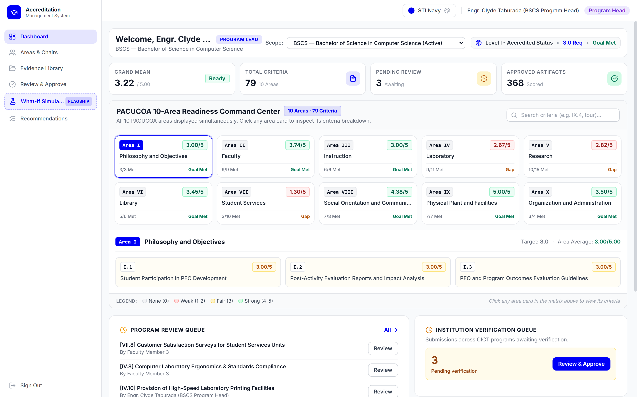
Figure 16. Executive 5x2 Command Dashboard and PACUCOA Area Status Overview
Evidence Management and Mapping Implementation
The completed web application implemented criterion-based evidence mapping aligned with the 2023 PACUCOA undergraduate manual. For the BSCS pilot program, across its seventy-nine (79) currently configured criteria spanning the ten Areas, the system enables faculty to upload exhibits in standard formats (PDF, DOCX, XLSX, PNG, JPG). Upon upload, a server-side routine extracts the text layer of PDF documents to suggest matching document types and effective dates; scanned or image-only PDFs are not read. The system's underlying data model supports program-level criteria isolation, enabling QA administrators to dynamically configure distinct criteria counts and provisions for other academic disciplines as needed. The 79 criteria were generated by a script from the opportunities for improvement in the CICT BSCS Compliance Report (CICT, n.d.), and the required document count (R) used in scoring is a configurable proxy that is not set by PACUCOA. To support institutional data hygiene, exhibits were validated against configurable validity windows. Figure 17 presents the documentary evidence upload interface and repository.
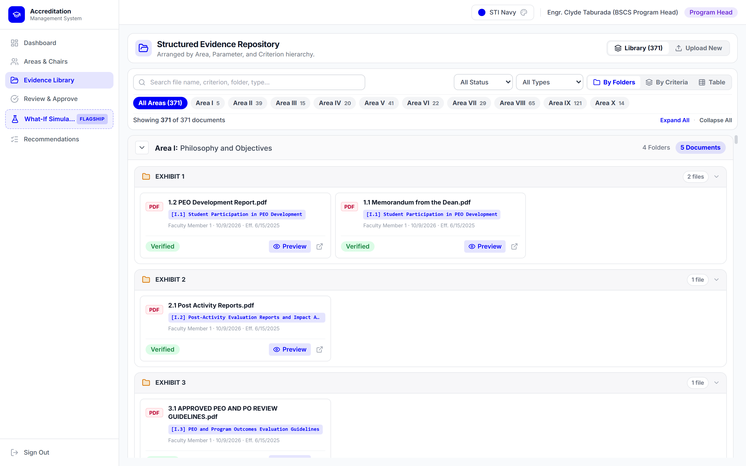
Figure 17. Accreditation Evidence Repository and Exhibit Ingestion Interface
Role-Based Access Control and Independent Verification (Self-Verification Block)
The system enforced separation of duties through a programmatic and database-level self-verification block. When an Area Chair, Co-Chair, or Program Head attempted to review an exhibit where their own user identifier matched the uploader identifier (uploader_id = verifier_id), the system blocked the verification button in the user interface and returned an authorization rejection at the Supabase PostgreSQL layer. Database Row-Level Security (RLS) policies and private storage buckets were designed to prevent unauthorized reading or direct URL tampering and to restrict exhibit access to authorized users. The QA Officer role is exempt from the self-verification check in the current policy. Figure 18 illustrates the independent verification queue demonstrating segregation of duties.
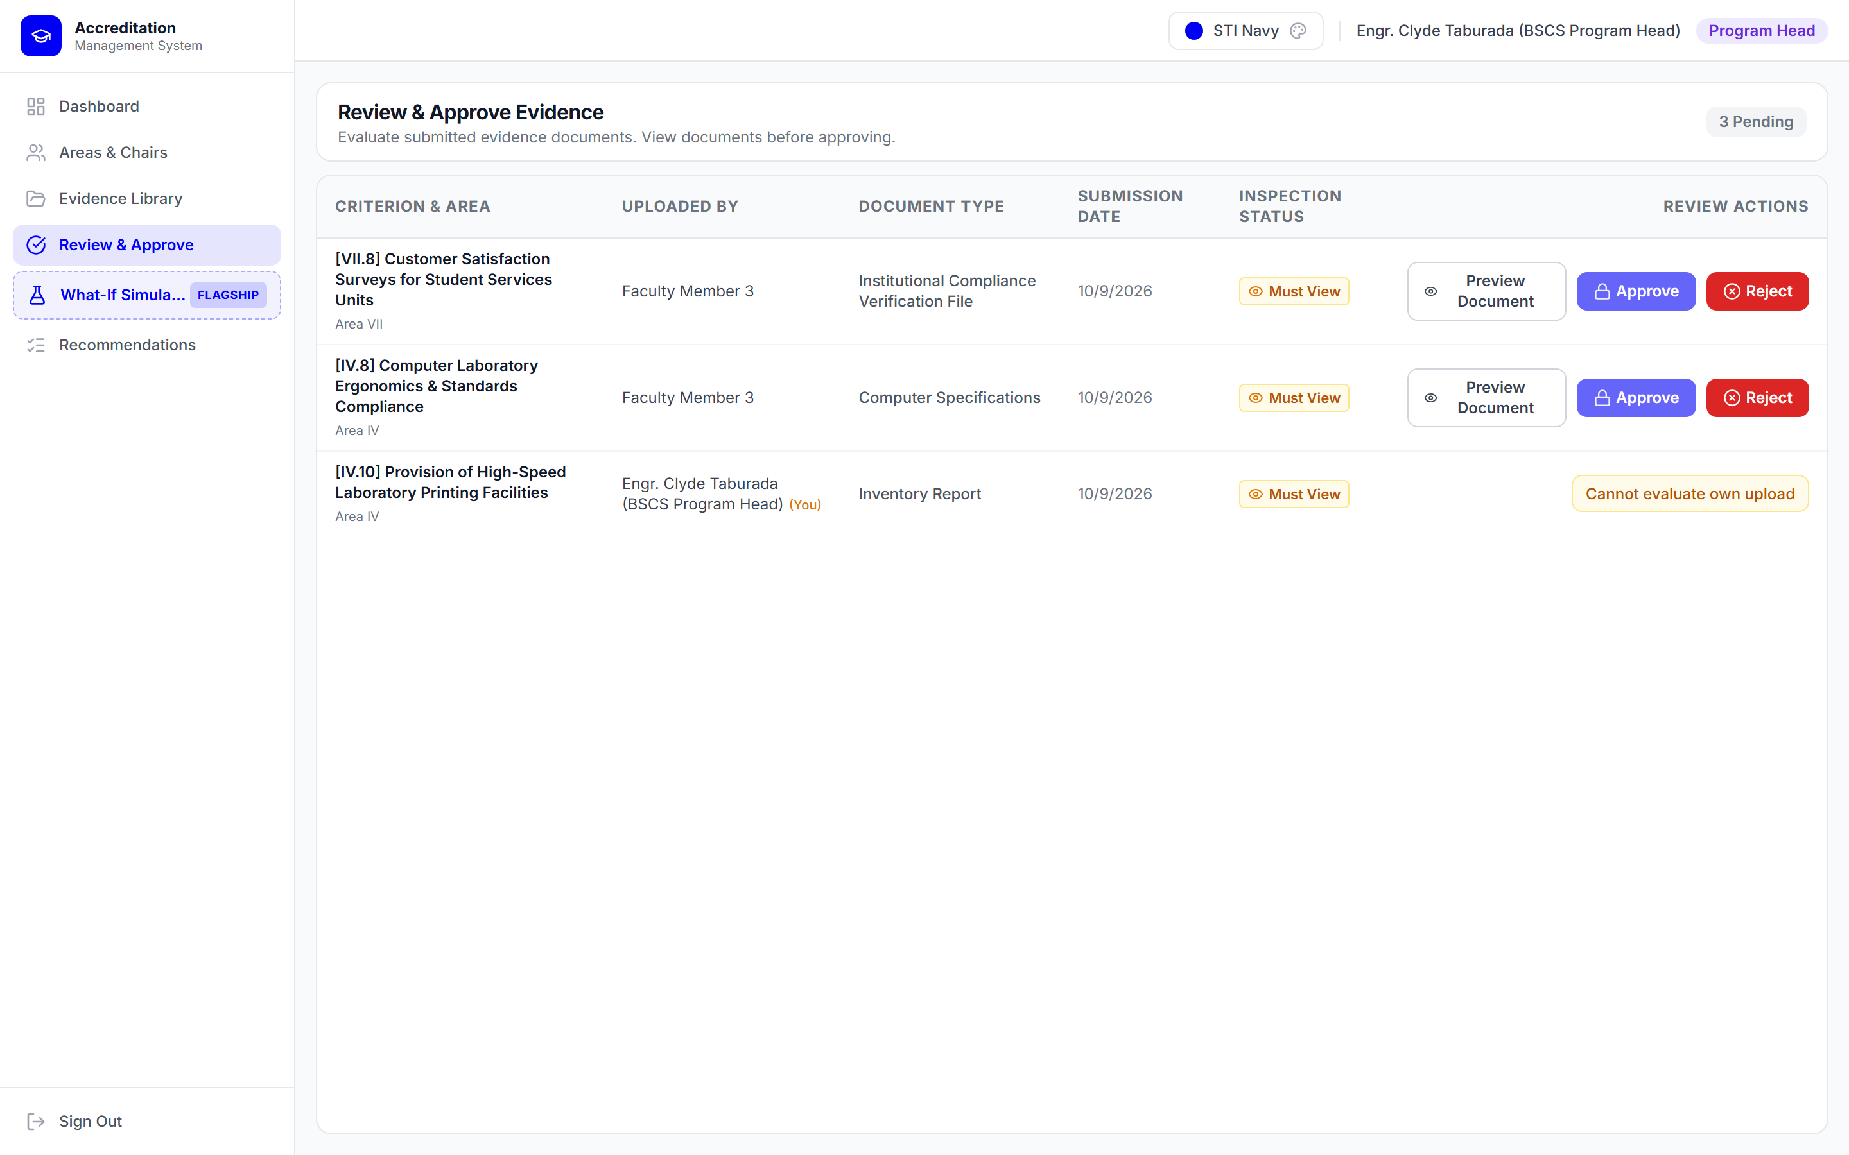
Figure 18. Independent Verification Queue with Enforced Self-Verification Block
What-If Readiness Simulation Sandbox
The Readiness Simulation module operated as an isolated analytical sandbox. Authorized academic managers could select up to ten unresolved criteria that represent strategic institutional priorities. The system applied a benchmark completion score of 4.00 (Very Good) to each selected criterion and instantaneously recalculated Area means, the overall program weighted rating, and level floor eligibility. Crucially, all simulation parameters and results were persisted in separate simulation records, leaving production self-survey scores completely unmutated. Figure 19 displays the what-if simulation sandbox forecasting eligibility gains.
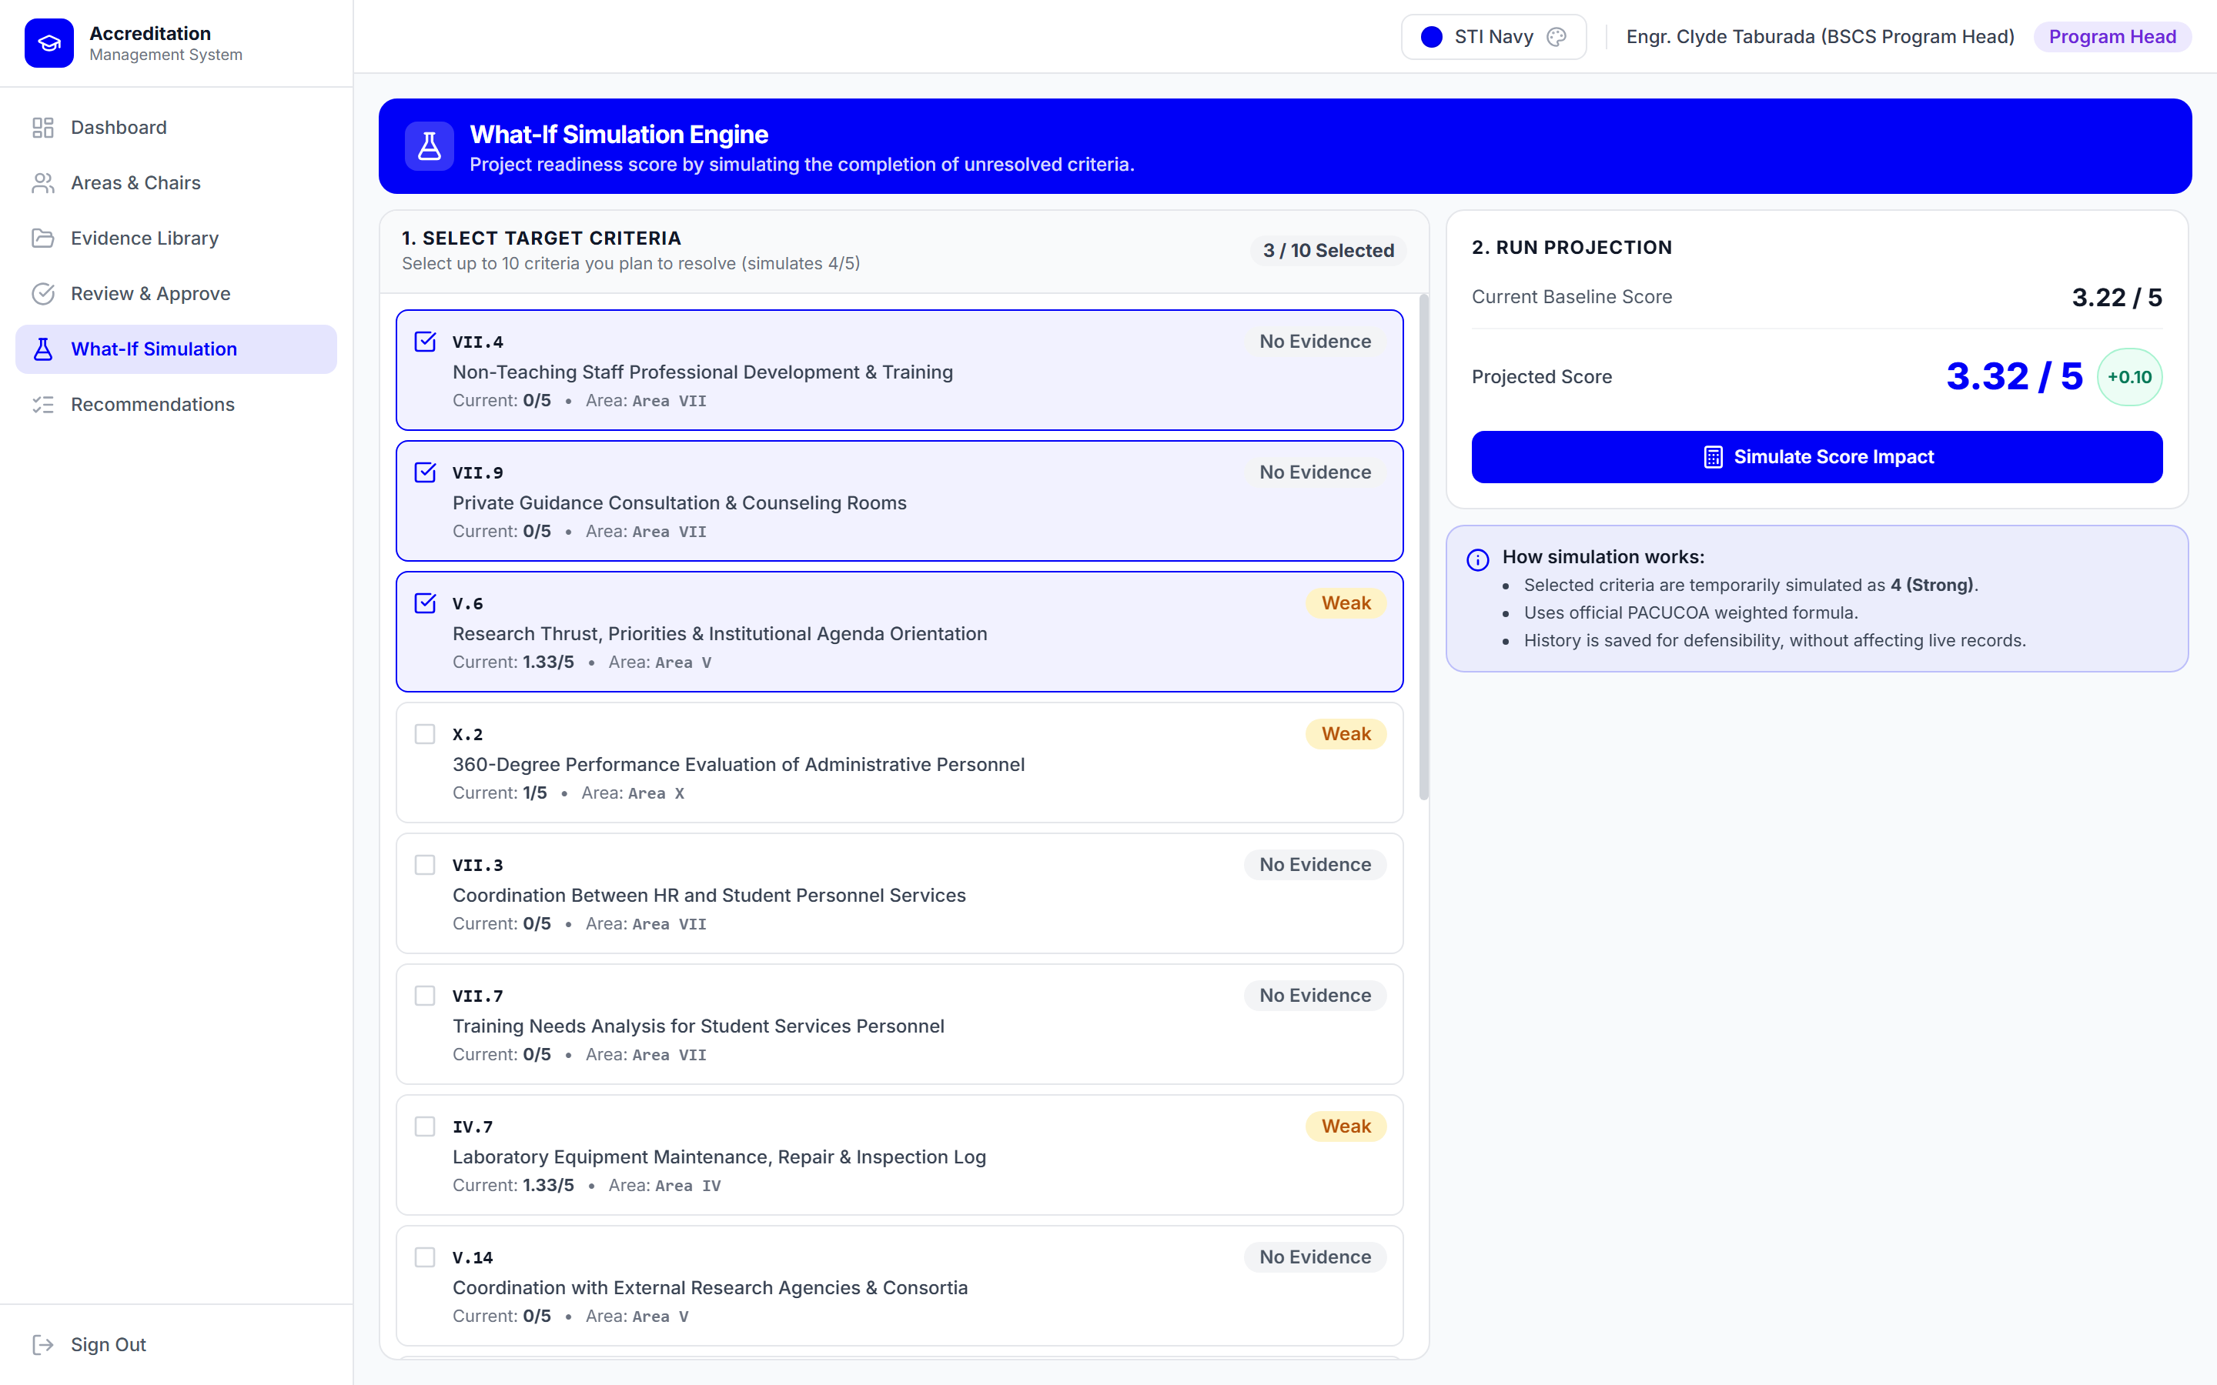
Figure 19. What-If Readiness Simulation Sandbox with Dual-Constraint Threshold Forecast
Four-Column Post-Visit Compliance Tracking Matrix
To prepare for PACUCOA revisits (where, under the Manual's Policy on Revisit, a compliance report is submitted at least 30 days before the visit) and for Level II reaccreditation (where, under the Level II Reaccreditation Visit provisions, a letter of intent, compliance report, and fresh self-survey are submitted at least 6 months before status expiry), the platform implemented a four-column compliance tracking module. The four-column layout followed the format of the CICT BSCS Compliance Report (CICT, n.d.); it is not a format mandated by PACUCOA or the QA Office. Separately, PACUCOA rates compliance with prior recommendations on a 1-to-5 compliance-verification scale (5 = Full Compliance, 4 = Very Satisfactory Partial Compliance, 3 = Satisfactory Partial Compliance, 2 = Unsatisfactory Partial Compliance, and 1 = Non-Compliance). The matrix recorded: Column 1 (Opportunity for Improvement), Column 2 (PACUCOA Recommendation), Column 3 (Actions Taken, structured with sub-numbered items e.g., 1.1, 1.2, 1.3), and Column 4 (Team Verification and Direct Links to Uploaded Verification Exhibits). It was designed to give post-visit compliance tracking an auditable digital form in place of paper-based tracking. Figure 20 displays the operational four-column compliance tracking matrix.
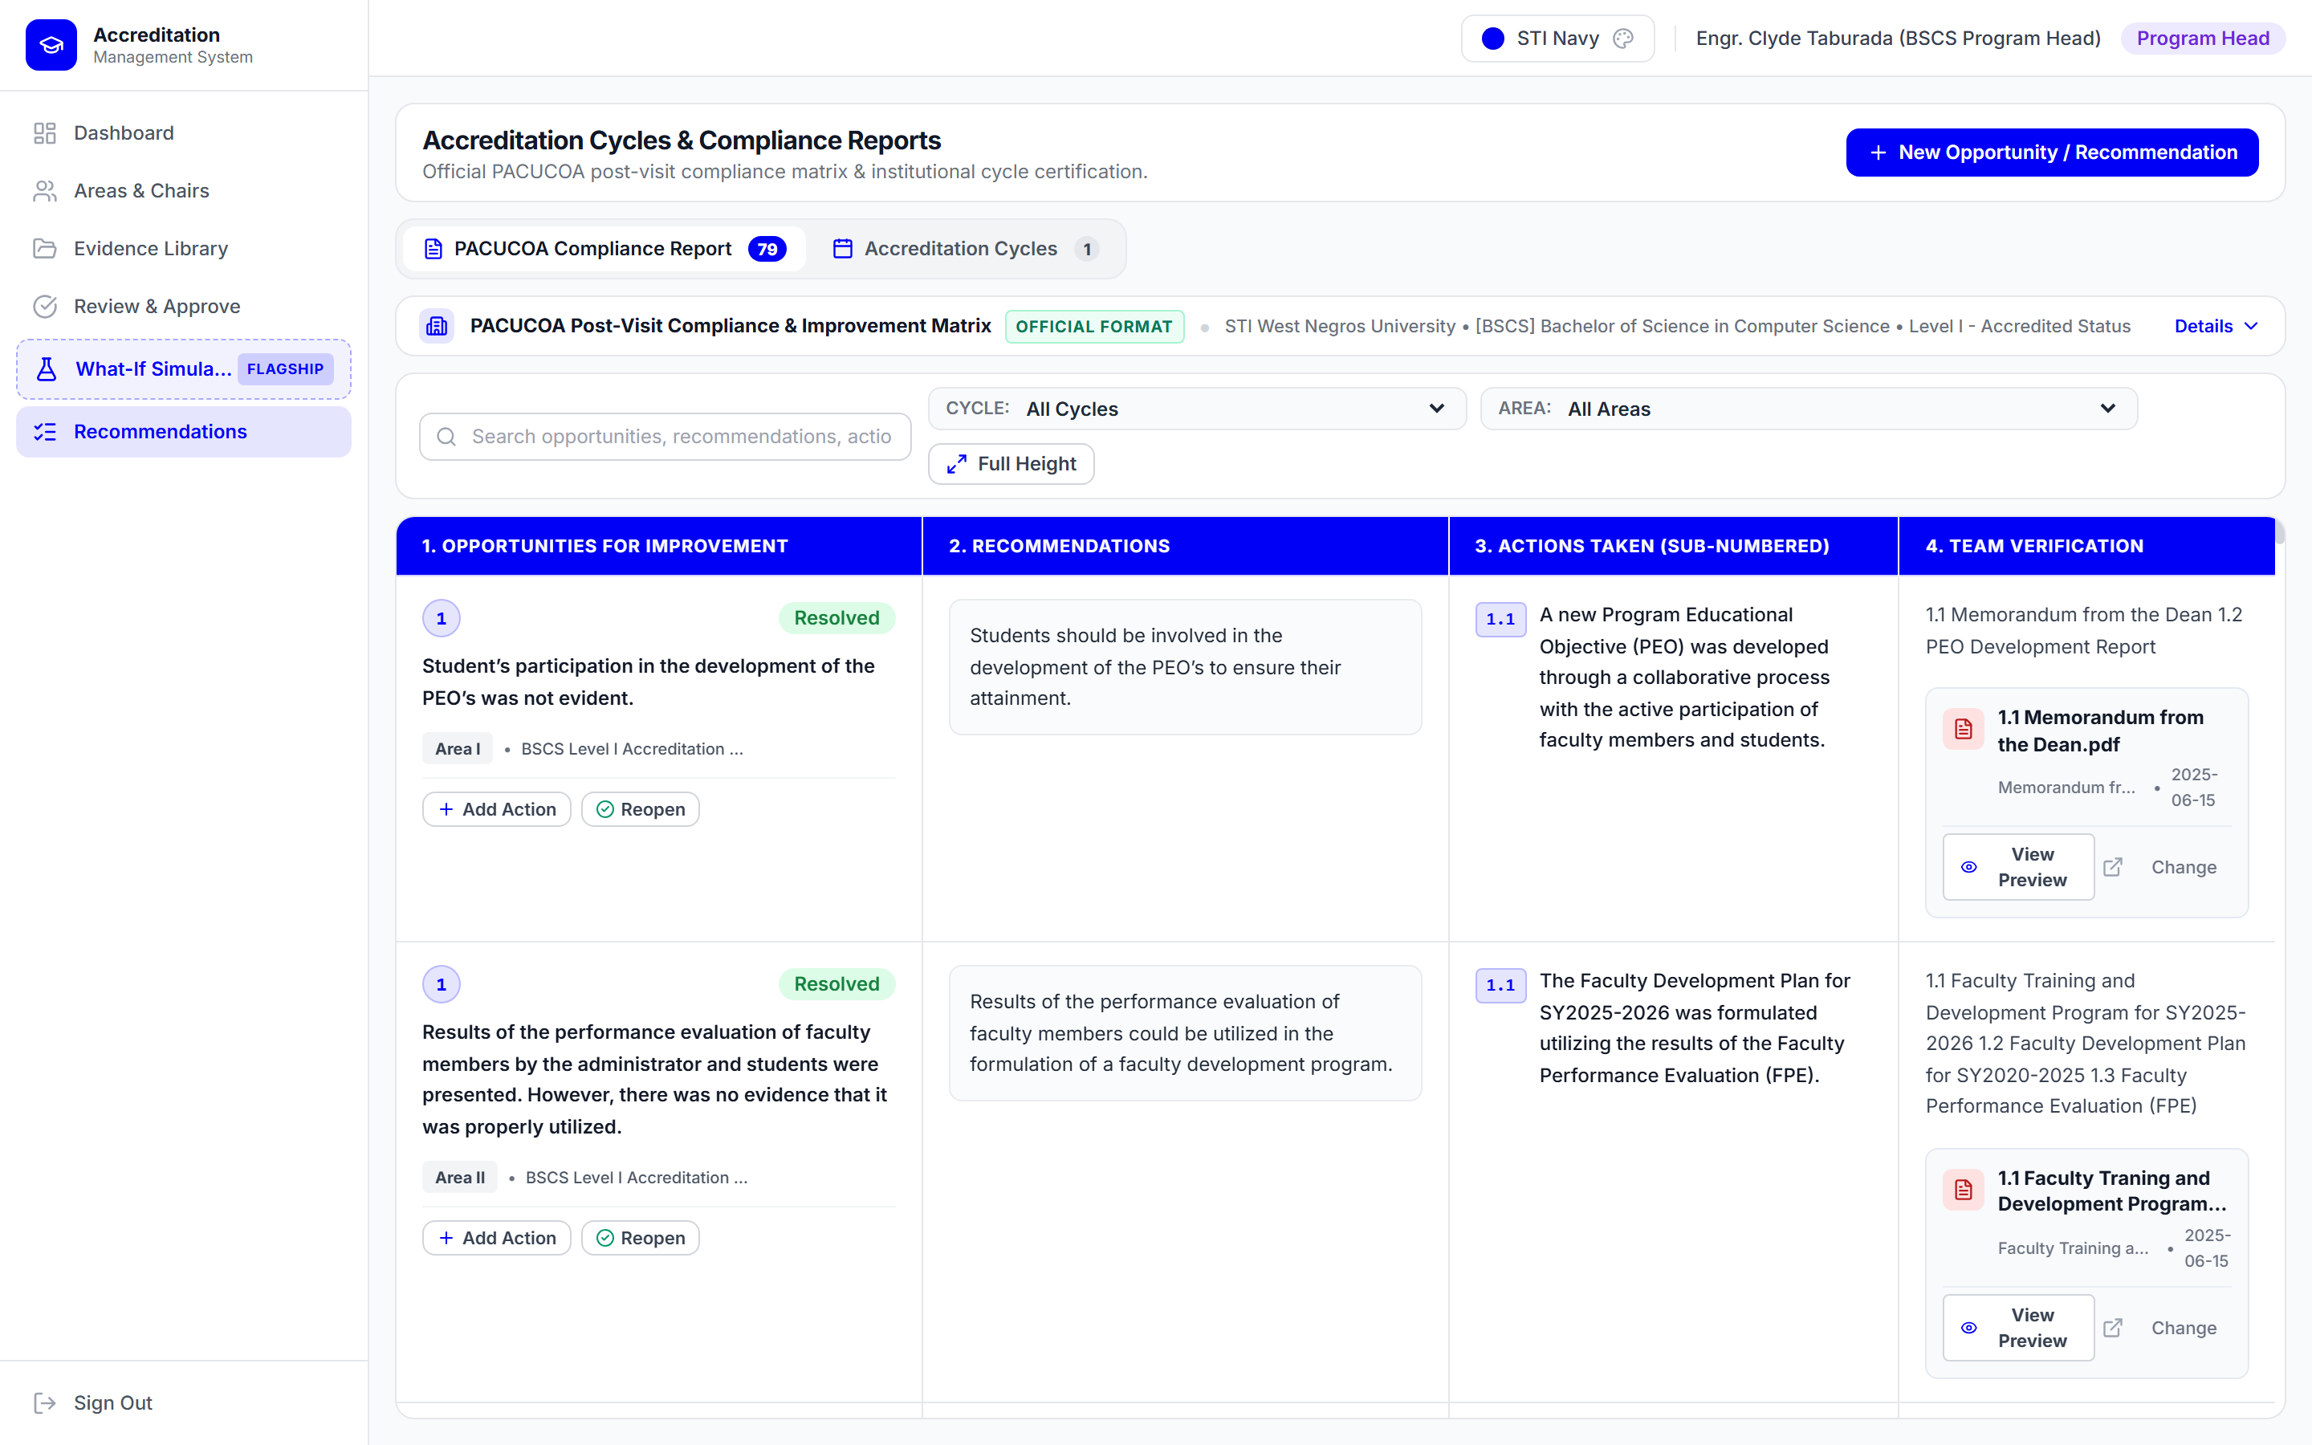
Figure 20. PACUCOA Four-Column Post-Visit Compliance Tracking Matrix
Verification of PACUCOA Scoring Mechanics and Empirical Assessment
Baseline Assessment of the BSCS Program
To check the scoring engine, baseline ratings were generated by the live system from the BSCS evidence loaded into it. Table 9 presents the baseline Area means, Area weights, and weighted values across all ten Areas, reflecting the verified digital exhibits evaluated during system deployment.
Table 9
Baseline Assessment of the BSCS Program by PACUCOA Area
PACUCOA Evaluative Area | Weight | Baseline Mean | Baseline Weighted
Area I: Philosophy and Objectives | 3 | 3.00 | 9.00
Area II: Faculty | 3 | 3.74 | 11.22
Area III: Instruction | 4 | 3.00 | 12.00
Area IV: Laboratory | 3 | 2.67 | 8.01
Area V: Research | 3 | 2.82 | 8.46
Area VI: Library | 3 | 3.45 | 10.35
Area VII: Student Services | 3 | 1.30 | 3.90
Area VIII: Social Orientation and Community Involvement | 3 | 4.38 | 13.14
Area IX: Physical Plant and Facilities | 2 | 5.00 | 10.00
Area X: Organization and Administration | 3 | 3.50 | 10.50
Total Weighted Value / Sum of Weights | 30 | -- | 96.58
Computed Overall Program Rating | -- | -- | 3.22
Note. Baseline overall rating = 96.58 / 30 = 3.22. Weights follow Table 1. Weighted values use unrounded Area means; displayed means are rounded to two decimals. Ratings are indicative and are not an official PACUCOA rating.
Dual-Constraint Threshold Analysis
Analysis of the baseline results shows that the BSCS program obtained an overall weighted rating of 3.22, which meets the Candidate Status threshold of 3.00 (3.22 >= 3.00). However, the program does not meet the Level I floor rule, under which no Area mean may fall below 3.00: Area IV (Laboratory, mean = 2.67), Area V (Research, mean = 2.82), and Area VII (Student Services, mean = 1.30) are below 3.00. Areas I and III are exactly at 3.00 and are therefore not below the floor. The overall rating of 3.22 is also below the 3.50 required for Level II. Consequently, the system flags Areas IV, V, and VII as the Areas whose documentary gaps must be resolved before the program can meet the Level I floor.
Relationship to the Official Accreditation Status
The baseline in Table 9 is an indicative readiness rating computed from the exhibits that had been uploaded, mapped, and rated in the system at the time of the run. It is not the official PACUCOA rating. The BSCS program was officially granted Level I accredited status through the PACUCOA survey process in September 2026 with a four-year validity period (September 2026 to September 2030). The two results are therefore not contradictory: the official determination rests on the accrediting team's full documentary and on-site evaluation, whereas the system baseline reflects only the portion of the evidence that had been digitized in the system. The authors attribute the Areas flagged in Table 9 (IV, V, and VII) to digital exhibits that had not yet been uploaded and rated at the time of the run. Completing the digital exhibits for these Areas is the practical preparation step for the program's next survey activity, which is Level II reaccreditation scheduled for 2030.
Simulation Analysis and Readiness Optimization
The What-If Readiness Simulation module was engineered to let academic administrators and quality assurance personnel project the mathematical effect of completing targeted criteria without altering live production records. In the live system, an authorized user can select up to ten (10) unresolved criteria across any of the evaluative Areas, assign a benchmark completion score of 4.00 (the standard benchmark for fully compliant exhibit verification) to each, and recalculate the projected Area means, program weighted sum, overall rating, and accreditation level qualification.
To test the readiness optimization capability of the system, a simulation was executed targeting the three deficit areas identified in the BSCS baseline assessment: Area IV (Laboratory, baseline mean = 2.67), Area V (Research, baseline mean = 2.82), and Area VII (Student Services, baseline mean = 1.30). A strategic allocation of the ten allowed criteria was configured based on institutional leverage: two (2) priority criteria in Area IV, three (3) priority criteria in Area V, and five (5) priority criteria in Area VII. Setting these ten unresolved criteria to the benchmark completion score of 4.00 produced the following empirical outcomes:
1. Area IV (Laboratory, weight = 3): Upgrading two unresolved criteria increased the Area sum of scores by +8.00 points, elevating the Area mean from 2.67 to 3.40 (a +0.73 increase). The Area weighted value rose from 8.01 to 10.19, clearing the PACUCOA Level I floor requirement of 3.00.
2. Area V (Research, weight = 3): Upgrading three unresolved criteria added +12.00 points to the Area sum, increasing the Area mean from 2.82 to 3.62 (a +0.80 increase). The Area weighted value rose from 8.46 to 10.86, eliminating the research documentary deficit and clearing the 3.00 floor.
3. Area VII (Student Services, weight = 3): Because Area VII exhibited the steepest baseline deficiency (mean = 1.30, sum = 13.00 across 10 criteria), five priority criteria were allocated to it. Upgrading five criteria added +20.00 points, increasing the Area sum to 33.00 and driving the Area mean from 1.30 to 3.30 (a +2.00 increase). Its weighted contribution rose substantially from 3.90 to 9.90 (a +6.00 gain), clearing the Level I floor.
4. Overall Program Impact and Level Eligibility: Across the remaining seven Areas (Areas I, II, III, VI, VIII, IX, and X), baseline scores were maintained. In total, the program weighted value increased by +10.58 points, rising from 96.58 to 107.16. Dividing by the total weight of thirty (30) yielded a projected overall program rating of 3.57, representing an overall increase of +0.35 points over the 3.22 baseline. Under PACUCOA's dual-constraint framework, this projected rating successfully satisfies both mandatory conditions: all ten Area means equal or exceed the 3.00 floor (satisfying Level I requirements), and the overall program rating of 3.57 clears the 3.50 minimum required for Level II reaccreditation status. The simulation empirically confirms that focused documentary completion across ten high-leverage criteria is sufficient to transition the BSCS program from deficit status to full Level II readiness ahead of its scheduled 2030 resurvey.
Software Quality Evaluation (ISO/IEC 25010)
Respondent Profile
The software was formally evaluated by twenty (20) purposive respondents comprising fifteen (15) institutional stakeholders directly involved in accreditation governance, academic management, and documentary review at STI West Negros University (1 QA Officer, 1 Dean, 2 Program Heads, 11 faculty members), and five (5) external IT experts (1 DIT, 1 master's degree holder, 3 IT industry practitioners). The respondents interacted with the deployed system, executing operational accreditation tasks—including exhibit uploading, text-layer PDF extraction, supervisory queue inspection, readiness dashboard monitoring, what-if simulations, and compliance tracking—prior to answering the standardized ISO/IEC 25010 evaluation questionnaire.
Evaluation Results Across Quality Characteristics
Table 10 summarizes the statistical results of the software quality evaluation across the eight characteristics defined in the ISO/IEC 25010 standard, comparing ratings between the institutional user group and the technical expert group alongside the combined sample.
Table 10
Summary of ISO/IEC 25010 Software Quality Evaluation Results Across User and Expert Groups
ISO/IEC 25010 Quality Characteristic | Users (n = 15) | Experts (n = 5) | Combined (N = 20) | Verbal Interpretation
1. Functional Suitability | 4.84 | 4.10 | 4.66 | Strongly Agree / Very Highly Acceptable
2. Performance Efficiency | 4.78 | 4.50 | 4.71 | Strongly Agree / Very Highly Acceptable
3. Compatibility | 4.80 | 4.10 | 4.63 | Strongly Agree / Very Highly Acceptable
4. Usability | 4.87 | 4.30 | 4.73 | Strongly Agree / Very Highly Acceptable
5. Reliability | 4.82 | 4.20 | 4.67 | Strongly Agree / Very Highly Acceptable
6. Security | 4.89 | 4.90 | 4.89 | Strongly Agree / Very Highly Acceptable
7. Maintainability | 4.77 | 4.60 | 4.73 | Strongly Agree / Very Highly Acceptable
8. Portability | 4.85 | 4.50 | 4.76 | Strongly Agree / Very Highly Acceptable
Overall Composite Grand Mean | 4.83 | 4.40 | 4.72 | Strongly Agree / Very Highly Acceptable
Note. Evaluated by N = 20 respondents (15 institutional users and 5 external IT experts). Verbal interpretations are based on the combined weighted means per Table 8 (4.21–5.00: Strongly Agree / Very Highly Acceptable; 3.41–4.20: Agree / Highly Acceptable). Standard deviations: Users (M = 4.83, SD = 0.37); Experts (M = 4.40, SD = 0.53); Combined (M = 4.72, SD = 0.46). Combined means are calculated as (15 × user mean + 5 × expert mean) / 20.
Interpretation and Qualitative Synthesis
Table 10 presents the comparative evaluation results across the institutional user cohort (n = 15), the external IT expert cohort (n = 5), and the total combined sample (N = 20). The overall composite grand means were 4.83 (SD = 0.37) for the user group, 4.40 (SD = 0.53) for the expert group, and 4.72 (SD = 0.46) across all twenty respondents. Under the evaluation scale established in Table 8, all three grand means (4.83, 4.40, and 4.72) fall within the 'Strongly Agree / Very Highly Acceptable' band (4.21–5.00).
A comparative analysis between the two respondent groups reveals that the IT experts evaluated the platform with an expert grand mean of 4.40 compared to the institutional user grand mean of 4.83. At the characteristic level, the institutional user group rated every one of the eight quality characteristics in the 'Strongly Agree / Very Highly Acceptable' band, with individual means ranging from 4.77 (Maintainability) to 4.89 (Security). In contrast, the expert group evaluated three characteristics in the 'Agree / Highly Acceptable' band (3.41–4.20): Functional Suitability (WM = 4.10), Compatibility (WM = 4.10), and Reliability (WM = 4.20); while evaluating five characteristics in the 'Strongly Agree / Very Highly Acceptable' band (4.21–5.00): Security (WM = 4.90), Maintainability (WM = 4.60), Performance Efficiency (WM = 4.50), Portability (WM = 4.50), and Usability (WM = 4.30). Notably, the IT expert cohort rated Security highest among all characteristics (WM = 4.90), reflecting a strong technical endorsement of the platform's multi-layered authorization safeguards and database-enforced integrity.
The divergence between the two evaluation cohorts was most pronounced in Functional Suitability (a rating gap of 0.74: 4.84 for users versus 4.10 for experts) and Compatibility (a rating gap of 0.70: 4.80 for users versus 4.10 for experts). This divergence is attributable to differing operational perspectives: external IT experts evaluated enterprise-level system interoperability—specifically identifying the need for automated API synchronization with legacy university Student Information Systems (SIS) and broader multi-department data import pipelines—whereas institutional users evaluated the platform against immediate, practical document collation workflows within the CICT department. Conversely, both cohorts exhibited strong convergence on Security, with users rating it 4.89 and IT experts rating it 4.90, recognizing the efficacy of Supabase Row-Level Security (RLS) policies, private object storage buckets, and programmatic self-verification constraints. Experts also rated Maintainability high (WM = 4.60) and Performance Efficiency at 4.50, confirming the architectural soundness of the Next.js, TypeScript, and PostgreSQL foundation. Across all twenty respondents, the combined means ranged from 4.63 (Compatibility) to 4.89 (Security), with every combined characteristic mean falling into the 'Strongly Agree / Very Highly Acceptable' range.
A methodological limitation of the evaluation is that certain institutional respondents also served as stakeholders during the earlier requirements gathering consultations, which may introduce potential familiarity bias into the user ratings. Overall, the empirical evaluation demonstrates strong functional and operational acceptability, providing initial empirical support for the system's technical design while highlighting specific areas for system hardening prior to broader deployment.

SUMMARY, CONCLUSION AND RECOMMENDATION
Summary of Findings
This capstone study designed, developed, and evaluated a Web-Based Accreditation Management and Readiness Assessment System for STI West Negros University, aligned with the PACUCOA undergraduate accreditation instrument. The core findings corresponding to the specific research objectives are as follows:
1. Evidence Management and Mapping: The platform provided a centralized, cloud-hosted digital exhibit repository covering the seventy-nine (79) criteria currently configured for the BSCS pilot program across ten Areas, while its relational schema supported different criteria counts across degree programs. Text-layer PDF extraction and metadata validation were engineered to assist exhibit tagging and to minimize the risk of misplaced documents.
2. Readiness Scoring and Executive Dashboard: The mathematical scoring engine automated the piecewise criterion formula, Area means, and the 30-weight PACUCOA program rating. On the BSCS baseline it produced an indicative program rating of 3.22, which met the Candidate threshold but not the Level I floor because Areas IV (2.67), V (2.82), and VII (1.30) fell below 3.00. The Executive 5x2 dashboard consolidated all ten Areas with progress bars and RAG status badges.
3. What-If Readiness Simulation: The simulation module was engineered to let program heads project the effect of completing up to ten targeted criteria without modifying production self-survey records. Simulating the completion of ten priority criteria across the three deficit areas (two in Area IV, three in Area V, and five in Area VII) at a benchmark score of 4.00 elevated the projected Area means to 3.40 (Area IV), 3.62 (Area V), and 3.30 (Area VII). This increased the program total weighted value from 96.58 to 107.16 and projected an overall rating of 3.57 (a +0.35 increase), successfully clearing the 3.00 Level I floor rule across all ten Areas and qualifying the program for Level II readiness (>= 3.50).
4. Post-Visit Compliance Tracking: The four-column compliance matrix module recorded post-survey opportunities for improvement, accreditor recommendations, sub-numbered actions taken, and linked verification exhibits, following the format of the CICT BSCS Compliance Report (CICT, n.d.).
5. Role-Based Access Control and Separation of Duties: Route guards, database Row-Level Security policies, and a self-verification block (uploader_id != verifier_id) were implemented to enforce multi-tiered audit integrity and to restrict access to confidential records. The QA Officer role is exempt from the self-verification block in the current policy.
6. Software Quality Evaluation: Formal evaluation by twenty (20) purposive respondents—comprising fifteen (15) institutional users and five (5) IT experts—yielded an institutional user grand mean of 4.83 (SD = 0.37, Strongly Agree / Very Highly Acceptable), an IT expert grand mean of 4.40 (SD = 0.53, Strongly Agree / Very Highly Acceptable), and an overall combined grand mean of 4.72 (SD = 0.46, Strongly Agree / Very Highly Acceptable). Institutional users rated all characteristics highly (4.77 to 4.89). IT experts rated Security highest (4.90) followed by Maintainability (4.60), while offering more critical ratings on Compatibility (4.10) and Functional Suitability (4.10). Across all 20 respondents, combined means ranged from 4.63 to 4.89.
Conclusion
Based on the empirical findings, the following conclusions are drawn:
1. The web-based system successfully addressed the difficulty of locating accreditation documents that are prepared by different people and kept in different drives, by providing a centralized, criterion-mapped repository at STI West Negros University.
2. Automating the PACUCOA weighting formula and dual-constraint floor rules eliminated manual calculation errors and provided academic administrators with a transparent, real-time view of program readiness. The BSCS baseline rating of 3.22 illustrates how the Level I floor rule flags Areas IV, V, and VII in the evidence loaded at the time of the run; it is an indicative readiness rating and not the official result, since the program has since been granted Level I accredited status in September 2026.
3. Separation of duties through the self-verification block safeguarded evaluation integrity by requiring that exhibits be validated by an authorized reviewer other than the uploader, with the QA Officer exempt in the current policy.
4. The what-if readiness simulation module provided empirical, data-driven decision support for resource allocation. By demonstrating that completing ten targeted criteria elevates the BSCS program rating from 3.22 to 3.57 and eliminates all Area floor deficits, the system enables academic administrators to prioritize high-leverage criteria—most notably in Student Services (Area VII) and Laboratories (Area IV)—ahead of the scheduled 2030 Level II resurvey.
5. The respondents evaluated the platform as Highly to Very Highly Acceptable across all ISO/IEC 25010 software quality characteristics, achieving grand means of 4.83 among institutional users, 4.40 among IT experts, and a combined grand mean of 4.72 (Table 10). Both groups strongly affirmed the platform's security (4.89 among users and 4.90 among experts) and maintainability (4.77 among users and 4.60 among experts), while technical experts offered more conservative ratings on compatibility (4.10) and functional suitability (4.10), indicating important avenues for external systems integration prior to wider deployment. Full operational deployment beyond the BSCS pilot remains contingent upon resolving the limitations identified in Chapter I.
Recommendation
In light of the conclusions, the researcher recommends the following actions:
1. Institutional Deployment: The administration and Quality Assurance Office of STI West Negros University may consider a phased adoption of the system for the BSCS program and its gradual extension to other programs, beginning with populating the BSIT program, after addressing the technical limitations noted by the expert evaluators and documented in Chapter I.
2. Continuous Evidence Policy: CICT should institutionalize a semester-end digital exhibit submission policy, requiring faculty members to upload syllabi, examinations, and committee minutes immediately following each academic term to maintain year-round accreditation readiness.
3. Systems Integration: Future iterations of the system should explore secure API integration with STI WNU's enterprise Student Information System (SIS), Learning Management System (LMS), and Human Resource Information System (HRIS) to automate exhibit ingestion.
4. Machine Learning Document Classification: Future researchers can enhance the PDF text parser with optical character recognition (OCR) and natural language processing (NLP) machine learning models to automatically classify unstructured documents and assess semantic alignment with PACUCOA criteria. Because the current system reads text-layer PDFs only, OCR support for scanned documents is a priority.
5. Multi-Accreditor Support: Future developers may extend the configurable framework engine to support other recognized Philippine and international quality frameworks, such as PAASCU, ALCUCOA, AACCUP, and the ASEAN University Network-Quality Assurance (AUN-QA).
6. Document Versioning and Licensure Eligibility: Future versions may add versioning of uploaded documents and model the board-examination-based licensure eligibility track described in the Manual.

REFERENCES
AchieveIt. (2024). Accreditation management software: Streamline compliance and manage your institutional accreditation. https://www.achieveit.com/?p=59266
Aftab, M. U., Qin, Z., Hundera, N. W., Ariyo, O., Son, S. T., & Dinh, T. V. (2019). Permission-based separation of duty in dynamic role-based access control model. Symmetry, 11(5), Article 669. https://doi.org/10.3390/sym11050669
Akdemir, N., Peterson, L. N., Campbell, C. M., & Scheele, F. (2020). Evaluation of continuous quality improvement in accreditation for medical education. BMC Medical Education, 20(Suppl 1), Article 308. https://doi.org/10.1186/s12909-020-02124-2
Aldaba, F. T., Sescon, J. T., & Alconis, K. E. (2024). Strengthening CHED's developmental and regulatory capacity (PIDS Discussion Paper Series No. 2024-41). Philippine Institute for Development Studies. https://www.pids.gov.ph/publication/discussion-papers/strengthening-ched-s-developmental-and-regulatory-capacity
Al-Qawasmi, A.-R. (2026). A Web-based academic quality management system for evidence traceability and continuous improvement in engineering education: The QAMS case study. Quality Assurance in Education, 34(1), 45–62. https://doi.org/10.1108/QAE-05-2026-0208
Aquino, J. M. D. R. (2025). Best practices of high performing higher education institutions in the Philippines towards the development of harmonized quality-assured instructional leadership framework. Frontiers in Education, 10, Article 1663289. https://doi.org/10.3389/feduc.2025.1663289
Beck, K., Beedle, M., van Bennekum, A., Cockburn, A., Cunningham, W., Fowler, M., Grenning, J., Highsmith, J., Hunt, A., Jeffries, R., Kern, J., Marick, B., Martin, R. C., Mellor, S., Schwaber, K., Sutherland, J., & Thomas, D. (2001). Manifesto for agile software development. https://agilemanifesto.org/
College of Information and Communications Technology. (n.d.). BSCS compliance report. STI West Negros University.
Commission on Higher Education. (2019). Policies and guidelines on the grant of autonomous and deregulated status to private higher education institutions (CHED Memorandum Order No. 12, Series of 2019). Republic of the Philippines. https://ched.gov.ph/cmo-no-12-s-2019/
Conchada, M. I., & Tiongco, M. M. (2015). A review of the accreditation system for Philippine higher education institutions (PIDS Discussion Paper Series No. 2015-30). Philippine Institute for Development Studies. https://doi.org/10.62986/dp2015.30
Creatrix Campus. (2023). Accreditation management software for higher education: Automate institutional and program accreditation workflows. https://creatrixcampus.com/accreditation-management-software
Dres, O., & Rabut, B. (2025). eDOCS: A Web-Based File Management System for Efficient File Organization. Psychology and Education: A Multidisciplinary Journal, 27(1), 45–56. https://ejournals.ph/article.php?id=23184
Etikan, I., Musa, S. A., & Alkassim, R. S. (2016). Comparison of convenience sampling and purposive sampling. American Journal of Theoretical and Applied Statistics, 5(1), 1–4. https://doi.org/10.11648/j.ajtas.20160501.11
Farhadighalati, N., Estrada-Jimenez, L. A., Nikghadam-Hojjati, S., & Barata, J. (2025). A systematic review of access control models: Background, existing research, and challenges. IEEE Access, 13, 14210–14235. https://doi.org/10.1109/ACCESS.2025.3533145
Galande, M. H. (2025). Accreditation Document Management System of Apayao State College, Conner Campus, Philippines. Advances in Research and Recent Topics in Social Sciences, 23(7), 104–121. https://doi.org/10.9734/arjass/2025/v23i7731
Groll, S., Fuchs, L., & Pernul, G. (2025). Separation of duty in information security. ACM Computing Surveys, 57(3), 1–38. https://doi.org/10.1145/3715959
International Organization for Standardization & International Electrotechnical Commission. (2011). Systems and software engineering — Systems and software quality requirements and evaluation (SQuaRE) — System and software quality models (ISO/IEC 25010:2011). https://www.iso.org/standard/35733.html
International Organization for Standardization & International Electrotechnical Commission. (2023). Systems and software engineering — Systems and software Quality Requirements and Evaluation (SQuaRE) — Product quality model (ISO/IEC 25010:2023). https://www.iso.org/standard/78176.html
Lagman, A. C., Ramirez, I. C. R., Esteban, A. P., Rivera, R. P. L., Delos Santos, R., & Juliano, J. J. (2024). Development and evaluation of an enterprise-level information system for digital governance in Philippine SUCs using Agile software methodology and ISO/IEC 25010 software quality model. In 2024 IEEE 16th International Conference on Humanoid, Nanotechnology, Information Technology, Communication and Control, Environment, and Management (HNICEM) (pp. 1–6). IEEE. https://doi.org/10.1109/hnicem64917.2024.11258693
Likert, R. (1932). A technique for the measurement of attitudes. Archives of Psychology, 22(140), 1–55.
Makki, A. A., Sindi, H. F., Brdesee, H., Alsaggaf, W., Al-Hayani, A., & Al-Youbi, A. O. (2022). Goal programming and mathematical modelling for developing a capacity planning decision support system-based framework in higher education institutions. Applied Sciences, 12(3), Article 1702. https://doi.org/10.3390/app12031702
Mindoro-Mesana, J. M. M., Mesana, J. P. M., & Mariño, L. M. (2022). Design and Development of Romblon State University Romblon Campus Accreditation Data Warehouse. Romblon State University Research Journal, 4(2), 17–24. https://doi.org/10.58780/rsurj.v4i2.54
Nauman, M., Aziz, Z., Rehman, M. U., & Khan, M. (2021). Guaranteeing correctness of machine learning based decision making at higher educational institutions. IEEE Access, 9, 87834–87848. https://doi.org/10.1109/ACCESS.2021.3088901
Pardiñan, E. G., Bondad, R. M., & Mangubat, J. C. (2024). Key informants' perception on records digitization and a web-based technology platform for accreditation of Philippine State Universities and Colleges. Education and Information Technologies, 30, 11127–11150. https://doi.org/10.1007/s10639-024-13256-z
Philippine Association of Colleges and Universities Commission on Accreditation. (2023). Manual of accreditation (Rev. ed.). PACUCOA.
Philippine Daily Inquirer. (2013a, September 5). STI to acquire West Negros University. Inquirer Technology. https://technology.inquirer.net/?p=28933
Philippine Daily Inquirer. (2013b, October 3). STI acquires West Negros U. Inquirer Business. https://business.inquirer.net/?p=145807
Pressman, R. S., & Maxim, B. R. (2020). Software engineering: A practitioner's approach (9th ed.). McGraw-Hill Education.
Ramos, D. L. T. (2024). Quality assurance information system for state universities and colleges in the Philippines. In Information Systems for Intelligent Systems (Lecture Notes in Networks and Systems, Vol. 1743, pp. 135–146). Springer. https://doi.org/10.1007/978-3-032-13006-8_12
Republic Act No. 10173. (2012). Data Privacy Act of 2012. Republic of the Philippines. https://www.privacy.gov.ph/data-privacy-act/
Richey, R. C., & Klein, J. D. (2007). Design and development research: Methods, strategies, and issues. Lawrence Erlbaum Associates.
Salac, R. M. A., Salac, D. M. V., Samonte, B. R., & Mercado, A. S. (2025). Enhancing university accreditation readiness through a tag-based document management and analysis system: Development and usability evaluation. International Research Journal on Innovations in Engineering, Science and Technology, 11, 1–10. https://ojs.batstate-u.edu.ph/index.php/IRJIEST/article/view/421
Samaranayake, S., Gunawardena, A. D. A., & Meyer, R. R. (2023). An interactive decision support system for college degree planning. Athens Journal of Education, 10(1), 105–124. https://doi.org/10.30958/aje.10-1-6
Sandhu, R. S., Coyne, E. J., Feinstein, H. L., & Youman, C. E. (1996). Role-based access control models. Computer, 29(2), 38–47. https://doi.org/10.1109/2.485845
Schellekens, L. H., Bok, H. G. J., de Jong, N., van der Schaaf, M. F., & van der Vleuten, C. P. M. (2023). Developing a digital application for quality assurance of assessment programmes in higher education. Quality Assurance in Education, 31(2), 346–366. https://doi.org/10.1108/QAE-03-2022-0066
Schwaber, K., & Sutherland, J. (2020). The Scrum guide: The definitive guide to Scrum: The rules of the game. https://scrumguides.org/scrum-guide.html
Sidhimantra, P. D., Sukoco, S., & Wardana, K. A. (2024). Development of repository system to support accreditation process: The role of information system to vocational education. AIP Conference Proceedings, 3116(1), Article 070020. https://doi.org/10.1063/5.0210441
STI West Negros University. (n.d.). About us. https://stiwnu.com/sti/aboutsti
Supabase. (n.d.). Row level security. https://supabase.com/docs/guides/database/postgres/row-level-security
Tarigan, T. M., & Zahara, F. (2024). Internal quality assurance system in achieving accreditation scores for Islamic religious higher education. Al-Hayat: Journal of Islamic Education, 8(2), 677–698. https://doi.org/10.35723/ajie.v8i2.638
Urera, F. L. J., & Balahadia, F. F. (2019). Evaluation of web-based information and e-learning module architectures using ISO/IEC 25010. International Journal of Computing Sciences Research, 3(1), 163–188. https://doi.org/10.25147/ijcsr.2017.001.1.31
Vercel. (n.d.). Next.js documentation. https://nextjs.org/docs
Watermark Insights. (2024). Watermark Planning & Self-Study: Continuous improvement and accreditation reporting. https://watermarkinsights.com/explore/accreditation/

APPENDICES
Appendix A. CURRICULUM VITAE
Personal Details
• Name: Clyde Taburada
• Degree: Bachelor of Science in Computer Science (BSCS)
• Institution: STI West Negros University, Bacolod City, Philippines
• Email: clyde.taburada@gmail.com
Educational Background
• Tertiary: Bachelor of Science in Computer Science, STI West Negros University (2022 – 2026)
• Secondary: Senior High School, STEM Strand (Graduated with Honors)
Technical Competencies
• Programming & Web: TypeScript, JavaScript, Python, React.js, Next.js, HTML5, CSS3, Tailwind CSS
• Database & Cloud: PostgreSQL, Supabase, Row-Level Security, REST APIs, Vercel
• Software Engineering: Agile Scrum Methodology, Systems Analysis & Design, ISO/IEC 25010 Quality Evaluation
Capstone Project Involvement
• Lead Developer & Proponent: Web-Based Accreditation Management and Readiness Assessment System for STI West Negros University
• Engineered PACUCOA mathematical scoring engine, 5x2 executive command dashboard, what-if simulation sandbox, and post-visit compliance matrix

Appendix B. CERTIFICATE OF PLAGIARISM
RESEARCH AND DEVELOPMENT OFFICE
This is to certify that the capstone project manuscript entitled "WEB-BASED ACCREDITATION MANAGEMENT AND READINESS ASSESSMENT SYSTEM FOR STI WEST NEGROS UNIVERSITY", prepared and submitted by CLYDE TABURADA in partial fulfillment of the requirements for the degree Bachelor of Science in Computer Science (BSCS), has been subjected to comprehensive similarity index analysis and plagiarism screening in accordance with the institutional research policies of STI West Negros University.
Screening was conducted utilizing institutional text-matching software (Turnitin / Grammarly) under the supervision of the Research and Development Office. The manuscript yielded an overall similarity index within the permissible institutional ceiling (below 15%), with no evidence of uncredited academic attribution, intellectual property violation, or verbatim duplication detected.
This certification is issued this October 2026 at the Research and Development Office, STI West Negros University, Bacolod City, Philippines, for presentation to the Committee on Oral Examination and for permanent binding in the official Capstone Book.
_________________________________________
Plagiarism Screening Coordinator
Research and Development Office
_________________________________________
Director, Research and Development Office
STI West Negros University

Appendix C. CERTIFICATE OF UTILIZATION
COLLEGE OF INFORMATION AND COMMUNICATIONS TECHNOLOGY
This is to certify that the "WEB-BASED ACCREDITATION MANAGEMENT AND READINESS ASSESSMENT SYSTEM", developed by CLYDE TABURADA, has been deployed, demonstrated, and utilized by the College of Information and Communications Technology (CICT) in coordination with the Quality Assurance Office of STI West Negros University.
The software successfully mapped PACUCOA undergraduate accreditation exhibits, calculated baseline readiness scores for the Bachelor of Science in Computer Science (BSCS) program, enforced separation of duties through independent verification, and provided effective what-if readiness simulation and post-visit compliance tracking. The system is hereby accepted for operational implementation in support of institutional self-survey and accreditation audits.
Given this October 2026 at STI West Negros University, Bacolod City, Philippines.
_________________________________________
Dean, College of Information and Communications Technology
STI West Negros University
_________________________________________
Director, Quality Assurance Office
STI West Negros University

Appendix D. USER'S MANUAL
WEB-BASED ACCREDITATION MANAGEMENT AND READINESS ASSESSMENT SYSTEM
This User's Manual provides step-by-step operating instructions for institutional users, faculty members, and academic administrators.
1. System Access and Authentication
• Navigate to the web portal URL using any standard web browser (Chrome, Edge, Firefox, Safari).
• Enter your institutional email address and secure password on the login screen.
• Upon authentication, the system automatically redirects you to the personalized dashboard corresponding to your assigned role (Admin, QA, Dean, Program Head, Faculty, or Representative).
2. Navigating the Executive 5x2 Command Dashboard
• Access the `/dashboard` route from the primary navigation bar.
• View the ten PACUCOA Areas displayed in a 5x2 grid: Row 1 (Areas I to V) and Row 2 (Areas VI to X).
• Inspect each Area card for its assigned weight, verified document ratio, computed Area mean, and color-coded status badge (Red, Amber, Yellow, Green).
• Click on any Area card to instantly drill down into its constituent criteria.
3. Uploading and Mapping Accreditation Evidence
• Navigate to the `/evidence` repository page.
• Select the target PACUCOA Area and specific criterion from the dropdown selectors.
• Drag and drop the documentary file (PDF, DOCX, XLSX, PNG, JPG) into the upload dropzone.
• The system automatically parses PDF text to suggest the expected document type and validity window.
• Enter the exhibit title, effective date, and remarks, then click 'Submit Evidence'.
4. Independent Verification and Self-Verification Block
• Area Chairs, Co-Chairs, and Program Heads review pending documents in their assigned Area.
• Click on the document title to open a secure, time-limited preview via signed cloud URL.
• Verify that the document matches the expected criteria, document type, and effective date.
• Click 'Verify Document' to accept or 'Reject' with feedback notes.
• Note: If you uploaded the document, the verification button is disabled to enforce separation of duties.
5. Running What-If Readiness Simulations
• Navigate to the `/simulation` route (available to QA Officers, Deans, and Program Heads).
• Review the current baseline Area means and overall program rating.
• Select up to ten (10) unresolved criteria that you plan to address.
• Click 'Run Simulation'. The system computes projected Area means, overall rating, and level eligibility.
• Review the delta indicators (change in the program rating) and export the simulation scenario for planning meetings.
6. Managing the Post-Visit Compliance Matrix
• Navigate to the `/recommendations` route.
• View the four-column matrix: Opportunity for Improvement, PACUCOA Recommendation, Actions Taken, and Verification.
• To add compliance progress, click 'Add Action Taken' and input sub-numbered items (e.g., 1.1, 1.2).
• Link uploaded verification exhibits directly from the evidence repository to substantiate compliance.
• Generate the formal PACUCOA Revisit Compliance Report for submission to the Research and QA Office.

