How to Change Your Eye Color in Photoshop

Table of Contents

Introduction 1

Before you begin, you will need: 1

Terms you should know: 1

Let’s get started 2

# Introduction

In this manual, you will be using Photoshop to change your eye color. This is a useful skill to have when using Photoshop, and can be used to change the color of anything you would like, not just eye color.

Before you begin, you should have a basic knowledge of how to use computer programs and how to open files. Previous knowledge of Photoshop is not necessary, but will be helpful.

After following these instructions you will know how to: mask out objects from a photo, how to apply an adjustment to the mask, and how to use that adjustment to change the color of whatever objects you want. This manual is for beginners with Photoshop.

# Before you begin, you will need:

1. Photoshop
   1. You can get a free one-week trial from Adobe’s website
2. A photo of the eye you want to recolor

# Terms you should know:

1. Layer mask
   1. In general, a mask is a greyscale “cover” that prevents certain aspects of a photo from being edited by tools in Photoshop. For this project, your mask will be used to recolor only your eye, and not the rest of the face around the eye. Note that in a mask, anything in black will NOT be edited by tools in Photoshop.
2. Adjustment layer
   1. An Adjustment layer is what we will be using to recolor the part of the eye you want to for this project. We will be using a few different adjustment layers for this project, and they will be explained as needed in the instructions.

# Let’s get started

1. To begin, open a picture of an eye/eyes you would like to change the color of, in Photoshop.
2. Create a curves adjustment layer.
   1. This will be used to brighten the photo so you can see what you are working on, as well as create a layer mask for our eye.
   2. To create a curves adjustment layer, click the button circled in the photo below, and then curves.  
      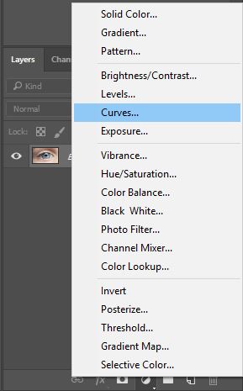
   3. This will create the following layer, and layer mask.  
      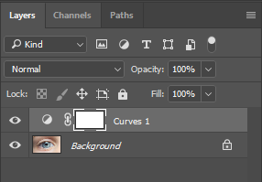

Curves Adjustment Layer

Layer mask

* 1. This will leave you with new layer and mask created at one time. Using the curve slider above, drag it up until your picture is brightened. Below you will see a picture of my eye with the brightness applied, and a picture of the curve slider.  
     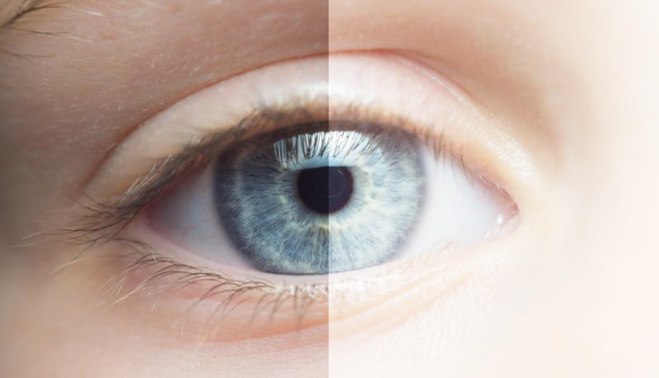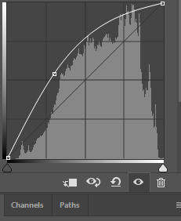

1. Use the elliptical marquee tool to make a selection around your eye. This will be used to create the mask around your eye. *Ensure you have selected the curves layer mask prior to doing this step.
   1. The marquee tool is found in the top of the tool selection bar. If you haven’t changed your layout, this is the top left of your screen. If the elliptical marquee tool isn’t available, click and hold on the rectangle marquee tool to bring of the elliptical marquee.  
      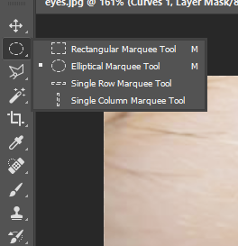  
      Click and drag to make your selection. If your selection isn’t quite centered, you can press and hold the spacebar to move your selection around.
   2. Once you are happy with your selection, press cmd/cntrl+I. This will invert your selection, creating your mask around your eye.
   3. If you would like, you can blur your mask by going to filter-blur-gaussian blur. This will make your adjustments softer around the edges. Increase the radius to adjust the blur.
2. Deselect your selection by pressing cmd/cntrl+D.
3. Now invert your mask by clicking on it in the layer panel, and press cmd/cntrl+I. You’ll notice that now your eye is the only part of the image that is still brightened.
   1. If your eye has eye lids covering part of it, you can adjust it by painting black over the eyelids. Press B to switch to the brush tool.  
        
      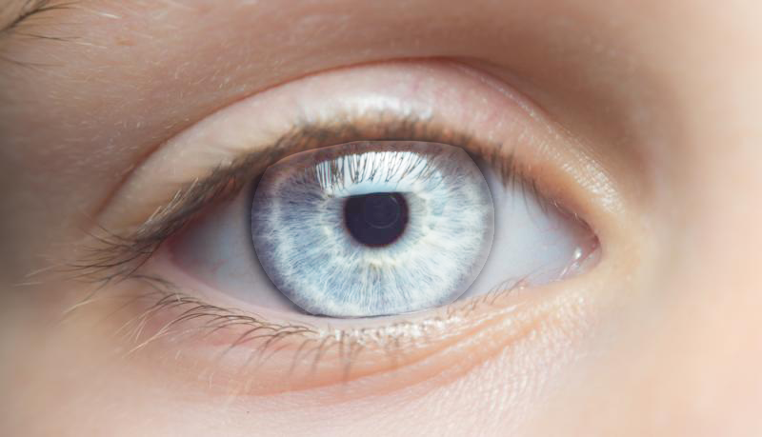
4. Next, create a group by clicking the folder icon that’s right next to the add adjustment layer button  
   
5. Move the mask to the group by clicking and dragging it to the new group.
   1. Drag your curves adjustment layer to the group as well so it will still have the mask applied.
   2. Note that anything inside the group will have the mask applied by default.
6. Now is the fun part, with your group selected, create a new hue/saturation adjustment layer using the same steps as you did for your curves adjustment layer.
7. Now it’s as easy as playing with the different sliders to see what you like best.  
   Below are a few eyes recolored by sliding only the Hue slider on the new adjustment layer:  
   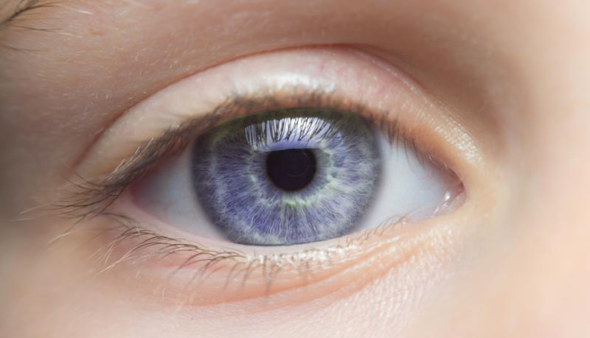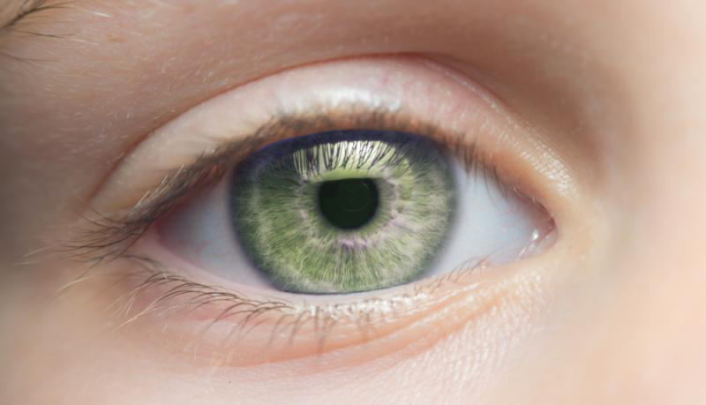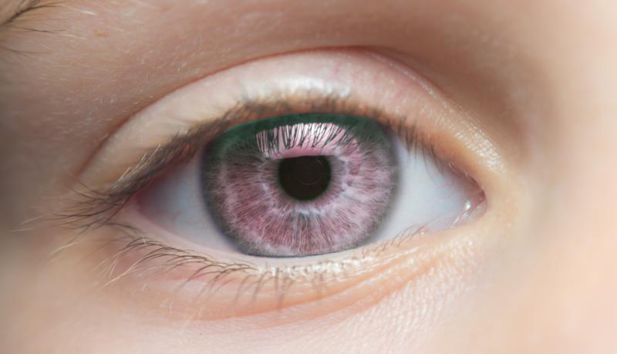
8. Feel free to play around with different settings, and even different adjustment layers!