How to automatically deploy our project

**( Check if you have setting permission,if yes follow next step,if not please fork the project in own repositories)**

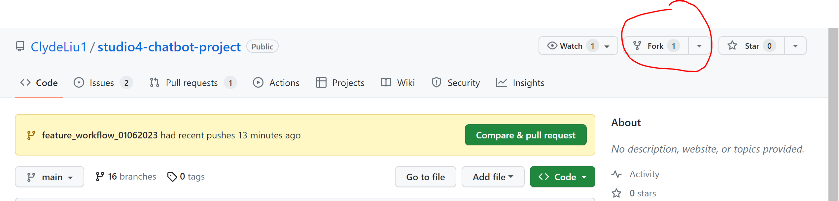

**1 Create self-hosted runner from github.**

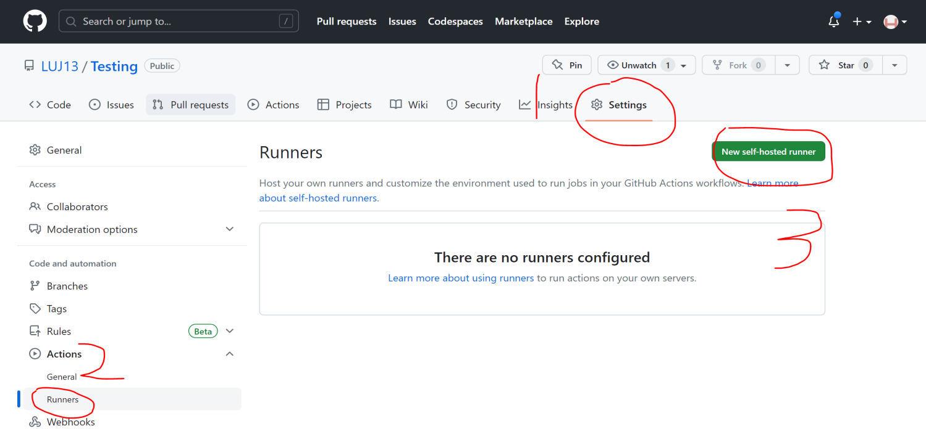

**2 Download, configure, and execute the GitHub Actions Runner**

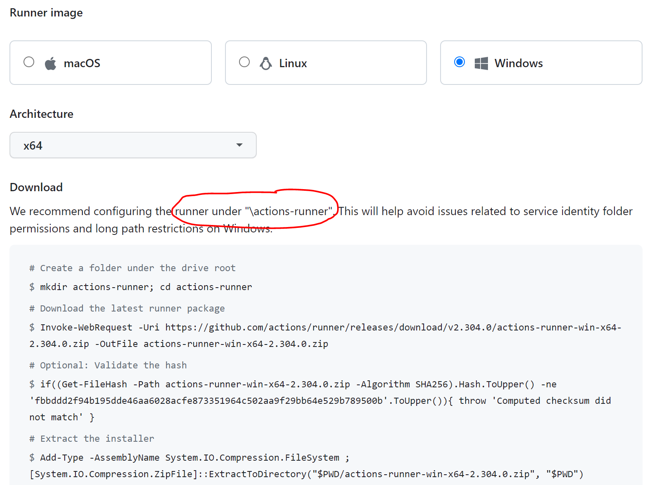

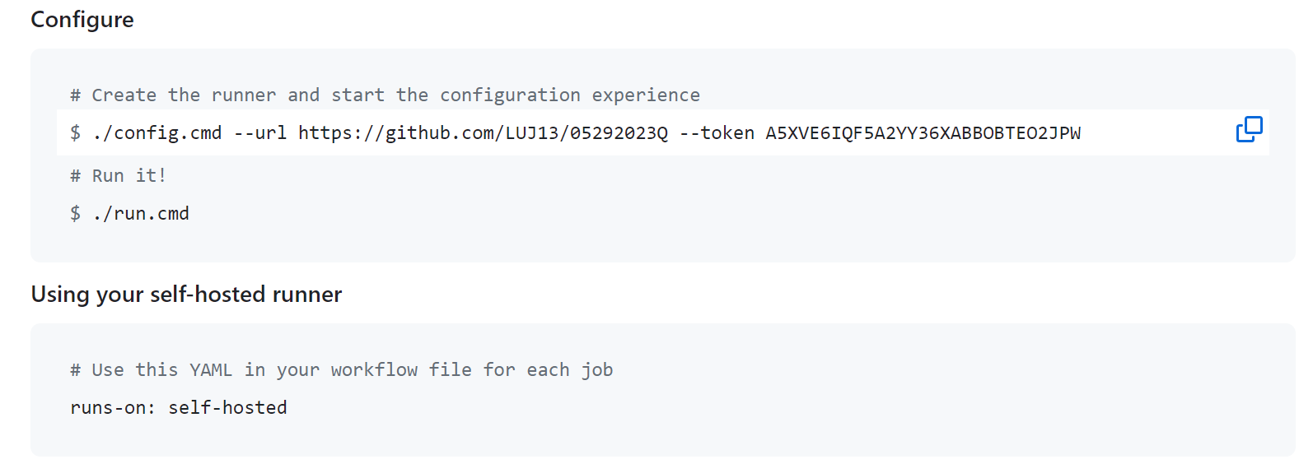

**3 Search “PowerShell” in your local machine,**

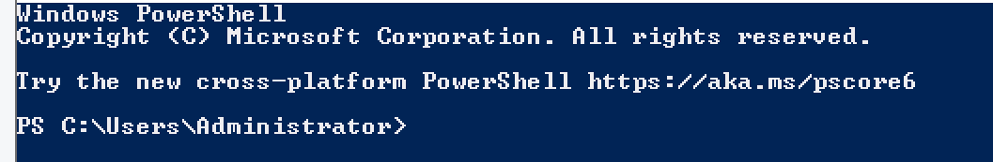

**4 Follow the 2 steps download,configure,run**

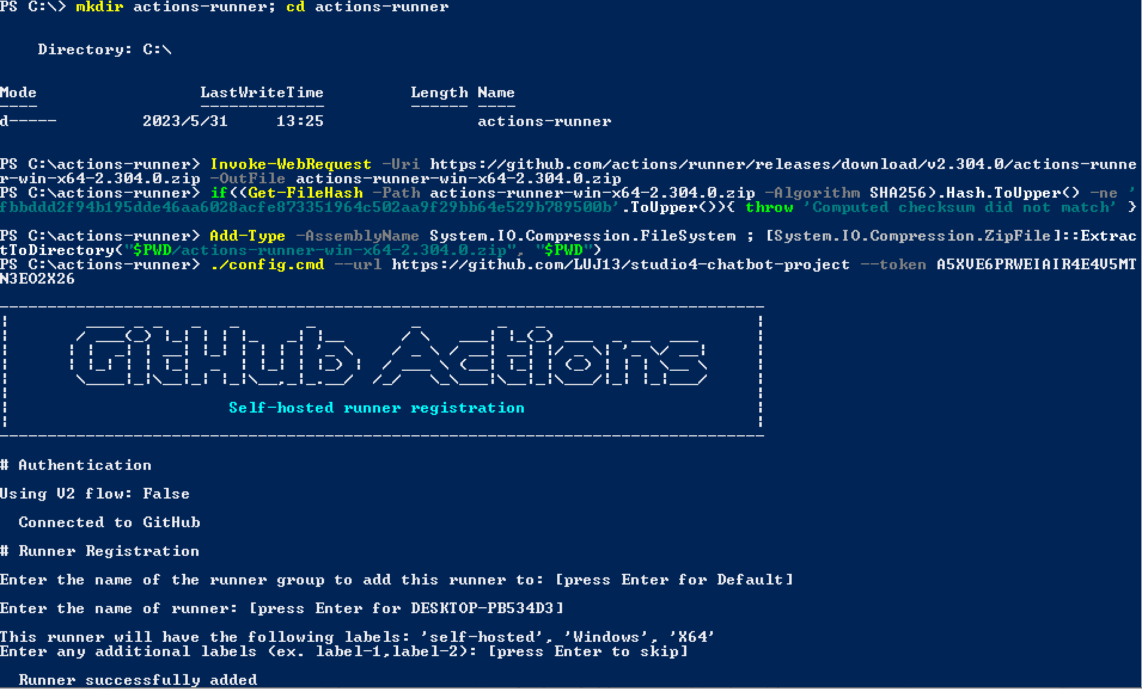

**5 Click the “Actions” button to create new workflow**

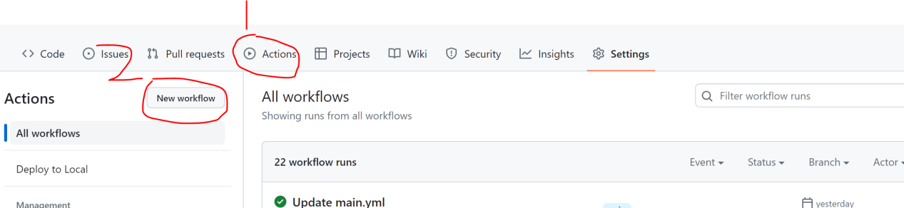

**6 Set up your workflow**

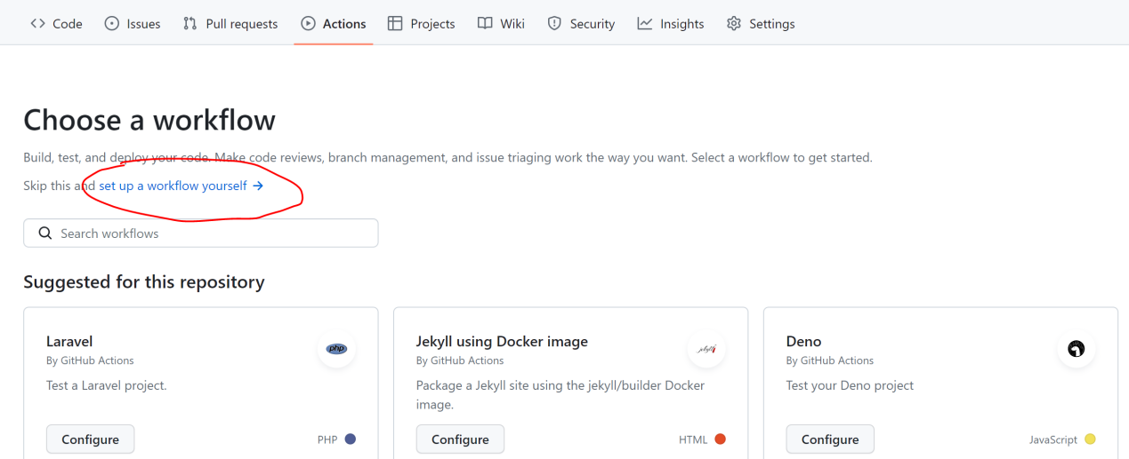

**7 Rename the .yml file and wirte down code**

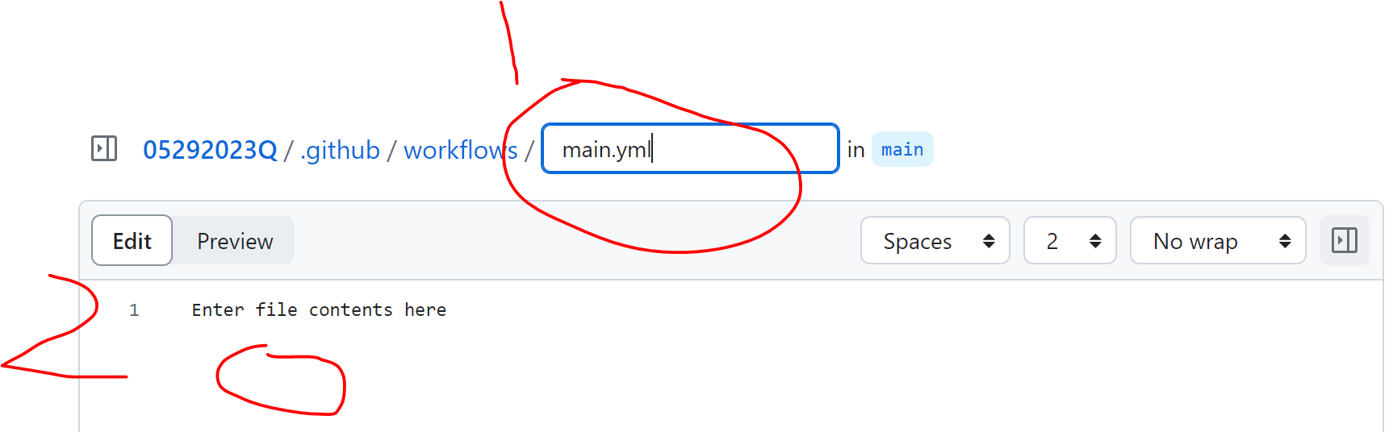

(Copy the code from here)

name: Deploy to Local

on:

push:

branches:

- main

jobs:

deploy:

runs-on: self-hosted

steps:

- name: Checkout Repository

uses: actions/checkout@v2

- name: Deploy to Local

run: cp -r pet-food-store C:\laragon\www\

**Notice(not code)**

# pet-food-store is the name of the file you want to copy

# C:\laragon\www\ is the local path you want to save

**8 There will be a newly file**

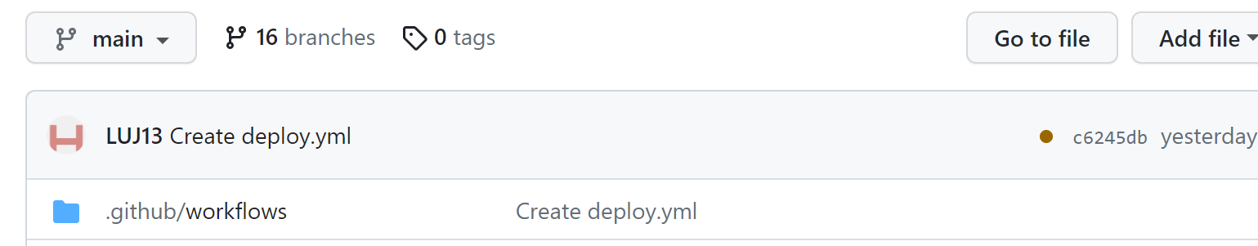

**9 Succeeded in PowerShell**

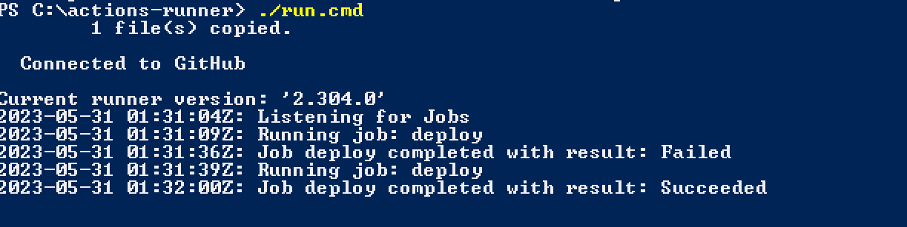

**10 Run the workflow project will be copied to local folder**

