1 How to automatically deploy our project

**( Check if you have setting permission,if yes follow next step,if not please fork the project in own repositories)**

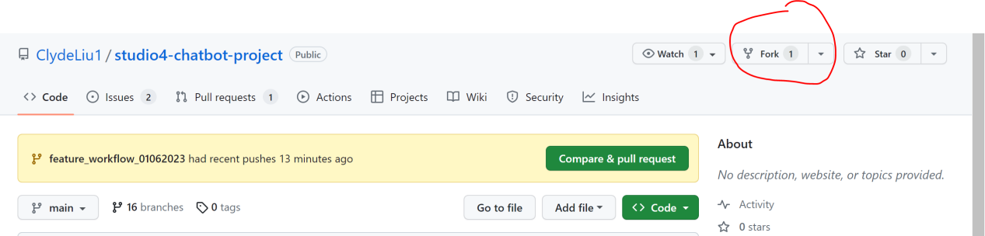

**1 Create self-hosted runner from github.**

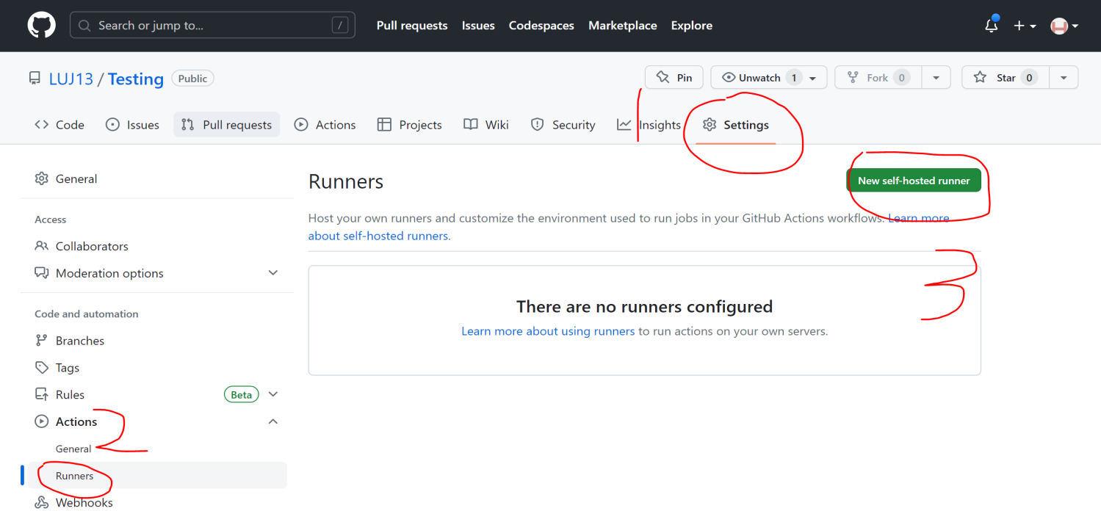

**2 Download, configure, and execute the GitHub Actions Runner**

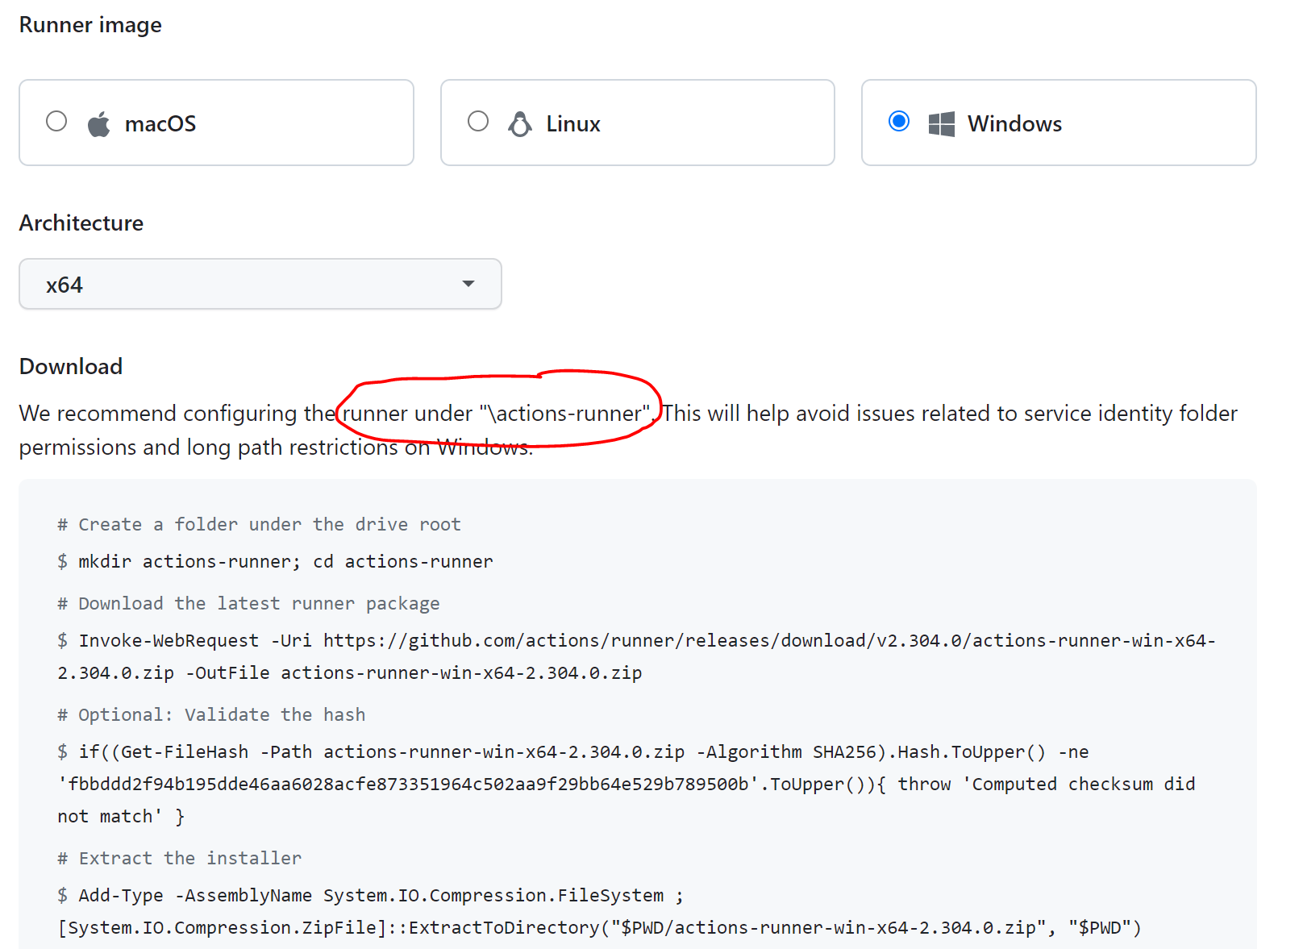

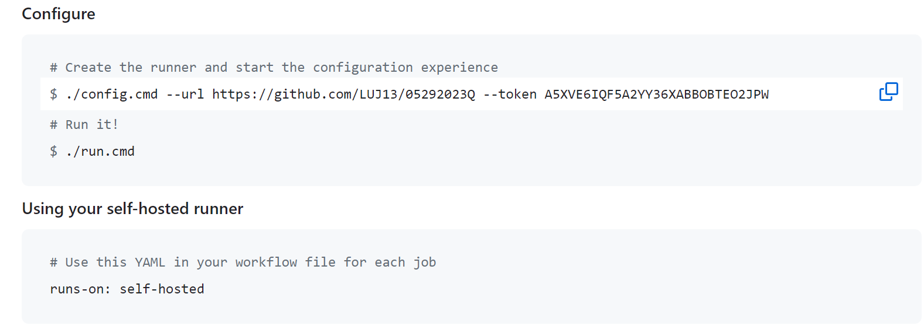

**3 Search “PowerShell” in your local machine,**

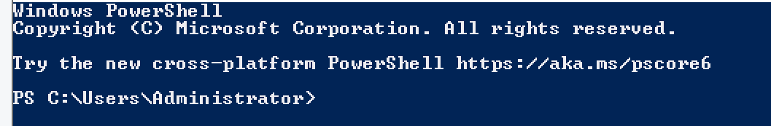

**4 Follow the 2 steps download,configure,run**

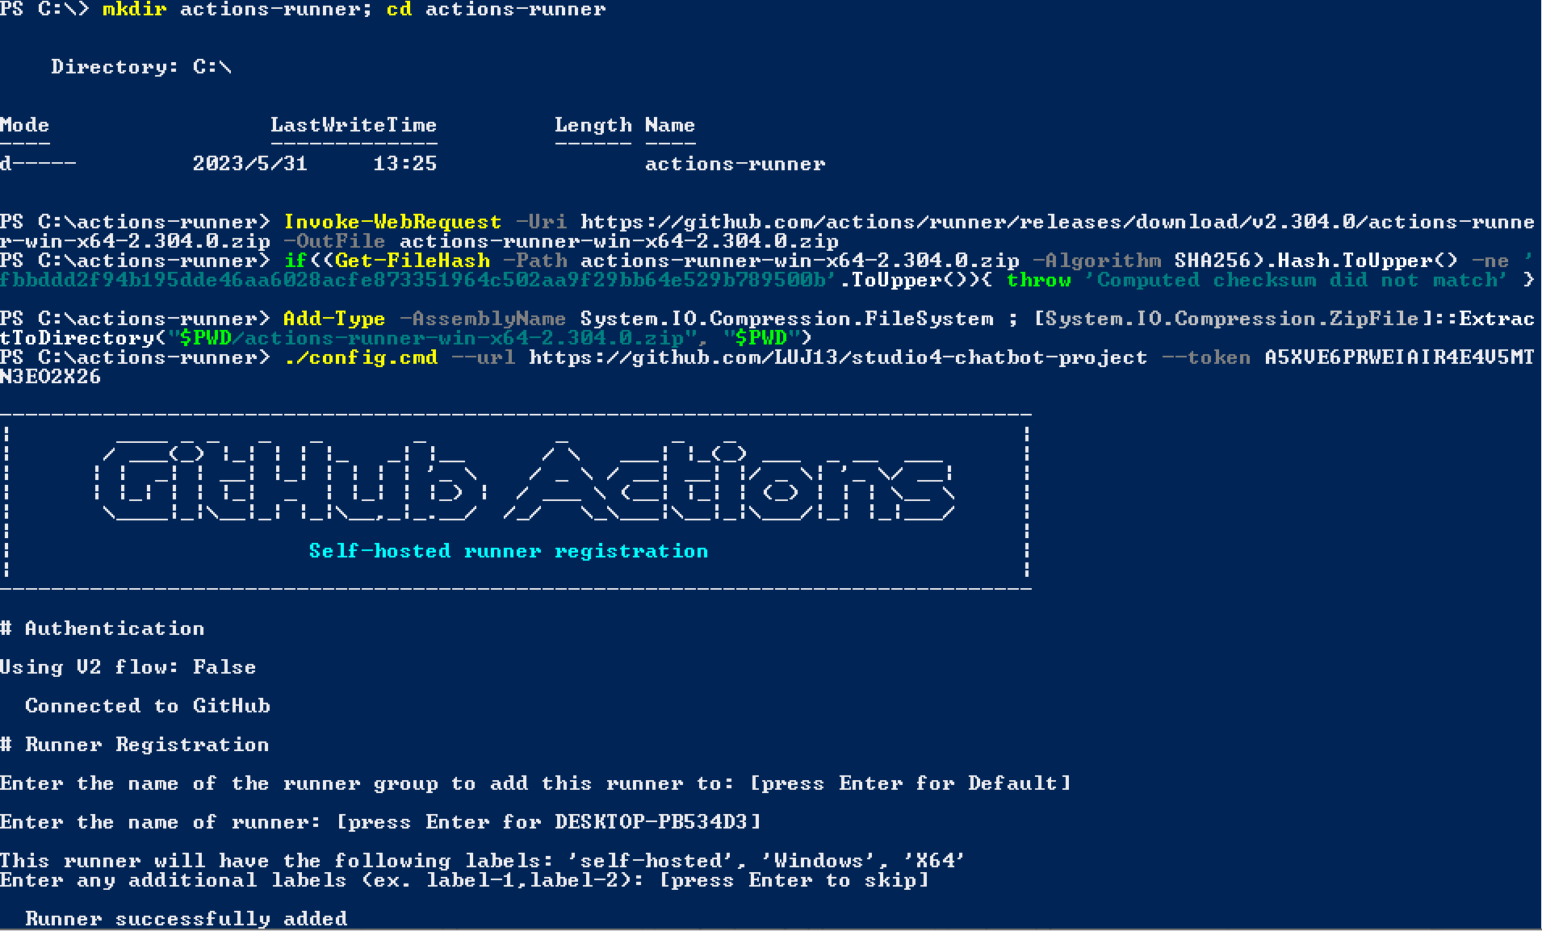

**5 Click the “Actions” button to create new workflow**

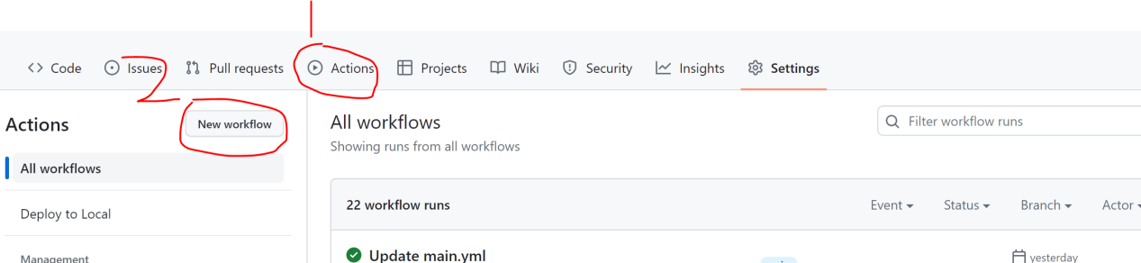

**6 Set up your workflow**

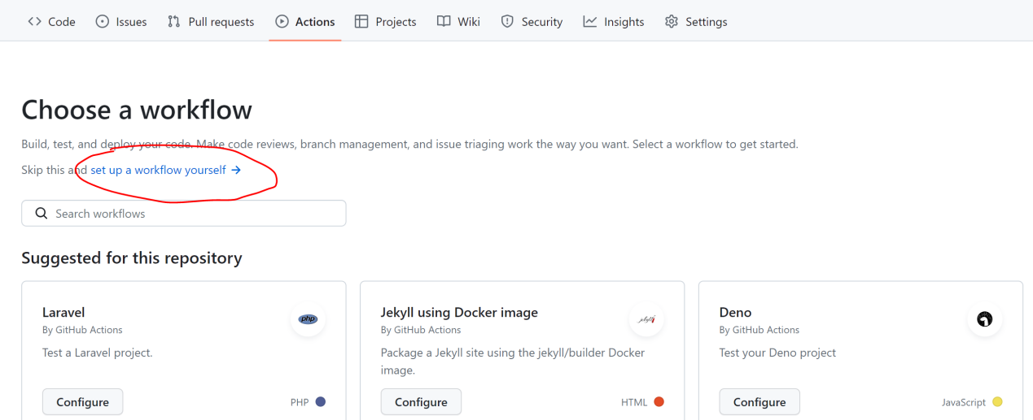

**7 Rename the .yml file and wirte down code**

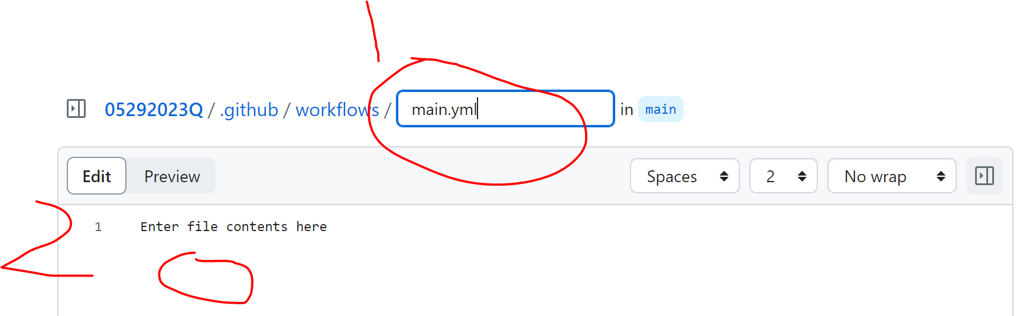

(Copy the code from here)

name: Deploy to Local

on:

push:

branches:

- main

jobs:

deploy:

runs-on: self-hosted

steps:

- name: Checkout Repository

uses: actions/checkout@v2

- name: Check if folder exists

run: |

if (Test-Path -Path "C:\laragon\www\pet-food-store" -PathType Container) { Remove-Item -Path "C:\laragon\www\pet-food-store" -Recurse -Force}

- name: Deploy to Local

run: cp -r pet-food-store C:\laragon\www\

- name: Deploy SQL files

run: |

Get-Content C:\laragon\www\pet-food-store\11.sql | mysql -h localhost -u root

build:

runs-on: self-hosted

steps:

- name: Checkout code

uses: actions/checkout@v2

- name: secret_key

run: setx API_KEY ${{ secrets.API_KEY }}

**Notice(not code)**

# pet-food-store is the name of the file you want to copy

# C:\laragon\www\ is the local path you want to save

**8 There will be a newly file**

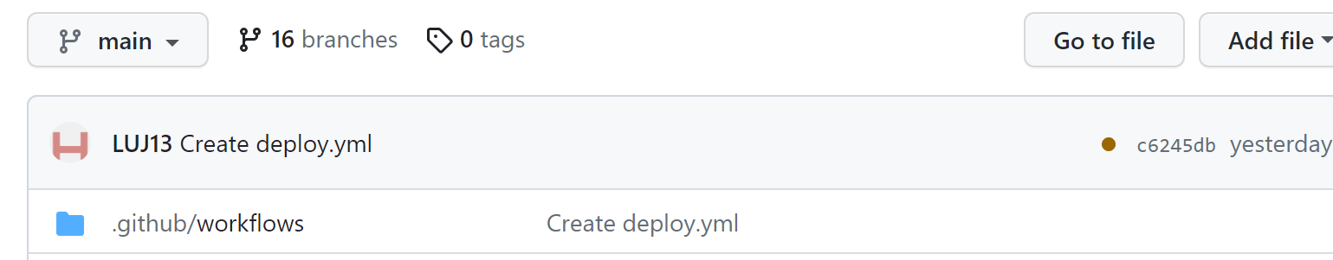

**9 Succeeded in PowerShell**

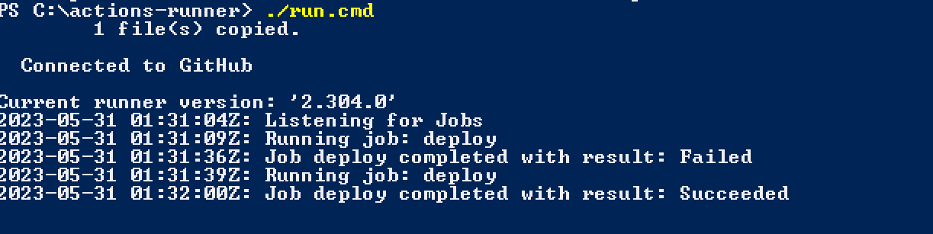

**10 Run the workflow project will be copied to local folder**

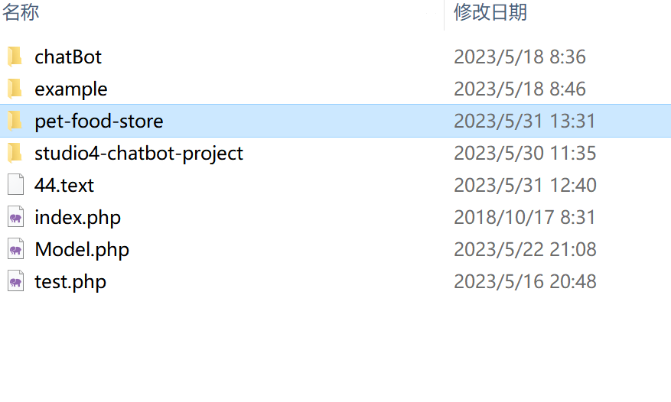

11 if you can not be able to run the file about .psl. Please right click the Powershell choose the administrator to run.Then configure according to the following steps(1 and 2)

1. **Set-ExecutionPolicy RemoteSigned**

This will allow you to run signed scripts on your local computer. Depending on your environment and security needs, you can also choose other execution strategies. But please note that changing the execution policy may have an impact on system security, please proceed with caution

1. **'C:\actions-runner\_work\_temp\f1f17458-82ad-40fa-8150-bd92c0c2aadd.ps1' -Force**

The -Force parameter can bypass the restrictions of the execution policy and allow the execution of script files.

**2 How to create secrets in GitHub.**

1. **First click on Settings.**

1. **After that click on Secrets and variables**

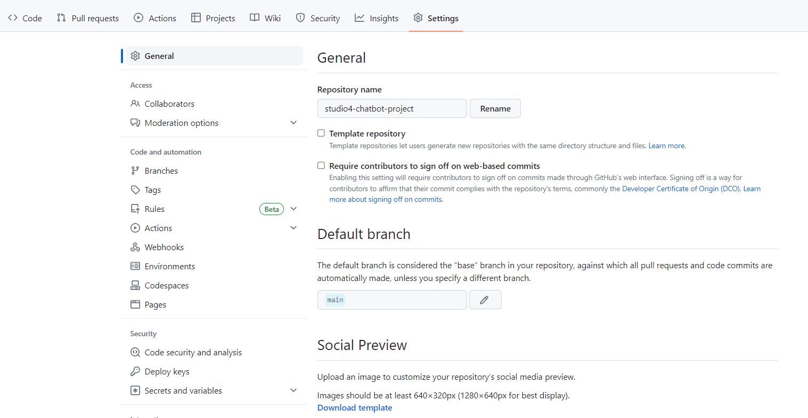

1. **Then click on Actions inside secrets and variable.**

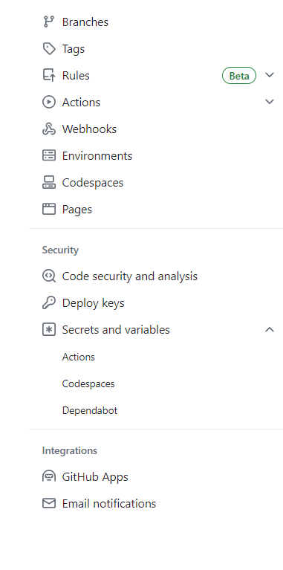

1. **Then click on green button New repository secret**

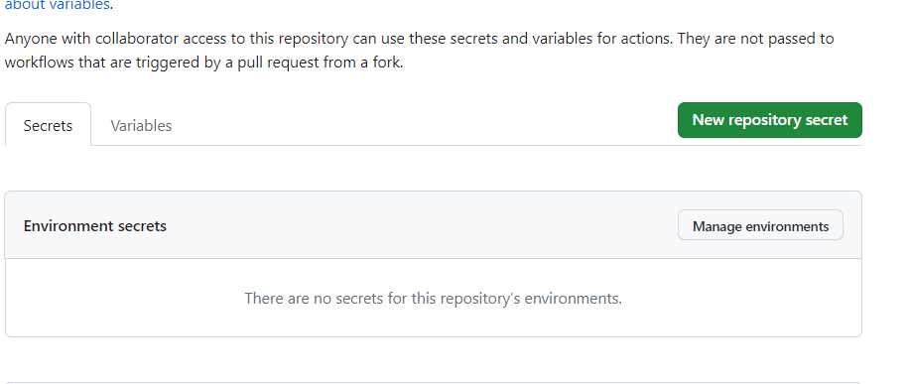

1. **Then you need to enter the name of secret key in Name box and value of key in Secret box. And after providing the details click on green button Add secret.**

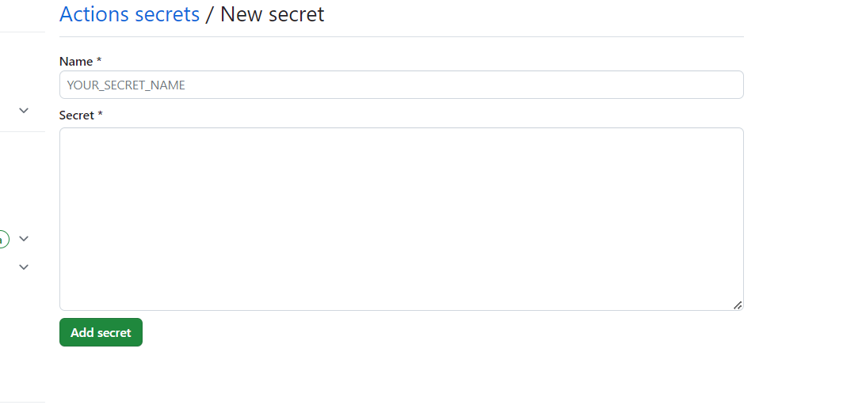

1. **After that you can see your key like this and if you want to change the key value you just need to click on edit button or you can delete by clicking on delete button. In this way you can create your secret value and you can use it in your code.**

1. **How to run the runner in GitHub.**
2. **Go to your GitHub Settings and click on Actions**



1. **Then click on Runners**

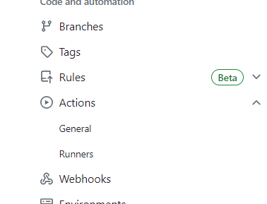

1. **If you haven’t created runner you need to create first. Once you have created the runner you can see them like below. Currently your runner is offline in a Status.**

1. **To start your runner. First open Windows PowerShell by searching on your system.**

1. **Then change the directory to c: by typing command cd \**

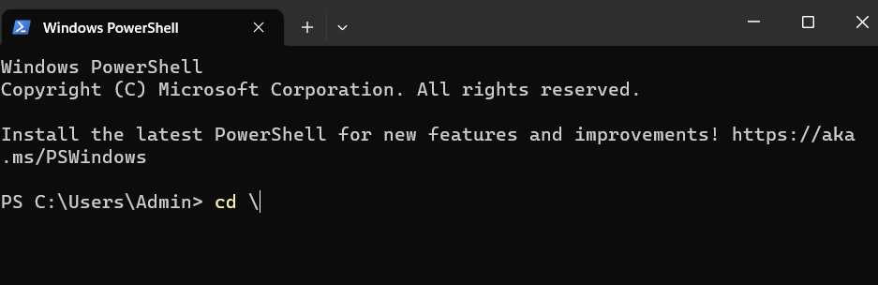

1. **Then change the directory to actions-runner folder by typing command cd actions-runner**

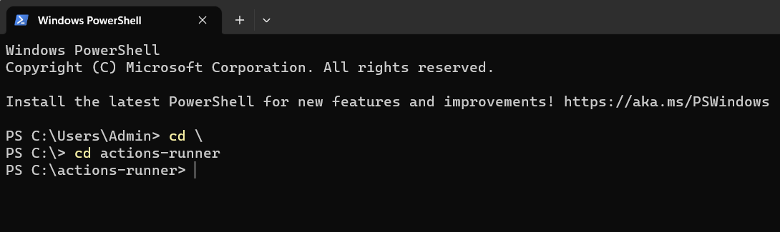

1. **And to start runner type ./run.cmd**

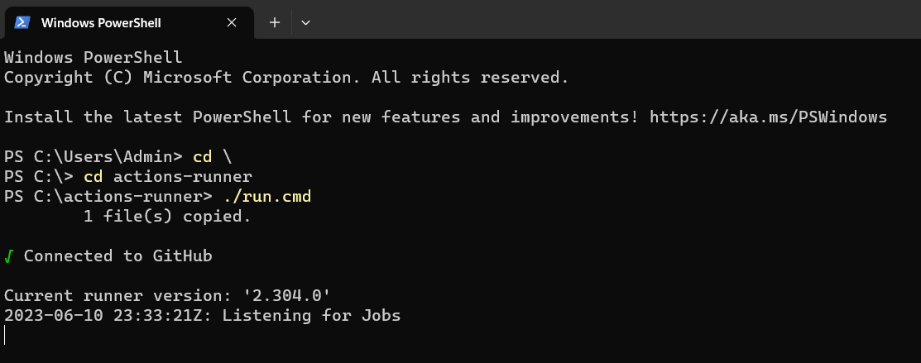

1. **At last, you can check your runner is working or not in status.**

1. **How to create workflow in GitHub.**
2. **Now to create workflow click on Actions.**

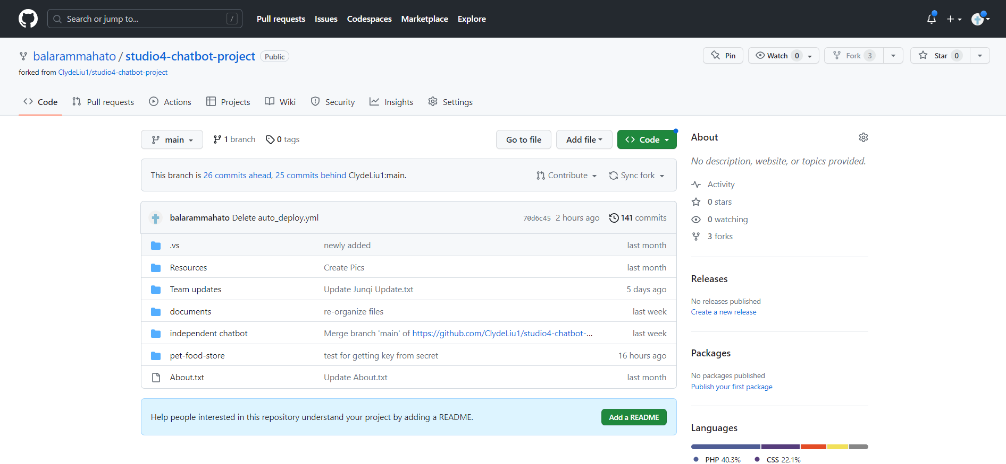

1. **Now click on New workflow button**

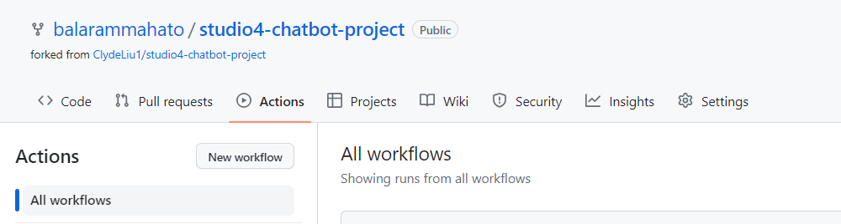

1. **Now click on set up a workflow yourself.**

1. **Now you can change the yml file name and enter your code.**

1. **After inserting code and changing name of yml file click on green button commit changes.**

1. **After that you can type a message of commit you want and click on green button commit changes.**

1. **After that your workflow will be ready.**

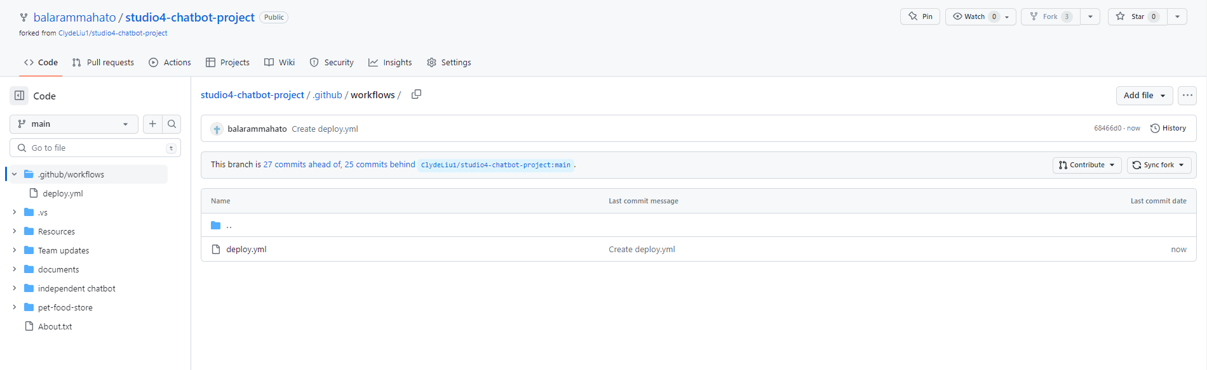

**Note: If your workflow deploy.yml file have no error then when you click on deploy.yml file you will see below**

1. **Once you click on Actions and you can see below**

1. **When you click on green ticked Create deploy.yml you can see what has been successfully triggered**

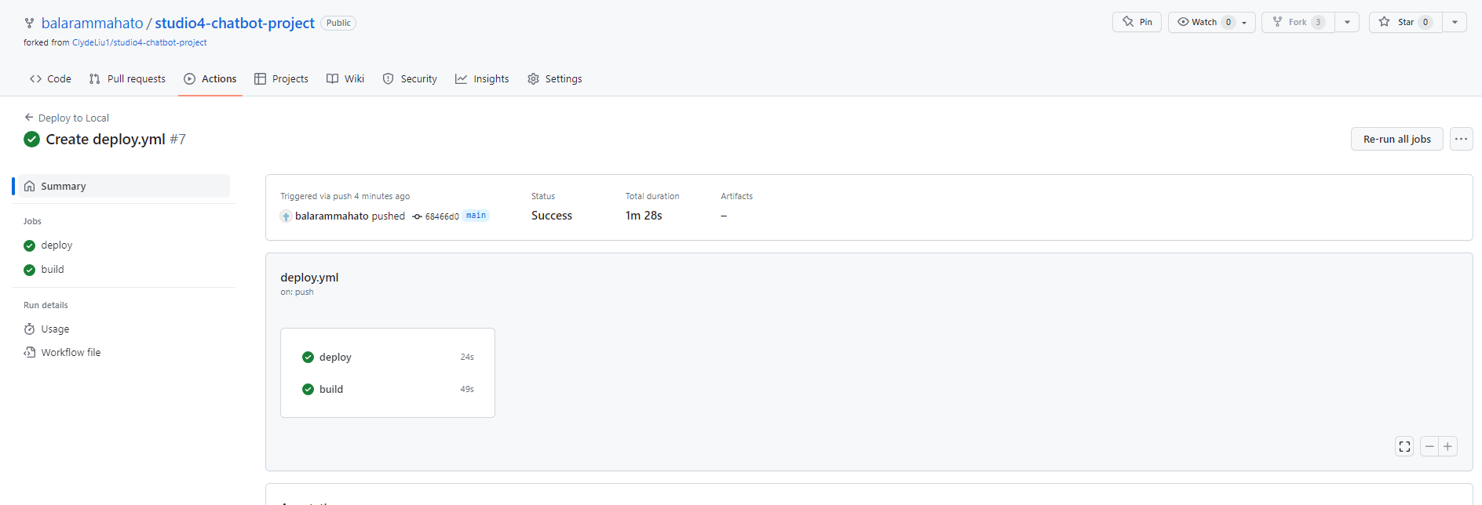

1. **After successfully running workflow, you will get the GitHub project on your system, and you can verify.**

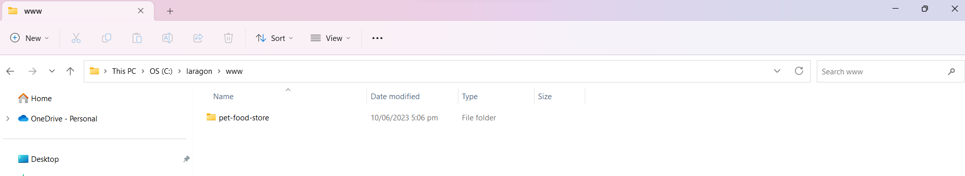

1. **And to verify API key you can right click on This PC and click on Properties.**

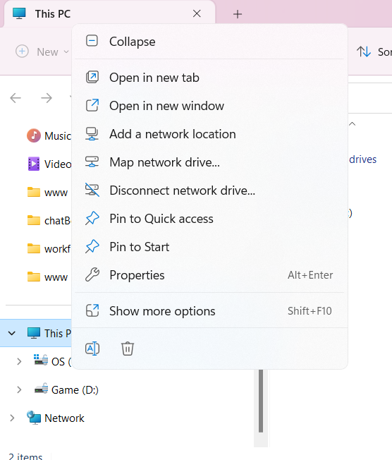

1. **Then click on Advance system setting.**

