Github repo: <https://github.com/ClydeyBoy/mission-5>

**Screenshot of Azure Dev-ops Task board:**

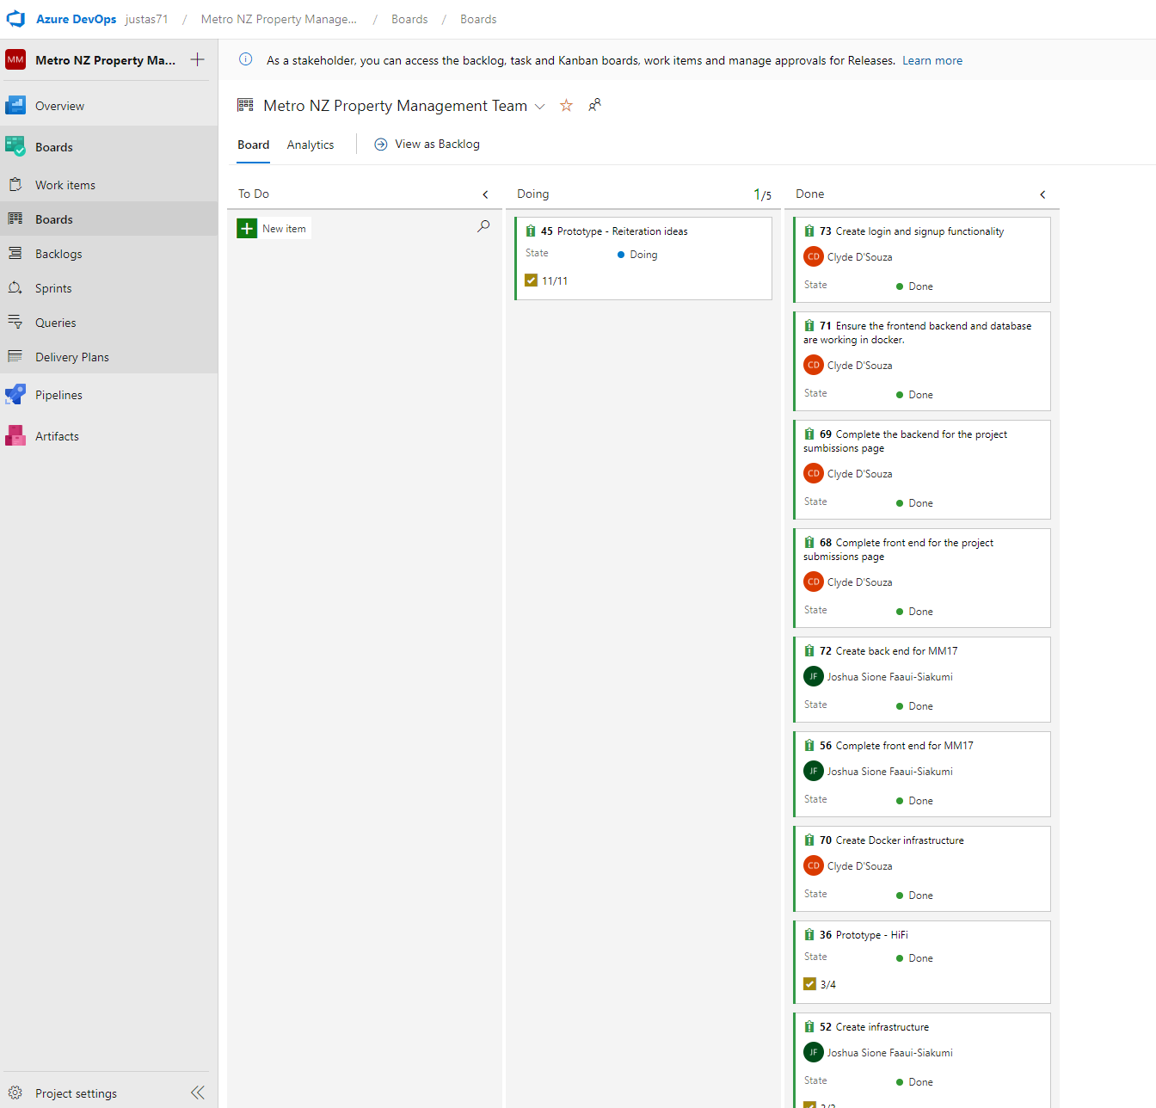

**Evidence of daily standup meetings:**

