## Due Date (See MyCourses ASSIGMENTS) Assignment Box PE05

## Name: Please put Last name (Lastname, Firstname)_____________Lynch, Connor___________________

## Instructions:

## 1) Download this Word Document. Type your answers in this Word Document.

## 2) Convert this Word Document INTO PDF Document

## after you complete all your answers.

For each problem below, normalize the relations into the second Normal Form 2nf.

**Be sure to use proper relational notation (relational scema):**   
 RELATION(pkattr, attribute1, attribute2, attribute3, *fkattr*)

**Include reference statements for foreign keys (Must Exist In or M.E.I**.) statements

**Problem #1**

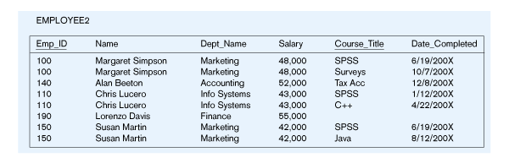

EMPLOYEE2(Emp_ID, Name, Dept_Name, Salary, Course_Title, Date_Completed)

**Functional Dependencies:**

Emp_ID, Course_Title 🡺 Name, Dept_Name, Salary, Date_Completed

EmpID 🡺 Name, Dept_Name, Salary

**YOUR ANSWER (in relationa scema format) is? What is/are your M.E.I. statement(s) ?**

EMPLOYEE(EmpID, Name, Dept_Name, Salary)

COURSE(*EmpID*, Course_Title, Date_Completed)

- - - -

COURSE(EmpID) M.E.I. EMPLOYEE(EmpID)**Problem #2**

ENGINEER-SERVICE(empID, firstname, lastname, email, serviceID, servicename)

**Note: an engineer can provide many services and a service can be provided by many engineers.**

**<M:N> Is the correct cardinality ratio of this problem.**

**Functional Dependencies:**

empID, serviceID 🡺 firstname, lastname, email, servicename

empID 🡺 firstname, lastname, email

email 🡺 empID, firstname, lastname

serviceID 🡺 servicename

**YOUR ANSWER (in relationa scema format) is? What is/are your M.E.I. statement(s) ?**

EMPLOYEE(empID, firstname, lastname, email)

SERVICE(serviceID, servicename)

EMP-SERV(*empID*, *serviceID*)

- - - - - - - -

EMP-SERV(empID) M.E.I. EMPLOYEE(empID)

EMP-SERV(serviceID) M.E.I. SERVICE(serviceID)

**Problem #3**

Movie

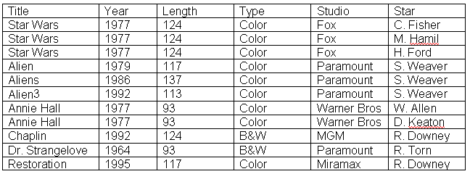

MOVIE(Title, Year, Length, Type, Studio, Star)

**Functional Dependencies:**

Title, Star 🡺 Year, Length, Type Studio

Title 🡺 Year, Length, Type, Studio

**YOUR ANSWER (in relationa scema format) is? What is/are your M.E.I. statement(s) ?**

MOVIE(title, year, length, type, studio)

STARS(*title*, star)

**- - -**

STARS(title) Must Exist In MOVIE(title)

**Problem #4  
Is This a relation?_______YES OR NO_______________**

**What is/are the Primary key? __SupplierId + ProductID_____ It appears to have 2 fields (COMPOSTE KEY)**

**Normalize the folling table. Use Relational Schema! Please include a proper M.E.I.**

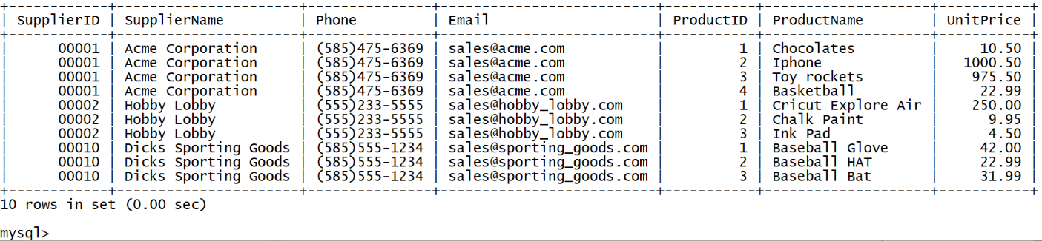

Study myfirstdb_version3.sql

**What is/are your M.E.I. statement(s) ? What are your relational schemas?**

SUPPLIER(SupplierID, SupplierName, Phone, Email)

PRODUCT(*SupplierID*, ProductID, ProductName, UnitPrice)

- - - -

PRODUCT(SupplierID) M.E.I. SUPPLIER(SupplierID)

**Problem #5**

Grocery Locations

You need to normalize**(to the 3rd Normal form rule)** an inventory database for a small-town grocery store. Write the normalized relations using relational schema. Also write the   
require **M.E.I.** (**M**ust **E**xist **I**n) Statement

* **Business Rule:**
  + **A product, regardless of brand, will only be stored in one place (aisle#) in the store.**

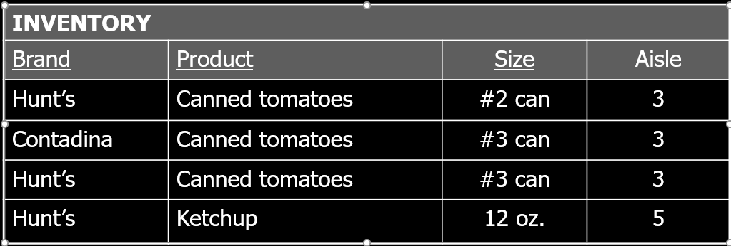

AISLE(Product, Aisle)

ITEM(Brand, *Product*, Size)

- - - -

ITEM(Product) M.E.I. AISLE(Product)