## Due Date (See MyCourses ASSIGMENTS) Assignment Box PE07

## Name: Please print Last name (Lastname, Firstname)_______Lynch, Connor_________________

## Recommend that you download this Word Document and type your Answers. You can upload it as a Word Document and/or PDF Document – I prefer PDF’s.

Use the following relations to answer the questions 1 through 4. For each question, show the operations used. **WRITE the required MySql** **AND** the results. DIFFERENCE IS **NOT** MySQL key word.

|  |  |  |  |  |  |  |  |  |  |  |  |  |  |  |  |  |  |  |  |  |  |  |  |  |  |  |  |  |  |  |  |  |  |  |  |  |  |  |  |  |  |  |  |
| --- | --- | --- | --- | --- | --- | --- | --- | --- | --- | --- | --- | --- | --- | --- | --- | --- | --- | --- | --- | --- | --- | --- | --- | --- | --- | --- | --- | --- | --- | --- | --- | --- | --- | --- | --- | --- | --- | --- | --- | --- | --- | --- | --- |
| STUDENT   |  |  |  | | --- | --- | --- | | StudentID | Name | Major | | 123 | Bill | IT | | 234 | Sue | CS | | 345 | Tom | SE | | 456 | Ann | BUS | | 567 | Linda | IT | | 678 | Tom | IT | | 789 | Sue | LA | | ITSTUDENT   |  |  |  | | --- | --- | --- | | StudentID | Name | Major | | 123 | Bill | IT | | 567 | Linda | IT | | 678 | Tom | IT | | 890 | Jon | IT | | 901 | Lynn | IT | |

1. What is the result of the union of STUDENT and ITSTUDENT?

**Relational Operation Here**

_____________________STUDENT union ITSTUDENT______________________  
**MySQL Here**

_____________SELECT * FROM student UNION SELECT * FROM itstudent;_______

**Results of Operation Here**

|  |  |  |
| --- | --- | --- |
| StudentID | Name | Major |
| 123 | Bill | IT |
| 234 | Sue | CS |
| 345 | Tom | SE |
| 456 | Ann | BUS |
| 567 | Linda | IT |
| 678 | Tom | IT |
| 789 | Sue | LA |
| 890 | Jon | IT |
| 901 | Lynn | IT |
|  |  |  |
|  |  |  |
|  |  |  |

**Note**: Not all rows may be used.

1. What is the result of the intersection of STUDENT and ITSTUDENT?

**Relational Operation Here**

___________________STUDENT ∩ ITSTUDENT___________________  
**MySQL Here**

____________SELECT * FROM student INTERSECT SELECT * FROM itstudent;_________

**Results of Operation Here**

|  |  |  |
| --- | --- | --- |
| StudentID | Name | Major |
| 123 | Bill | IT |
| 567 | Linda | IT |
| 678 | Tom | IT |
|  |  |  |
|  |  |  |
|  |  |  |
|  |  |  |
|  |  |  |
|  |  |  |
|  |  |  |
|  |  |  |
|  |  |  |

**Note**: Not all rows may be used.

1. What is the result of the difference of STUDENT and ITSTUDENT?

**Relational Operation Here**

__________________STUDENT - ITSTUDENT______________________  
**MySQL Here**

SELECT * FROM Student

WHERE Student.studentID NOT IN

(

SELECT itstudent.studentID FROM itstudent JOIN student USING (studentID)

);

**Results of Operation Here**

|  |  |  |
| --- | --- | --- |
| StudentID | Name | Major |
| 234 | Sue | CS |
| 345 | Tom | SE |
| 456 | Ann | BUS |
| 789 | Sue | LA |
|  |  |  |

**Note**: Not all rows may be used.

1. What is the result of the difference of ITSTUDENT and STUDENT

**Relational Operation Here**

_____________________ITSTUDENT - STUDENT______________________  
**MySQL Here**

SELECT * FROM itstudent

WHERE itstudent.studentID NOT IN

(

SELECT student.studentID FROM student JOIN itstudent USING (studentID)

);

**Results of Operation Here**

|  |  |  |
| --- | --- | --- |
| StudentID | Name | Major |
| 890 | Jon | IT |
| 901 | Lynn | IT |
|  |  |  |
|  |  |  |
|  |  |  |
|  |  |  |
|  |  |  |
|  |  |  |

**Note**: Not all rows may be used.

**Consider these two tables below when answering question #5.**

Left table is relation dept and it can be found in script jimsNEW.sql

Right table is relation emp and it can also be found in script jimsNEW.sql

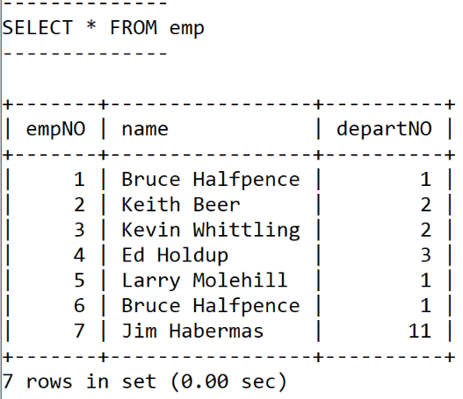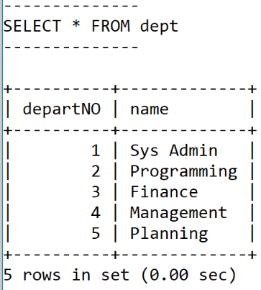

**See question #5 on NEXT page.**

1. Using MySQL **only** create a FULL OUTER JOIN of   
   dept AND emp  
    **MySQL Here ( some starter code was provided to you below)**

SELECT DISTINCT dept.departNO AS "Dept #", dept.name AS "Department_Name", emp.name AS "Employee_Name"

FROM dept LEFT JOIN emp USING (departNO)

UNION

SELECT DISTINCT dept.departNO AS "Dept #", dept.name AS "Department_Name", emp.name AS "Employee_Name"

FROM dept RIGHT JOIN emp USING (departNO);

What does your version of a FULL OUTER JOIN between emp and dept produce?

|  |  |  |
| --- | --- | --- |
| **Dept #** | **Department_Name** | **Employee_Name** |
| **1** | **Sys Admin** | **Bruce Halfpence** |
| **1** | **Sys Admin** | **Larry Molehill** |
| **2** | **Programming** | **Keith Beer** |
| **2** | **Programming** | **Kevin Whittling** |
| **3** | **Finance** | **Ed Holdup** |
| **4** | **Management** | **NULL** |
| **5** | **Planning** | **NULL** |
| **NULL** | **NULL** | **Jim Habermas** |
|  |  |  |
|  |  |  |