Properties Section
Properties Section | Area ($A_{m}$) = |  | in²
Properties Section | Moment of Inertia ($I_{xx}$) = |  | in⁴
Properties Section | Plastic Modulus ($Z_{xx}$ ) = |  | in³

Beam  Data | Span ($L$) = |  | ft
Beam  Data | Spacing ($s$) = |  | ft
Beam  Data | Span Type =
Beam  Data | $α$=
Beam  Data | $β$=

Material  Data | Material =
Material  Data | Mullion density ($ρ_{m}$) = |  | pcf | Glass Weight ($w_{g}$) = |  | psf
Material  Data | Modulus of Elasticity ($E$) = |  | ksi | Yield Strength ($F_{y}$) = |  | ksi
Material  Data | Mass ${(M}_{t}={(L s w_{g}+{{L A}_{m} ρ}_{m})}/g)$= |  | kips-sec²/in
Material  Data | Dynamic Increase factor ($DIF$) = |  | Strength Increase Factor($SIF$) =

SDOF Properties | KLM_{e}= |  |  | 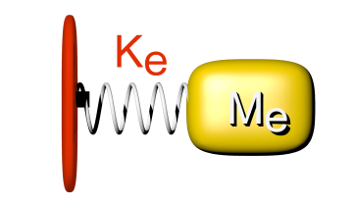
SDOF Properties | KLM_{p}=
SDOF Properties | Equivalent Mass($M_{e}=KLM M_{t}$) = |  | kips-sec²/in
SDOF Properties | Equivalent Stiffness($K_{e}=\frac{EI_{XX}}{αL^{3}}$) = |  | kips/in
SDOF Properties | System Period $(T=2π\sqrt{\frac{M_{e}}{K_{e} }})$= |  | m-sec

Results | Plastic Moment($M_{P}={DIF SIF F}_{y}Z_{xx}$) = |  | kips-in
Results | Ultimate Resistance$(R_{u}=\frac{βM_{P}}{L}$) = |  | Kips
Results | Yield Displacement $(y_{e}=\frac{R_{u}}{K_{e}}$) = |  | in
Results | Maximum Displ. $(δ_{max}$) = |  | in | Minimum Displ. $(δ_{min}$) = |  |  | In
Results | Ductility Factor $(μ)$ = |  |  | Sup. Rotation$\left(θ_{max}\right)$ = |  |  | °

Displacement
(inches)

Velocity
(inch/sec)

Restoring
Force (kips)

Applied Load
(kips)

Reactions
(kips)

Time (seconds)

