AMS 617 cat

R Markdown
- Generate Appropriate Graphs to Present the Data
# Load necessary libraries
library(ggplot2)
library(dplyr)
##
## Attaching package: 'dplyr'
## The following objects are masked from 'package:stats':
##
## filter, lag
## The following objects are masked from 'package:base':
##
## intersect, setdiff, setequal, union
library(readr)
library(corrplot)
## corrplot 0.95 loaded
library(tinytex)
# Load dataset
df <- read_csv("C:\\Users\\franc\\rdatascience\\projects\\Housing.csv", show_col_types = FALSE)
# Convert categorical variables to factors
categorical_columns <- c("mainroad", "guestroom", "basement",
"hotwaterheating", "airconditioning", "prefarea", "furnishingstatus")
df[categorical_columns] <- lapply(df[categorical_columns], as.factor)
# View the first few rows
head(df)
## # A tibble: 6 × 13
## price area bedrooms bathrooms stories mainroad guestroom basement
## <dbl> <dbl> <dbl> <dbl> <dbl> <fct> <fct> <fct>
## 1 13.3 7.42 4 2 3 yes no no
## 2 12.2 8.96 4 4 4 yes no no
## 3 12.2 9.96 3 2 2 yes no yes
## 4 12.2 7.5 4 2 2 yes no yes
## 5 11.4 7.42 4 1 2 yes yes yes
## 6 10.8 7.5 3 3 1 yes no yes
## # ℹ 5 more variables: hotwaterheating <fct>, airconditioning <fct>,
## # parking <dbl>, prefarea <fct>, furnishingstatus <fct>
Explanation show_col_types = FALSE → Suppresses the message. as.factor() → Converts categorical (chr) columns to factor. lapply(df[categorical_columns], as.factor) → Converts all specified categorical columns.
Histogram of House Prices
ggplot(df, aes(x = price)) +
geom_histogram(fill = "blue", bins = 30, alpha = 0.7) +
labs(title = "Distribution of House Prices", x = "Price", y = "Count")
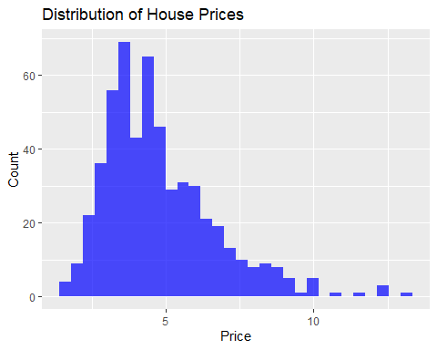
Scatter Plot: Price vs. Area
ggplot(df, aes(x = area, y = price)) +
geom_point(color = "red", alpha = 0.6) +
labs(title = "Scatter Plot: Price vs Area", x = "Area", y = "Price")
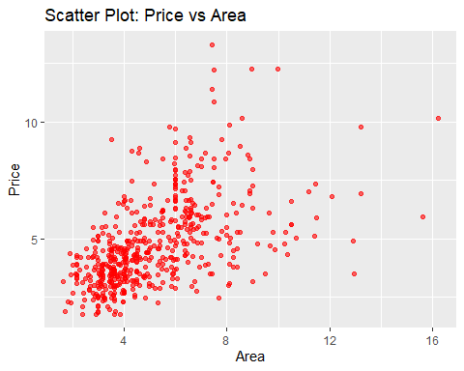
Correlation Heatmap
# Convert categorical variables to numeric
df_numeric <- df %>%
mutate(across(where(is.character), as.factor)) %>%
mutate(across(where(is.factor), as.numeric))
# Compute correlation matrix
corr_matrix <- cor(df_numeric)
# Heatmap
corrplot(corr_matrix, method = "color", type = "upper", tl.cex = 0.8)
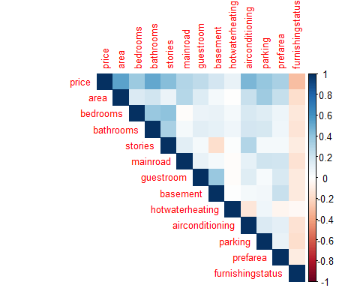
mutate(across(where(is.factor), as.numeric)) → Converts factors to numeric for correlation.
- Perform Descriptive Analysis of the Dataset
# Summary statistics
summary(df)
## price area bedrooms bathrooms
## Min. : 1.750 Min. : 1.650 Min. :1.000 Min. :1.000
## 1st Qu.: 3.430 1st Qu.: 3.600 1st Qu.:2.000 1st Qu.:1.000
## Median : 4.340 Median : 4.600 Median :3.000 Median :1.000
## Mean : 4.767 Mean : 5.151 Mean :2.965 Mean :1.286
## 3rd Qu.: 5.740 3rd Qu.: 6.360 3rd Qu.:3.000 3rd Qu.:2.000
## Max. :13.300 Max. :16.200 Max. :6.000 Max. :4.000
## stories mainroad guestroom basement hotwaterheating airconditioning
## Min. :1.000 no : 77 no :448 no :354 no :520 no :373
## 1st Qu.:1.000 yes:468 yes: 97 yes:191 yes: 25 yes:172
## Median :2.000
## Mean :1.806
## 3rd Qu.:2.000
## Max. :4.000
## parking prefarea furnishingstatus
## Min. :0.0000 no :417 furnished :140
## 1st Qu.:0.0000 yes:128 semi-furnished:227
## Median :0.0000 unfurnished :178
## Mean :0.6936
## 3rd Qu.:1.0000
## Max. :3.0000
- Formulate Five Objectives, Perform Tests of Hypothesis, and Discuss Results
If p-value ≤ 0.05, reject HO (significant effect).
If p-value > 0.05, fail to reject HO (no significant effect).
Objective 1: Does Area Affect Price?
Hypothesis:
HO: Area has no effect on price.
HA: Area has an effect on price.
# Test: Pearson Correlation
cor_test <- cor.test(df$area, df$price)
cor_test
##
## Pearson's product-moment correlation
##
## data: df$area and df$price
## t = 14.795, df = 543, p-value < 2.2e-16
## alternative hypothesis: true correlation is not equal to 0
## 95 percent confidence interval:
## 0.4733158 0.5932784
## sample estimates:
## cor
## 0.5359973
conclusion: Area has an effect on price
Objective 2: Do Houses Near the Main Road Have Higher Prices?
Hypothesis:
HO: No price difference based on proximity to the main road.
HA: Houses near the main road have different prices.
# Test: t-test
t.test(price ~ mainroad, data = df)
##
## Welch Two Sample t-test
##
## data: price by mainroad
## t = -11.853, df = 210.68, p-value < 2.2e-16
## alternative hypothesis: true difference in means between group no and group yes is not equal to 0
## 95 percent confidence interval:
## -1.857781 -1.327964
## sample estimates:
## mean in group no mean in group yes
## 3.398905 4.991777
conclusion: Main Road has an effect on price.
p-value ≤ 0.05,hence reject HO
Objective 3: Does the Number of Bedrooms Impact Price?
Hypothesis:
HO:Number of bedrooms does not affect price.
HA:Number of bedrooms affects price.
# Test: Linear Regression
model_bedrooms <- lm(price ~ bedrooms, data = df)
summary(model_bedrooms)
##
## Call:
## lm(formula = price ~ bedrooms, data = df)
##
## Residuals:
## Min 1Q Median 3Q Max
## -4.6967 -1.2103 -0.2653 0.9409 7.5721
##
## Coefficients:
## Estimate Std. Error t value Pr(>|t|)
## (Intercept) 2.0127 0.3092 6.510 1.71e-10 ***
## bedrooms 0.9288 0.1012 9.179 < 2e-16 ***
## ---
## Signif. codes: 0 '***' 0.001 '**' 0.01 '*' 0.05 '.' 0.1 ' ' 1
##
## Residual standard error: 1.742 on 543 degrees of freedom
## Multiple R-squared: 0.1343, Adjusted R-squared: 0.1327
## F-statistic: 84.25 on 1 and 543 DF, p-value: < 2.2e-16
conclusion: Number of Bedrooms has an effect on price since,
p-value ≤ 0.05,hence reject HO (significant effect).
Objective 4: Is There a Significant Price Difference Between Furnished and Unfurnished Houses?
HO:No significant difference in price based on furnishing.
HA:There is a significant difference.
# Test : ANOVA
anova_model <- aov(price ~ furnishingstatus, data = df)
summary(anova_model)
## Df Sum Sq Mean Sq F value Pr(>F)
## furnishingstatus 2 179.8 89.90 28.27 2.09e-12 ***
## Residuals 542 1723.4 3.18
## ---
## Signif. codes: 0 '***' 0.001 '**' 0.01 '*' 0.05 '.' 0.1 ' ' 1
conclusion: Level of finishing has an effect on price since, p-value ≤ 0.05,hence reject HO.
Objective 5: Does Having Air Conditioning Increase the Price?
HO:Air conditioning has no effect on price.
HA:Air-conditioned houses have higher prices.
# Test: t-test
t.test(price ~ airconditioning, data = df)
##
## Welch Two Sample t-test
##
## data: price by airconditioning
## t = -10.659, df = 262.47, p-value < 2.2e-16
## alternative hypothesis: true difference in means between group no and group yes is not equal to 0
## 95 percent confidence interval:
## -2.157719 -1.484842
## sample estimates:
## mean in group no mean in group yes
## 4.191940 6.013221
conclusion: Having Air-conditioned houses has an effect on price since,
p-value ≤ 0.05,hence reject HO.

