**Similarities in Collisional Dynamics between Pulsed and cw-laser photoionization of laser-cooled 87Rb atoms**

**Wei-Chen Liang1, Fei-Wang1, Xi-Zhang1, Feng-Dong Jia1, Ping Xue2, and Zhi-Ping Zhong1**

1 *School of Physical Sciences, University of Chinese Academy of Sciences, PO Box 4588, Beijing 100049, China*

2 *State Key Laboratory of Low-dimensional Quantum Physics, Department of Physics, Tsinghua University and Collaborative Innovation Center of Quantum Matter, Beijing 100084, China*

E-mail: *zpzhong@ucas.ac.cn*

Photoionization is an important process in many fields of science, such as atomic and molecular physics, astrophysics, plasma physics, and atmospheric science. The existence of a mixture of electrons, ions, and neutral particles in a photoionization process provides a tool for understanding the structure and dynamics of complex physical systems. Laser-cooled atoms can be photoionized near the ionization threshold to create an ultracold neutral plasma (UNP) [1] . Collisions play an important role in the evolution of an UNP. However, up to now, only electron-ion collisions are considered in the study of UNPs, and the interactions of the charged particles with the neutral atoms are neglected [2]. An ion–neutral hybrid trap is a combination of two separate but spatially concentric traps, one is usually a magneto-optical trap (MOT) for the neutral species and another trap is a mass-selective linear Paul trap (LPT) for the ionic species [3]. The co-trapped species can collide for reactions to proceed, the ion trap serves as a tube. Such hybrid systems have been used to measure ion-neutral chemical reactions for alkaline earth-ion, and alkaline earth- or alkali metal-heteronuclear systems [3] and Rb+-Rb homonuclear systems [4].

In this work, we study collisional dynamics of pulsed and cw-laser photoionization of laser-cooled 87Rb atoms. All our experiments start with production of a typically 5×107 87Rb atoms in the 5S1/2, F =2, mF = 2 hyperfine state and held in standard a magneto-optical trap (MOT). Then atom-ion collision experiments are conducted by two-step photoionization of laser-cooled 87Rb atoms. The first excitation laser is the MOT cooling laser. The second excitation laser, that is, ionization laser, can be a cw-diode laser or a pulsed dye laser. We hold the ions (atomic ions and molecular ions) in the linear Paul trap for variable hold time in different scenarios followed by ion extraction onto a microchannel plate detector (MCP) to count the number of ions survived. Rb2+ signal as the product of ion-neutral chemical reaction is observed in different photoionization schemes. Moreover, figure 1 display the similarities in collisional dynamics between pulsed and cw-laser photoionization in terms of the evolution of Rb+ and Rb2+ signal, and sum of the Rb+ and Rb2+ signals as a function of the interaction time are similar.

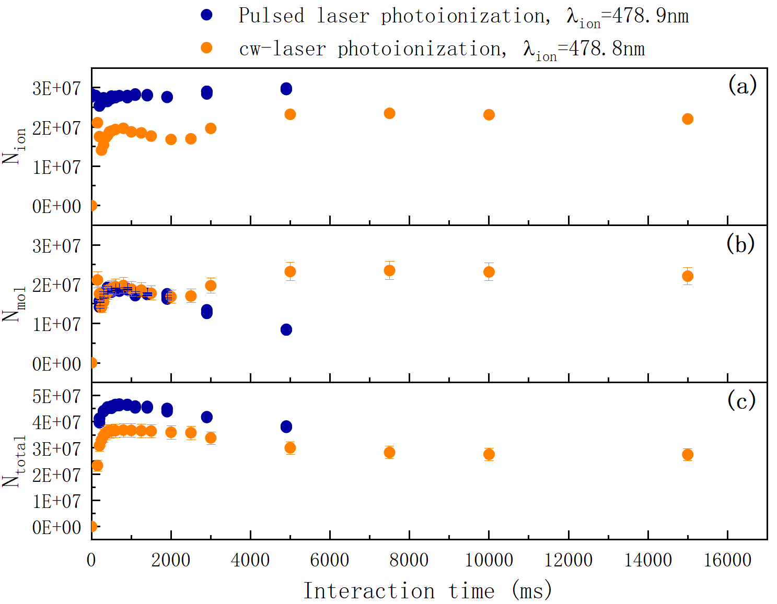

Fig. 1 Comparison of evolution of charged particles in different photoionization schemes: the second excitation laser is a pulsed dye laser or a cw-diode laser. (a), (b) and (c) are the measured Rb+ signal, Rb2+ signal, and sum of the Rb+ and Rb2+ signals as a function of the interaction time, respectively.

[1] T. C. Killian, T. Pattard, T. Pohl, J.M. Rost, Phys. Rep.-Rev. Sec. Phys. Lett., 449(4-5), 77(2007).

[2] S. D. Bergeson et al., Physics of Plasmas, 26, 100501(2019)

[3] M. Tomza et al., Rev. Mod. Phys. 91, 035001(2019).

[4]T. Dieterle et al., Phys. Rev. A 102,041301(2020).