**Rydberg and autoionizing spectroscopy close to the first ionization threshold of Se and Te**

**Wei-Chen Liang1, Xi-Zhang1, Fei-Wang1, Feng-Dong Jia1 and Zhi-Ping Zhong1,2**

**1** *School of Physical Sciences, University of Chinese Academy of Sciences, PO Box 4588, Beijing 100049, China*

**2** *Center of Excellence in Topological Quantum Computation and School of Physical Sciences, University of Chinese Academy of Sciences, PO Box 4588, Beijing 100049, China*

E-mail: *zpzhong@ucas.ac.cn*

The photoabsorption spectra of oxygen-group elements with four valence *p* electrons are rich in resonance structure near the first ionization threshold, it is caused by the presence of a large number of Rydberg series attached to these closely spaced thresholds as well as inter-series interactions with each. Moreover, as a heavy element in the oxygen group for the Se (Z=34) and the Te (Z=52) atoms, relativistic effects increase, the spin-orbit interaction starts to exceed the electron-electron correlation. The resulting complexity causes the difficulties in interpreting experimental spectra and theoretical calculations. Recently, multistep resonant laser ionization spectroscopy of Se and Te have been studied, many even-parity Rydberg series and odd-parity autoionization Rydberg series are identified [1-3]. However, corresponding assignments are generally based on the spectrum regularity due to the lack of theoretical work. observed [1-3].

In this work, we have calculated Rydberg and autoionizing spectroscopy close to the first ionization threshold of Se and Te by relativistic multi-channel theory within the framework of multi-channel quantum defect theory [4,5]. In the calculations, we include the ionic core dipole polarization effect due to the Rydberg electron. To achieve convergence of the calculation, the number of channels entered in the calculations increases as the atomic number increases, and effective potential in the self-consistent calculations is optimized. The overall agreement is good between experimental and the present data as shown in Figs. 1 and 2. The quantum defects of experimental and calculated results generally differ by less than 0.01. Fig. 3 displays the effect of electron correlation effect on line-shape.

[1] R. Li, Y. Liu, M. Mostamand, J. Lassen, Spectrochimica Acta Part B: Atomic Spectroscopy, 175, 106017(2021)

[2] R. Li, Y. Liu, M. Mostamand, T. Kieck, K. D. A. Wendt, and J. Lassen, Phys. Rev. A 100, 052510(2019)

[3] T. Kieck, Y. Liu, D.W. Stracener, R. Li, J. Lassen, K.D.A. Wendt, Spectrochimica Acta Part B: Atomic Spectroscopy, 159, 105645(2019)

[4] Y. Zou, X. M. Tong, and J. M. Li, Acta. Phys. Sin. 44, 50 (1995)

[5] Huang W, Zou Y, Tong X M, Li J M 1995 Phys. Rev. A 52 2770.

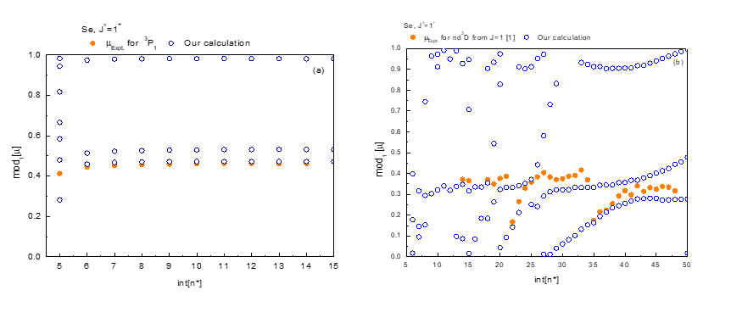

Fig. 1 Comparison of the calculated and experimental Lu-Fano plot for Se with J = 1. (a) Even-parity Rydberg series below the ionization threshold; (b) Odd-parity AI Rydberg series.

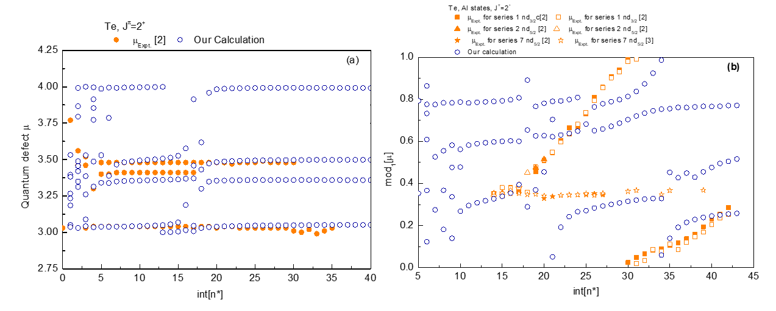

Fig. 2 Comparison of the calculated and experimental Lu-Fano plot for Te with J = 2. (a) Even-parity Rydberg series below IP; (b) Odd-parity AI Rydberg series.

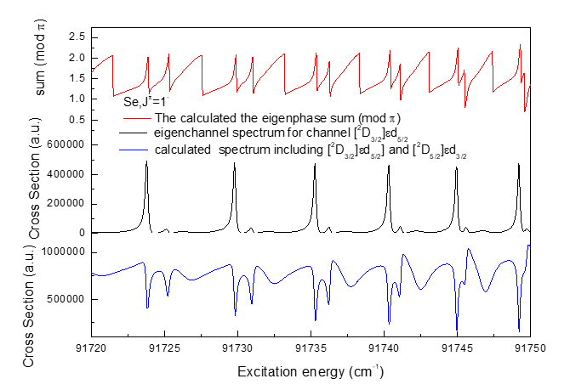

Fig.3 Comparison of the total collision eigenphase shifts，eigenchannel spectrum for [2D3/2]εd5/2 and the superposition of eigenchannel spectrum for [2D3/2]εd5/2 and eigenchannel spectrum for [2D5/2]εd3/2  in Jπ=1- symmetry of Se.