**Reactive two-body collisions and three-body recombination in cw-laser photoionization of laser-cooled 87Rb**

**Wei-Chen Liang1, Fei-Wang1, Xi-Zhang1, Yu-Han Wang1, Jin-Yu Zhou1, Feng-Dong Jia1, Jian-Guo Wang3, Yong Wu3, Ping Xue2, and Zhi-Ping Zhong1**

1 *School of Physical Sciences, University of Chinese Academy of Sciences, PO Box 4588, Beijing 100049, China*

2 *State Key Laboratory of Low-dimensional Quantum Physics, Department of Physics, Tsinghua University and Collaborative Innovation Center of Quantum Matter, Beijing 100084, China*

3 *Institute of Applied Physics and Computational Mathematics, Beijing 100088, China*

E-mail: *zpzhong@ucas.ac.cn*

The mechanism of charged-neutral reactions and yield of the reaction products is a key of understanding processes in astrochemistry and cold-controlled chemistry [1]. The rate coefficient is an important physical quantity. Currently, reactive two-body collisions coefficients or cross section for atomic ion-atom systems are only reported experimentally for alkaline earth-ion, and alkaline earth- or alkali metal-heteronuclear systems[1], As for the cold Rb+-Rb homonuclear systems, previous experiments[2-4] investigated the collisions between a single trapped Rb+ ion and an ultracold atom cloud; three-body recombination dominates reaction collision, and three-body recombination rate coefficients were reported by reference [3] as k3=6(2)×10-25 cm6/s and the initial kinetic energy of the ion Ekin3b=kB× 5(2) mK .

In this work, Rb2+ molecular ions were created by two-step cw-laser photoionization of laser-cooled 87Rb atoms in the ion-neutral hybrid trap and distinguished reaction products Rb2+ molecular ions through time-of-flight (TOF) mass spectrometry. The detailed description of our apparatus can be found in our previous study [5]. In brief, the ion-atom hybrid trap comprises an Rb standard MOT and a mass-selective linear Paul trap (LPT), which are spatially concentric and combined in a polyhedral flat non-magnetic stainless-steel cavity. The first excitation laser was the MOT cooling laser. The second excitation laser, that is, ionization laser, was provided by another cw-diode laser with λion= 450 nm. The atom number and size of the cold atomic cloud were measured using absorption imaging. Under the condition that the ionization laser, MOT, and LPT are turned on, the density of remaining atoms, Rb+ signal and Rb2+ signal as a function of the interaction time is shown in Figure 1. With a relatively simple model by considering the two- and three-body collision dynamics, we established rate equations to describe the evolution of Rb atoms, Rb+ ions, and Rb2+ molecular ions, thus can extract corresponding rate coefficients. Specifically, the evolution of the particles can reach steady state, the three-body recombination can be ignored in this case because the density of atoms is significantly small. Thus, the two-body reaction collision-rate coefficient can be obtained as k2= 1.2(0.5) × 10-11 cm 3/s. Using theoretical model considering both of ion-atom two-body collision and ion-atom three-body recombination, the only free parameters entering our model are the value for three-body recombination rate coefficients k3, theoretical calculation reproduces the main features in the measured Rb+ signal and Rb2+ signal well as shown in Figs 1(b) and 1(c) and k3 is determined as 1.2(0.1)×10-25 cm6/s. Calculation considering only ion-atom two-body collision are given as a comparison, which fails to reproduces the main features in the measured Rb+ signal and Rb2+ signal as the density of atoms is large.

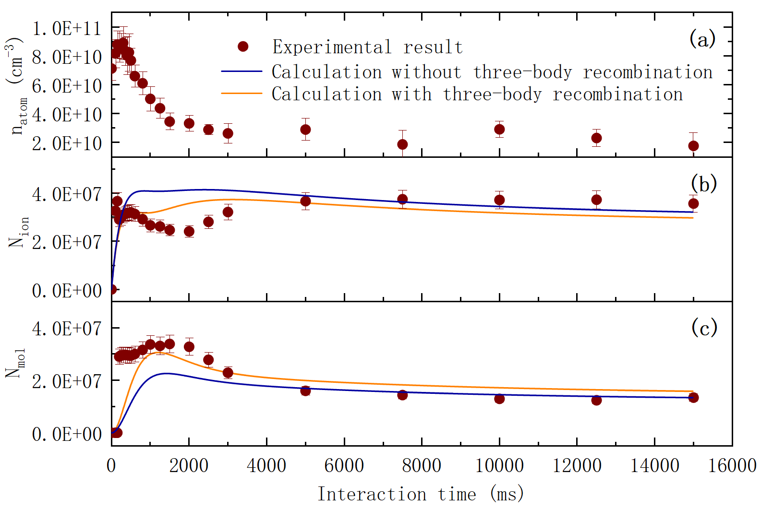

Fig. 1 (a) The measured density of remaining atoms as a function of the interaction time. the interaction time is the period that MOT, ionization laser, and LPT are turned on. Rb+ signal, Rb2+ signal, and sum of the Rb+ and Rb2+ signals as a function of the interaction time. the interaction time is the period that MOT, ionization laser, and LPT are turned on.

Fig.1 (b) Comparison of the measure Rb+ signal and theoretical calculations with and without ion-atom three-body recombination.

Fig.1 (c) Comparison of the measure Rb2+ signal and theoretical calculations with and without ion-atom three-body recombination.

[1] M. Tomza et al., Rev. Mod. Phys. 91, 035001(2019).

[2] A. Harter et al., Phys. Rev. Lett. 109, 123201 (2012).

[3] T. Dieterle et al., Phys. Rev. A 102,041301(2020).

[4] T. Dieterle et al., Phys. Rev. Lett. 126,033401 (2021).

[5] S. F. Lv et al., Chin.Phys.Lett. 34,013401 (2017).