WorkshopPLUS

Microsoft Azure Infrastructure as a Service

Introduction to Microsoft Azure Automation (Classic)

Student Lab Manual

V1.4, September 14, 2015

Information in this document is subject to change without notice. The example companies, organizations, products, people, and events depicted herein are fictitious. No association with any real company, organization, product, person or event is intended or should be inferred. Complying with all applicable copyright laws is the responsibility of the user. Without limiting the rights under copyright, no part of this document may be reproduced, stored in or introduced into a retrieval system, or transmitted in any form or by any means (electronic, mechanical, photocopying, recording, or otherwise), or for any purpose, without the express written permission of Microsoft Corporation.

Microsoft may have patents, patent applications, trademarked, copyrights, or other intellectual property rights covering subject matter in this document. Except as expressly provided in any written license agreement from Microsoft, the furnishing of this document does not give you any license to these patents, trademarks, copyrights, or other intellectual property.

© 2014 Microsoft Corporation. All rights reserved.

Microsoft, MS-DOS, MS, Windows, Windows NT, MSDN, Active Directory, BizTalk, SQL Server, SharePoint, Outlook, PowerPoint, FrontPage, Visual Basic, Visual C++, Visual J++, Visual InterDev, Visual SourceSafe, Visual C#, Visual J#,  and Visual Studio are either registered trademarks or trademarks of Microsoft Corporation in the U.S.A. and/or other countries.

Other product and company names herein may be the trademarks of their respective owners.

Contents

Introduction to Microsoft Azure Automation 4

Prerequisites 5

Task 1 – Create an Azure Automation Account 5

Task 2 – Create an Azure Active Directory User 7

Task 3 – Assign Service Administration Rights to the User 11

Task 4 – Change the User’s Temporary Password 12

Task 5 – Create an Azure Automation Credential 14

Task 6 – Create an Automation Variable 16

Task 7 – Create an Automation Runbook 18

# Introduction to Microsoft Azure Automation

In this lab, you will create some virtual machines and use Azure Automation shutdown and de-provision them. De-provisioning VMs means that they are still in your subscription, but not using resources or incurring charges (other than storage). Azure Automation will de-provision the machines for you and send you a status email upon completion.

You'll learn:

* How to create an Automation Account
* How to create an Azure Storage Account
* Provision an Azure Active Directory user that can be used by Azure Automation to access resources in an Azure Subscription
* Create an Automation Credential Asset
* Create an Automation Variable Asset

## Prerequisites

The following is required to complete this hands-on lab:

* A Microsoft Azure subscription
* One or more virtual machines running in the subscription that can be shutdown. You can create the VMs using the Azure portal or PowerShell. Please start this process **before** continuing on to Task 1.

## Task 1 – Create an Azure Automation Account

To begin using Azure Automation, the first thing you need is an Automation Account. Automation accounts securely contain the resources that configure and run your runbook jobs. An Automation Account is a logical container and security boundary for all automation assets (runbooks, connections, etc). Assets within an Automation account are visible only to other assets within the account. An Automation Account also provides affinity to a region, which helps with data sovereignty concerns (if your runbook IP or data can't leave a region).

1. Log in to the Azure Management Portal
2. Click **Automation** on the left nav.
3. On the Automation page, click **Create an Automation Account**

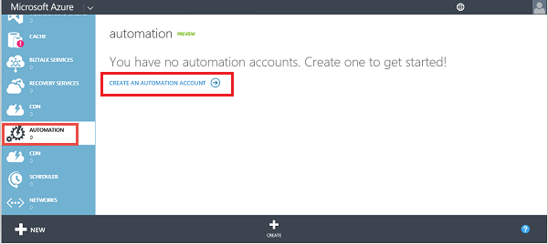

Automation menu

1. In the **Create An Automation Account** dialog, type a unique **account name.**
2. Choose a **region** for the automation account resources.
3. If you have multiple subscriptions, choose the **subscription** that will be billed for automation account resources.
4. Click the check mark.

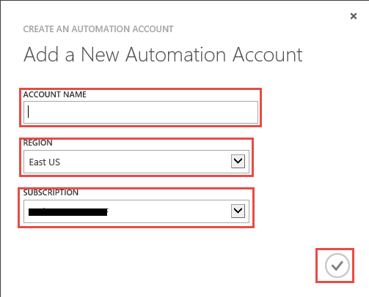

Create An Automation Account dialog

## Task 2 – Create an Azure Active Directory User

The Automation roles (worker roles) that actually execute your runbooks are not in your subscription, they’re part of the Azure infrastructure. In order for the Azure infrastructure to execute a runbook in your subscription, Azure needs an Azure Active Directory user in your subscription. An *Automation User Credential* is an Azure Active Directory user and password used by your runbook tasks to access the subscription that contains the resources they must operate on.

1. First create the user in Azure Active Directory. In the portal, click on **Active Directory**.

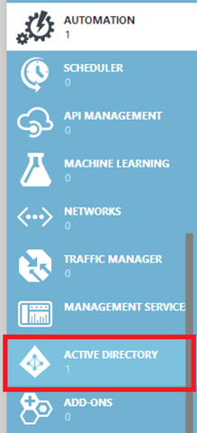

Active Directory

1. Click on the name that is associated with your class trial subscription. It will probably be the Microsoft Id that you created to activate the subscription. If you do not see a directory, you will need to follow these steps to create a new [Azure Active Directory](http://blogs.technet.com/b/chrisavis/archive/2013/04/21/getting-started-with-windows-azure-active-directory-setting-up-the-windows-azure-ad-tenant.aspx).

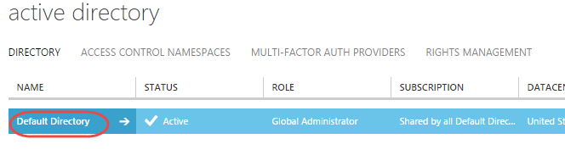

Active Directory associated with the Subscription

1. Click on the **Users** menu.

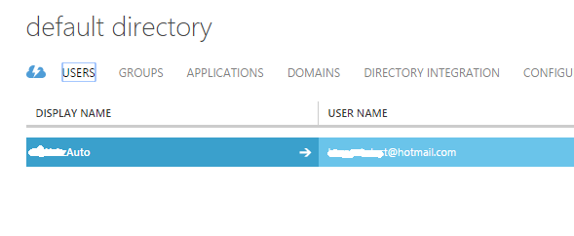

1. Click **Add User** on the bottom center of the portal.

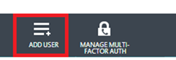

1. Set the **Type of User** to “New user in your organization” and enter “AutomationUser” as the **user name**. Click the **arrow**.

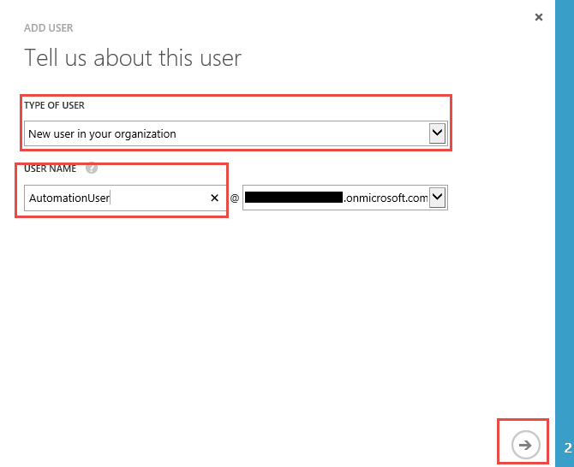

1. Fill out the user’s profile as shown below and click the right arrow.

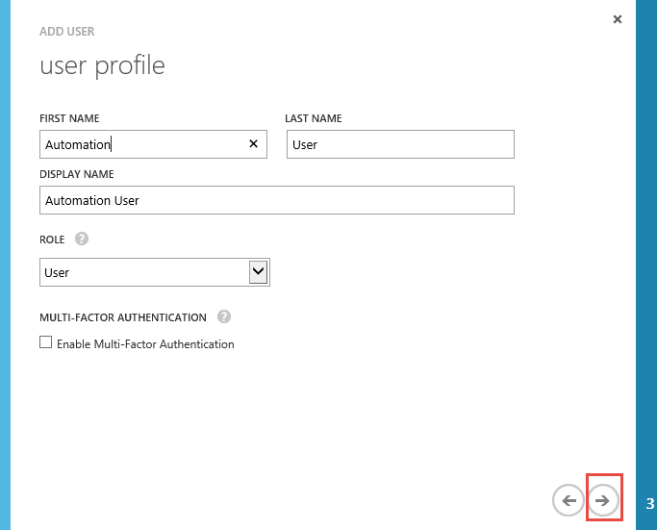

1. Click **Create**.

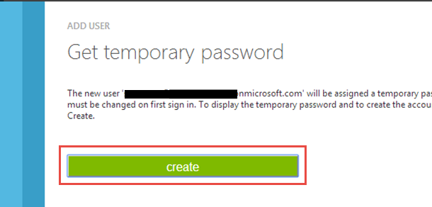

1. Write down the full user name, including its domain name after the ‘@’ sign, and the temporary password. After you’ve recorded the information, check the check mark in the lower right of the dialog.

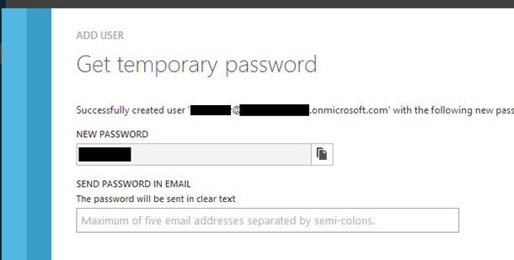

## Task 3 – Assign Service Administration Rights to the User

1. Click on **Settings** in the portal, left nav.

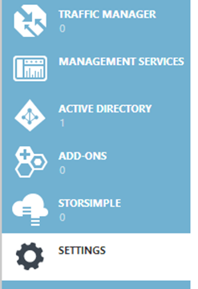

1. Click on **Administrators**.

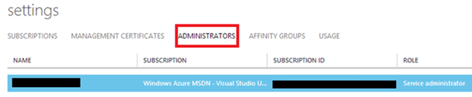

1. Click **Add**.

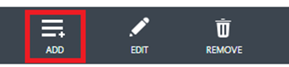

1. Type the full user name, recorded in step 8 of the last task, into the Email Address box.
2. Click the check box next to your class trial subscription name.
3. Write down or copy to Notepad, the **Subscription Id**. You’ll need it later.
4. Click the check mark at the bottom right of the dialog.

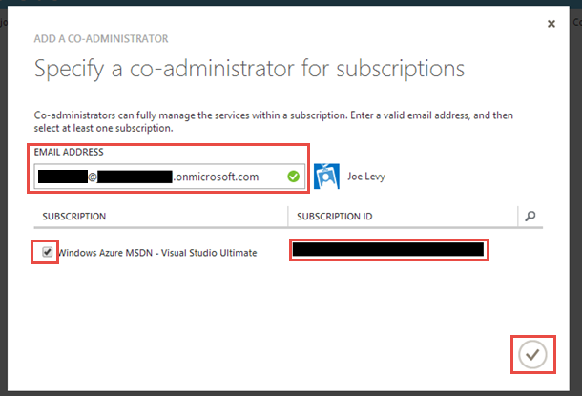

## Task 4 – Change the User’s Temporary Password

1. Start Internet Explorer. Once it has started, press Ctrl+Shift+P to start an InPrivate browsing window.

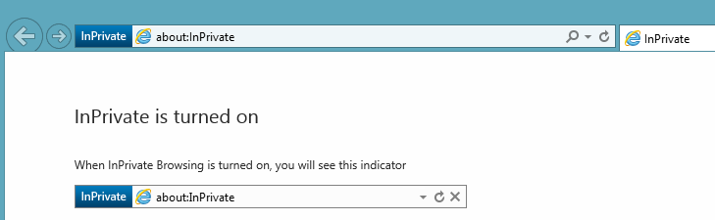

1. Navigate to the Azure Portal at <http://manage.windowsazure.com> . Specify your full AutomationUser name and domain, and click Continue.

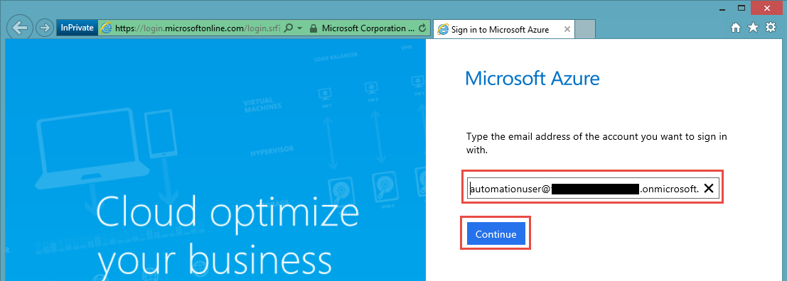

1. Type the temporary password and click Sign in.

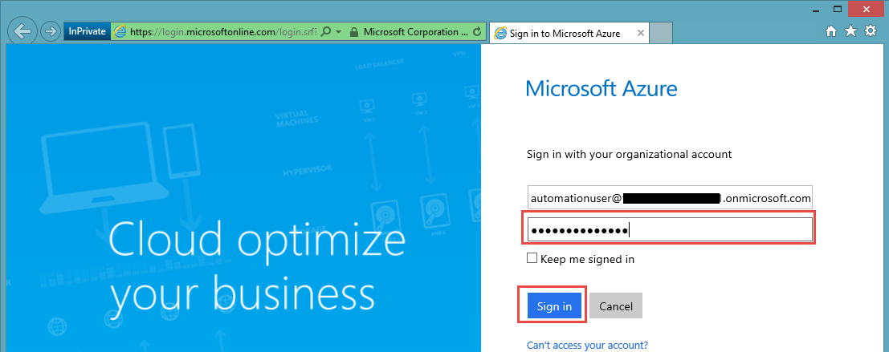

1. You will be prompted to change the password. Do so and submit the change. Make sure you remember what you changed it to as you’ll need it later.
2. Close the InPrivate browser window.

## Task 5 – Create an Azure Automation Credential

An Azure Automation credential allows you to use a username\password credential within a running script if that script needs to access something that requires username\password.

1. If you are not currently logged in to the Azure portal, log in with your Microsoft account (not the user account you created in the previous steps). In the portal, click on **Automation** in the left nav.
2. Click on the automation account name you created.
3. Click on the **Assets** menu.

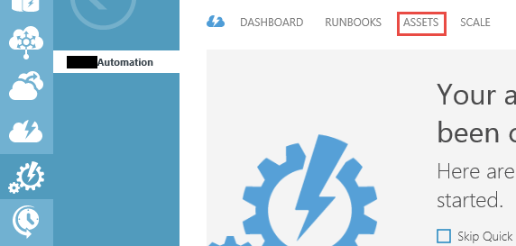

1. Click on **Add Setting** at the bottom of the portal.

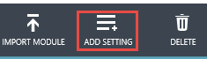

1. Click **Add Credential**.

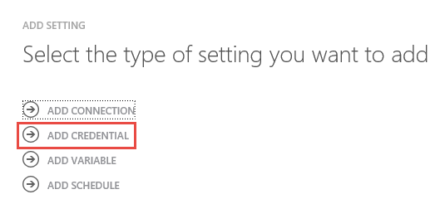

1. Choose **Windows PowerShell Credentia**l as the type and name it **AutomationCredential**. Click the right arrow.

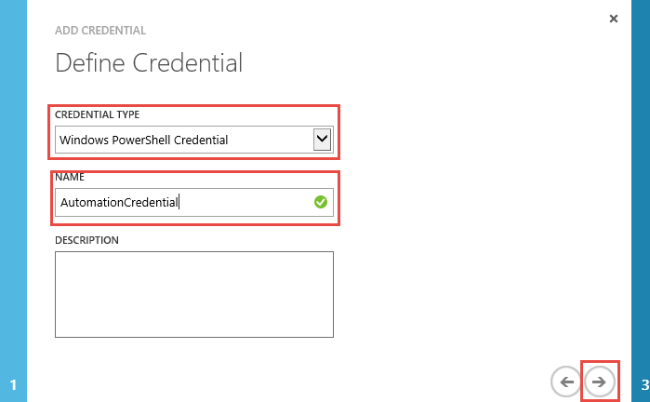

1. Type the Azure Active Directory username and password you created in the previous tasks. Make sure you use the new password that you chose. Click the check mark.

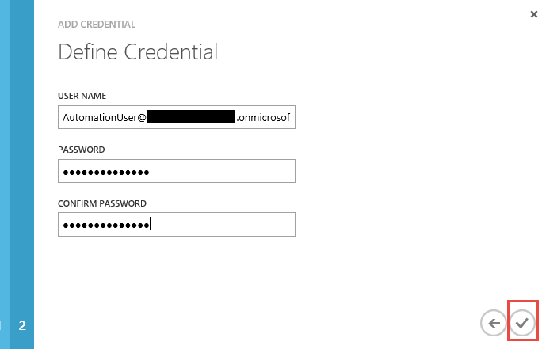

1. Now create another credential by repeating steps 4 through 7. Set its name to ‘**EmailCredential’** and its type to PowerShell Credential as before. Set the user name to the Microsoft Id you used to create your trial subscription. Set the password to the password for that Microsoft Id. The objective of this is to allow Automation to send status email using this account when a runbook finishes.

## Task 6 – Create an Automation Variable

1. Click on the **Assets** menu as you did earlier.
2. Click on **Add Setting** at the bottom of the portal.
3. Click on **Add Variable**.

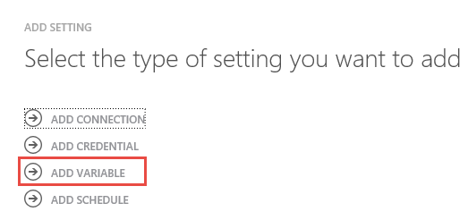

1. Set the variable type to String. Name the variable ‘SubscriptionId’. Click the right arrow.

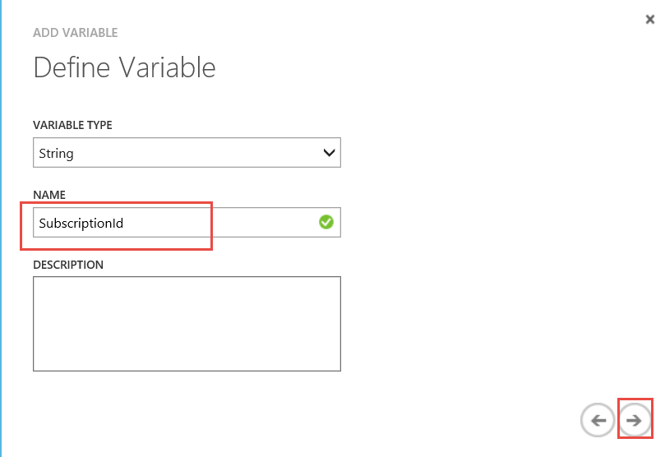

1. Set the value of the variable to your trial subscription Id. This was the value you recorded in step 6 of task 3. Click the check mark at the bottom right.

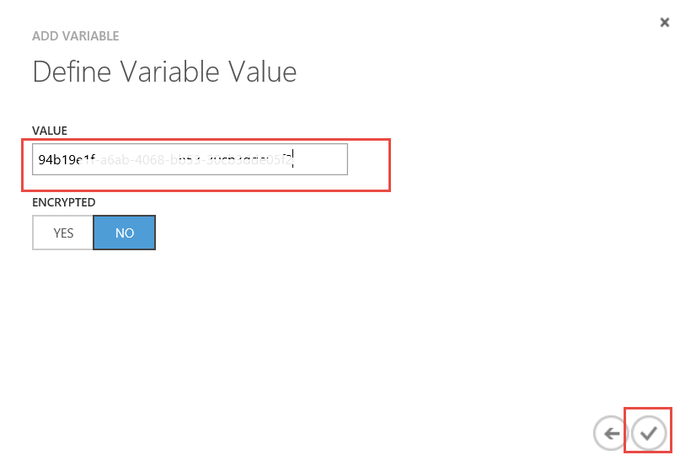

## Task 7 – Create an Automation Runbook

A Runbook is the central concept in Azure Automation. Runbooks are PowerShell Workflow scripts that contain the steps you want to automate. When you run a Runbook, it is queued for execution as a job. The Automation roles pick up the job, run it, and record status. You do not have control over the Automation roles. They are part of the Automation infrastructure and managed by Azure.

1. Click on the **Runbooks** menu in the portal for your Automation Account.



1. At the bottom of the Azure Portal, click on the **+New** menu item.

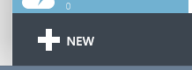

New button

1. Click on **Runbook**.
2. Click on **Quick Create**.
3. Name the runbook **Stop-SubscriptionVMs**.
4. Select your Automation Account in the drop down.
5. Select your trial subscription in the drop down.
6. Click on **Create**.

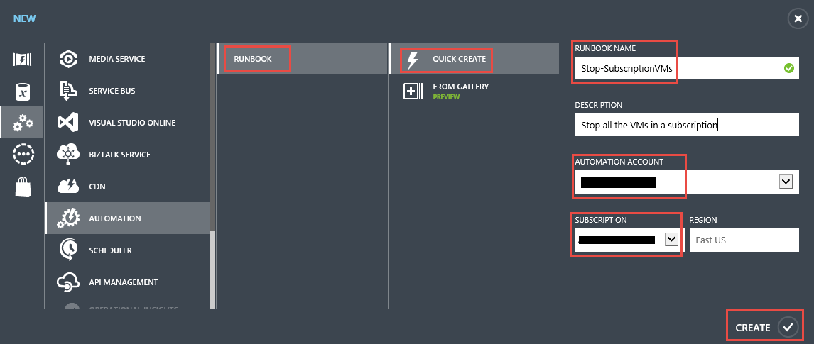

1. Your new runbook will show up in the list. Click on **Stop-SubscriptionVMs**.

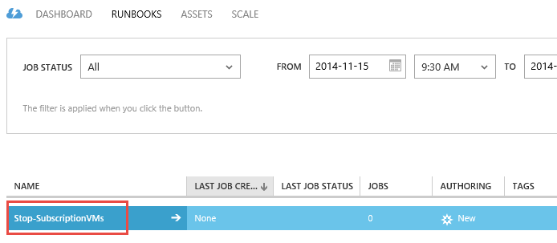

1. Click on **Author**.



1. Copy and paste the following code into the script location:

workflow Stop-SubscriptionVMs

{

param (

[string] $sendResultsTo

)

$startTime = get-date

$cred = Get-AutomationPSCredential -Name "AutomationCredential"

$throwAway = Add-AzureAccount -Credential $cred

$subscriptionId = Get-AutomationVariable -Name "SubscriptionId"

$throwAway = Select-AzureSubscription -SubscriptionId $subscriptionId

$results = Get-AzureVM | Stop-AzureVM -force | Out-String

if($results -eq $null)

{

Write-Output "There are no VMs to stop"

}

else

{

$subject = "Script Run Time " + ([DateTime]::Now - $startTime).ToString()

$cred = Get-AutomationPSCredential -Name "EmailCredential"

Send-MailMessage `

-To $sendResultsTo `

-Subject $subject `

-Body $results `

-Port 587 `

-SmtpServer smtp.live.com `

-Credential $cred `

-UseSsl `

-From $cred.Username

}

}

1. Click on the **Test** button at the bottom of the screen.



1. Click on **Yes** when asked to verify that you want to save and run.
2. Type in a valid email address to which you’d like the results of the run sent.

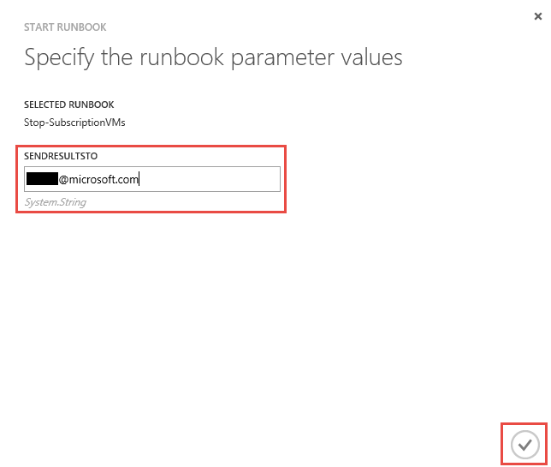

1. You’ll see an Output pane appear showing the status of your test run.

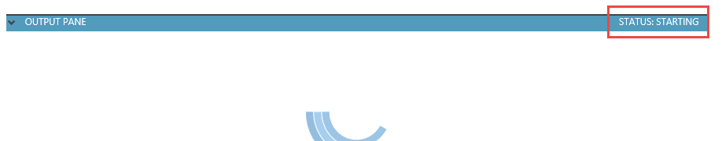

1. Once the status has reached Completed, you should receive email at the address you specified showing the results of the test run. Note that it may take a few minutes to stop the VMs and receive the email.

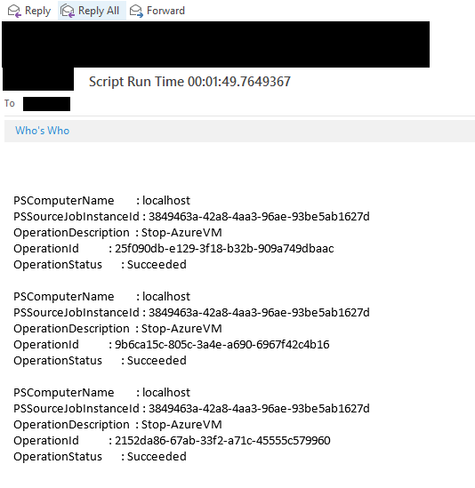

NOTE: If you do not receive an email, make sure you have at least once, logged into the email account you have used for the EmailCredential.