DSC 640 · DATA PRESENTATION & VISUALIZATION
Films Win the Opening Week. TV Owns the Long Tail.
A Netflix Top 10 content-strategy briefing

The story
Across 146 weeks and 94 countries, films and serialized TV split the weekly #1 slot evenly: films are superb at the loud launch. But the moment you look past opening week, the picture flips. TV titles linger in the Top 10 roughly 50% longer than films, are about 2.6× more likely to last five weeks or more, and pull 3.6× the first-91-day hours among all-time hits. The single most durable bet on the platform is non-English TV.
Durability is not a vanity metric. Weekly staying power is what keeps a subscriber opening the app, and the format that produces it most efficiently deserves a larger slice of marginal spend.

The evidence: six core visuals

1. Staying power: TV lingers, films flame out
Each unique title is plotted by how many weeks it held the global Top 10. Film is a spike at weeks one and two; TV carries a long right tail of multi-week residents.
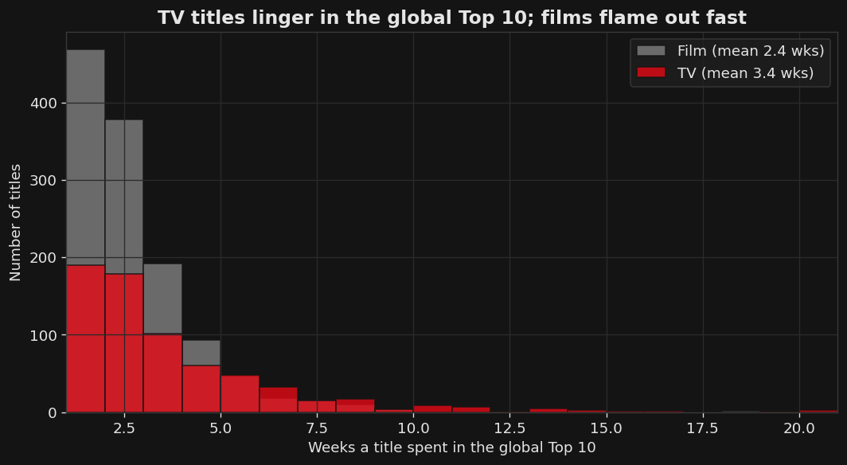
Figure 1 — Distribution of weeks in the global Top 10, Film vs TV (Source: all-weeks-global).

2. The marathon titles are serialized TV
Ten of the twelve longest-running titles are TV, led by non-English telenovelas (Yo soy Betty, la fea; Café con aroma de mujer) and Korean drama.
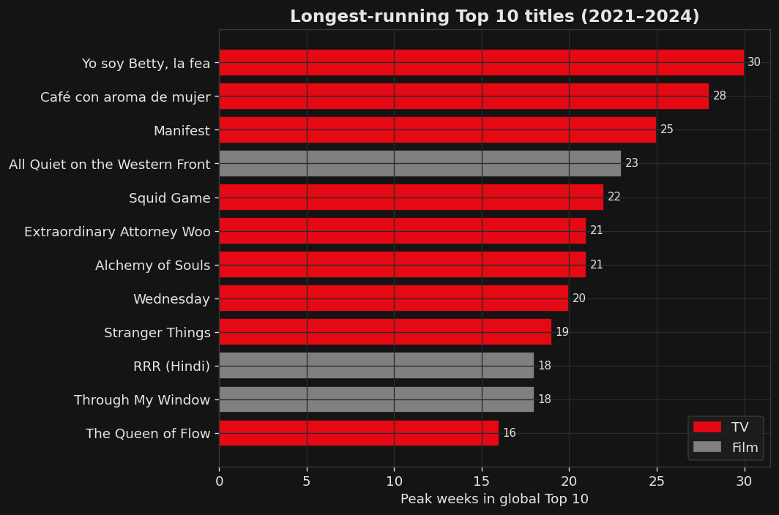
Figure 2 — Longest-running Top 10 titles, 2021–2024 (Source: all-weeks-global).

3. All-time demand: TV pulls 3.6× the hours
On Netflix’s all-time most-popular list, even the weakest TV quadrant out-draws the strongest film quadrant over a title’s first 91 days.
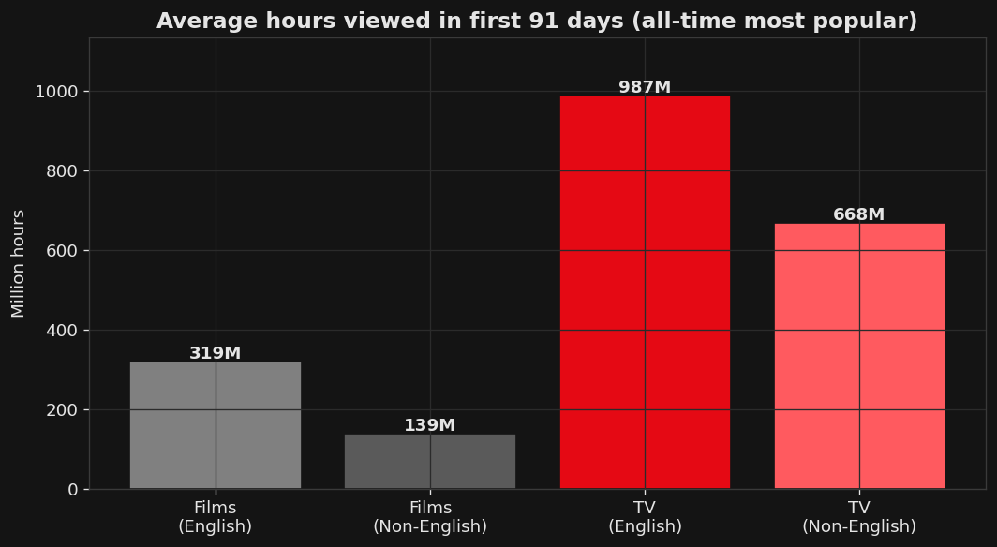
Figure 3 — Average first-91-day hours by category (Source: most-popular).

4. Country durability: TV is held far longer, everywhere
TV holds a country’s Top 10 for 4.8 weeks on average versus 2.1 for film. Latin-American markets cling to serialized TV longest — the telenovela effect.
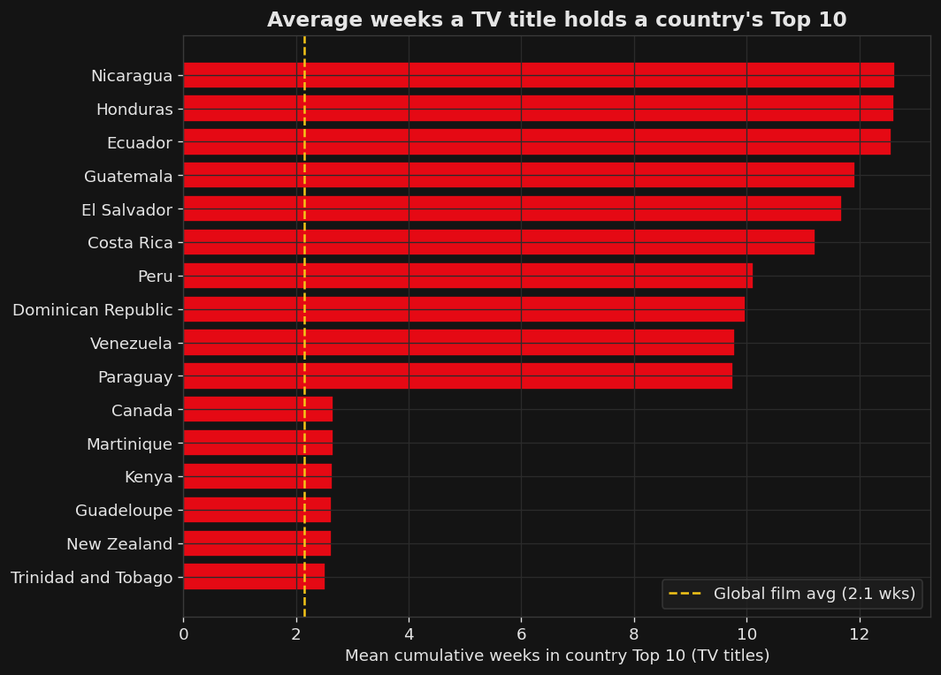
Figure 4 — Average weeks a TV title holds a country Top 10; gold line = global film avg (Source: all-weeks-countries).

5. The gap is persistent, not a fluke
Month by month across three years, the TV durability line sits above film almost without exception. This is structural, not a single breakout hit.
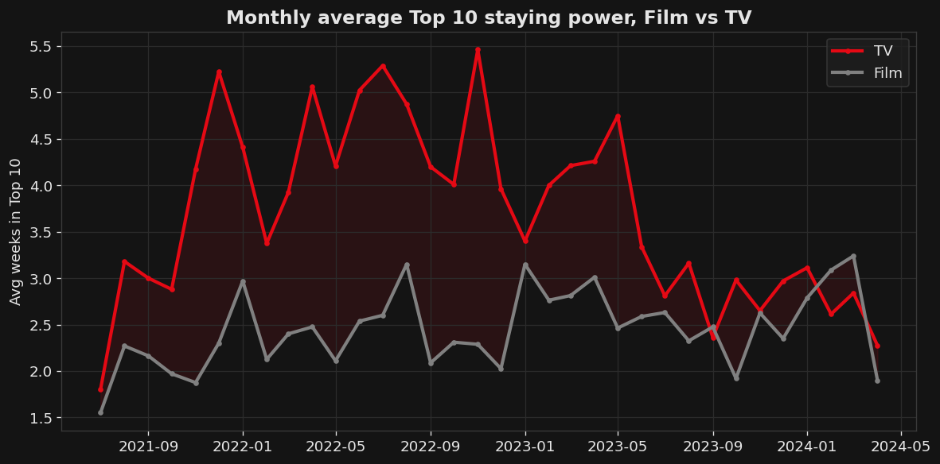
Figure 5 — Monthly average staying power, Film vs TV (Source: all-weeks-global).

6. The most durable quadrant: Non-English TV
Splitting by language confirms where to lean: non-English TV (3.81 weeks) is the most durable cell in the matrix.
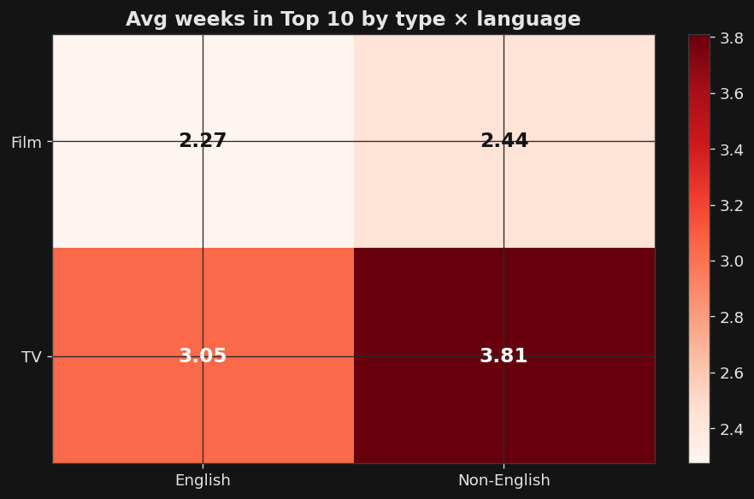
Figure 6 — Average weeks in Top 10 by type × language (Source: all-weeks-global).

Call to action
Reallocate a defined slice of next year’s marginal content budget (on the order of 10–15%) from one-off films toward returnable, non-English serialized TV. Keep films for the launch splash they reliably deliver; redirect growth spend toward the format that compounds weekly engagement. Measure it honestly: track average weeks-in-Top-10 and 91-day hours per production dollar by format, reviewed quarterly, and revisit the tilt if the durability gap narrows.

Summary Notes

Audience, purpose, and medium
Audience. Netflix executives and board members: insiders who know the business but are time-poor and outcome-focused. They are fluent in metrics like engagement and churn, so light jargon (“staying power,” “91-day hours”) is fair game, but they want the implication, not a data-literacy lecture.
Purpose. This is persuasive, not merely informational. The intent is a decision: approve a budget tilt toward serialized non-English TV. The audience should walk away understanding one thing: films win opening week, but TV owns the durable engagement that fights churn. They should be asked to act on that understanding.
Medium. Written document that carries the narrative and call to action. The document suits executives who want all the relevant information for a decision and only that information.

Design strategy
Color. A restrained Netflix palette, its signature red reserved exclusively for TV (the protagonist of the story) and neutral grey for film, so the comparison reads pre-attentively without a legend. Gold marks reference lines only.
Text. Headlines state the takeaway as a sentence, not a label; chart captions name the source dataset.
Alignment & spacing. A consistent grid, generous whitespace.

Ethical considerations
Transformations. Netflix’s four categories were collapsed to Film vs TV for the headline (language preserved separately); per-title durability uses the maximum cumulative-weeks value to avoid double-counting weekly rows. No weeks or countries were filtered out, and missing runtime/season fields were left un-imputed.
Avoiding a misleading metric. Each country-week contains exactly ten film and ten TV slots, so raw slot “share” is 50/50 by construction; presenting that as a finding would mislead. Durability (weeks held) and reach (countries charted) are reported instead, and the film-favoring reach chart is shown rather than hidden.
Sourcing, credibility, and risk. Data comes directly from Netflix’s public Tudum Top 10 release which is self-reported, and therefore subject to the publisher’s own definitions, which is a considerable caveat to the integrity of the data. The main risk is over-generalizing: Top 10 lists capture the hits, not the full catalog or profitability, so the recommendation is framed as a marginal-budget tilt with quarterly review, not a wholesale strategy. Mitigation is transparency: every chart cites its dataset, assumptions are logged in the notebook, and the ask is bounded and measurable.

