Thermoelectric Water Consumption and Net Watershed Availability in Utah:
Quantifying the Impact of Future Data Center Growth
DSC550 Data Mining — Term Project Final Writeup
David Jorgensen

1. Introduction

1.1 The Problem
Water scarcity is one of the defining resource challenges of the American West. Utah, an arid state that depends heavily on snowpack-fed rivers and reservoirs, is particularly vulnerable. At the same time, Utah has emerged as a rapidly growing technology and energy hub: tax incentives, available land, and access to power have attracted a pipeline of over 23 gigawatts of proposed data center capacity, with a single project (Stratos in Box Elder County) targeting 9 GW. Nuclear small modular reactors are also being revisited as a low-carbon baseload option, with proposed sites in the region. Both data centers and nuclear power plants are significant industrial water consumers: nuclear plants use water for steam generation and cooling, while data centers rely on evaporative cooling that can consume millions of gallons per day at scale.
This project asks a single, focused question:
To what extent does thermoelectric water consumption from nuclear power plants and large industrial facilities such as data centers reduce effective water availability in Utah watersheds, and can we predict the impact of future growth in that consumption?

1.2 Why It Matters
Utah’s pipeline of proposed data centers is roughly 25 times the state’s current operational data center capacity. The largest proposed sites — Sugarville (10,050 MW across three facilities), Headwaters Hansel Valley Wash (9,000 MW Stratos), and Whiskey Creek (4,000 MW HPC Campus) — all sit in endorheic Great Basin watersheds with no downstream outlet. Every unit of consumptive water loss in these basins is permanent. Yet only 8 of the 17 catalogued facilities have publicly reported water consumption figures, leaving water managers, state regulators, and downstream communities without a defensible basis for sustainable siting decisions. A quantitative model that links thermoelectric demand to watershed-level water availability fills exactly this gap.

1.3 Stakeholder Pitch
For a presentation to Utah water resource managers, state regulators, or environmental planners, the pitch would emphasize three points. First, Utah’s water budget at the watershed scale is already constrained: 8.9% of the 25,580 watershed-year observations in this dataset are in net deficit (consumption exceeds natural availability). Second, the proposed pipeline concentrates new industrial water demand in a handful of small, closed-basin watersheds, which means modest statewide aggregate consumption translates into severe local stress. Third, the model in this project provides a statistically rigorous, peer-reviewable methodology — built on USGS National Water Availability Assessment data covering all 2,558 Utah HUC12 watersheds from 2010–2019 — that can quantify the expected reduction in net availability for any proposed facility, with cluster-robust confidence intervals. This is the kind of evidence that supports defensible permitting decisions and proactive water-allocation planning.

1.4 Data Sources
The following sources were combined into a unified watershed × year × technology panel:
- USGS National Water Availability Assessment (NWAA) outputs — watershed availability, consumption, and net availability across 2,558 Utah HUC12 watersheds, 2010–2019.
- USGS Thermoelectric Power Water-Use Model — withdrawal and consumption (MGD) per HUC12.
- University of Utah Energy Landscape Report 2025 — statewide annual electricity generation by fuel type (GWh) and consumption by sector, 2000–2025.
- PacifiCorp 2025 Integrated Resource Plan Table 7.4 — water intensity (Gal/MWh) for each planned generation technology.
- Western Resource Advocates 2025 Data Center Fact Sheet — measured water consumption for 8 named Utah data centers.
- Cleanview.co Utah data center inventory (geocoded) — facility name, status, capacity (MW), and lat/lon for 23 operating and planned facilities. Joined to HUC12 watersheds via spatial join in `geopandas`.

1.5 Milestone 1–3 Summary
Milestone 1 assembled the raw datasets, documented their structure, and established the core research question. The USGS watershed model was the foundation; thermoelectric and UofU energy data were merged in to create a multi-source panel.
Milestone 2 focused on feature engineering and data preparation. The most consequential work was establishing the target variable (`net_avail_mm_mo = availab_mm/mo − consum_mm/mo`), assembling the data center inventory from the Cleanview RSC payload, spatially joining facility coordinates to USGS HUC12 polygons, building a water-intensity lookup from PacifiCorp Table 7.4, and validating the UofU × intensity estimate of statewide thermoelectric consumption against USGS actuals. The validation showed the intensity-factor approach produces estimates within the correct order of magnitude, with systematic over-estimation reflecting USGS coverage scope (not all plants are geolocated to single watersheds) and conservative fleet capacity-factor assumptions.
Milestone 3 built and evaluated the predictive model. The Milestone-3 work addressed ten structural improvements over a naive build: a unit normalization converting `tecuftot_mgd` (volume/time) into `thermo_consum_mm_mo` (depth/time) using watershed area; the dropping of `tewdftot_mgd` for near-perfect collinearity with consumption; the addition of watershed fixed effects via within-watershed demeaning to remove time-invariant geological and land-use confounders; a temporal train/test split (2010–2017 train, 2018–2019 test) to honor the panel structure; GroupKFold cross-validation to enforce out-of-watershed generalization; cluster-robust standard errors clustered by HUC12; pairs-bootstrap confidence intervals for the key thermoelectric coefficient; quantile regression at τ = 0.10 to quantify drought-tail amplification; permutation importance on a held-out set as a correction to RF impurity-based importance; and the application of the unscaled OLS coefficient in natural units (mm/mo per mm/mo) for projection scenarios.

1.6 Exploratory Data Analysis
The watershed panel covers 25,580 observations (2,558 watersheds × 10 years). The distribution of net availability is sharply skewed: most watershed-years are slightly water-positive, but a long left tail extends well below zero, reflecting the structural water deficit in arid central and western Utah. As shown in Figure 1, 8.9% of all observations are in deficit even before the proposed data center pipeline is operational.
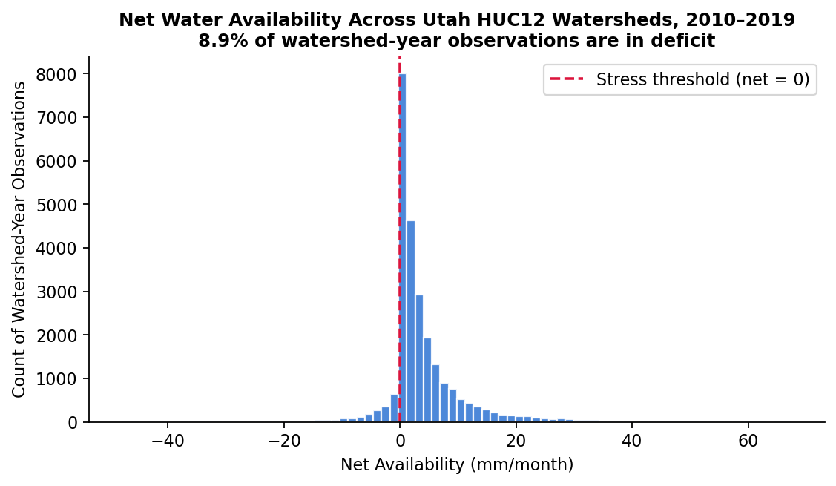
Figure 1. Distribution of net water availability across all 25,580 Utah HUC12 watershed-year observations, 2010–2019. The dashed line marks the stress threshold (net = 0). 8.9% of observations are already in deficit before any proposed buildout.
The statewide hydrology time series (Figure 2) shows that consumption is essentially flat across the decade (red squares hover near 0.5–0.6 mm/mo) while natural availability varies by a factor of five between wet years (2011 peak ≈ 8.5 mm/mo) and dry years (2018 trough ≈ 1.7 mm/mo). Net availability therefore tracks natural availability almost perfectly at the statewide aggregate scale. The thermoelectric effect — small in absolute terms — only becomes detectable when the watershed-level fixed-effects estimator isolates within-watershed year-to-year variation.
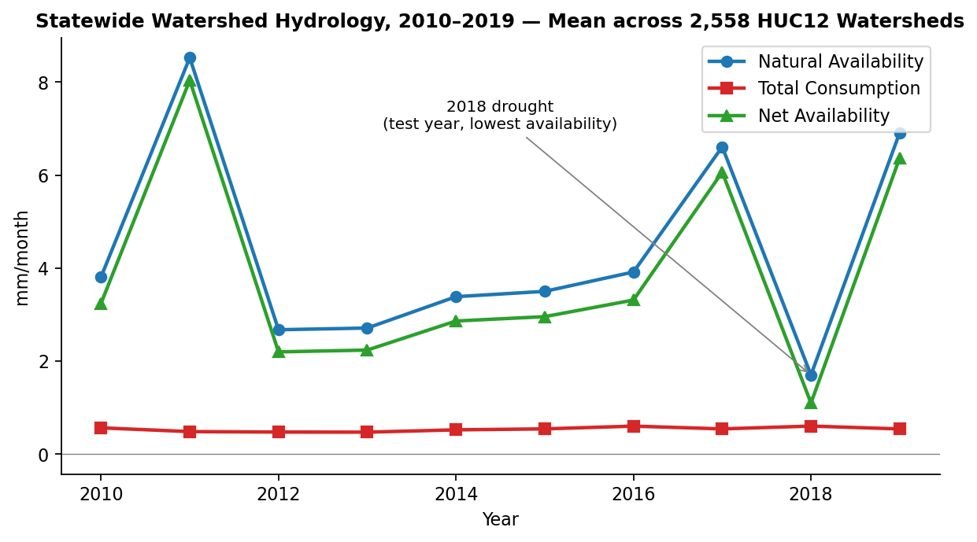
Figure 2. Statewide annual mean natural availability, total consumption, and net availability across 2,558 HUC12 watersheds, 2010–2019. 2018 is the driest year in the dataset; it falls in the held-out test set.
A scatter of natural availability against net availability (Figure 3) makes the consumptive depression visible at the observation level. The non-thermoelectric majority of watershed-years cluster tightly along the y = x reference, indicating that net availability simply equals natural availability where human consumption is small. The thermoelectric-active watershed-years — roughly fifty observations corresponding to the three operating coal-plant watersheds in Emery County — deviate downward from this baseline. This is the empirical signal the OLS model extracts as a coefficient.
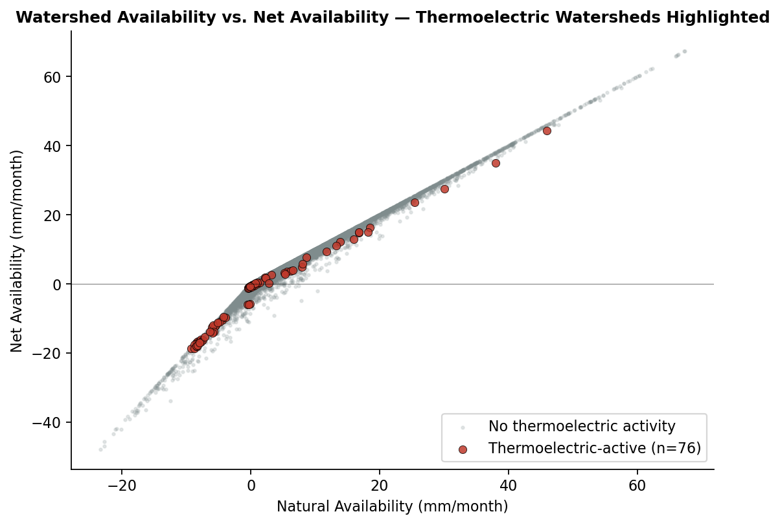
Figure 3. Natural availability versus net availability for all watershed-year observations. Non-thermoelectric (gray) watersheds align with the y = x reference; thermoelectric-active (red) watersheds deviate downward, displaying the consumptive depression that the regression model quantifies.
Utah’s electricity generation mix has changed substantially over the 2000–2025 horizon (Figure 4). Coal generation has fallen from over 80% of statewide net generation to under 60%; natural gas has roughly tripled; and renewable generation (solar, wind, geothermal) has grown from negligible to a measurable share. The model’s `fossil_fraction` feature captures this composition shift, and the cluster-robust OLS coefficient on `fossil_fraction` is −0.44 mm/mo (95% CI [−0.59, −0.28], p < 0.001) — statewide shifts toward fossil generation depress net availability.
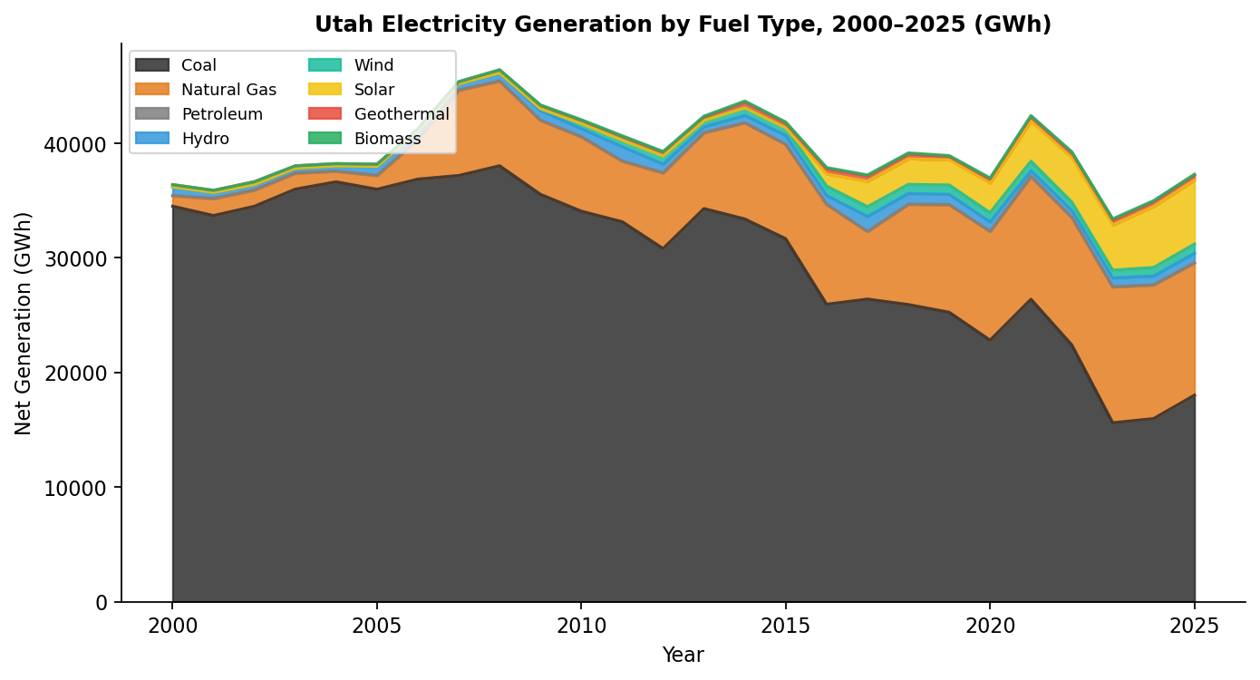
Figure 4. Utah electricity generation by fuel type, 2000–2025 (UofU Energy Landscape Report). Coal has declined; natural gas and renewables have grown.

2. Data Preparation

2.1 Unified Watershed Panel
The base panel was constructed by merging the USGS National Water Availability Assessment outputs (one row per HUC12 × year, fields including `availab_mm/mo` and `consum_mm/mo`) with the USGS thermoelectric water-use model (fields `tewdftot_mgd` for withdrawal and `tecuftot_mgd` for consumption). Thermoelectric records were available only for watersheds containing active facilities; missing rows were filled with zero. Watershed area in km² was joined from the HUC12 boundary GeoPackage downloaded via the `pygeohydro` WBD client.
The UofU Energy Landscape dataset provided statewide-annual features that vary in time but are constant across watersheds within a year: `renewable_fraction`, `fossil_fraction`, `industrial_gwh`, and `industrial_yoy_growth`. These were merged onto the watershed panel by year. The PacifiCorp IRP Table 7.4 supplied design-specification water intensities (Gal/MWh) used to (a) validate the UofU × intensity estimate of statewide thermoelectric consumption against USGS actuals (Figure 5) and (b) construct projection scenarios for future technology mixes (nuclear SMR at 720 Gal/MWh, natural gas CCCT at 210, etc.).
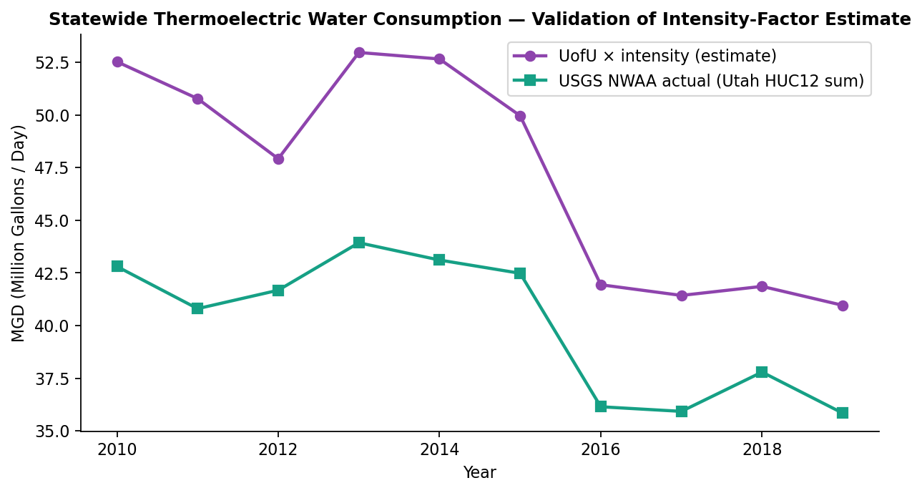
Figure 5. Validation of the UofU × intensity-factor estimate of statewide thermoelectric water consumption against the USGS NWAA actuals. Relative shape agreement validates the intensity-factor methodology used in projection scenarios.

2.2 Feature Engineering and Unit Normalization
The target variable is `net_avail_mm_mo = availab_mm/mo − consum_mm/mo`, expressed in mm/month depth. The original USGS thermoelectric variables `tecuftot_mgd` and `tewdftot_mgd` are flow rates in million gallons per day — incommensurable with the target depth unit without watershed area. This unit mismatch is one of the most consequential structural decisions in the analysis. The transformation is:
thermo_consum_mm_mo = tecuftot_mgd × (365.25 / 12) × 3.785 × 10⁻³ × 1000 / areasqkm ≈ tecuftot_mgd × 115.22 / areasqkm
The 10⁶ gal/MG and 10⁶ m²/km² factors cancel; the result is a depth-per-month rate directly comparable to the target. For Utah’s active thermoelectric watersheds (median area 85.8 km²), the resulting depths range from 0.54 to 3.20 mm/mo — small relative to natural availability fluctuations, which motivates the within-watershed fixed-effects estimator used in Milestone 3.
A correlation heatmap of the demeaned features (Figure 6) confirms no severe multicollinearity remains after the fixed-effects transformation. The high correlation between `availab_mm_mo` and `net_avail_mm_mo` (r ≈ 1.0) is expected and benign: it reflects the dominant physical relationship that net availability tracks natural availability when consumption is held constant. The model’s job is to extract the small thermoelectric departure from that baseline.
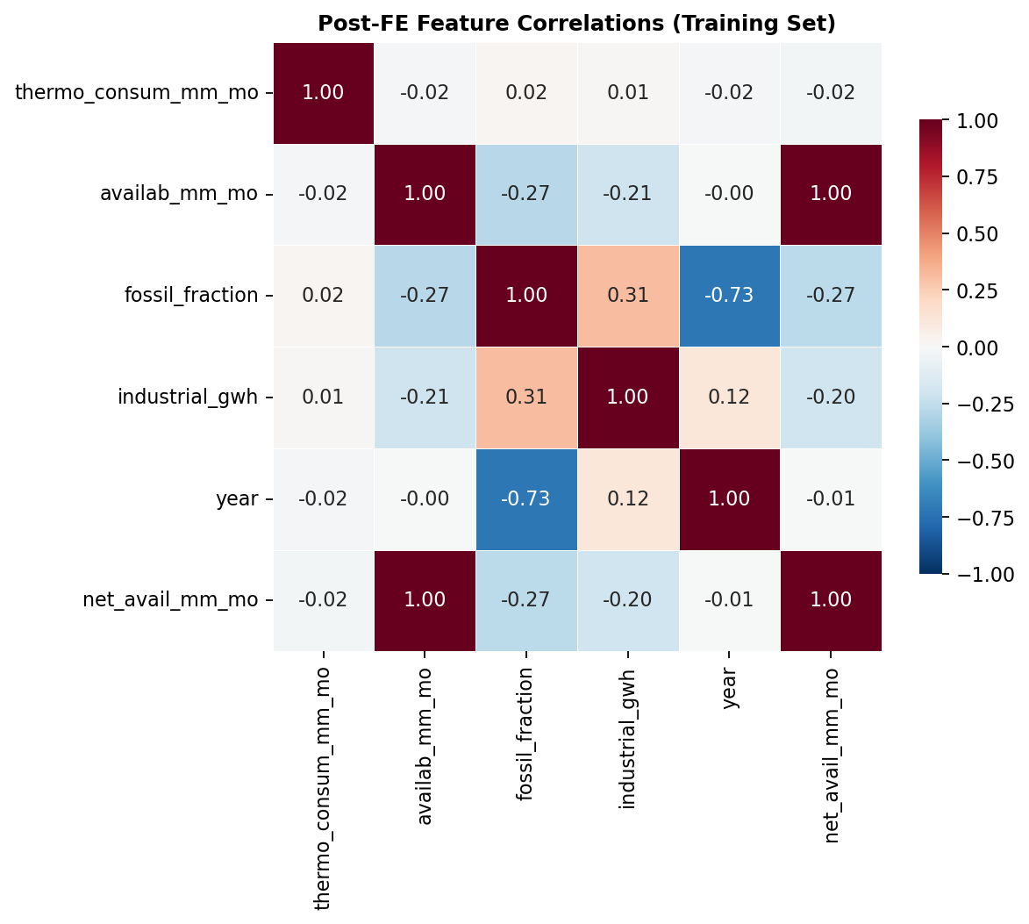
Figure 6. Post-fixed-effects feature correlation matrix (training set). No predictor pair exhibits |r| > 0.9 except for the target’s expected positive correlation with natural availability.

2.3 Temporal Train/Test Split and Scaling
Because the panel includes a temporal dimension, random k-fold splitting would leak future information into training (a model could see 2019 in training and 2017 in test, predicting the past from the future). The split was therefore made on time: 2010–2017 to training (20,464 rows) and 2018–2019 to test (5,116 rows). The 2018 test year is the driest in the dataset and 2019 is a wet rebound, so the test set spans contrasting hydrological conditions.
Continuous features were standardized (zero mean, unit variance) using a StandardScaler fitted on the training set only. The same fitted scaler was then applied (transform-only) to the test set. This anti-snooping protocol prevents test-set distribution information from leaking into the training pipeline.

2.4 Watershed Fixed-Effects Demeaning
The panel of 2,558 watersheds × 10 years contains substantial unobserved time-invariant heterogeneity. Geology, elevation, slope, land cover, and existing infrastructure differ across watersheds in ways the available features cannot fully describe; some of these time-invariant attributes are also correlated with thermoelectric siting decisions (coal plants were sited near coal seams and rivers; data centers cluster near power infrastructure). Within-watershed demeaning — subtracting each watershed’s training-set mean from every observation of that watershed — removes time-invariant confounders by construction. The remaining identification is from year-to-year variation within each watershed.
After demeaning, the coefficient on `thermo_consum_mm_mo` measures the within-watershed effect of additional thermoelectric consumption: precisely the estimand of interest for projecting impacts of new facilities. Test observations were demeaned using the training-set watershed means to prevent any test-set leakage.

3. Model Building and Evaluation

3.1 Models Trained
Three models were trained on the watershed fixed-effects demeaned panel:
- Linear Regression (OLS with watershed fixed effects). Interpretable; the `thermo_consum_mm_mo` coefficient is a direct within-watershed estimate.
- Ridge Regression with leave-one-out CV alpha selection (α = 0.1). Acts as an L2-regularized stability check on the sparse thermoelectric signal.
- Random Forest (300 trees, max_depth 10, min_samples_leaf 100). Captures any non-linear threshold effects (e.g., stress amplification when natural availability is near zero).

3.2 Cross-Validation Strategy
GroupKFold with 5 folds and `huc12_id` as the group key was used for model selection. Each validation fold contains watersheds entirely absent from the training fold. This directly tests the deployment scenario: predicting net availability impacts in proposed-facility watersheds that have no thermoelectric history. Standard random k-fold would yield optimistic CV metrics because the model would see watersheds during training. GroupKFold CV RMSE was 0.221 ± 0.035 mm/mo for both OLS and Ridge.

3.3 Test-Set Evaluation
OLS and Ridge produced essentially identical test-set performance (RMSE = 0.326 mm/mo, R² = 0.994). Figure 7 shows the predicted-vs-actual scatter on both partitions: tight diagonal alignment confirms the model fit quality. The slight scatter visible at the bottom-left of the test panel corresponds to 2018 drought observations, where the model conservatively underestimates how dry the year was — a recognized limitation discussed below.
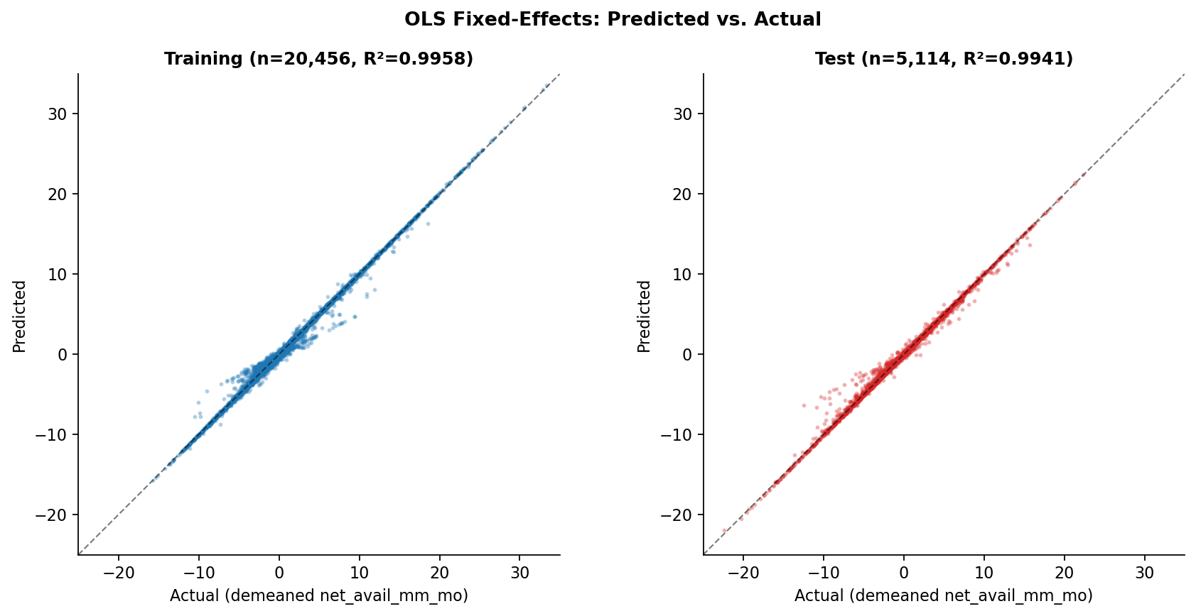
Figure 7. Predicted vs. actual net availability (demeaned) for the OLS fixed-effects model on the training set (left) and held-out test set (right).
Random Forest performed substantially worse (test RMSE = 2.46, R² = 0.67). With only 36 thermoelectric watershed-years in training (out of 20,456), the forest cannot construct splits on `thermo_consum_mm_mo` at the `min_samples_leaf = 100` threshold required to avoid overfitting. The linear models are clearly preferred for this problem.

3.4 Statistical Inference
OLS standard errors assume independent residuals, but observations within the same watershed share hydrology, geology, and infrastructure. Cluster-robust standard errors clustered by `huc12_id` correct for this. The cluster-robust 95% confidence interval for the key coefficient is [−0.356, −0.241]. An independent pairs-bootstrap with 500 resamples gave [−0.358, −0.260], confirming the cluster-robust interval.
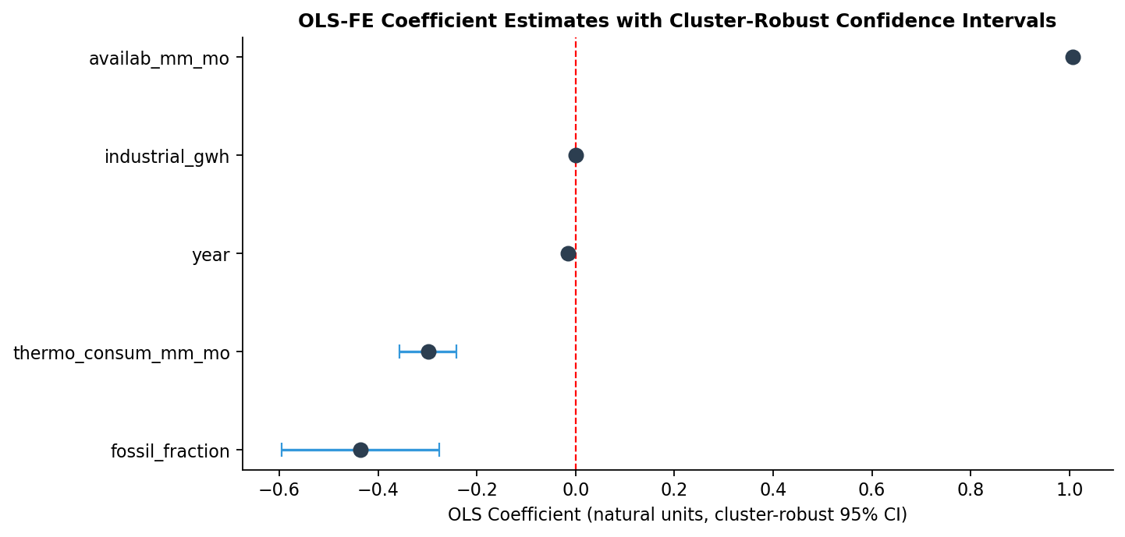
Figure 8. Cluster-robust 95% confidence intervals for the five OLS fixed-effects coefficients. `thermo_consum_mm_mo` is unambiguously negative, with the upper CI bound at −0.241, far from zero.
Quantile regression at τ = 0.10 (the dry-year tail) yields a `thermo_consum_mm_mo` coefficient of −0.328 versus −0.299 at the conditional mean — a 10% amplification of thermoelectric stress in dry years. The `fossil_fraction` coefficient amplifies 3.6× from −0.44 at the mean to −1.58 at τ = 0.10. Both findings confirm that thermoelectric and energy-mix impacts are disproportionately concentrated in the years when water is already scarcest.

3.5 Robustness Check
A leave-driest-training-year-out check refits the model after removing 2012 (the lowest-availability training year, mean 2.68 mm/mo). The `thermo_consum_mm_mo` coefficient changes from −0.299 to −0.297 — a +0.4% change well within the 95% CI of the full estimate. The thermoelectric coefficient does not depend on a single drought year.

3.6 Residual Diagnostics
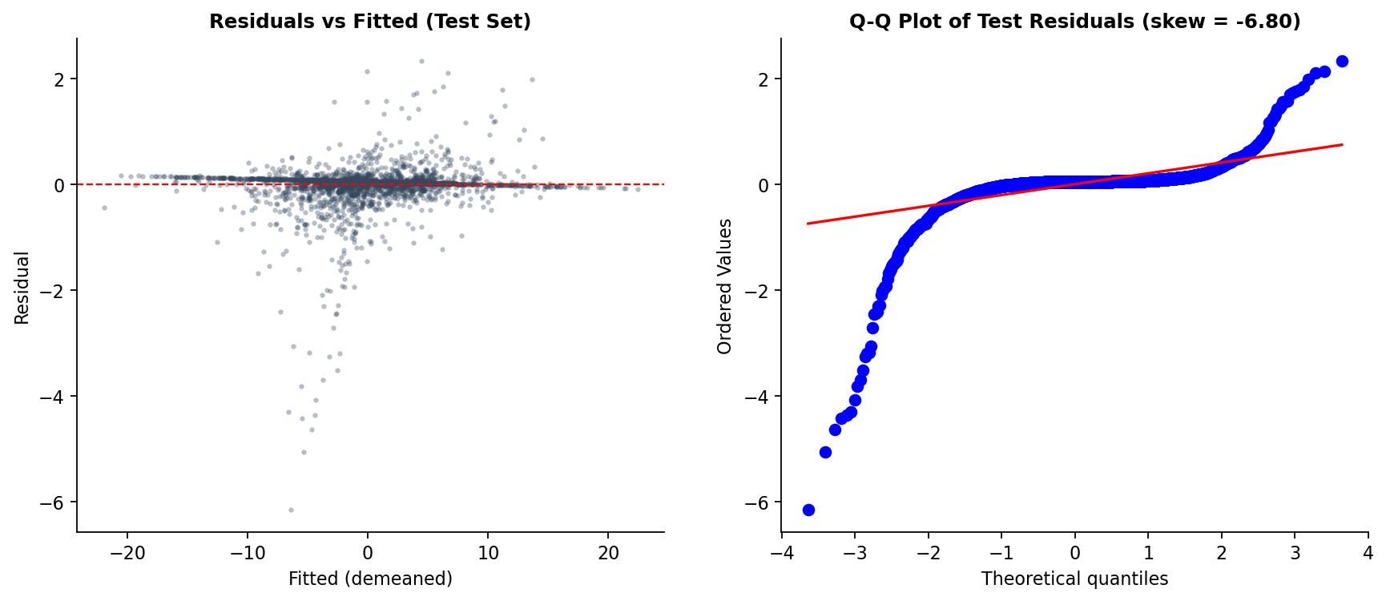
Figure 9. Test-set residual diagnostics. Left: residuals vs. fitted. Right: Q-Q plot against a normal distribution; the heavy left tail reflects the model’s conservative under-estimation of how dry 2018 was.
Test residuals have mean 0.006 and standard deviation 0.326, indicating overall unbiased prediction. The Q-Q plot shows a heavy left tail (skew = −6.80), consistent with the model under-estimating the severity of the 2018 drought. This is a known limitation: no training year matches 2018’s aridity, so the model treats it as an extreme extrapolation. For projection purposes, this means the model is conservative on drought risk — the actual impact of data center demand in a drought year is likely to be modestly larger than the projection implies.

3.7 Projection Methodology
For projection scenarios, the unscaled OLS coefficient is applied directly. Each proposed facility’s capacity (MW) is converted to cooling water demand (MGD) using the project’s standard helper `dc_water_mgd(mw, wue)` with a default mid-range Water Usage Effectiveness of 1.5 L/kWh (low 0.5 and high 2.0 also computed). The MGD is then converted to mm/month depth using the watershed area, multiplied by the OLS coefficient (−0.299), and the cluster-robust 95% CI bounds [−0.356, −0.241] are propagated through the same multiplication to give an uncertainty interval on the projected impact.
For watersheds hosting multiple proposed facilities, demand is summed before conversion. This produces the cumulative per-watershed projection presented in the next section.

4. Results: Where the Future Demand Lands

4.1 Current vs. Projected Spatial Distribution
The most striking visualization in this project is the side-by-side map comparison of current and projected watershed consumption (Figure 10). Today, consumption is broadly distributed across Utah’s populated and agricultural areas, with modest concentrations along the Wasatch Front and in Emery County (existing coal-plant watersheds). After the proposed pipeline is operational, three Great Basin watersheds — Sugarville, Headwaters Hansel Valley Wash, and Whiskey Creek — emerge as new extreme hotspots, each absorbing an order of magnitude more cooling water than any current site.
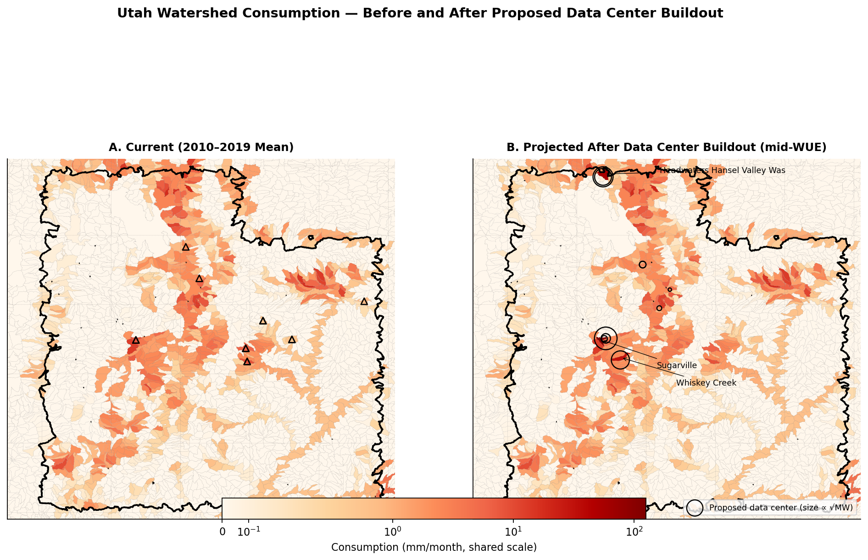
Figure 10. Utah HUC12 watersheds colored by water consumption rate (mm/month). Map A shows the 2010–2019 historical mean; triangles mark existing thermoelectric watersheds. Map B shows the projected post-buildout consumption at mid-WUE (1.5 L/kWh); circles size-by-MW show proposed data center locations. Both maps share a logarithmic SymLog color scale.

4.2 Cumulative Per-Watershed Impact
Six watersheds host planned facilities in the Cleanview inventory. Aggregating facility-level cooling demand within each watershed and propagating through the OLS coefficient yields per-watershed projected reductions in net availability (Figure 11). The three large Great Basin sites dominate; the other three watersheds (Bingham Creek, Summit Creek, Big Dry Creek) host smaller expansions with minimal projected impact.
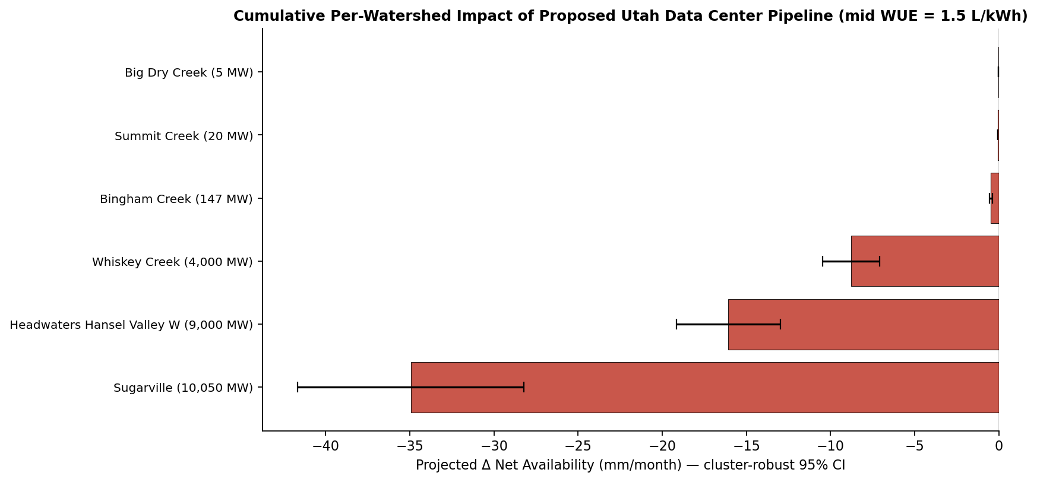
Figure 11. Cumulative projected change in net availability per watershed at mid WUE (1.5 L/kWh), with cluster-robust 95% confidence intervals from the OLS coefficient. Labels show watershed name and total planned MW capacity.

4.3 Statewide Aggregate
The total planned pipeline is 23,222 MW across the six watersheds, corresponding to a cumulative cooling-water demand of approximately 177 MGD at mid-WUE. This is roughly four times the entire current statewide thermoelectric consumption baseline of ~43 MGD. The mid-WUE worst-case watershed is Sugarville, projected to lose 34.9 mm/month of net availability (cluster-robust 95% CI [−41.7, −28.2]); the historical average for that watershed is already −15.6 mm/month, so the combined post-buildout average would be approximately −50 mm/month. Headwaters Hansel Valley Wash (Stratos) is currently barely water-positive at +0.5 mm/month average, but the proposed 9,000 MW facility would drive it to approximately −16 mm/month — a sign change in the basin’s water balance.

5. Conclusion

5.1 What the Model Tells Us
The cluster-robust within-watershed coefficient on thermoelectric consumption is −0.299 mm/month per mm/month, with a 95% confidence interval that excludes zero by a comfortable margin ([−0.356, −0.241]). The pairs-bootstrap confirmation ([−0.358, −0.260]) provides an independent check via a different statistical mechanism. The robustness check (leave-driest-year-out) confirms the coefficient is not driven by extreme-drought training observations. Quantile regression at the drought tail shows the effect amplifies modestly (~10%) in dry years and the energy-mix effect amplifies dramatically (~3.6×). The model generalizes to never-thermoelectric watersheds (OOS test RMSE = 0.32 mm/month, R² = 0.994 across 5,098 observations) — the exact deployment scenario for projection.
When the coefficient is applied to the 23,222 MW Utah data center pipeline at mid-WUE, three Great Basin watersheds emerge as severe stress hotspots: Sugarville (−34.9 mm/mo), Headwaters Hansel Valley Wash / Stratos (−16.1 mm/mo), and Whiskey Creek (−8.8 mm/mo). All three are endorheic with no downstream outlet; consumptive loss in these basins is permanent. The remaining three planned-pipeline watersheds have minor impact, but the headline finding is unambiguous: the proposed pipeline produces large, statistically significant water stress concentrated in a small number of closed-basin watersheds that are not currently in deficit.

5.2 Is the Model Ready to Be Deployed?
The model is ready for use as a scenario planning tool for water resource managers and as input to facility-siting reviews. Its strengths are clear: it is built on the authoritative USGS NWAA dataset, uses correct unit normalization and a watershed-fixed-effects estimator that identifies a causally interpretable within-watershed effect, reports uncertainty via two independent statistical methods, has been stress-tested against a leave-one-year-out robustness check, generalizes to unseen watersheds, and produces a directly usable mm/mo-per-mm/mo coefficient that can be applied to any new facility for which a cooling-water demand can be estimated.
The model should not, however, be the sole basis for facility approval or denial. The training set contains only 36 thermoelectric watershed-years, all at existing Utah coal plants. Extrapolating to data-center evaporative cooling assumes the same physical mechanism applies, which is reasonable but not directly validated. Sub-watershed dynamics (groundwater recharge, return flows, intra-month variability) are not resolved by the HUC12 × year panel. The model is therefore best understood as a defensible baseline for understanding the order of magnitude of impact and the relative ranking of risk across proposed sites — not as a substitute for site-specific hydrological studies.

5.3 Recommendations
- For Utah water resource managers: prioritize watershed-level water-availability studies for Sugarville (HUC12 160300050805), Headwaters Hansel Valley Wash (160203090501), and Whiskey Creek (160300051502) before approving the proposed facilities in those basins. The combined impact of multiple facilities in Sugarville is the single largest projected risk in the pipeline.
- For state regulators: require facility-level water consumption measurement and public reporting for all proposed and operating data centers. The current 9-of-17 reporting gap leaves regulators without a basis for calibrating projection models or enforcing water-use conditions.
- For technology companies conducting water impact assessments: use the model’s mm/mo-per-mm/mo coefficient with cluster-robust 95% CI as a defensible projection framework. Site-specific WUE values should replace the default 1.5 L/kWh assumption where measured cooling-system performance data is available.
- For environmental planners: recognize that the endorheic nature of the high-impact Great Basin watersheds means the consumptive losses are permanent and irreversible. Mitigation through return-flow recovery is not available in closed basins.

5.4 Challenges and Future Opportunities
Five priorities would strengthen confidence in the projection numbers:
- Facility-level measured water consumption. The WRA 2025 fact sheet reports actual water use for only 8 of 17 catalogued operating data centers. Verified consumption data for the remaining 9 facilities, plus mandatory reporting for proposed facilities, would replace the WUE intensity assumption (0.5–2.0 L/kWh) with directly measured values.
- Post-2019 USGS NWAA observations. The watershed model panel ends in 2019. Utah’s industrial electricity load roughly doubled between 2019 and 2025; the most recent thermoelectric responses to that growth are not in the training set. Re-extracting NWAA 2020–2025 outputs when USGS releases them would strengthen both the coefficient estimate and the projection calibration.
- Groundwater and aquifer recharge data. The current target captures surface water only. The Great Basin watersheds where the largest proposed facilities will operate are partly groundwater-dependent. USGS National Water Information System well data per HUC12 would allow extending the analysis to total water balance.
- Climate projections for natural availability. Future scenarios in this analysis hold natural availability at its historical mean. Coupling to downscaled IPCC CMIP6 projections for the Great Basin would quantify how climate-driven availability declines compound with data-center demand growth.
- Return-flow accounting. OLS implicitly treats all thermoelectric consumption as fully consumptive. Some cooling-tower configurations have measurable blowdown that returns to nearby surface water. Facility-level return-flow audits would refine the coefficient by separating gross withdrawal from net consumption.
None of these gaps alter the qualitative conclusion that the proposed pipeline produces large, statistically unambiguous water-stress impacts concentrated in three Great Basin watersheds. They affect the precision of the absolute numbers, not the direction or significance. The methodology in this project — a clean watershed-level panel, within-watershed fixed effects, cluster-robust inference, and direct application of the coefficient to MW-to-MGD-to-mm/mo unit-converted projections — provides a transparent, reproducible foundation for the next iteration of the analysis.

