Camryn Evans
May 9, 2026

Behavioral Ethogram Study on Captive Chilean Flamingos

Introduction

Behavioral observation is an important aspect of conservation biology because it provides insight into how animals allocate their time to different behaviors and activities, as well as how they respond to each other and their environments. Ethograms are a helpful tool in behavioral observation as they provide lists of defined, observable behaviors that researchers can use to efficiently identify behavioral patterns and compare those patterns across other captive and wild populations. This is ultimately useful in zoos and other conservation settings because it can provide important information about whether enclosure spaces are suitable and captive populations’ are exhibiting appropriate, natural behaviors and social dynamics.
This research focuses on the species Phoenicopterus chilensis (the Chilean flamingo), a highly social wading bird native to the wetlands and lagoons of South America. These flamingos commonly exhibit flocking behavior, synchronized group movement, and specialized feeding behaviors in which they sweep their bills through shallow water and muddy substrate to filter algae, invertebrates, and other small food particles (Delfino and Carlos 2021). Chilean flamingos are currently classified as Near Threatened due to breeding site disturbance, water pollution, and reductions in habitable wetland space across their native range (IUCN 2024).

Methods

Chilean flamingos were observed through the Flamingo Cam livestream in the Houston Zoo’s South American Wetlands Exhibit at approximately 4:00 PM on May 7, 2026 under cloudy conditions with a temperature of 76°F, humidity of 70%, and wind speeds of 8 mph. Prior to collecting data, the flock was observed for several minutes in order to identify commonly exhibited behaviors that could be used to assemble an ethogram. All behaviors were categorized as maintenance, active, inactive, or aggression behaviors.
This study used both scan sampling and focal animal sampling in recording data. Scan sampling was conducted over six one-minute observational scans of the flock during which the number of flamingos engaged in each behavior was recorded. Focal animal sampling was conducted by continuously observing a single flamingo over two separate three-minute sessions during which the time and corresponding behavior were recorded whenever the focal flamingo changed behavioral states.

Results

Twelve distinct behaviors were identified and categorized into four behavioral categories: maintenance, active, inactive, and aggression. Maintenance behaviors included feeding/foraging, preening, bathing, and wing stretching; active behaviors included solitary locomotion, group locomotion, and running; inactive behaviors included standing and roosting; aggression behaviors included biting and chasing (Table 1). Preening was the most frequently exhibited behavior according to both the scan and focal sampling data (Figures 1 and 2).

Table 1: Ethogram of observed flamingo behaviors, including behavioral categories and definitions used during scan and focal sampling.

Category | Behavior | Description
Maintenance
 | F = Feeding/Foraging | Head submerged in water, bill sweeping through water, or bill dragging along wet substrate while foraging.
 | P = Preening | Using the bill to clean or arrange feathers on the body.
 | B = Bathing | Ruffling feathers, flapping wings, splashing, or preening while partially submerged in water.
 | W = Wing Stretch | Extending one or both wings outward while stationary, sometimes in a brief display-like posture
Active
 | SL = Solitary Locomotion | Casual movement through the enclosure that is not clearly coordinated with nearby individuals.
 | GL = Group Locomotion | Two or more flamingos moving together simultaneously in the same direction or as part of a coordinated flock movement.
 | R = Running | Rapid locomotion involving quick steps or a short burst of movement.
Inactive
 | S = Standing | Motionless upright posture without locomotion, feeding, or obvious interaction.
 | RO = Roosting | Standing on one leg or sitting/lying on the ground with eyes closed or head tucked beneath its wing.
Aggression
 | BI = Biting | Biting or pecking another individual with the bill.
 | C = Chasing | One flamingo moving forcefully toward or pursuing another individual.

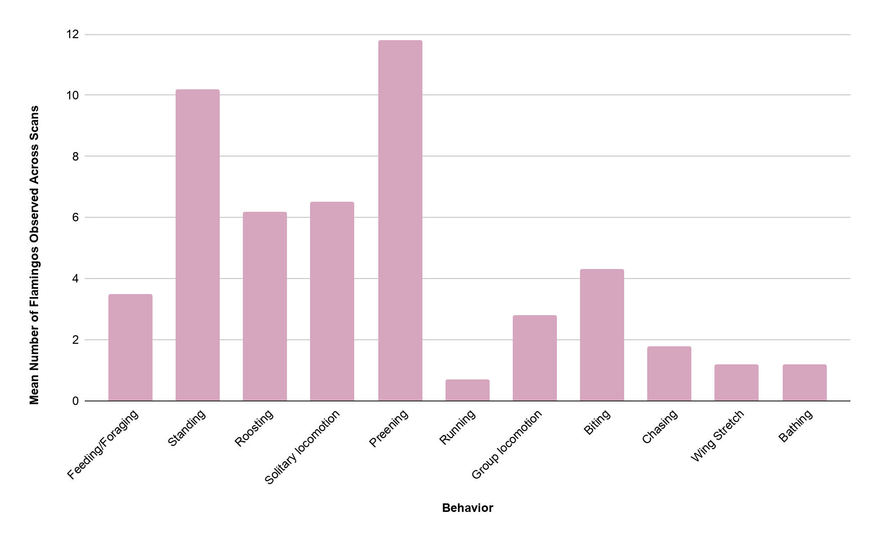

Figure 1: Mean Frequency of Flamingo Behaviors Observed Across Six Scan Samples

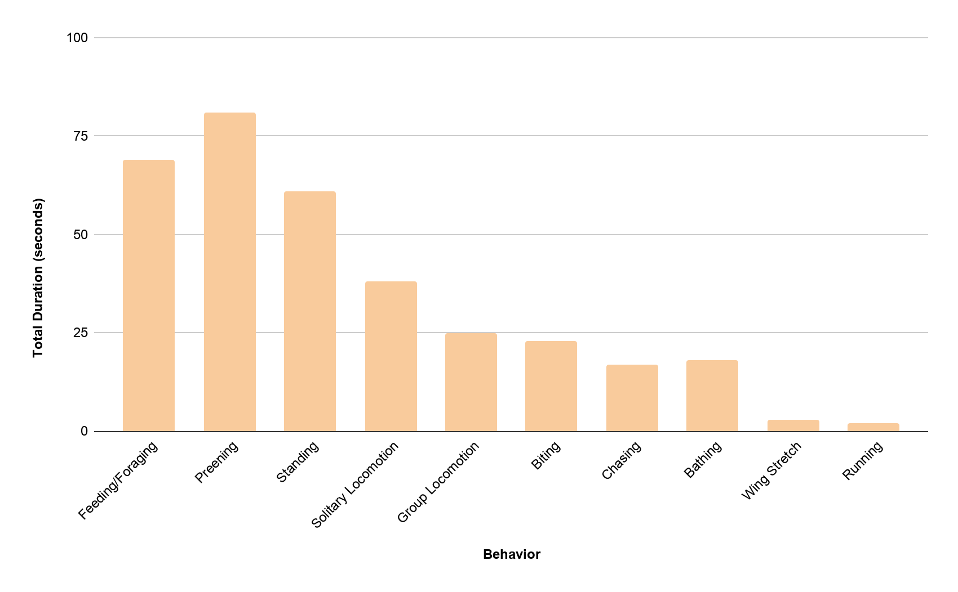

Figure 2: Total Duration of Focal Flamingo Behaviors

Discussion

- What types of behaviors characterized your zoo population, and which behaviors were most frequently observed? Why do you think this was the case?

The Chilean flamingo flock was predominantly characterized by maintenance and inactive behaviors, with preening being the most frequently observed behavior for both the scan and focal sampling data, followed closely by standing during the scan samples, and feeding/foraging during the focal samples. The high rates of preening are consistent with known flamingo biology and behavior, as flamingos dedicate significant amounts of time to feather maintenance behaviors that ultimately aid in waterproofing, insulation, thermoregulation and social display (Rose et al. 2024).

- Did you tend to “split” or “lump” behaviors? What are the benefits and backdraws of either approach?

I both split and lumped behaviors at various points in the ethogram where it made sense to do so. For example, locomotion was split into solitary and group locomotion because moving independently versus moving as part of a coordinated group indicates different social contexts. However, smaller actions were lumped into broader behaviors when they served the same functional role. For example, the “bathing” description included several different maintenance actions like splashing, feather ruffling, and wing flapping in the water because they all served the broader purpose of bathing.
I chose not to organize the ethogram primarily around solitary versus social behaviors because flamingos are extremely flock-oriented birds, and during observation, most behaviors occurred directly alongside other individuals, even if they did not involve physical interaction. For this reason, categorizing all behaviors as social would not have been particularly meaningful, so behaviors were instead organized according to function, with only certain behaviors being separated by social context when necessary.
Splitting behaviors in ethograms can help reveal more minute and specific patterns when studying behavior, but doing so excessively can make it difficult to correctly distinguish between behaviors. Alternatively, lumping behaviors can make data recording more efficient and streamlined, but it can also result in important behavioral distinctions being overlooked.

- Did you observe any behaviors that may be unique to captivity or zoo settings?

While I did not observe any classic stereotypic behaviors like pacing, some of the natural behaviors that I did observe may have been performed in a manner or at a frequency unique to captive settings. For example, there were various other species of large wading birds housed in the South American Wetlands Exhibit, and I observed the flamingos frequently interrupting their foraging and preening behaviors in order to walk away from and avoid contact with heterospecifics; in a wild setting, these species would likely not be as tightly condensed, and would thus be able to engage in maintenance behaviors with less frequent interruption by heterospecifics.

- How might this ethogram and your results be used to help manage or understand this animal?

This ethogram could be helpful in identifying behavioral patterns that may signify an inadequate enclosure that does not support natural behaviors, which zoo staff can adjust accordingly. If incorporated into a longer-term behavioral monitoring project, it could also help the zoo track changes in flock behavior, enclosure use, and social structures over time while identifying patterns potentially associated with stress, overcrowding, or other captive considerations. While the flamingos at the Houston Zoo may be a permanent captive flock, ethogram data in general can be helpful in assessing appropriate natural behaviors prior to release for populations or individuals that are only temporarily captive.

References

Delfino, H. C., and C. J. Carlos. 2021. Behavioral repertoire of a population of wild Chilean Flamingos Phoenicopterus chilensis in southern Brazil. Journal of Natural History 55:1957–1981.
IUCN. 2018, August 9. IUCN Red List of Threatened Species: Phoenicopterus chilensis. Name. https://www.iucnredlist.org/es/species/22697365/132068236.
Rose, P. E., R. Kinnaird, and K. A. Wood. 2024. What influences feather care and unipedal resting in flamingos? Adding evidence to clarify behavioural anecdotes. Applied Animal Behaviour Science:106364–106364.

