Mapping More than Land: Anthropology’s Approach to the Politics and Science of Protection
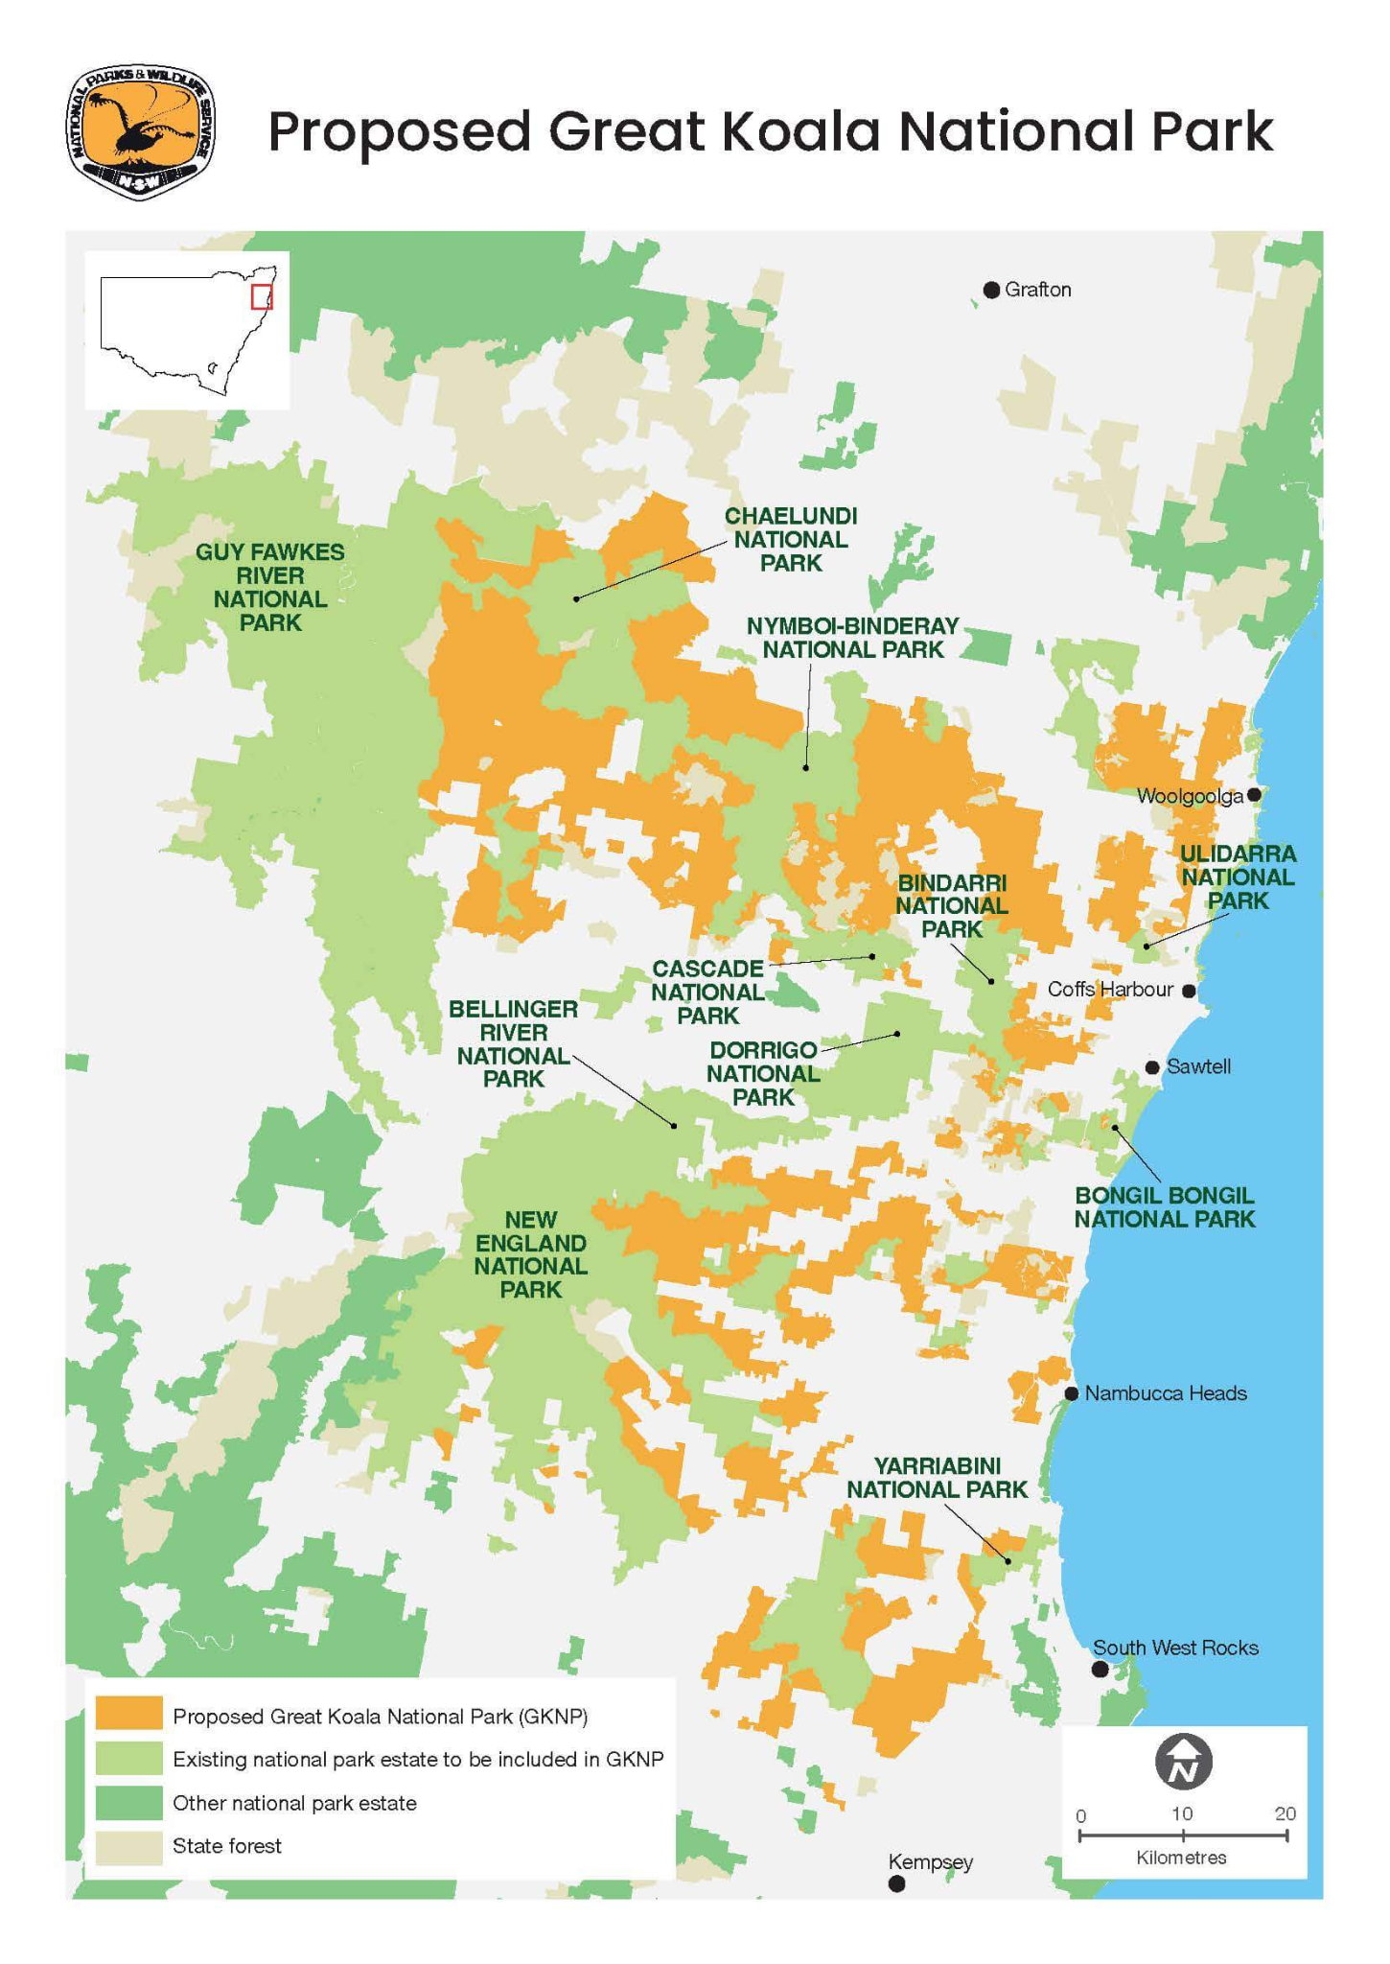
Camryn Evans
February 15, 2026

I recently came across a map of a newly designated protected National Park forest in Australia. The map was visually precise with clear boundary lines, extensive orange shading, and a legend explaining the conservation zones. On the surface, it looked like a success story. Thousands of acres were preserved, and wildlife was protected.

But there was something missing. Not necessarily from the map itself, but from the narrative surrounding it. Who lived there before those lines were drawn? Who decided that those boundaries would be rewritten? What happens when a forest becomes “protected” for flora and fauna, but not for human beings?
Proposed Great Koala National Park Map, NSW Government

The Map, the Data, and the Stories in Between

That moment clarified to me what anthropology is really meant for. It aims to fill in these missing stories, exploring not only what is happening, but also how these happenings are lived, experienced, and understood by the human beings most affected.

Now imagine this same forest, but from a different lens. Instead of beginning with satellite imagery or species range data, we begin with a family whose grandparents harvested medicinal plants there. We listen to how this family describes the land not as a resource, but as a relationship and a repository of memory. When we consider this part of the ecological story, the once very clear lines on the map begin to blur.

Conservation policy decisions might be globally celebrated as climate or wildlife victories, but on a local scale, they might mean restricted grazing, forced relocation, or the criminalization of subsistence practices. Our environmental goals are certainly valid and necessary, but they don’t unfold in isolation. In many cases, they actually reshape the daily lives of human beings, disrupting things like labor patterns, governance structures, and cultural or spiritual relationships to land.

This is where an anthropological lens becomes essential. It does not dismiss scientific technicalities or legal frameworks, but instead situates them within human stories and lived experiences.

Centering Lived Experience

To me, anthropology’s biggest strength lies in its commitment to listening and centering lived experience. Through ethnographic research, interviews, and long-term community engagement, it prioritizes firsthand narrative while still engaging meaningfully with data and legal analysis. Ultimately, it shifts the guiding theme, not stopping at questions like “how many acres can we protect?” but continuing on to ones like “Who is affected by this protection, and how?”

This perspective is especially necessary when examining Western conservation models. Our increasing expansion of conservation zones is often framed as an obvious ecological imperative. It’s usually the major objectives like “protect biodiversity,” “regulate land use,” or “mitigate climate change” that we hold as being the most pressing. But this framing can obscure the attendant social realities occurring locally.

Consider environmental justice cases, for example. Legal analysis can outline the rulings determined and the precedents set, but anthropology moves beyond pure legal analysis to examine how communities actually experience this litigation. It asks how environmental policy and subsequent lawsuits affect community dynamics, or how activists narrate their resistance. Ultimately, anthropology reflects on who gets to write the rules, whose knowledge gets to count, and whose voices get to be heard.

This approach holds that the law itself is a cultural system embedded with firm assumptions, deep histories, and evolving values. Just as much as villages or households, anthropologists treat courtrooms and datasets as cultural spaces, expanding our understanding of “field sites” to be literally anywhere that human meaning is produced. Technical details and data are necessary, but it’s equally necessary to weave these things into lived experience, and that weaving is what anthropology does best. It understands that environmental policy can derail labor systems, community authority, and spiritual practices, and accordingly, it inquires about historical relationships to land, it examines whether affected communities were consulted and their knowledge embraced, and it identifies potential inequities in how a project’s benefits and burdens are distributed.

Environmental harm is rarely just about ecosystem science alone. Human rights, sovereignty, cultural survival, and power dynamics are almost always intertwined with ecological concerns. Anthropology urges us to consider all of these dimensions at once, reminding us that protecting land without understanding the people who live on it can cause considerable harm, even when intentions seem noble.

Slowing Down and Listening

There is also something slower and more intentional about anthropology’s centering of lived experience. In contemporary conservations about climate change or development, urgency tends to dominate, with scientists and policymakers hammering things like efficiency and rapid solutions. This MO, while seemingly favorable in a rapidly changing world, often comes at the expense of context and the proper consideration of it. What anthropology does exceptionally well is complicate that urgency. It suggests that speed alone is not a marker of efficiency, and that a truly effective pace is actually one that allows for the thorough consideration and integration of human context. After all, an ecological solution developed quickly but without regard for local people’s realities is sure to produce at least some amount of damage that undermines the solution’s original goals.

Picture a development team arriving in a rural community with a sustainability project already fully designed, funding already secured, and predicted outcomes already quantified. From a professional standpoint in environmental law or science, this likely appears organized and efficient. An anthropologist, however, would likely begin somewhere else entirely, whether that looks like sitting in kitchens and breaking bread with local families, attending community meetings and cultural events when appropriate, or asking about local governance to learn how decisions are made in that area before proposing any change of their own.

This slower field work is by no means an inefficient delay in a project’s timeline, but rather a crucial, non-negotiable form of due diligence. Anthropology recognizes that policies and projects (environmental or otherwise) are never socially neutral. They intersect with histories of inequality, patterns of governance, and existing tensions that persist within communities. Ignoring these layers does not make them go away; it only makes them harder to anticipate and thus all the more destructive to the affected communities.

Returning to the Map

When I think back to that conservation map now, I no longer see its clearly defined lines as dismissive or incomplete. Instead, I see them as an invitation. Those lines represent one layer of reality, the ecologically quantifiable. And when I look at that map with its protected zones and bold lines, I feel urgently invited to color in the negative space with the human stories that maps and statistics simply cannot color on their own.

In our current context, with environmental crises and human rights struggles becoming increasingly entangled, the anthropological approach feels less like a niche academic method and more like a necessary orientation for navigating our world. It encourages us to look for the human story in every policy, project, or dataset that we work with.

In finding these human narratives, we connect environmental metrics to cultural practices, legal frameworks to lived experiences, and ecological conservation to questions of sovereignty and justice.

Once you start looking for these stories, it becomes impossible not to see them. That, to me, is the truest manifestation of the anthropological approach.

References

New South Wales Government. (2026). Great koala national park. Environment and Heritage. https://www.environment.nsw.gov.au/topics/parks-reserves-and-protected-areas/establishing-new-parks-and-protected-areas/changes-to-parks/great-koala-national-park

