Camryn Evans
Artifact Vignette Exercise
25 September 2023

The Place Where Cranes Dance

6:35pm. The last rays of the evening sun illuminate the Platte River — the river that will soon provide refuge for 600,000 Sandhill cranes as they rest on their long journey north. We gather on the bridge. Strangers yet family. Connected spiritually by our shared love for cranes that pulls us like magnets to this sacred location. And connected physically, each pair of our hands grasping the same ocular devices — the keys — that will allow us to be a part of something fascinating. The assembly holds its breath as the first bugle call reaches our ears, and 600,000 Sandhill cranes begin to speckle the horizon.

I hold onto my binoculars a little bit tighter.

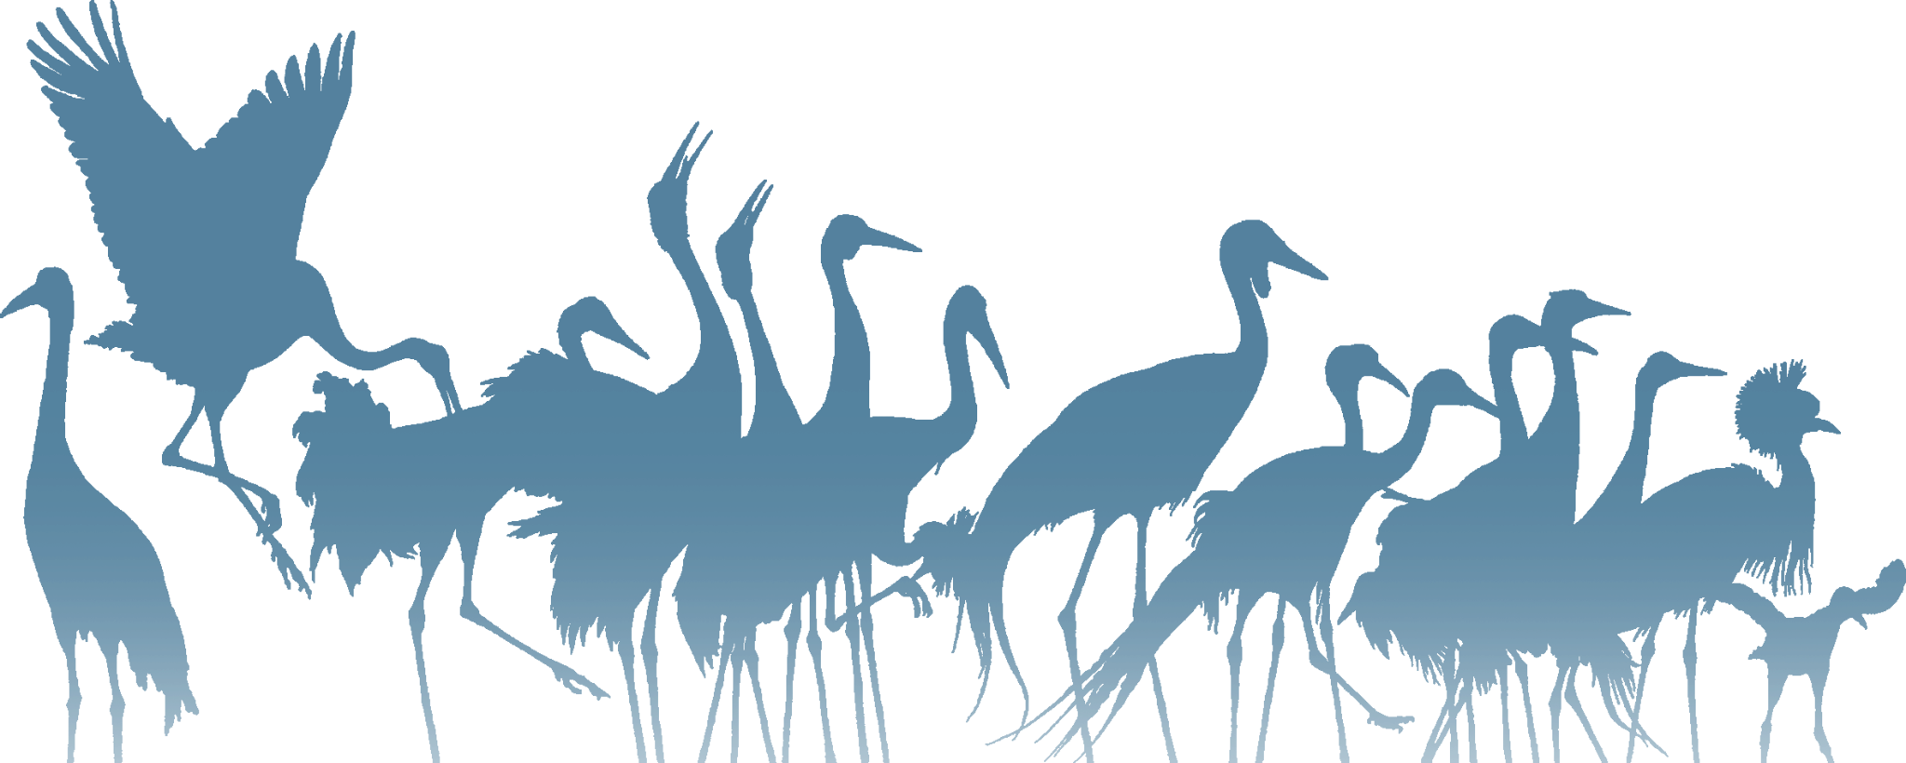
600,000 Sandhill cranes now flood the evening sky, their sonorous, united call growing like an orchestra in permanent crescendo. I raise my binoculars, ready to glance through their lenses at the massive cloud of birds drawing nearer. “Here they come!” one birdwatcher exclaims to the rest of us, and we exchange looks of wild exhilaration. Most of the group is so astonished that we have completely lost our words. And while radically connected to these onlookers around me, I feel simultaneously set apart from them; having spent each day of the past six months in service to a captive flock in the name of species preservation has left me with a deeply intimate knowledge of nearly 100 individual cranes — their intelligence, their grace, their personal quirks and idiosyncrasies. This avian mass in the sky is not just a flock of Sandhill cranes… it’s a million Vinnies, Starlords, and Rockets flying to me. Flying back to say, “Hello again, friend, and thank you for taking care of us.” This moment on the bridge represents something so profoundly personal to me, and as I witness it all in such fine, incredible detail, a tear slides gently down my cheek. Locating a single crane as it soars elegantly across the orange sky, I transcend distance. Five hundred feet turn into fifty… five… one. The crane is now inches within my reach. I squeeze the shaft of my binoculars, clutching vigorously as to never break my focus on this spectacular animal. It extends its legs forward in preparation for landing, upon which my binoculars uncover every crack and crevice in its rough, withered scutes. I zoom out. The enormous flock begins to land in droves, and somehow, amid a blanket of identical appearances, each crane effortlessly locates its own family group in the shallows of the river. A long day of flight across America’s southern skies leaves 600,000 Sandhill cranes ready for leisure.

I let my binoculars guide me across the thick sea of birds.

600,000 Sandhill cranes begin to chatter about the day’s adventures and the journey that lies ahead. Social hour for these feathered friends gives rise to a spell of friskiness that ripples throughout the flock, a phenomenon that can only be described as nature’s own Swan Lake ballet. An onlooker points the crowd to a particular pair of cranes whose dance has just begun. I desperately fiddle with the center focus of my binoculars, readying my lenses to follow every swift step of the cranes’ performance. The pair blazes a trail with their elegant pirouette, bowing their red crowns as the dance begins to surge like wildfire through the rest of the flock. The beauty of this magnificent scene is only amplified by the warming truth that cranes mate for life; hundreds of loving partners twirl and spin with their sweethearts, the sun’s fiery orange beam their spotlight and the gently flowing river their stage. I am breathless, transported to another realm entirely where 600,000 Sandhill cranes command the most graceful of ballets.

I yield to nature’s might as my binoculars become an extension of my being.

They are no longer just an ocular device for me to use. No longer just a tool that allows me to be a part of something fascinating; they are my very line of sight. They are my body’s eyepiece. Its compass. They are what connect my soul so indelibly to this flock — to this feathered beacon of light whose beauty lies anchored beyond the reach of words.


I lower my binoculars as the setting sun greets the rising moon, and 600,000 Sandhill cranes begin to fall asleep.

