中文分词

1. 把老师提供的sphinx文件包上传到/root目录
2. 安装相关软件

yum -y install make gcc g++ gcc-c++ libtool autoconf automake imake mysql-devel libxml2-devel libtool.i686 expat-devel php-devel

如果报错，先删除

yum remove -y MySQL-server-5.5.38-1.rhel5.i386

yum remove -y MySQL-client-5.5.38-1.rhel5.i386

-------------------------------------安装mmseg-------------------------------------------

1. tar zxvf /root/sphinx/coreseek-4.1-beta.tar.gz
2. cd /root/coreseek-4.1-beta/mmseg-3.2.14/
3. ./bootstrap #测试安装环境
4. ./configure --prefix=/usr/local/mmseg3 #指定安装目录
5. make
6. make install

-------------------------------------分词测试-------------------------------------------

9./usr/local/mmseg3/bin/mmseg -d

/usr/local/mmseg3/etc

/root/coreseek-4.1-beta/mmseg-3.2.14/src/t1.txt

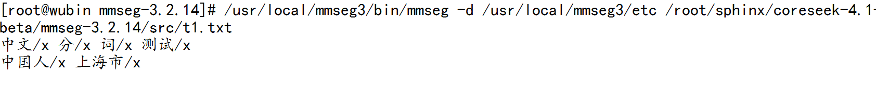

-------------------------------------安装csft-------------------------------------------

1. cd /root/coreseek-4.1-beta/csft-4.1/
2. sh buildconf.sh
3. ./configure --prefix=/usr/local/coreseek --without-unixodbc --with-mmseg --with-mmseg-includes=/usr/local/mmseg3/include/mmseg/ --with-mmseg-libs=/usr/local/mmseg3/lib/ --with-mysql

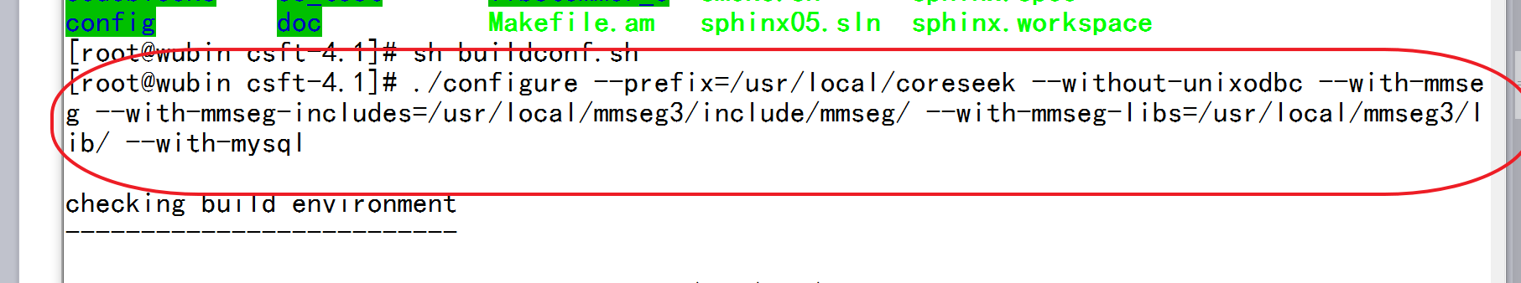

1. make & make install

-------------------------------------安装mysql------------------------------------------

1. yum install -y mysql mysql-server
2. service mysqld restart

-------------------------------------初始化mysql-----------------------------------------

1. mysql_sec 按一下tab

---------------------------------mysql数据分词实验------------------------------------

1. 使用sql.php创建数据库表
2. 复制配置文件：cp /root/sphinx/csft.conf /usr/local/coreseek/etc/
3. 生成索引 /usr/local/coreseek/bin/indexer --all
4. 搜索 /usr/local/coreseek/bin/search 后盾

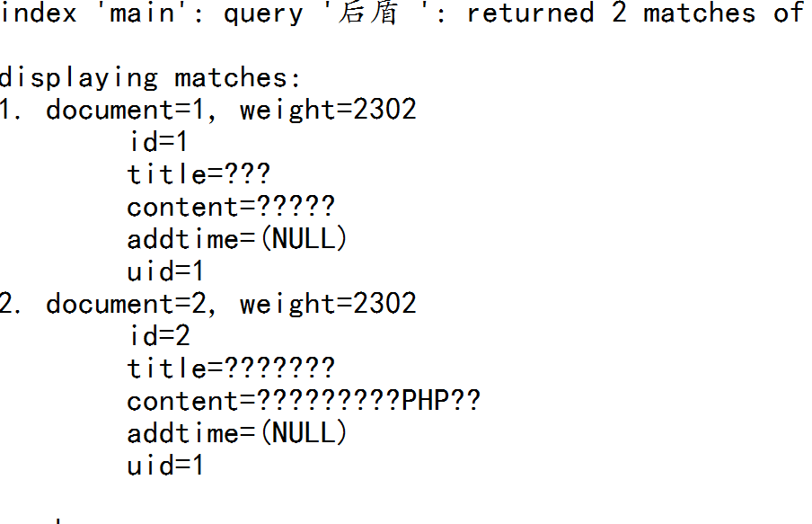

------------安装libsphinxclient否则无法安装php的sphinx扩展-------------

1. cd /root/coreseek-4.1-beta/testpack/api/libsphinxclient
2. ./configure
3. make & make install

---------------------------------------php的sphinx-------------------------------------

1. cd /root/sphinx/
2. tar zxvf php-module-sphinx-1.3.2.tgz
3. cd sphinx-1.3.2/
4. phpize (如果不存在此命令，执行yum -y install php-devel 安装)
5. ./configure --with-php-config=/usr/bin/php-config --with-sphinx
6. make & make install

----------------------------------修改php的配置文件----------------------------------

1. cd /etc/php.d/
2. cp gd.ini sphinx.ini
3. 修改内容为extension=sphinx.so

----------------------------------启动sphinx----------------------------------

1. /usr/local/coreseek/bin/searchd -c

/usr/local/coreseek/etc/csft.conf

----------------------------------更新索引----------------------------------

1. /usr/local/coreseek/bin/indexer -c

/usr/local/coreseek/etc/csft.conf --all --rotate

-------------------把php文件放入web访问目录----------------

-------------------运行index.Php----------------

1. 运行报错执行 yum -y install php-mysqli【重启apache】

-------------------执行定时任务，创建日志文件----------------

1. touch /usr/local/coreseek/var/log/main.log
2. touch /usr/local/coreseek/var/log/delta.log

---------------------------------------创建shell脚本-------------------------------------

1. mkdir /usr/local/coreseek/sh/
2. cd /usr/local/coreseek/sh
3. touch main.sh
4. touch delta.sh
5. chmod a+x -R /usr/local/coreseek/sh/
6. 修改主索引

#!/bin/sh

/usr/local/coreseek/bin/indexer main --rotate>>/usr/local/coreseek/var/log/main.log

1. 修改增量索引

#!/bin/sh

/usr/local/coreseek/bin/indexer delta --rotate >> /usr/local/coreseek/var/log/delta.log

----------主索引每5分钟更新，主索引每天凌晨3：30更新------------------

1. crontab -e 编辑crontab 文件

command not found执行：yum install -y vixie-cron

检查是否设置了开机启动：chkconfig --list crond

启动crontab：service crond start

*/5 * * * *  /bin/sh /usr/local/coreseek/sh/delta.sh

30 3 * * * /bin/sh /usr/local/coreseek/sh/main.sh