**Innovation Week HOME PAGE**

Remove the banner at the very top of the page:



Remove/Hide the Schedule and Keynote buttons; change Recordings to “IW Recordings”; change Spirit of Innovation to “Past Honorees”



Change Innovation Week 2005 to Spirit of Innovation Awards 2025

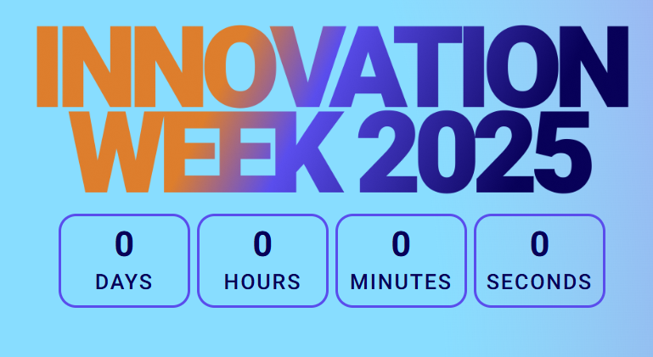

Update countdown to expire on Oct. 30 and put a title under that says “Celebration and Project Showcase: Oct. 30, 2025”

Change the save the date box to “Nominations Open: June 2-20” and button to say “Nominate Here!”

Remove info/photos about Award Points



Move the section at the bottom of the page that says “Spirit of Innovation Awards 2025” to the top and move the section “What is Innovation Week?” to the bottom

(in the first sentence capitalize Award) on the View

Previous Winners say “View Past Honorees”



Remove the info below and replace with a new [Timeline image that we will send soon]



Example timeline:

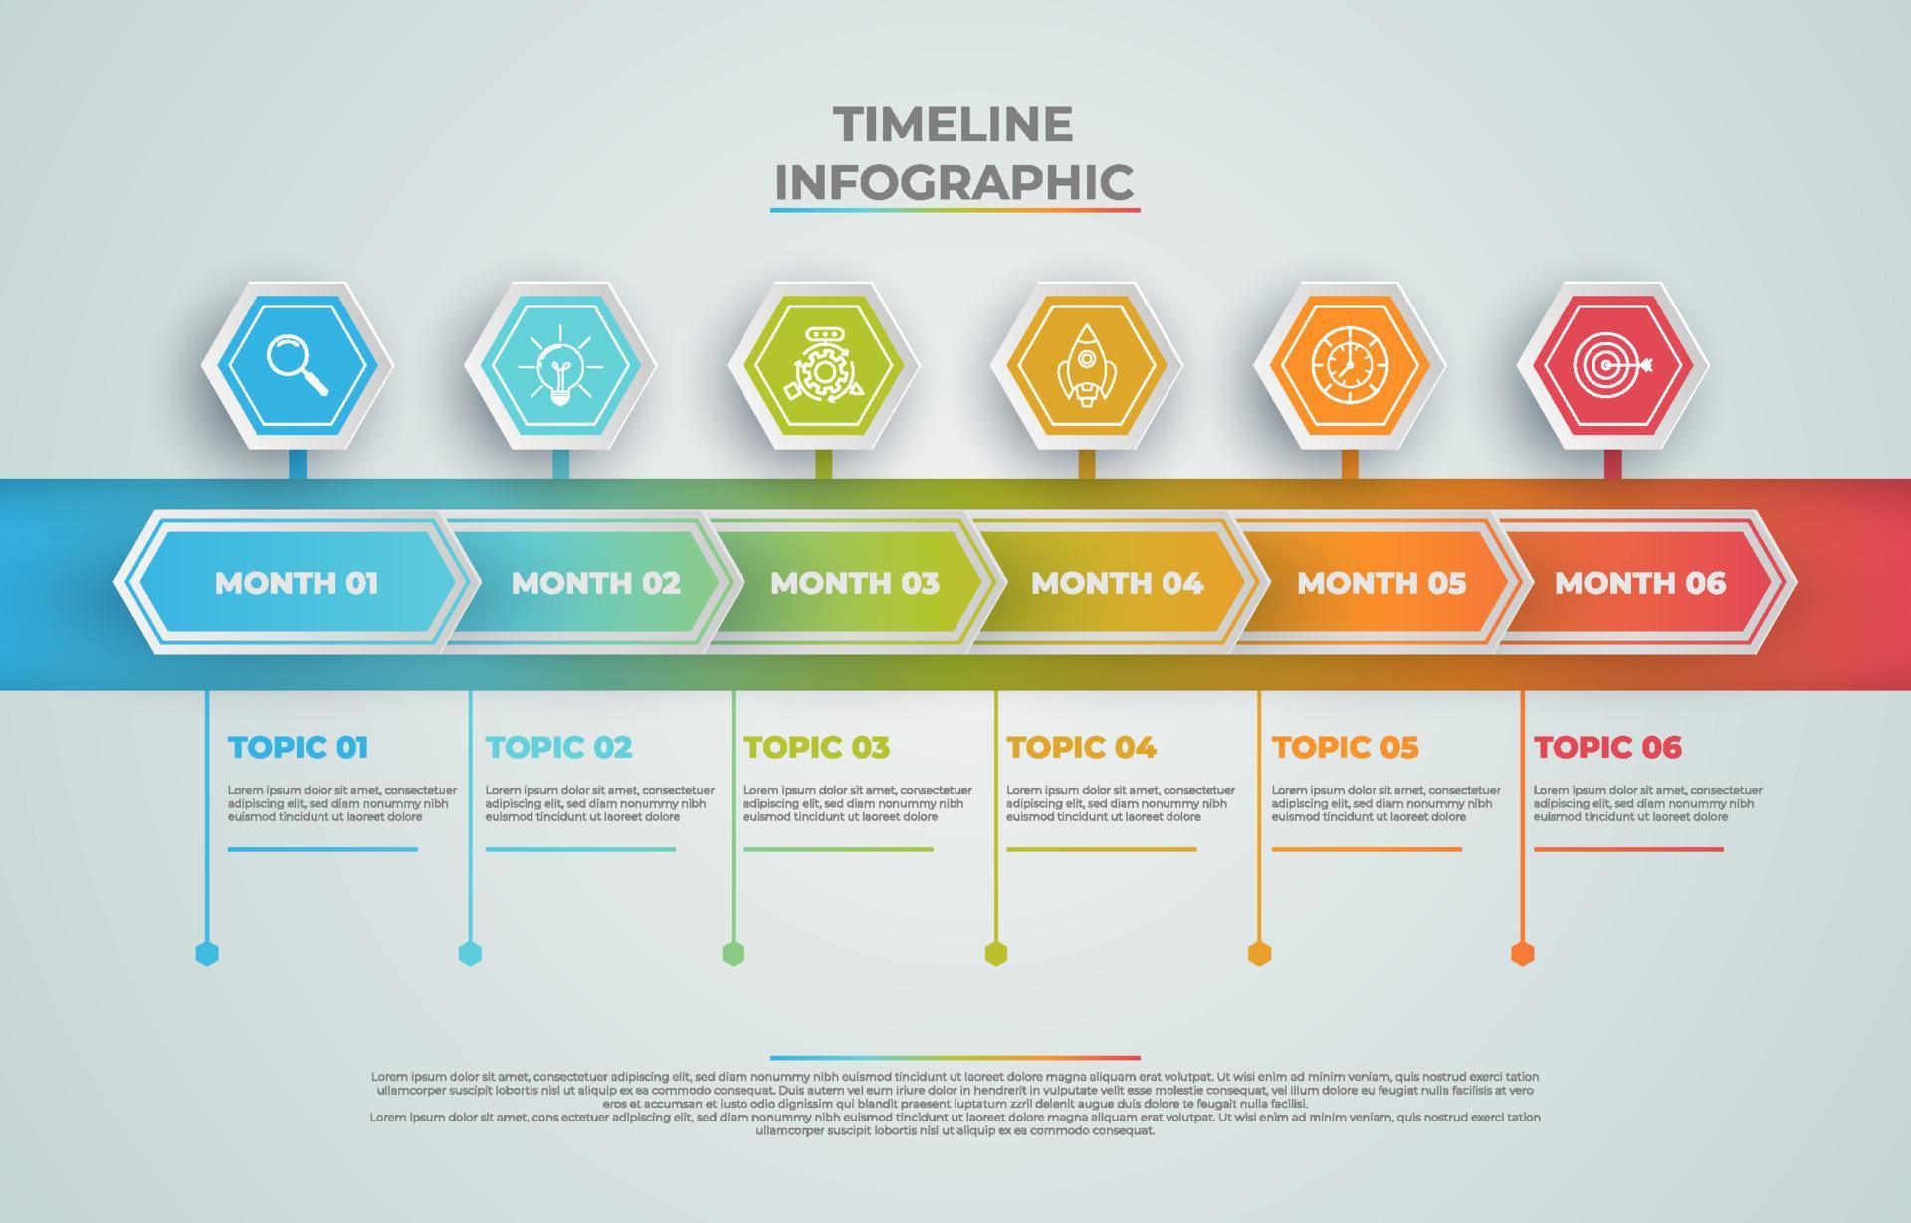

From “Nominate Here” button, link to Smartsheet Form.