AZ-104 Crucial Subjects – Azure Administrator Project Lab
Chhiring Moktan
Azure Administrator (AZ-104) Hands-On Project

Phase 1 – Governance, Identity & Resource Organization

1.1 Azure Advisor & Resource Governance
This phase focused on establishing governance, visibility, and control over Azure resources by leveraging Azure Advisor, Resource Groups, and resource locks. Azure Advisor recommendations were reviewed to identify optimization opportunities across cost, security, and performance domains. A Resource Group was created to logically organize resources, followed by the implementation of a 'CanNotDelete' lock to protect critical assets from accidental deletion.
Screenshot Allocation:
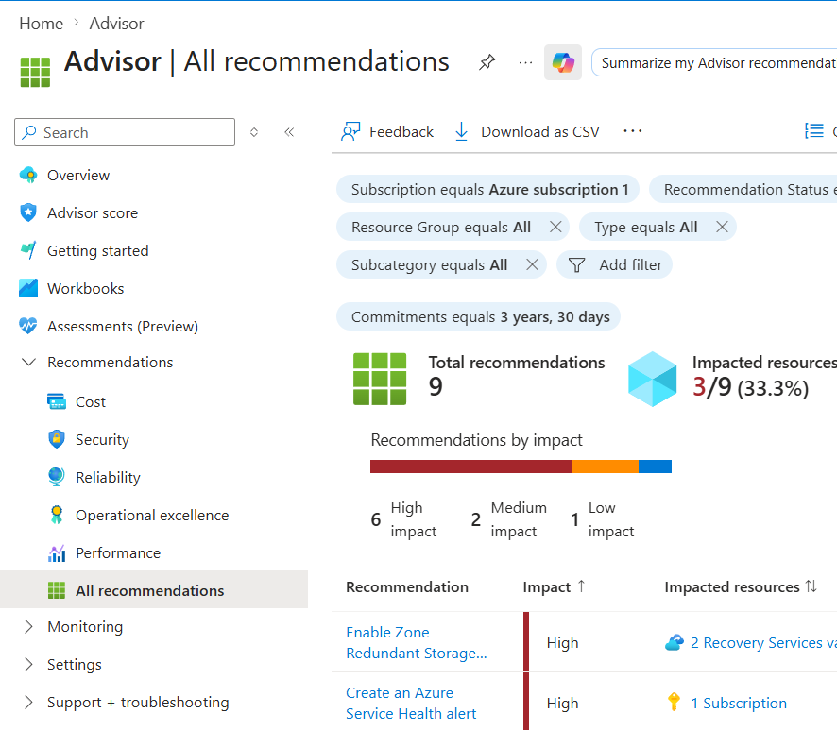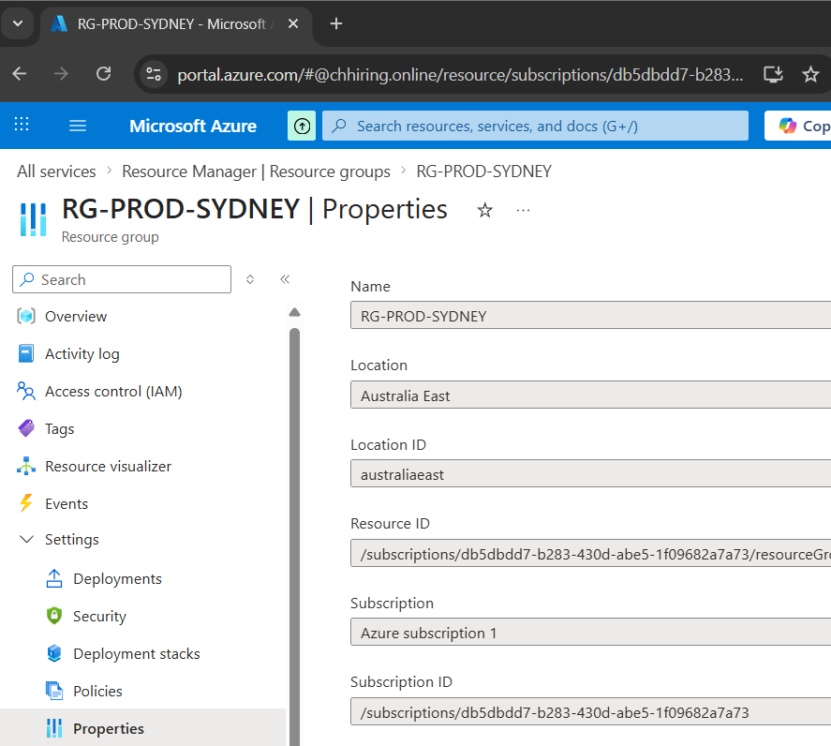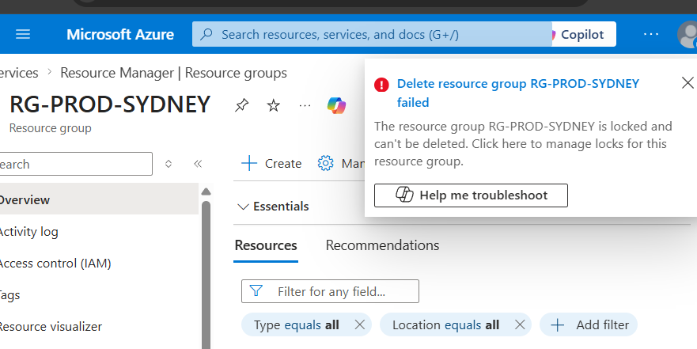

1.2 Infrastructure Deployment using ARM Templates
Infrastructure-as-Code principles were implemented using ARM Templates to ensure consistent and repeatable deployments. Resources were defined declaratively and deployed via the Azure Portal, reducing manual configuration errors and improving scalability.
Screenshot Allocation:
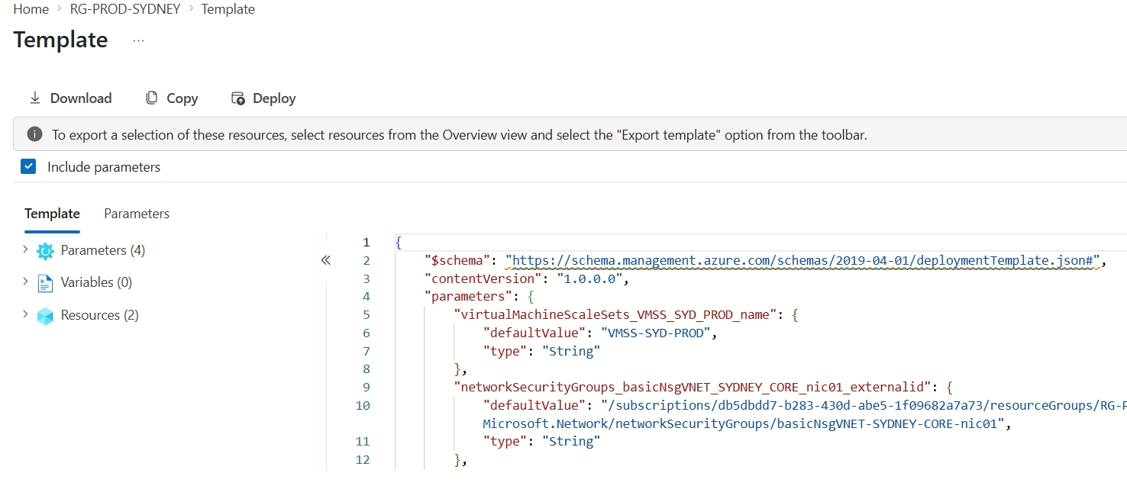

Phase 2 – Networking & Security Controls

2.1 Virtual Network Architecture & Peering
A segmented virtual network architecture was designed using subnets to isolate workloads. Virtual Network Peering was configured to enable private communication between networks without exposing traffic to the public internet, ensuring high performance and secure connectivity.
Screenshot Allocation:
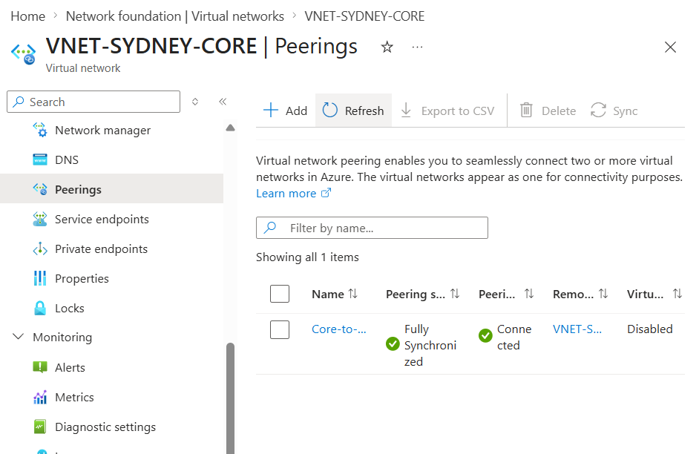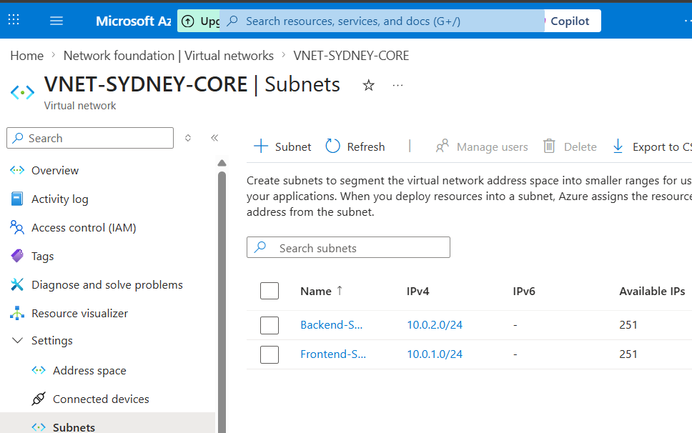

2.2 Network Security Implementation using NSG
Network Security Groups (NSGs) were configured to control inbound and outbound traffic. Custom rules were applied, including high-priority deny rules, to enforce strict security policies and protect resources from unauthorized access.
Screenshot Allocation:
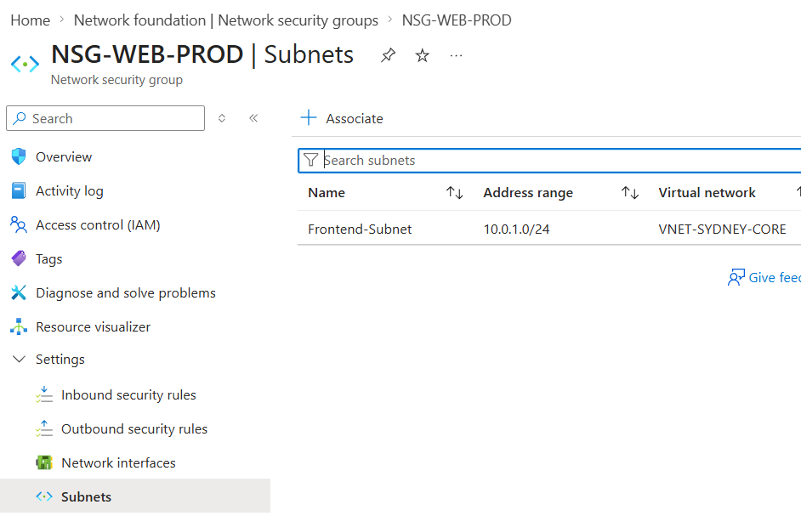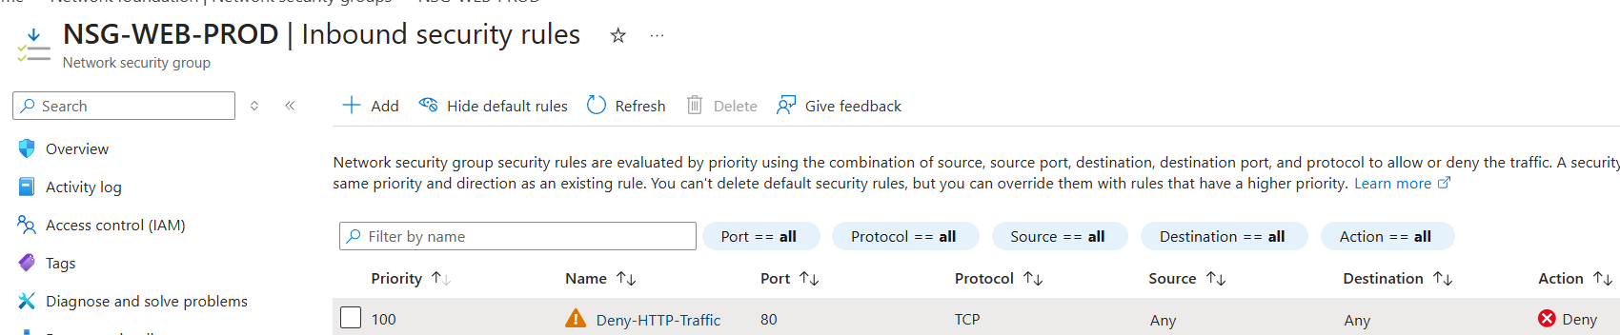

Phase 3 – Hybrid Connectivity & Traffic Distribution

3.1 Site-to-Site VPN Implementation
A Site-to-Site VPN was configured to establish secure hybrid connectivity between on-premises infrastructure and Azure. This included deploying a Virtual Network Gateway, configuring a Local Network Gateway, and establishing a connection using a shared key.
Screenshot Allocation:
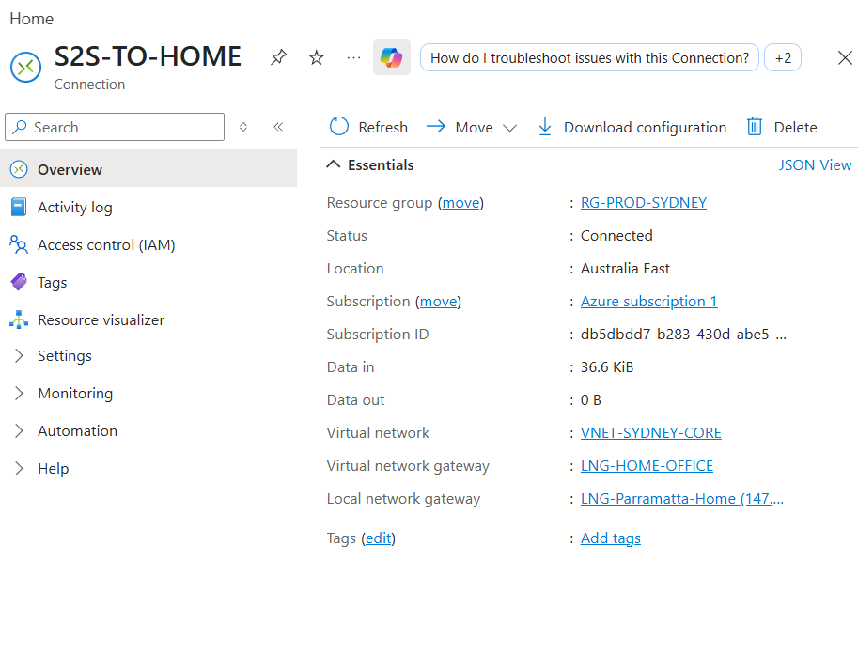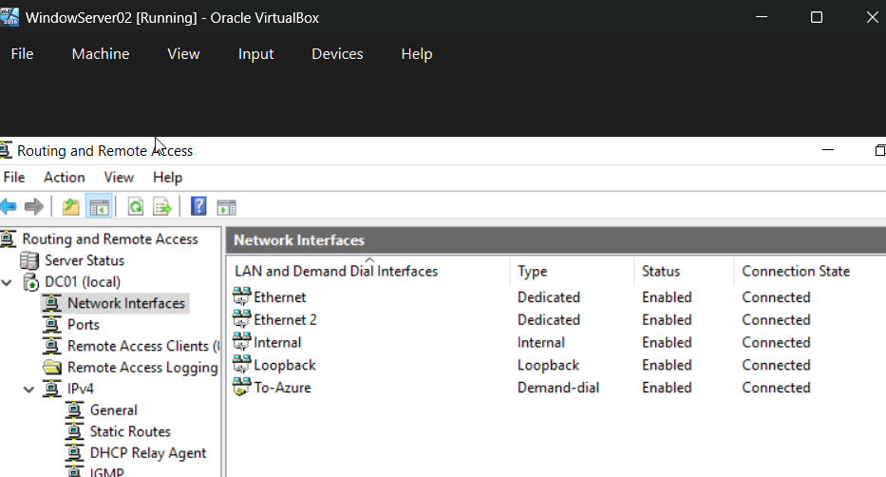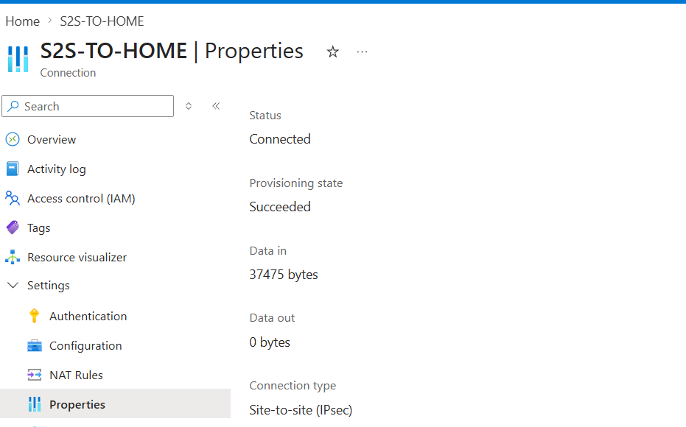

3.2 Azure Load Balancer Implementation
An Azure Load Balancer was deployed to distribute traffic across backend virtual machines. Backend pools and health probes were configured to ensure high availability and that only healthy instances handle incoming traffic.
Screenshot Allocation:
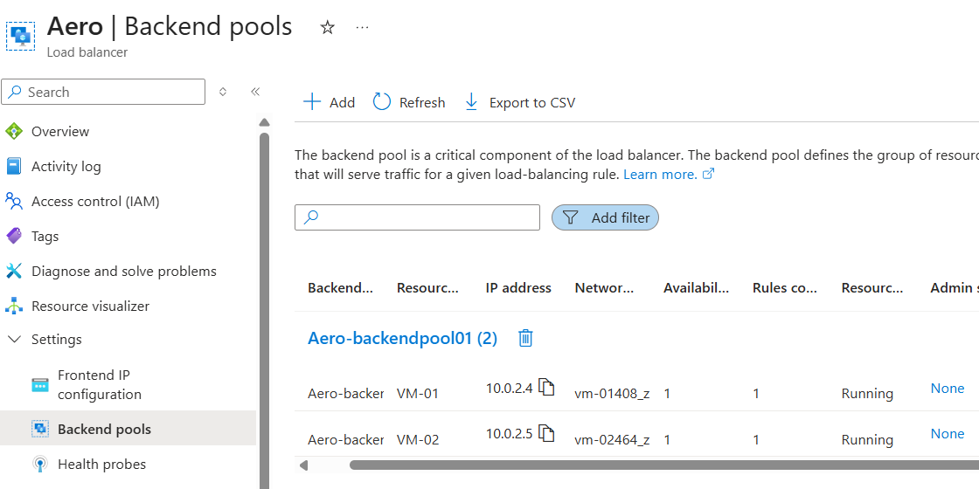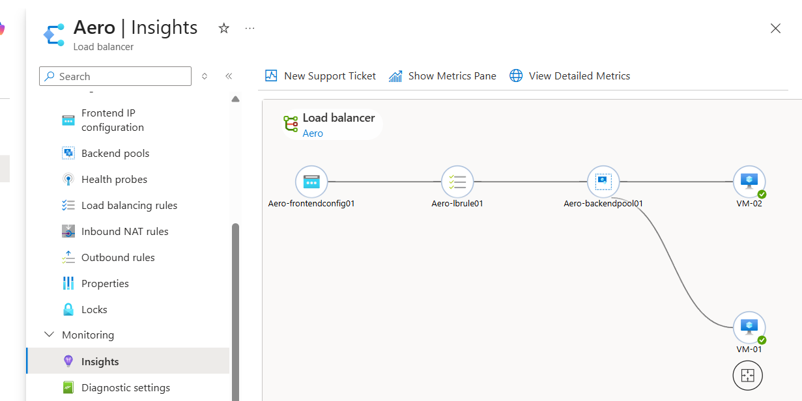

Phase 4 – Compute & Scaling

4.1 VM Scale Set Deployment & Scaling
Virtual Machine Scale Sets were deployed to provide scalable compute resources. Autoscaling rules based on CPU utilization were configured to dynamically adjust the number of instances, ensuring optimal performance and cost efficiency.
Screenshot Allocation:
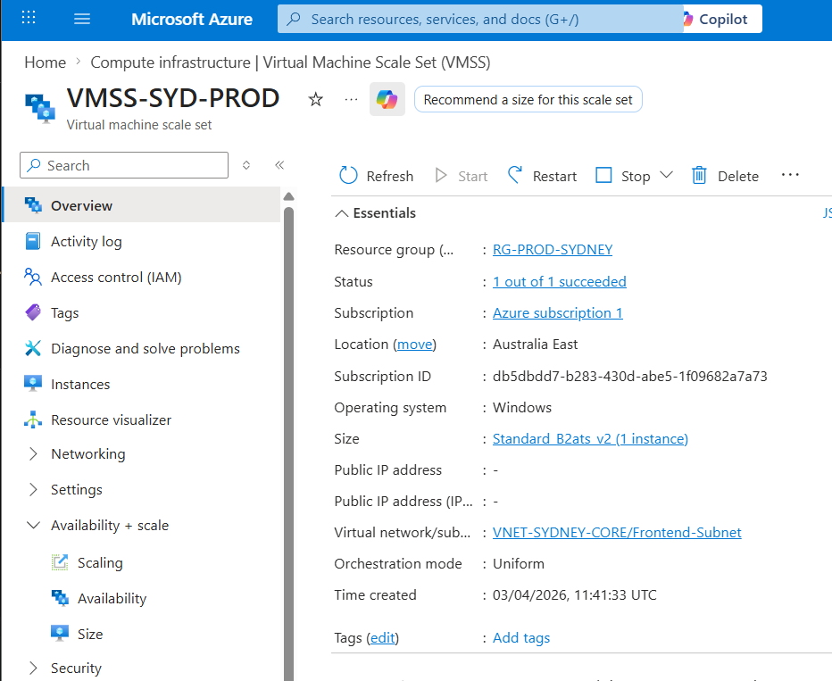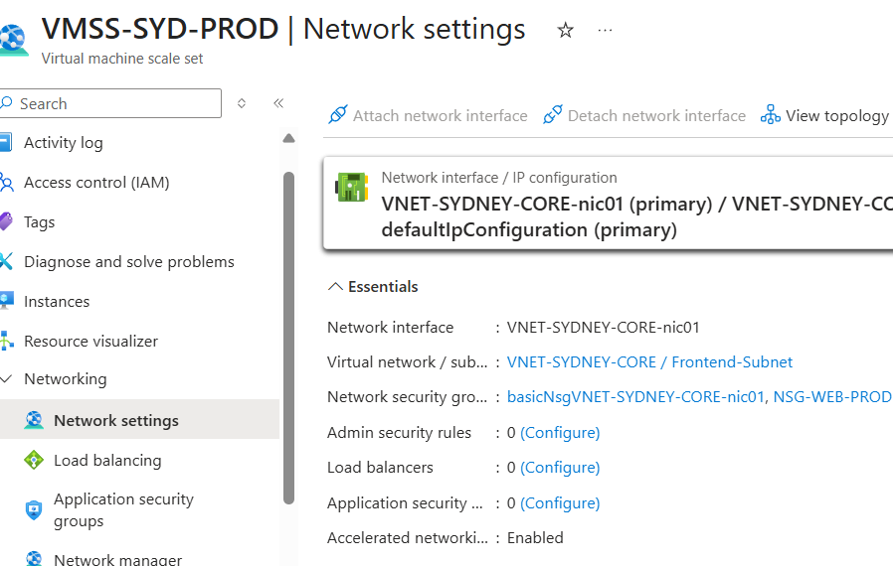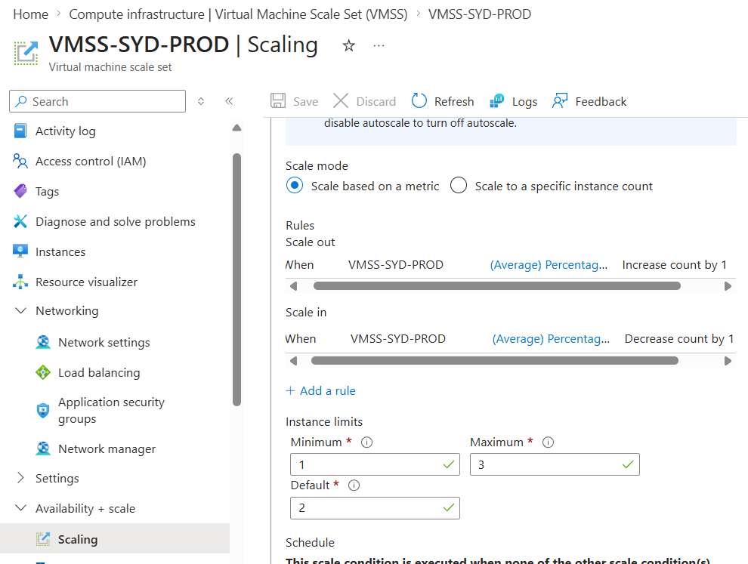

4.2 Remote Access Configuration
Remote Desktop Protocol (RDP) access was configured to enable secure administrative access to virtual machines for management and troubleshooting purposes.
Screenshot Allocation:
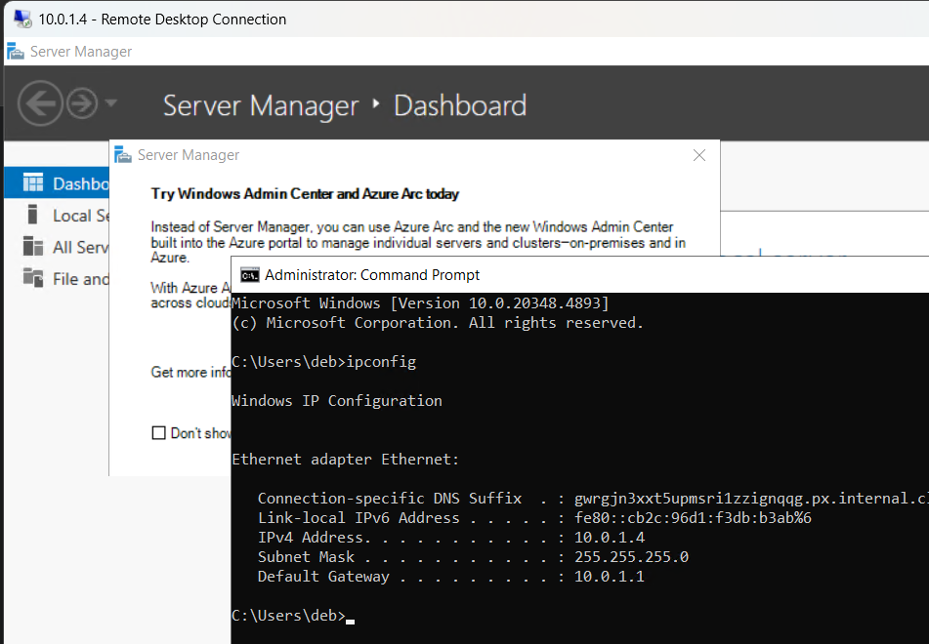

Phase 5 – Storage, Monitoring & Backup

5.1 Storage & Access Management
A Storage Account was created to provide scalable storage solutions. Blob storage was configured, and role-based access control (RBAC) was implemented to ensure secure and controlled access to resources.
Screenshot Allocation:
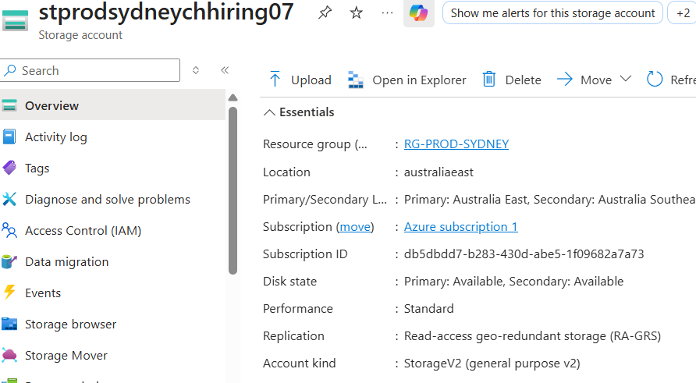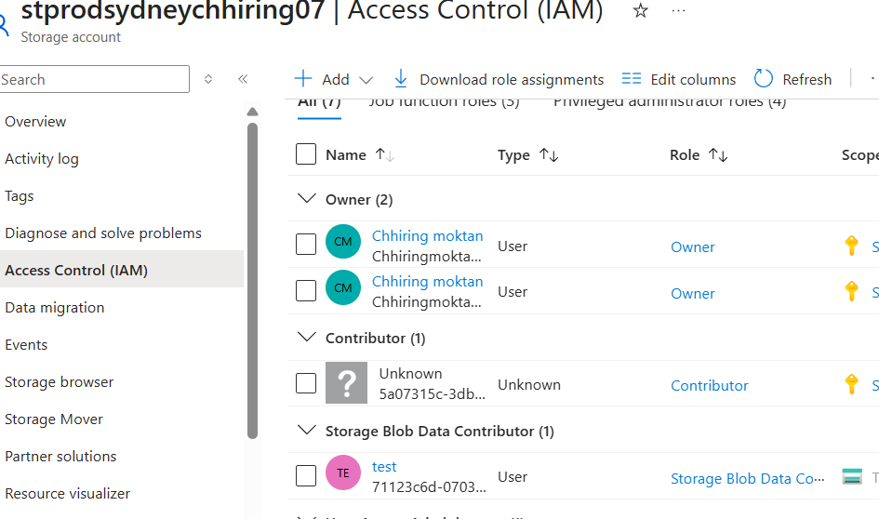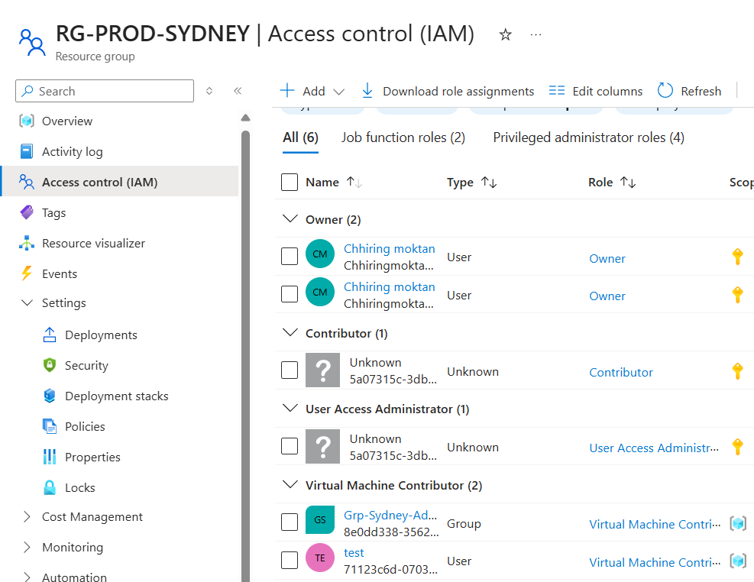

5.2 Monitoring, Backup & Logging
Monitoring and backup solutions were implemented to ensure operational visibility and data protection. CPU metrics were tracked, backup policies were configured, and logs were archived to support auditing and compliance requirements.
Screenshot Allocation:
