Marion Creek Gardens Database

Author: Charles Prinslow
Function: Originator

Project Resources
The resources that the project has are a software engineer and a business analyst. The business analyst focus is getting the project charter, use cases, and getting the requirements for the database. Once they have that done, then the next objective is to test the database, deliver the database, and train the users. The software engineer will be implementing the database, and do minor tests.

1. Overview
  - Problem/Opportunity Statement

My customers have a nursery they are working on that is in their backyard. Their current system is using a word document to keep track of what they have. A lot of time the document doesn’t get updated every day because they both also have a full-time job. Also the word document isn’t always correct because they don’t compare it to what they actually have. They have requested to get a database system that will help them keep track of the inventory and better help them when customers ask how much of a certain plant that they have.

Once they get the database, the nursery will get to see what is the most popular plants that they sale. They will get to know whether a plant in a certain stage gets sold more. Even be able to see the times of day that plants get sold most often. This will help them with keeping up with the demand and know when the most important times they would need to be there to run the nursery the most.

  - System Context

The business is in its beginning stages and they have been worried about getting the product going. They are now ready to get the paperwork side into an inventory database. They plan on getting a tablet that will be used for the database and other business needs. It will help them when they are busy and need a quick answer.

During business hours, it will be left by the front of the nursery and will be accessed for transaction purposes only. For an hour after business hours, the tablet will be used to check inventory and make sure that nothing got stolen and to make sure that they have enough product for the next day. Maybe a copy of the database will be printed so that other employees can also help out.

2. Business Use Cases (user stories)

Interview with Gene Cellucci:

What would you like the welcome screen of the database to look like?

I would like to see a picture of the nursery and be able to direct myself to where I would like to go. I don’t want to do more than 2 clicks to get to where I need to go. I don’t want to start with the welcome screen to have more than 3 buttons.

How will the database be used?

It will get used to get the answer of if we have a plant or not right when they ask instead of having to go search for it. I will also use it to find where the plant is and also be able to show describe a little about the plant while there is a picture to the side of description to let them see what the plant will look like.

What are some features you would like to have?

I would like to be able to pull up the inventory itself and print out so that I can make sure we have what the inventory says it does. I would like to be able to search for a couple of plants and compare them side to side instead of having to use two windows. Another cool feature to have would be to go directly from one part of the database to another directly instead of having to go to the main menu all the time.

What are some queries or reports you would like to do?

I would like to be able to query different types of plants and be able to see all the plants we have of that type, or even all types of plants that will be of the bloom into the color that I am looking for. I would like to get a report of how many plants we sold, the last the database got updated, and be able to see who made those changes.

Interview with Anna Cellucci:

What would you like the welcome screen of the database to look like?

I would like a picture of the nursery with a welcome statue in the picture. I would like to see just the picture and when I’m ready to move to the next page that I just click on the picture.

How will the database be used?

It will be used to give customers quick answer and show them a description of the plants they are looking for. I will use it to be able to just direct a customer to where the plant is so that if they want to look at on their own.

What are some features you would like to have?

I would like to be able to change something on the database and it just being one screen away. I want to also be able to pull up information on the while pulling up a query on plants if there is less than 10 plants in the query.

What are some queries and reports you would like to do?

I would like to do queries on the plants that we have, how many plants we have by the type of plants, and if we could also know what we are almost out of stock on. I would like to get reports on the top five plant sold, the top 5 priced plants that got sold, and the top 5 times of the day that the most plants got sold.

3. Requirements and Specification

3.1 Functional/Behavioral Requirements
- Customer asks for a specific type of plant
- Employees search in database to find plants that are like the ones the customer asked for.
- Employees lead customer to plant area and describe it.
- If plant is unavailable in one area check the next or say that we will get something started for you.
- When product is ready to notify the customer.
- If nursery can’t get product, offer something close to the requested product.
3.2 Non-Behavioral/Non-Functional Requirements
- Employee keeps track of wait they sell.
- Employee keeps track of requests that couldn’t be fulfilled.
- Employee keeps track of plant stage is different than database says it is.
- Manager will inform employees on what they can do differently.
3.3System Constraints
- The amount of time between requests should be short and efficient.
- Communication between employees and managers need to be clear.
- The database should be easy to find.

Logical/Architectural Object Model
4.1 CRC Model
Candidate Class Name: Suppliers
Responsibilities: | Collaborators:
Supplier_ID  Address_ID  supplier_name  supplier_email  supplier_phone  supplier_cell_phone  other_supplier_details | Plant_Suppliers  Address  Plants

Candidate Class Name: Inventory_Levels
Responsibilities: | Collaborators:
Plant_ID  Stock_Taking_Date  Quantity_in_Stock | Address  Nurseries  Plants  Ref_Plants_Categories

Candidate Class Name: Ref_Plants_Categories
Responsibilities: | Collaborators:
Plant_Category_Code  Parent_Plant_Category_Code  Plant_Category_Description  eg Rose Bush | Plant_Suppliers  Plants  Inventory_Levels  Ref_Plants_Categories

Candidate Class Name: Plants
Responsibilities: | Collaborators:
Plant_ID  Nursery_ID  Plant_Category_Code  Plant_Name  Plant_Description  Average_Weekly_Sales  Reorder_Level  Reorder_Quantity  Other_Details | Plant_Suppliers  Address  Nurseries  Inventory_Levels  Ref_Plants_Categories

Candidate Class Name: Plant_Suppliers
Responsibilities: | Collaborators:
Plant_Supplier_ID  Plant_ID  Supplier_ID  value_supplied_to_date  quantity_supplied_to_date  first_item_supplied_date  last_item_supplied_date  delivery_lead_time  standard_price  percentage_discount  minimum_order_quantity  maximum_order_quantity  Other_details | Suppliers  Address  Nurseries  Plants  Ref_Plants_Categories

Candidate Class Name: Addresses
Responsibilities: | Collaborators:
Address_ID  line_1  line_2  line_3  city  zip_or_postcode  state_province_county  country  other_address_details | Plant_Suppliers  Suppliers  Nurseries  Plants  Inventory_Levels

Candidate Class Name: Nurseries
Responsibilities: | Collaborators:
Nursery_ID  Address_ID  nursery_name  email_address  office_phone  cell_mobile_phone  other_supplier_details | Plant_Suppliers  Address  Plants  Inventory_Levels

4.2 Class Diagram 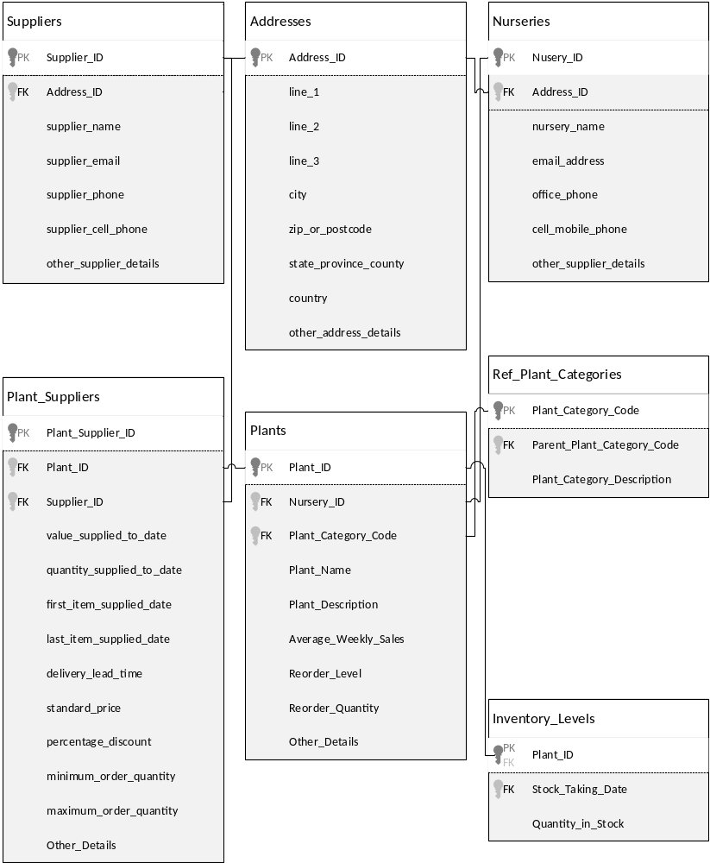
4.3 Sequence Diagrams
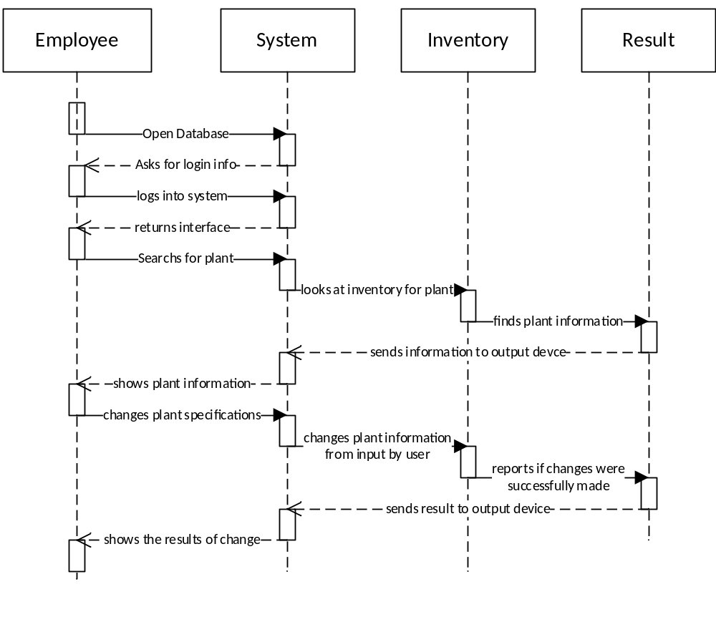
Under normal circumstances
- User logs in successfully
- Database able to find the plant
- Inventory accepts changes to the plants information from user

Under Exceptions
- User able to log in and find plant but from database but inventory doesn’t accept the change
- User able to log in but plant isn’t found
- User unable to log in
Works Cited

Cellucci, Anna. Plant Availablity Charles Prinslow. 12 04 2014.

Cellucci, Gene. Customer Service Charles Prinslow. 12 04 2014.

Williams, Barry. Database Answers. 13 January 2014. Web. 18 May 2014.

