Marion Creek Gardens Database

Logical/Architectural Design

Revision 1.1

Author: Charles Prinslow
Function: Originator

PC Revision History
5/5/2014 | Revision 1.0 | Initial Creation
5/18/2014 | Revision 1.1 | Finished assignment

APPROVALS:

Function | Name | Signed | Date
Product Planning Team
Originator | Charles Prinslow
Senior Management | Mandy Reininger
Marketing | Gene Cellucci
Sales | Anna Cellucci
Engineering | George Martusheff

Disclaimer – This constitutes an internal commitment for target capabilities and is not intended to be construed as customer commitments. Actual capabilities will be characterized on the as-built product during the Design Development Process.

Overview
  - Problem/Opportunity Statement (updated)

My customers have a nursery they are working on that is in their backyard. Their current system is using a word document to keep track of what they have. A lot of time the document doesn’t get updated every day because they both also have a full-time job. Also the word document isn’t always correct because they don’t compare it to what they actually have. They have requested to get a database system that will help them keep track of the inventory and better help them when customers ask how much of a certain plant that they have.

Once they get the database, the nursery will get to see what is the most popular plants that they sale. They will get to know whether a plant in a certain stage gets sold more. Even be able to see the times of day that plants get sold most often. This will help them with keeping up with the demand and know when the most important times they would need to be there to run the nursery the most.

  - System Context (updated)

The business is in its beginning stages and they have been worried about getting the product going. They are now ready to get the paperwork side into an inventory database. They plan on getting a tablet that will be used for the database and other business needs. It will help them when they are busy and need a quick answer.

During business hours, it will be left by the front of the nursery and will be accessed for transaction purposes only. For an hour after business hours, the tablet will be used to check inventory and make sure that nothing got stolen and to make sure that they have enough product for the next day. Maybe a copy of the database will be printed so that other employees can also help out.

They have been checking what their inventory is like

  - Overview and issues of the object model
  - Overview and issues of the data model

Logical/Architectural Object Model
  - Class Model
    - CRC Model
Candidate Class Name: Suppliers
Responsibilities: | Collaborators:
Supplier_ID  Address_ID  supplier_name  supplier_email  supplier_phone  supplier_cell_phone  other_supplier_details | Plant_Suppliers  Address  Plants

Candidate Class Name: Inventory_Levels
Responsibilities: | Collaborators:
Plant_ID  Stock_Taking_Date  Quantity_in_Stock | Address  Nurseries  Plants  Ref_Plants_Categories

Candidate Class Name: Ref_Plants_Categories
Responsibilities: | Collaborators:
Plant_Category_Code  Parent_Plant_Category_Code  Plant_Category_Description  eg Rose Bush | Plant_Suppliers  Plants  Inventory_Levels  Ref_Plants_Categories

Candidate Class Name: Plants
Responsibilities: | Collaborators:
Plant_ID  Nursery_ID  Plant_Category_Code  Plant_Name  Plant_Description  Average_Weekly_Sales  Reorder_Level  Reorder_Quantity  Other_Details | Plant_Suppliers  Address  Nurseries  Inventory_Levels  Ref_Plants_Categories

Candidate Class Name: Plant_Suppliers
Responsibilities: | Collaborators:
Plant_Supplier_ID  Plant_ID  Supplier_ID  value_supplied_to_date  quantity_supplied_to_date  first_item_supplied_date  last_item_supplied_date  delivery_lead_time  standard_price  percentage_discount  minimum_order_quantity  maximum_order_quantity  Other_details | Suppliers  Address  Nurseries  Plants  Ref_Plants_Categories

Candidate Class Name: Addresses
Responsibilities: | Collaborators:
Address_ID  line_1  line_2  line_3  city  zip_or_postcode  state_province_county  country  other_address_details | Plant_Suppliers  Suppliers  Nurseries  Plants  Inventory_Levels

Candidate Class Name: Nurseries
Responsibilities: | Collaborators:
Nursery_ID  Address_ID  nursery_name  email_address  office_phone  cell_mobile_phone  other_supplier_details | Plant_Suppliers  Address  Plants  Inventory_Levels

    - Class Diagram
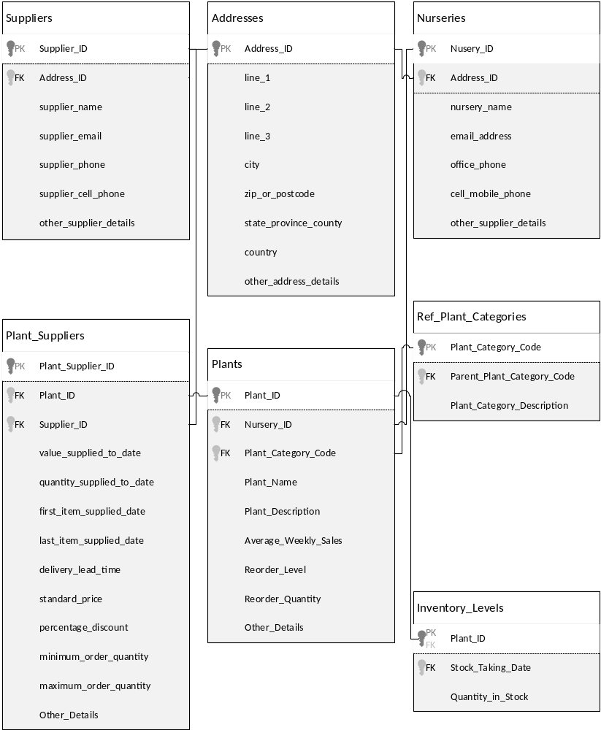
  - Collaboration Diagram

  - Sequence Diagrams
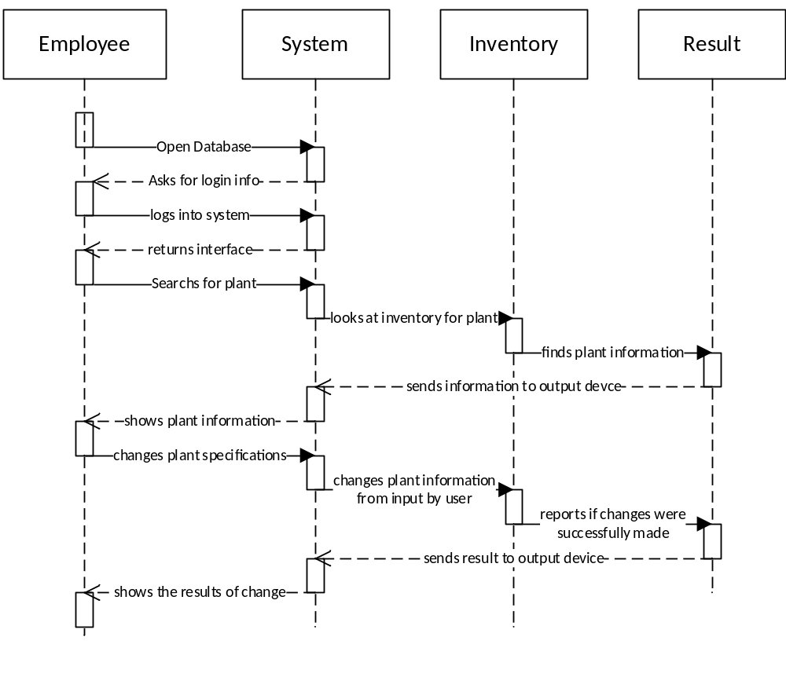
Under normal circumstances
- User logs in successfully
- Database able to find the plant
- Inventory accepts changes to the plants information from user

Under Exceptions
- User able to log in and find plant but from database but inventory doesn’t accept the change
- User able to log in but plant isn’t found
- User unable to log in

Logical/Architectural Data Model
  - System ER Diagram
  - Data Dictionary

Miscellaneous Issues

Appendices

Works Cited
Cellucci, Anna. Plant Availablity Charles Prinslow. 12 04 2014.

Cellucci, Gene. Customer Service Charles Prinslow. 12 04 2014.

Williams, Barry. Database Answers. 13 January 2014. Web. 18 May 2014.

