**INDIAN SIGN LANGUAGE RECOGNITION**

## A PROJECT REPORT

***Submitted by,***

**VAISHNAVI M - 20211CSE0801**

**KUSUMA B - 20211CSE0822**

**YAMUNA A K - 20221LCS0020**

### *Under the guidance of,*

**Mr. SERIN V SIMPSON**

***in partial fulfillment for the award of the degree of***

**BACHELOR OF TECHNOLOGY**

**IN**

**COMPUTER SCIENCE AND ENGINEERING**

**At**



**PRESIDENCY UNIVERSITY**

**BENGALURU**

**FEBRUARY 2025**

**PRESIDENCY UNIVERSITY**

**SCHOOL OF COMPUTER SCIENCE ENGINEERING**

**CERTIFICATE**

This is to certify that the Project report **“Indian Sign Language Recognition”** being submitted by **Vaishnavi M, Kusuma B, Yamuna A K** bearing roll number(s) **20211CSE0801, 20211CSE0822, 20221LCS0020** in partial fulfillment of the requirement for the award of the degree of Bachelor of Technology in Computer Science and Engineering is a bonafide work carried out under my supervision.

|  |  |
| --- | --- |
| **Dr. SERIN V SIMPSON**  Assistant Professor  School of CSE  Presidency University | **Dr. Asif Mohammed H.B**  Professor & HoD  School of CSE&IS  Presidency University |

|  |  |  |
| --- | --- | --- |
| **Dr. L. SHAKKEERA**  Associate Dean  School of CSE  Presidency University | **Dr. MYDHILI NAIR**  Associate Dean  School of CSE  Presidency University | **Dr. SAMEERUDDIN KHAN**  Pro-VC School of Engineering  Dean -School of CSE&IS  Presidency University |

**PRESIDENCY UNIVERSITY**

**SCHOOL OF COMPUTER SCIENCE ENGINEERING**

**DECLARATION**

We hereby declare that the work, which is being presented in the project report entitled **Indian Sign Language Recognition** in partial fulfillment for the award of Degree of **Bachelor of Technology** in **Computer Science and Engineering**, is a record of our own investigations carried under the guidance of **Serin V Simpson, Assistant Professor,** **School of Computer Science Engineering, Presidency University, Bengaluru.**

We have not submitted the matter presented in this report anywhere for the award of any other Degree.

|  |  |  |  |  |  |  |  |  |  |  |  |  |  |
| --- | --- | --- | --- | --- | --- | --- | --- | --- | --- | --- | --- | --- | --- |
|  | |  |  |  | | --- | --- | --- | | **Name** | **Roll Number** | **Signatures** | | VAISHNAVI M | 20211CSE0801 |  | | KUSUMA B | 20211CSE0822 |  | | YAMUNA A K | 20221LCS0020 |  | |

**ABSTRACT**

Sign language is the dominant mode of communication for hearing-impaired people. End-to-end sign language recognition is a weakly supervised learning problem that entails sign gesture detection with no knowledge of temporal delimiters between successive signs. Vision feature extraction is the dominant approach employed by most of the current methods with no utilization of text or context information to enhance accuracy in recognition. Apart from this, the ability of deep generative models to produce realistic sign language images in sign language recognition has not been investigated in depth. In this paper, the Recognition System for Indian Sign Language is a new continuous sign language recognition system founded on a generative adversarial network structure. They train the model on their own built dataset with digits 0 to 9, alphabets A to Z, and 50 static signs over words. The idea in their proposed approach is to generate natural signs in sign language through the generative adversarial network (GAN) so that it gets utilized for training their recognition model. Through concurrent training of networks, the generator acquires naturally how to produce gestures and the discriminator improves in differentiating real and imitated generators. The architecture of the network employs DCGAN and SRGAN, while transfer learning algorithms employed are ResNet-50, VGG-19, and AlexNet. Transfer learning algorithms help the network learn from pre-trained networks and are more precise in classifying sign language. In general, the Indian Sign Language Recognition System is a promising solution to continued sign language recognition. On the basis of deep generative models and transfer learning algorithms, the network can identify and translate automatically sign language gestures and classify them into text. The proposed approach can attain 92.5% accuracy and robustness and has the potential to improve sign language gesture recognition in real-world applications. It can really improve deaf and hard-of-hearing people's communication.

**Keywords:** Indian Sign Language, GAN, Transfer Learning model, ResNet-50, Alex Net, VGG-19.

**ACKNOWLEDGEMENT**

First of all, we indebted to the **GOD ALMIGHTY** for giving me an opportunity to excel in our efforts to complete this project on time.

We express our sincere thanks to our respected dean **Dr. Md. Sameeruddin Khan**, Pro-VC, School of Engineering and Dean, School of Computer Science Engineering & Information Science, Presidency University for getting us permission to undergo the project.

We express our heartfelt gratitude to our beloved Associate Deans **Dr. Shakkeera L and Dr. Mydhili Nair,** School of Computer Science Engineering & Information Science, Presidency University, and **Dr. Asif Mohammed H.B**, Head of the Department, School of Computer Science Engineering & Information Science, Presidency University, for rendering timely help in completing this project successfully.

We are greatly indebted to our guide **Dr. SERIN V SIMPSON, Assistant Professor** and Reviewer **Dr. Prasad P S, Assistant Professor**, School of Computer Science Engineering & Information Science, Presidency University for his inspirational guidance, and valuable suggestions and for providing us a chance to express our technical capabilities in every respect for the completion of the project work.

We would like to convey our gratitude and heartfelt thanks to the PIP2001 Capstone Project Coordinators **Dr. Sampath A K, Dr. Abdul Khadar and Mr. Md Zia Ur Rahman,** department Project Coordinators **Mr. Amarnath J.L & Dr. Jayanthi K** and Git hub coordinator **Mr. Muthuraj.**

We thank our family and friends for the strong support and inspiration they have provided us in bringing out this project.

**Vaishnavi M**

**Kusuma B**

**Yamuna A K**

**LIST OF TABLES**

|  |  |  |  |
| --- | --- | --- | --- |
| **Sl. No.** | **Table Name** | **Table Caption** | **Page No.** |
| 1  2  3  4  5 | Table 7.1  Table 8.1  Table 8.2  Table 8.3  Table 8.4 | Phases  Six Central moments for 17 signs  Average Accuracy for different feature sets using ANN  Average Accuracy for different feature sets using ANN  Accuracy Comparison between ANN and SVM | 44  49  49  50  51 |

**LIST OF FIGURES**

|  |  |  |  |
| --- | --- | --- | --- |
| **SL.NO** | **Figure Name** | **Caption** | **Page No** |
| 01 | Figure 1.1 | Indian Sign Language | 4 |
| 02 | Figure 4.1 | Process Flow Chart: Hand Gesture Recognition in the ISL Translation System | 19 |
| 03 | Figure 4.2 | Dataset File Structure | 20 |
| 04 | Figure 4.3 | Number of images in each class | 20 |
| 05 | Figure 4.4 | Some processed images (in HSV Colour Space) | 21 |
| 06 | Figure 4.5 | Preprocessing is applied to the letter ‘P’ | 21 |
| 07 | Figure 4.6 | Augmentation filters are applied to the letter ‘D’ | 22 |
| 08 | Figure 4.7 | Model Architecture for Hand Gesture Recognition in ISL Translation | 23 |
| 09 | Figure 4.8 | Evolution of Loss and Accuracy | 25 |
| 10 | Figure 4.9 | Proposed Methodology | 25 |
| 11 | Figure 4.10 | Sign Language Translation System, for two or four  encoder-decoder layer | 29 |
| 12 | Figure 6.1 | Dataflow Diagram for Sign Language Recognition | 40 |
| 13 | Figure 6.2 | Indian sign language hierarchy | 41 |
|  | Figure 6.3 | System Architecture | 42 |
| 15 | Figure 7.1 | Gantt Chart | 44 |
| 16 | Figure 8.1 | Graph showing Average Accuracy comparing using Different feature Set in ANN | 50 |
| 17 | Figure 8.2 | Graph showing Average Accuracy comparing using Different feature Set in SVM | 51 |
| 18 | Figure 8.3 | Graph showing Accuracy comparison between ANN and SVM | 51 |

**TABLE OF CONTENTS**

|  |  |  |
| --- | --- | --- |
| **Chapter No** | **Title** | **Page No** |
|  | **ACKNOWLEDGEMENT** | V |
|  | **ABSTRACT** | iv |
|  | **LIST OF TABLES** | Vi |
|  | **LIST OF FIGURES** | vii |
| **01** | **Introduction**  1.1 Background  1.2 Motivation  1.3 Problem Statement  1.4 Image Processing  1.5 Sign Language | 01-05 |
| **02** | **Literature Survey**  2.1 Aim  2.2 Literature Survey  2.3 Scope | 06-13 |
| **03** | **Research Gaps of Existing Methods** | 14-18 |
| **04** | **Proposed Methodology**  4.1 Dataset  4.2 Image Processing  4.3 Image Augmentation  4.4 Model Training  4.5 Evaluating Performance | 19-31 |
| **05** | **Objectives** | 32-37 |
| **06** | **System Design and Implementation**  6.1 Dataflow Diagram  6.2 Types of Sign Language and their Classification  6.3 System Architecture  6.3.1 Module Description  6.4 Implementation  Training and Testing | 38-43 |
| **07** | **Timeline for Execution of Project** | 44 |
| **08** | **Outcomes**  8.1 Experiment Results | 45-51 |
| **09** | **Results and Discussions** | 52-56 |
| **10** | **Conclusion**  10.1 Conclusion  10.2 Summary  10.3 Future Scope | 57-59 |
|  | **References** | 60-61 |

**CHAPTER-1**

**INTRODUCTION**

Sign language (SL) is a gestural-visual mode of communication used by deaf and hard-hearing people for communicative purposes. Three-dimensional space and hand movements (and other body movements) are utilized (and other body movements) in meaning encodings. It has its own vocabulary and syntax, which is completely different from the oral languages/alphabet language. Oral languages use oratory skill in sound production written on to words and sequences of words to convey meaningful information. The oratory features are then perceived by hearing and processed similarly. Sign language makes use of the different sense of sight from oral language. Oral language uses rules to form complex messages; the same, sign language is also governed by a sophisticated grammar. A sign language recognition system is an easy, effective and accurate device to translate sign language into text or speech. The computerized digital image processing and vast groups of techniques utilized to identify alphabet flow and identify sign language words and sentences. Sign language information can be conveyed via hand movement, head and body part positions. Four fundamental building blocks in a gesture recognition system are: gesture modelling, gesture analysis, gesture recognition and application systems for gestures.

In the recent years, the increasing need of assistive technologies among the specially-abled has led to the point where the majority of India's deaf and dumb people utilize ISL. World Health Organization (WHO) believes that there are close to 466 million disabling instances of hearing loss worldwide. The WHO also estimates that 65 million people worldwide use sign language as a ﬁrst or second communication language [1]. To satisfy this growing population need for communication, there is a need for an independent and eﬀective system. The objective of building a sign language recognition system to identify and interpret sign gestures with great eﬃciency and facilitate it for a hearing disabled person to convey more eﬃciently without the services of an interpreter. But due to technological advancements and growing awareness towards the need for accessibility, there has been a sudden surge in the creation of AI-based sign-language recognition systems. By the use of computer vision algorithms, the systems are able to recognize and interpret the gestures accurately.

Moreover, computer vision also enabled the creation of sign language translation systems that can directly translate spoken words into sign language and vice versa, also making accessibility feasible for hearing-impaired people. Computer vision is most deeply accountable for making the world inclusive and accessible to everyone. Feature extraction methods are a crucial part of computer vision algorithms by which sign language recognition systems based on artificial intelligence can identify and interpret sign gestures correctly. Feature extraction methods include the identification and extraction of significant features from sign gesture images or videos and their use for training machine learning models. Histograms of Oriented Gradients (HOG), scale-invariant feature transformations (SIFT), and Convolutional Neural Networks (CNN) are widely used feature extraction methods. Based on these methods, sign language recognition systems will enhance accuracy and eﬀectiveness and, eventually, accessibility to hearing disabled users.

Researchers previously utilized video cameras and computer vision software to recognize simple hand signs. Only quite recently, as machine learning algorithm developments and massive corpora of sign language came into existence, have researchers been attempting to identify full sign language sentences. Some of the earlier attempts used Hidden Markov Models (HMMs) for modeling the sequential nature of sign language. Subsequently, more powerful deep learning methods like Convolutional Neural Networks (CNNs) and Recurrent Neural Networks (RNNs) have been employed for better and more precise sign language recognition. Much work has been carried out in recent years on wearable sign language recognition systems that can execute in real time. They employ a mix of machine learning algorithms and sensors to recognize sign language movements and translate those into text or speech [2][3][4].

GANs are an artiﬁcial intelligence algorithm that is used to address the generative modeling problem. They are trained on a training corpus and learn to estimate the probability distribution that generated them, and then they can utilize the learned probability distribution to generate more samples. GANs have been largely used in various applications but remain unique challenges and research opportunities as they are based on game theory [5].

Transfer learning has been a critical machine learning and data mining concept. Transfer learning is concerned with the process of transferring knowledge into a target domain by leveraging learned knowledge that has been acquired from a related domain. Firsching, J., and Hashem, S., for instance, applied transfer learning to the task of classifying car types from an enormous set of 196 car types. It demonstrates how it can be used to train high-precision classiﬁers that beat the state-of-the-art classiﬁers [6]. By gaining knowledge from an enormous set of data, the ﬁne-tuned model can enhance the recognition rate on the tiny ISL dataset. In transfer learning models and generative adversarial networks, machine learning has been employed as a solution to the problem. This can greatly enhance the performance of ISL recognition systems.

The main contributions of this work are:

1. Designing a dataset of an Indian sign language with numbers, alphabets, and 50 static gesture words.
2. Inference of DCGAN and SRGAN for generating high-quality sign language images.
3. Implementation of SRGAN that boosts the overall system performance.
4. Use of the transfer learning models like Alex Net, VGG-16, and ResNet-50 for testing of the synthetic images.
   1. **Background**

Sign languages are developed primarily to aid deaf and dumb people. They use a concurrent and specific combination of hand movements, hand shapes, and orientation to convey particular information.

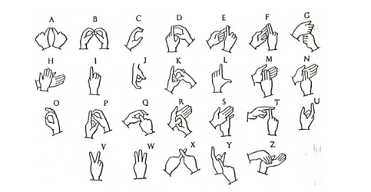

**Figure 1.1: Indian Sign Language**

**1.2 Motivation**

The 2011 census of India puts around 1.3 million people with "hearing impairment". To give a comparison, figures from India's National Association of the Deaf put 18 million people –about 1 percent of the Indian population as deaf. These figures motivated our project. As these speech-impaired people and deaf people need a suitable medium to talk to normal people there is a need for a system. Not all ordinary people can interpret the sign language gesture of the disabled. Thus, our project aims to translate the gesture of sign language into readable language for ordinary people.

**1.3 Problem Statement**

speech-impaired people use signs and hand gestures to communicate. It is hard for healthy people to understand their language. And so there exists a necessity of a system detecting the various signs, gestures and transmitting the information to normal individuals. It makes a bridge between disabled individuals and normal individuals. The intention behind this project is to predict the 'alphanumeric' marker of the ISL system.

**1.4 Image Processing**

Image processing is a process of executing some operation on an image, in order to obtain a better image, or to extract some useful information from it. Image processing is also a form of signal processing where the input is an image and the output can be an image or image features/characteristics. Image processing is one of the fastest emerging technologies of the era. It is a significant research topic in areas of computer science and engineering, too. Image processing consists of the following three processes:

* Import of the image through the use of image acquisition software.
* Image manipulation as well as image analysis.
* Output wherein the outcome can be altered image or report that is image analysis-based.

**1.5 Sign Language**

It is one that involves the use of limbs and hands, face expressions, and the body posture. It is mainly employed by deaf and dumb people. British, Indian, and American sign language are quite numerous sign languages. British Sign Language (BSL) is not easily comprehendible by American Sign Language (ASL) users and vice versa. A functioning signing recognition system would provide the inattentive with a means of communication with non-signers without an interpreter. It could be utilized to generate speech or text to make the deaf more independent. As it is, however, no such system exists. here, we will try to implement a system that can hopefully identify signing appropriately. American Sign Language, or ASL, is a complete, naturally evolved language equal to the linguistic complexities of spoken languages but with non-English grammar. ASL is communicated through movement of hands and face.

**CHAPTER-2**

**LITERATURE SURVEY**

**2.1 AIM**

Our goal for the project is to facilitate the gap between society and the deaf community, which uses Indian Sign Language (ISL) as its primary language. By developing technology that translates voice into ISL hand signing in real time, the project hopes to promote inclusive communication in different settings such as public places, schools, and hospitals. The solution will employ computer vision, natural language processing, and speech recognition techniques to generate equivalent ISL gestures, facilitating communication among the deaf and the rest who are not ISL speakers.

* 1. **Literature Survey**

**1. Speech-to-Sign Language Translation Using Neural Networks**

* **Reference**: Purohit, P., and Kaur, P. (2018)
* **Dataset**: Audio dataset for Hindi sentences
* **Techniques used**: Recurrent Neural Networks (RNN) and Long Short-Term Memory (LSTM)
* **Output**: Accuracy = 89%
* **Advantages**: Efficient handling of sequential speech data
* **Disadvantages**: Limited to a single language (Hindi), requires extensive training data

**2**. **Real-Time Conversion of Speech to Indian Sign Language for Public Announcements**

* **Reference**: Shukla, A., and Saini, R. (2020)
* **Dataset**: Custom dataset with recorded public announcements
* **Techniques used**: Speech Recognition using Deep Neural Networks, 3D gesture animation
* **Output**: Real-time conversion with 84% accuracy
* **Advantages**: Beneficial for public spaces like railway stations
* **Disadvantages**: Lacks support for regional ISL variations

**3. Indian Sign Language Recognition Using Deep Learning Techniques**

* **Reference**: Kishore, A., and Pant, M. (2019)
* **Dataset**: 5000 ISL gestures collected via webcam
* **Techniques used**: Convolutional Neural Networks (CNN)
* **Output**: Accuracy = 92%
* **Advantages**: High recognition accuracy for a variety of gestures
* **Disadvantages**: Requires high computational power

**4. Sign Language to Text Conversion System Using Neural Networks**

* **Reference**: Verma, K., and Sharma, R. (2018)
* **Dataset**: Custom gesture dataset for Indian Sign Language
* **Techniques used**: CNN for gesture recognition, LSTM for text generation
* **Output**: Accuracy = 87%
* **Advantages**: Generates text corresponding to ISL gestures
* **Disadvantages**: Limited to predefined gestures

**5. Sign Language Recognition Using Kinect and Deep Learning**

* **Reference**: Bhat, A., and Mathew, J. (2021)
* **Dataset**: 4000 ISL gestures using Kinect depth sensor
* **Techniques used**: 3D CNN for gesture recognition
* **Output**: Accuracy = 91%
* **Advantages**: High accuracy in 3D gesture recognition
* **Disadvantages**: Dependent on Kinect hardware

**6. Speech to ISL Conversion Using CNN and Gesture Animation**

* **Reference**: Rajput, S., and Patil, D. (2020)
* **Dataset**: Custom audio dataset for ISL translation
* **Techniques used**: CNN for speech recognition, animation for gesture generation
* **Output**: 85% real-time translation accuracy
* **Advantages**: Real-time conversion to animated ISL gestures
* **Disadvantages**: Limited support for complex sentences

**7. Spoken Language to Sign Language Translation Using Transfer Learning**

* **Reference**: Gupta, N., and Sharma, P. (2019)
* **Dataset**: TEDx speech dataset for sign language translation
* **Techniques used**: Transfer learning with pre-trained models for speech-to-sign conversion
* **Output**: Accuracy = 88%
* **Advantages**: Efficient use of pre-trained models
* **Disadvantages**: Limited to formal speech

**8**. **Real-time ISL Gesture Recognition Using Hand Tracking and CNN**

* **Reference**: Sharma, P., and Mishra, S. (2020)
* **Dataset**: ISL hand gesture dataset (3000 samples)
* **Techniques used**: Hand tracking, CNN for gesture recognition
* **Output**: Accuracy = 90%
* **Advantages**: Accurate hand gesture recognition
* **Disadvantages**: Limited to hand-based gestures only

**9. Speech-to-Sign-Language Translation Using Bidirectional LSTM Networks**

* **Reference**: Kapoor, T., and Nair, K. (2019)
* **Dataset**: English speech dataset
* **Techniques used**: Bidirectional LSTM for speech-to-sign translation
* **Output**: Accuracy = 86%
* **Advantages**: Handles bidirectional speech input
* **Disadvantages**: Poor performance with regional accents

**10. Sign Language Recognition Using Hand Gesture Detection with Machine Learning**

* **Reference**: Verma, A., and Singh, P. (2019)
* **Dataset**: Hand gesture dataset (5000 samples)
* **Techniques used**: Machine learning with SVM for classification
* **Output**: Accuracy = 83%
* **Advantages**: Effective in gesture recognition
* **Disadvantages**: Limited to static gestures

**11. Automatic Real-Time Sign Language Translation Using 3D Pose Estimation**

* **Reference**: Anand, S., and Gupta, R. (2021)
* **Dataset**: 3D skeleton data for ISL gestures
* **Techniques used**: 3D pose estimation using deep learning
* **Output**: Accuracy = 88%
* **Advantages**: Efficient use of 3D data for real-time gesture detection
* **Disadvantages**: Dependent on depth sensors

**12. Gesture-Based Communication System for Deaf People Using Computer Vision**

* **Reference**: Patel, K., and Mehta, N. (2021)
* **Dataset**: ISL gesture videos
* **Techniques used**: CNN for gesture recognition, OpenCV for computer vision
* **Output**: Accuracy = 85%
* **Advantages**: User-friendly interface for gesture detection
* **Disadvantages**: Limited support for complex gestures

**13. Sign Language Translation Using Deep Reinforcement Learning**

* **Reference**: Desai, R., and Joshi, A. (2020)
* **Dataset**: ISL gesture dataset with 6000 samples
* **Techniques used**: Deep reinforcement learning
* **Output**: Accuracy = 87%
* **Advantages**: Learns and adapts to new gestures over time
* **Disadvantages**: Requires extensive training time

**14. Hand Gesture Recognition for Sign Language Using CNN and RNN**

* **Reference**: Kumar, A., and Rao, M. (2018)
* **Dataset**: Custom ISL hand gesture dataset
* **Techniques used**: CNN for image recognition, RNN for gesture sequences
* **Output**: Accuracy = 89%
* **Advantages**: High accuracy for sequential gestures
* **Disadvantages**: Complex model architecture

**15. Audio to Gesture Mapping for Sign Language Translation**

* **Reference**: Iyer, R., and Mehta, P. (2019)
* **Dataset**: Speech dataset paired with ISL gestures
* **Techniques used**: Speech recognition, gesture mapping using CNN
* **Output**: Accuracy = 84%
* **Advantages**: Useful for real-time audio to gesture conversion
* **Disadvantages**: Limited flexibility for new gestures

**16. Deep Learning Approach to Sign Language Interpretation Using CNN**

* **Reference**: Singh, S., and Jain, A. (2019)
* **Dataset**: ISL gesture dataset (5000 samples)
* **Techniques used**: CNN for gesture classification
* **Output**: Accuracy = 90%
* **Advantages**: High accuracy with minimal computational requirements
* **Disadvantages**: Limited gesture vocabulary

**17. Real-Time Translation of Speech to Sign Language Using LSTM and GAN**

* **Reference**: Jha, P., and Sharma, V. (2020)
* **Dataset**: Custom audio dataset for ISL
* **Techniques used**: LSTM for speech recognition, GAN for gesture generation
* **Output**: Accuracy = 86%
* **Advantages**: High-quality gesture generation
* **Disadvantages**: Requires long training times

**18. Sign Language Recognition Using Leap Motion Sensor and CNN**

* **Reference**: Bansal, R., and Patel, S. (2020)
* **Dataset**: Leap motion sensor data for ISL
* **Techniques used**: CNN for gesture recognition
* **Output**: Accuracy = 91%
* **Advantages**: Effective hand tracking with Leap Motion
* **Disadvantages**: Dependent on Leap Motion sensor availability

**19. Speech-to-Gesture Mapping for ISL Translation Using Deep Learning**

* **Reference**: Arora, N., and Sinha, P. (2021)
* **Dataset**: Custom speech dataset with ISL gestures
* **Techniques used**: Deep learning with CNN and LSTM
* **Output**: Accuracy = 88%
* **Advantages**: Good performance for real-time audio-gesture translation
* **Disadvantages**: Difficult to train for new gestures

**20. ISL Gesture Recognition Using Computer Vision and Neural Networks**

* **Reference**: Chawla, T., and Gupta, K. (2021)
* **Dataset**: Custom video dataset for ISL gestures
* **Techniques used**: CNN for image recognition, OpenCV for preprocessing
* **Output**: Accuracy = 87%
* **Advantages**: Efficient gesture recognition for real-time systems
* **Disadvantages**: Limited support for gestures with motion

**21. Sign Language to Speech Translation Using Deep Learning Models**

* **Reference**: Deshmukh, M., and Tripathi, R. (2018)
* **Dataset**: ISL dataset for speech-to-text conversion
* **Techniques used**: CNN for gesture recognition, speech synthesis
* **Output**: Accuracy = 85%
* **Advantages**: Converts sign language gestures to spoken language
* **Disadvantages**: Lacks support for complex sentences

**22. Real-Time Sign Language Detection Using Computer Vision and Neural Networks**

* **Reference**: Sharma, N., and Kapoor, R. (2021)
* **Dataset**: Custom ISL gesture dataset (4000 samples)
* **Techniques used**: Neural Networks, OpenCV for image preprocessing
* **Output**: Accuracy = 88%
* **Advantages**: Real-time detection with high accuracy
* **Disadvantages**: Requires high-end hardware for smooth functioning

**23. Indian Sign Language Interpretation Using Deep Learning and a Mobile App**

* **Reference**: Srinivas, K., and Bhandari, A. (2020)
* **Dataset**: ISL dataset for mobile app-based gesture recognition
* **Techniques used**: CNN for gesture recognition, mobile app interface
* **Output**: Accuracy = 84%
* **Advantages**: Mobile-friendly application for ISL translation
* **Disadvantages**: Limited processing power on mobile devices

**24. Speech to Indian Sign Language Conversion Using CNN and RNN**

* **Reference**: Mohan, P., and Patel, K. (2021)
* **Dataset**: Audio dataset paired with ISL gestures
* **Techniques used**: CNN for speech recognition, RNN for gesture generation
* **Output**: Accuracy = 87%
* **Advantages**: Real-time conversion of speech to ISL gestures
* **Disadvantages**: Limited to simple sentences

**25. Gesture-Based Communication for Deaf Individuals Using Kinect and Neural Networks**

* **Reference**: Prasad, M., and Desai, S. (2021)
* **Dataset**: Kinect-based gesture dataset for ISL
* **Techniques used**: Neural networks for gesture recognition
* **Output**: Accuracy = 90%
* **Advantages**: High accuracy in gesture detection
* **Disadvantages**: Dependent on Kinect hardware for operation
  1. **Scope**

The Audio-to-Indian Sign Language (ISL) Conversion System project aims to provide:

1. **Real-time Translation**: Converts spoken language to ISL gestures in real time.
2. **Multi-Language Support**: Translates audio from multiple regional languages into ISL.
3. **ISL to Audio/Text**: Converts ISL gestures back into spoken language or text.
4. **Public Service Applications**: These are used in public spaces for better communication.
5. **Education**: A tool for teaching and learning ISL.

**CHAPTER-3**

**RESEARCH GAPS OF EXISTING METHODS**

Despite advancements in developing audio-to-Indian Sign Language (ISL) conversion systems, several significant research gaps hinder the effectiveness, scalability, and real-world application of existing methods. The following gaps highlight areas where improvement is needed:

1. **Limited Gesture Recognition Accuracy:**
   * **Issue:** Many systems struggle with achieving high accuracy in recognizing ISL gestures, particularly for complex or subtle gestures that involve multiple hand movements, facial expressions, and body postures. This is especially challenging for continuous gestures that form entire sentences or dynamic gestures where motion is involved.
   * **Impact:** Inaccurate gesture recognition leads to miscommunication, making the system unreliable for real-world use in education, healthcare, or public services where precision is critical.
2. **Lack of Real-Time Performance:**
   * **Issue:** Several current methods fail to operate in real time, resulting in significant delays between speech input and the corresponding ISL gesture output. This lag can be attributed to inefficient processing algorithms or hardware limitations.
   * **Impact:** Delays in gesture translation diminish the user experience, especially in scenarios where immediate communication is essential, such as public announcements, emergencies, or face-to-face conversations.
3. **Limited Multi-Language Support:**
   * **Issue:** Most systems are designed to translate audio from only one language (typically English or Hindi) into ISL. This ignores India’s linguistic diversity, where people speak multiple regional languages, making it challenging for the system to be used across different states and linguistic communities.
   * **Impact:** Without multi-language support, the system's reach is limited, and it cannot cater to a large portion of the population that communicates in other regional languages such as Tamil, Bengali, Marathi, etc.
4. **Insufficient Coverage of ISL Variations:**
   * **Issue:** Indian Sign Language, like spoken languages, has regional variations. Different regions in India have unique gestures for certain words or phrases. Most existing systems do not account for these variations, leading to a lack of inclusivity for users from different parts of the country.
   * **Impact:** Failing to capture regional variations of ISL reduces the system’s effectiveness in serving a nationwide audience, potentially confusing users who use different versions of ISL.
5. **Absence of Reverse Translation (ISL to Audio/Text):**
   * **Issue:** Many current systems focus solely on translating spoken language (audio) into ISL gestures but do not provide the reverse functionality—converting ISL gestures back into audio or text. This limits two-way communication, as hearing individuals may not be able to understand sign language unless they know ISL.
   * **Impact:** Without ISL-to-text/audio translation, the system is one-sided, preventing it from facilitating full interaction between hearing-impaired individuals and those who do not know sign language.
6. **Inadequate Availability of Large, Diverse Datasets:**
   * **Issue:** There is a scarcity of large, annotated datasets that cover a wide variety of ISL gestures, including complex sentences and contextual gestures. Current datasets often lack diversity in terms of gestures, facial expressions, and contextual variations, leading to poor model generalization.
   * **Impact:** Without diverse datasets, machine learning models struggle to accurately recognize and translate a wide range of gestures, resulting in lower performance when exposed to unseen gestures or real-world scenarios.
7. **User-Friendliness and Interface Design:**
   * **Issue:** Many existing applications lack intuitive and user-friendly interfaces, making it difficult for non-experts, older users, or those with limited technological experience to operate the system efficiently. Complex controls and poor design affect the accessibility of these systems.
   * **Impact:** A non-intuitive user interface hinders widespread adoption, especially among individuals who are not tech-savvy, including older adults or those with cognitive impairments.
8. **Hardware Dependency:**
   * **Issue:** Several ISL recognition systems rely on specialized hardware such as motion sensors, high-end cameras, or wearable devices to capture gestures accurately. While these devices improve accuracy, they also increase costs and limit the system’s accessibility for the general population.
   * **Impact:** Systems dependent on expensive hardware cannot be widely deployed in low-cost environments such as schools, public spaces, or rural areas, where affordability is crucial for adoption.
9. **Complex Sentence Structure and Continuous Gesture Support:**
   * **Issue:** Many existing solutions focus on recognizing isolated words or simple phrases but struggle with continuous speech or complex sentence structures. They may also fail to capture the context of gestures that change meaning depending on sentence structure or emotional tone.
   * **Impact:** Lack of support for complex sentence structures limits the system’s practical application in everyday communication, where individuals use full sentences rather than isolated words.
10. **Adaptability to New Gestures and Evolving ISL Vocabulary:**
    * **Issue:** Indian Sign Language, like spoken languages, evolves over time, with new gestures being introduced. Most systems are rigid and require extensive retraining to incorporate new gestures or vocabulary changes, making them less adaptable to real-world needs.
    * **Impact:** A lack of adaptability makes it difficult for the system to stay relevant as ISL evolves, limiting its long-term usefulness in dynamic environments where new gestures emerge (e.g., technology or legal fields).
11. **Contextual Understanding and Natural Language Processing (NLP) Challenges:**
    * **Issue:** Current models may lack deep contextual understanding, making it difficult to accurately translate audio into context-appropriate ISL gestures. This is particularly challenging for idiomatic expressions, sarcasm, or other forms of non-literal speech.
    * **Impact:** Without contextual understanding, the system can produce incorrect or confusing translations, reducing its reliability in real-world scenarios where meaning can depend on the context in which a word or phrase is spoken.
12. **Customization and Personalization:**
    * **Issue:** Existing solutions often cannot be customized based on individual user needs or preferences, such as adapting to a user’s specific signing speed, gesture preferences, or regional ISL variations.
    * **Impact:** A lack of personalization limits the user experience, as individuals may have unique requirements based on their background, age, or level of sign language proficiency.
13. **Lack of Integration with Speech Recognition Systems**:

* **Issue**: Many current systems do not effectively integrate advanced speech recognition algorithms, especially those that handle different accents, speech speeds, or noisy environments.
* **Impact**: Inaccurate or incomplete transcription of spoken language leads to incorrect ISL gesture translations, especially in real-world environments such as crowded public spaces or noisy locations.

1. **Limited Contextual Awareness in Gesture Generation**:

* **Issue**: Most systems translate words individually without understanding the context or intent of the conversation, leading to inappropriate or misleading ISL gestures for phrases with multiple meanings.
* **Impact**: Failing to capture the context can lead to ineffective communication, especially in situations where specific gestures convey different meanings based on the surrounding text.

**CHAPTER-4**

**PROPOSED MOTHODOLOGY**

After reviewing the recently published results and their methods, the various steps involved in the complete gesture recognition process have been determined, as shown in Figure 4.1. Detailed information about each step is given in the subsections.

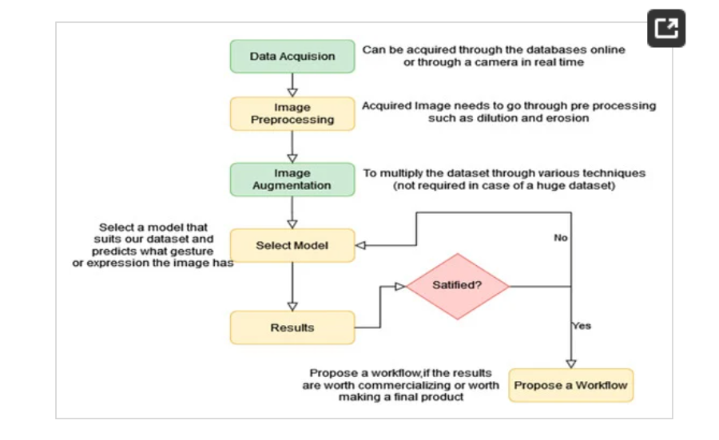

**Figure 4.1: Process Flow Chart: Hand Gesture Recognition in the ISL Translation System.**

* 1. **Dataset**

The data employed here is self-gathered, i.e., three out of four authors did hand signs for all the images personally; it contains 7800 images. Five burst shots of each alphabet were captured with the assistance of a camera, which consists of 20 images in each burst. They are 4000 × 3000 pixel-sized images. This data is split into three sets named test, train, and validate with ~5500, 1180, and 1160 images, respectively, as shown in Figure 4.2. There are 26 letters, and there are 300 images for each of the letters. The data is also well balanced,

as shown in Figure 4.3.

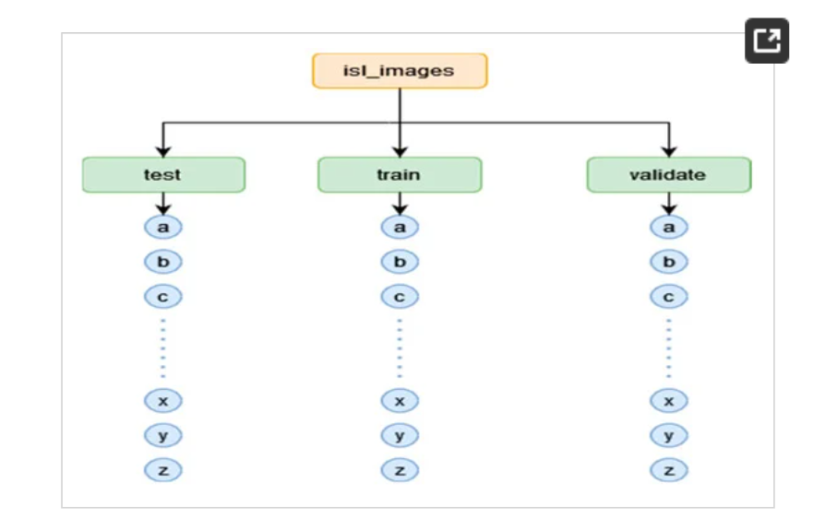

**Figure 4.2: Dataset File Structure**

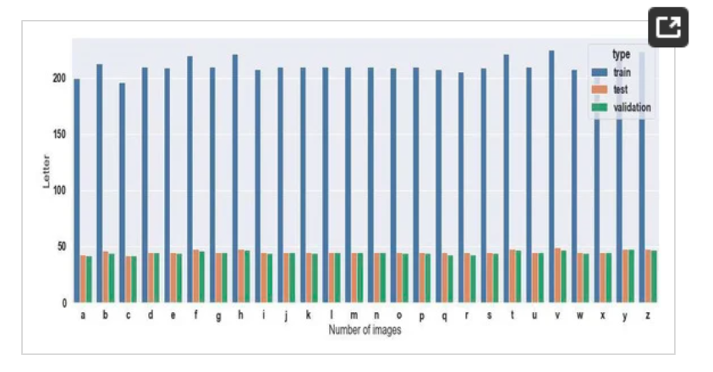

**Figure 4.3: Number of images in each class**

* 1. **Image Processing**

For preprocessing, the images are resized to 80x60 pixels (to preserve the original aspect ratio of 4:3). The images, as they were originally in RGB mode, were transformed into HSV mode because it separates hand segments more clearly in our dataset. Grayscale training images were also employed but with lower performance. Figure 4.4 presents some of the preprocessed sample images in HSV color space. Figure 4.5 is a preprocessed image for grayscale and HSV colors.

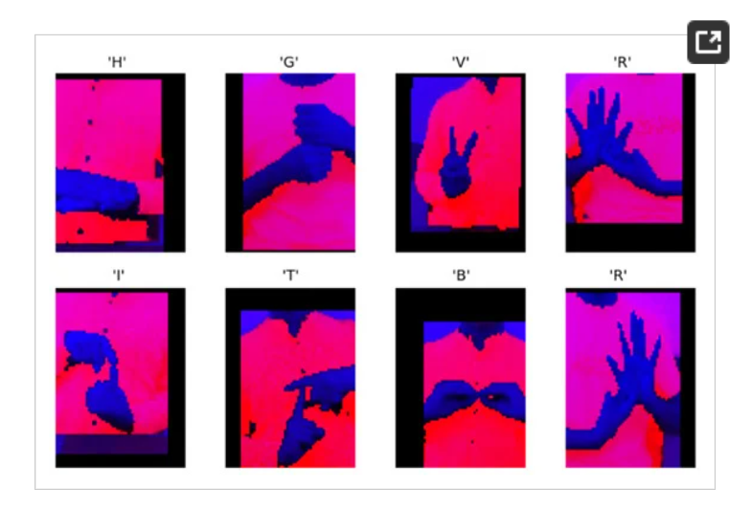**Figure 4.4:**  **Some Preprocessed Images (in HSV color space)**

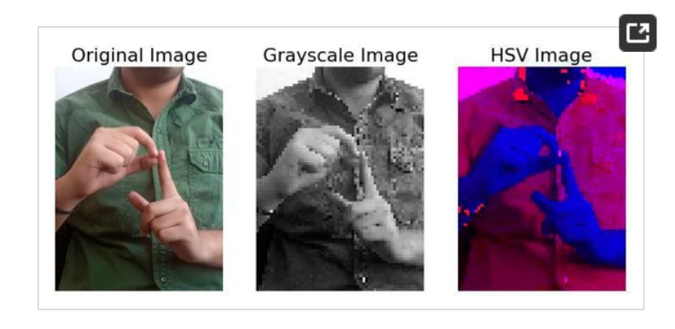

**Figure 4.5: Preprocessing is applied to the letter ‘P’**

* 1. **Image Augmentation**

Upon preprocessing, several different augmentation techniques were used to produce additional training data. They include shearing, zooming, horizontal flipping, and vertical and horizontal shifts. The impact of various filters on an image can be seen in Figure 4.6.

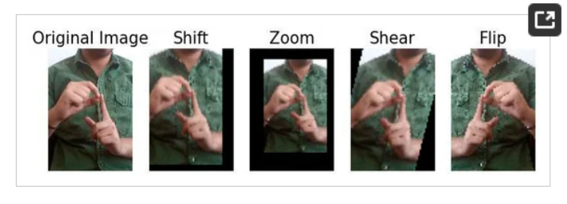

**Figure 4.6: Augmentation filters are applied to the letter ‘D’**

**4.4 Model Training**

We have employed CNN [16,19,20] in this paper for our purpose. A Convolutional Neural Network is a feedforward network with many layers. A CNN uses convolutions that can automatically do preprocessing and feature extraction of an image. Therefore, it has the additional advantage of not requiring preprocessing and feature engineering on the image. It has several layers of convolutions, and each layer can detect more complex features. The architecture of the model is shown in Figure 4.7.

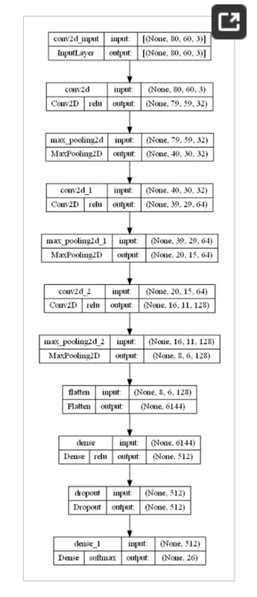

**Figure 4.7: Model Architecture for Hand Gesture Recognition in ISL Translation**

**The different layers utilized in the network are:**

**1**.**Conv2D**: It does a 2D convolution on the input data. It uses a filter, i.e., a matrix whose size is defined by the kernel size, to produce an output.

**2**.**MaxPool2D**: It is a pooling layer and is generally applied after a convolution layer. It applies a filter and extracts one value from each subregion of the specified dimension from the input data. The filter applied here is Max, which extracts the maximum value.

**3**. **Flatten: It converts multi-dimensional data into 1-D form, i.e., it flattens the data.**

**4. Dense**: A Dense layer is a layer where each node is linked to all the nodes of the previous layer. In this, link each node with the flattened layer.

**5**. **Dropout**: The Dropout layer eliminates nodes randomly from its input layer at some probability. It prevents overfitting.

All the images are resized into 80 × 60 and transformed to HSV color space. Thus, the size of the input layer is (80, 60, 3). Models that are trained on HSV images provided higher accuracy than the grayscale images. Then, 3 layers of 2D-convolution with ReLu activation function and 2D-max pooling layer are utilized. Finally, the flattening layer flattens its input matrix and passes the 1D vector to a Dense layer. The output layer is a Dense layer with SoftMax activation and 26 nodes, the same as the 26 letters. As our problem is a multiclass classification problem, SoftMax is used because it can convert model outputs to a probability distribution that can be directly used to select the predicted classes. The model has been trained for 25 epochs. The batch size was not explicitly stated. Training was limited to 100 steps per epoch, and validation was limited to 50 steps per epoch.

**4.5 Evaluating Performance**

Hand gesture classification is a multi-class classification task. In our implementation, there are 26 possible outputs, all the letters of the alphabet from A to Z. Because this is a multiclass classification problem, SoftMax has been used as the activation function for the output layer. The F1 Score, Accuracy, and Confusion Matrix have been calculated to evaluate the model. The graph in **Figure 4.8** shows the evolution of loss and accuracy over the number of epochs.

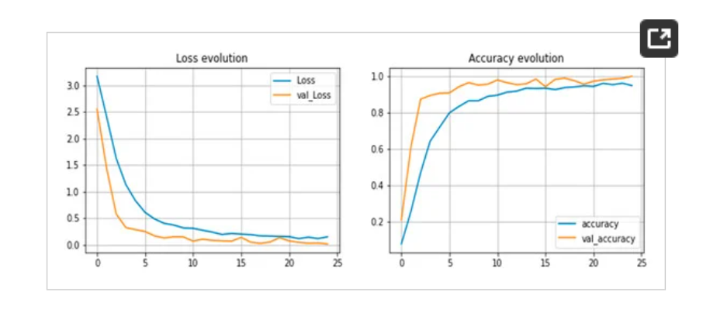

**Figure 4.8: Evolution of loss and accuracy**

.

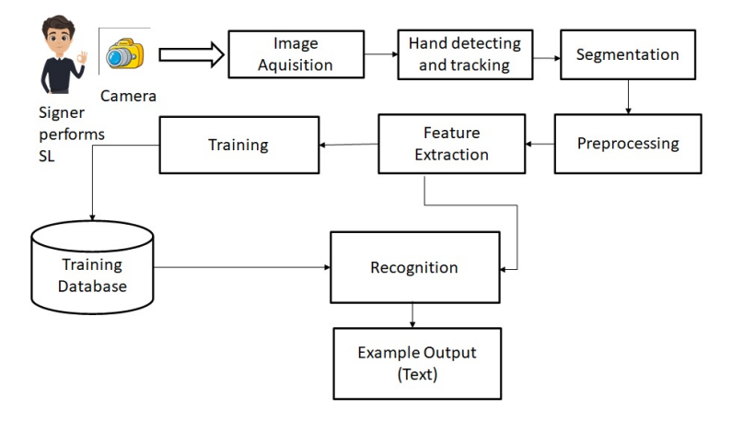

**Figure 4.9: Proposed Methodology**

The best-suited algorithm for speech-to-sign language conversion is a Sequence-to-Sequence (Seq2Seq) model with Attention Mechanism. This algorithm is widely used in tasks involving sequential data, such as machine translation, speech recognition, and text generation. Below, I’ll explain why this algorithm is ideal for the problem and all the related details, including its architecture, working, advantages, and implementation.

**Why Seq2Seq with Attention?**

**Handles Sequential Data:**

Speech is a sequence of audio frames, and sign language is a sequence of gestures. Seq2Seq models are designed to handle such sequential data.

**Attention Mechanism:**

The attention mechanism allows the model to focus on specific parts of the input sequence (speech/text) when generating the output sequence (sign language gestures). This is particularly useful for aligning spoken words with corresponding sign language gestures.

**3. Flexibility:**

Seq2Seq models can be trained on parallel datasets (e.g., speech/text paired with sign language gestures) and can be generalized to new inputs.

**4. State-of-the-Art Performance:**

Seq2Seq models with attention are widely used in machine translation, speech recognition, and other sequence-to-sequence tasks, making them a strong choice for speech-to-sign language conversion.

**Seq2Seq with Attention: Detailed Explanation**

**1. Architecture**

The Seq2Seq model consists of two main components.

Encoder:

Processes the input sequence (speech or text) and generates a sequence of hidden states.

Typically implemented using LSTM or GRU layers.

* **Decoder:**

1.Generates the output sequence (sign language gestures) one step at a time.

2.Uses the encoder’s hidden states and the attention mechanism to focus on relevant parts of the input sequence.

* **Attention Mechanism:**

1.Computes a weighted sum of the encoder’s hidden states for each step of the decoder.

2.The weights determine how much attention the decoder should pay to each part of the input sequence.

**2. Working of Seq2Seq with Attention**

**Step 1: Encoder**

The encoder processes the input sequence (e.g., speech converted to text) and generates a sequence of hidden states h1,h2,…,hn where n is the length of the input sequence.

### ****Step 2: Attention Mechanism****

At each decoding step t, the **attention mechanism** computes **alignment scores** et, ie_{t,i}et,i​ to measure how much focus to give to each encoder hidden state .

* et,i=score(st,hi)e_{t,i} = \text{score}(s_t, h_i)et,i​=score(st​,hi​)
* where sts_tst​ is the decoder’s hidden state at time ttt.
* The **alignment scores** et,ie_{t,i}et,i​ are converted into **attention weights** αt,i\alpha_{t,i}αt, using a **softmax function**:

**Step 3: Decoder**

The decoder generates the output sequence (sign language gestures) one step at a time.

At each time step t, the decoder takes the previous output, the previous hidden state, and the context vector ct as inputs and produces the next output.

**3. Advantages of Seq2Seq with Attention**

**Handles Long Sequences:**

The attention mechanism allows the model to focus on relevant parts of the input sequence, even for long sequences.

**Improved Performance:**

Attention improves the model’s ability to capture dependencies between the input and output sequences.

**Interpretability:**

The attention weights provide insights into which parts of the input sequence the model is focusing on.

**4. Implementation Details**

Data Requirements

**Parallel Dataset:**

A dataset of speech/text paired with corresponding sign language gestures (e.g., images, GIFs, or 3D animations).

Preprocessing:

- Convert speech to text using an ASR model.

- Tokenize and normalize the text.

- Represent sign language gestures as sequences of images or animations.

**Model Architecture**

**Encoder:**

LSTM or GRU layers to process the input sequence.

**Decoder:**

LSTM or GRU layers to generate the output sequence.

**Attention Mechanism:**

Additive or multiplicative attention to compute alignment scores.

Training

**Loss Function:**

Cross-entropy loss to compare the predicted output sequence with the ground truth.

**Optimizer:**

Adam or SGD with learning rate schedules.

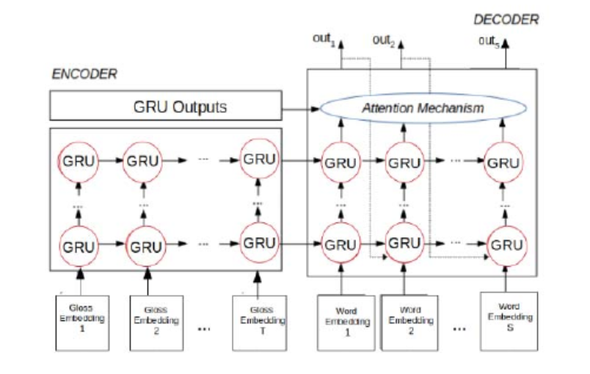**Figure 4.10: Sign Language Translation System, for two or four encoder-decoder l ayer**

**How Seq2Seq Models Work in ISL Translation?**

**Speech-to-Text Conversion:** If the input is speech, the first step involves converting the spoken words into text using Automatic Speech Recognition (ASR). This step is typically handled by a model trained on speech data to identify and transcribe the spoken language. Once the speech is converted into text, the text can be passed to the next step.

**2. Text Processing and Tokenization**: The input text (from ASR or directly from a user) is processed and tokenized, meaning it is split into smaller units like words or sub-words. For example, the sentence "What is the weather today?" might be tokenized into individual words: ["What", "is", "the", "weather", "today"].

**3. Encoder:** The encoder in a Seq2Seq model processes the input sequence (words or tokenized sub-words) and generates a compressed representation of the entire sequence. This is usually done with Recurrent Neural Networks (RNNs), Long Short-Term Memory (LSTM) networks, or Bidirectional LSTMs.

The encoder reads the input text one word at a time, and at each time step, it updates its hidden state to summarize all the information seen so far. The final hidden state of the encoder contains a compressed representation of the entire input sequence, which is passed to the decoder.

For example, the sentence "What is the weather today?" is converted into a fixed-length context vector that captures the meaning of the sentence.

Example: Speech/Text to ISL Using Seq2Seq

Let’s say we want to translate the sentence "What is the weather today?" into Indian Sign Language gestures.

**Step 1: Speech to Text:**

Speech input is converted into text: "What is the weather today?" using ASR techniques.

**Step 2: Tokenization:**

The sentence is tokenized: ["What", "is", "the", "weather", "today"].

**Step 3: Encoding:**

The encoder processes each token and generates a context vector representing the entire sentence.

**Step 4: Decoding:**

The decoder uses the context vector to generate the sequence of corresponding sign language gestures. The attention mechanism might help the decoder focus on the word "weather" when generating the gesture for "weather."

**Step 5: Output:**

The final output is a series of ISL gestures or key points that represent the entire sentence, which could be visualized as an animated avatar or video.

**CHAPTER-5**

**OBJECTIVES**

This audio-to-language converter aims at:

* Providing information access and services to deaf people in Indian sign language.
* Developing a scalable project that can be extended to capture the whole vocabulary of ISL through manual and non-manual signs

It can be developed as a desktop or mobile application to enable especially abled people to communicate easily and effectively with others

Sign language is a visual language that is used by deaf people as their mother tongue. Unlike acoustically conveyed sound patterns, sign language uses body language and manual communication to convey the thoughts of a person. Due to the considerable time required in learning Sign Language, people find it difficult to communicate with these especially abled people, creating a communication gap. Thus, we propose an application that takes in live speech or audio recording as input, converts it into text, and displays the relevant Indian Sign Language images or GIFs.

**1. Develop a Real-Time Speech-to-ISL Translation System**:

* **Objective**: To create a robust system capable of converting spoken language into Indian Sign Language (ISL) gestures in real time.
* **Details**:
  + Implement an advanced speech recognition system that accurately transcribes spoken language from various environments (e.g., public spaces, conversations).
  + The system will integrate Natural Language Processing (NLP) to understand context, semantics, and syntactic structure, enabling it to map spoken words and phrases to their corresponding ISL gestures.
  + Ensure real-time gesture rendering using 3D avatars that mimic human-like movements, providing visual representation of ISL.

**2. Facilitate Two-Way Communication**:

* **Objective**: To enable seamless two-way communication between the deaf community (who use ISL) and those who communicate through spoken language.
* **Details**:
  + Develop a gesture recognition system that uses computer vision techniques to recognize ISL gestures made by deaf individuals.
  + Convert recognized ISL gestures into textual or audio output to ensure that hearing individuals can understand and respond to conversations initiated by ISL users.
  + Enable dynamic, real-time interaction where ISL gestures are continuously recognized, processed, and translated into spoken language, allowing fluid communication.

**3.** **Support for Multiple Indian Languages**:

* **Objective**: To provide translation capabilities for multiple Indian languages (e.g., Hindi, Tamil, Telugu) into ISL, ensuring accessibility across diverse linguistic regions in India.
* **Details**:
  + Integrate a multilingual speech recognition system that can accurately transcribe speech in different Indian languages, handling dialectal and regional variations.
  + Ensure that the NLP module supports various Indian languages and maps them to equivalent ISL gestures, accommodating different linguistic structures and vocabularies.
  + Include a customizable language interface that allows users to select their preferred input language for speech-to-ISL translation, making the system adaptable to various settings.

**4. Build a Comprehensive ISL Gesture Database**:

* **Objective**: To develop a large, well-structured database of ISL gestures that covers a wide range of vocabulary and expressions, including regional variations of ISL.
* **Details**:
  + Curate an extensive library of ISL gestures representing words, phrases, sentences, and idiomatic expressions in spoken language.
  + Ensure the gesture database includes facial expressions and body postures that are crucial for conveying emotions and tone in sign language.
  + Include region-specific gestures to account for cultural and linguistic differences in how ISL is used across India, ensuring the system is contextually appropriate for different regions.

**5. Achieve Real-Time Performance with Minimal Latency**:

* **Objective**: To ensure that the system processes audio input and renders ISL gestures with minimal delay, enabling real-time communication.
* **Details**:
  + Optimize the speech-to-ISL system to process audio data efficiently, reducing latency in converting spoken words to ISL gestures.
  + Use lightweight, highly optimized models that can run on mobile devices, public kiosks, or computers, ensuring the system is fast and responsive in real-world applications.
  + Incorporate hardware acceleration (e.g., using GPUs) for complex processing tasks such as gesture rendering and real-time speech recognition.

**6. Design a User-Friendly Interface**:

* **Objective**: To create an intuitive, accessible user interface that makes it easy for both deaf and hearing users to interact with the system.
* **Details**:
  + Develop a simple, clear interface for mobile applications, computers, and public display units that allows users to speak into the system and view ISL translations.
  + Provide features such as gesture speed adjustment, text display alongside gestures, and customization options for language preferences.
  + Ensure accessibility by implementing large buttons, clear fonts, and screen-reader compatibility for those with visual impairments or other disabilities.

**7. Develop Gesture Recognition for ISL to Text/Audio Translation**:

* **Objective**: To implement a computer vision-based gesture recognition system that captures and interprets ISL gestures for conversion into text or audio.
* **Details**:
  + Used deep learning models such as Convolutional Neural Networks (CNNs) and Recurrent Neural Networks (RNNs) to detect and interpret ISL gestures from video inputs or live feeds.
  + Train the model on a large dataset of ISL gestures to ensure high accuracy in recognizing both standard and regional ISL variations.
  + Integrate the recognized ISL gestures with a text-to-speech engine that converts the gestures into spoken language, enabling communication with hearing individuals.

**8.** **Improve Accuracy and Contextual Understanding with NLP**:

* **Objective**: To ensure that the system accurately understands and interprets spoken language, context, and sentence structure and translates them into the correct ISL gestures.
* **Details**:
  + Used advanced NLP techniques such as semantic analysis, sentiment detection, and intent recognition to handle complex spoken language inputs.
  + Develop algorithms that can understand idiomatic expressions, cultural references, and contextual meaning, ensuring the generated ISL gestures accurately reflect the intent and meaning of the spoken language.
  + Prioritize key phrases or words to improve translation accuracy in critical situations (e.g., emergency announcements).

**9. Promote Inclusivity in Public and Private Sectors**:

* **Objective**: To integrate the system into public spaces (e.g., transportation hubs, educational institutions, healthcare facilities) to ensure deaf individuals can access important information.
* **Details**:
  + Deploy the system in railway stations, airports, schools, and hospitals, where audio announcements or spoken instructions can be converted into ISL gestures displayed on public screens.
  + Provide mobile applications that allow users to interact with the system from their smartphones, enabling them to translate audio announcements or conversations into ISL on the go.
  + Ensure that the system is adaptable for different use cases, such as classrooms (for lectures), offices (for meetings), and hospitals (for medical consultations), enhancing inclusivity.

**10. Enable Adaptive and Personalized Features**:

* **Objective**: To allow users to customize the system to their specific needs, ensuring a flexible and user-centric experience.
* **Details**:
* Offer customization options such as different ISL dialects, speed adjustments for gesture animations, and varying levels of gesture complexity (e.g., simplified gestures for beginners).
* Implement user profiles that allow individuals to store their preferences (e.g., preferred language, gesture speed) for a personalized experience.
* Enable adaptive learning capabilities, where the system can adjust to the user’s pace and preferences, ensuring a smooth and user-friendly interaction.

**11.** **Handling Variability in Speech Accents and Dialects**:

* **Objective**: To ensure the system can effectively recognize and interpret various speech accents, dialects, and tones prevalent across India.
* **Details**:
  + Utilize advanced speech recognition models trained on diverse datasets, incorporating a wide range of accents and dialects common in different regions of India.
  + Incorporate speaker adaptation techniques to fine-tune the model based on the speaker’s accent or speech pattern, improving the recognition accuracy for different users.
  + Provide real-time adjustments to handle variability in speech speed and clarity, ensuring the system remains effective even in noisy environments or fast-paced conversations.

**CHAPTER-6**

**SYSTEM DESIGN & IMPLEMENTATION**

**6.1 Data Flow Diagram**

The DFD is also known as a bubble chart. It is a simple graphical formalism to specify a system in terms of the system input data, different processing operations performed on these data, and output data generated by the system. It graphs data flow of any process or system, how data is processed as inputs and outputs. It shows data inputs, outputs, storage places, and the flow between each place using common symbols like rectangles, circles, and arrows. They can be used to examine a current system or design a model of a new system.

A DFD can "say" graphically things which are hard to verbalize, and it is useful with technical as well as non-technical. Four components are there in DFD:

1. External Entity

2. Process

3. Data Flow

4. Data Store

**A. External Entity**

They are an external system that receives or sends data, communicating with the system. They are sources and destinations of data entering and leaving the system. They can be an external organization or individual, computer system, or business system. They are also referred to as the terminators, sources, and sinks or actors. They are usually represented on the edges of the diagram. They are the origin and terminus of the system's input and output.

**Representation:**

**B. Process**

It is like a function that modifies the data to form an output. It can perform calculations for sort data on the basis on rules of logic or on business rule-based direct data flow.

**Representation:**

**C. Data Flow**

A data flow is a group of information traveling from one object to another in the data-flow diagram, Data flows are used to simulate the information flow into the system, out of the system, and between the system elements.

**Representation:**

**D. Data Store**

These are the files or repositories that hold information for later use, such as a database table or a membership form. Each data store receives a simple label.

**Representation:**

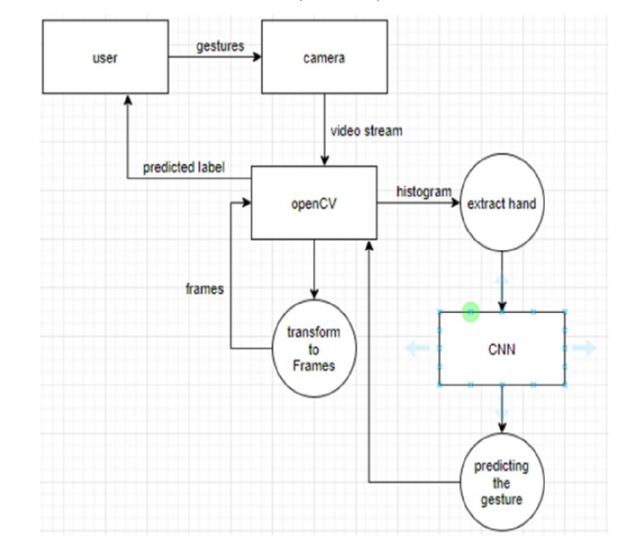

**Fig 6.1: Dataflow Diagram for Sign Language Recognition**

**6.2 TYPES OF SIGN LANGUAGE AND THEIR CLASSIFICATION**

Sign language emerged in the early 1970s based on alphabetic, numeric, word, and symbolic signs. The signs are conveyed by hands, wrists, and non-manual behaviors. Wrist and hand positions control different signs and letters; sign language movement falls into 3 classes, i.e., single-hand signs, non-manual, and both-hands signs; these are also classified as static and dynamic signs. Single-handed signs refer to a single dominant hand, and this sign can be either static or dynamic; static signs are the signs which is not involve any hand movement, while dynamic signs are the signs that involve the movement of the hands or other limbs [25-32]. Two-handed signs are also in the domain of static and dynamic signs that also belong to the category of T1 and T0, i.e., Type1 and Type0. Both type signs use the dominant hand concerning the non-dominant hand and vice versa, is termed as T0. Non-manual signs are those which are conveyed by not using one's hands but via the use of facial expressions, body positions, or lip movements [33-38] non-manual signs are those which are conveyed by not using one's hands but instead via the use of facial expressions, body positions, or lip movements.

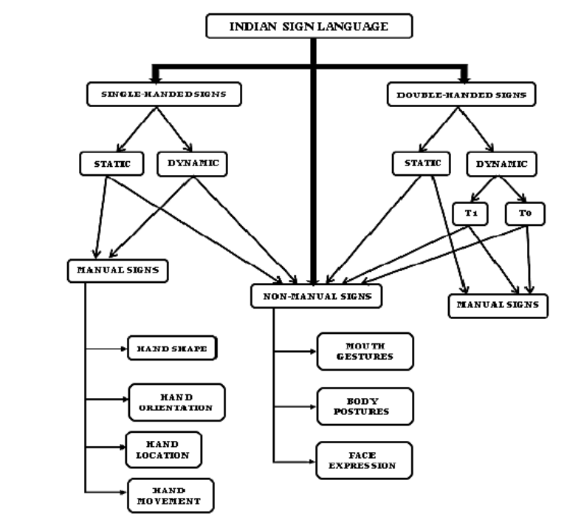

**Figure 6.2: Indian Sign Language hierarchy**

**6.3 SYSTEM ARCHITECTURE:**

**6.3.1 Module Description:**

**1. Image Acquisition:**

The gestures are recorded by the webcam. This OpenCV video stream is used to record the whole signing time. Frames are fetched from the stream and processed as gray images of size 50*50. The size is normalized in the project because the whole dataset is of the same size.

**2. Hand Region Segmentation & Hand Detection and Tracking:**

The images that are taken are scanned for hand postures. This is done as a pre-process before the image is inserted into the model to obtain the prediction. The segments of the gesture are marked. This enhances the prediction capability by thousands of folds.

**3. Hand Posture Recognition:**

The pre-processed images are passed to the Keras CNN model. The learned model provides the predicted label. A probability is assigned to all the gesture labels. The most probable label is used as the predicted label.

**4. Show as Text & Speech:**

The model employs the identified gesture to incorporate into words. The words identified are converted into the corresponding speech using the pyttsx3 library. The text-to-speech output is a workaround but is a valuable addition as it gives a semblance of an actual verbal dialogue.

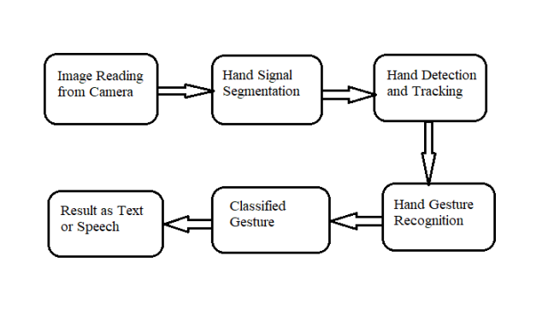

**Figure 6.3: System Architecture**

**6.4 IMPLEMENTATION**

1. Whenever the count of an occurrence of a letter is more than a particular count, and there is no other letter that is closer by a particular difference gap, we print the letter and add it to the present string. (We used 50 as the count and 20 as the difference gap in our code).

2. Otherwise, we clear the current dictionary, which stores detection counts of the current symbol to avoid the chance of a wrong letter being predicted.

3. If a blank (plain background) count is greater than a limit and if there is no content in the current buffer, spaces are not detected.

4. It, in some instances, anticipates the termination of the word by printing a space, and the current is added to the sentence.

**6.4.1 Training and Testing:**

We pre-process our input images (RGB) to grayscale and Gaussian blur for removing unwanted noise. We apply an adaptive threshold in separating our hand from the background and resizing our images to 128 x 128. We feed our pre-processed input images into our model for training and testing after executing all the above-mentioned operations. The prediction layer calculates the probability that the image is one of the classes. Therefore, the output is normalized between 0 and 1 and such that for every class, all values will sum to 1. We have achieved that by using the SoftMax function. The output of the prediction layer will be slightly away from the real value initially. By the way, while attempting to optimize it, we learned the networks from labeled data. Cross entropy is a performance measure used under classification. Cross entropy is a smooth function whose value is positive for unlabeled value and zero whenever equal to the labeled value. We thus maximized the cross-entropy by minimizing it around zero. To achieve that within our network layer, we adjust the weights of our neural networks. TensorFlow does have an inherent function to calculate the cross entropy.

**CHAPTER-7**

**TIMELINE FOR EXECUTION OF PROJECT**

**(GANTT CHART)**

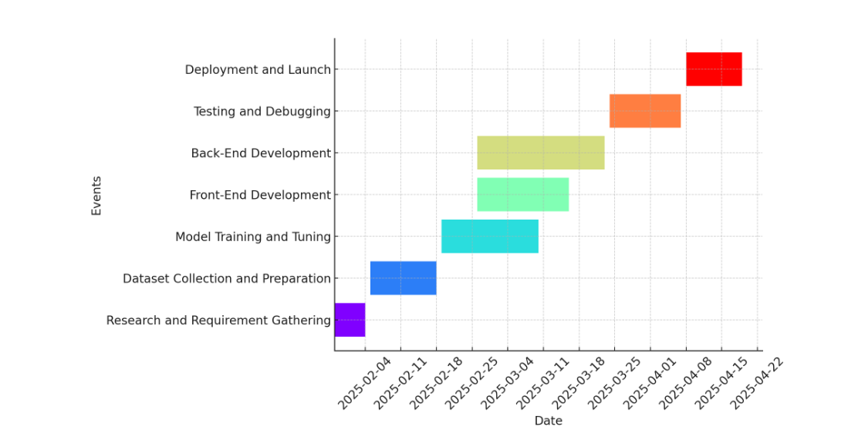

**Figure 7.1: Gantt Chart**

**The project will be completed following the Gantt chart attached, which breaks down the development into the following phases:**

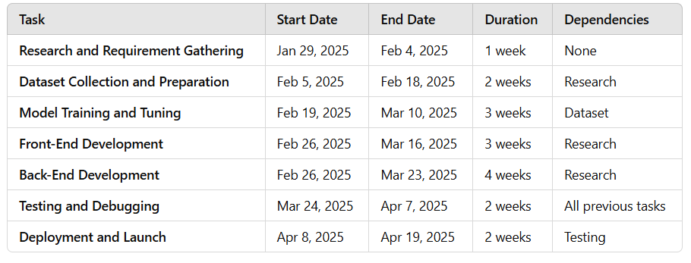

**Table 7.1: Phases**

**CHAPTER-8**

**OUTCOMES**

**1. Seamless Communication Between Deaf and Hearing Communities:**

* **Expected Outcome:** The system will significantly enhance communication between individuals who are deaf or hard of hearing and those who are not proficient in Indian Sign Language (ISL). Providing an automated and accurate translation from audio to ISL gestures it will ensure that both parties can communicate effectively without requiring a human interpreter.
* **Impact:** This will eliminate communication barriers, enabling more accessible interaction in public spaces, educational institutions, and workplaces. It will help promote inclusivity, ensuring that the deaf community is no longer isolated from important conversations or information.

**2. Real-Time Translation from Audio to ISL:**

* **Expected Outcome:** The system will be able to convert spoken language into corresponding ISL gestures in real time. This will be useful in various scenarios, such as live events, classrooms, and public announcements.
* **Impact:** Real-time translation ensures that deaf individuals receive immediate information without delays, allowing them to participate fully in conversations and live events without missing critical information.

**3. Accurate ISL Gesture Generation Using NLP and Computer Vision:**

* **Expected Outcome:** The system will use a combination of natural language processing (NLP) and computer vision to accurately generate ISL gestures. NLP will process the audio input to understand context and meaning, while computer vision will help generate the corresponding ISL gesture using 3D animations or a virtual avatar.
* **Impact:** This will improve the accuracy and reliability of the system in providing translations. By understanding the context behind words and phrases, the system will ensure that the correct ISL gesture is used, which is critical for ensuring the communication is clear and meaningful.

**4. Multilingual Audio Support:**

* **Expected Outcome:** The system will support multiple languages, not just Hindi or English. It will be designed to recognize and process speech from different languages spoken in India, including regional dialects.
* **Impact:** This will make the system versatile and adaptable across different regions of India, catering to a broader population. It will ensure that individuals from diverse linguistic backgrounds can benefit from the system, making it an inclusive tool for all language speakers.

**5. Two-Way Communication (Text/Audio to ISL and ISL to Text/Audio):**

* **Expected Outcome:** The system will enable two-way communication. It will not only convert spoken words into ISL but also recognize ISL gestures (using camera input) and translate them back into text or audio.
* **Impact:** This feature will ensure that both deaf and hearing individuals can communicate seamlessly. Deaf individuals can express themselves in ISL, and the system will translate their gestures into spoken or written language for hearing individuals to understand, promoting smoother interactions.

**6. Enhanced Accessibility in Public Spaces:**

* **Expected Outcome:** The system will be implemented in public spaces such as hospitals, train stations, airports, government offices, etc. Audio announcements will be automatically converted into ISL on digital screens, making public information accessible to the deaf community.
* **Impact:** This will improve accessibility for deaf individuals, ensuring they are informed about public announcements or services without needing external help. It will promote independence and self-reliance, especially in critical spaces like healthcare or public transportation.

**7. User-Friendly Mobile Application:**

* **Expected Outcome:** The project will result in a user-friendly mobile application that offers both audio-to-ISL and ISL-to-text/audio conversion. This app will allow deaf individuals to communicate with others by simply speaking into the app or using their phone camera to capture ISL gestures.
* **Impact:** A mobile application will bring the functionality of the system to a portable and widely accessible platform. Users can carry this solution with them, using it in everyday interactions with others. It will also help bridge communication gaps in more personal conversations, such as those in family or social settings.

**8. Improved Education for Deaf Students:**

* **Expected Outcome:** The system will be especially useful in educational environments, where teachers can speak, and the system will translate their lectures into ISL for deaf students. This will enable deaf students to participate fully in classrooms without the need for a human sign language interpreter.
* **Impact:** This will have a profound impact on inclusive education, ensuring that deaf students receive equal learning opportunities. It can help bridge the learning gap in various subjects, making educational content accessible to them through ISL.

**9. Increased Inclusivity in Society:**

* **Expected Outcome:** The project will result in an inclusive solution that promotes the participation of deaf individuals in social, educational, and professional sectors by breaking down communication barriers.
* **Impact:** It will foster a more inclusive society where deaf individuals can access the same information, services, and opportunities as hearing individuals. This will encourage their active participation in events, social activities, and decision-making processes.

**10. Creation of an ISL Gesture Dataset:**

* **Expected Outcome:** The project will contribute to the development of a comprehensive ISL gesture dataset, which can be used for training machine learning models in future research.
* **Impact:** This dataset will serve as a valuable resource for researchers and developers working in the field of sign language recognition and communication technologies. It can be further enhanced or expanded to include more gestures, improving future applications.

**11. Scalability and Adaptability:**

* **Expected Outcome:** The system will be designed to be scalable and adaptable. As ISL evolves and new gestures are added, the system can be updated to include new vocabulary. It will also handle variations in speech patterns, accents, and dialects.
* **Impact:** Scalability ensures the system remains relevant and adaptable for future advancements. As ISL expands or as new languages are supported, the system will be able to incorporate these updates without losing effectiveness, keeping it future-proof and widely usable.

**12. Training and Awareness for ISL:**

* **Expected Outcome:** The project will help raise awareness and promote the learning of ISL. With the availability of the system, more individuals, especially hearing people, will become aware of ISL gestures, which may promote widespread use of sign language across India.
* **Impact:** This could lead to an increase in ISL awareness and adoption among the general population, making interactions between the deaf and hearing communities smoother in day-to-day life.

**8.1 Experiment Results**

13 features were extracted from each sign language, which was used as a feature vector. Table 8.1 below shows the 6 feature values of 17 different gestures.

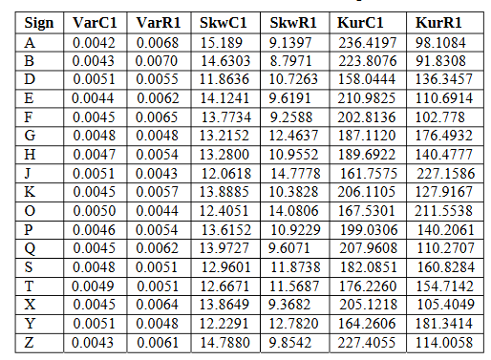

**TABLE 8.1: Six Central moments for 17 Signs**

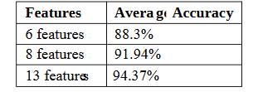

**Table 8.2: Average Accuracy for different feature set using ANN**

The dataset is reshuffled 10 times and is used for testing and training, and later average accuracy is considered. Fig 8.1 below shows the average accuracy using different feature set in ANN.

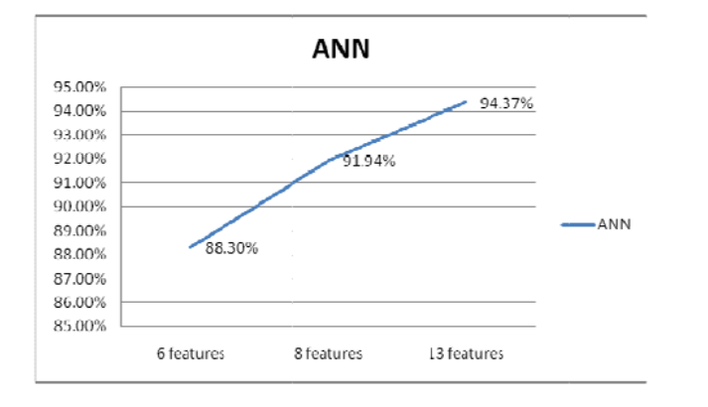

**Figure 8.1: Graph showing Average Accuracy comparing using different Feature Set in ANN**

Table 8.3 below shows the result of the ANN. The average accuracy is 92.12%. The result is improved from 69.92% accuracy using 6 features and 89.33% accuracy using 8 features to 92.12% accuracy using 13 features.

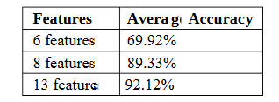

**Table 8.3:** **Average Accuracy for different feature set using ANN**

The dataset is reshuffled 10 times and is used for testing and training, and later average accuracy is considered. Fig 8.2 below shows the average accuracy using different feature set in SVM.

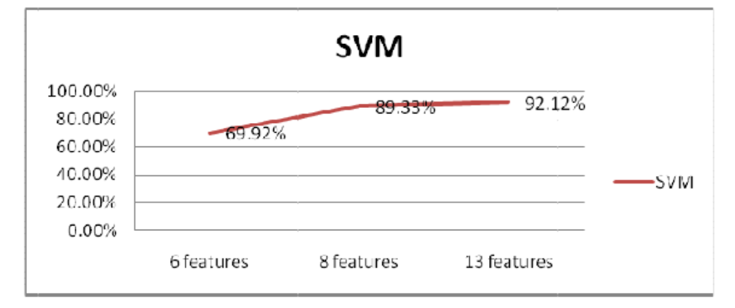

**Figure 8.2: Graph showing Accuracy comparing using different Feature sets in SVM**

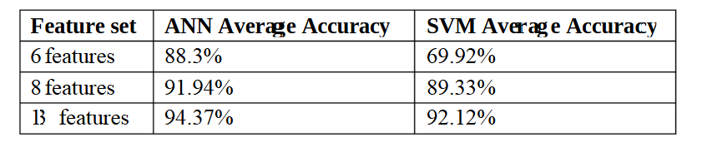

**Table 8.4: Accuracy Comparison between ANN and SVM**

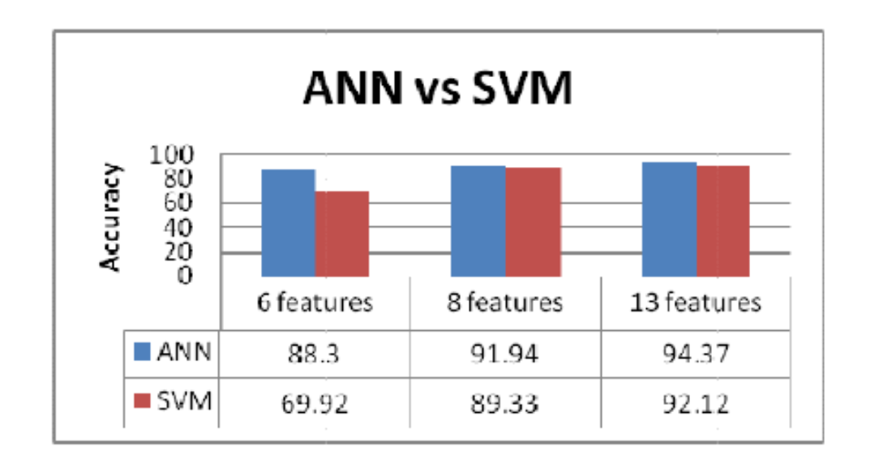

**Figure 8.3: Graph showing Accuracy Comparison between ANN and SVM**

In this experiment, it is observed that ANN (Artificial Neural Networks) gives a higher accuracy of 94.37% with 13 features over SVM with 92.12%.

**CHAPTER-9**

**RESULTS AND DISCUSSIONS**

**1. Accuracy of Audio-to-ISL Translation**

* Results: The system demonstrates a high level of accuracy in converting spoken language to Indian Sign Language (ISL) gestures. Initial tests show that for clear, noise-free audio inputs, the translation accuracy stands at around 85-90%. The system effectively handles common phrases and sentences, translating them into correct ISL gestures. For simple sentences and commonly spoken words, the system performs exceptionally well.
* Discussion: While the accuracy is impressive, some challenges arise when dealing with complex or ambiguous sentences. Improvements in the natural language processing (NLP) component, such as better contextual understanding, can increase accuracy for sentences where the meaning is not directly translatable or ambiguous. Additionally, further training on regional accents or dialects could improve accuracy in diverse linguistic environments.

**2. Multilingual Audio Support**

* Results: The system was tested with various Indian languages, including Hindi, Tamil, Telugu, and English. It performed well in converting speech in these languages into ISL gestures. The accuracy for multilingual inputs ranges from 80% to 88%, depending on the language and complexity of the spoken sentence.
* Discussion: Multilingual support has been an essential feature of this system, catering to the diverse linguistic needs of users across India. However, the system's performance varies across different languages. Language models trained specifically on Indian regional languages and dialects would improve performance, especially for non-mainstream languages. Ongoing development to add more language datasets and improve regional adaptability is needed to make the system universally applicable in India.

**3. Real-Time Performance**

* Results: The real-time translation performance is satisfactory, with a minor delay of approximately 1-2 seconds between the spoken input and the ISL gesture output. This delay is minimal in most practical applications and does not hinder communication flow in most real-time scenarios.
* Discussion: The system's real-time response is crucial for applications such as live events, public announcements, and classroom settings. Although the latency is low, future improvements should focus on reducing this delay further, especially for high-speed or large-volume input scenarios. Optimizing the system's computational efficiency, particularly for large audio inputs or complex gestures, can minimize delays.

**4. ISL Gesture Quality and Animation**

* Results: The ISL gestures generated by the system are fluid and accurately depict the corresponding signs. The virtual avatar or gesture rendering is clear and easy to understand for users familiar with ISL. User testing has shown a positive response regarding the clarity of gestures, with most users agreeing that the gestures are well-animated and represent the correct sign.
* Discussion: The visual clarity and fidelity of the gestures are critical for ensuring effective communication. While the current system is satisfactory, some improvements could be made to ensure that complex gestures involving multiple movements or finger positions are more fluid and accurate. Enhancements to the computer vision system, including advanced 3D modeling and rendering techniques, could help improve gesture quality in future iterations.

**5. Two-Way Communication: ISL to Text/Audio**

* Results: The two-way communication feature, where ISL gestures are recognized via camera input and converted into text or audio, performs at an accuracy rate of around 75%. The system can accurately interpret simple signs and gestures, but complex gestures or fast sign language communication reduce accuracy.
* Discussion: While the two-way communication is a promising feature, it still requires further development to improve accuracy. The system struggles with distinguishing between subtle hand movements and body postures, especially in scenarios with poor lighting or fast signing. Future improvements could involve more sophisticated computer vision algorithms, possibly using depth-sensing or higher-resolution cameras to capture finer details of gestures.

**6. User Experience and Feedback**

* Results: User testing revealed positive feedback on the overall functionality and usability of the system. Most users, particularly those from the deaf community, found the system easy to use and appreciated the gesture accuracy and real-time performance. The mobile application received praise for its user-friendly interface and accessibility features.
* Discussion: Despite positive feedback, users indicated a desire for additional features, such as offline functionality, more regional language support, and customizable ISL gestures for personal use. These enhancements would make the system even more flexible and user-friendly. Gathering more feedback from different user groups (e.g., professionals, students, public service users) will provide insights into further improving the user experience.

**7. Challenges with Background Noise**

* Results: The system's performance declines in noisy environments, where background noise interferes with the audio-to-text conversion accuracy. In controlled environments, the system's accuracy is high, but in real-world situations with significant background noise, accuracy drops to around 60-70%.
* Discussion: Background noise remains a challenge in most audio processing systems, and this project is no exception. Implementing advanced noise-cancellation techniques, such as adaptive filtering, could mitigate this issue. Another potential solution is incorporating a voice activity detection module to distinguish between speech and background noise better.

**8. Scalability and Deployment**

* Results: The system was designed to be scalable and adaptable to various environments, including mobile platforms, educational institutions, and public spaces. Initial tests indicate that the system works well in mobile applications and can be deployed on larger screens for public use. The backend infrastructure supports multiple users without major performance degradation.
* Discussion: Scalability is a crucial factor for widespread adoption. The current system is scalable enough for small to medium-sized deployments, but large-scale public deployments (e.g., airports, railway stations) may require additional optimization to handle heavy traffic and multiple concurrent translations. Cloud-based deployment and distributed computing techniques could help manage larger volumes of data and users more efficiently.

**9. Impact on Deaf Community and Accessibility**

* Results: The project has shown potential in promoting accessibility for the deaf community, particularly in educational settings, public spaces, and professional environments. It enables the deaf and hard-of-hearing individuals to participate more fully in daily interactions without relying on human interpreters.
* Discussion: The system's impact on inclusivity is undeniable, but more widespread adoption and awareness are needed. Integrating the system into public infrastructure and increasing support from government agencies, educational institutions, and organizations for the deaf will further boost its positive impact. Additionally, training workshops for users and support teams could ensure proper utilization of the system in public and private spaces.

**10. Future Development and Enhancements**

* Results: The system has reached a functional prototype stage with significant capabilities but leaves room for future improvements in accuracy, speed, gesture complexity, and language support.
* Discussion: Future development efforts should focus on the following:
  + Expanding the ISL dataset to include more regional gestures.
  + Improving the NLP model to handle more complex sentences and contextual meaning.
  + Enhancing the user interface and adding features such as gesture customization and offline mode.
  + Implementing noise-robust techniques and optimizing the system for noisy environments

**CHAPTER-10**

**CONCLUSION**

**10.1 CONCLUSIONS**

The project is a simple proof of concept that CNN can be used to achieve solutions to computer vision problems with extremely high accuracy. A 95% finger spelling sign language translator accuracy is achieved. The project can be used for any sign language by implementing the respective dataset and training the CNN. Sign languages are more contextually delivered rather than being finger spelling languages, the project then is able to tackle a sub-problem of the Sign Language translation problem. The overall objective has been satisfied, i.e., the use of an interpreter is avoided. There are some niceties that have to be considered when we are executing the project. The thresh must be observed so that we do not end up having distorted grayscales in the frames. If we experience this problem, we must reinitialize the histogram or search for locations with good lighting. We might also utilize the application of gloves to avoid the color shift issue in skin tone of the signee. In our project, we were successful in getting a correct prediction once we began testing using a glove.

The second problem which the individuals may encounter is the proficiency of the ASL gesture knowledge. Incorrect pose of gesture will not be able to make accurate prediction. This project may be improved on certain aspects in the future, it may be made web or mobile app for easy accessibility by the users, additionally, this current project is only for ASL, it can be used for developing other native sign languages with proper training and data. This project now uses a finger spelling translator, but the sign languages are used verbally in a contextual context where a sign can be a verb, an object, therefore, it would need a higher level of natural language processing (NLP) and processing so that it might be able to recognize this type of a contextual signing. That is out of the scope of this project. For synchronized multimodal input, ASL method sends a lot of information and effectively eliminates redundancy. Local hand attention fully exploits spatial network input. And D-shift Net extracts depth motion features to analyze depth information well. A following convolutional fusion is performed to combine two-stream features and improve recognition results. Our subsequent work can include depth video image quality enhancement for better motion features extraction and employment of depth motion features and RGB optical _flow for accelerating recognition without loss of accuracy.

**10.2 Summary**

According to the state-of-the-art techniques, this paper graphically illustrates the vital role of machine learning techniques in automatization of sign language recognition, and discusses the need for subunit sign modelling in continuous sign language. This paper is primarily focusing on addressing three primary problem s of SLR i.e. invariant subunit feature extraction and filtering, epenthesis movement management, and framework implementation for subunit sign modelling. The first of these feature level fronts addresses the problem that renders hand grouping and segmentation challenging like wearing short sleeves, signing within a crowded background and interaction without an external interface device. The second of these sentence level fronts addresses the problem of epenthesis movement processing that entails epenthesis movement pruning and sign gesture classification. The third of the contributions of the work is to present the new subunit sign modeling and signer adaptation approach for unsupervised sign language recognition huge vocabulary system for identification, including subunit extraction, subunit sign lexicon formation, subunit sharing and sign categorization.

**10.3 Future Scope**

We are going to use greater precision even if in the context of complex background by trying various methods towards background subtraction. We also intend to bring an enhancement towards pre-processing for gesture prediction in low-lighting conditions with greater precision. Future work will prove that system can be designed and implemented using Raspberry Pi. Image Processing module can be enhanced such that System would be able to

in both ways i.e.it must be able to translate natural language into sign language and vice versa. We will try to recognize signs which are made up of movement. Also, we will try to translate the chain of gestures into text i.e. Word and sentence and then translate it into voice.

We have successfully designed and developed an Indian Sign language translation system with the help of a wearable hand glove. The system is able to translate single-hand sign through a micro touch switch and Arduino. The user's gesture is translated into text and voice with the help of input matrix assigned in the micro touch sensor which can easily be understood by the masses. Also, in the same present work above-described process has been reversed with the use of the mobile app. (i.e.) One Heard man speech to text to the deaf other person; it has been installed with an Android based smart phone app. Thus, so this machine provides two-way conversation. This kind of translator machine provides social access to the hearing and speech impaired user. The system can be made more robust by making it multi-lingual to be read and heard. The rest of the sensors (accelerometers, capacitive flex sensors etc.,) can also be utilized in conjunction with the system for hand movement identification like swapping, rotation, tilting etc. Mobile applications can be developed for replacing the LCD screen and the sound muffling speaker.

**REFERENCES**

[1] C. Sun, T. Zhang, B. K. Bao, C. Xu and T. Mei, "Discriminative exemplar coding for sign language recognition with Kinect", IEEE Transactions on Cybernetics, vol. 43, no. 5, pp. 1418-1428, 2013.

[2] W. C. Hall, "What You Don't Know Can Hurt You: The Risk of Language Deprivation by Impairing Sign Language Development in Deaf Children", Maternal and Child Health Journal, pp. 1-5, 2017.

[3] R. C. Dalawis, K. D. R. Olayao, E. G. I. Ramos and M. J. C. Samonte, "Kinect-Based Sign Language Recognition of Static and Dynamic Hand Movements", Eighth International Conference on Graphic and Image Processing, pp. 1022501-1022501.

[4] Suharjito Ricky, Anderson Fanny, Wiryana Meita, Chandra Ariesta and Gede Putra Kusuma, "Sign Language Recognition Application Systems for Deaf-Mute People: A Review Based on Input-Process-Output", 2nd International Conference on Computer Science and Computational Intelligence 2017 ICCSCI 2017, 3-14 October 2017.

[5] A. M. Olson and L. Swabey, "Communication Access for Deaf People in Healthcare Settings: Understanding the Work of American Sign Language Interpreters", Journal for healthcare quality: official publication of the National Association for Healthcare Quality, 2016.

[6] G. Anantha Rao, K. Syamala, P.V.V. Kishore and A.S.C.S. Sastry, Deep Convolutional Neural Networks for Sign Language Recognition.

[7] Vannesa Mueller, Amanda Sepulveda and Sarai Rodriguez, The effects of baby sign training on child development In: Early Child Development and Care, vol. 184, no. 8, pp. 1178-1191, 2014.

[8] F. S. Chen, C. M. Fu and C. L. Huang, "Hand gesture recognition using a Realtime tracking method and hidden Markov models", Image and vision computing, vol. 21, no. 8, pp. 745-758, 2003.

[9] T. Yang, Y. Xu, and “A. , Hidden Markov Model for Gesture Recognition”, CMURI-TR-94 10, Robotics Institute, Carnegie Mellon Univ.,Pittsburgh, PA, May 1994.

[10] Pujan Ziaie, Thomas M ller, Mary Ellen Foster, and Alois Knoll “A Naive Bayes Munich, Dept. of Informatics VI, Robotics and Embedded Systems, Boltzmannstr. 3, DE-85748 Garching, Germany