JUnit

What is Unit testing?

Testing a specific method or class.

What is Junit?

Junit is framework to call a particular method of class and check if its functionality is working as expected. Advantage of writing Junit tests is they are automated and we can run any number of times and this can run in continuous integration (when there is a change or frequently in every hour or so for example.)

We have to create a separate source folder with the name test, so keep our test code separate from actual code and also this will make sure our test code won’t get deployed.

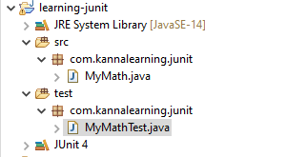

@Test annotation is used on methods to make them unit test cases.

There are many methods used for Junit testing but the most commonly used ones are the below.

**Original Code:**

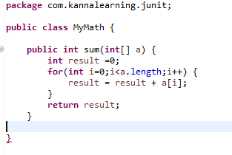

**Test Code:**

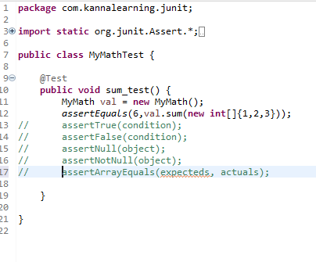

In addition to @Test annotations there are two more annotations to be kept in mind.

@Before and @After

@Before if we put on a method and if test cases are ran, and then this code gets executed every time before the test case is run.

Similarly @After, code is ran every time after each test case is ran.

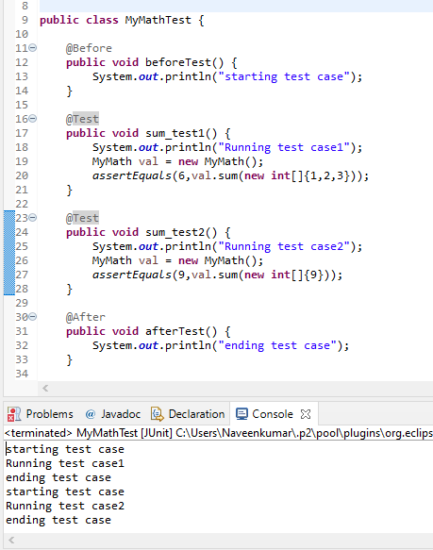

Other two annotations are **@BeforeClass and @AfterClass** and the methods should be **static** since these are class level annotations.