**Maven**

**What is Maven?**

* Maven is a project management tool for our application.
* Most popular use of Maven is for build management and dependencies.

**What problems can maven solve?**

When building a Java project we may need additional Jar files like for example Spring, hibernate, servlets, logging etc to build our Java application. One approach is to download the Jar files manually and add them manually to the class path/build path.

So instead of manually downloading them individually and add them in the class path of our project, Maven does it all for us. We just have to tell the projects (dependencies) we need to maven and it downloads the corresponding Jars from maven central repository and make them available for our application during the compile/run time. Maven also downloads the depending jars for each dependency in maven pom file.

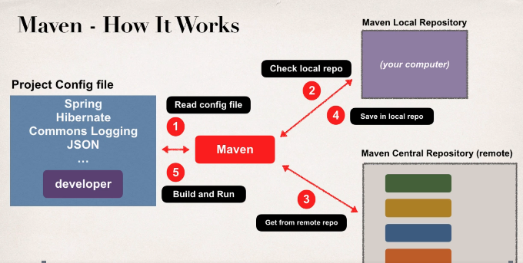

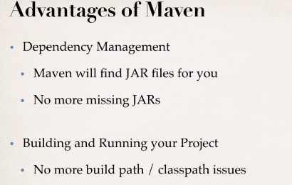

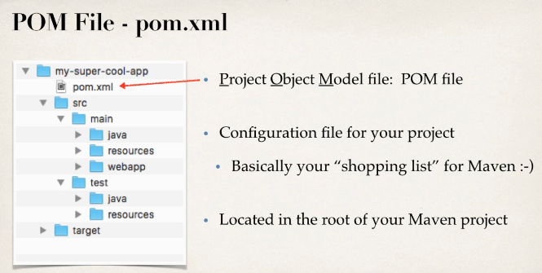

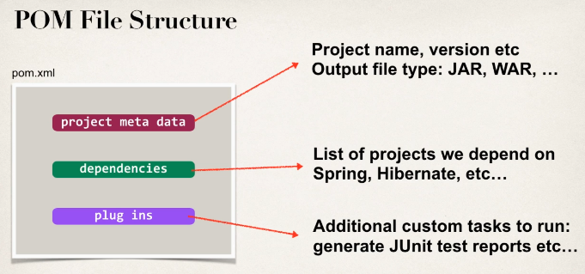



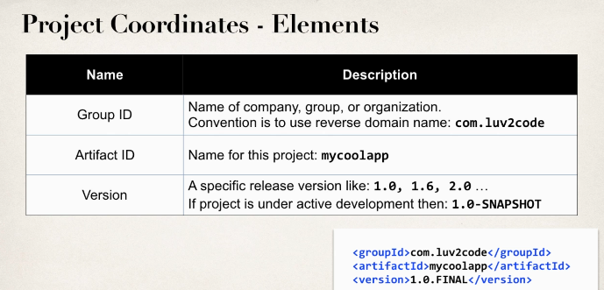

The main difference between the groupId and artifactId is groupId specifies the ID of the project group while the artifactId specifies the id of the project. So group Id is always used to identify the project group and artifactId is used to identify the specific project that is developed by that particular group of organization.

