**React**

React is a **declarative**, **efficient**, and **flexible** **JavaScript library** for building user interfaces. It lets you compose **complex UIs** from small and **isolated pieces of code** called “**components**”.

In order to create a basic react project structure we need to use the following cli tool call create-react-app

***npx create-react-app app-name***

Now in order to run dev server use the below command

***npm start***

In React, **App** component is the root component and all the component we develop will be under this app componenet.

In react, components can be written using classes or functions with hooks. These days functions with hooks is more popular.

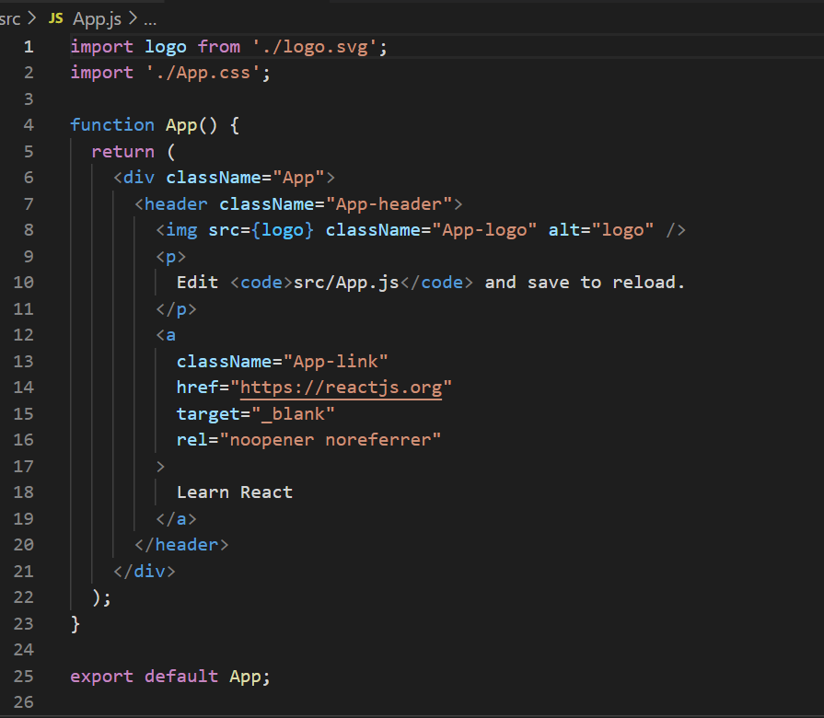

App.js looks like this in the above screenshot and this is the default one created when we created folder structure.

If we notice **return** statement has **html like code** but it is not html is jsx (JavaScript syntax extension)

Our app is nothing but bunch of components. So now lets start building components. Create a **components folder under src**. And all the components we create should start with upper case letter.

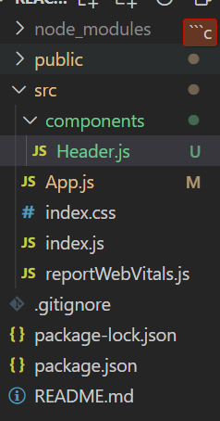

Now install **ES7 React/Redux/GraphQL/React-Native snippets** plugin in visual studio code. This will help us generating code with simple commands.

Now if we want to create boiler plate code for function with hooks just go to component js file and type **rafce.**

Props

defaultProps

PropTypes