JavaScript Versions

**ES5 (ECMAScript 5)** supported by all browsers

ES6 (2015)

ES2016

ES62017

**Declaring variables**

In typescript, there are two ways to declare variables. Either var or let keyword.

Eg: var d =32;

let d =43;

ES6 version of JavaScript also has let keyword.

The variable which is declared with type var has scope to the nearest function.

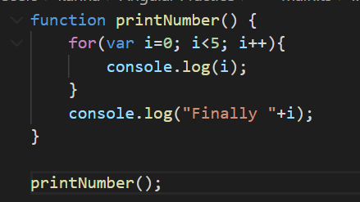

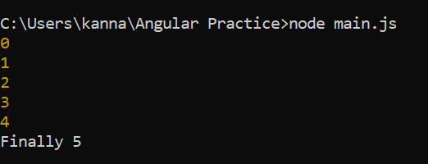

The variable declared with type let has scope to the nearest block.

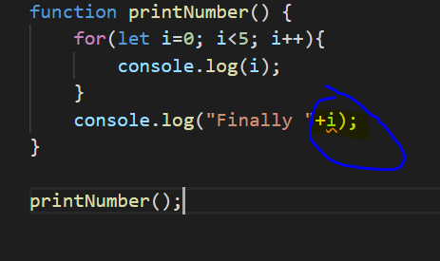

Since let variable scope is block specific here, when we try to use out side of that block, compile error will be shown in vs code.