1. Christopher Nelson: tuh40752
2. AutoLunacy
3. Welcome to our page. To navigate the site, click the links in the upper right-hand corner of this landing page. The 'Home' link will bring you back to this page, the 'Blog' link will take your to our blog page. Hover over the 'Ads' link for a drop down menu of more options. For more related content, please visit our sister site, American Dream Cars, for more great content on collector cars and street rods.
4. a) **Table Design user_role:**

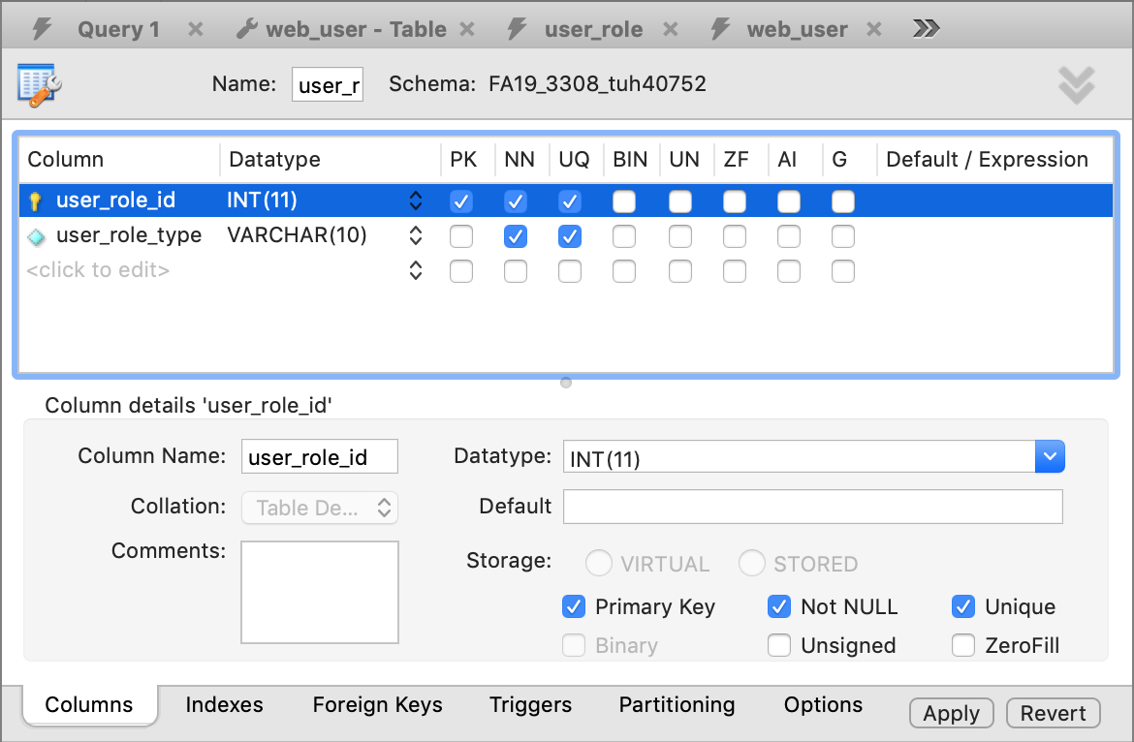

**Table Design web_user:**

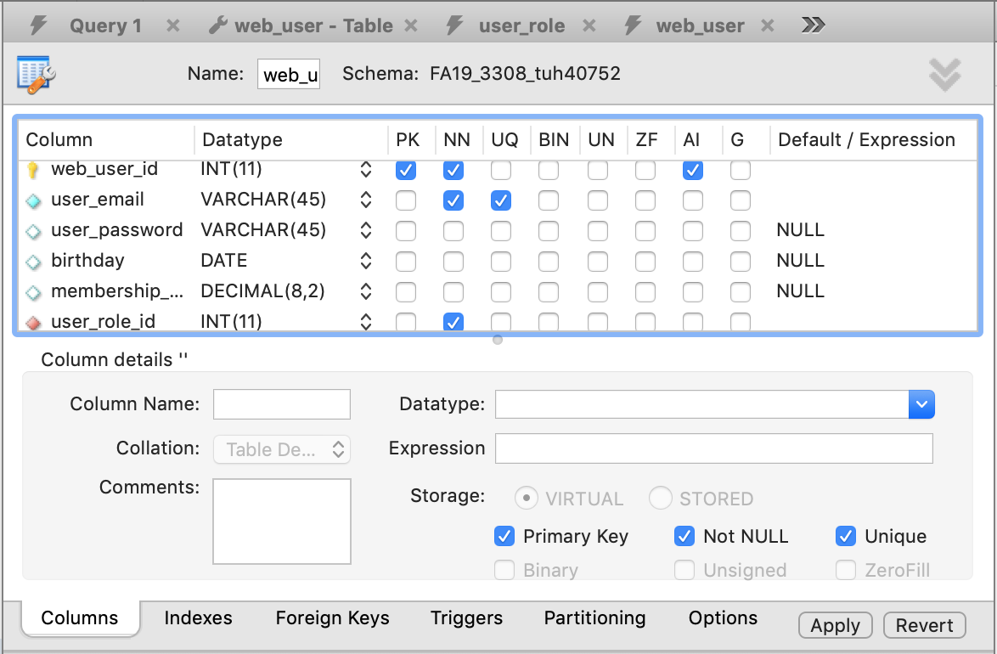

**Foreign Key web_user:**

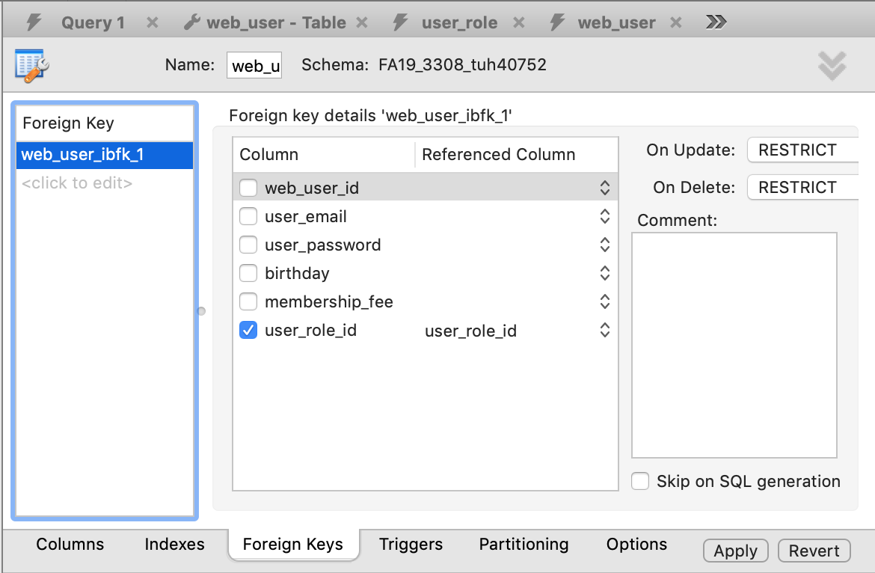

**Table Design ad_post (“other” table):**

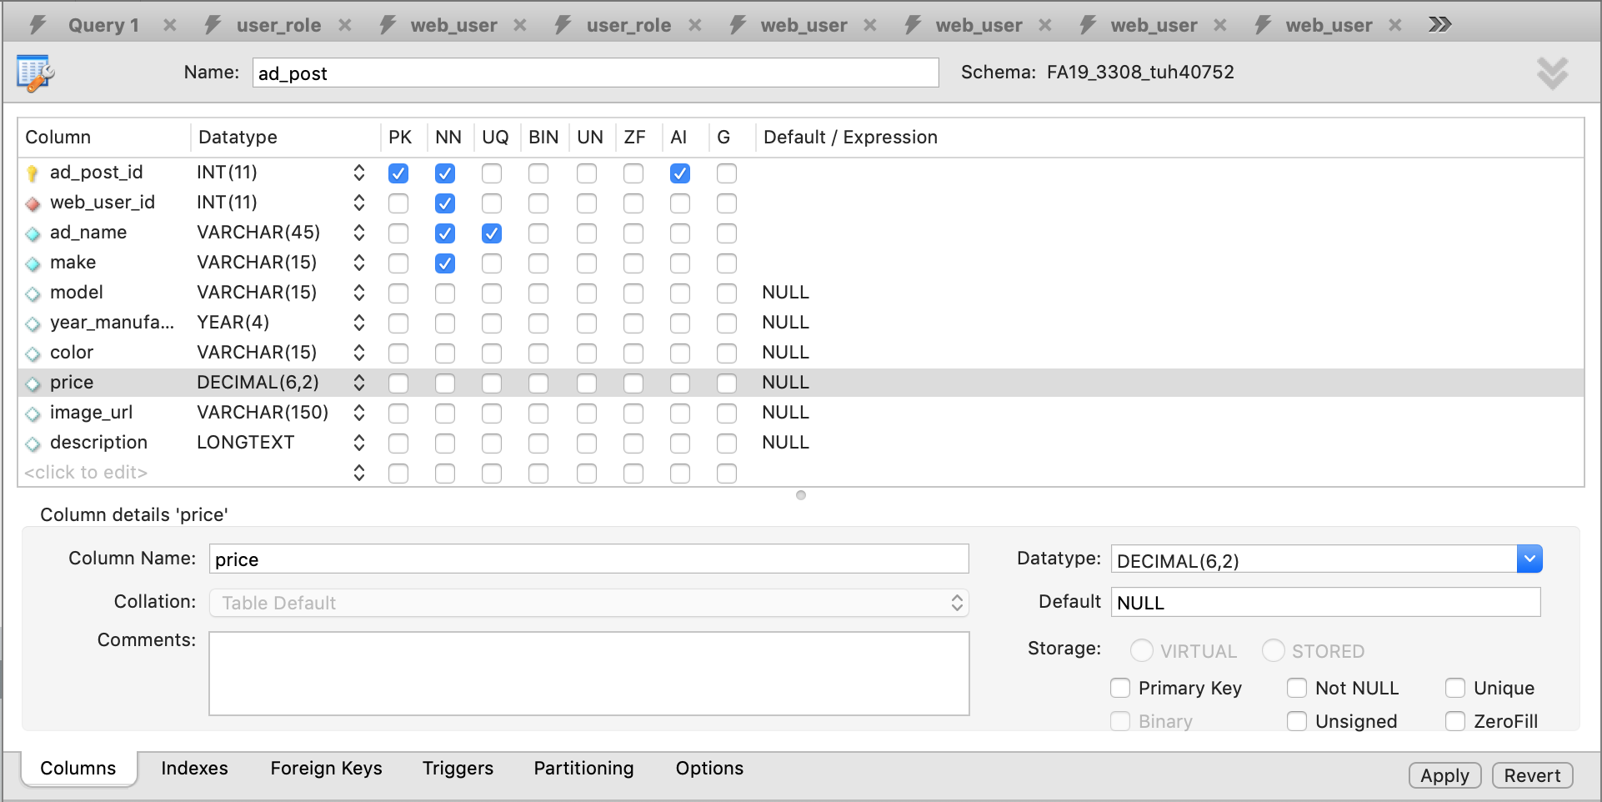

**Foreign Key ad_post (“other” table):**

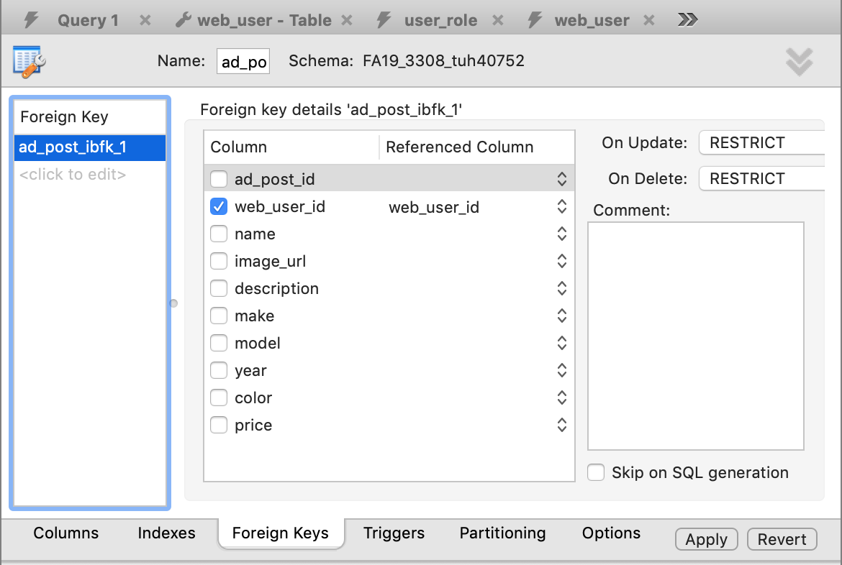

**c) SELECT statement ad_post ORDER BY**

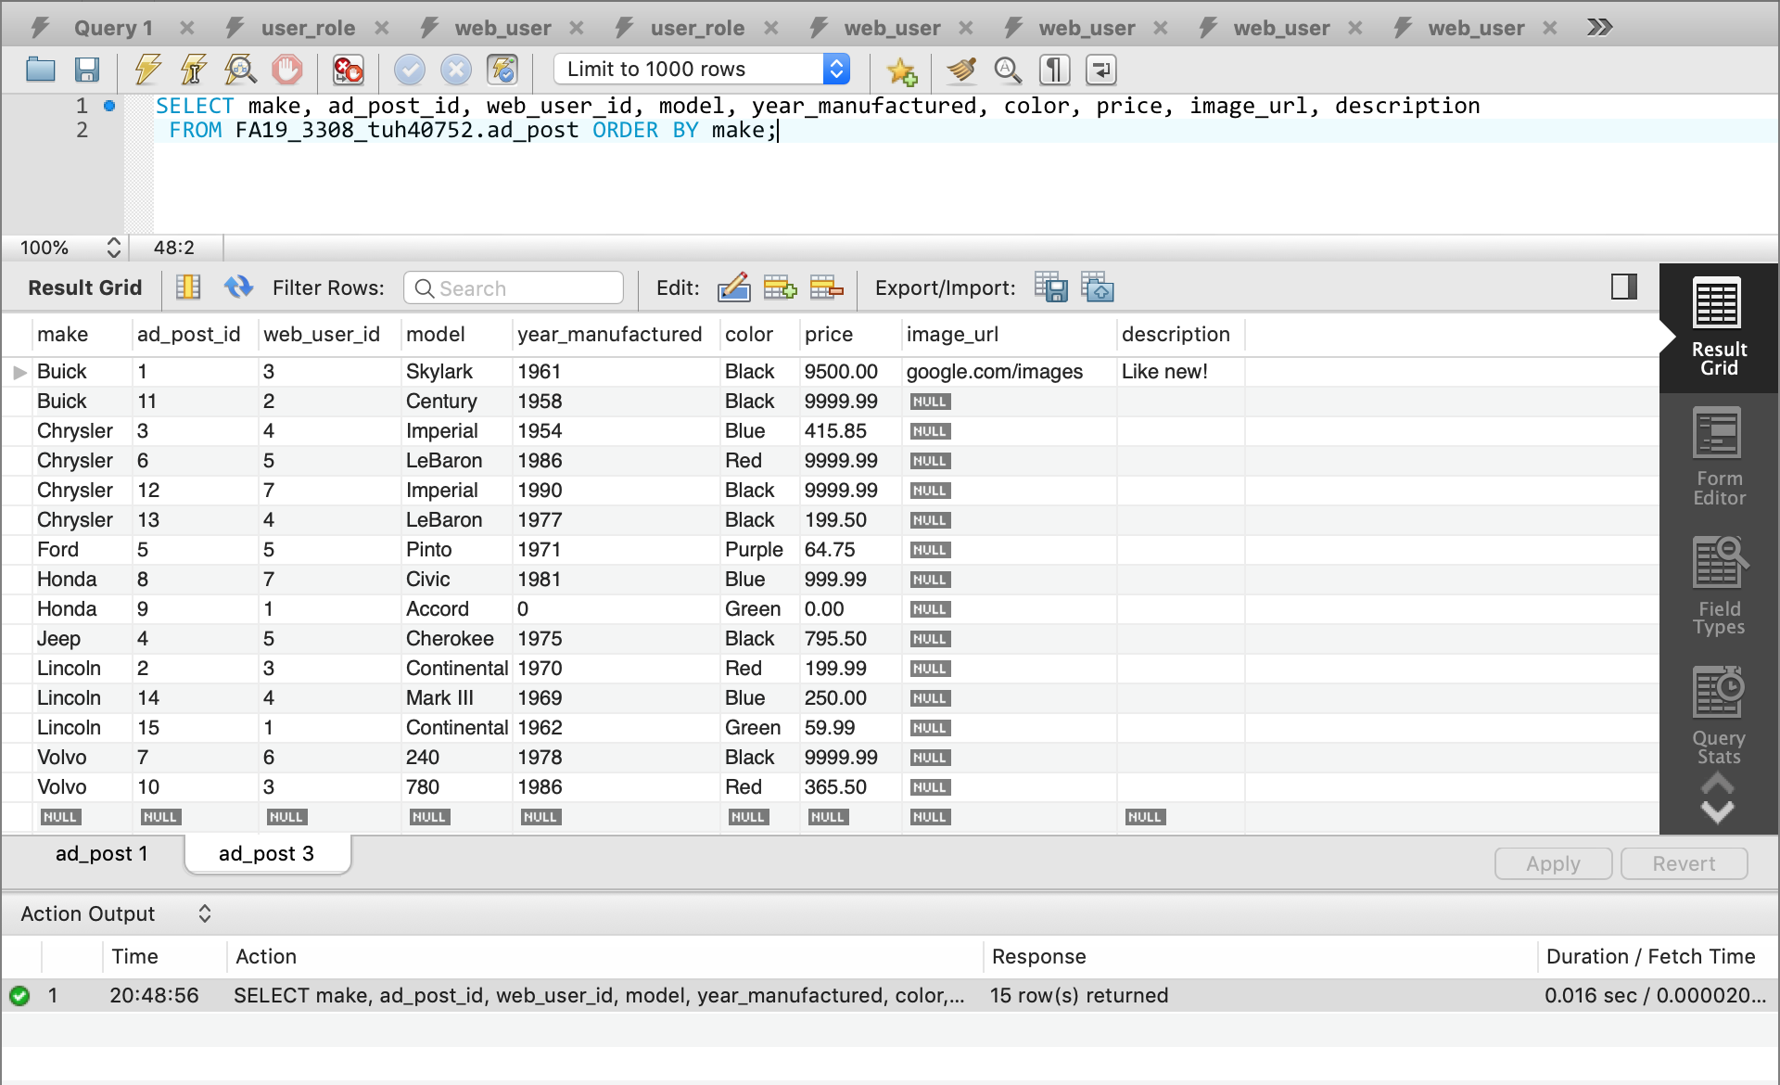

**SELECT statement ad_post WHERE**

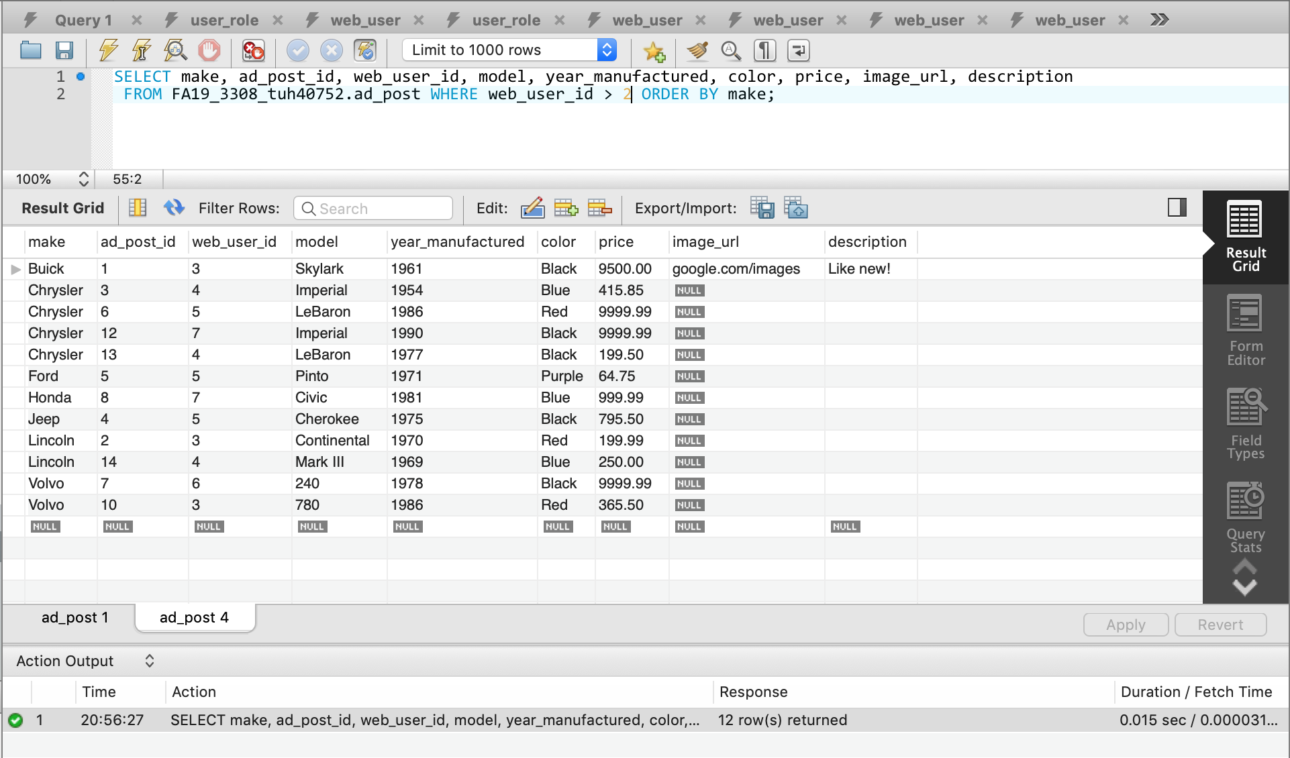

**Join web_user and user_role tables**

