class TcpOption

{

class data // data for send

{

ByteDataSendArray100 = new byte[100]; // Led location in decimal

private void InsertLocationLedBit(int LedLocation) // put location Led decimal in doc show

ByteDataSendArray100Clear( ) //clear all data ByteDataSendArray100

public StringBuilder DataShow( ) //show data now

}

calss AllResult // data result will be return

{

public String DataReceive; //show in string recive

public byte[] ByteDataReceive = new byte[2048]; //show in byte recive

public String DataSend; //show in string send

public byte[] ByteDataSend = new byte[2048]; //show in byte send

public string ErrorMessage= "null" ; //null is the initial status

public string SendErrorMessage = "success send"; //if error send happen will show at here

public string ReviceErrorMessage = "success recive"; //if error receive happen will show at here

public bool Result = true; //true = success false = failed

public Byte[] CRC = new byte[10]; //checksum

}

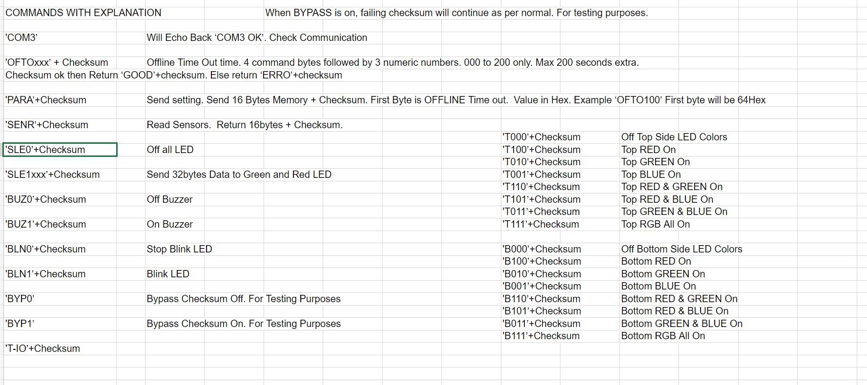 int action

|  |  |
| --- | --- |
| 0 | SLE1 |
| 1 | SLE0 |
| 2 | SENR |
| 3 | BLN1 |
| 4 | BLN0 |
| 5 | BUZ0 |
| 6 | BUZ1 |
| 7 | BYP0 |
| 8 | BYP1 |
| 9 | T000 |
| 10 | T001 |
| 11 | T010 |
| 12 | T011 |
| 13 | T100 |
| 14 | T101 |
| 15 | T110 |
| 16 | T111 |
| 17 | B000 |
| 18 | B001 |
| 19 | B010 |
| 20 | B011 |
| 21 | B100 |
| 22 | B101 |
| 23 | B110 |
| 24 | B111 |

}

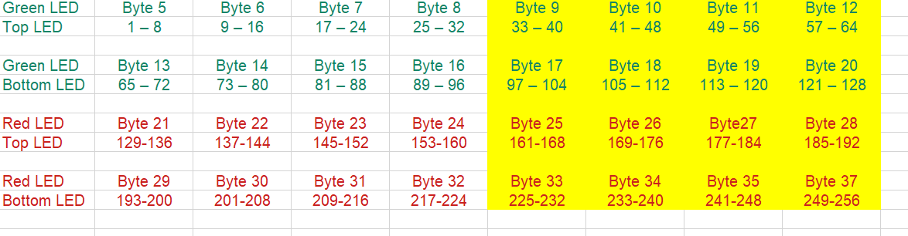for example u declare

Tcp.TcpOption t1 = new TcpOption(); // this is tcp u create

Tcp.TcpOption.AllResult Result; // this parameter for recive data return

t1.ConnectTcp("192.168.1.1" , "1"); //this function for connection(ip,port)

Console.WriteLine(t1.TCPResult.ErrorMessage + " == " + t1.TCPResult.Result); // this is check success or not will be return

t1.Action = int.Parse(textBox2.Text); //choose the action before send

t1.ByteLedQty100.InsertLocationLedBit(Convert.ToInt32(LedLocation.Text)); // inssert the Led location u wan follow doc

Result = t1.TCPSend(t1.ByteLedQty100.ByteDataSendArray100); // tcp send byte the checksum will be create automatic

Console.WriteLine("//Error Bool="+Result.Result +" //Error = " + Result.ErrorMessage + " send = " + Result.Result + " data Send = " + Result.DataSend + " DataResult = " + Result.DataReceive + " Data byte Receive= " + BitConverter.ToString(Result.ByteDataReceive)); show result

Thread.Sleep(100);