Ch 5 Food and human / Ch 12.1-2 Biomolecules

Organic有機 & Inorganic 無機
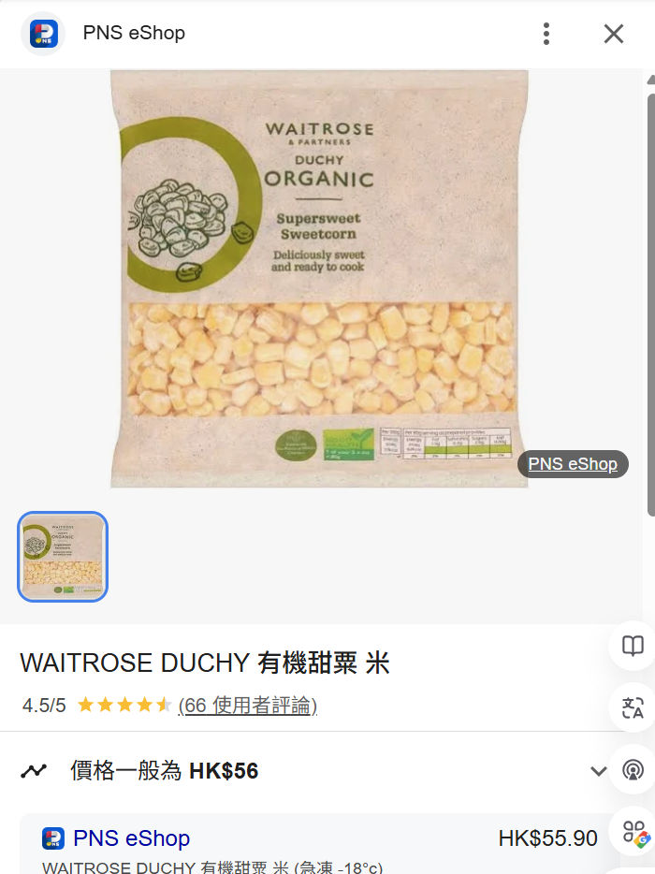
“organic products”
Food produced under the rules of organic farming有機農業,
e.g. without artificial fertilizers
Type | Definition | Examples
Organic有機Molecules | - Compounds with carbon, typically produced by living organisms.  - include C-C & C-H bonds. | - Carbohydrates碳水化合物,  - Lipids 脂質  - Proteins蛋白質,  - Nucleic Acids核酸 e.g. DNA  - Vitamins 維生素
Inorganic無機Molecules | - Doesn’t include C-C & C-H bonds | - Water H₂O  - Minerals礦物質  e.g. calcium鈣, iron鐵

Hydrolysis & Condensation
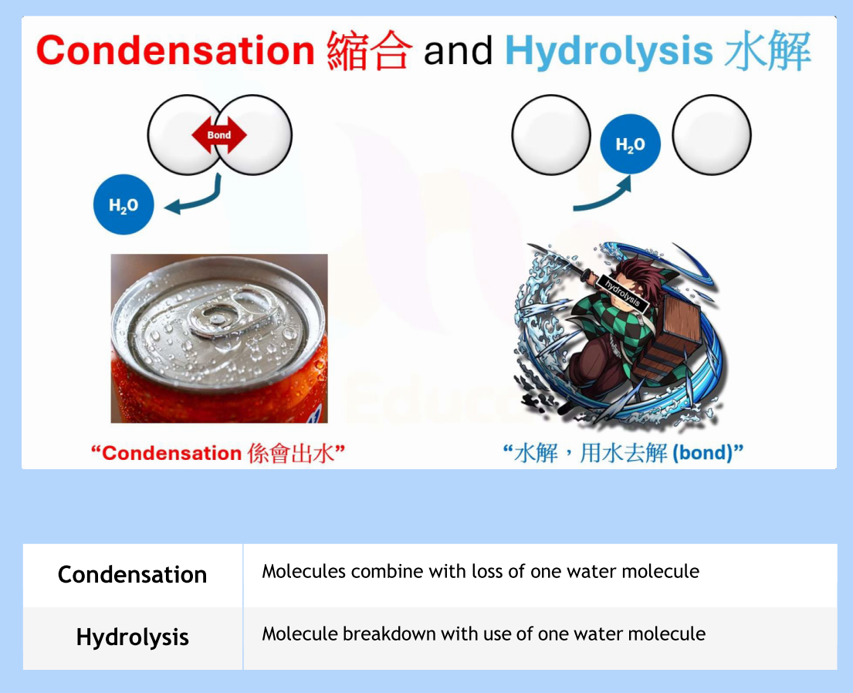
Scenario | Reaction | Water molecule
Two glucoses (葡萄糖) combine to form one maltose (麥芽糖)  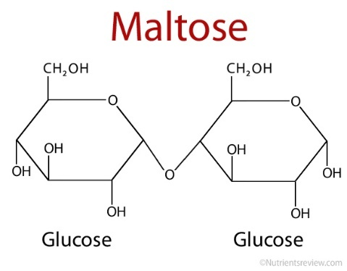 | Condensation / Hydrolysis | Gain / Loss
One maltose (麥芽糖) breaks down into two glucose molecules (葡萄糖) | Condensation / Hydrolysis | Gain / Loss
One glycerol (甘油) combines with three fatty acids (脂肪酸) to form a triglyceride (甘油三酯)  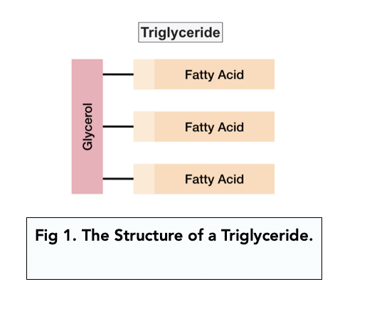 | Condensation / Hydrolysis | Gain / Loss
A triglyceride (甘油三酯) breaks down into one glycerol (甘油) and three fatty acids (脂肪酸) | Condensation / Hydrolysis | Gain / Loss
Amino acids (氨基酸) combine to form a dipeptide (二肽)  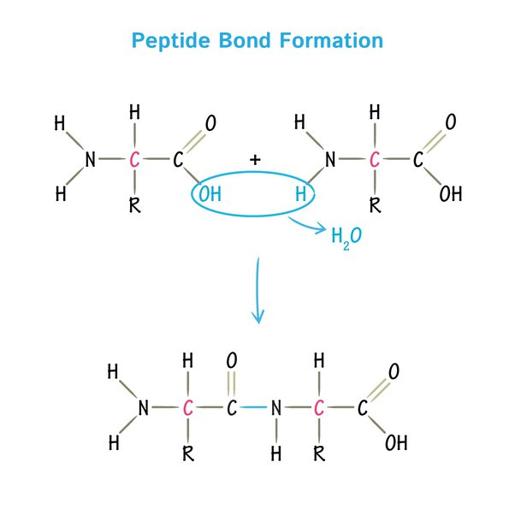 | Condensation / Hydrolysis | Gain / Loss
A dipeptide (二肽) breaks down into two amino acids (氨基酸) | Condensation / Hydrolysis | Gain / Loss
Starch (澱粉) breaks down into maltose (麥芽糖) molecules  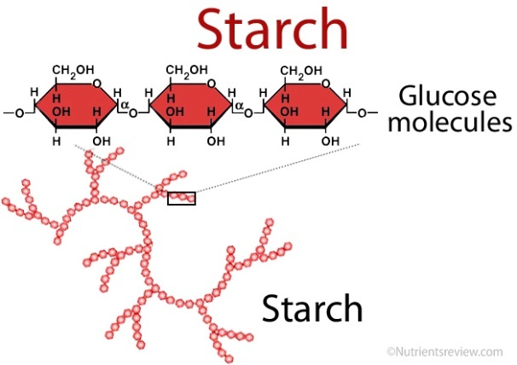 | Condensation / Hydrolysis | Gain / Loss
Cellulose (纖維素) breaks down into glucose (葡萄糖) molecules | Condensation / Hydrolysis | Gain / Loss
DNA nucleotides (核苷酸) combine to form a DNA strand (DNA鏈) | Condensation / Hydrolysis | Gain / Loss
A DNA strand (DNA鏈) breaks down into nucleotides (核苷酸) | Condensation / Hydrolysis | Gain / Loss
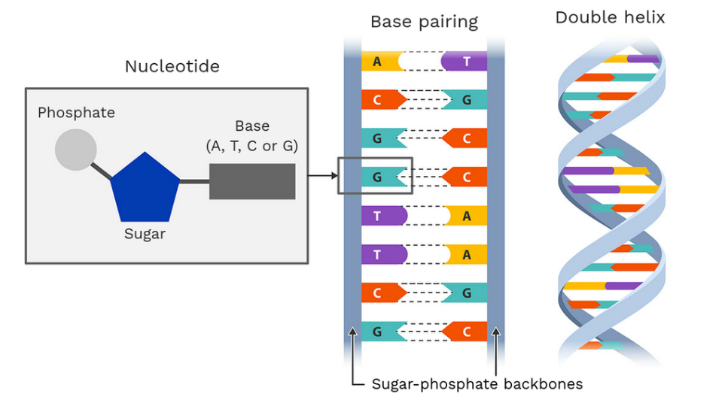
Carbohydrates碳水化合物
example: glucose葡萄糖 and maltose麥芽糖
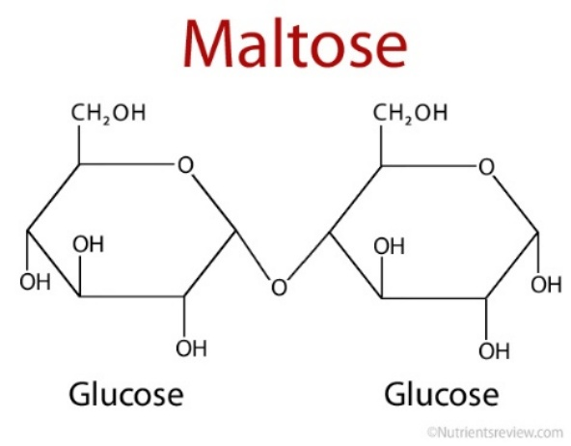
 | Reaction | Number of bonds鍵
Maltose breakdown | Condensation / Hydrolysis

Hydrolysis reaction:

Maltose麥芽糖 + ___ water -> glucose葡萄糖 + glucose 葡萄糖

Condensation reaction:

glucose葡萄糖 + glucose 葡萄糖 -> Maltose麥芽糖 + ___ water
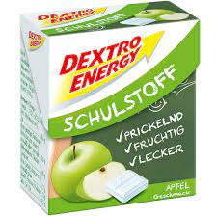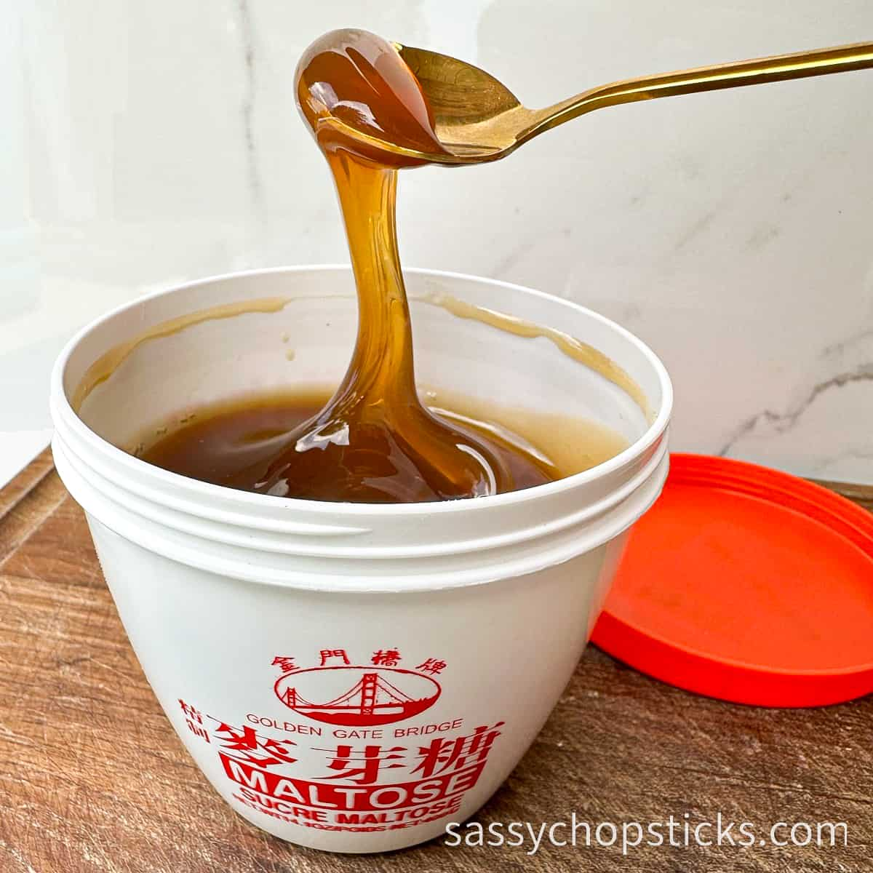
Lipids脂質
example: triglycerides三酸甘油酯 - fats脂肪and oils油
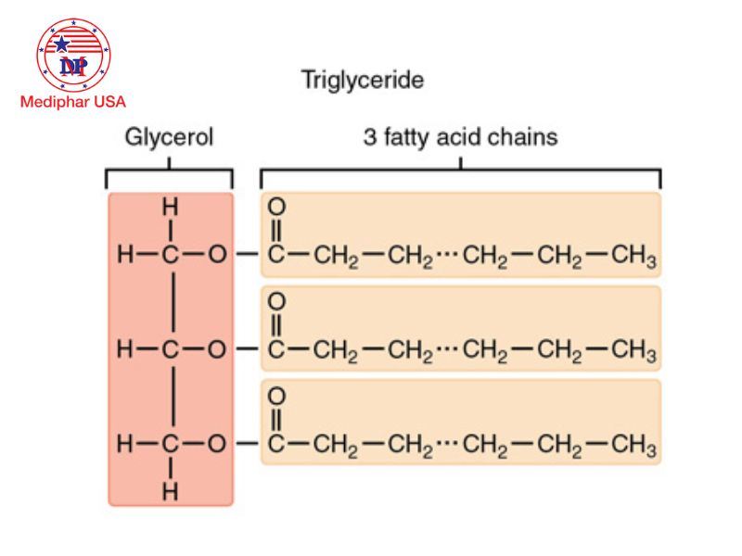
 | Reaction | Number of bonds鍵
Triglyceride breakdown | Condensation / Hydrolysis

Hydrolysis reaction:

Triglyceride甘油三酯 + __ water -> glycerol甘油 + 3 fatty acids脂肪酸

Condensation reaction:

Glycerol甘油 + 3 fatty acids脂肪酸 -> Triglyceride甘油三酯 + __ water
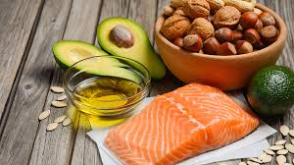
Proteins蛋白質
Amino acids 胺基酸 – 20 types (20 types of side chain側鏈)
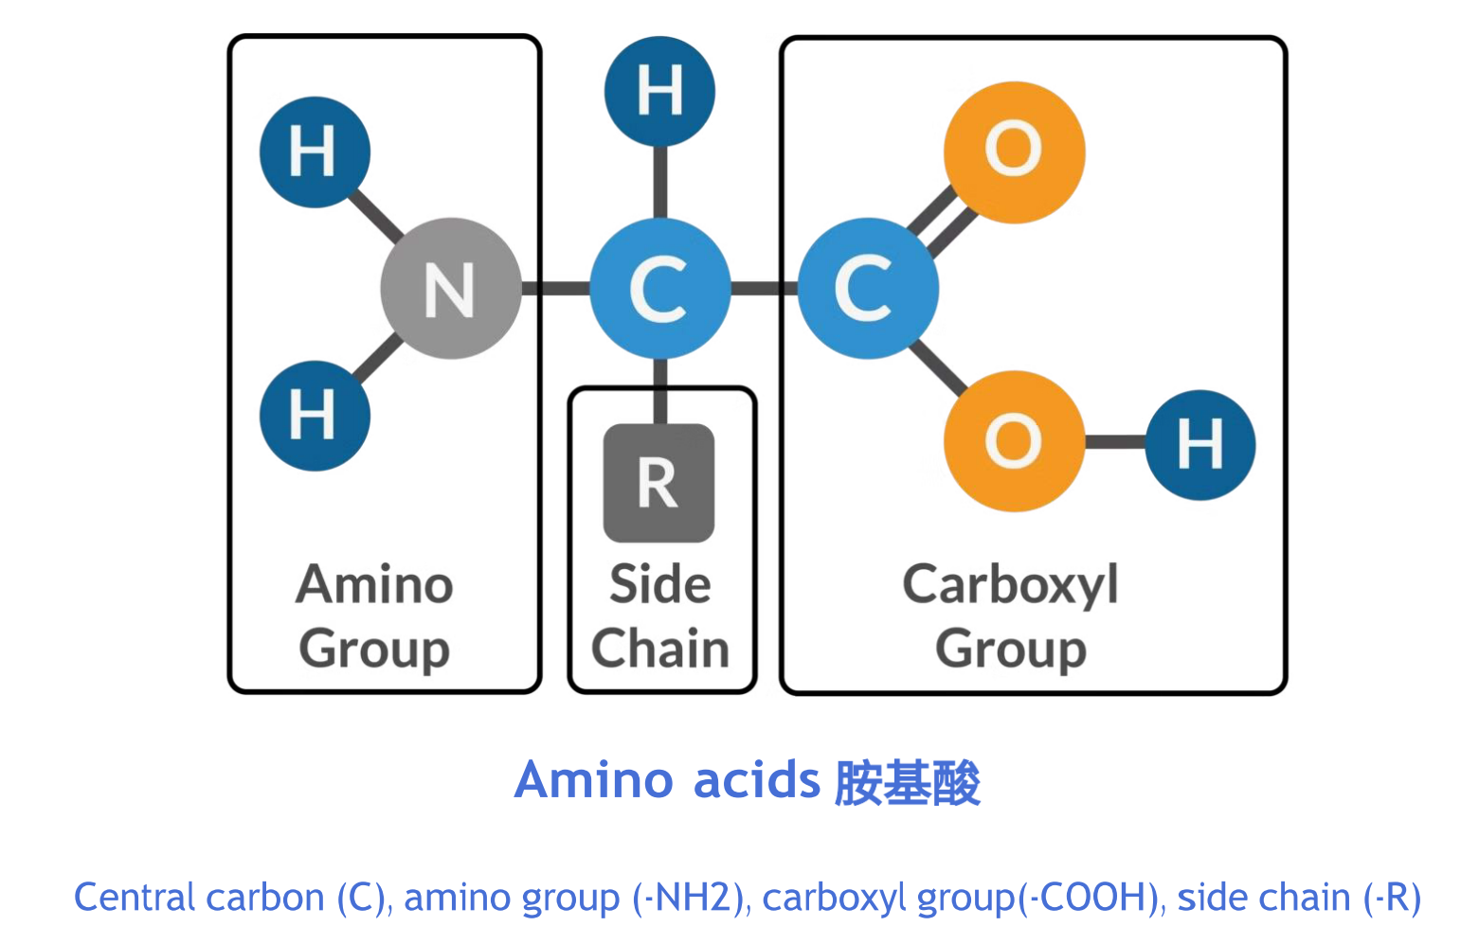

Dipeptide 二肽
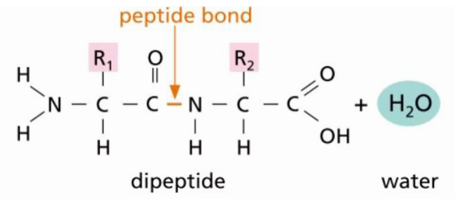

Polypeptide 多肽
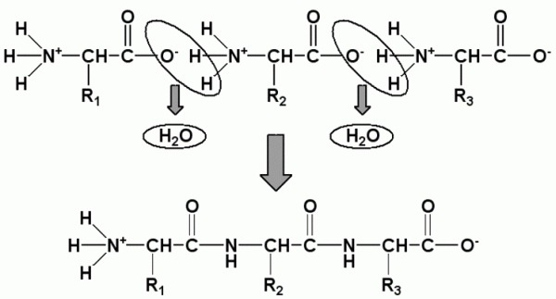
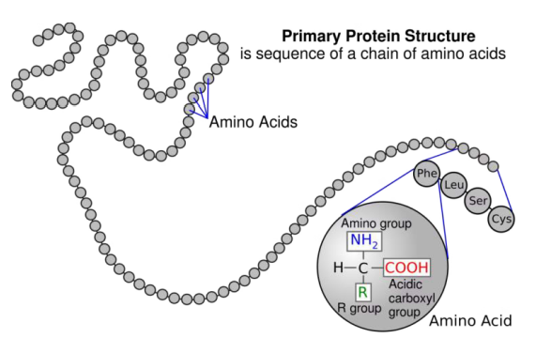

 | Reaction | Number of bonds鍵
2 amino acids胺基酸form  1 dipeptide二肽 | Condensation / Hydrolysis

Hydrolysis reaction:

Dipeptide + 1 water -> 2 amino acids

Condensation reaction:

2 amino acids -> Dipeptide + 1 water

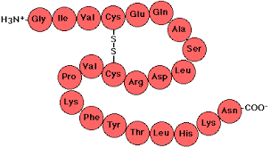

 | Reaction | Number of bonds鍵
Polypeptide多肽breakdown into 6 amino acids | Condensation / Hydrolysis
5 amino acids form polypeptide | Condensation / Hydrolysis
Polypeptide多肽breakdown into 22 amino acids | Condensation / Hydrolysis

Polypeptide fold 折疊into protein with 3D conformation 構象
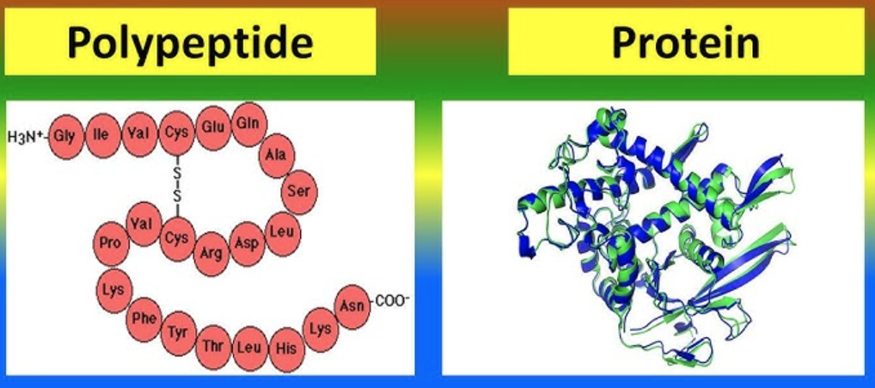

Polypeptide | ▶ | Protein
Formed by amino acid condensation | Folding  (Hydrogen bonds between amino acids) | Formed by one or more polypeptides
Linear線性 / chain |  | 3D conformation determined by amino acid sequence  胺基酸序列
Inactive |  | Specific獨特function
Denature 變性 is irreversible! 不可逆轉！ 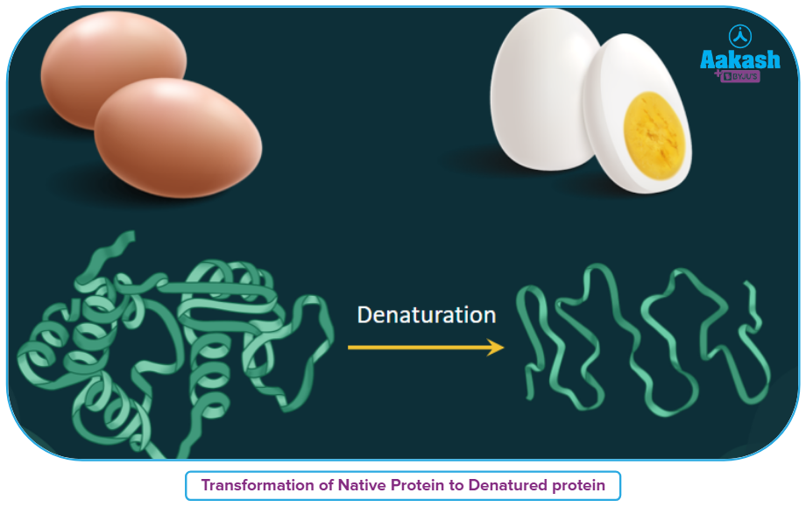
Denaturation 變性 common causes:
Non-optimal 非最優 pH, High temperature (boiling)
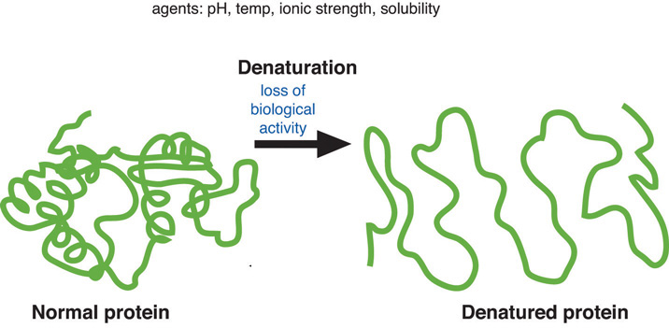

Denature = Loss of specific 3D conformation -> Loss of specific function

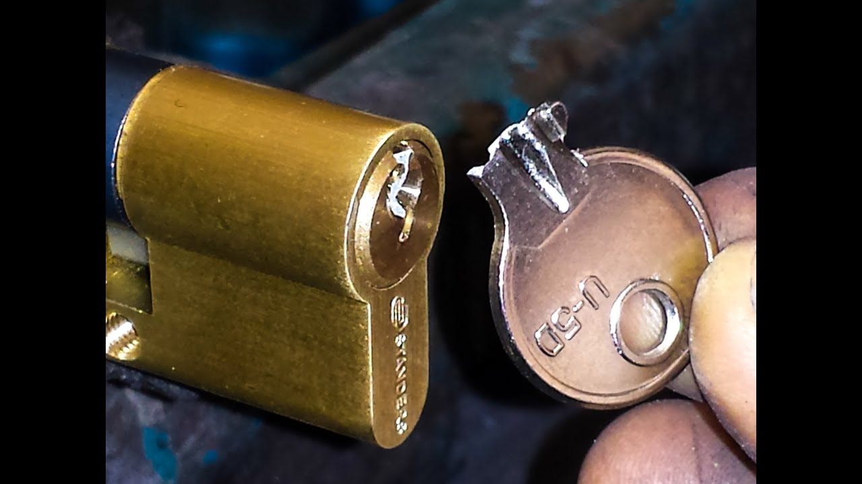
Concept checks
Multiple-Choice Questions (MCQs)
- Which of the following is an example of a carbohydrate?
A. Glucose
B. Glycerol
C. Amino acid
D. Triglyceride

- Which food is rich in lipids?
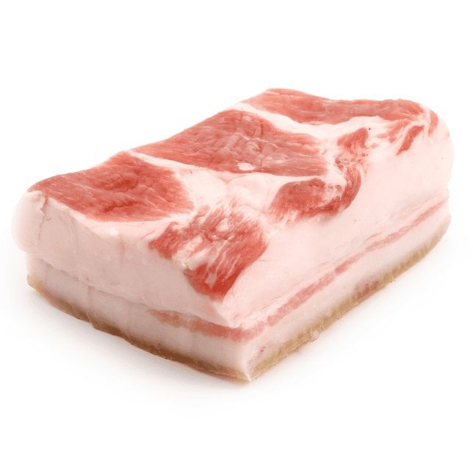
A. Rice
B. Butter
C. Fish
D. Eggs

- Which of the following processes breaks down a polypeptide into amino acids?
A. Condensation
B. Hydrolysis
C. Denaturation
D. Polymerization

- What is the product of condensation between two amino acids?
A. Polypeptide
B. Dipeptide
C. Glucose
D. Triglyceride

- Which of the following is a protein-rich food?
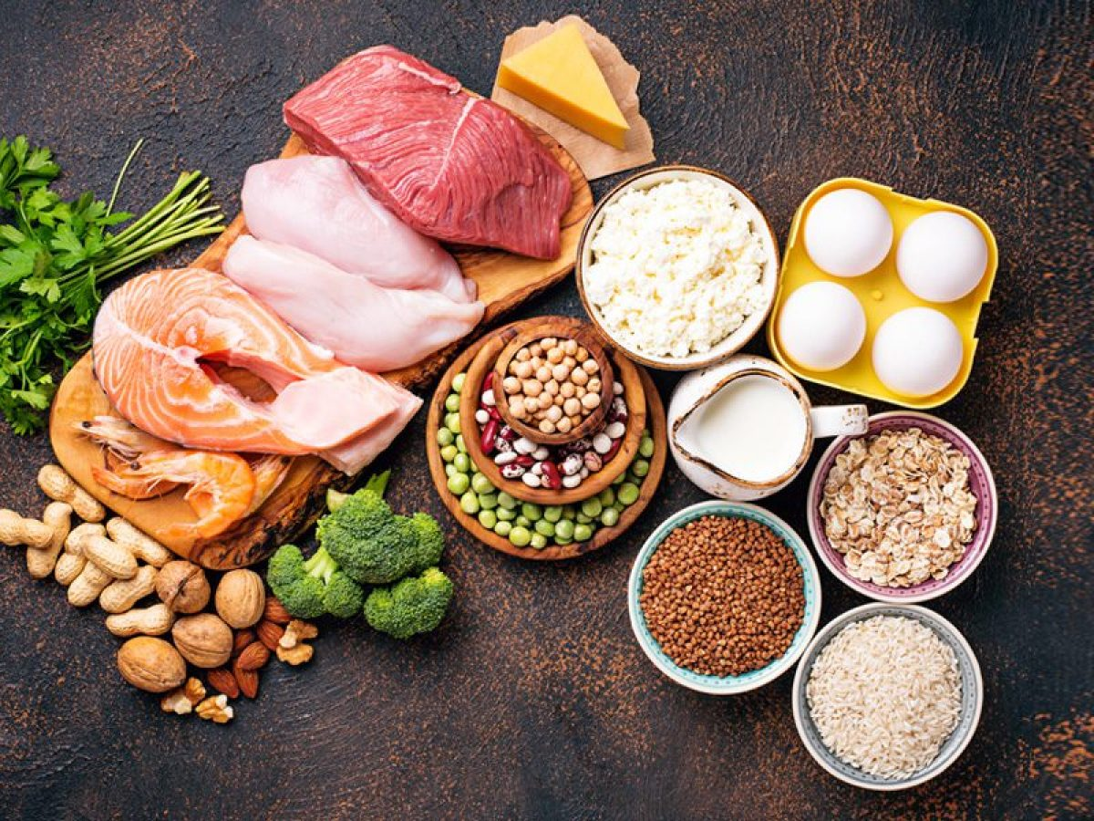
A. Bread
B. Cheese
C. Avocado
D. Honey
- What happens during denaturation of a protein?
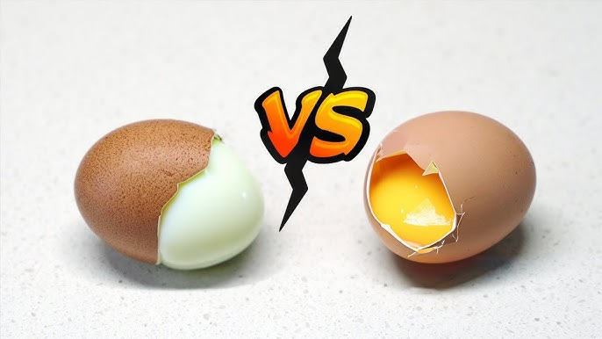
A. It gains 3D conformation.
B. It loses its specific shape and function.
C. It forms a dipeptide.
D. It undergoes hydrolysis.

- Which of the following is a lipid molecule?
A. Maltose
B. Polypeptide
C. Triglyceride
D. Amino acid

- What is the role of water in hydrolysis?
A. It creates bonds.
B. It breaks bonds.
C. It forms triglycerides.
D. It denatures proteins.
- Which of the following foods contains carbohydrates?
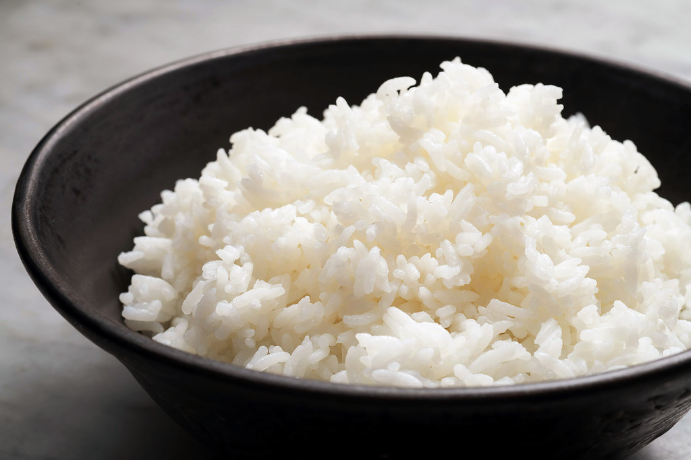
A. Butter
B. Rice
C. Chicken
D. Salmon

- Which reaction forms a triglyceride?
A. Hydrolysis
B. Condensation
C. Denaturation
D. Oxidation

- Which of the following is a characteristic of proteins?
A. They are made of amino acids.
B. Plant-based food commonly has more proteins than animal-based food.
C. They are needed in small amounts.
D. They are simple sugars.

- Which food is rich in carbohydrates?
A. Milk
B. Bread
C. Meat
D. Fish

- What molecule is formed between two glucose molecules by condensation?
A. Dipeptide
B. Protein
C. Starch
D. Maltose

- Which process breaks down a triglyceride into glycerol and fatty acids?
A. Condensation
B. Hydrolysis
C. Denaturation
D. Polymerization

- What happens to a protein when it is exposed to high temperatures?
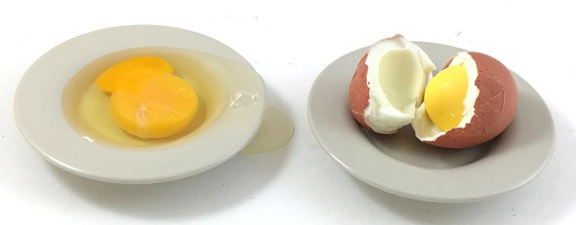
A. It forms a polypeptide.
B. It denatures.
C. It undergoes condensation.
D. It hydrolyzes.

- Which of the following is a protein?
A. Maltose
B. Polypeptide
C. Triglyceride
D. Glucose

- Which food is rich in protein?
A. Butter
B. Chicken
C. Potato
D. Rice

- Which of the following foods is rich in lipids?
A. Apple
B. Fish
C. Rice
D. Bread

- What is the main component of butter?
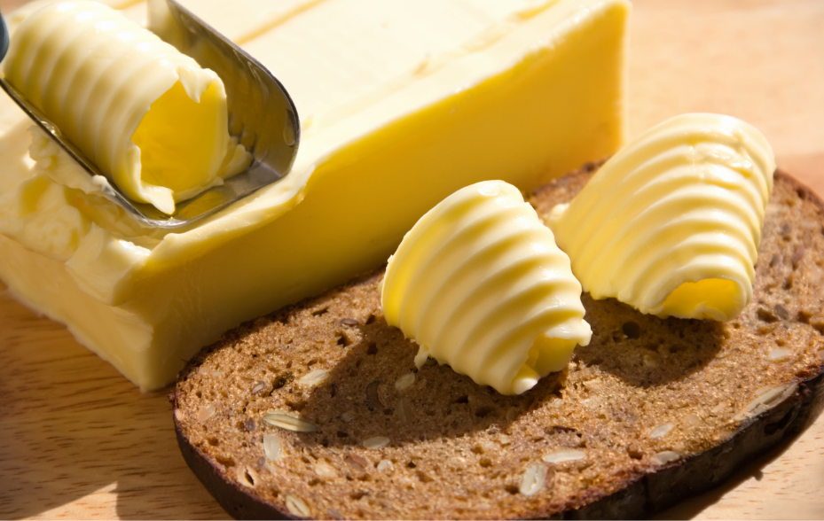
A. Protein
B. Carbohydrate
C. Lipid
D. Amino acid

- Which of the following is NOT an organic molecule?
A. Carbohydrate
B. Protein
C. Lipid
D. Water

- What is the smallest unit of a protein?
A. Glucose
B. Amino acid
C. Triglyceride
D. Polypeptide

- Which reaction produces water as a by-product?
A. Hydrolysis
B. Condensation
C. Denaturation
D. Oxidation

- What is the 3D structure of a protein called?
A. Polypeptide
B. Primary structure
C. 3D conformation
D. Dipeptide

- What is the stored form of carbohydrates in plants?
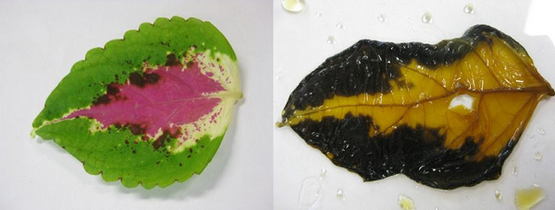
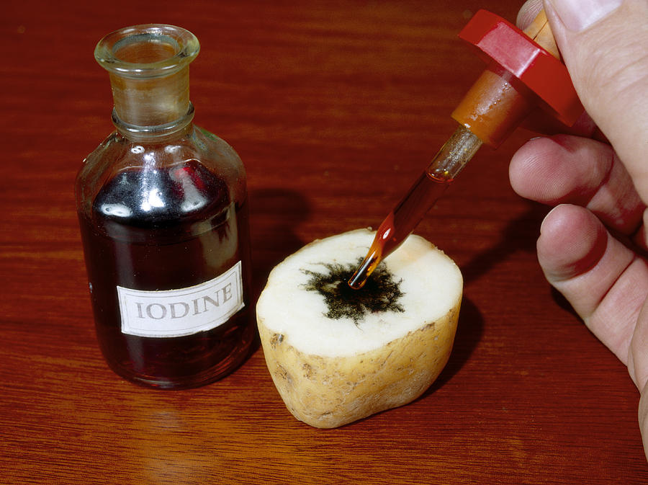
A. Starch
B. Glycogen
C. Triglyceride
D. Protein

- Which food is rich in carbohydrates?
A. Avocado
B. Bread
C. Salmon
D. Butter

- Which of the following is an organic biomolecule?
A. Protein
B. Water
C. Oxygen
D. Carbon dioxide

- What is the product of hydrolysis of a dipeptide?
A. Polypeptide
B. Amino acids
C. Lipids
D. Glucose

- Which of the following is a carbohydrate?
A. Triglyceride
B. Maltose
C. Polypeptide
D. Amino acid

- Which food is rich in proteins?
A. Chicken breast
B. Rice
C. Orange
D. Honey

- What happens to the function of a protein when it denatures?
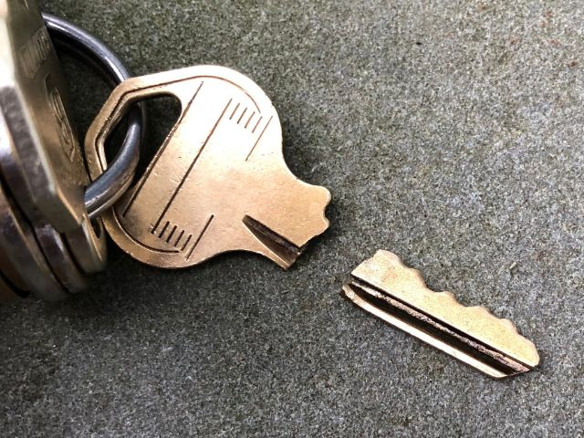
A. It becomes more efficient.
B. It loses its specific function.
C. It forms amino acids.
D. It produces glucose.

True or False
Direction: put a “✔” is the sentence is correct and put a “✘” on the phrase or words that are wrong.

- Hydrolysis breaks bonds in molecules.
- Denaturation is a reversible process.
- Proteins are made of amino acids.
- Lipids are hydrophilic molecules.
- Triglycerides are formed by condensation reactions.
- Carbohydrates provide energy for the body.
- Proteins are usually absent in the human body.
- Butter is rich in carbohydrates.
- Hydrolysis requires water to break bonds.
- Lipids are used to form cell membranes.
- Condensation produces water as a by-product.
- Amino acids are the building blocks of proteins.
- Starch is a form of stored glucose in plants.
- Triglycerides are broken down into glycerol and fatty acids.
- Proteins are inactive when denatured.

Fill in the Blanks
Choose from the following:
☐ condensation ☐ hydrolysis ☐ carbohydrates ☐ proteins ☐ lipids
☐ amino acid ☐ denature ☐ triglyceride ☐ polypeptide ☐ 3D conformation

- ________ is the process that breaks down a molecule using water.
- ________ reactions join smaller molecules to form larger ones.
- ________ are the main energy source for the body.
- ________ are made up of amino acids.
- A ________ is formed by three fatty acids and glycerol.
- A ________ is a chain of amino acids.
- Proteins lose their ________ when they denature.
- ________ is the building block of proteins.
- ________ are insoluble in water and used for energy storage.
- A protein’s specific function depends on its ________.
- ________ reactions are required to break down triglycerides.
- ________ is the process that forms a dipeptide from two amino acids.
- ________ are organic molecules that include sugars and starches.
- ________ refers to the loss of a protein’s functional shape.
- ________ are used to build tissues and enzymes in the body.
Further details on carbohydrates, lipids and proteins
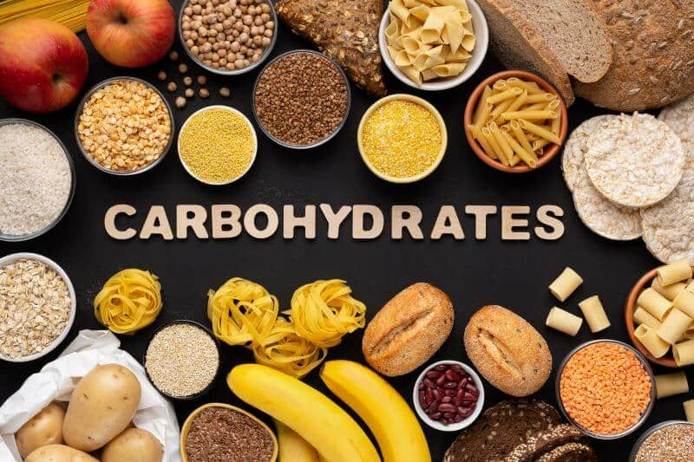
Carbohydrates
 | Names | Functions | Found in
Monosaccharides 單醣 | Glucose 葡萄糖 | Main respiratory呼吸作用 fuel for quick energy | Candy
 | Fructose 果糖 | Sweetener甜味劑 | Fruit
 | Galactose 半乳糖 | Component of lactose乳糖 | Milk
Disaccharides  雙醣 | Maltose 麥芽糖 | Provides energy (提供能量) | Malt麥芽
 | Sucrose 蔗糖 | Sweetener甜味劑 | Sugarcane蔗, fruits
 | Lactose 乳糖 | Sugar in milk | Milk
Polysaccharides 多醣 | Starch 澱粉 | Energy storage in plants | Potato,  grains穀物
 | Cellulose 纖維素 | Structural component in plant cell wall細胞壁 | Vegetables
 | Glycogen 肝醣 | Energy storage in animals | Liver 肝and muscles
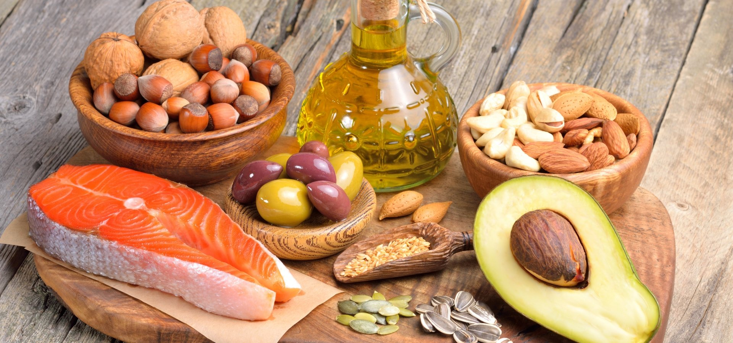
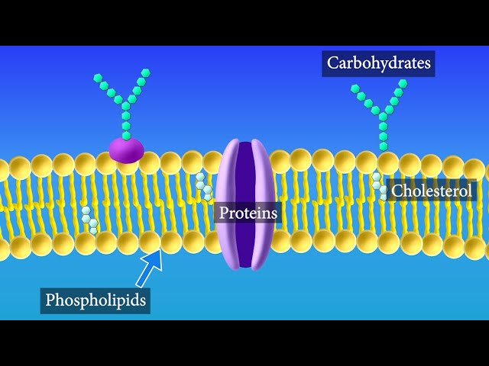
Lipids
Names |  | Functions | Found in
Triglycerides  三酸甘油酯 | Glycerol 甘油+  3 fatty acids脂肪酸 | Energy storage能量儲存, insulation保溫, organ protection器官保護 | Fats脂肪 and oils 油
Phospholipids 磷脂質 | Phosphate 磷+  Glycerol 甘油+  2 fatty acids脂肪酸 | Main component of  cell membranes 細胞膜 | Cell membrane
Steroids  類固醇 | e.g. Cholesterol  膽固醇 | Sex hormones性荷爾蒙  cell membranes | Body tissues

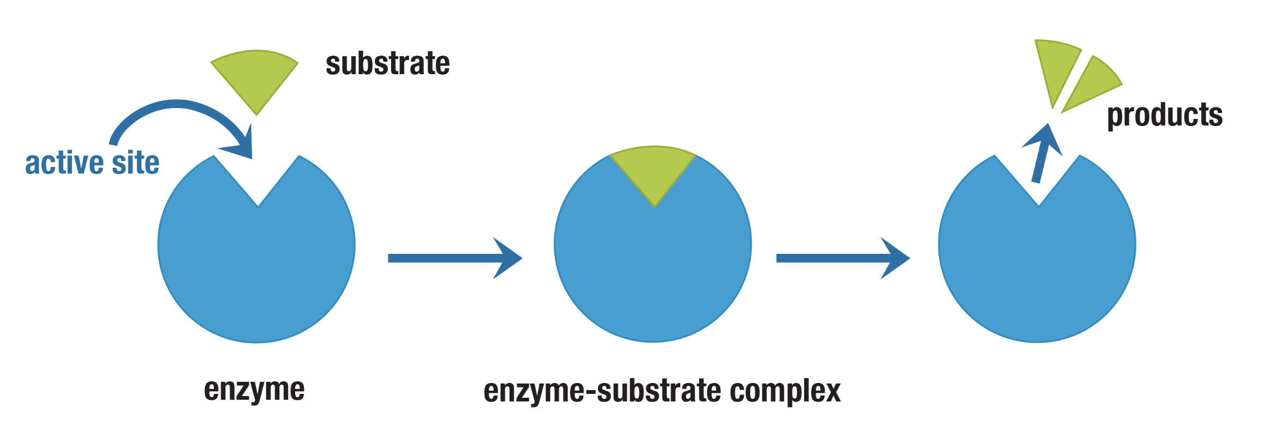
Protein
Names | Functions | Found in
Amino acids 胺基酸 | 20 types, basic building blocks of proteins | All cells
Dipeptide二肽 | 2 amino acids
Polypeptide 多肽  (Linear /chain) | Many amino acids
Protein  蛋白質  (specific 3D conformation) | - Growth and repair修復 of tissues組織  - Cell membranes  - Enzymes 酶: Speed up reactions  - Most hormones 荷爾蒙 (in blood):  Regulate body functions | Meat, eggs, beans
Concept checks
Multiple-Choice Questions (MCQs)
- Which of the following is a monosaccharide?
A. Starch
B. Glucose
C. Lactose
D. Sucrose

- Which of the following is stored in the liver and muscles as an energy reserve?
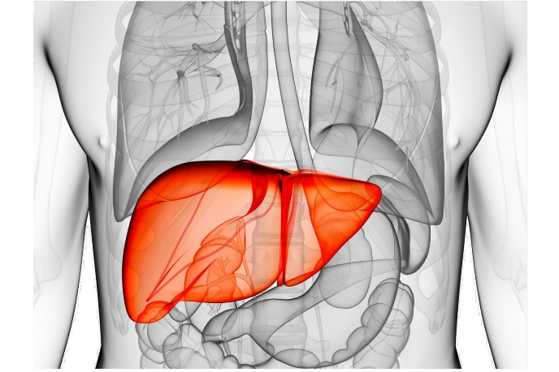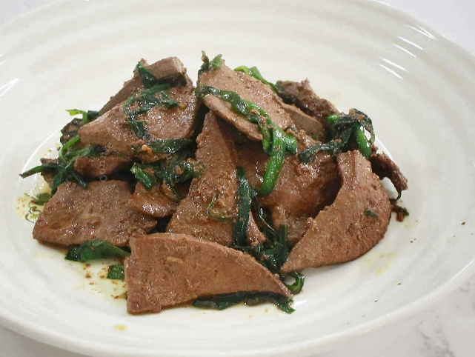

A. Cellulose
B. Glycogen
C. Starch
D. Fructose

- Which type of biomolecule is the main component of cell membranes?
A. Proteins
B. Lipids
C. Carbohydrates
D. Nucleic acids
- What is the main function of proteins in the human body?
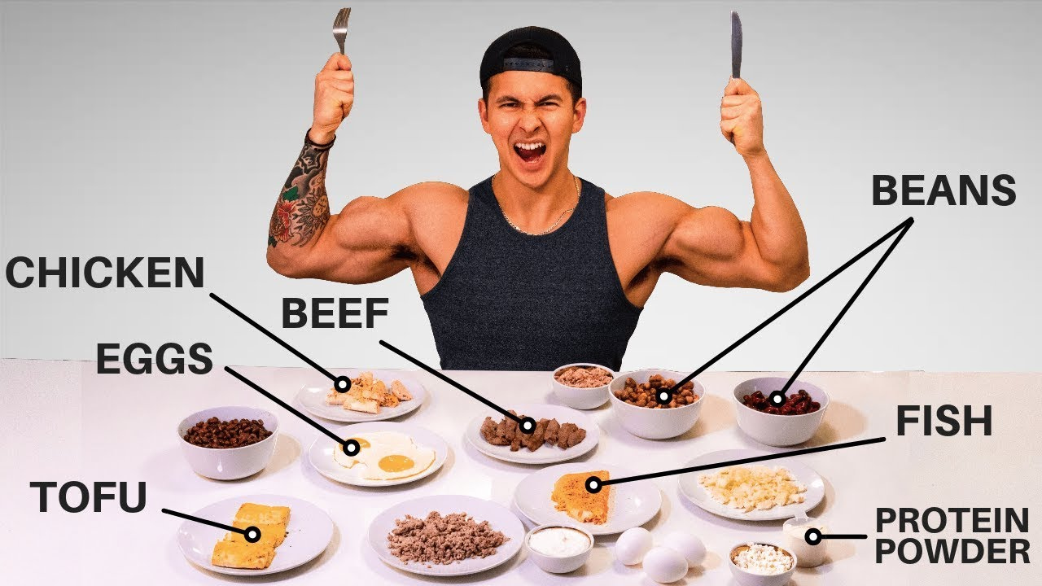
A. Energy storage
B. Growth and repair of tissues
C. Insulation
D. Hormone regulation

- Which of the following is a disaccharide?
A. Glucose
B. Maltose
C. Cellulose
D. Glycogen

- Why should a diabetic patient糖尿病患者 avoid consuming glucose directly?
A. It causes dehydration.
B. It raises blood sugar levels rapidly.
C. It is difficult to digest.
D. It damages the liver.
- Which biomolecule is primarily used for quick energy in the body?
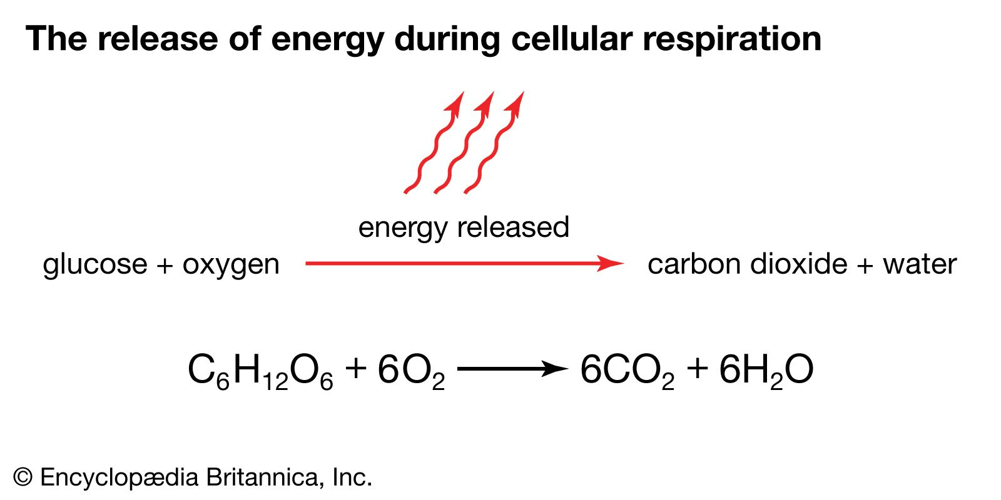
A. Proteins
B. Lipids
C. Carbohydrates
D. Steroids

- Which of the following is a structural component in plant cell walls?
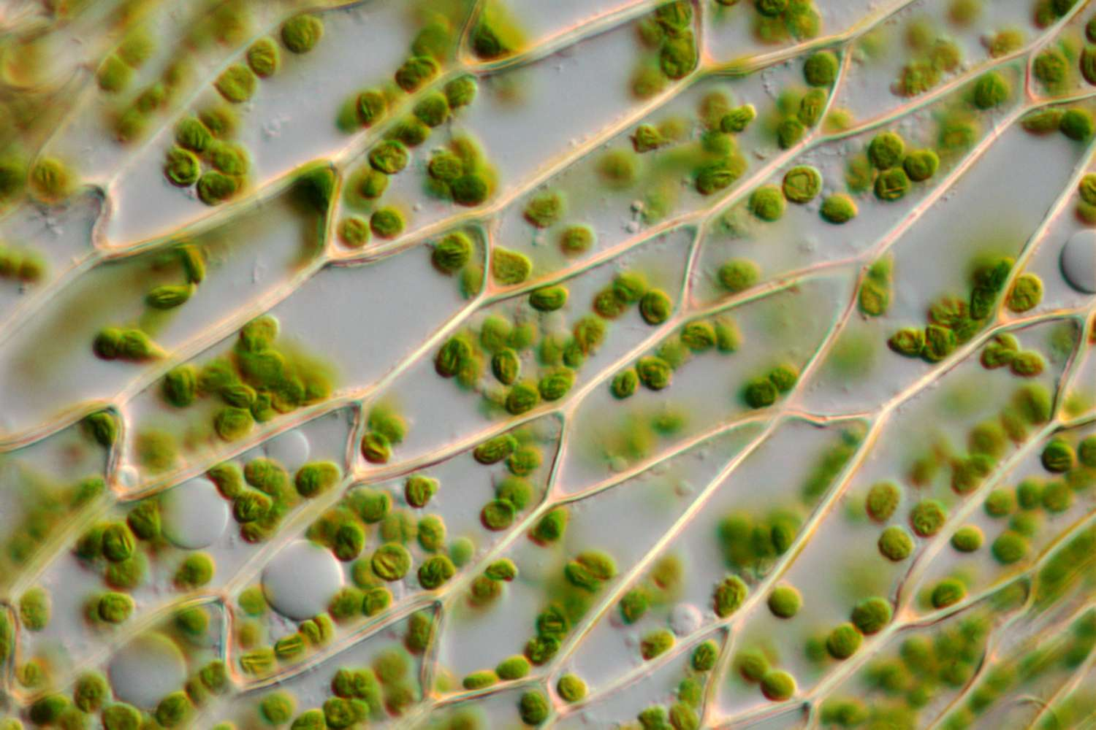
A. Glycogen
B. Cellulose
C. Starch
D. Fructose
- What happens if a starving 飢餓patient consumes glucose instead of bread?

A. Glucose is digested more slowly.
B. Glucose provides immediate energy.
C. Bread causes dehydration.
D. Bread is absorbed faster.

- Which of the following lipids is essential for cell membrane structure?
A. Triglycerides
B. Phospholipids
C. Steroids
D. Fatty acids

- Which carbohydrate is a sweetener found in fruits?
A. Glucose
B. Fructose
C. Sucrose
D. Maltose
- What is the stored form of energy in animals?
A. Starch
B. Cellulose
C. Glycogen
D. Glucose

- Which of the following speeds up reactions in the human body?
A. Triglycerides
B. Glucose
C. Hormones
D. Enzymes

- What is the main energy source for respiration in humans?
A. Proteins
B. Glucose
C. Lipids
D. Vitamins

- Which of the following is NOT a function of proteins?
A. Growth and repair
B. Enzyme production
C. Energy storage
D. Hormone regulation

- Which part of the body stores glycogen?
A. Brain
B. Liver and muscles
C. Heart
D. Kidneys

- Which of the following is a lipid that regulates body functions as a hormone?
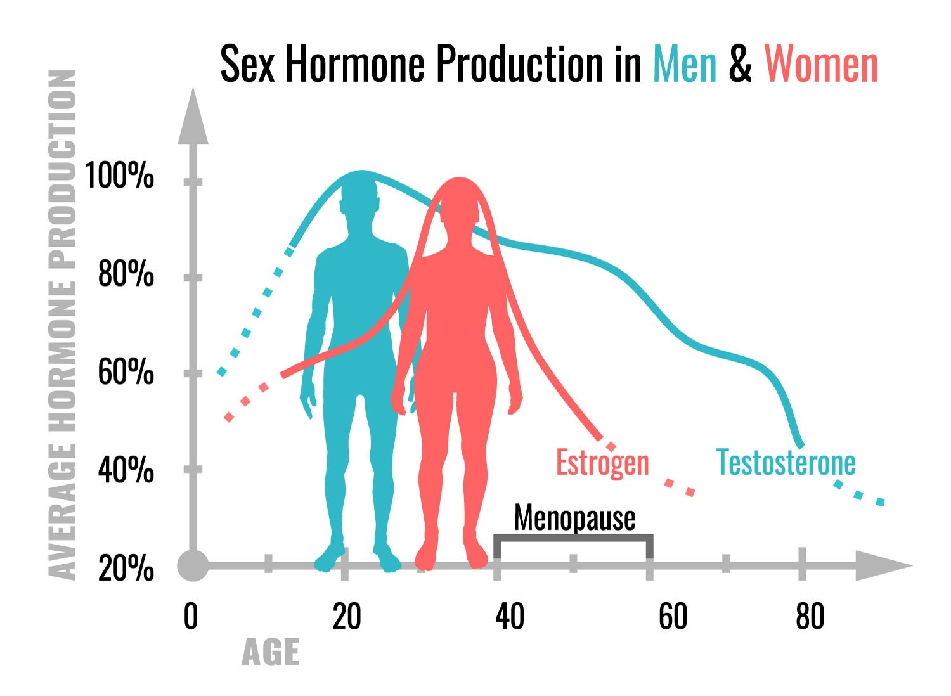
A. Cholesterol
B. Glycerol
C. Phospholipid
D. Triglyceride

- Which carbohydrate is used as a respiratory substrate in humans?
A. Lactose
B. Starch
C. Glucose
D. Cellulose

- Why is milk a good source of energy for infants?
A. It contains proteins only.
B. It contains lactose, a disaccharide.
C. It contains starch.
D. It contains cellulose.

- Why do athletes consume food rich in starch before a match?

A. To build muscle mass.
B. To store energy for long-term use.
C. To provide glucose steadily for energy during the race.
D. To repair tissues.
True or False
Direction: put a “✔” is the sentence is correct and put a “✘” on the phrase or words that are wrong.

- Glucose is a monosaccharide.
- Proteins are used for energy storage in the body.
- Cellulose is found in the cell walls of plants.
- Glycogen is stored in the liver and muscles.
- Lipids are the main source of quick energy in humans.
- Enzymes are proteins that speed up chemical reactions.
- Fructose is a disaccharide found in fruits.
- Starch is a storage carbohydrate in plants.
- Phospholipids are the main components of cell membranes.
- Proteins are required for growth and repair in humans.
- Steroids are a type of lipid that acts as a hormone.
- Maltose is a monosaccharide.
- Glycogen is the stored form of glucose in plants.
- Non-green parts of plants, like potatoes, store starch.
- Lactose is a carbohydrate found in milk.

Fill in the Blanks
Choose from the following:
☐ glycogen ☐ starch ☐ glucose ☐ enzymes ☐ proteins ☐ fructose ☐ lactose
☐ triglycerides ☐ phospholipids ☐ cellulose
The main carbohydrate stored in animals is ________.
- ________ is the carbohydrate stored in plant cell walls.
- Milk contains ________, a disaccharide.
- ________ are used to speed up chemical reactions in the body.
- The stored form of glucose in plants is ________.
- ________ is a monosaccharide that provides quick energy.
- The main lipid component of cell membranes is ________.
- ________ is a carbohydrate found in fruits.
- Proteins are essential for ________ and repair of tissues.
- ________ is a lipid used for energy storage and insulation.
- ________ is a carbohydrate used by athletes for quick energy.
- ________ is the storage carbohydrate in the liver and muscles.
- ________ is the carbohydrate found in milk.
- ________ are the building blocks of proteins.
- ________ is the structural carbohydrate found in plant cell walls.

Answer Key
Concept check – basics of carbohydrates, proteins and lipids
MCQs:
- A 2. B 3. B 4. B 5. B 6. B 7. C 8. B 9. B 10. B
- A 12. B 13. D 14. B 15. B 16. B 17. B 18. B 19. C 20. D
- B 22. B 23. C 24. A 25. B 26. A 27. B 28. B 29. A 30. B
True/False:
- ✔ 2. ✘ (Denaturation is irreversible) 3. ✔ 4. ✘ (Lipids are hydrophobic)
- ✔ 6. ✔ 7. ✘ 8. ✘ (Butter is rich in lipids)
- ✔ 10. ✔ 11. ✔ 12. ✔ 13. ✔ 14. ✔ 15. ✔
Fill in the Blanks:
- Hydrolysis
- Condensation
- Carbohydrates
- Proteins
- Triglyceride
- Polypeptide
- 3D conformation
- Amino acid
- Lipids
- 3D conformation
- Hydrolysis
- Condensation
- Carbohydrates
- Denature
- Proteins

Concept check – Functions and names of carbohydrates, proteins and lipids
MCQs
- B 2. B 3. B 4. B 5. B
- B 7. C 8. B 9. B 10. B
- B 12. C 13. D 14. B 15. C
- B 17. A 18. C 19. B 20. C
True/False
- ✔ 2. ✘ (Respiration occurs all the time.)
- ✔ 4. ✔ 5. ✔
- ✔ 7. ✘ (Fructose is a monosaccharide.)
- ✔ 9. ✔ 10. ✔
- ✔ 12. ✘ (Maltose is a disaccharide.)
- ✘ (Glycogen is stored in animals.)
- ✔ 15. ✔
Fill in the Blanks
- Glycogen
- Cellulose
- Lactose
- Enzymes
- Starch
- Glucose
- Phospholipids
- Fructose
- Growth
- Triglycerides
- Glucose
- Glycogen
- Lactose
- Proteins
- Cellulose

