JUNIOR MATHS

Answer

Ch 23 (A): AREAS AND VOLUMES II

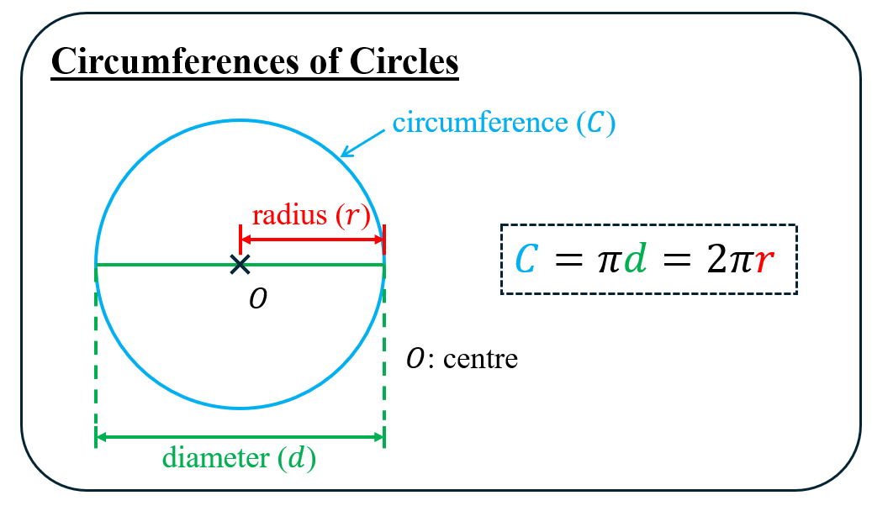

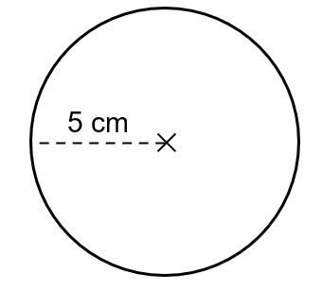
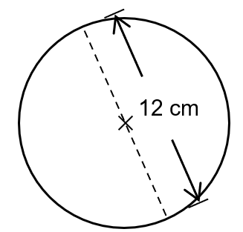
1. Find the circumferences of the following circles.
(Give your answers correct to 3 significant figures.)
(a) (b)

c

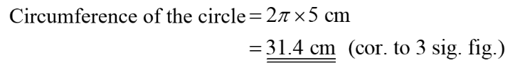
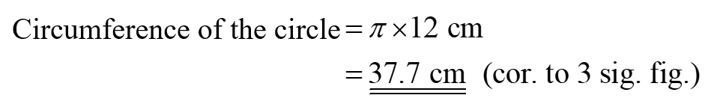

2. Find the radius of a circle with circumference 14$π$ cm.

c

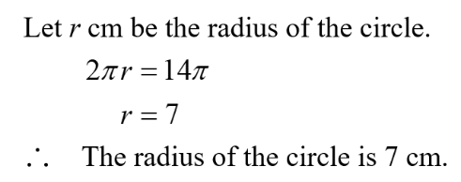

3. Find the diameter of a circle with circumference 49 cm.
(Give your answer correct to 3 significant figures.)

c

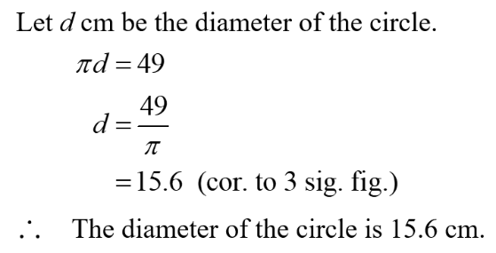

4. Complete the following table. (Give your answers in terms of $π$ if necessary.)
Radius | Diameter | Circumference
6 mm
 | 11 cm
 |  | 58$π$m

c

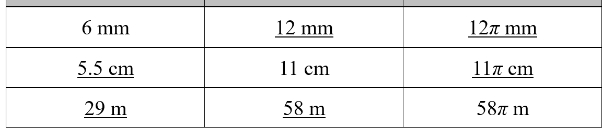

5. A wire of 30 cm long is bent to form a circle. What is the radius of the circle?
(Give your answer correct to 3 significant figures.)

c

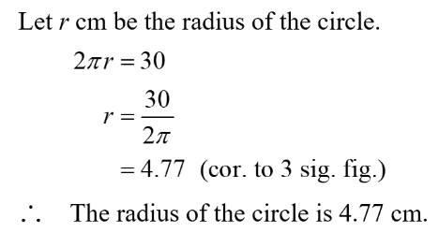

6. $A$ and $B$ are two circles. The circumference of $A$ is 10$π$cm. The circumference of $B$ is 4$π$cm longer than that of $A$. Find the radius of $B$.

c

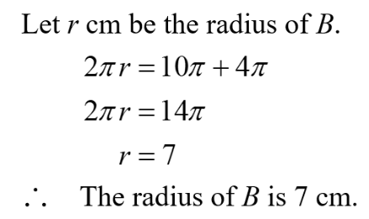


7. The radius of a coin is 11 mm. If it rolls on the ground and makes 30 revolutions, how far does it travel?
(Give your answer correct to the nearest cm.)

c

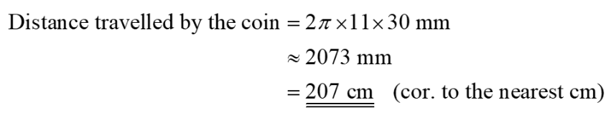

8. The radius of a bicycle wheel is 0.5 m. If the bicycle travels a distance of 100 m, how many revolutions has the wheel made? (Give your answer correct to the nearest integer.)

c

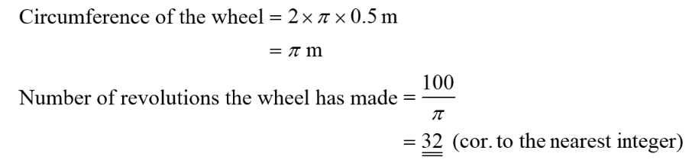


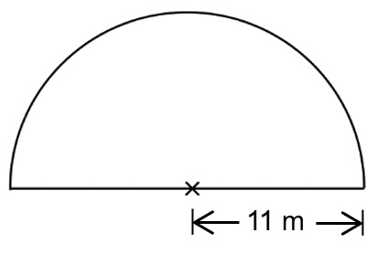
9. Find the perimeter of a semi-circle with radius 11 m as shown.
(Give your answer correct to 3 significant figures.)

c

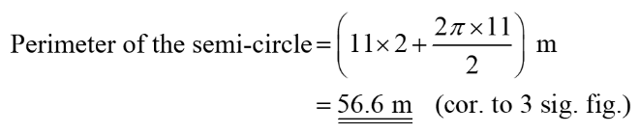

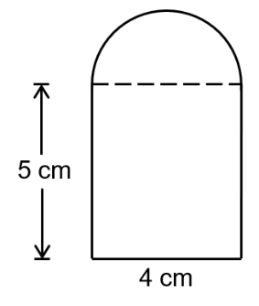
10. The figure is formed by a rectangle and a semi-circle. Find the perimeter of the figure.
(Give your answer in terms of $π$.)

c

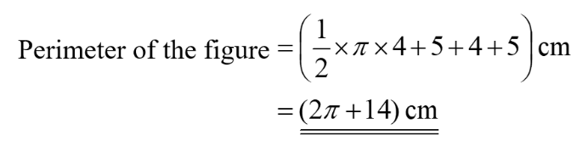

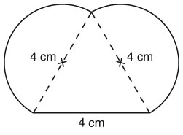
11. The figure is formed by an equilateral triangle and 2 semi-circles. Find the perimeter of the figure.
(Give your answer correct to 3 significant figures.)

c

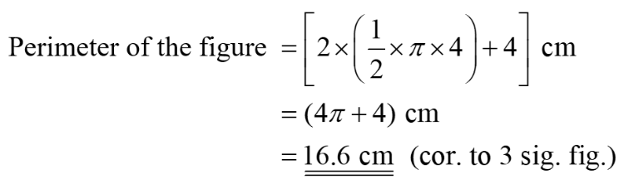

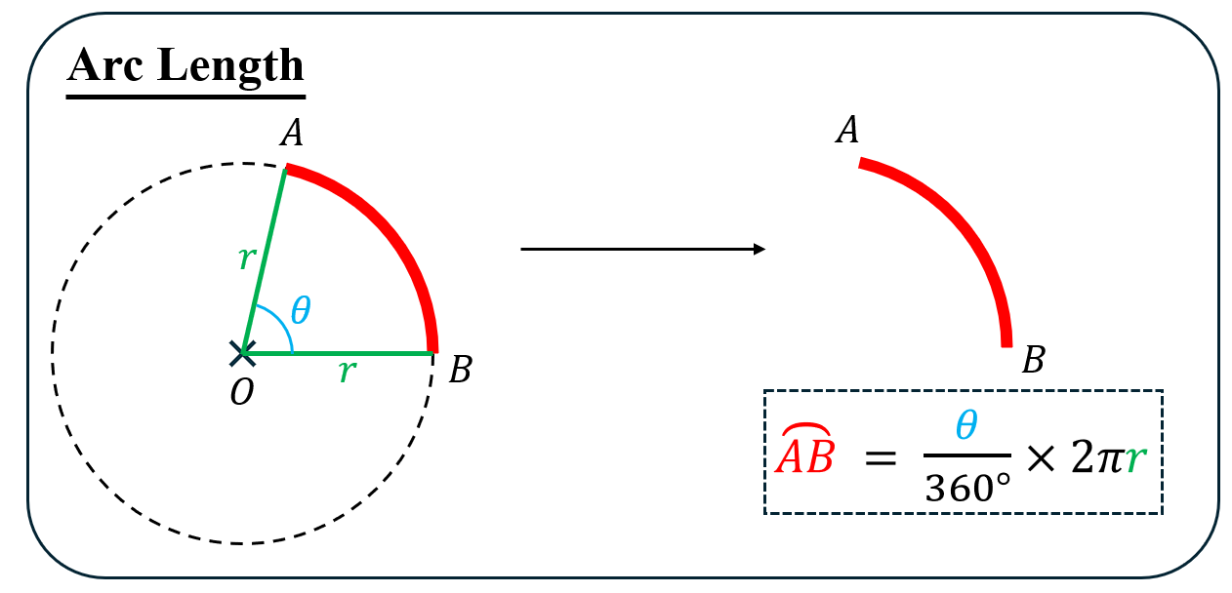

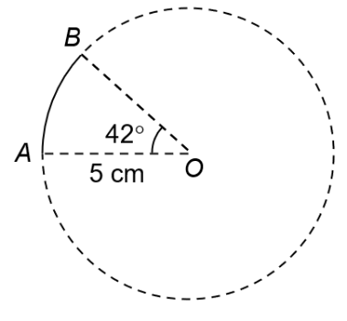
12. Find the length of $\overset{⏜}{AB}$ in the figure.
(Give your answer correct to 3 significant figures.)

c

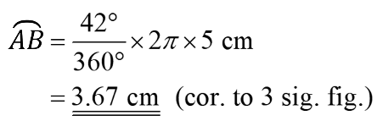

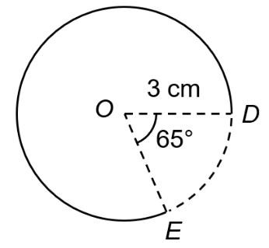
13. Find the length of $\overset{⏜}{DE}$ in the figure.
(Give your answer correct to 3 significant figures.)

c

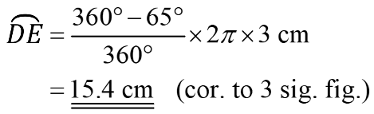

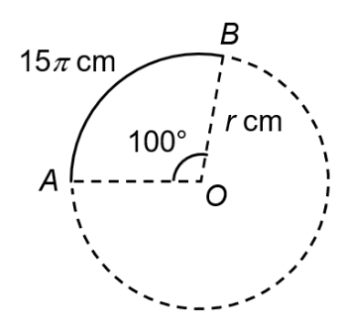
14. In the figure, ∠$AOB$ is the angle subtended at the centre $O$ by $\overset{⏜}{AB}$. It is given that $\overset{⏜}{AB}=15π$cm and ∠$AOB =$ 100°. Find the value of $r$.

c

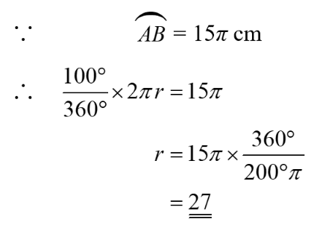

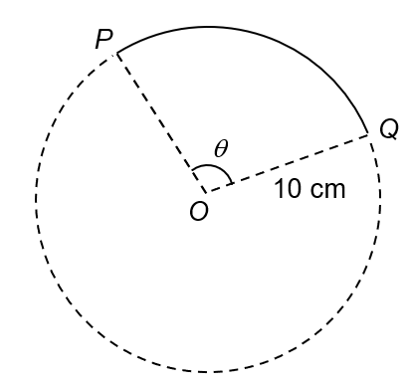
15. In the figure, ∠$POQ$ is the angle subtended at the centre $O$ by $\overset{⏜}{PQ}$. It is given that the radius of the circle is 10 cm and $\overset{⏜}{PQ}=$18 cm. Find .
(Give your answer correct to 1 decimal place.)

c

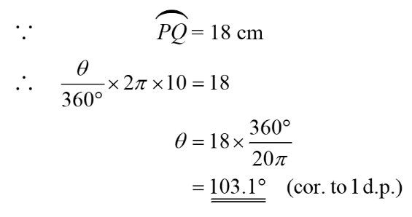

16. Complete the following table. (Give your answers in terms of $π$ if necessary.)
Radius | Angle subtended at the centre by the arc | Arc length
9 mm | 260°
 | 40° | 4π cm
24 m |  | 16π m

c

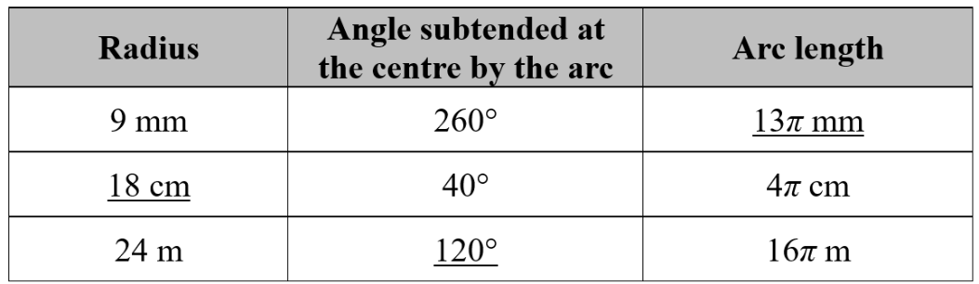

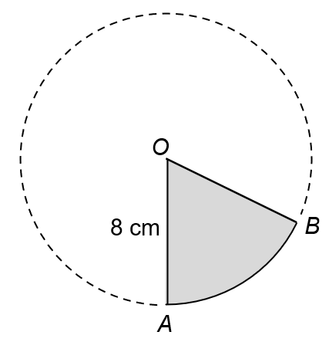
17. The figure shows a circle with centre $O$. It is given that the radius of the circle is 8 cm and the perimeter of the shaded region is 25 cm. Find ∠$AOB$.
(Give your answer correct to 2 decimal places.)

c

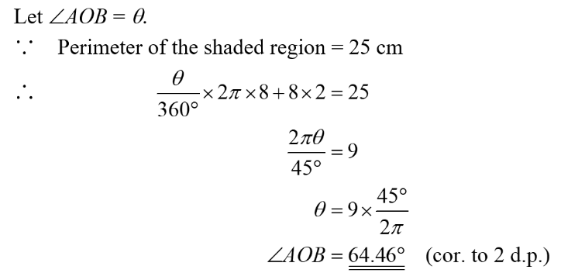

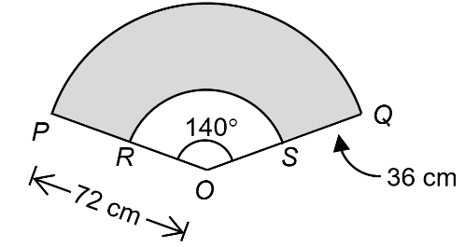
18. In the figure, $ORP$ and $OSQ$ are straight lines. $\overset{⏜}{PQ}$ and $\overset{⏜}{RS}$ are arcs of circles with the common centre $O$ such that ∠$POQ =$ 140°, $OP =$ 72 cm and $QS =$ 36 cm. Find the perimeter of the shaded region $PQSR$ in terms of .

c

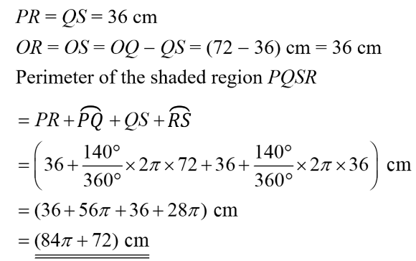

Level 2

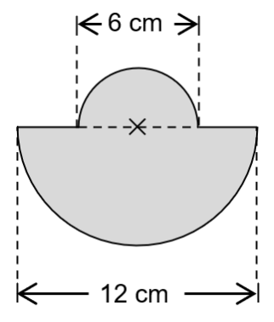
19. The figure is formed by 2 semi-circles. Find the perimeter of the shaded region.
(Give your answer correct to 3 significant figures.)

c

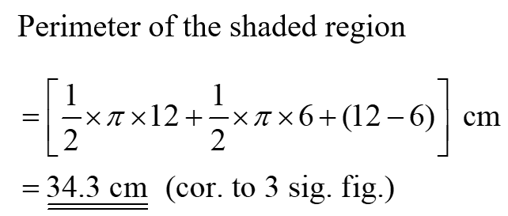

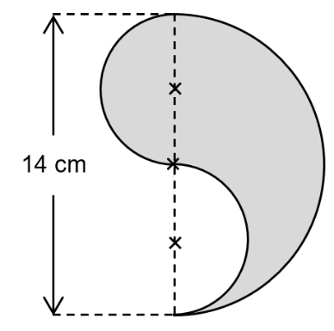
20. The figure is formed by 3 semi-circles. Find the perimeter of the shaded region.
(Give your answer correct to 3 significant figures.)

c

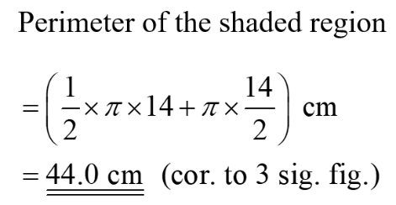

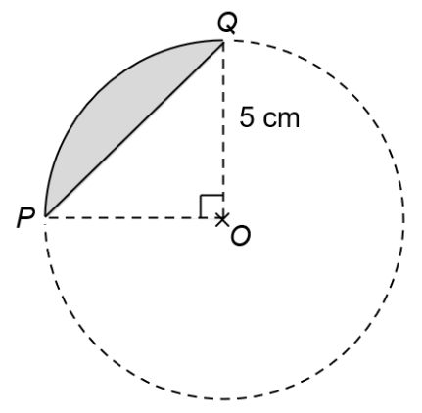
21. The figure shows a circle with centre $O$ and radius 5 cm.
(a) Find the length of $PQ.$
(b) Find the perimeter of the shaded region.
(Give your answers correct to 3 significant figures.)

c

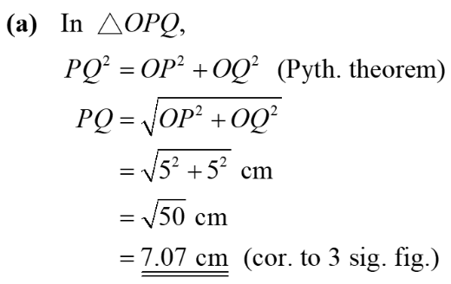
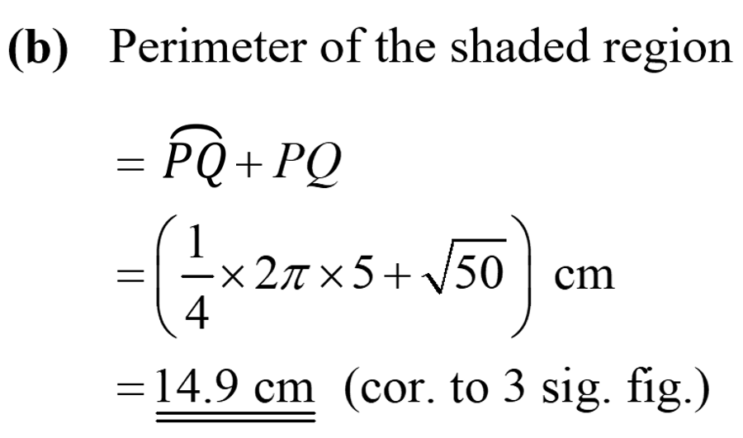

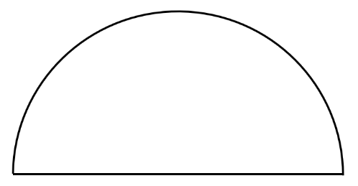
22. A wire of 32 cm long is bent to form a semi-circle. Find the radius of the semi-circle.
(Give your answer correct to 3 significant figures.)

c

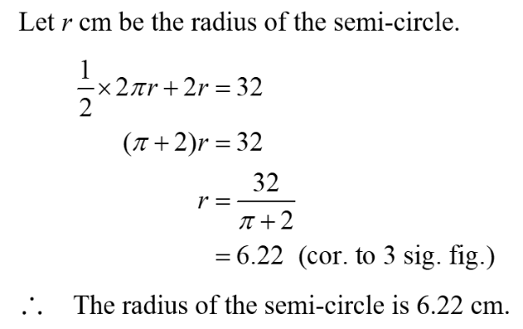

23. The diameters of the front and the rear wheels of a bulldozer (推土機) are 50 cm and 60 cm respectively. How many revolutions does the rear wheel make when the front wheel makes 36 revolutions?

c

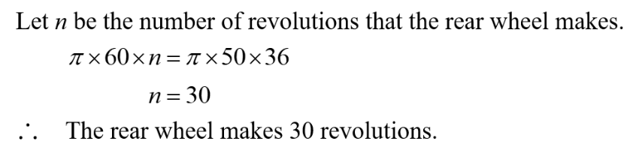

24. The length of a circular track is 942 cm. If a toy car completes one lap of the track, its front wheel will make 50 revolutions.
(a) Find the radius of the front wheel of the toy car.
(b) If the radius of the rear wheel is 2 cm, find the number of revolutions that the rear wheel will make for the toy car to complete one lap of the track.
(Give your answers correct to the nearest integer.)

c

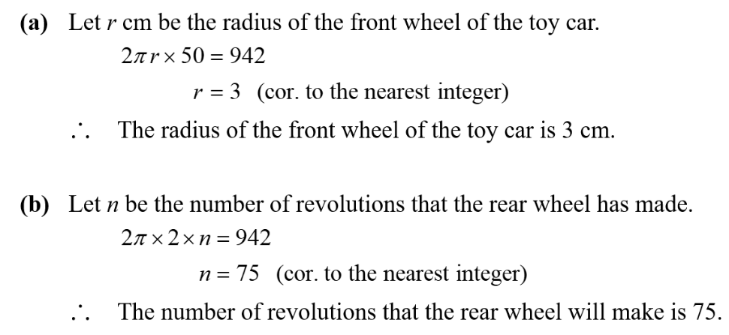
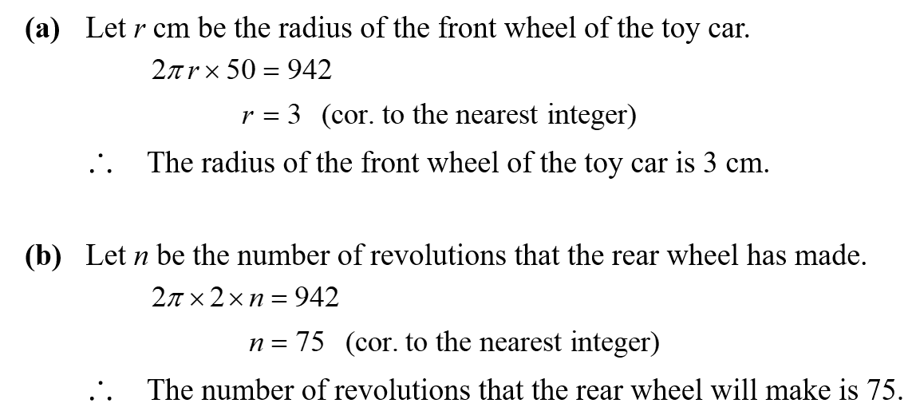

25. If the sum of the radii of 2 circles is 30 cm, what is the sum of the circumferences of the 2 circles?
(Give your answer correct to 2 decimal places.)

c

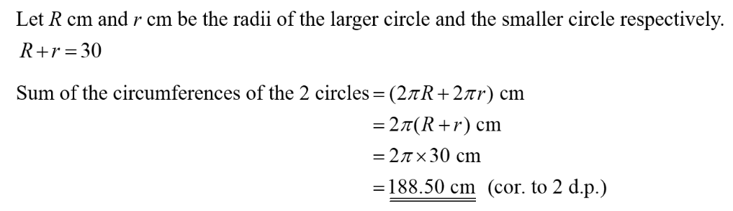

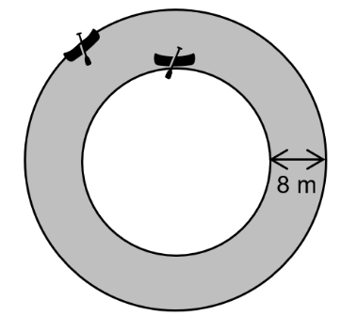
26. A circular river is 8 m wide. Two boats travel along the inner edge and the outer edge for a lap respectively. What is the difference between the distances travelled by the two boats?
(Give your answer in terms of π.)

(Give your answer correct to 2 decimal places.)

c

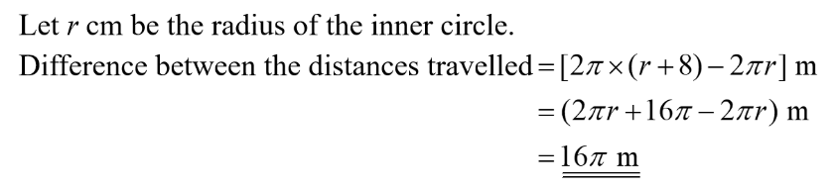

27. Susan cuts a piece of wire of 66$π$cm long into two parts. These two parts are bent into two circles with radii $a$ cm and $b$ cm. If $a$:$b$ $=$ 4 : 7, find the radii of both circles.

(Give your answer correct to 2 decimal places.)

c

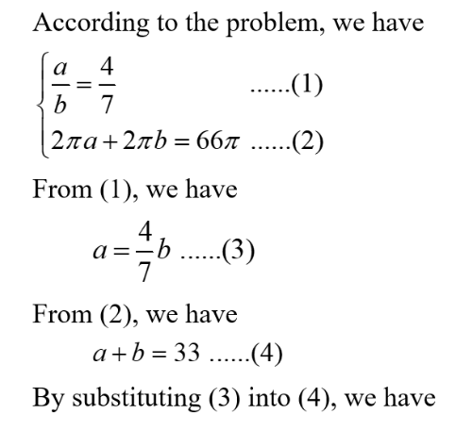
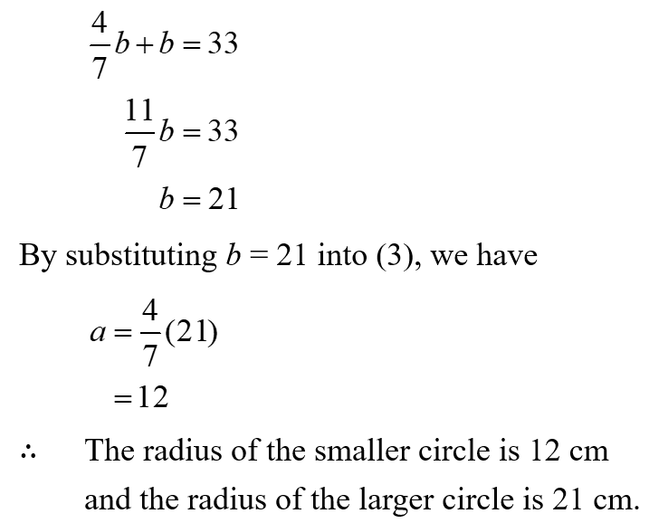

28. If the angle subtended at the centre by an arc of a circle is increased by $x$% and its radius is decreased by 25% so that the arc length is decreased by 10%, then $x =$

A. 10.
B. 15.
C. 20.
D. 35.

c
C

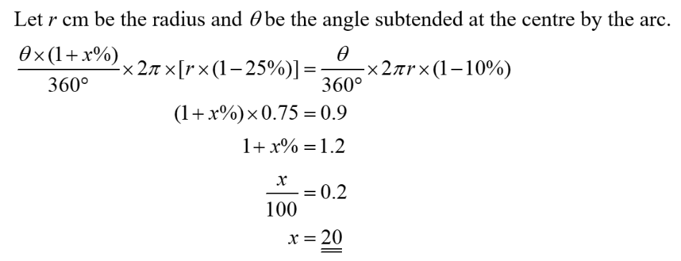

29. If the angle subtended at the centre by an arc of a circle is increased by 30% and its radius is decreased by $x$% so that the arc length is increased by 17%, then $x =$

A. 10.
B. 13.
C. 87.
D. 90.

c
A

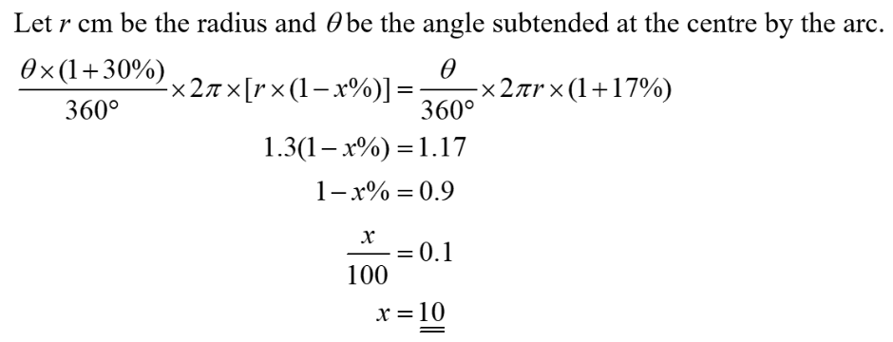

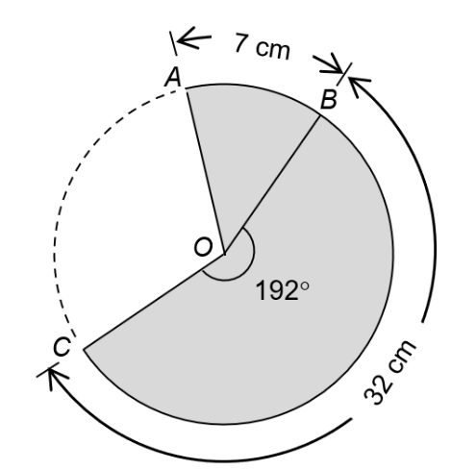
30. The figure shows a circle with centre $O$. If reflex ∠$BOC =$ 192°, $\overset{⏜}{AB}=$ 7 cm and $\overset{⏜}{BC}=$ 32 cm, find ∠$AOB$.

c

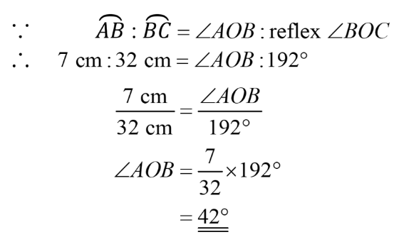
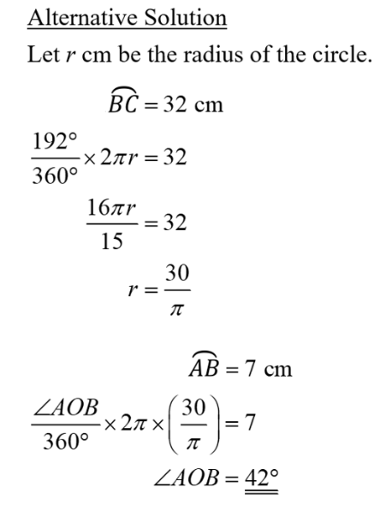

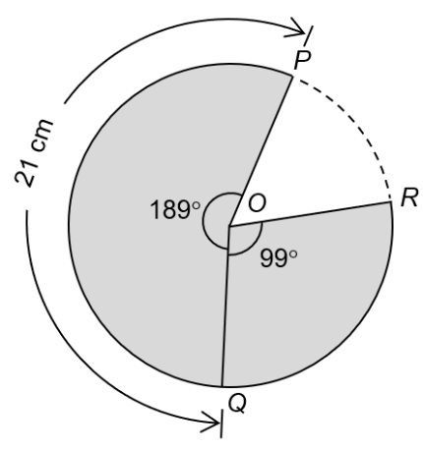
31. The figure shows a circle with centre $O$. If reflex ∠$POQ=$189°, ∠$QOR=$99° and$\overset{⏜}{PQ}=$ 21 cm, find the length of $\overset{⏜}{PQR}$.

c

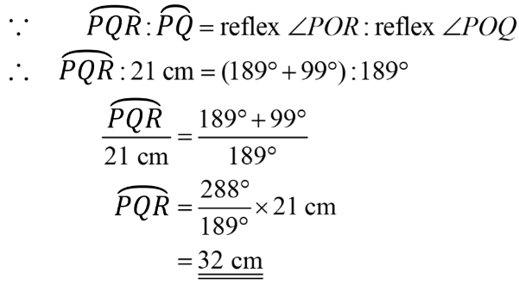
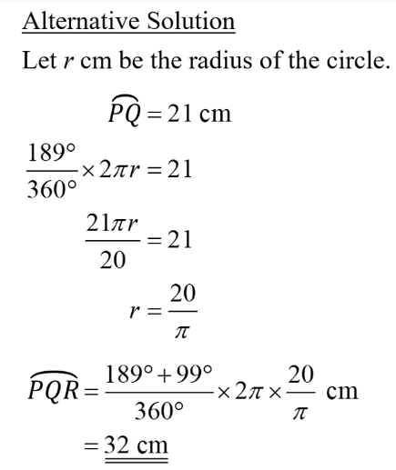

32. The length of the hour hand of a clock is 8 cm.
(a) What is the distance travelled by the tip of the hour hand in 2 days?
(b) If the minute hand is 4 cm longer than the hour hand, what is the distance
travelled by the tip of the minute hand from 3:00 p.m. to 3:36 p.m.?
(Give your answers correct to the nearest 0.1 cm.)

(Give your answer correct to 2 decimal places.)

c

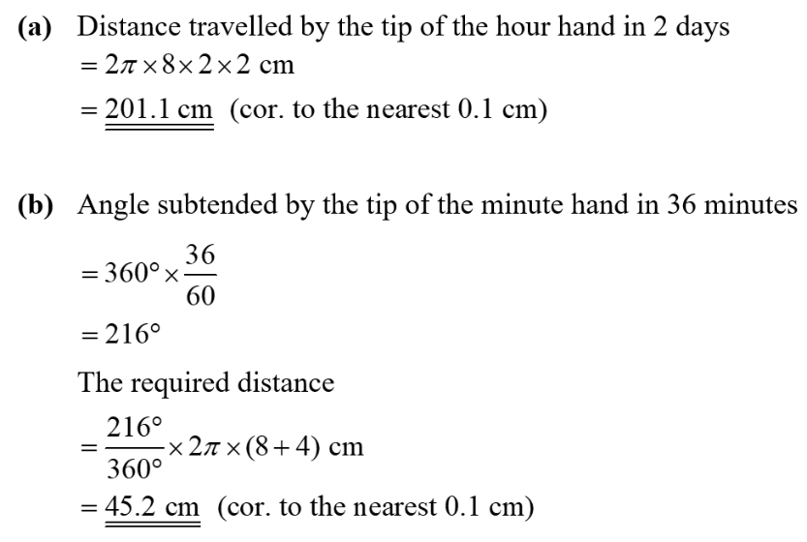
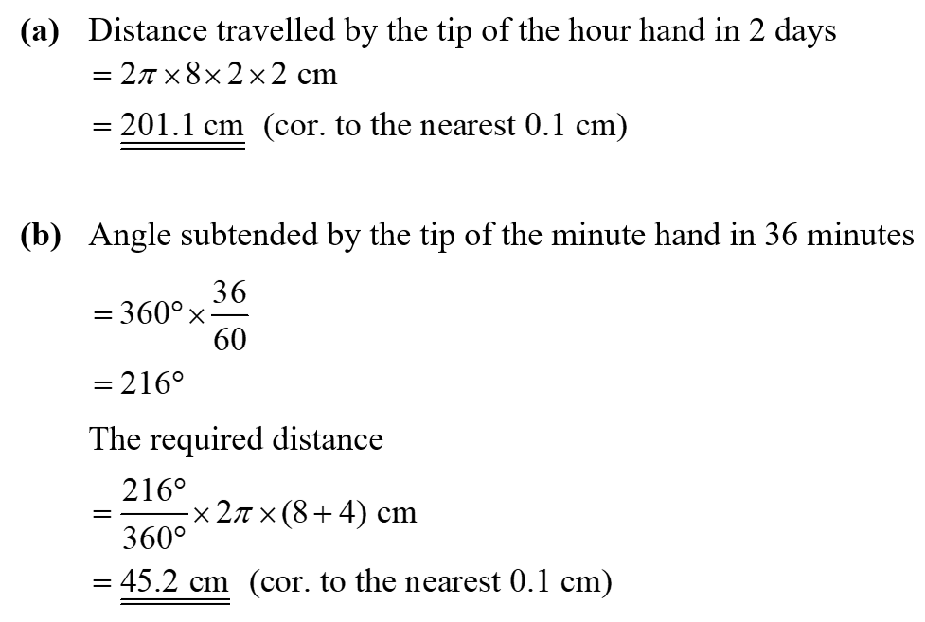

33. The lengths of the minute hand and the hour hand of a clock are 12 cm and 6 cm respectively. Find the difference between the distances travelled by the tips of the minute hand and the hour hand from 12:00 p.m. to 1:15 p.m.
(Give your answer in terms of $π$.)

(Give your answer correct to 2 decimal places.)

c

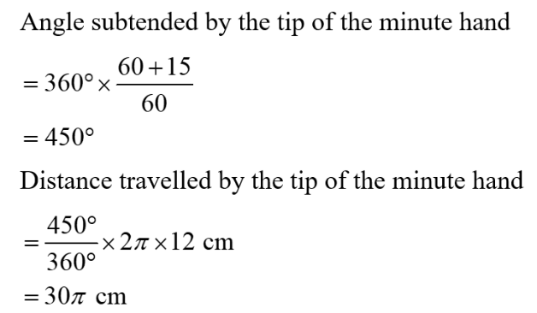
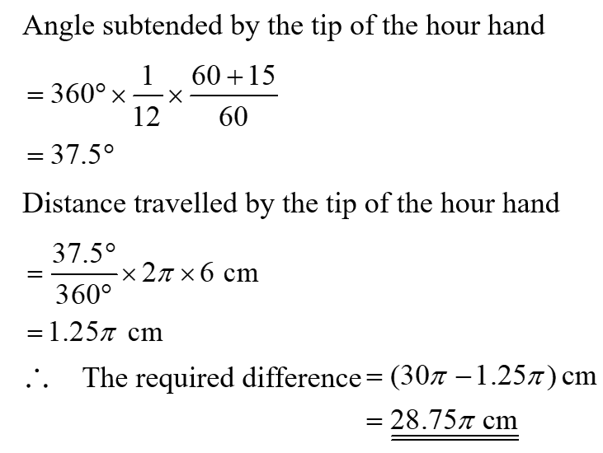

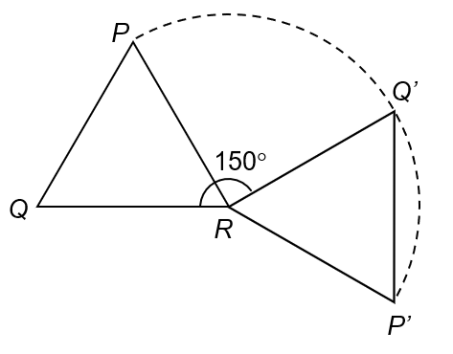
34. In the figure, $PQR$ is an equilateral triangle of side 6 cm. When the triangle is rotated clockwise about $R$ through 150°, vertices $P$ and $Q$ are moved to $P’$ and $Q’$ respectively. Find the distance travelled by $P$ when it moves to $P’$.
(Give your answer correct to 3 significant figures.)

(Give your answer correct to 2 decimal places.)

c

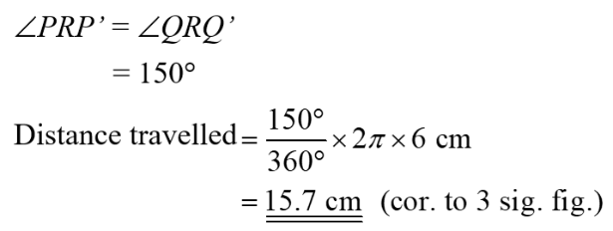

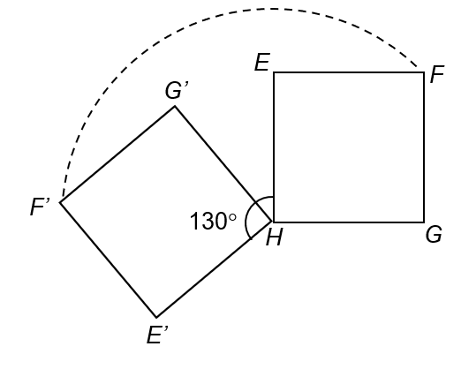
35. In the figure, $EFGH$ is a square of side 7 cm. When the square is rotated anticlockwise about $H$ through 130°, vertices $E$, $F$ and $G$ are moved to $E’$, $F’$ and $G’$ respectively. Find the distance travelled by $F$ when it moves to $F’$.
(Give your answer correct to 3 significant figures.)

(Give your answer correct to 2 decimal places.)

c

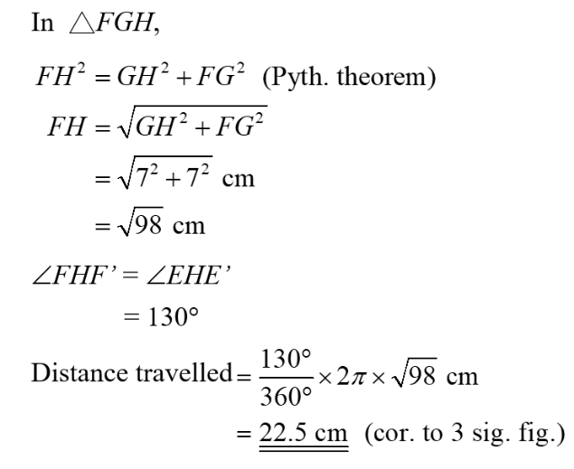

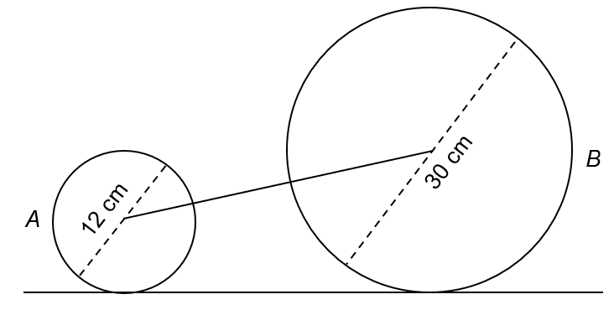
36. The figure shows two wheels $A$ and $B$ of diameters 12 cm and 30 cm respectively held together by a beam at their centres. When wheel $A$ has completed one revolution, find the angle that wheel $B$ has rotated.

(Give your answer correct to 2 decimal places.)

c

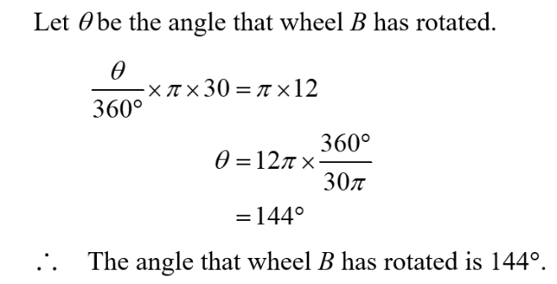

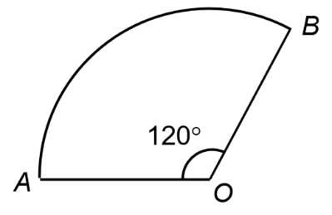
37. A piece of wire of 50 cm long is bent into the shape as shown. It consists of an arc $\overset{⏜}{AB}$ of a circle with centre $O$, and its two radii $OA$ and $OB$. Find the radius of the circle. (Give your answer correct to 3 significant figures.)

c

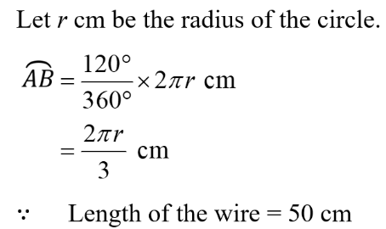
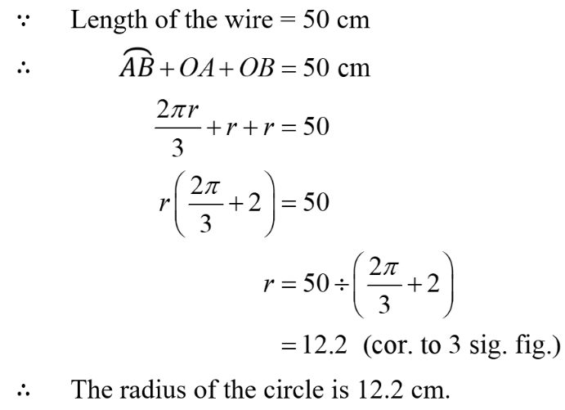

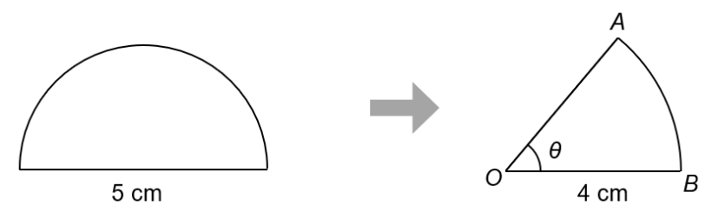
38. As shown in the figure, a piece of wire is bent into a semi-circle with diameter 5 cm.
It is then bent into the shape as shown. It consists of an arc $\overset{⏜}{AB}$ of a circle with centre$O$, and its two radii $OA$ and $OB$. Find $θ$.
(Give your answer correct to 3 significant figures.)

c

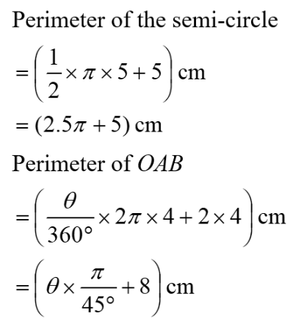
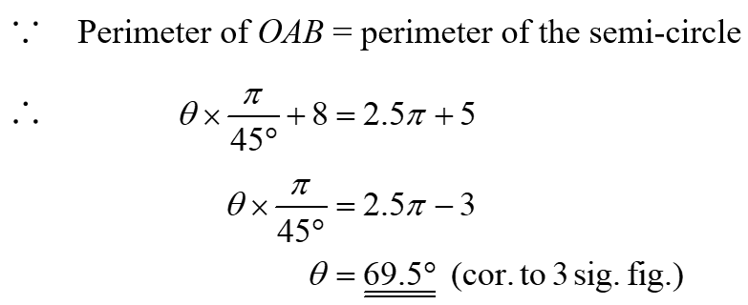

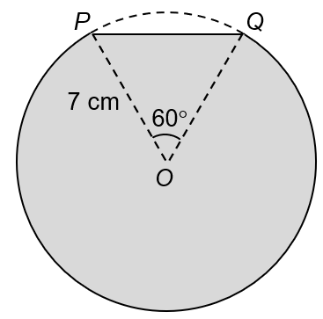
39. In the figure, $P$ and $Q$ are two points on the circumference of a circle. Find the perimeter of the shaded region.
(Give your answer correct to 3 significant figures.)

c

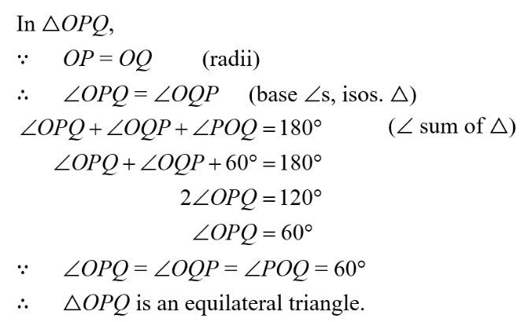
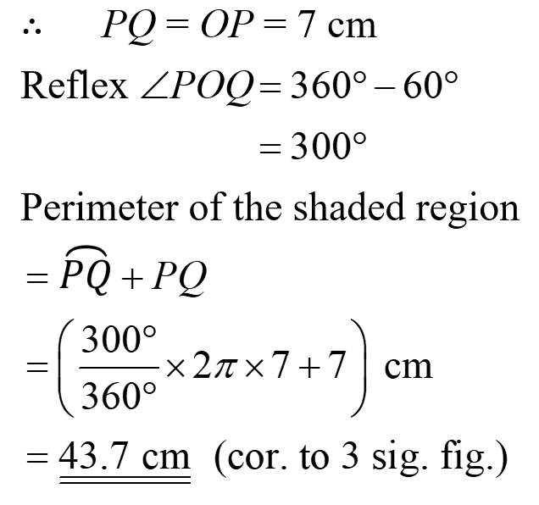

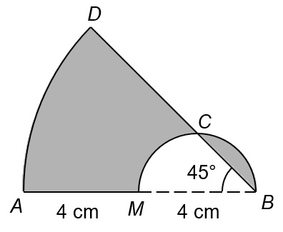
40. In the figure, $\overset{⏜}{AD}$is an arc with centre $B$ and $BCM$ is a semi-circle. $AMB$ and $BCD$ are straight lines. It is given that $AM = BM =$ 4 cm and ∠$ABD =$ 45°. Find the perimeter of the shaded region.
(Give your answer correct to 3 significant figures.)

c

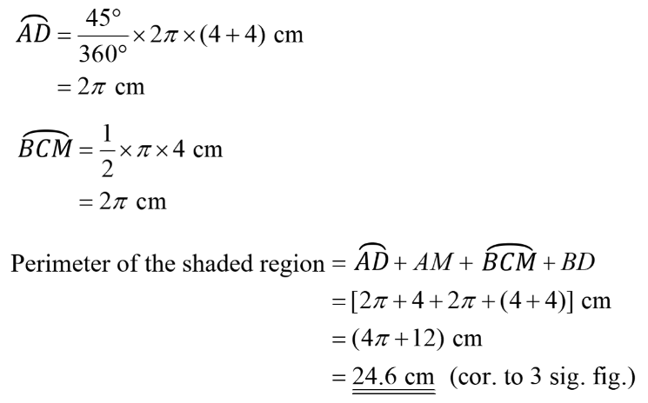

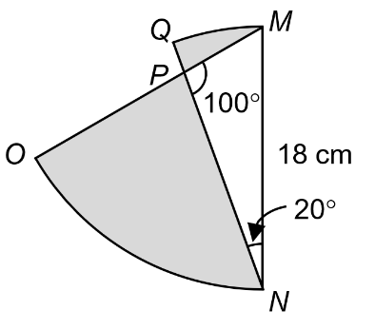
41. In the figure, $OPM$ and $NPQ$ are straight lines. $\overset{⏜}{ON}$and $\overset{⏜}{QM}$ are arcs of circles with centres $M$ and $N$ respectively. It is given that $∠MPN={100}^{∘},∠MNP={20}^{∘}$ and $MN=18 cm$. Find the perimeter of the shaded region.
(Give your answer correct to 3 significant figures.)

c

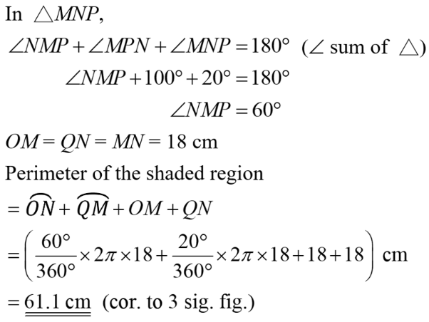

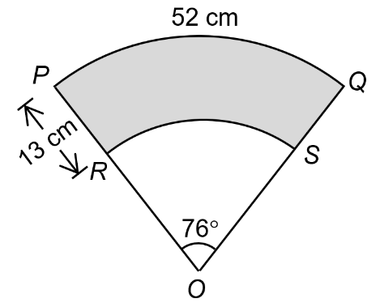
42. In the figure, $PRO$ and $QSO$ are straight lines. $\overset{⏜}{PQ}$ and $\overset{⏜}{QS}$ are arcs of circles with the common centre $O$ such that $\overset{⏜}{PQ}=$52 cm, $PR=$13 cm and ∠$POQ=$76°. Find the lengths of
(a) $OR$,
(b) $\overset{⏜}{RS}$.
(Give your answers correct to 3 significant figures.)

c

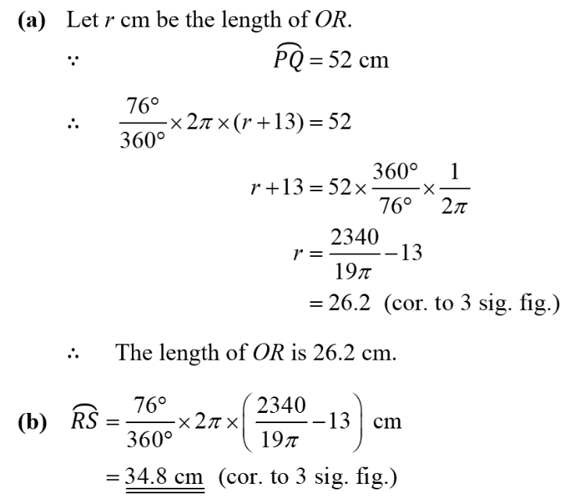
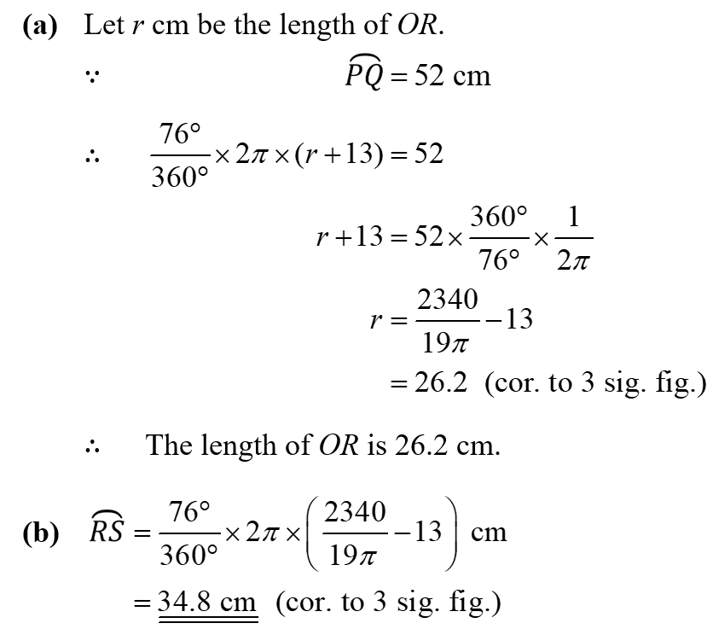

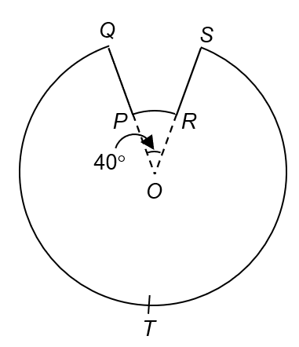
43. In the figure, $OPQ$ and $ORS$ are straight lines. $O$ is the centre of $\overset{⏜}{PR}$ and $\overset{⏜}{QS}$. $PQ = RS =$ 6 cm. If the perimeter of $PQTSR$ is 75 cm, find the length of $OQ$.
(Give your answer correct to 3 significant figures.)

c

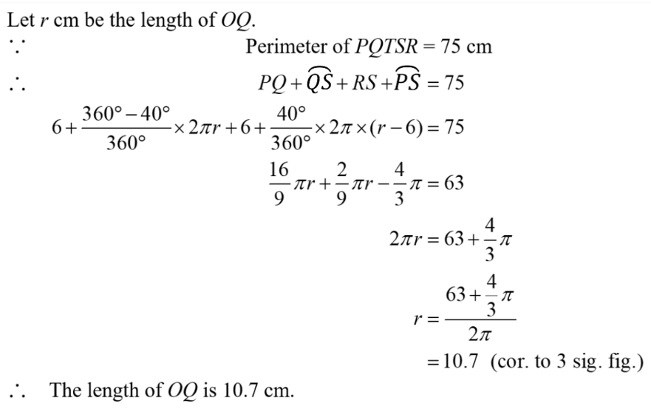

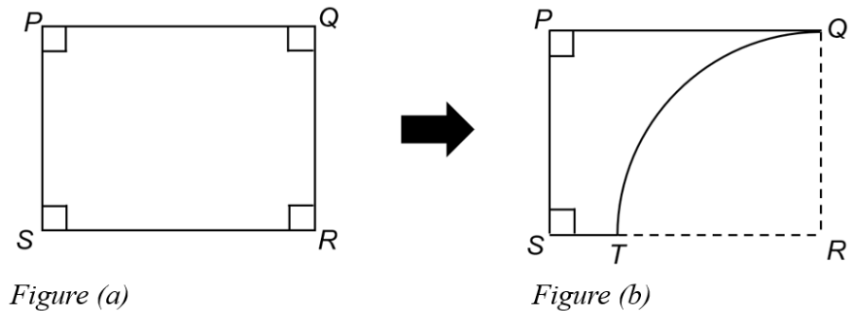
44. Figure (a) shows a rectangle $PQRS$ with $PR =$ 25 cm and $PQ :PS =$ 4 : 3. A quarter-circle of radius $PS$ is cut out from rectangle $PQRS$ to obtain Figure (b).
(a) Find the lengths of $PQ$ and $PS$.
(b) Find the perimeter of $PQTS$ in Figure (b).
(Give your answer correct to 3 significant figures.)

c

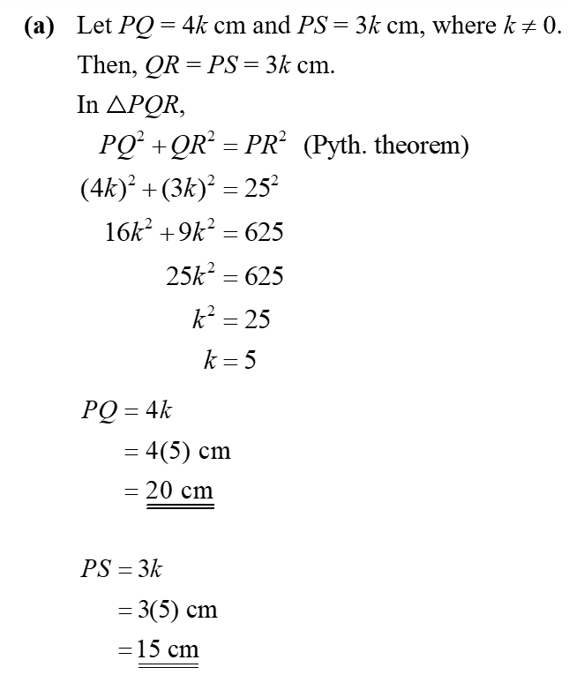
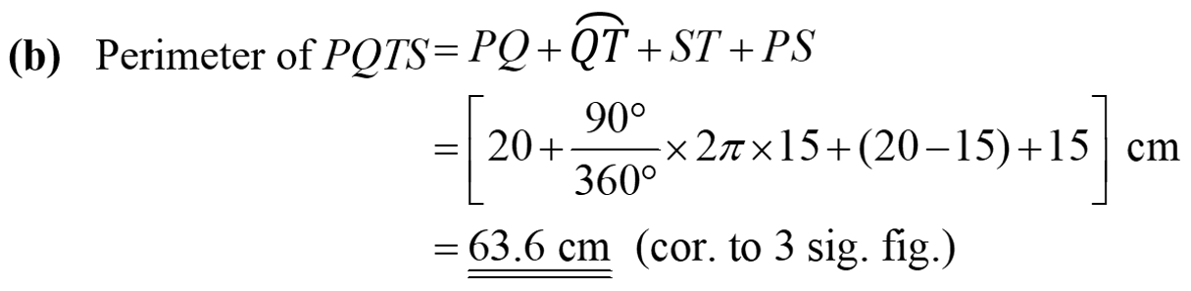

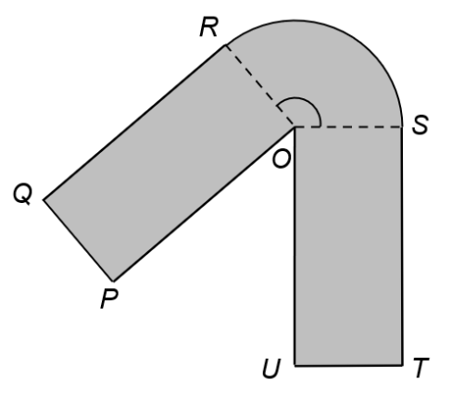
45. The figure shows a logo. $OPQR$ and $OUTS$ are two identical rectangles and $\overset{⏜}{RS}$ is an arc of a circle with centre $O$. It is given that $OP =$ 15 cm, $PQ =$ 5 cm and the perimeter of the logo is 82 cm. Find the angle subtended at the centre by $\overset{⏜}{RS}$.
(Give your answer correct to 3 significant figures.)

c

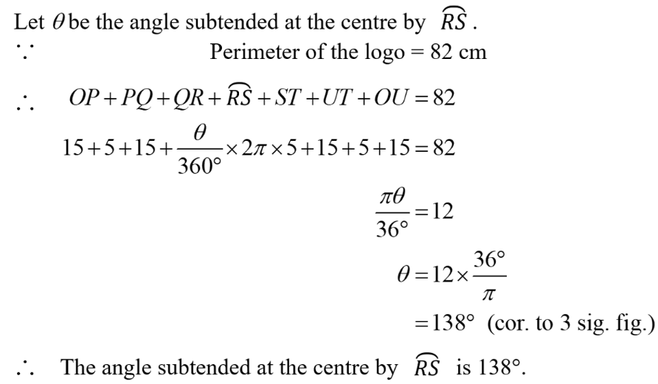

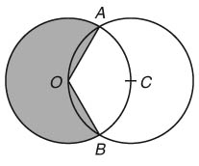
46. The figure shows 2 identical circles with radii 8 cm. $O$ and $C$ are the centres of the circles. Each circle passes through the centre of the other one.
(a) Find ∠$AOC$.
(b) Find the perimeter of the shaded region.
(Give your answers correct to 1 decimal place if necessary.)

c

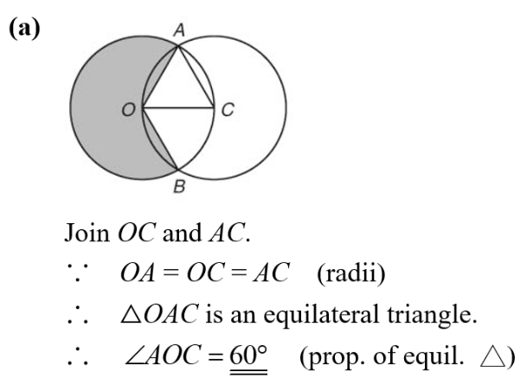
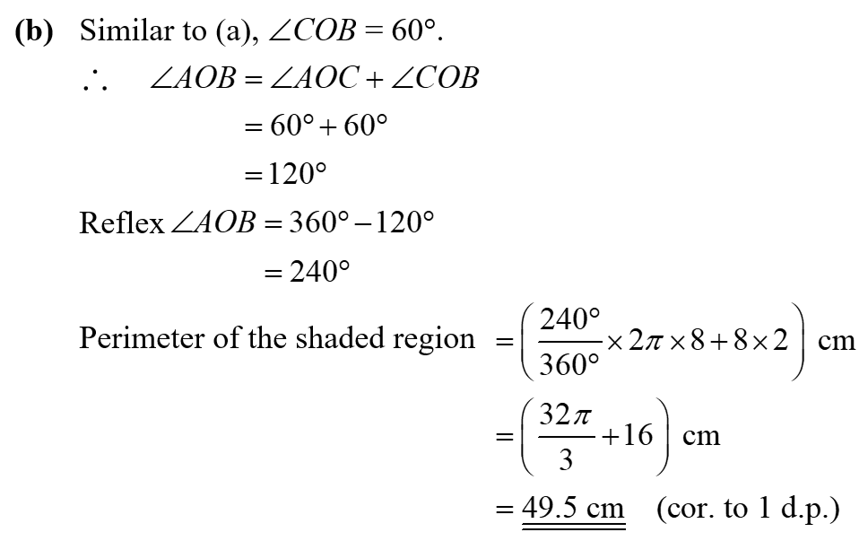

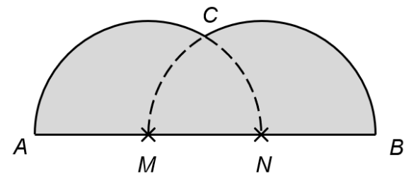
47. In the figure, $AMNB$ is a straight line. $ACN$ and $MCB$ are two identical semi-circles, centred at $M$ and $N$ respectively. Their radii are 4 cm. Find the perimeter of the shaded region.
(Give your answer correct to 3 significant figures.)

c

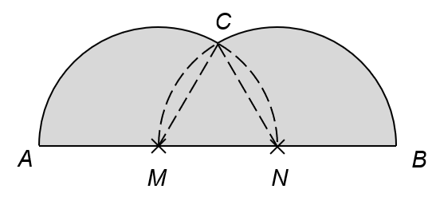
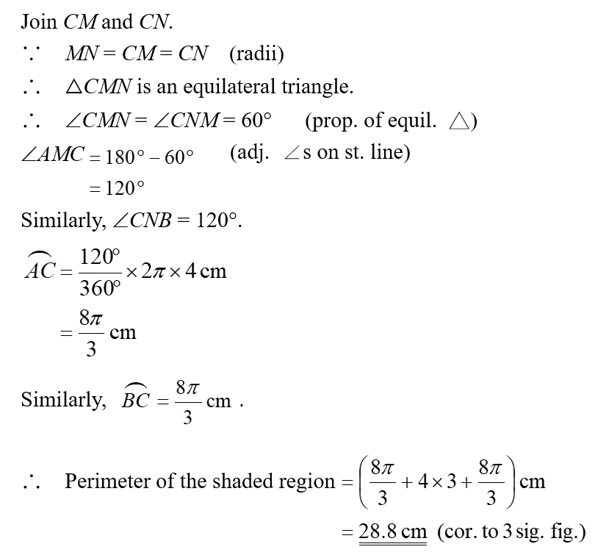

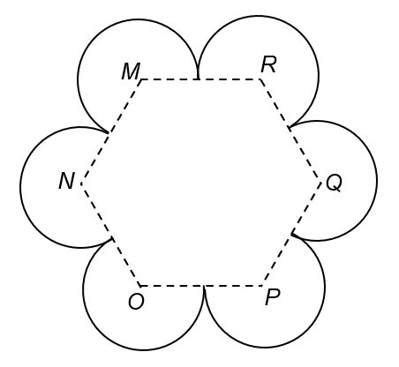
48. The figure shows a flower pattern consisting of 6 arcs of equal radii. $M$, $N$, $O$,$P$, $Q$ and $R$ are the centres of the arcs. If $MN =$ 10 cm, find the perimeter of the figure.
(Give your answer correct to 3 significant figures.)

c

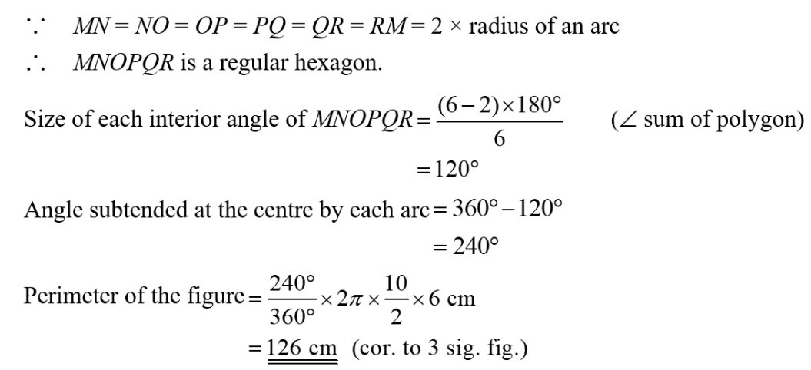

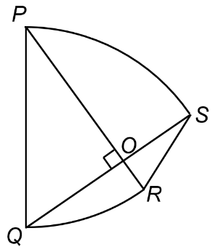
49. In the figure, $P$ and $Q$ are centres of $\overset{⏜}{QR}$ and $\overset{⏜}{PS}$ respectively. $PR$ and $QS$ intersect
at $O$. It is given that $PR$ ⊥ $QS$, $OP =$ 10 cm and $OQ =$ 7.5 cm. Find the perimeter of $PQRS$.
(Give your answer correct to 3 significant figures.)

c

