Accelerating Information Experts through Compiler Design
Permission to make digital or hard copies of all or part of this work for personal or classroom use is granted without fee provided that copies are not made or distributed for profit or commercial advantage and that copies bear this notice and the full citation on the first page. To copy otherwise, or republish, to post on servers or to redistribute to lists, requires prior specific permission and/or a fee.
SIGPLAN’05 June 12–15, 2005, Location, State, Country.
Copyright © 2004 ACM 1-59593-XXX-X/0X/000X…$5.00.
Aaron W. Hsu
Indiana University
awhsu@indiana.edu

Dyalog APL is a tool of thought for information experts, enabling rapid and effective development of domain-centric software without the costly software engineering feedback loop that is required for other programming environments. The interpreted nature of the Dyalog APL environment, however, introduces constraints on the performance characteristics of the system that hinders the rapid exploration and analysis of large data sets, especially on modern, highly-parallel computing architectures. The Co-dfns compiler project aims to greatly reduce the overheads involved in creating high-performance scalable code in APL. In particular, the compiler focuses on integrating with the environment already familiar to users of Dyalog APL. It compiles a familiar subset of the entire Dyalog APL language, and delivers significant performance improvements and platform independence to information experts without requiring them to rewrite or rework their code into another language.
We discuss the design of the Co-dfns compiler, which is itself an APL program, and in particular, we discuss the unique implementation architecture that allows us to write the compiler without branching, recursion, or other complex forms of control flow, as well as the specific optimizations used to deliver performance on par with hand-written C code in the domain of financial simulations. We discuss preliminary results of platform independence that demonstrates significant performance independence of APL programs between traditional CPUs and GPU platforms, allowing information experts to take their code unmodified and obtain performance equivalent to handwritten C or CUDA code. We also discuss ongoing work to improve these numbers further, and improve the design of the compiler itself, with the eventual goal of expanding the domains for which array programming is not only a possible solution, but a compelling one as well.
Categories and Subject Descriptors D.3.3 [Programming Languages]: Language Constructs and Features – abstract data types, polymorphism, control structures.
General Terms Algorithms, Performance, Design, Languages
Keywords APL, array programming, compiler architecture
- Introduction
Dyalog APL [Dyalog 2015] is a modern, interpreted language which follows in the tradition of APL systems by providing a "tool of thought" [Iverson 2007] that enables information experts to rapidly develop and explore solutions without requiring significant early investment in external software engineering resources. Its mathematically oriented language is concise and it encourages data exploration through array programming. The performance of the APL interpreter is surprisingly good, and many good applications have been designed that outperform more traditional systems by a large margin [Grosvenor 2013]. However, there are limitations to the performance of an interpreter.
The Co-dfns compiler project [Hsu 2014] is an effort to provide a highly integrated compiler into the Dyalog APL environment that enables turnkey performance for information experts using Dyalog APL, while retaining the rapid development environment that such experts prefer. In particular, we leverage the high-level nature of APL in order to deliver platform independent performance of data parallel applications, enabling information experts to scale their models written in APL to larger data sets and a wider array of hardware.
In addition to this, Co-dfns as a project hopes to expand and push the boundaries of what most users think of as "suitable" array programming domains. By implementing the compiler in a purely data-parallel fashion using nothing but the dfns APL dialect we demonstrate the feasability of writing a compiler in this fashion. Moreover, we demonstrate the effectiveness of this approach, as the compiler remains simple and direct, without complex encoding schemes. We also intend to demonstrate some of the benefits of using array programming for such software, including the increased parallelism and analysis opportunities that arise from the intentionally restricted and simplified language subset from which the compiler is constructed.
Our recent efforts have delivered a completely data-parallel compiler modulo the parser (written using parser combinators) and some aspect of code generation. The compiler produces code that integrates directly with the Dyalog APL interpreter through the use of the DWA [Dyalog 2014] infrastructure. The performance of the code produced exceeds that of traditional hand-written C program integrated using the Dyalog APL foreign function interface alone, while also possessing platform independence, compiling to GPU and CPU targets from the same code, unmodified, with significant performance improvements in both cases.
We make the following contributions:
- We describe the high-level architecture of a purely data-parallel compiler written without recursion, branching, or other complex control flow, providing a demonstration of the feasibility of such a compiler and the relative compactness and directness with which it can be written.
- We provide performance analysis of the costs of integrating foreign code into the Dyalog APL environment by comparing the performance of hand-written C code against the Co-dfns compiler, which integrates more completely with the host environment.
- We have built a compiler which delivers device independent performance gains in the range of 50 - 10,000% over the base interpreter by allowing unmodified APL programs to be compiled for the CPU and GPU. These gains are possible in part from the high-level nature of the APL language.
- We describe the set of optimizations necessary to deliver increased performance on scalar heavy computational code when written in APL and other array-oriented notations.
- Compiler Architecture
The Co-dfns compiler has a somewhat unique architecture. In line with the project goals, the Co-dfns compiler is designed around "eating our own dog food." In other words, we use the dfns language to implement the compiler, and focus on demonstrating the feasibility of such a task at scale. This motivates a different perspective on compiler construction.
In particular, the Co-dfns compiler is written as a purely data flow, data parallel, functional program. The core of the compiler is written using nothing but basic function composition over a set of general purpose array operators and vectorized array primitives. There are no explicit branching statements, such as switches, if-statements, or visitor-style design patterns. The compiler uses no recursive or other means of complex control flow. Instead, all control flow is direct and simple function composition. All the basic operators are data-parallel or vectorized, and have parallel semantics. (Note that the Co-dfns language includes recursion, branching, and traditional control flow; we simply choose not to use these features when writing the compiler.)
The compiler is not yet able to self-host, so the interpreter executes the code instead. In this case, the implementations of the primitives are in fact sequential, but the primitive operations themselves do not require this interpretation. The compiler produces vectorized and parallel code for the same primitives as an alternative, particularly on parallel architectures like the Xeon Phi and the NVIDIA GPUs.
The parser is written using recursive parser combinators, but there is some evidence that the parser can eventually be rewritten into this purely data-parallel style as well. Some parts of the code generator currently use branching control flow, but we are also phasing this out as we continue to develop the compiler. We anticipate that the next version of the compiler will completely eliminate complex control flow from all aspects of the compiler except for the parser combinators used to implement the parser.
The resulting code exhibits a high degree of concision and uniformity. The core compiler passes are 43 lines of pure dfns that fits onto a single 8.5" × 11" letter sized page with 12 point font. The code itself is currently much denser than other languages, but we believe that the consision gained more than justifies this tersity.
We currently represent the AST as a matrix of one node per row in the matrix. In addition to the node attributes and other information about the node, each node is associated with a depth, which indicates the level at which that node appears in the syntax tree. We order the nodes in the matrix according to a pre-order depth-first traversal of the AST. While this representation does allow us to implement the compiler using the above architecture, it is not clearly the "right" representation. We actively explore new representations for the AST, as changes in the AST representation have far reaching ramifications for the ease of implementing a compiler using only data-parallel primitives.
Critically, the memory management design of the compiler greatly affects its performance in real applications. In line with our desire to integrate with Dyalog APL and, particularly, to reduce the overheads involved for the information expert, we utilize the DWA (Direct Workspace Access) features of Dyalog APL to provide access to the internal memory manager of the APL interpreter. This allows us to operate directly over structures inside the interpreter, rather than introducing a conversion phase in and out of the interpreted environment. Initial versions of the compiler used a separate representation for arrays and handled memory management outside of the DWA infrastructure. Doing so gave advantages for flexibility to the compiler but at a severe performance cost. We discuss these performance costs later on, as they turn out to be the first stumbling block we removed in order to achieve reasonable performance gains inside of the compiler.
- Optimizations
The optimizations currently implemented in the compiler focus on improving the results of financial simulation software, epitomized in the Black Scholes benchmark. This code contains mostly numerical calculations over large arrays, and in particular, scalar computations, instead of heavy manipulations of the shapes of arrays. We implement four major optimizations which significantly improve performance of the compiler.
  - Scalar loop fusion
In APL, primitive scalar operations, such as addition or subtraction, operate point-wise over every scalar element in an array argument. In other words, there is an implicit map or fork over each element in an array (which can be nested) to compute addition or subtract on the individual scalar elements of the array. When strung together, as in the following example, the interpreter must iterate over the entire array multiple times:
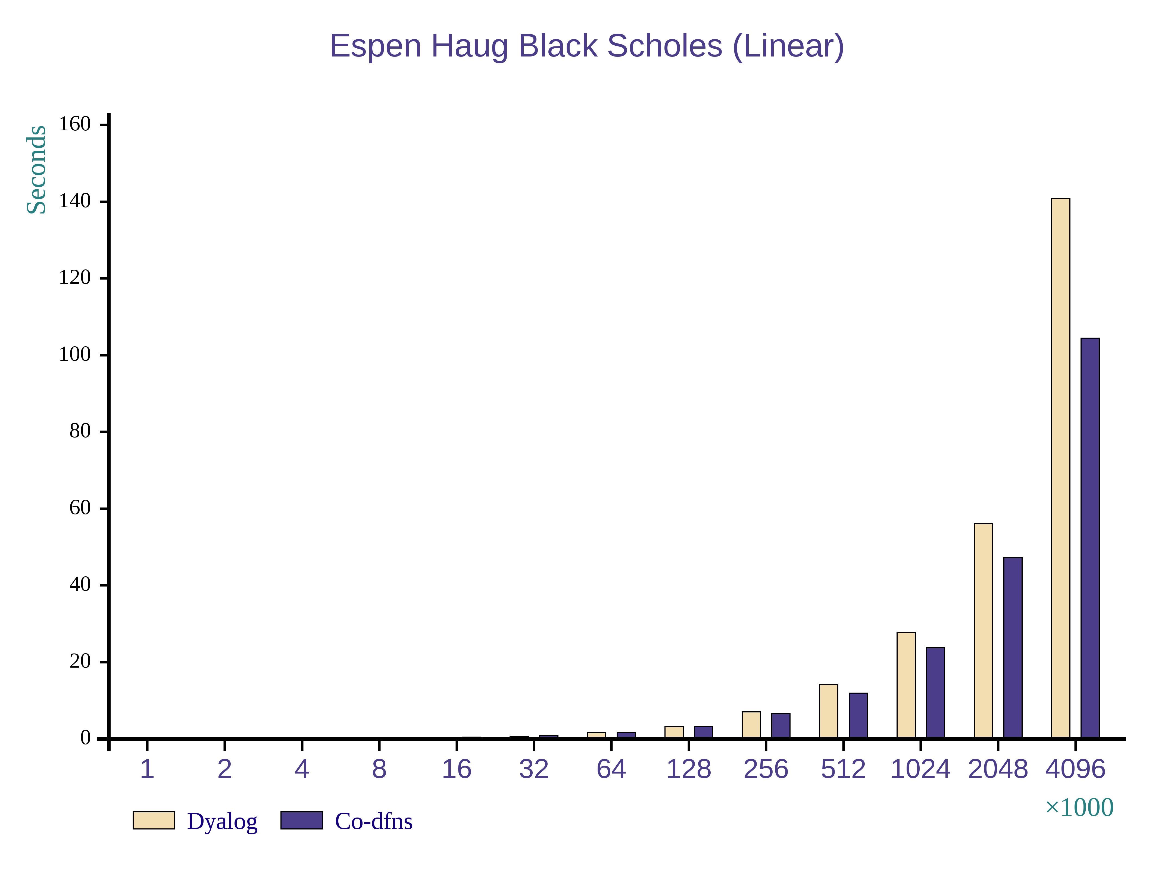
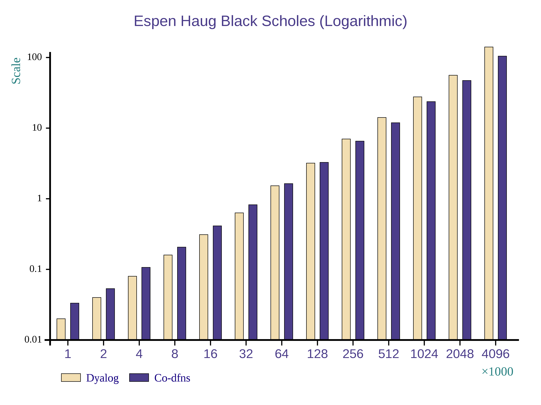
5+A×B
Figure 1. Performance of un-optimized Co-dfns compiler code in the Black Scholes benchmark on the CPU.
If arrays A or B are large, then these multiple iterations can eliminate the benefits of modern cache hierarchies. This results in poor scaling of the interpreter on these results to large simulations. What should be a near perfect scaling loses ground quickly compared to hand-written C code, despite the use of vectorized operations on the iterations.
The solution to this in the compiler is to recognize these loops and fuse them together. This is a well studied and difficult problem [Darte 2000] for languages like Fortrain, which use things like polyhedral models to fuse arbitrary loops. However, the situation is much better and simpler in APL, because we do not need to recognize explicit loops, but instead can take advantage of the implicit behavior of the scalars. This makes it much easier to recognize when it is safe to fuse these loops. We can thus guarantee that all scalar functions operating over the same set of data will be fused together into a single large loop. We base this fusion on whether two arrays are "shape-dependent" through a flow dependency in the code.
This optimizations allows us to take advantage of modern cache architectures and to take advantage of other optimizations in vectorization engines available through lower level C and CUDA compilers. We can design these loops to ensure that they are vectorized and if the user desires, automatically parallelized. Generally, parallelization of this sorts works well on the GPU, but vectorization alone is usually better than multi-core parallelism with normal CPUs like the Intel i7 in our experience.
  - Function inlining and allocation
All functions are inlined when possible in the compiler. This is especially true for the operators which take functions as operands. By inlining these operations, it is often possible to reduce significant overheads involed in repeated iterations. Furthermore, becuase Dyalog APL does not permit functions to be returned as values, though they can be passed as operands to operators, there is no need to have a facility for creating closures, as in many other high-level functional programming languages. The current version of the compiler still creates some environments to hold some free variables in the compiler, but the next version of the compiler will be able to mostly eliminate additional environment overheads and almost completely eliminate function call overheads.
  - DWA as an optimization
While the above optimizations are fairly classical, the most surprising and significant optimization for our use case turned out to be the integration of DWA (Direct Workspace Access) [Dyalog 2014] into the compiler. In this case, the compiler operates directly over structures inside of the interpreter, completely eliminating copying and conversion overheads associated with calling foreign code from within the interpreter. Our use cases assume that the information expert will conduct most of their development through the interpereter, and use the compiler as a later optimization stage or to deploy. By eliminating the overhead for calling into foreign functions, we experienced the single largest performance increase among all of these optimizations and the environment in general.
- Performance
We obtained the following benchmark results using an Intel Core i7-3610QM @ 2.30GHz with 8 Hyperthreaded cores. The machine contains 16GB of RAM and an NVIDIA GTX 675M graphics card. Results were obtained with the 64-bit Linux version of Dyalog APL.
  - Without Optimizations
The previous version of Co-dfns [Hsu 2014a] used its own internal representation for arrays that differed slightly in structure from that used by the Dyalog interpreter. It also did not include explicit inlining of primitives. It did use a reasonably efficient representation of functions, however. We expanded this to include targeting CUDA-capable hardware [Hsu 2014b].
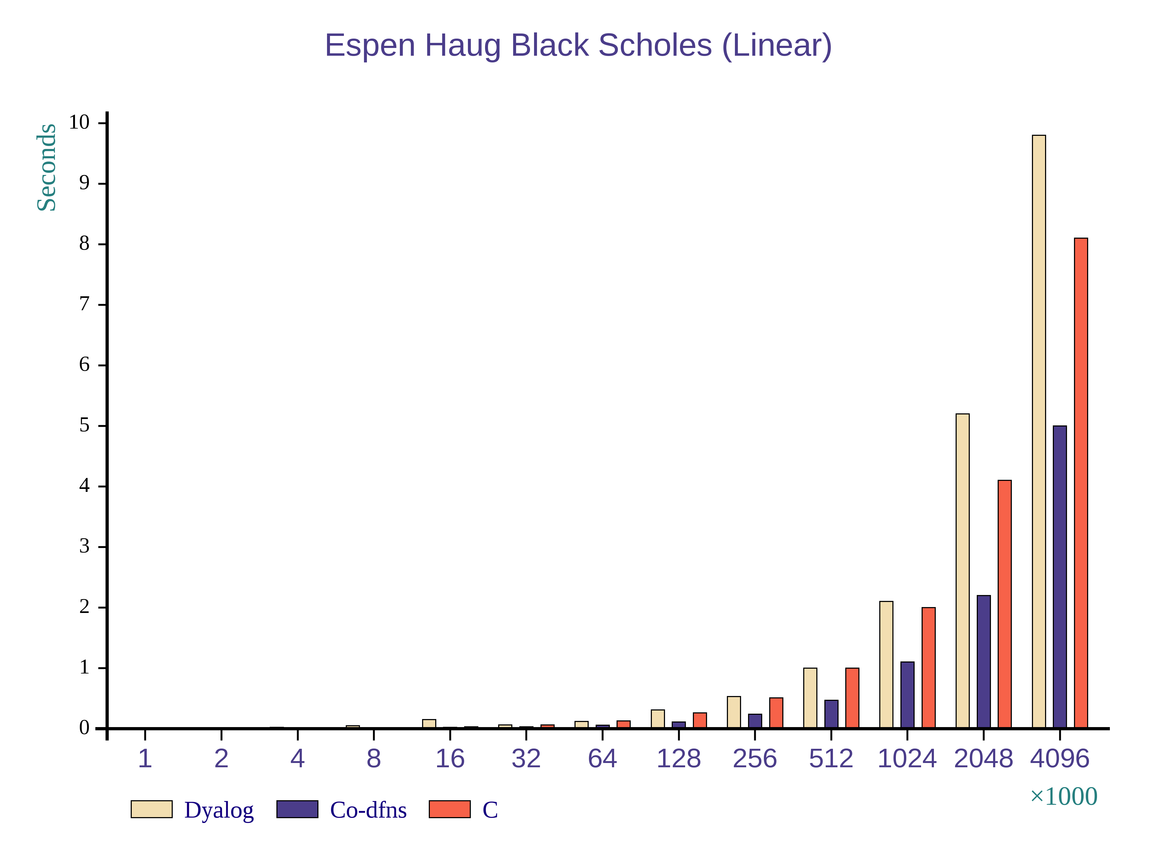
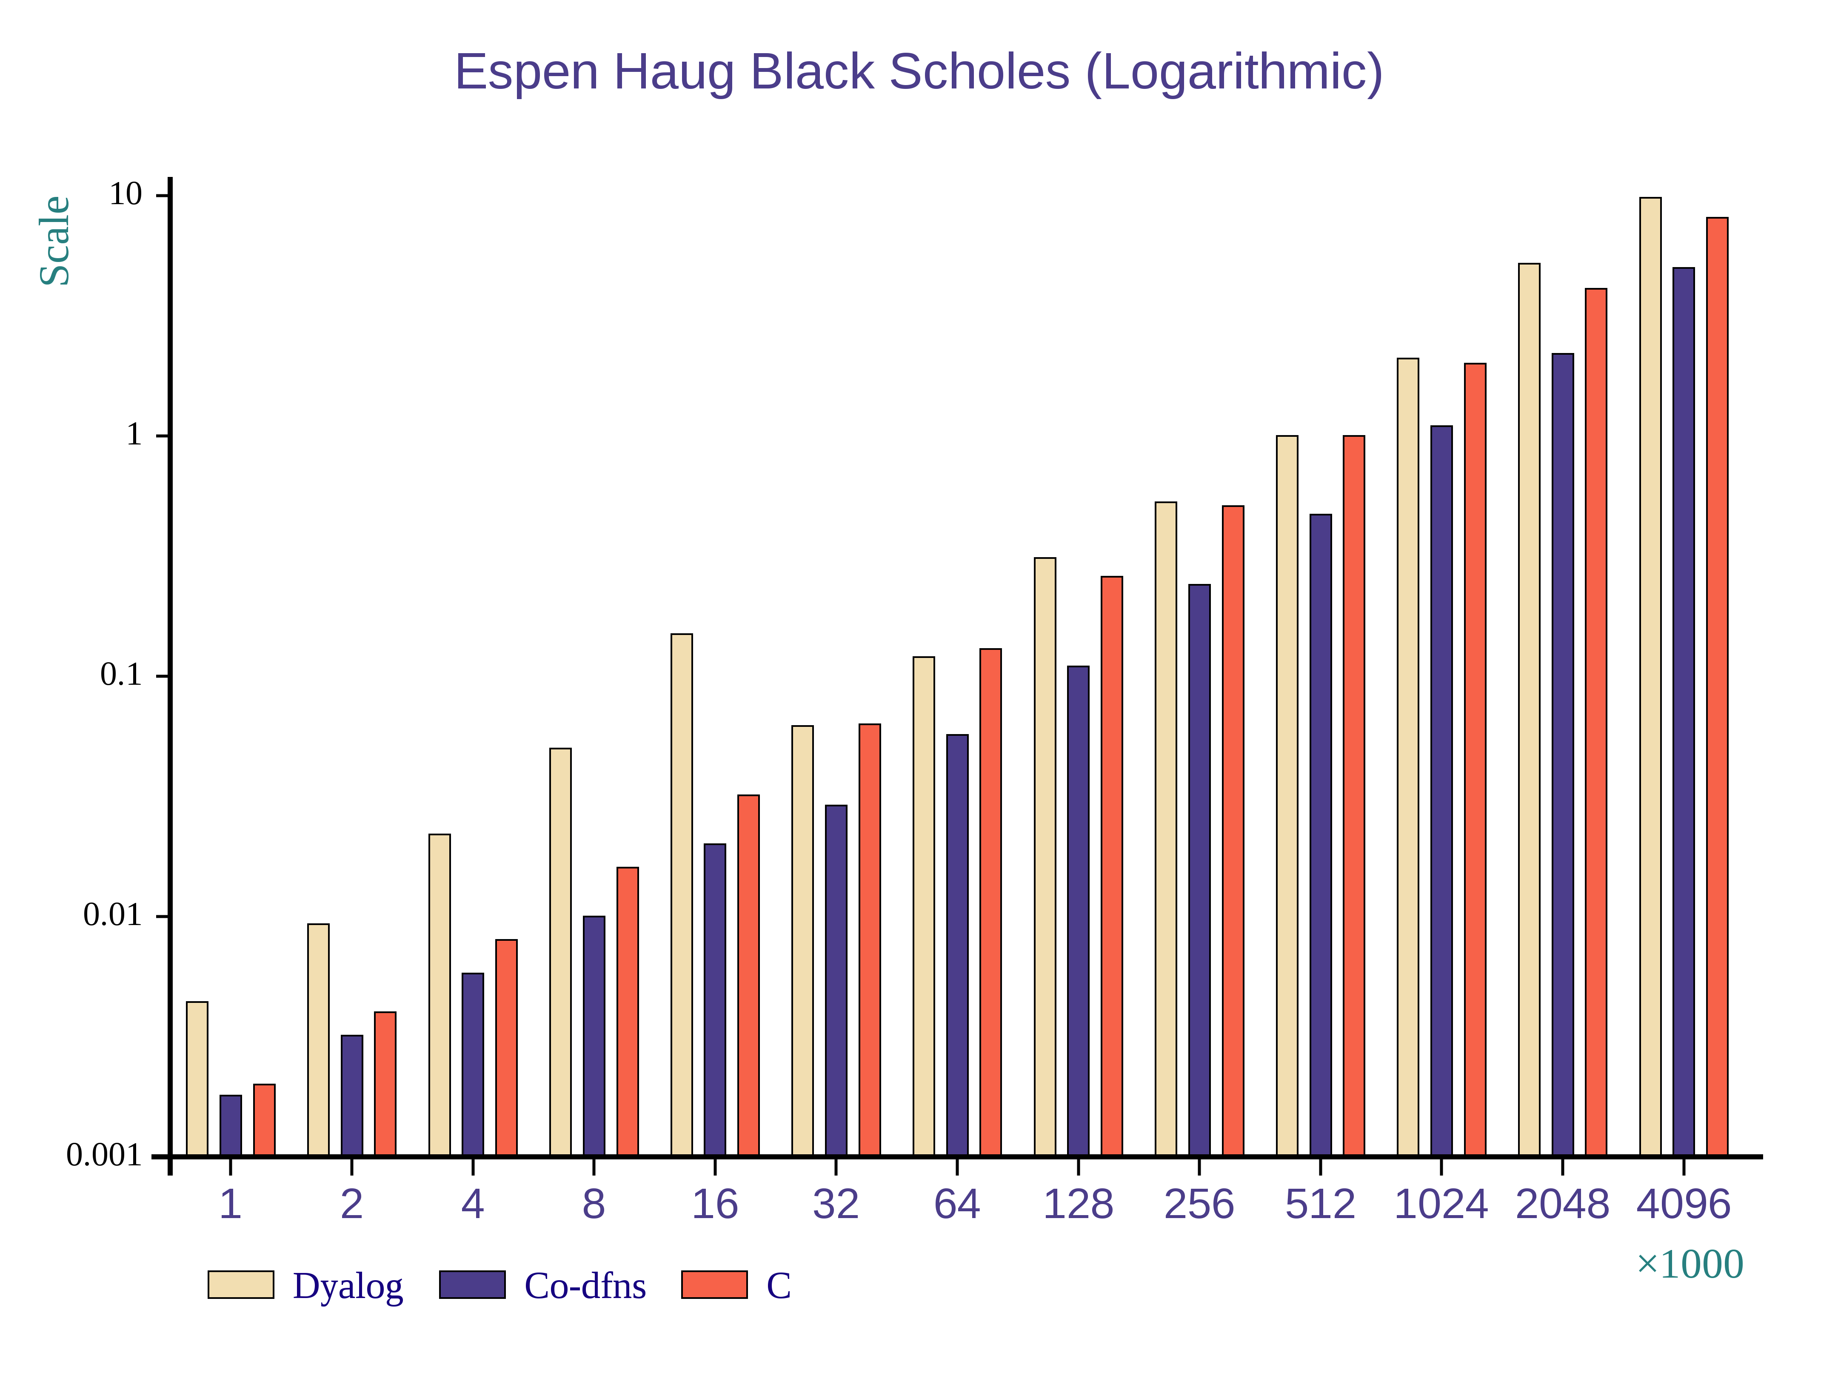
The CPU based code executed with speedups of roughly 20 - 30% as seen in Figure 1. On the GPU, without some specific special implementations of certain parts of the code, the performance actually slightly degraded from the interpreter. However, with the appropriate primitives in place, the performance was the same as that of the CPU, around 20 - 30%.
Figure 2. Performance of optimized Co-dfns code in the Black Scholes benchmark on the CPU.
In fact, through exploration of various implementation techniques and analyzing the code, we discovered that the most we could expect from the compiler on these sorts of ideal scalar computations with the then-current architecture was about a 30% improvement over the interpreter. Even if the computation happened almost instantly, the cost of transferring data in and out of the interpreter overwhelmed every other runtime cost. Data copy overhead was simply too great.
Unfortunately, there is little way in which to support generalized array operations in and out of the interpreter without incurring these overheads if we wished to stay with our own representation of arrays.
  - With Optimizations
In the next version of the compiler, we re-architected the design of the arrays to make use of Dyalog's DWA (Direct Workspace Access) infrastructure, which allows foreign code to operate over native interpreter structures. While somewhat more complicated then the normal FFI function interface, in our case, it provides significant benefits. By designing the compiler to operate over native Dyalog arrays instead of requiring a translation/conversion phase, we completely eliminate the overheads involved in transferring data in and out of the interpreter. When combined with the current optimizations that are in the compiler, including scalar function loop fusion and primitive inlining, we see performance improvements in the range of 50-90% on the CPU. In Figure 2 we include the alternative of using a handwritten C version of Black Scholes with the standard FFI interface in the Dyalog interpreter to compare the performance of hand-writing the code instead of using the Co-dfns compiler.
  - Preliminary GPU results
While we do not have complete results for the GPU yet, we have evaluated the performance potential of the compiler with the DWA interface, and have seen performance in the range of 100 - 200× increase on our hardware compared to the interpreter. This comes close to the expected ideal performance on our graphics card with these problems; we are confident that our ongoing work to include additional optimizations and the new DWA-based architecture will permit information experts operating on large scalar domains to maximize their GPU's capabilities through Dyalog APL and Co-dfns without requiring any changes in their program code.
  - Comparing to C
In Figure 2 the performance of the interpreter and the compiler appear in relation to hand written C code. The hand written C code simulates the process an information expert might use to optimize a particular piece of code that is going too slowly. That is, they would call out to a specific C library call to handle the inner loops, or they might write their own version in C or CUDA and then call into that code from the rest of the interpreter. The graphs here show the dangers of doing so. While the handwritten C code by itself would perform more quickly than the interpreter, it is difficult to use such code inside of an inner loop or just in a single "hot spot" because the overheads of getting data in and out of the foreign functions is too high. Thus, while the performance of the compiled code and the C code are not that far apart, the C code performs much worse in this use case because it does not integrate with the interpreter's data structures.
An information expert could manually integrate with the interpreter using the same DWA API that Dyalog provides, but this greatly increases the complexity of the code and the overall interfaces, and makes it more difficult to use "off the shelf" tuned libraries. By using the compiler instead, this difficult work of hand-writing optimized code or linking into existing high-performance tuned libraries disappears and the compiler can be relied upon to produce code of similar performance, even using these tuned libraries underneath without any user intervention.
- Ongoing Work
The Co-dfns compiler continues to evolve at a rapid pace, with significant components rewritten often as new techniques and solutions present themselves. The following projects give an idea of the roadmap for Co-dfns moving forward and especially for the near term improvements planned for the compiler.
We are working closely with industry partners through Dyalog, Ltd. to develop benchmarks and implementations of end-user code directly from the code bases of current Dyalog APL customers. This will allow us to not only examine Co-dfns from the perspective of traditional micro-benchmarks, but also give us a host of ready-to-use real life applications, which often diverge from micro-benchmarks in interesting ways.
We actively examine new programming methods and approaches for constructing the compiler. In particular, the next version will be using a Functional Relational Programming model which maps nicely onto the data-parallel infrastructure of the compiler. The use of this model provides a number of interesting optimizations at a very low cost to us. It remains to be seen whether it will provide enhancements to the general structure and clarity of the code base.
Work by Lenore Mullin [Mullin 1988] provides a firm base from which to develop a hybrid verification/type system on top of APL. A number of type systems have been created in industry [Shack-Nielsen 2014] and academia [Slepak 2014] to type APL code of various forms. Our audience for such a type system is the information experts themselves, coupled with the tuning expert, which presents interesting challenges in its design. We have preliminary models of such a type system, but no working implementation as yet.
The construction of programs in the branchless, recursion-less style of the compiler exposes a side-benefit that will be integrated into the compiler at a later date. Namely, with the simple control flow and well understood primitives, it is possible to automatically derive a worst-case performance model from the code without complex analysis. This allows us to obtain worst-case performance metrics about the runtime complexity of the compiler as well as memory usage automatically. We plan to integrate this feature into the compiler itself, so that the information expert can receive an automatic analysis of the runtime complexity of any program run through the compiler without requiring hand-working the solution.
The next optimizations which have revealed themselves as vitally important to improved imperformance are traditional constant propagation and folding. The compiler right now introduces overheads for each constant value in scalar computations which should not be there, sometimes interacting poorly with the vectorization engines of the underlying C compiler. Constant propagation and folding fixes this issue nicely.
Finally, it is possible for us to almost completely eliminate runtime type checking of most of the variables in code like Black Scholes through type inference, allowing us to dispatch early on the argument types and greatly reducing the generated C code both in size and complexity. This of course has obvious benefits to the runtime performance, but especially in terms of compile times and compiled object size.
- Related Work
The APEX compiler [Bernecky 1997] developed vectorized approaches to handling certain analyses to compile traditional APL, including a SIMD tokenizer [Bernecky 2003]. It uses a SSA representation, and converts the dynamic scope of traditional APL functions into a static form early on. It also uses a matrix format to represent the AST. Traditional APL did not have nested function definitions, however, and thus the APEX compiler does not have any specific approaches to dealing with function lifting. Bernecky suggests an approach for introducing parallelism into the compiler itself. While APEX is not self-hosting, its efforts to introduce parallel compiler passes should inform Co-dfns pass design. APEX does suffer from strong restrictions, though some could evaporate given enough effort. Both APEX and Co-dfns share some restrictions, such as not allowing the dynamic fixing of new functions at runtime. However, Co-dfns strives to ensure greater compatibility with dfns programs in Dyalog than analogous programs and APEX.
Bernecky further identified methods of reducing or optimizing the computational complexity or cost of certain array operations, allowing improved performance of easy to understand array expressions [1999].
Timothy Budd implemented a compiler [1984; 1988] for APL which targeted vector processors as well as one for C code. They used a method of lazy evaluation to avoid intermediate data copying. Budd provided thoughts and some ideas on how the compiler might be implemented in parallel as well. Budd's compiler delayed computation until the point at which the program requested the value. As in most traditional APL compilers, the accepted language does not coincide with normal APL programs of the time. Budd's compiler also managed allocation without requiring a garbage collector.
Walter Schwarz implemented an APL to C compiler for the ACORN system targeting the CM-2 machine, demonstrating performance potential for APL as a massively parallel language [1991].
W. Ching and D. Ju have spent significant work on the ELI language and other APL-class language implementations, especially on parallelized code and optimization. [Ching 1990; 2000; Ching, et al. 1993; Ching and Katz 1994; Hendriks and Ching 1990; Ju and Ching 1991; Ju, et al. 1991]
J. D. Bunda and J. A. Gerth presented a method for doing table driven parsing of APL which suggested a parallel optimization for parsing, but did not elucidate the algorithm [1984].
Single-assignment C [Grelck and Scholz 2006] attempts to deliver a high-level, C-like language that uses arrays as first-class data types. It focuses heavily on a functional paradigm and automatically parallelizes code. The same issues of memory copying and array management occur in SAC as in Co-dfns, but SAC is a purely functional language, whereas Co-dfns admits array mutation and variable assignment within a single scope.
Dyalog has provided a good deal of input into Co-dfns, and so it makes sense that the current release of their interpreter begins to implement some of the ideas in Co-dfns. This includes a facility for doing coarse-grained parallelism with futures, but does not include any ability to do more refined concurrent operations since the interpreter lacks single assignment arrays for synchronization; the interpreter itself makes no guarantees when effects occur in parallel. [Kromberg and Foad 2013]
The McLAB project [Casey, et al. 2010] implements a compiler and supporting systems for MATLAB code. Like Co-dfns, it provides an explicit intermediate language for work, but goes to a lower level with its own JIT. It also produces Fortran and C code, which are not explicit targets of Co-dfns. The MATLAB language itself differs from Co-dfns, which naturally results in differences of approach with McLAB and Co-dfns. Co-dfns adapts the APL language with explicit parallelism constructs, rather than emphasizing automatic parallelization of the runtime primitives.
Languages like X10 [Charles, et al. 2005], Fortress [Steele 2006], and Chapel [Chamberlain, et al. 2007] also strive to scale programming to large distributed systems. They inherit much of their linguistic history from Fortran, Java, and C++, rather than APL. They also emphasize a more object-oriented approach than the array-centric, functional approach of Co-dfns. They expose much more explicit syntactic constructs for controlling data layout and synchronization, whereas Co-dfns tries to minimize explicit syntax as much as possible.
A number of systems such as ZPL [Lin and Snyder 1994] and Accelerate [Chakravarty, et al. 20011] are able to provide interesting implementation strategies for array programming, each emphasizing different elements. They all take the overall approach of altering the language design in favor of making certain features prevalent. Accelerate, for instance, lifts rank to the type level, meaning that shapes are no longer first class entities. ZPL uses a more traditional language but enables predictable data layout for distributed computing. Accelerate takes advantage of the language and implementation to make heavy use of fusion.
Eric Holk's Harlan system [Holk 2011] takes a unique approach. Targeting the GPU explicitly, it tries to introduce traditional programming concepts as native concepts on the GPU, so that traditional programs can run reasonably on the GPU. This approach, instead of lifting array programming to the general-purpose sphere, pulls general-purpose language constructs such as ADTs into the GPU and array world through the use of region inference and a number of other transformations. It also uses the nanopass style of compiler design and includes a macro system on top of it to reduce the number of core forms the compiler must consider.
- Conclusion
The Co-dfns compiler enables information experts to convert their interpreted APL programs into efficient C and CUDA code that integrates into the Dyalog APL interpreter. This allows them to optimize hotspots in their code and to realize increased performance without rewriting key elements of their software. It also increases the range of hardware platforms available to the Dyalog APL programmer, as they are now able to execute their code on highly parallel processors like GPUs and the Xeon Phi. To achieve this performance on scalar centric algorithms like Black Scholes, integration into the interpreter makes the largest single performance difference in performance, to eliminate interpreter overheads getting data in and out of the system. After this, scalar function loop fusion becomes critical to make effective use of the cache hierarchies on modern architectures.
In addition to producing fast code, the compiler is written as a simple, data-flow, data-parallel program without any explicit recursion, branching, or other forms of complex control-flow. The directness and concision afforded by this method demonstrates that the number of domains for which array-oriented programming is suitable is larger than commonly granted.

Robert Bernecky. 1997. APEX: The APL parallel executor. (1997).
Robert Bernecky. 1999. Reducing computational complexity with array predicates. ACM SIGAPL APL Quote Quad 29, no. 3 (1999): 39-43.
Robert Bernecky. 2003. An SPMD/SIMD parallel tokenizer for APL. In Proceedings of the 2003 conference on APL: stretching the mind, pp. 21-32. ACM, 2003.
Timothy A. Budd. 1984. An APL Compiler for a Vector Processor. ACM Trans. Program. Lang. Syst. 6, 3 (July 1984), 297-313. DOI=10.1145/579.357248 http://doi.acm.org/10.1145/579.357248
Timothy A. Budd. 1988. An APL compiler. NY: Springer-Verlag, 1988.
J. D. Bunda and J. A. Gerth. 1984. APL two by two-syntax analysis by pairwise reduction. SIGAPL APL Quote Quad 14, 4 (June 1984), 85-94. DOI=10.1145/384283.801081 http://doi.acm.org/10.1145/384283.801081
Andrew Casey, Jun Li, Jesse Doherty, Maxime Chevalier-Boisvert, Toheed Aslam, Anton Dubrau, Nurudeen Lameed, Amina Aslam, Rahul Garg, Soroush Radpour, Olivier Savary Belanger, Laurie Hendren, and Clark Verbrugge. 2010. McLab: An extensible compiler toolkit for MATLAB and related languages. In C 3 S 2 E-10. Montreal.
Manuel M.T. Chakravarty, Gabriele Keller, Sean Lee, Trevor L. McDonell, and Vinod Grover. 2011. Accelerating Haskell array codes with multicore GPUs. In Proceedings of the sixth workshop on Declarative aspects of multicore programming (DAMP '11). ACM, New York, NY, USA, 3-14. DOI: http://doi.acm.org/10.1145/1926354.1926358
B.L. Chamberlain, D. Callahan, and H.P. Zima. 2007. Parallel Programmability and the Chapel Language. International Journal of High Performance Computing Applications vol. 21 no. 3. (August 2007). 291-312.
Philippe Charles, Christian Grothoff, Vijay Saraswat, Christopher Donawa, Allan Kielstra, Kemal Ebcioglu, Christoph von Praun, and Vivek Sarkar. 2005. X10: an object-oriented approach to non-uniform cluster computing. In Proceedings of the 20th annual ACM SIGPLAN conference on Object-oriented programming, systems, languages, and applications (OOPSLA '05). ACM, New York, NY, USA, 519-538. DOI=10.1145/1094811.1094852 http://doi.acm.org/10.1145/1094811.1094852
Wai-Mee Ching. 1990. Automatic parallelization of APL-style programs. In Conference Proceedings on APL 90: For the Future (Copenhagen, Denmark, August 13 - 17, 1990). P. Gjerløv, Ed. APL '90. ACM, New York, NY, 76-80. DOI= http://doi.acm.org/10.1145/97808.97826
Wai-Mee Ching. 2000. The design and implementation of an APL dialect, ELI. In Proceedings of the international Conference on Apl-Berlin-2000 Conference (Berlin, Germany, July 24 - 27, 2000). APL '00. ACM, New York, NY, 69-76. DOI= http://doi.acm.org/10.1145/570475.570485
Wai-Mee Ching, Paul Carini, and Dz-Ching Ju. 1993. A primitive-based strategy for producing efficient code for very high level programs. Comput. Lang. 19, 1 (Jan. 1993), 41-50. DOI= http://dx.doi.org/10.1016/0096-0551(93)90038-3
Wai-Mee Ching and Alex Katz. 1994. An experimental APL compiler for a distributed memory parallel machine. In Proceedings of the 1994 ACM/IEEE Conference on Supercomputing (Washington, D.C., November 14 - 18, 1994). IEEE Computer Society Press, Los Alamitos, CA, 59-68.
Alain Darte. 2000. On the complexity of loop fusion. Parallel Computing, 26(9), 1175-1193. DOI=10.1016/S0167-8191(00)00034-X http://dx.doi.org/10.1016/S0167-8191(00)00034-X
Dyalog, Ltd. 2014. SA4: Introduction to Direct Workspace Access (DWA). (September 2014). In Dyalog '14. (September 2014). Retrieved March 23, 2015 from http://www.dyalog.com/user-meetings/dyalog14.htm
Dyalog, Ltd. 2015. Dyalog: A Tool of Thought for Software Solutions. (March 2015). Retrieved March 23, 2015 from http://www.dyalog.com
Clemens Grelck and Sven-Bodo Scholz. 2006. SAC — A Functional Array Language for Efficient Multi-threaded Execution. In International Journal of Parallel Programming, Vol. 34, No. 4, (August 2006). DOI: 0.1007/s10766-006-0018-x
Paul Grosvenor. 2013. COSMOS Performance Improvements. In Dyalog '13. (October 2013). Retrieved March 23, 2015 from http://video.dyalog.com/Dyalog13/?v=oK_XGobiFmM
Ferdinand Hendriks and Wai-Mee Ching. 1990. Sparse matrix technology tools in APL. In Conference Proceedings on APL 90: For the Future (Copenhagen, Denmark, August 13 - 17, 1990). P. Gjerløv, Ed. APL '90. ACM, New York, NY, 186-191. DOI= http://doi.acm.org/10.1145/97808.97844
Eric Holk, William Byrd, Nilesh Mahajan, Jeremiah Willock, Arun Chauhan, Andrew Lumsdaine. 2011. Declarative Programming for GPUs. In International Conference on Parallel Computing (ParCo 2011). (September 2011).
Aaron W. Hsu. 2014a. Co-dfns: Ancient Language, Modern Compiler. In Proceedings of ACM SIGPLAN International Workshop on Libraries, Languages, and Compilers for Array Programming (ARRAY'14). ACM, New York, NY, USA, , Pages 62 , 6 pages. DOI=10.1145/2627373.2627384 http://doi.acm.org/10.1145/2627373.2627384
Aaron W. Hsu. 2014b. Co-dfns Report: Performance and Reliability Prototyping. In Dyalog '14. (September 2014). Retrieved March 23, 2015 from http://video.dyalog.com/Dyalog14/?v=8VPQmaJquB0
Kenneth E. Iverson. 2007. Notation as a tool of thought. In ACM Turing award lectures. ACM, New York, NY, USA. DOI=10.1145/1283920.1283935 http://dx.doi.org/10.1145/1283920.1283935
Dz-Ching Ju. and Wai-Mee Ching. 1991. Exploitation of APL data parallelism on a shared-memory MIMD machine. In Proceedings of the Third ACM SIGPLAN Symposium on Principles and Practice of Parallel Programming (Williamsburg, Virginia, USA, April 21 - 24, 1991). PPOPP '91. ACM, New York, NY, 61-72. DOI= http://doi.acm.org/10.1145/109625.109633
Dz-Ching Ju, Wai-Mee Ching, and Chuan-lin Wu. 1991. On performance and space usage improvements for parallelized compiled APL code. In Proceedings of the international Conference on APL '91 (Palo Alto, California, USA, August 04 - 08, 1991). APL '91. ACM, New York, NY, 234-243. DOI= http://doi.acm.org/10.1145/114054.114080
Morten Kromberg and Jay Foad. 2013. Parallel Language Features in Version 14.0. Video. In Dyalog '13. (October 2013). Retrieved on March 23, 2015 from http://video.dyalog.com/Dyalog13/?v=Bmx_yUKxVv0
Calvin Lin and Lawrence Snyder. 1994. ZPL: An array sub-language. Languages and Compilers for Parallel Computing Lecture Notes in Computer Science Volume 768. 96-114.
Lenore Mullin. 1988. A mathematics of arrays. Ph.D. Dissertation. School of Computer and Information Science, Syracuse University.
Walter Schwarz. 1991. Acorn Run-Time System for the CM-2. In Arrays, Functional Languages, and Parallel Systems, pp. 35-57. Springer US, 1991.
Anders Shack-Nielsen. 2014. Parsing APL for Static Analysis. (September 2014). Retrieved March 23, 2015 from http://video.dyalog.com/Dyalog14/?v=7Z0wzY9Oip4
Justin Slepak, Olin Shivers, and Panagiotis Manolios. 2014. An array-oriented language with static rank polymorphism. In Programming Languages and Systems (pp. 27-46). Springer Berlin Heidelberg. DOI=10.1007/978-3-642-54833-8_3 http://dx.doi.org/10.1007/978-3-642-54833-8_3
Guy L. Steele Jr. 2006. Parallel Programming and Parallel Abstractions in Fortress. In FLOPS.

